ANSWERS TO REVIEWERS

We thank the Referees for their interest in our work and for helpful comments that will greatly improve the manuscript and we have tried to do our best to respond to the points raised. The Referees have brought up some good points and we appreciate the opportunity to clarify our research objectives and results. As indicated below, we have checked all the general and specific comments provided by the Referees and have made necessary changes accordingly to their indications.
Referees report JSCS 1664

Synthesis and antimicrobial activity of new 3,5-diarylidene-4-piperidone derivatives

Kulathooran Singaram, Dhamodaran Marimuthu, Selvakumar Baskaran and Venkataraman Ramaswamy

C1. Scheme 1 should be corrected in following issues:
- Compounds 3a, 3b, 3d and 3f were isolated as HCl salts, but derivatives 3c and 3e not. They were isolated in the basic form.
- Compounds 8 were isolated as TFA salts.
- Structures for Ar, R₁ and R₂ groups must be given in Scheme 1, or complete structures for corresponding reactants and products. Without those structures spectral and analytical data and nomenclature could not be checked.

A1. As suggested by Referee,
-Compounds 3a, 3b, 3d and 3f were mentioned as HCl salts in Table 1. Similarly, derivatives 3c and 3e were mentioned as basic form in Table-1.
-We have further investigated the compounds 8a and 8b with skilled person about the TFA salt confirmation through ¹³C NMR. Result showed that, we have not observed the signals for TFA salt in ¹³C NMR. Finally, we concluded the compounds 8a and 8b were isolated as free bases. Author really apologize for this mistake. Thus, we have not captured TFA salt information in the table.
-Structure for Ar, R₁ and R₂ groups are mentioned in Tables 1, 2, 3, 4, 5 and 6 with corresponding reactants and products.

TABLE 1. Synthesis of compounds 3(a-f)
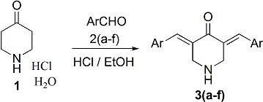
Entry | ArCHO | 3(a-f)
3a
3b
3c
3d
3e
3f

TABLE 2. Synthesis of compounds 5(a-f)
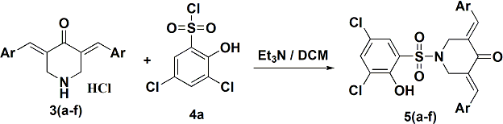
Entry | 3(a-f) | 5(a-f)
5a
5b
5c
5d
5e
5f

TABLE 3. Synthesis of compounds 5(g-l)
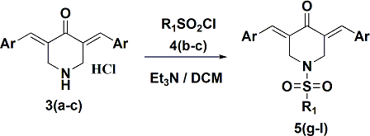
Entry | 3(a-c) | R₁SO₂Cl | 5(g-l)
5g
5h
5i
5j
5k
5l

TABLE 4. Synthesis of compounds 5(m-q)
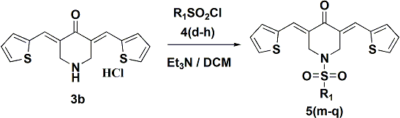
Entry | R₁SO₂Cl | 5(m-q)
5m
5n
5o
5p
5q

TABLE 5. Synthesis of compounds 7(a-b)
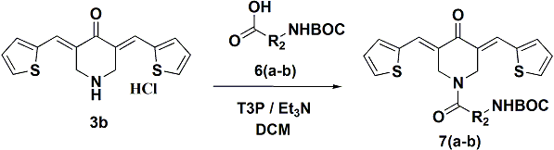

Entry | 6(a-b) | 7(a-b)
7a
7b

TABLE 6. Synthesis of compounds 8(a-b)
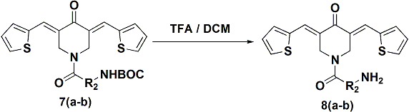

Entry | 7(a-b) | 8(a-b)
8a
8b

C2. Derivatives 3a, 3b, 3d, 3f and 8 were tested as salts, other derivatives were tested as neutral compounds, but that was not quoted or discussed neither in the main text nor in the Table 1. Do different forms (salts or neutral molecules) of tested compounds influence their biological activities? If not, how that was checked?

A2. As suggested by Referee, we have captured the salt and neutral forms of all synthesized compounds in Tables 1, 2, 3, 4, 5 and 6. Further, compounds 3a, 3b, 3d and 3f were isolated as HCl salts which we mentioned in the main text, especially in antimicrobial evaluation part. However, we tested the biological activities for compounds 3a, 3b, 3d and 3f as HCL salt and compounds 3c and 3e were tested as basic form.

C3. ESI-HRMS data (calculated and found values) must be given with four decimal places.
A3. As suggested by Referee, we have captured the ESI-HRMS data (calculated and found values) for all synthesized compounds in four decimals.

C4. Major bands from IR spectra for all compounds should be given along with other spectral data.
A4. As suggested by Referee, we have captured the major bands from IR for all compounds along with other spectral data in supplementary part.

C5. Since combustion analysis were omitted, copies of ¹H and ¹³C NMR spectra for all compounds should be provide as supplementary information (SI2).
A5. Copies of ¹H and ¹³C NMR spectra with structure for all the synthesised compounds have been captured in the supplementary part.

C6. In ¹³C NMR spectra of derivatives 8, presence of CF₃CO₂- was not confirmed.
A6. Compounds 8a and 8b were isolated as free bases. Author really apologize for this mistake about the TFA salt.

C7. Is it possible to use derivative 3f in performed reactions without previous protection of hydroxyl group?
A7. Yes, it is possible. We have performed the reaction for synthesis of 5f using 3f without protection of hydroxyl group and obtained only 64% of yield. At present, we have performed only the preliminary scanning of compound 5f, which we required very minimal sample. Thus, we have not protected the hydroxyl group during the synthesis of compound 5f.

C8. Since substantial numbers of compounds were obtained, authors should consider giving structures of compounds with corresponding spectral data in SI.
A8. As suggested by Referee, we have captured the corresponding structure for all the synthesised compounds with corresponding spectral data in the supplementary part.

C9. Derivative 5e showed best antifungal activity, not promising. Also, 5b, 5p and 5d are less active (not much, but less) corresponding to 5e, and could not be characterised as excellent active.
Discussion of obtained biological results should be more appropriate.
A9. As suggested by Referee, we have modified the biological results. Especially, compound 5e mentioned as best antifungal activity.

C10. Last, but not less important. English and spelling should be revised.
A10. As suggested by Referee, we have checked the spelling and modified the English format in the manuscript as per the journal requirement.

