SUPPLEMENTARY MATERIAL

The analytical and spectral data of the synthesized compounds are available

Synthesis and antimicrobial activity of new 3,5-diarylidene-4-piperidone derivatives

KULATHOORAN SINGARAM¹, DHAMODARAN MARIMUTHU^{2*}, SELVAKUMAR BASKARAN³ and VENKATARAMAN RAMASWAMY⁴

¹Research & Development Centre, Bharathiar University, Coimbatore-641046, India, ^{2*}Department of Chemistry, Perunthalaivar Kamarajar Institute of Engineering and Technology, Karaikal-609603, India and ^{3&4}Department of Chemistry, PG and Research Centre, Sriparamakalyani College, Alwarkurichi 627412, India
*Corresponding author. E-mail: dhamu_762003@yahoo.co.in
Table of Content
S. No. | Content | Page No.
1 | General description | S2
2 | General experimental procedure for compounds 3(a-f) | S2
3 | General experimental procedure for compounds 5(a-q) | S2-S3
4 | General experimental procedure for compounds 7(a-b) | S3
5 | General experimental procedure for compounds 8(a-b) | S3-S4
6 | Spectral data of compounds 3(a-f) | S4-S6
7 | Spectral data of compounds 5(a-q) | S6-S14
8 | Spectral data of compounds 7(a-b) | S14-15
9 | Spectral data of compounds 8(a-b) | S15
10 | ¹H and ¹³C-NMR charts of compounds 3(a-f) | S16-S21
11 | ¹H and ¹³C-NMR charts of compounds 5(a-q) | S22-S38
12 | ¹H and ¹³C-NMR charts of compounds 7(a-b) | S39-S40
13 | ¹H and ¹³C-NMR charts of compounds 8(a-b) | S41-S42
14 | TABLE 1. Synthesis of compounds 3(a-f) | S43
15 | TABLE 2. Synthesis of compounds 5(a-f) | S44-S45
16 | TABLE 3. Synthesis of compounds 5(g-l) | S46-S47
17 | TABLE 4. Synthesis of compounds 5(m-q) | S47-S48
18 | TABLE 5. Synthesis of compounds 7(a-b) | S48
19 | TABLE 6. Synthesis of compounds 8(a-b) | S49
20 | TABLE 7. Antimicrobial result | S50

1. General description:
All the purchased reagents and solvents were of reagent grade and used without further purification. Progress of reactions was monitored by TLC on silica gel-coated aluminum sheets (Type 60 GF254). FTIR spectra (in KBr pellets) were recorded on a Nucon infrared spectrophotometer and only characteristic peaks are reported in cm⁻¹. The melting points were measured in open capillaries and are uncorrected. ¹H and ¹³C NMR were recorded on a Bruker 400/100 MHz spectrometer in DMSO-d₆ as solvent. The chemical shift values are reported in ppm and J values are given in Hz. Mass spectrometric data was determined using an Agilent 1200 (Liquid chromatography) series instrument. Products were purified by flash column chromatography using silica gel (60-120 mesh). The analytical and spectral data of the synthesized compounds are included in the supplementary material of this paper.

2. General experimental procedure for compounds 3(a-f):
A mixture of 4-piperidone monohydrate hydrochloride 1 (10 mmol) and various substituted aryl aldehydes (20 mmol) in ethanol (10 mL) was stirred at room temperature (29 °C) for 10 minutes. Cooled the reaction mixture to 0 °C and conc. HCl (2.0 g, 20mmol) was added drop wise. The resulting mixture was refluxed for about 4.5 h. The progress of the reaction was monitored by TLC. After completion of the reaction, the crude product was filtered and recrystallized from ethanol to obtain pure 3,5-bis(4-fluorobenzylidene)piperidin-4-one hydrochloride 3a in excellent yield (3.26 g, 94%) except compounds 3c and 3e. The above general method was adopted for the synthesis of compounds 3b, 3d and 3f of this series. The compounds 3c and 3e were neutralized with 10% NaOH (8 mL) extracted twice with chloroform (2 × 50 mL) and dried over by sodium sulfate. Combined organic layer was concentrated under reduced pressure and crude product was purified by column chromatography using 5% mixture of methanol and chloroform as an eluent to obtain pure compounds 3c and 3e. Detailed structures for corresponding reactants and products are shown in Table 1.

3. General experimental procedure for compounds 5(a-q):
A mixture of 3,5-bis(4-fluorobenzylidene)piperidin-4-one hydrochloride 3a (0.34 g, 1 mmol) and triethylamine (0.203 g, 2 mmol) in DCM (10 mL) was stirred at room temperature (29 °C), 3,5-dichloro-2-hydroxyphenylsulfonyl chloride 4a (0.28g, 1.1 mmol) was added to the mixture and stirring was continued for 30 minutes. The progress of the reaction was monitored by TLC. After completion of the reaction, the resulting mixture was diluted with water and extracted twice with DCM (2 × 10 mL). The crude product was purified by gravity column chromatography using 3% mixture of methanol and DCM as an eluent to obtain 3,5-bis(4-fluorobenzylidene)-1-(3,5-dichloro-2-hydroxyphenylsulfonyl) piperidin-4-one 5a in excellent yield (0.49g, 92%). The above general method was adopted for the synthesis of compounds 5b-q of this series. Compound 5f has been synthesized from 3f without protection of hydroxyl group. Detailed structures for corresponding reactants and products are shown in Tables 2, 3 and 4.

4. General experimental procedure for compounds 7(a-b):
A mixture of 3,5-bis(thiophen-2-ylmethylene)piperidin-4-one hydrochloride 3b (0.32 g, 1 mmol) and 2-(tert-butoxycarbonylamino)acetic acid 6a (0.17 g, 1.1 mmol) in DCM (10 mL) was stirred at room temperature (29 °C), triethylamine (0.50 g, 5 mmol) was added to the mixture and stirring was continued for 15 minutes. The reaction mixture was cooled to 0 °C, propylphosphonic anhydride 50% solution in ethyl acetate (T3P) (1.59 g, 2.5 mmol) was added drop wise to the mixture and stirring was continued for 12 h at (29 °C). The progress of the reaction was monitored by TLC. After completion of the reaction, the resulting mixture was diluted with DCM (30 mL) and washed with water (2 × 50 mL). DCM layer was dried over sodium sulfate and concentrated under reduced pressure. The crude product was purified by chromatography using 5% mixture of methanol and DCM as an eluent to obtain tert-butyl 2-oxo-2-(4-oxo-3,5-bis(thiophen-2-ylmethylene)piperidin-1-yl)ethylcarbamate 7a in good yield (0.35 g, 78%). The above general method was adopted for the synthesis of compound 7b of this series. Detailed structures for corresponding reactants and products are shown in Table 5.

5. General experimental procedure for compounds 8(a-b):
A mixture of tert-butyl 2-oxo-2-(4-oxo-3,5-bis(thiophen-2-ylmethylene)piperidin-1-yl)ethylcarbamate 7a (0.44 g, 1 mmol) in dry DCM (10 mL) was stirred at room temperature (29 °C) for 15 minutes. Cooled the reaction mixture to 0 °C, TFA (0.57 g, 5 mmol) was added drop wise to the mixture and stirring was continued for 2 h at (29 °C). The progress of the reaction was monitored by TLC. After completion of the reaction, excess solvent was evaporated under reduced pressure to dryness. The crude product was washed with n-hexane repeatedly to remove traces of residual acid to obtain 1-(2-aminoacetyl)-3,5-bis(thiophen-2-ylmethylene)piperidin-4-one 8a in excellent yield (0.42 g, 93%). The above general method was adopted for the synthesis of compound 8b of this series. Detailed structures for corresponding reactants and products are shown in Table 6.

6. Spectral data of compounds 3(a-f):
3,5-Bis(4-fluorobenzylidene)piperidin-4-one hydrochloride (3a).
Yellow crystals; Yield: 94%; m.p. 236-238 °C; IR (KBr, cm⁻¹): 3157 (N-H), 2814 (C-H), 1663 (C=O); ¹H-NMR (400 MHz, DMSO-d₆, δ / ppm): 4.40 (4H, s, -CH₂-NH-CH₂), 7.35-7.40 (4H, m, Ar), 7.59 (4H, dd, J = 8.8 Hz, 5.6 Hz, Ar), 7.84 (2H, s, Ar-CH=C), 9.64 (2H, s, NH.HCl); ¹³C-NMR (100 MHz, DMSO-d₆, δ / ppm): 44.5 (NCH₂), 116.4 (d, J = 21.6 Hz), 128.9, 130. 9, 133.4 (d, J = 8.6 Hz), 138.0, 162.0 (d, J = 247.8 Hz), 183.3 (CO); ESI-HRMS (m/z): Calcd. for C₁₉H₁₅F₂NO [M+H]⁺: 312.3262, found 312.3241.

3,5-bis(Thiophen-2-ylmethylene)piperidin-4-one hydrochloride (3b).

Yellow crystals; Yield: 96%; m.p. 357-359 °C; IR (KBr, cm⁻¹): 3051 (N-H), 2789 (C-H), 1668 (C=O); ¹H-NMR (400 MHz, DMSO-d₆, δ / ppm): 4.47 (4H, s, -CH₂-NH-CH₂), 7.31 (2H, dd, J = 5.0, 3.8 Hz, Ar), 7.69 (2H, s, Ar-CH=C), 8.02-8.06 (4H, m, Ar), 10.1 (2H, s, NH.HCl); ¹³C-NMR (100 MHz, DMSO-d₆, δ / ppm): 44.0 (NCH₂), 124.7, 129.3, 131.3, 133.4, 136.0, 137.4, 181.8 (CO); ESI-HRMS (m/z): Calcd. for C₁₅H₁₃NOS₂ [M+H]⁺: 288.4006, found 288.4001.

3,5-bis(Benzo[d][1,3]dioxol-5-ylmethylene)piperidin-4-one (3c).

Yellow powder; Yield: 93%; m.p. 256-258 °C; IR (KBr, cm⁻¹): 3122 (N-H), 2811 (C-H), 1669 (C=O); ¹H-NMR (400 MHz, DMSO-d_{6,} δ / ppm): 3.95 (4H, s, -CH₂-NH-CH₂), 5.75 (1H, s, NH), 6.09 (4H, s, OCH₂O), 7.01-7.05 (6H, m, Ar), 7.49 (2H, s, Ar-CH=C); ¹³C-NMR (100 MHz, DMSO-d₆ , δ / ppm): 48.1 (NCH₂), 102.0 (OCH₂O), 109.0, 110.5, 126.2, 129.6, 134.1, 134.9, 148.1, 148.5, 187.8 (CO); ESI-HRMS (m/z): Calcd. for C₂₁H₁₇NO₅ [M+H]⁺: 363.3644, found 364.3647.

3,5-bis(Thiophen-3-ylmethylene)piperidin-4-one hydrochloride (3d).
Yellow powder; Yield: 90%; m.p. 348-350 °C; IR (KBr, cm⁻¹): 3108 (N-H), 2784 (C-H), 1667 (C=O); ¹H-NMR (400 MHz, DMSO-d_{6 ,}δ / ppm): 4.49 (4H, s, -CH₂-NH-CH₂), 7.40 (2H, d, J = 5.2 Hz, Ar), 7.76-7.77 (2H, m, Ar), 7.85 (2H, s, Ar), 8.04 (2H, s, Ar-CH=C), 9.95 (2H, s, NH.HCl); ¹³C-NMR (100 MHz, DMSO-d_{6,} δ / ppm): 44.3 (NCH₂), 126.4, 128.2, 129.7, 132.0, 132.9, 136. 0, 182.8 (CO); ESI-HRMS (m/z): Calcd. for C₁₅H₁₃NOS₂ [M⁺]: 287.7606, found 287.7646.

3,5-Dibenzylidenepiperidin-4-one (3e).
Yellow powder; Yield: 90%; m.p. 211-213 °C; IR (KBr, cm⁻¹): 3128 (N-H), 2815 (C-H), 1668 (C=O); ¹H-NMR (400 MHz, DMSO-d₆, δ / ppm): 4.48 (4H, s, -CH₂-NH-CH₂), 7.52-7.60 (6H, m, Ar), 7.62-7.64 (4H, m, Ar), 7.68 (2H, s, Ar-CH=C), 9.81 (1H, s, NH); ¹³C-NMR (100 MHz, DMSO-d₆, δ / ppm): 44.6 (NCH₂), 129.1, 131.1, 133.7, 138.2, 142.2, 144.7, 184.5 (CO); ESI-HRMS (m/z): Calcd. forC₁₉H₁₇NO [M⁺]: 275.2954, found 275.2954.
3,5-bis(3-Chloro-4-hydroxybenzylidene)piperidin-4-one hydrochloride (3f).
Yellow crystals; Yield: 95%; m.p. 320-322 °C; IR (KBr, cm⁻¹): 3188 (N-H), 2810 (C-H), 1663 (C=O); ¹H-NMR (400 MHz, DMSO-d₆, δ / ppm): 4.46 (4H, s, -CH₂-NH-CH₂), 7.15 (2H, d, J = 8.4 Hz, Ar), 7.34-7.37 (2H, m, Ar), 7.57 (2H, d, J = 2.0 Hz, Ar), 7.74 (2H, s, Ar-CH=C), 9.76 (2H, s, NH.HCl), 11.12 (2H, s, OH); ¹³C-NMR (100 MHz, DMSO-d_{6,} δ / ppm): 44.3 (NCH₂), 117.4, 120. 8, 126.3, 126.4, 131.6, 132.9, 138.4, 155.6 (COH), 182.4 (CO); ESI-HRMS (m/z): Calcd. for C₁₉H₁₅Cl₂NO₃ [M⁺]: 375.9442, found 375.9401.

7. Spectral data of compounds 5(a-q):
3,5-bis(4-Fluorobenzylidene)-1-(3,5-dichloro-2-hydroxyphenylsulfonyl) piperidin-4-one (5a).
Pale yellow solid; Yield: 92%; m.p. 221-223 °C; IR (KBr, cm⁻¹): 2856 (C-H), 1663 (C=O); ¹H-NMR (400 MHz, DMSO-d₆, δ / ppm): 4.73 (4H, s, -CH₂-NH-CH₂), 7.28 (1H, d, J = 2.8 Hz, -SO₂-Aryl), 7.34 (4H, t, J = 8.8 Hz, Ar), 7.52 (4H, dd, J = 8.4, 5.6 Hz, Ar), 7.57 (2H, s, ArCH=C), 7.82 (1H, d, J = 2.8 Hz, -SO₂-Aryl), 11.06 (1H, s,-OH); ¹³C-NMR (100 MHz, DMSO-d₆, δ / ppm): 46.8 (NCH₂), 116.2 (d, J= 21.5 Hz), 124.7, 128.5, 128.8, 131.1, 131.5, 133.2 (d, J = 8.5 Hz), 134.3, 135.6, 151.7 (COH), 161.7 (d, J = 247.2 Hz), 185.4 (CO); ESI-HRMS (m/z): Calcd. for C₂₅H₁₇Cl₂F₂NO₄S [M⁺-2]: 534.0356, found 534.0356.

1-(3,5-Dichloro-2-hydroxyphenylsulfonyl)-3,5-bis(thiophen-2-ylmethylene)piperidin-4-one (5b).
Pale yellow solid; Yield: 93.0%; m.p. 219-221 °C; IR (KBr, cm⁻¹): 2891 (C-H), 1661 (C=O); ¹H-NMR (400 MHz, DMSO-d₆, δ / ppm): 4.77 (4H, s, -CH₂-NH-CH₂), 7.28 (2H, dd, J = 5.2, 3.6 Hz, Ar), 7.49 (1H, d, J = 2.4 Hz, Ar), 7.59 (2H, d, J = 3.6 Hz, Ar), 7.77 (2H, s, Ar-CH=C), 7.82 (1H, d, J = 2.8 Hz, Ar), 7.98 (2H , d, J = 4.8 Hz, Ar), 11.16 (1H, s, OH); ¹³C-NMR (100 MHz, DMSO-d₆, δ / ppm): 46.8 (NCH₂), 123.4, 124.6, 127.5, 128.8, 129.0, 133.1, 133.9, 134.6, 135.3, 137.9, 138.3, 151.0 (COH), 184.3 (CO); ESI-HRMS (m/z): Calcd. for C₂₁H₁₅Cl₂NO₄S₃ [M⁺-2]: 509.8200, found 509.8210.

3,5-bis(Benzo[d][1,3]dioxol-5-ylmethylene)-1-(3,5-dichloro-2-hydroxyphenyl-sulfonyl)piperidin-4-one (5c).
Pale yellow solid; Yield: 95.0%; m.p. 242.5-243.4 °C; IR (KBr, cm⁻¹): 2946 (C-H), 1669 (C=O); ¹H-NMR (400 MHz, DMSO-d₆, δ / ppm): 4.70 (4H, s, -CH₂-NH-CH₂), 6.1 (4H, s, OCH₂O), 6.99 (6H, m, Ar), 7.34 (1H, d, J = 2.8 Hz, Ar), 7.50 (2H, s, Ar-CH=C), 7.82 (1H, d, J = 2.4 Hz, Ar), 11.04 (1H, s, OH); ¹³C-NMR (100 MHz, DMSO-d₆, δ / ppm): 47.0 (NCH₂), 102.2 (OCH₂O), 109.2, 110.5, 126.5, 128.5, 128.7, 130.1, 134.4, 136.7, 148.2, 149.0, 151.0 (COH), 185.1 (CO); ESI-HRMS (m/z): Calcd. for C₂₇H₁₉Cl₂NO₈S [M⁺-2]: 586.4138, found 586.4142.

1-(3,5-Dichloro-2-hydroxyphenylsulfonyl)-3,5-bis(thiophen-3-ylmethylene)piperidin-4-one (5d).
Pale yellow solid; Yield: 92.0%; m.p. 217-219 °C; IR (KBr, cm⁻¹): 2818 (C-H), 1667 (C=O); ¹H-NMR (400 MHz, DMSO-d₆, δ / ppm): 4.73 (4H, s, -CH₂-NH-CH₂), 7.34 (2H, d, J = 4.4 Hz, Ar), 7.47 (1H, d, J = 5.6 Hz, Ar), 7.60 (2H, s, Ar), 7.72 (2H, dd, J = 5.2, 4.8 Hz, Ar), 7.84 (1H, d, J = 2.4 Hz, Ar), 7.92 (2H, s, Ar-CH=C); 11.08(1H, s, OH); ¹³C-NMR (100 MHz, DMSO-d₆, δ / ppm): 47.3 (NCH₂), 123.4, 124.3, 127.9, 128.7, 129.7, 130.0, 130.1, 131.0, 134.4, 136.3, 136.5, 150.8(COH), 185.2 (CO); ESI-HRMS (m/z): Calcd. for C₂₁H₁₅Cl₂NO₄S₃ [M⁺-2]: 511.9000, found 511.9017.
3,5-Dibenzylidene-1-(3,5-dichloro-2-hydroxyphenylsulfonyl)piperidin-4-one (5e).
Pale yellow solid; Yield: 98.0%; m.p. 191-193 °C; IR (KBr, cm⁻¹): 2896 (C-H), 1659 (C=O); ¹H-NMR (400 MHz, DMSO-d₆, δ / ppm): 4.75 (4H, s, -CH₂-NH-CH₂), 7.30 (1H, d, J = 2.4 Hz, SO₂-aryl), 7.49-7.54 (10H, m, Ar), 7.61 (2H, s, ArCH=C), 7.85 (1H, d, J = 2.4 Hz, -SO₂-aryl), 11.07 (1H, s, OH); ¹³C-NMR (100 MHz, DMSO-d₆, δ / ppm): 47.0 (NCH₂), 123.3, 124.5, 128.5, 129.2, 129.3, 130.1, 130.9, 131.7, 134.5, 136.9, 150.8 (COH), 185.4 (CO); ESI-HRMS (m/z): Calcd. for C₂₅H₁₉Cl₂NO₄S [M⁺-2]: 498.1048, found 498.1091.

3,5-bis(3-Chloro-4-hydroxybenzylidene)-1-(3,5-dichloro-2-hydroxyphenylsulfonyl) piperidin-4-one (5f).
Yellow solid; Yield: 64.0%; m.p. 300-302 °C; IR (KBr, cm⁻¹): 2916 (C-H), 1661 (C=O); ¹H-NMR (400 MHz, DMSO-d₆, δ / ppm): 4.69 (4H, s, -CH₂-NH-CH₂), 7.08 (2H, d, J = 8.4 Hz, Ar), 7.26 (2H, dd, J = 8.4, 2.0 Hz, Ar), 7.34 (1H, d, J = 2.4 Hz, SO₂-aryl), 7.45-7.47 (4H, m, Ar and Ar-CH=C), 7.82 (1H, d, J = 2.4 Hz, SO₂-aryl), 10.87 (2H, s, OH), 10.99 (1H, s, OH); ¹³C-NMR (100 MHz, DMSO-d₆, δ / ppm): 46.9, 117.3, 120.7, 123.4, 124.5, 126.8, 128.6, 129.1, 129.9, 131.2, 132.9, 134.4, 135.7, 150.8 (COH), 155.0 (COH), 184.9(CO); ESI-HRMS (m/z): Calcd. for C₂₅H₁₇Cl₄NO₆S [M⁺-1]: 599.7236, found 599.7242.

Methyl 2-(3,5-bis(4-fluorobenzylidene)-4-oxopiperidin-1-ylsulfonyl)benzoate (5g).
Pale yellow solid; Yield: 93.5%; m.p. 187-189 °C; IR (KBr, cm⁻¹): 2916 (C-H), 1647 (C=O); ¹H-NMR (400 MHz, DMSO-d₆, δ / ppm): 3.58 (3H, s, COOCH₃), 4.66 (4H, s, -CH₂-NH-CH₂), 7.35 (4H, t, J = 8.8 Hz, Ar), 7.60-7.76 (5H, m, Ar), 7.78 (2H, s, Ar-CH=C), 7.79-7.80 (3H, m, Ar); ¹³C- NMR (100 MHz, DMSO-d₆, δ / ppm): 47.0 (NCH₂), 53.2 (COOCH₃), 116.3 (d, J = 28.5 Hz), 128.9, 129.3, 131.1, 131.4, 133.3, 133.5 (d, J= 8.5 Hz), 134.1, 134.8, 136.3, 161.9 (d, J = 247.6 Hz), 168.1 (COOCH₃),184.8 (CO); ESI-HRMS (m/z): Calcd. for C₂₇H₂₁F₂NO₅S [M+1]⁺: 510.2624, found 510.2614.

3,5-bis(4-Fluorobenzylidene)-1-((E)-styrylsulfonyl)piperidin-4-one (5h).
Pale yellow solid; Yield: 92%; m.p. 204-206 °C; IR (KBr, cm⁻¹): 2891 (C-H), 1659 (C=O); ¹H-NMR (400 MHz, DMSO-d₆, δ / ppm): 4.64 (4H, s, -CH₂-NH-CH₂), 7.26-7.47 (6H, m, Ar), 7.48-7.49 (3H, m, Ar), 7.56-7.59 (4H, m, Ar& styryl), 7.66-7.68 (2H, m, Ar& styryl), 7.72 (2H, s, ArCH=C); ¹³C-NMR (100 MHz, DMSO-d₆, δ / ppm): 47.0 (NCH₂), 116.3 (d, J = 21.5 Hz), 123.7, 129.2, 129.4, 131.1, 131.4, 133.0, 133.4 (d, J = 8.8 Hz), 136.3, 143.2, 161.9 (d, J = 247.6 Hz), 185.1 (CO); ESI-HRMS (m/z): Calcd. for C₂₇H₂₁F₂NO₃S [M⁺-1]: 476.0436, found 476.0439.

Methyl 2-(4-oxo-3,5-bis(thiophen-2-ylmethylene)piperidin-1-ylsulfonyl)benzoate (5i).
Pale yellow solid; Yield: 91.0%; m.p. 185-187 °C; IR (KBr, cm⁻¹): 2891 (C-H), 1661 (C=O); ¹H-NMR (400 MHz, DMSO-d₆, δ / ppm): 3.72 (3H, s, COOCH₃), 4.70 (4H, s, -CH₂-NH-CH₂), 6.96-6.97 (1H, m, Ar), 7.00-7.03 (2H, m, Ar), 7.07-7.09 (5H, m, Ar), 7.21-2.24 (1H, m, ArCH=C), 7.42-7.47 (3H, m, Ar); ¹³C-NMR (100 MHz, DMSO-d₆, δ / ppm): 46.7 (NCH₂), 53.4 (COOCH₃, 128.0, 129.1, 129.2, 129.3, 129.48, 131.4, 133.2, 133.3, 134.1, 135.0, 135.2, 137.8, 168.0 (COOCH₃), 183.8 (CO); ESI-HRMS (m/z): Calcd. for C₂₃H₁₉NO₅S₃ [M+1]⁺: 486.0768, found 486.0792.

1-(Styrylsulfonyl)-3,5-bis(thiophen-2-ylmethylene)piperidin-4-one (5j).
Pale yellow solid; Yield: 93.0%; m.p. 200-202 °C; IR (KBr, cm⁻¹): 2816 (C-H), 1667 (C=O); ¹H-NMR (400 MHz, DMSO-d₆, δ / ppm): 4.69 (4H, s, -CH₂-NH-CH₂), 7.30-7.32 (2H, m, Ar), 7.35 (1H, s, Ar), 7.43-7.46 (4H, m, Ar& styryl), 7.63-7.69 (4H, m, Ar& styryl), 7.90 (2H, s, Ar-CH=C), 8.00 (2H, d, J = 4.8 Hz, Ar); ¹³C-NMR (100 MHz, DMSO-d₆, δ / ppm): 46.7(NCH₂), 123.6, 128.1, 129.2, 129.2, 129.4, 129.5, 131.5, 133.0, 133.1, 135.3, 137.8, 143.5, 184.0 (CO); ESI-HRMS (m/z): Calcd. for C₂₃H₁₉NO₃S₃ [M⁺]: 453.0480, found 453.0472.

Methyl 2-(3,5-bis(benzo[d][1,3]dioxol-5-ylmethylene)-4-oxopiperidin-1-ylsulfonyl) benzoate (5k).
Pale yellow solid; Yield: 95.0%; m.p. 191-193 °C; IR (KBr, cm⁻¹): 2816 (C-H), 1669 (C=O); ¹H-NMR (400 MHz, DMSO-d₆, δ / ppm): 3.64 (3H, s, -COOCH₃), 4.63 (4H, s, -CH₂-NH-CH₂), 6.14 (4H, s,OCH₂O), 7.08 (4H, s, Ar), 7.14 (2H, s, Ar), 7.59 (2H, s, Ar-CH=C), 7.61-7.63 (1H, m, Ar), 7.72-7.80 (3H, m, Ar); ¹³C-NMR (100 MHz, DMSO-d₆, δ / ppm): 47.2 (NCH₂), 53.5,102.0 (OCH₂O), 109.0 (COOCH3), 109.5, 110.3, 110.8, 126.5, 127.1, 128.7, 129.6, 133.4, 134.0, 134.8, 137.3, 148.3, 149.2, 168,1 (COOCH3), 184.5 (CO); ESI-HRMS (m/z): Calcd. for C₂₉H₂₃NO₉S [M+1]⁺: 562.2406, found 562.2470.
3,5-bis(Benzo[d][1,3]dioxol-5-ylmethylene)-1-((E)-styrylsulfonyl)piperidin-4-one (5l).
Pale yellow solid; Yield: 94.0%; m.p. 211-213 °C; IR (KBr, cm⁻¹): 2819 (C-H), 1654 (C=O); ¹H-NMR (400 MHz, DMSO-d₆, δ / ppm): 4.61 (4H, s, -CH₂-NH-CH₂), 6.13 (4H, s, OCH₂O), 7.03-7.09 (6H, m, Ar), 7.28-7.39 (2H, m, Ar), 7.47-7.49 (3H, m, Ar and styryl), 7.64 (2H, s, Ar-CH=C), 7.68-7.70 (2H, m, Ar and styryl); ¹³C-NMR (100 MHz, DMSO-d₆, δ / ppm): 47.2 (NCH₂), 102.2 (OCH₂O), 108.9, 110.2, 123.6, 127.0, 128.7, 129.2, 129.4, 129.9, 131.4, 133.1, 137.3, 143.07, 148.3, 149.2, 184.8 (CO); ESI-HRMS (m/z): Calcd. for C₂₉H₂₃NO₇S [M⁺]: 529.8618, found 529.8614.

N-(4-Methyl-5-(4-oxo-3,5-bis(thiophen-2-ylmethylene)piperidin-1-ylsulfonyl)thiazol-2-yl)acetamide (5m).
Pale yellow solid; Yield: 93.0%; m.p. 231-233 °C; IR (KBr, cm⁻¹): 2812 (C-H), 1661 (C=O); ¹H-NMR (400 MHz, DMSO-d₆, δ / ppm): 2.18 (3H, s, CH₃CO), 2.40 (3H, s, CH₃), 4.71 (4H, s, -CH₂-NH-CH₂), 7.31-7.33 (2H, m, Ar), 7.65 (2H, d, J = 3.3 Hz, Ar), 7.88 (2H, s, Ar-CH=C), 8.03 (2H, d, J = 5.2 Hz, Ar), 12.65 (1H, s, NH); ¹³C-NMR (100 MHz, DMSO-d₆, δ / ppm): 17.0 (CH3), 22.9 (COOCH₃), 47.1 (NCH₂), 119.0, 127.5, 129.2, 129.8, 133.4, 135.7, 137.6, 153.8, 160.4, 170.0 (COOCH₃), 183.3 (CO); ESI-HRMS (m/z): Calcd. for C₂₁H₁₉N₃O₄S₄ [M⁺-1]: 504.6444, found 504.6416.

1-(1,2-Dimethyl-1H-imidazol-4-ylsulfonyl)-3,5-bis(thiophen-2-ylmethylene)piperidin-4-one (5n).
Pale yellow solid; Yield: 91.0%; m.p. 231-233 °C; IR (KBr, cm⁻¹): 2861 (C-H), 1657 (C=O); ¹H-NMR (400 MHz, DMSO-d₆, δ / ppm): 2.28 (3H, s, CH₃), 3.58 (3H, s, NCH₃), 4.57 (4H, s, -CH₂-NH-CH₂), 7.28-7.30 (2H, m, Ar), 7.60 (2H, d, J = 3.6 Hz, Ar), 7.74 (1H s, Ar), 7.82 (2H, s, Ar-CH=C), 7.98 (2H, d, J= 5.2 Hz, Ar); ¹³C-NMR (100 MHz, DMSO-d₆, δ / ppm): 12.9 (CH₃), 33.5 (NCH₃), 47.1 (NCH₂), 127.0, 128.2, 128.9, 129.1, 132.9, 134.0, 135.1, 137. 9, 147.8, 184.0 (CO); ESI-HRMS (m/z): Calcd. for C₂₀H₁₉N₃O₃S₃ [M+1]⁺: 446.5793, found 446.5723.

1-(3,5-Dichlorophenylsulfonyl)-3,5-bis(thiophen-2-ylmethylene)piperidin-4-one (5o).
Yellow solid; Yield: 94.0%; m.p. 211-213 °C; IR (KBr, cm⁻¹): 2856 (C-H), 1681 (C=O); ¹H-NMR (400 MHz, DMSO-d₆, δ / ppm): 4.8 (4H, s, -CH₂-NH-CH₂), 7.31-7.33 (2H, m, Ar), 7.51 (2H, d, J = 2.0 Hz, Ar), 7.64 (2H, d, J = 3.6 Hz, Ar), 7.76 (2H, s, ArCH=C), 7.99 (1H, s, Ar), 8.00-8.04 (2H, m, Ar); ¹³C-NMR (100 MHz, DMSO-d₆, δ / ppm): 46.9 (NCH₂), 126.1, 126.8, 129.3, 129.9, 133.4, 133.6, 135.7, 135.8, 137.5, 140.9, 183.1 (CO); ESI-HRMS (m/z): Calcd. for C₂₁H₁₅Cl₂NO₃S₃ [M⁺]: 496.4606, found 496.4610.
1-(6-Chloropyridin-3-ylsulfonyl)-3,5-bis(thiophen-2-ylmethylene)piperidin-4-one (5p).
Pale yellow solid; Yield: 91.0%; m.p. 234-235 °C; IR (KBr, cm⁻¹): 2891 (C-H), 1659 (C=O); ¹H-NMR (400 MHz, DMSO-d₆, δ / ppm): 4.72 (4H, s, -CH₂-NH-CH₂), 7.31-7.33 (2H, m, Ar), 7.67 (2H, d, J = 3.6 Hz, Ar), 7.77 (1H, d, J = 3.6 Hz, Ar), 7.79 (2H, s, ArCH=C), 8.03 (2H, d, J = 5.2 Hz, Ar), 8.12-8.31 (1H, m, Ar), 8.69-8.70 (1H, m, Ar); ¹³C-NMR (100 MHz, DMSO-d₆, δ / ppm): 46.9 (NCH₂), 125.9, 126.9, 129.3, 130.0, 133.5, 135.7, 137.6, 139.1, 148.7, 155.3, 183.4 (CO); ESI-HRMS (m/z): Calcd. for C₂₀H₁₅ClN₂O₃S₃ [M⁺]: 462.9936, found 462.9937.

1-(3,5-Dimethylisoxazol-4-ylsulfonyl)-3,5-bis(thiophen-2-ylmethylene)-piperidin-4-one (5q).
Pale yellow solid; Yield: 92.0%; m.p. 232-233 °C; IR (KBr, cm⁻¹): 2892 (C-H), 1659 (C=O); ¹H-NMR (400 MHz, DMSO-d₆, δ / ppm): 2.21 (3H, s, CH₃), 2.47 (3H, s, CH₃), 4.76 (4H, s, -CH₂-NH-CH₂), 7.32-7.33 (2H, m, Ar), 7.70 (2H, d, J = 3.6 Hz, Ar), 7.92 (2H, s, ArCH=C), 8.03 (2H, d, J = 5.2 Hz, Ar); ¹³C-NMR (100 MHz, DMSO-d₆, δ / ppm): 11.2 (CH₃), 13.1 (CH₃), 46.7 (NCH₂), 114.8, 127.2, 129.3, 130.0, 133.7, 136.0, 137.5, 157.5, 174.4, 183.1 (CO); ESI-HRMS (m/z): Calcd. for C₂₀H₁₈N₂O₄S₃ [M⁺]: 446.5640, found 446.5671.

8. Spectral data of compounds 7(a-b):
tert-Butyl 2-oxo-2-(4-oxo-3,5-bis(thiophen-2-ylmethylene)piperidin-1-yl)ethylcarbamate (7a).
Red crystals; Yield: 78.0%; m.p. 301-304 °C; IR (KBr, cm⁻¹): 3340 (N-H), 2892 (C-H), 1710, 1663, 1595; ¹H-NMR (400 MHz, DMSO-d₆, δ / ppm): 1.35 (9H, s ,t-butyl), 3.87 (2H, d, J = 6.0 Hz, -COCH₂NH), 4.82 (4H, d, J = 24.8 Hz, -CH₂-NH-CH₂), 6.81 (1H, t, J = 5.6 Hz, -NH), 7.30-7.32 (2H, m, Ar), 7.67 (2H, d, J = 8.8 Hz, Ar), 7.89 (2H, s, ArCH=C), 7.99 (2H, d, J = 5.2 Hz, Ar); ¹³C NMR (100 MHz, DMSO-d₆, δ / ppm): 28.6 (-C(CH₃)₃), 40.6 (-COCH₂NH), 47.0 (NCH₂) 78.5 (-C(CH₃)), 129.1, 133.0, 135.2, 138.0, 156.2 (-NCOO), 168.4 (-COCH₂NH), 185.1 (CO); ESI-HRMS (m/z): Calcd. for C₂₂H₂₄N₂O₄S₂ [M+1-BOC]⁺: 345.2684, found 345.2637.

tert-Butyl-(S)-3-methyl-1-oxo-1-(2-oxo-2-(4-oxo-3,5-bis(thiophen-2-ylmethylene)piperidin-1-yl)ethylamino)butan-2-ylcarbamate (7b).
Red crystals; 70% yield; m.p. 311-313 °C; IR (KBr, cm⁻¹): 3310, 3216, 2892, 1719, 1671, 1616, 1595; ¹H-NMR (400 MHz, CD₃OD, δ / ppm): 1.27 (6H, m, -CH(CH₃)₂), 1.33 (9H, s, C(CH₃)₃), 2.07 (1H, m, -CH(CH₃)₂), 3.97 (1H, d, J = 6.0 Hz, -COCHNH), 4.13 (2H, m, -COCH₂NH), 4.94 (4H, d, J = 25.2 Hz, -NCH₂), 7.26-7.28 (2H, m, Ar), 7.54-7.55 (2H, m,Ar), 7.84 (2H, d, J = 3.2 Hz, Ar), 7.84-7.91 (2H, m, ArCH=C); ¹³C NMR (100 MHz, DMSO-d₆, δ / ppm): 18.0 (CH(CH₃)₂), 28.8 (C(CH₃)₃), 31.4 (CH(CH₃)₂), 41.8 (-COCH₂NH), 46.6 (NCH₂), 59.9 (COCHNH), 79.1 (C(CH₃)₃), 129.1, 129.4, 129.5, 133.0, 135.6, 139.0, 154.1 (-NCOO), 168.9 (-COCH₂NH), 170.1 (COCHNH), 186.4 (CO); ESI-HRMS (m/z): Calcd. for C₂₇H₃₃N₃O₅S₂ [M+1-BOC]⁺: 444.7000, found 444.7124.

9. Spectral data of compounds 8(a-b):
1-(2-Aminoacetyl)-3,5-bis(thiophen-2-ylmethylene)piperidin-4-one (8a).
Yellow powder; Yield: 93.0%; m.p. 333-335 °C; IR (KBr, cm⁻¹): 3378, 2812, 1696, 1671; ¹H-NMR (400 MHz, DMSO-d₆, δ / ppm): 4.05 (2H, d, J = 5.2 Hz, -COCH₂NH₂), 4.78 (2H, s, -NCH₂), 4.96 (2H, s, -NCH₂), 7.30 (2H, m, Ar), 7.68 (2H, dd, J = 9.6, 3.4 Hz, Ar), 7.90 (2H, d, J = 10.8 Hz, ArCH=C), 8.00-8.05 (2H, m, Ar); ¹³C NMR (100 MHz, DMSO-d₆, δ / ppm): 42.6 (-COCH₂NH₂), 45.7 (NCH₂), 128.9, 129.1, 129.2, 133.0, 135.0, 137.9, 165.8 (-COCH₂NH₂), 184.9 (CO); ESI-HRMS (m/z): Calcd. for C₁₇H₁₆N₂O₂S₂ [M+1]⁺: 345.4521, found 345.4513.

(S)-2-Amino-3-methyl-N-(2-oxo-2-(4-oxo-3,5-bis(thiophen-2-ylmethylene)-piperidin-1-yl)ethyl)butanamide (8b).
Yellow powder; Yield: 94%; m.p. 341-343 °C; IR (KBr, cm⁻¹): 3321, 2822, 1696, 1671, 1604; ¹H-NMR (400 MHz, CD₃OD, δ / ppm): 1.09-1.10 (6H, m, -CH(CH₃)₂), 2.17-2.25 (1H, m, -CH(CH₃)₂), 3.74 (1H, d, J = 5.6 Hz, -COCHNH), 4.25 (2H, d, J = 4.4 Hz, -COCH₂NH), 4.95 (4H, s, -NCH₂), 7.22 (2H, s, Ar), 7.46 (2H, d, J = 4.0 Hz, Ar), 7.79 (2H, s, ArCH=C), 7.90 (2H, d, J = 8.8 Hz, Ar); ¹³C NMR (100 MHz, DMSO-d₆, δ / ppm): 31.0 (CH(CH₃)₂), 41.8 (CH(CH₃)₂), 44.9 (-COCH₂NH), 46.6 (NCH₂), 59.9 (COCHNH₂), 129.1, 129.4, 131.1, 133.0, 135.6, 139.0, 168.8 (-COCH₂NH), 170.0 (COCHNH₂), 186.4 (CO); ESI-HRMS (m/z): Calcd. for C₂₂H₂₅N₃O₃S₂ [M+1]⁺: 444.5837, found 444.5819.
10. ¹H and ¹³C-NMR charts of compounds 3(a-f):
1. Compound 3a:
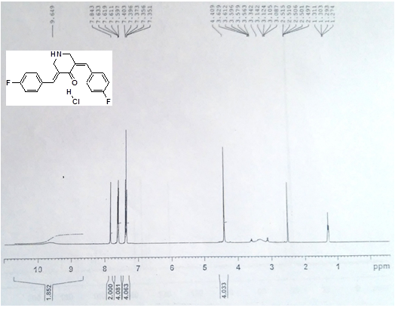
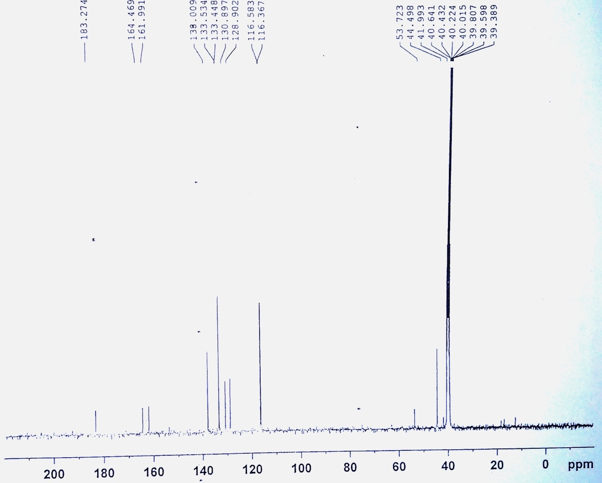
Compound 3b:
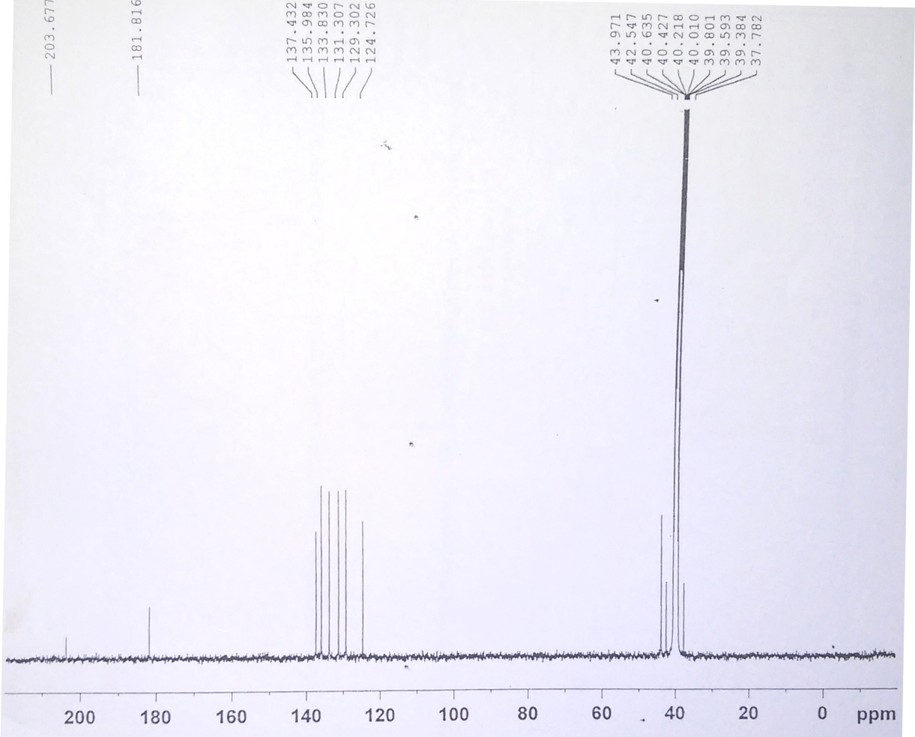
Compound 3c:
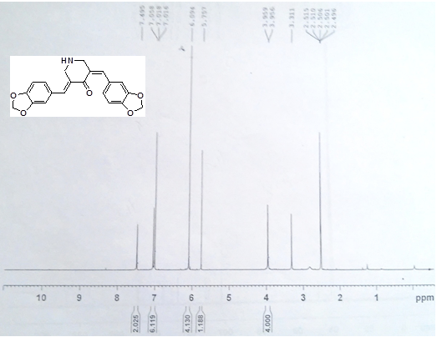
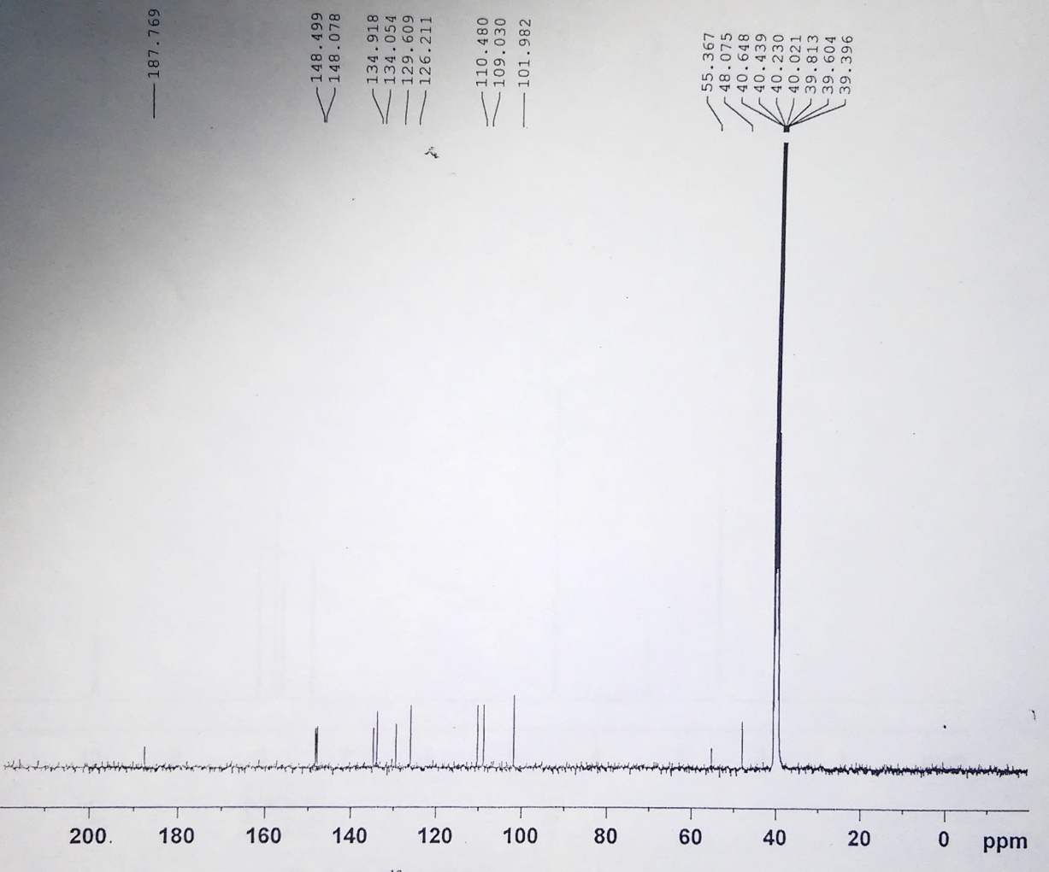
Compound 3d:
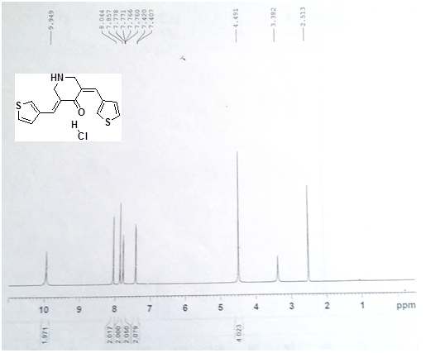
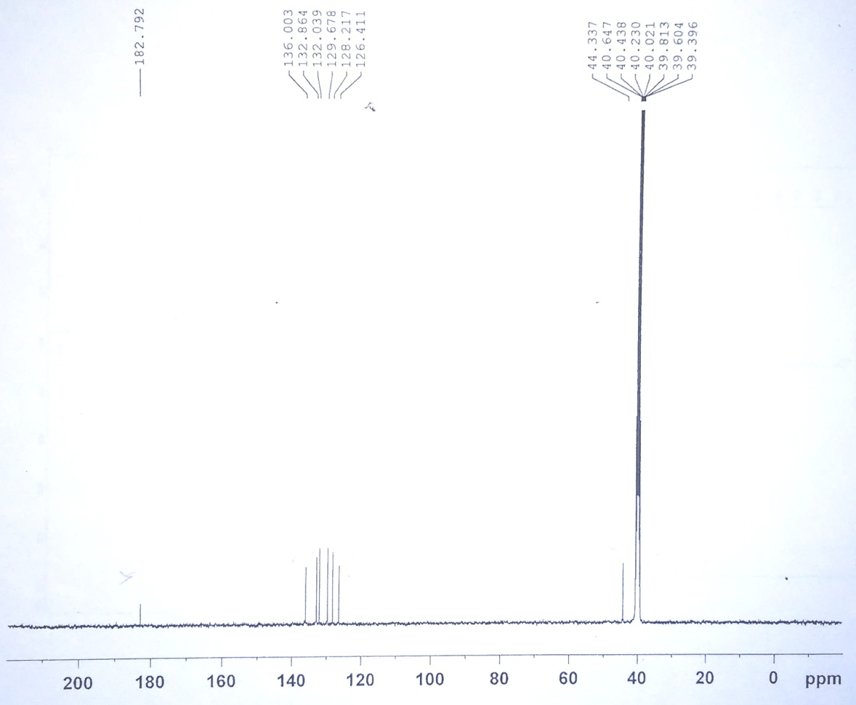
Compound 3e:
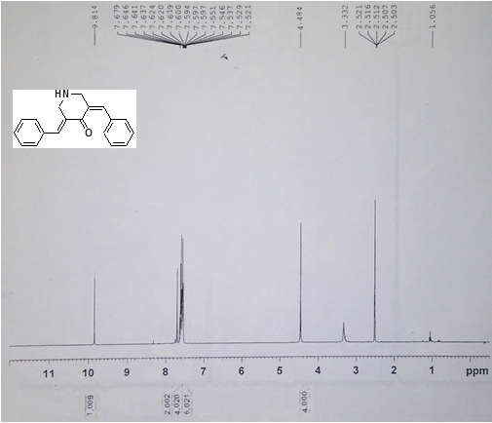
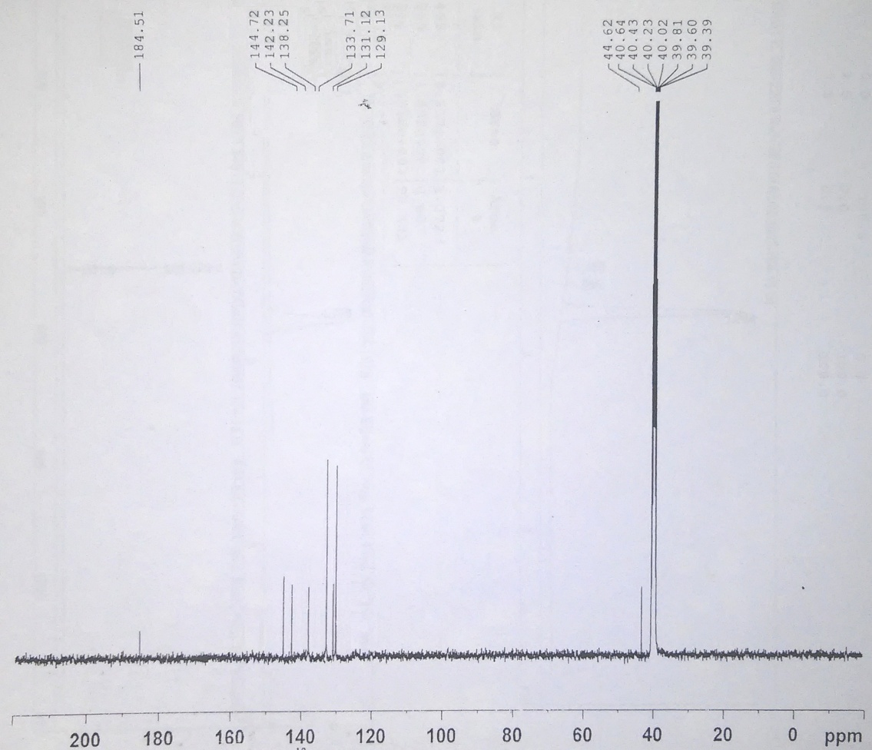
Compound 3f:
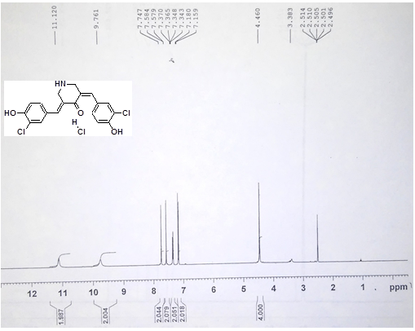
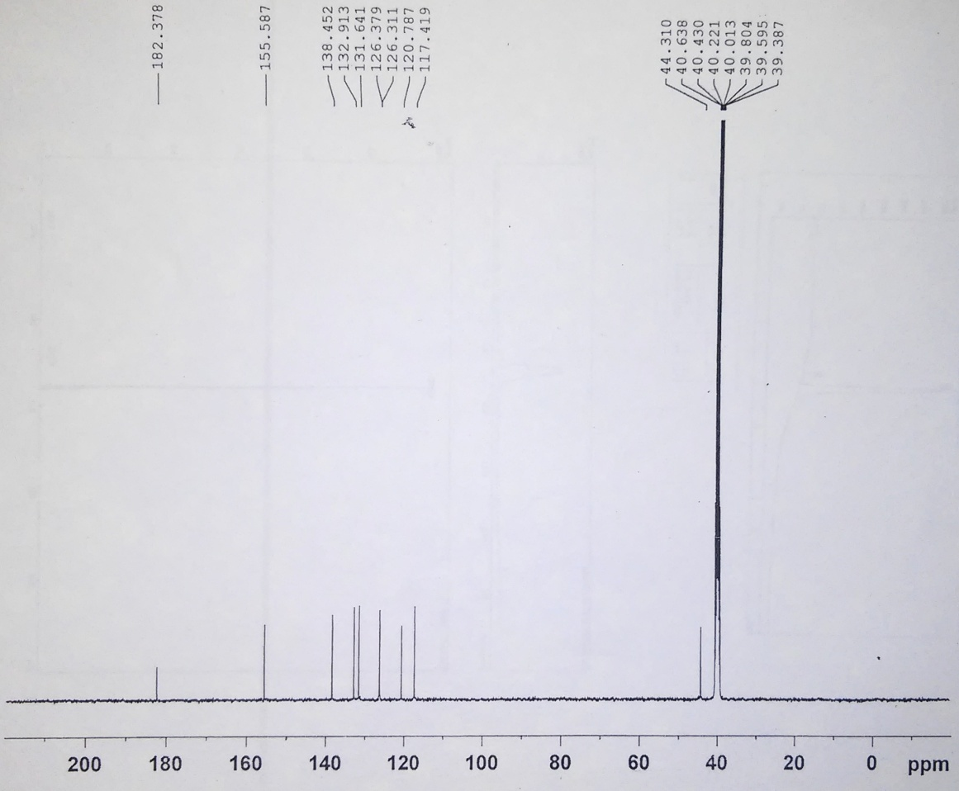
11. ¹H and ¹³C-NMR charts of compounds 5(a-q):
Compound 5a:
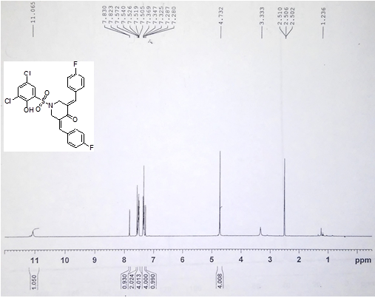
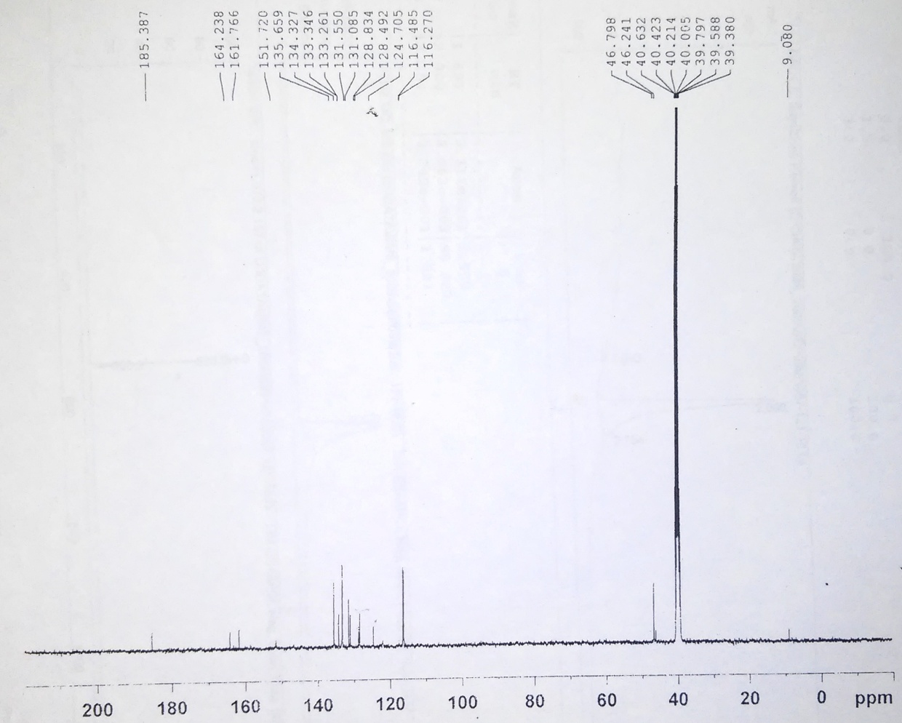
Compound 5b:
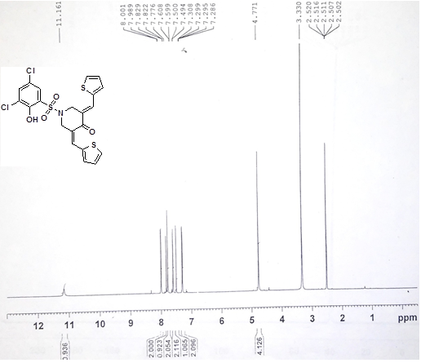
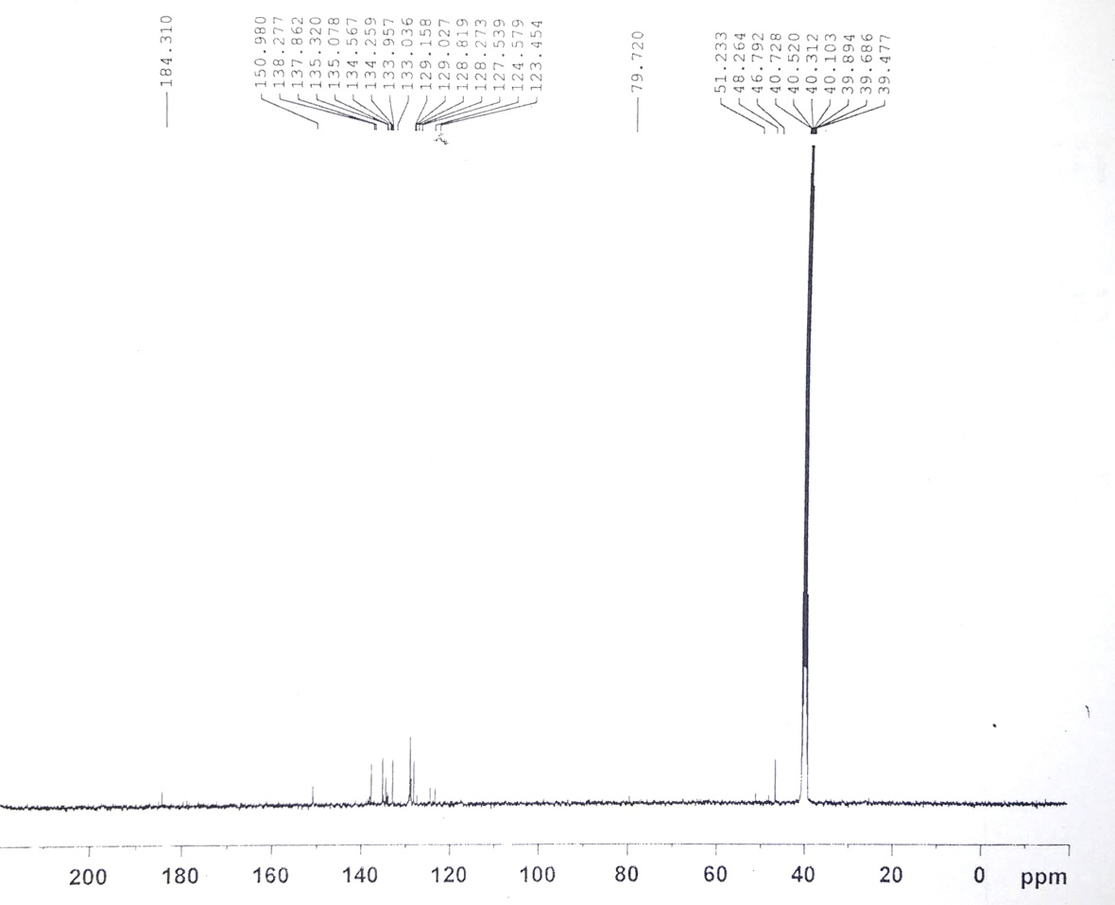
Compound 5c:
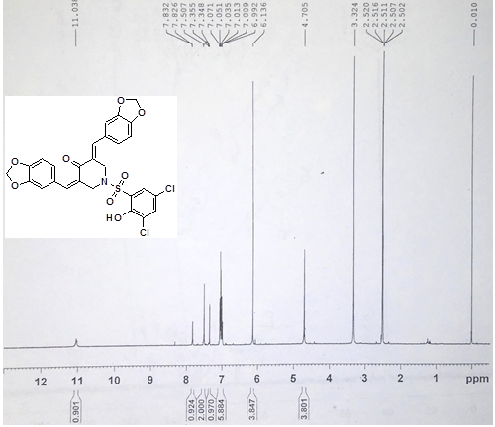
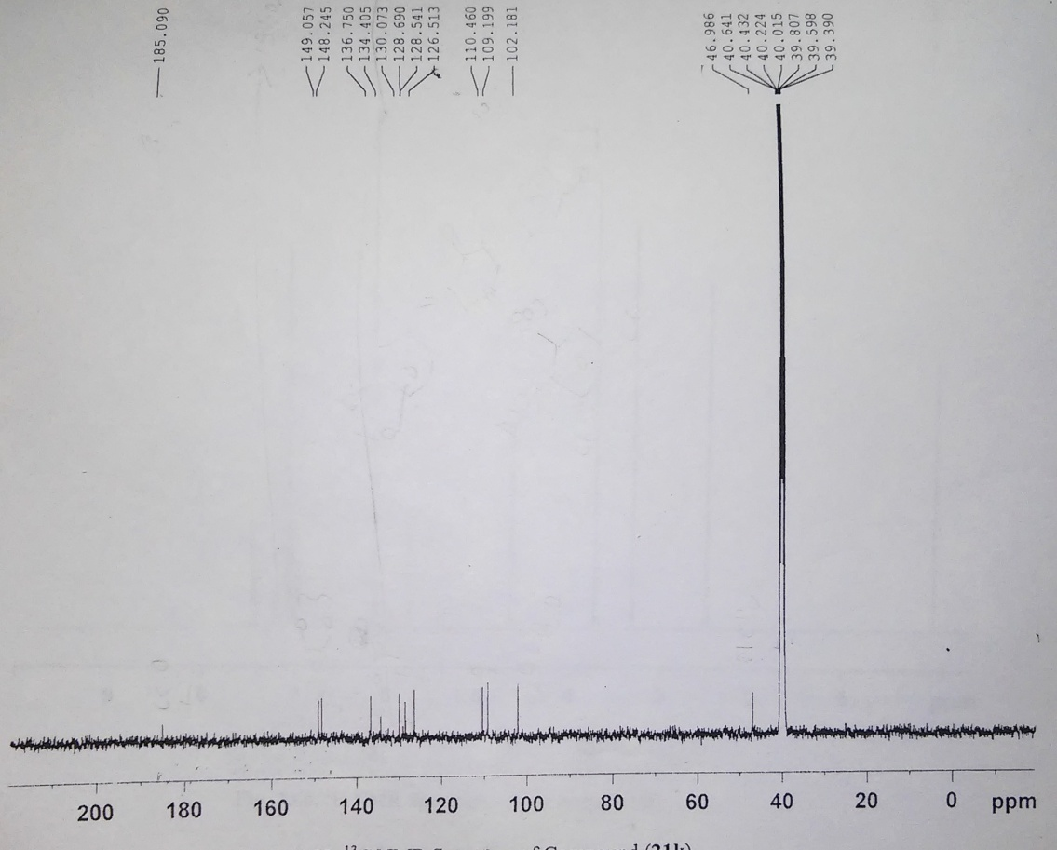
Compound 5d:
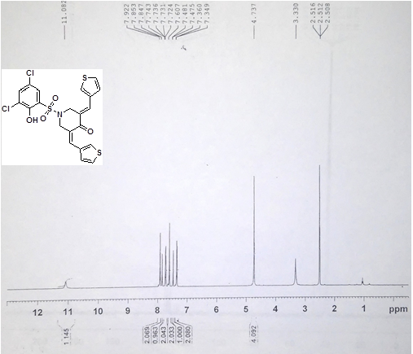
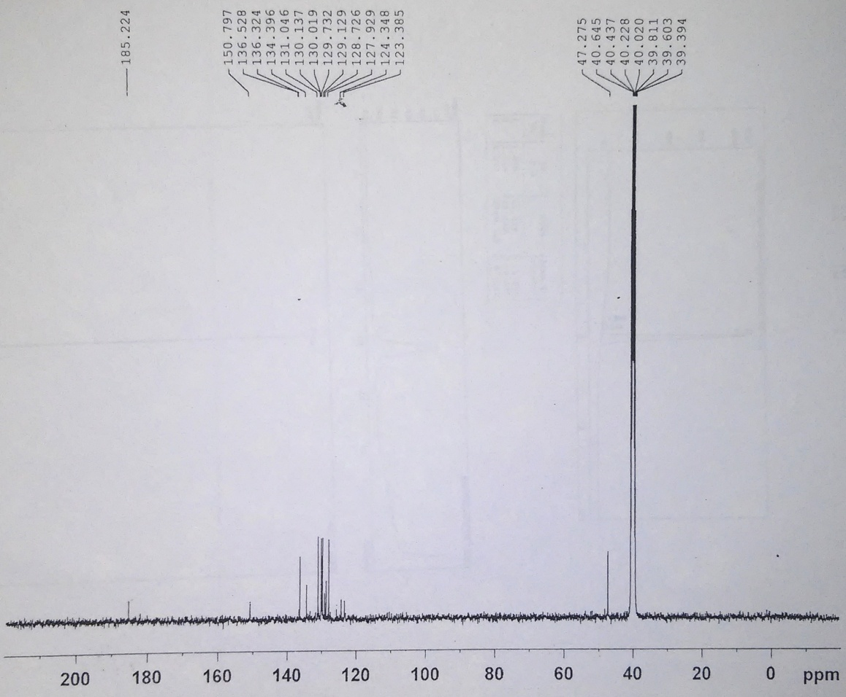
Compound 5e:
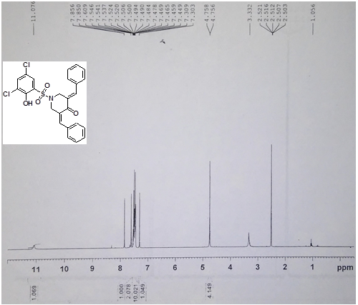
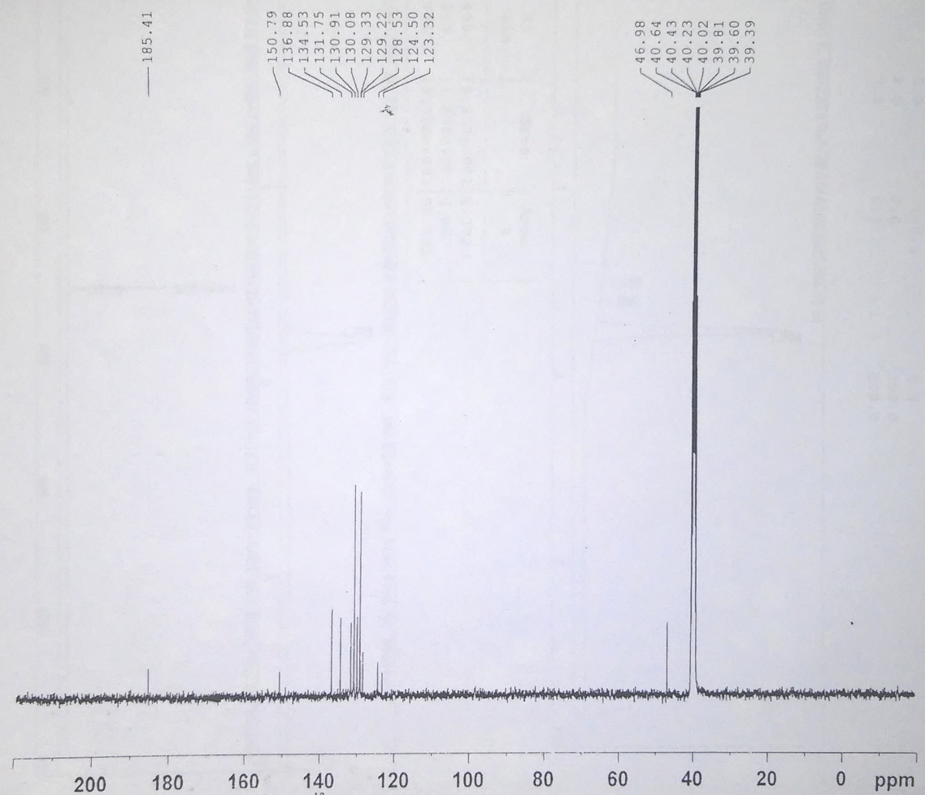
Compound 5f:
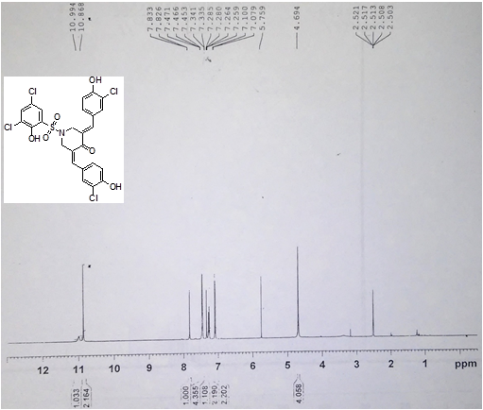
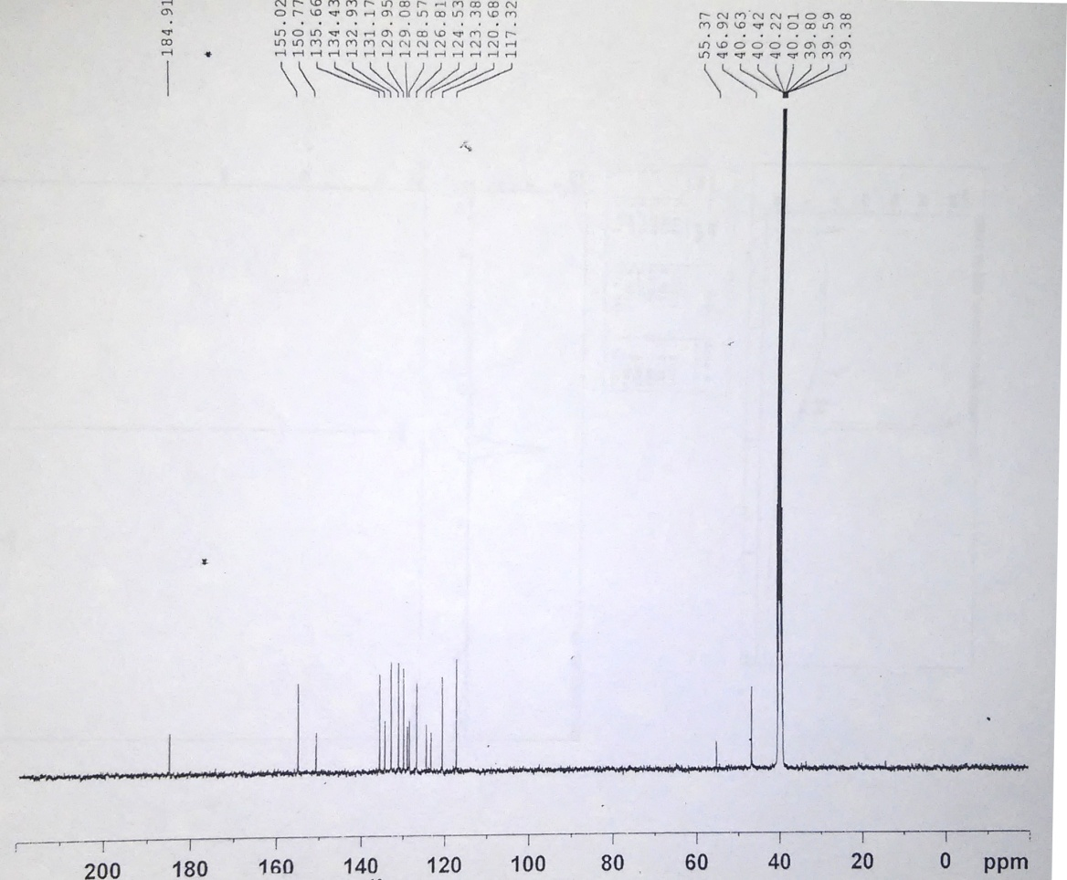
Compound 5g:
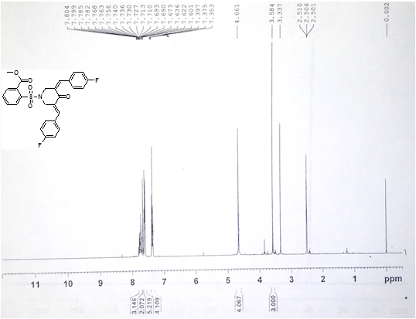
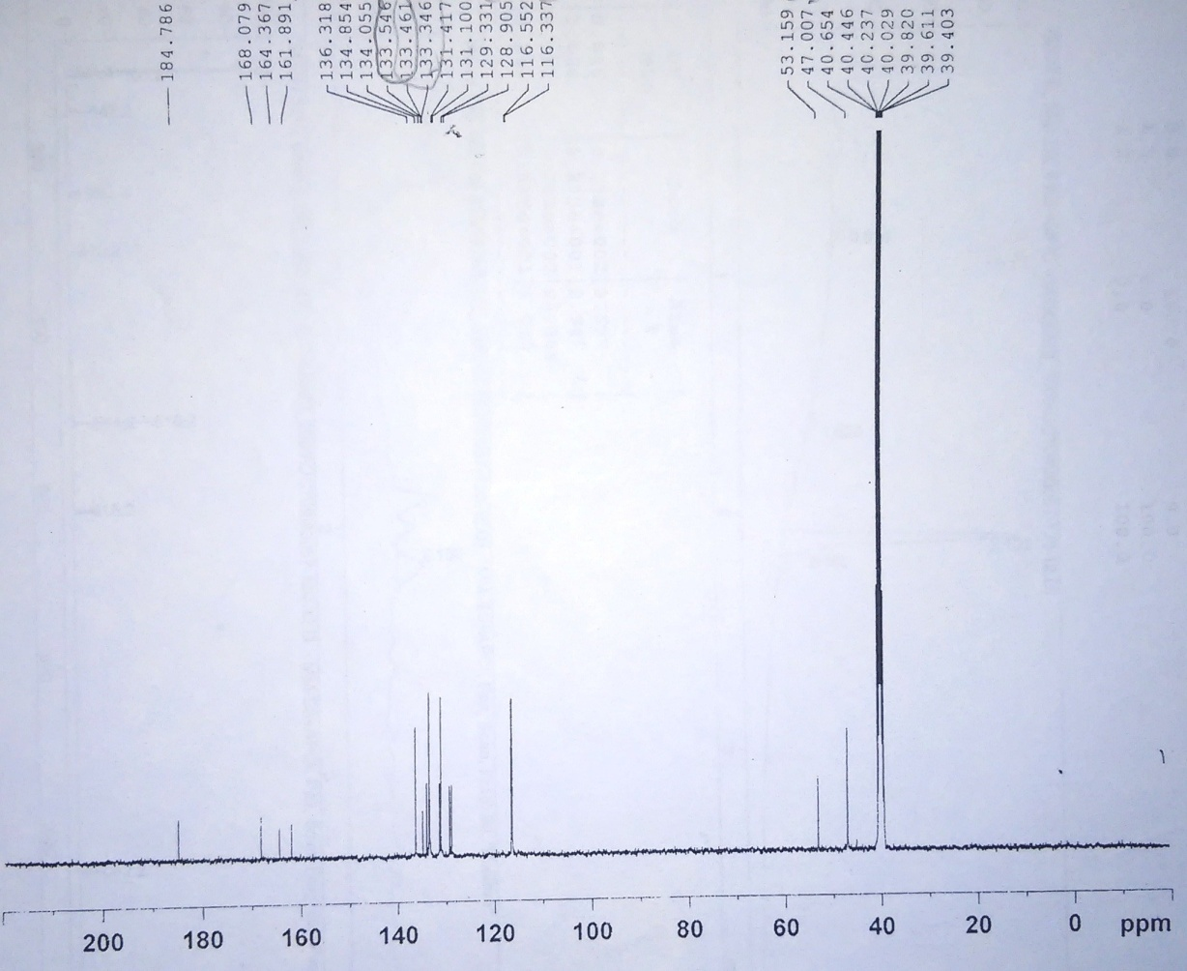
Compound 5h:
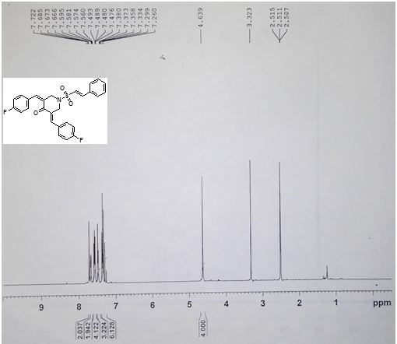
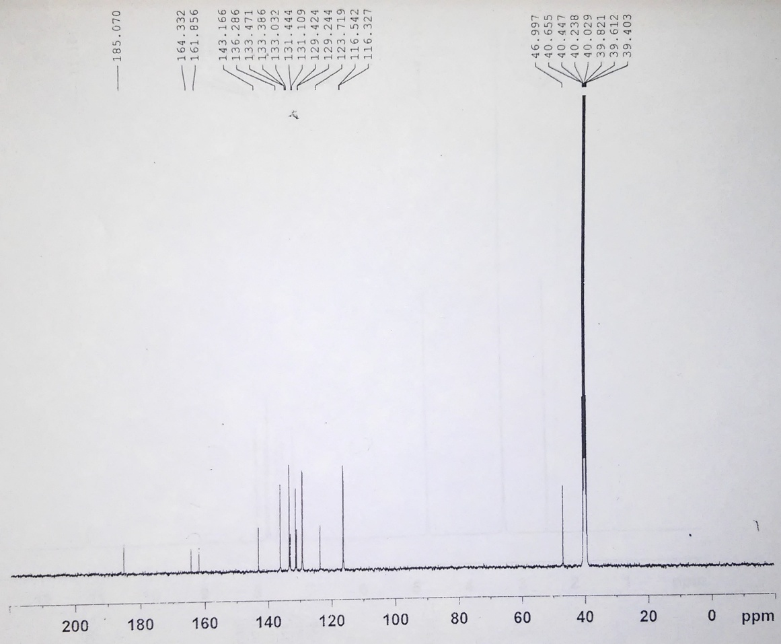
Compound 5i:
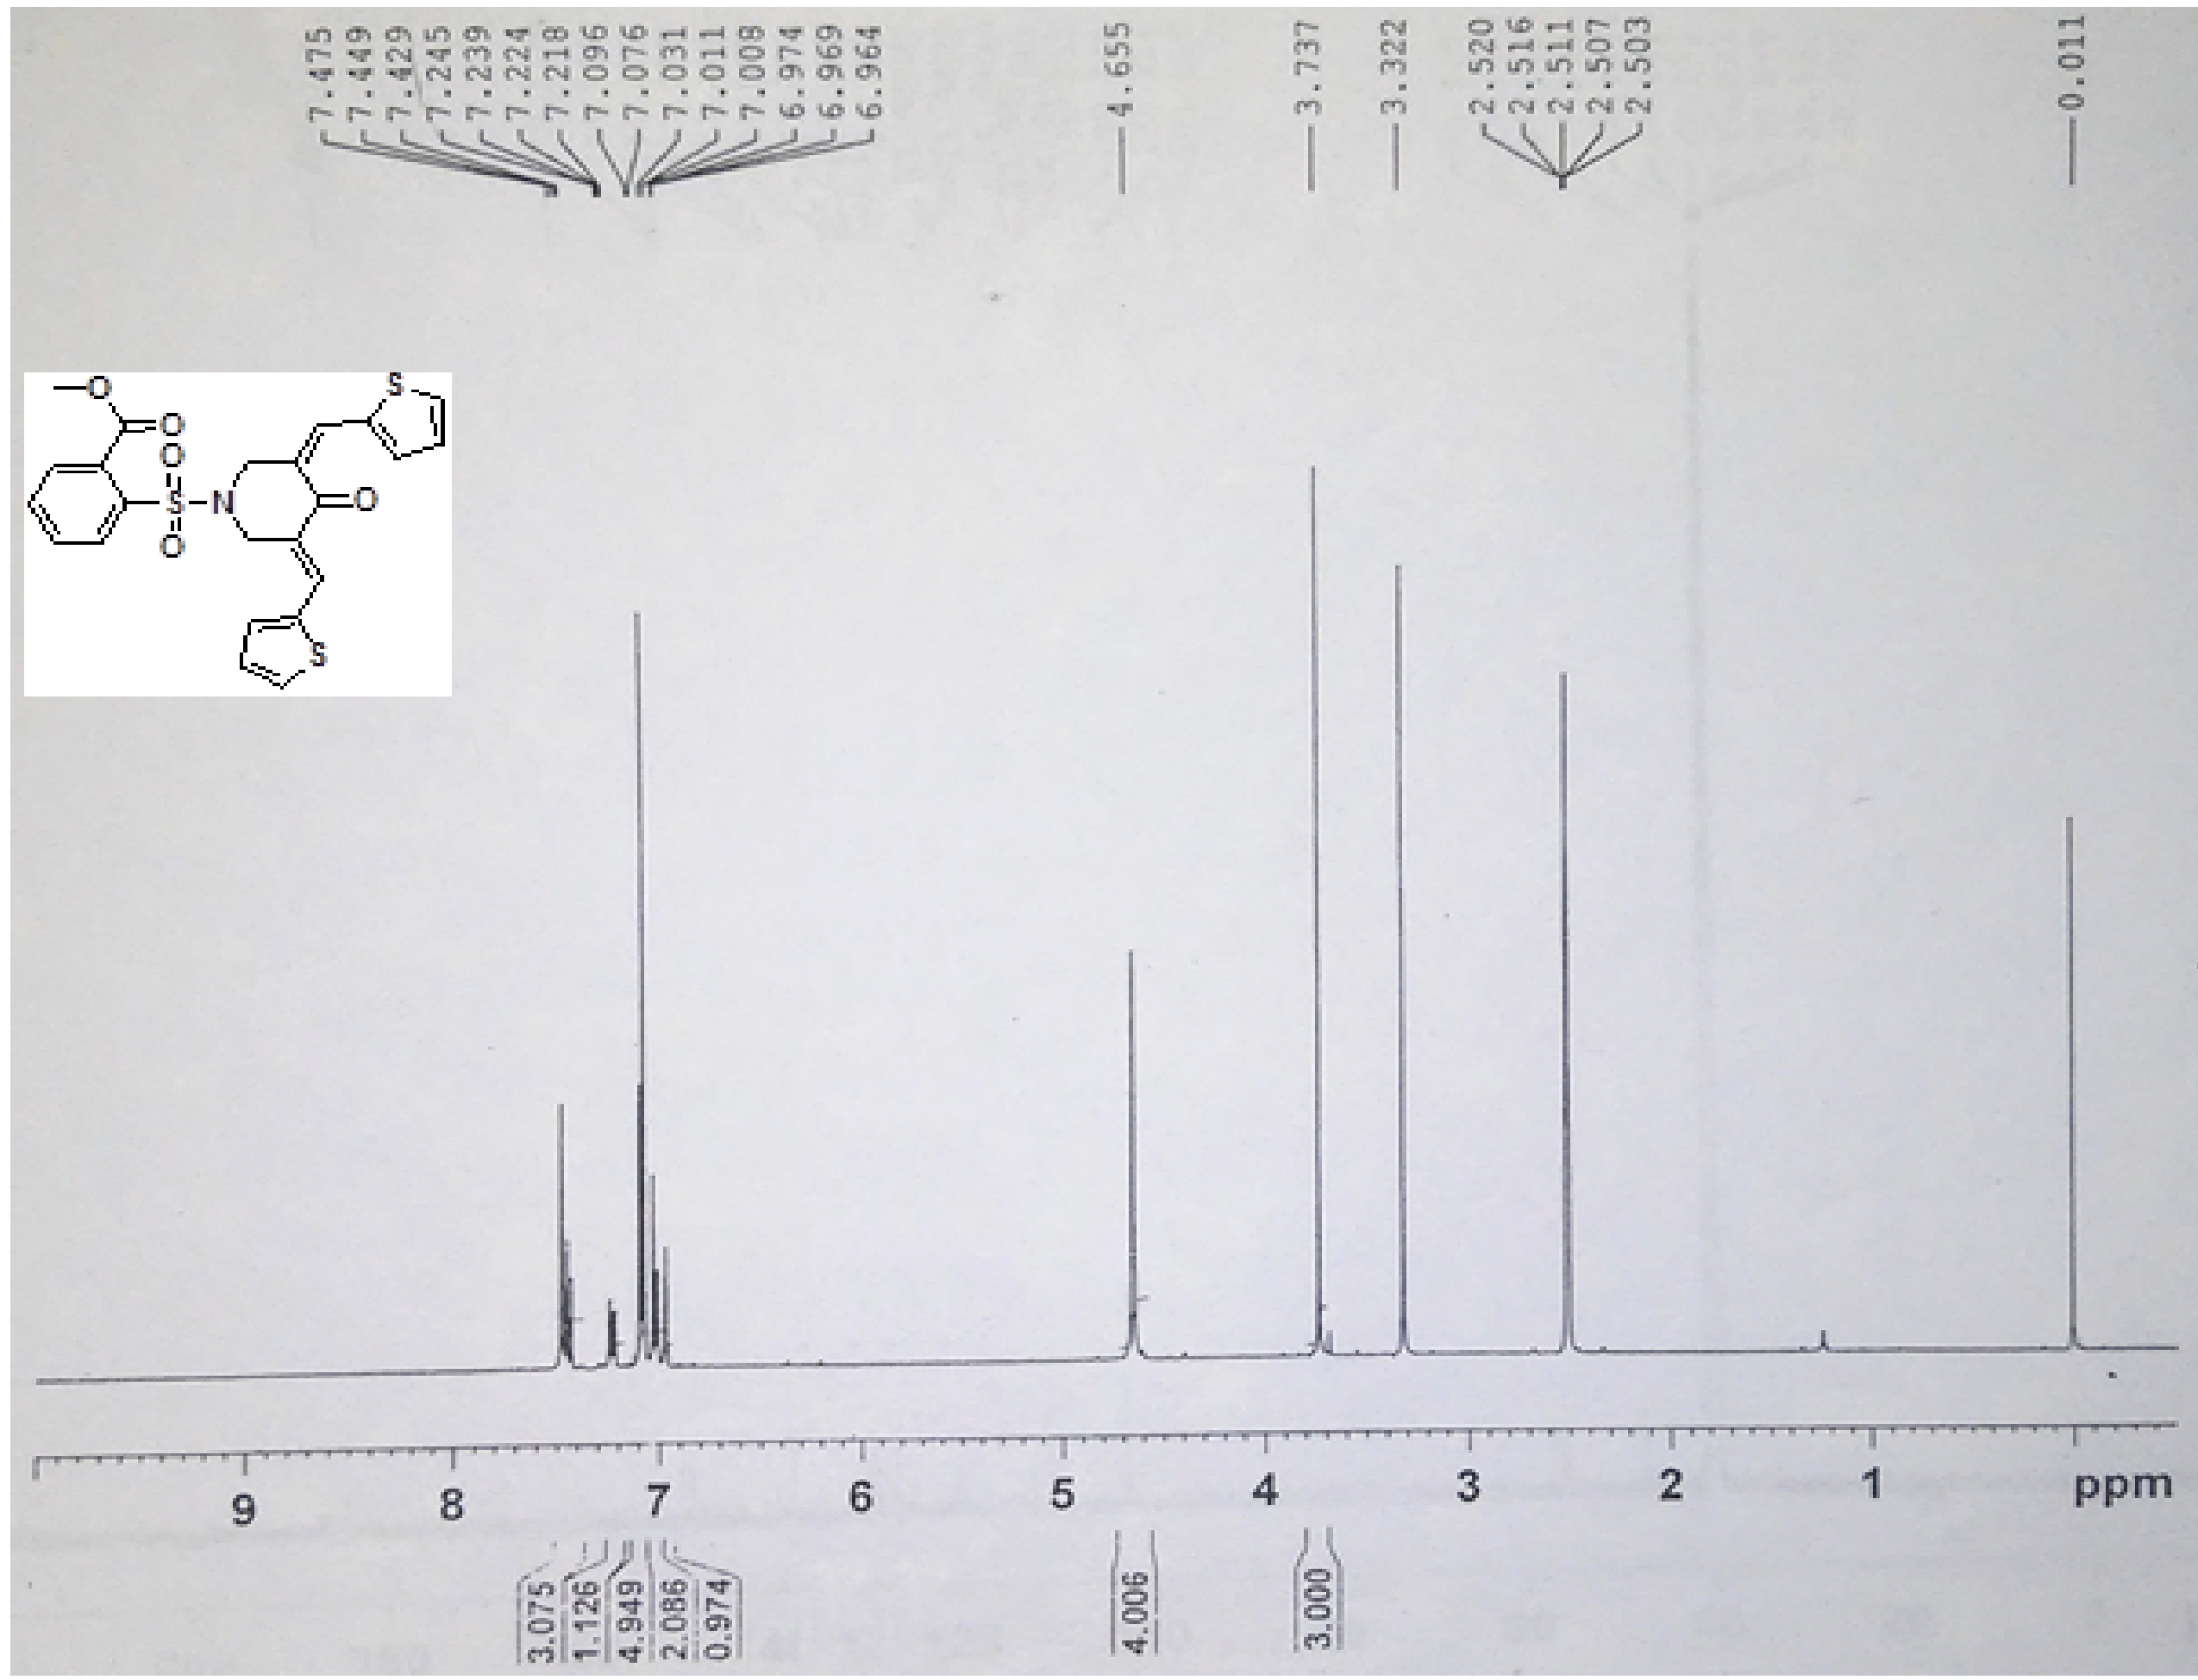
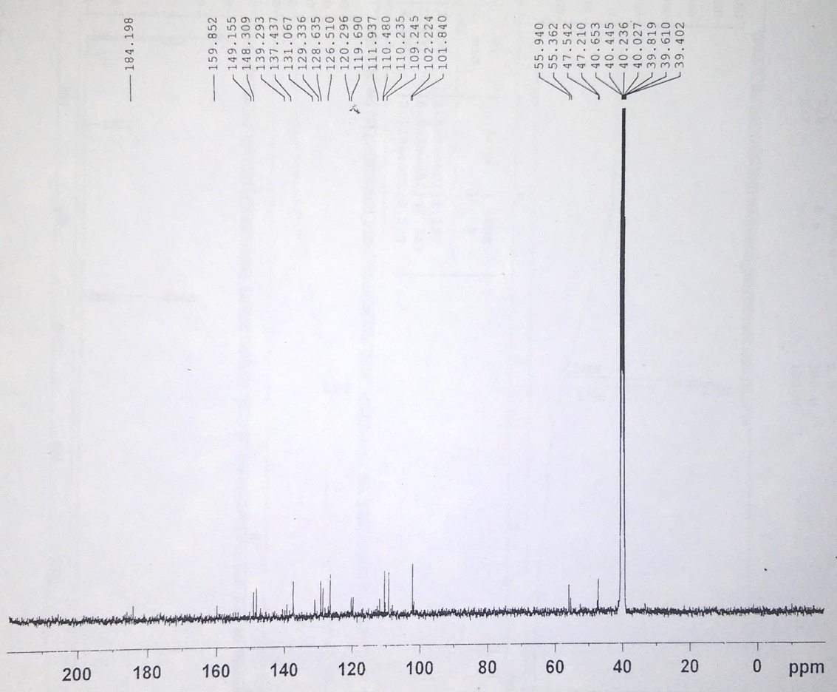
Compound 5j:
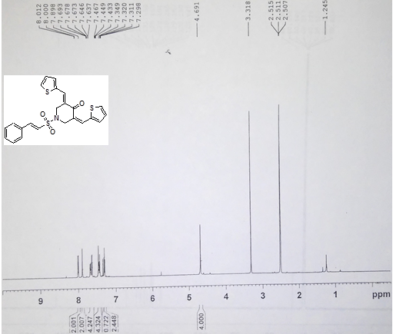
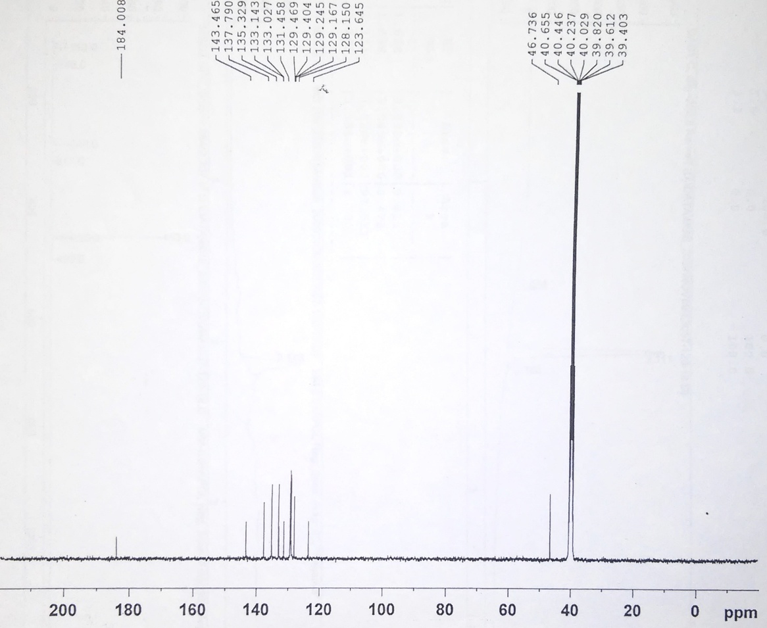
Compound 5k:
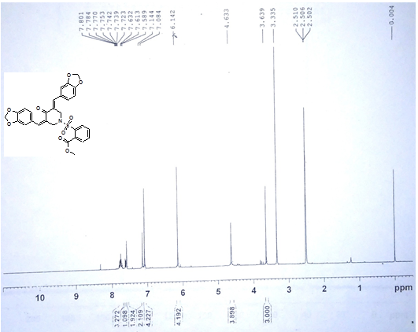
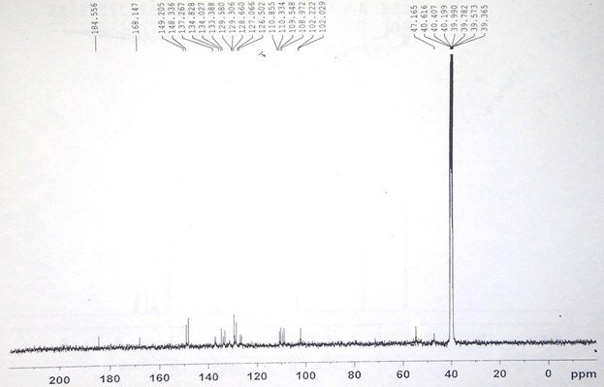
Compound 5l:
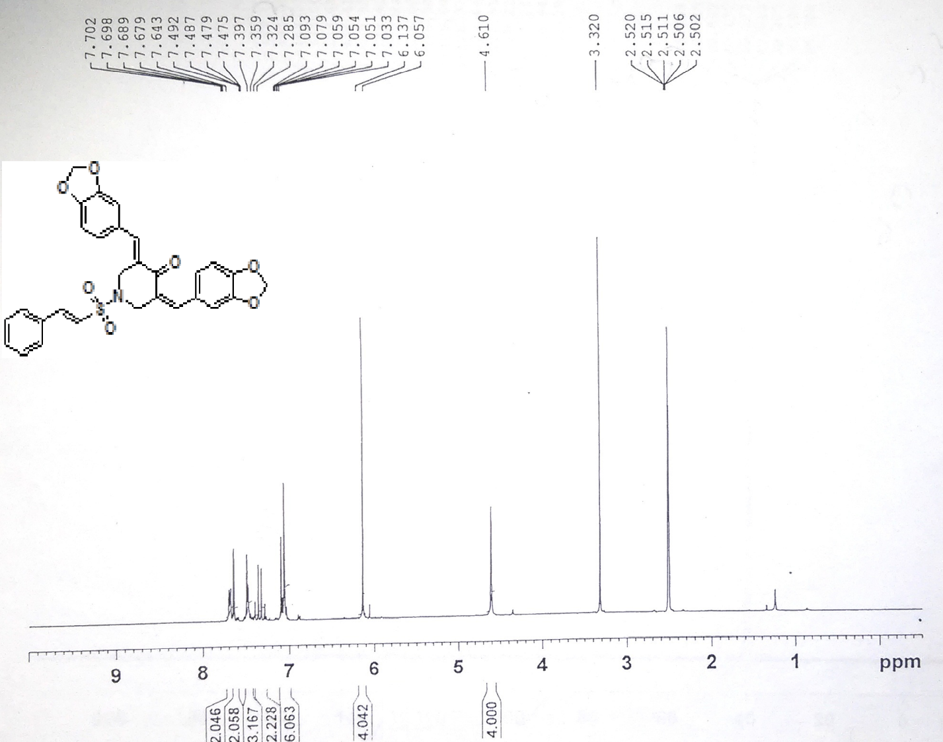
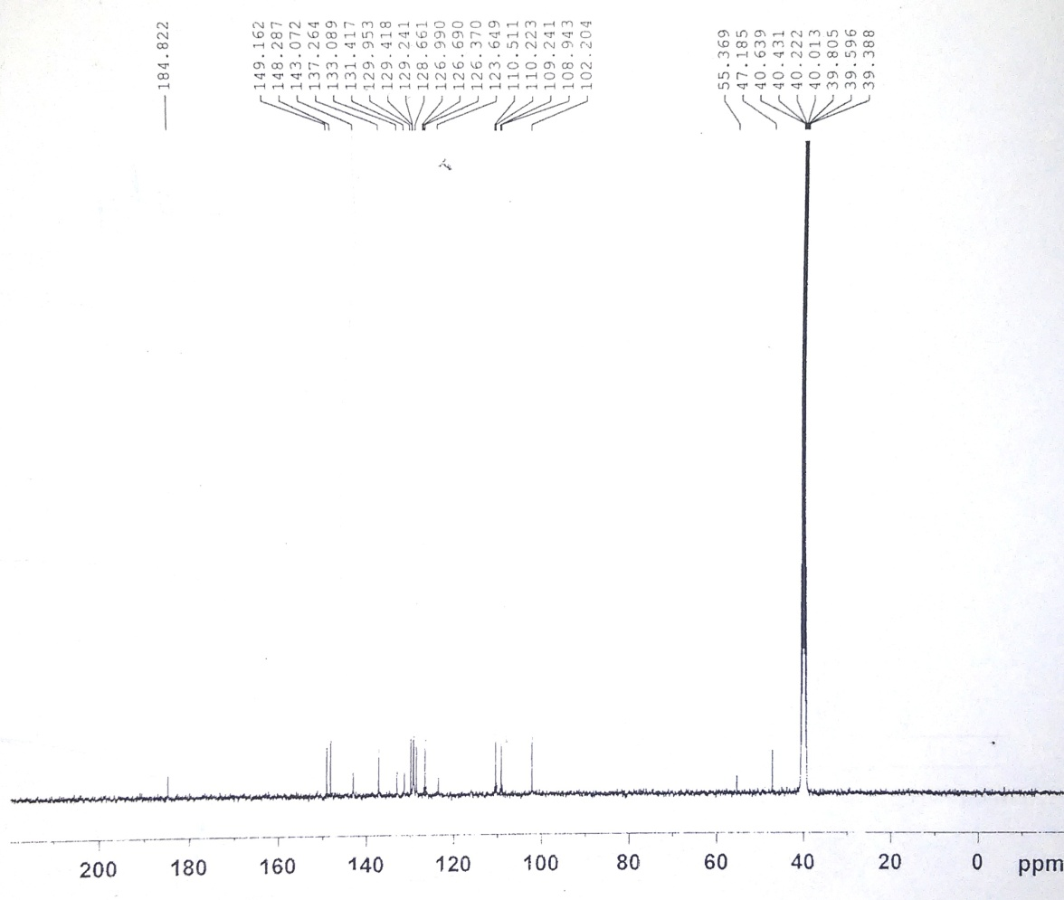
Compound 5m:
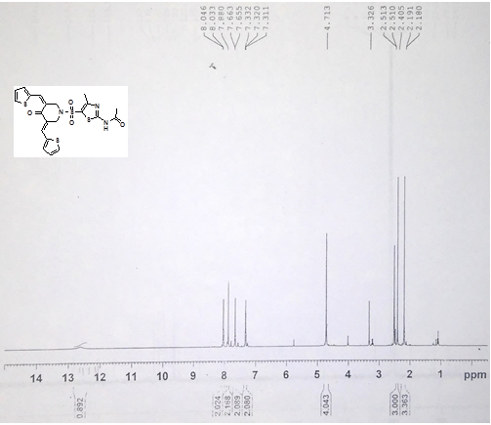
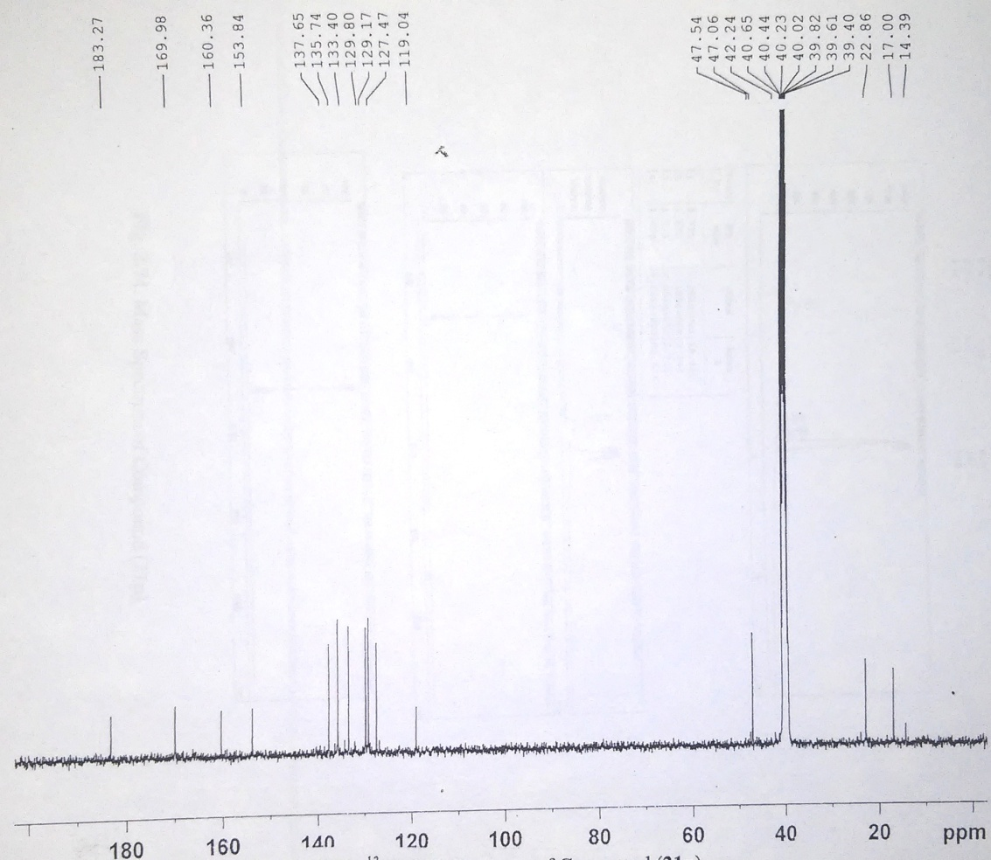
Compound 5n:
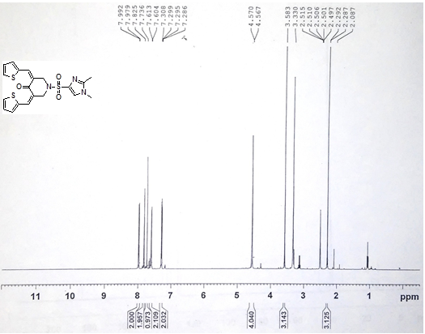
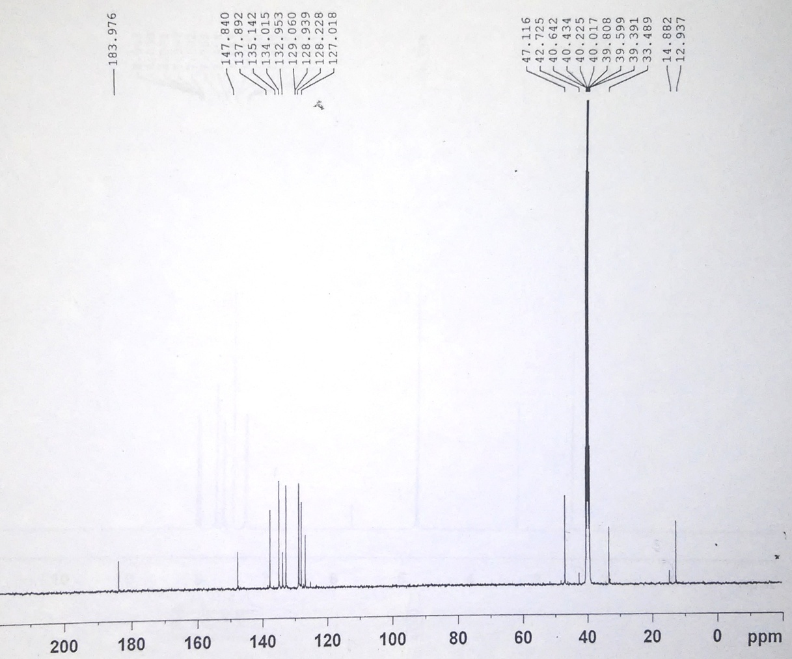
Compound 5o:
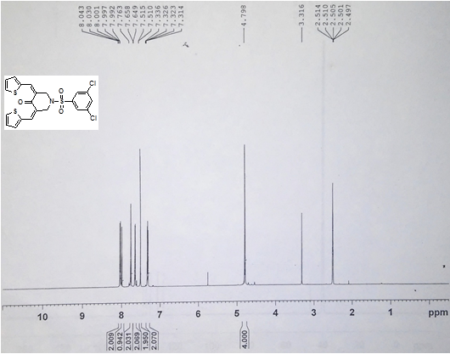
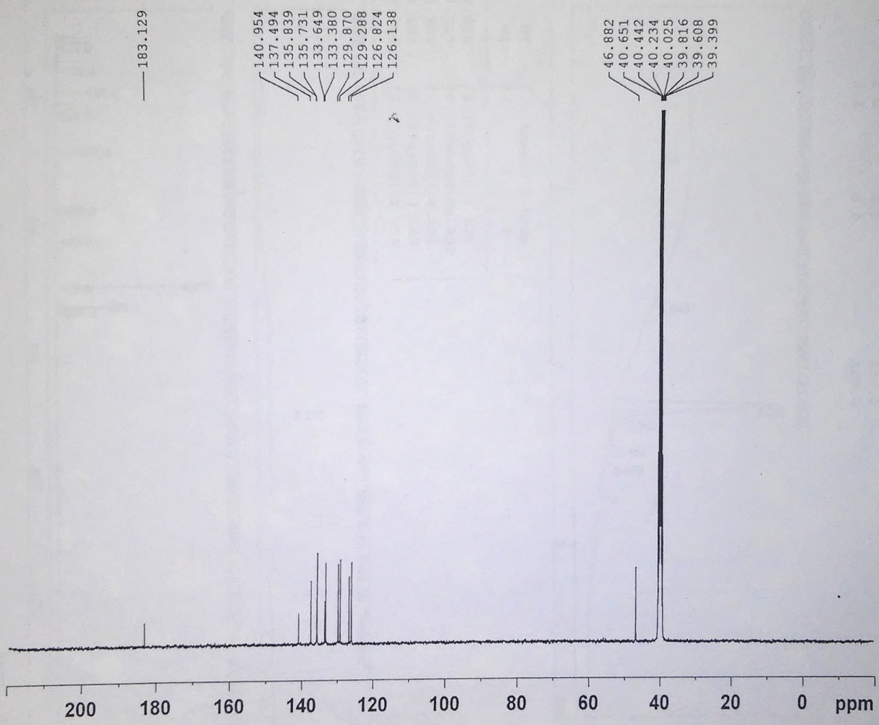
Compound 5p:
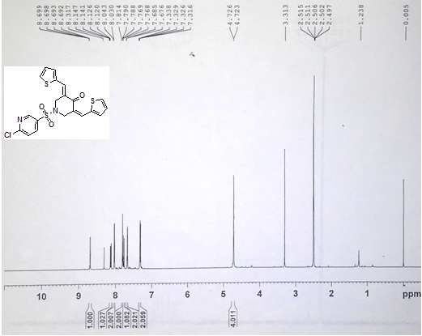
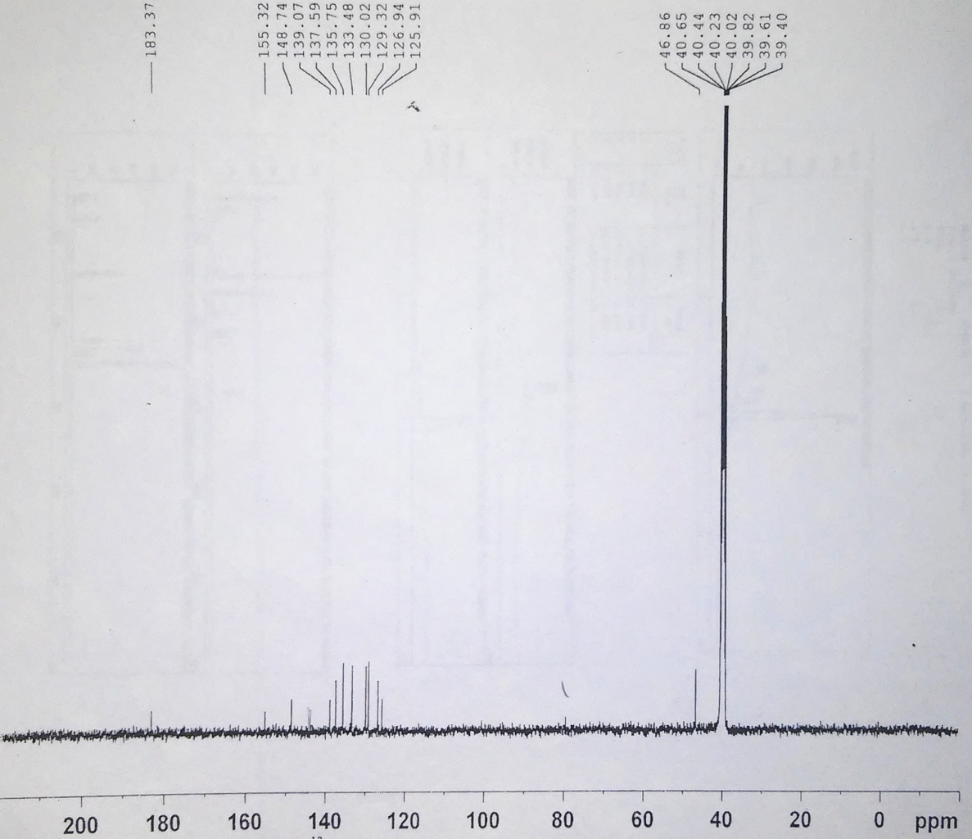
Compound 5q:
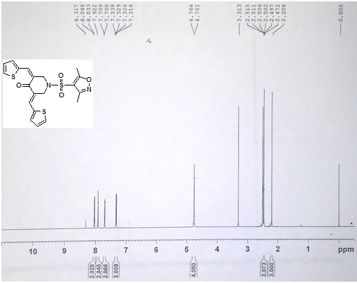
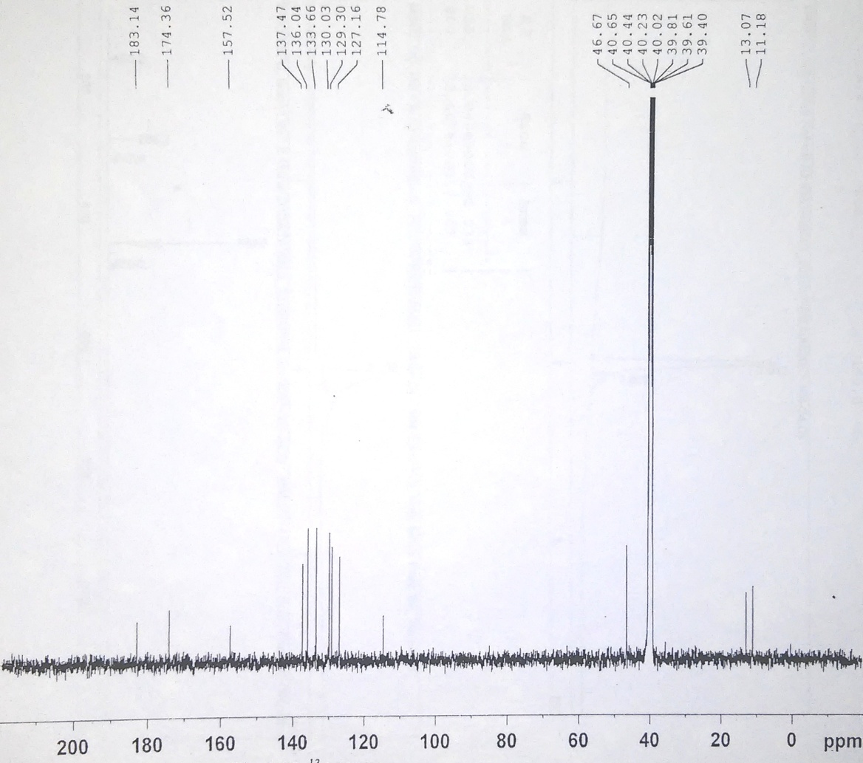
12. ¹H and ¹³C-NMR charts of compounds 7(a-b):
Compound 7a:
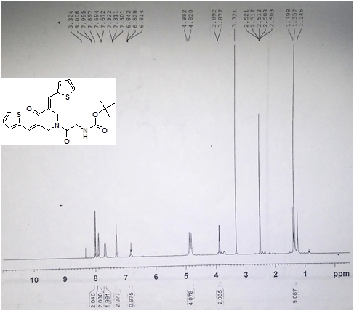
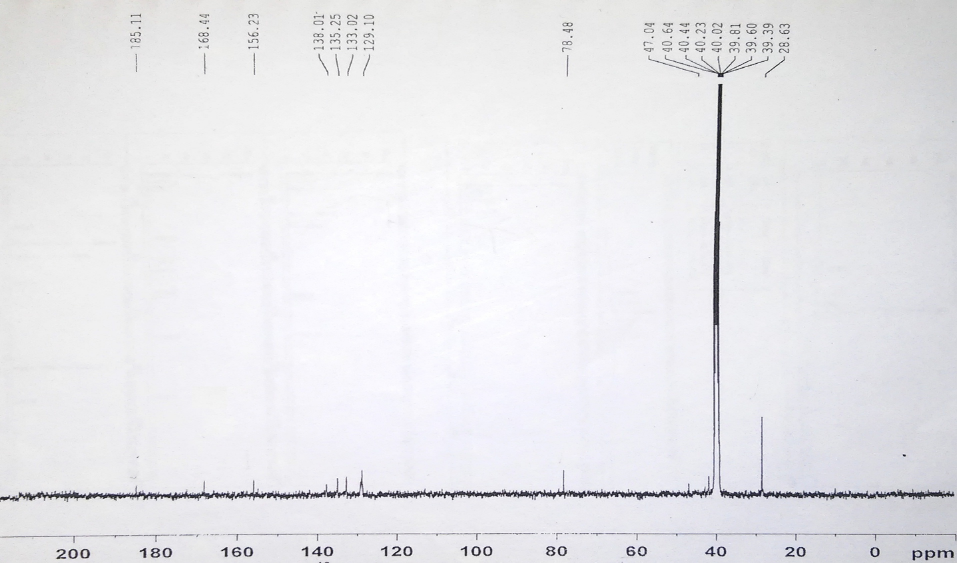
Compound 7b:
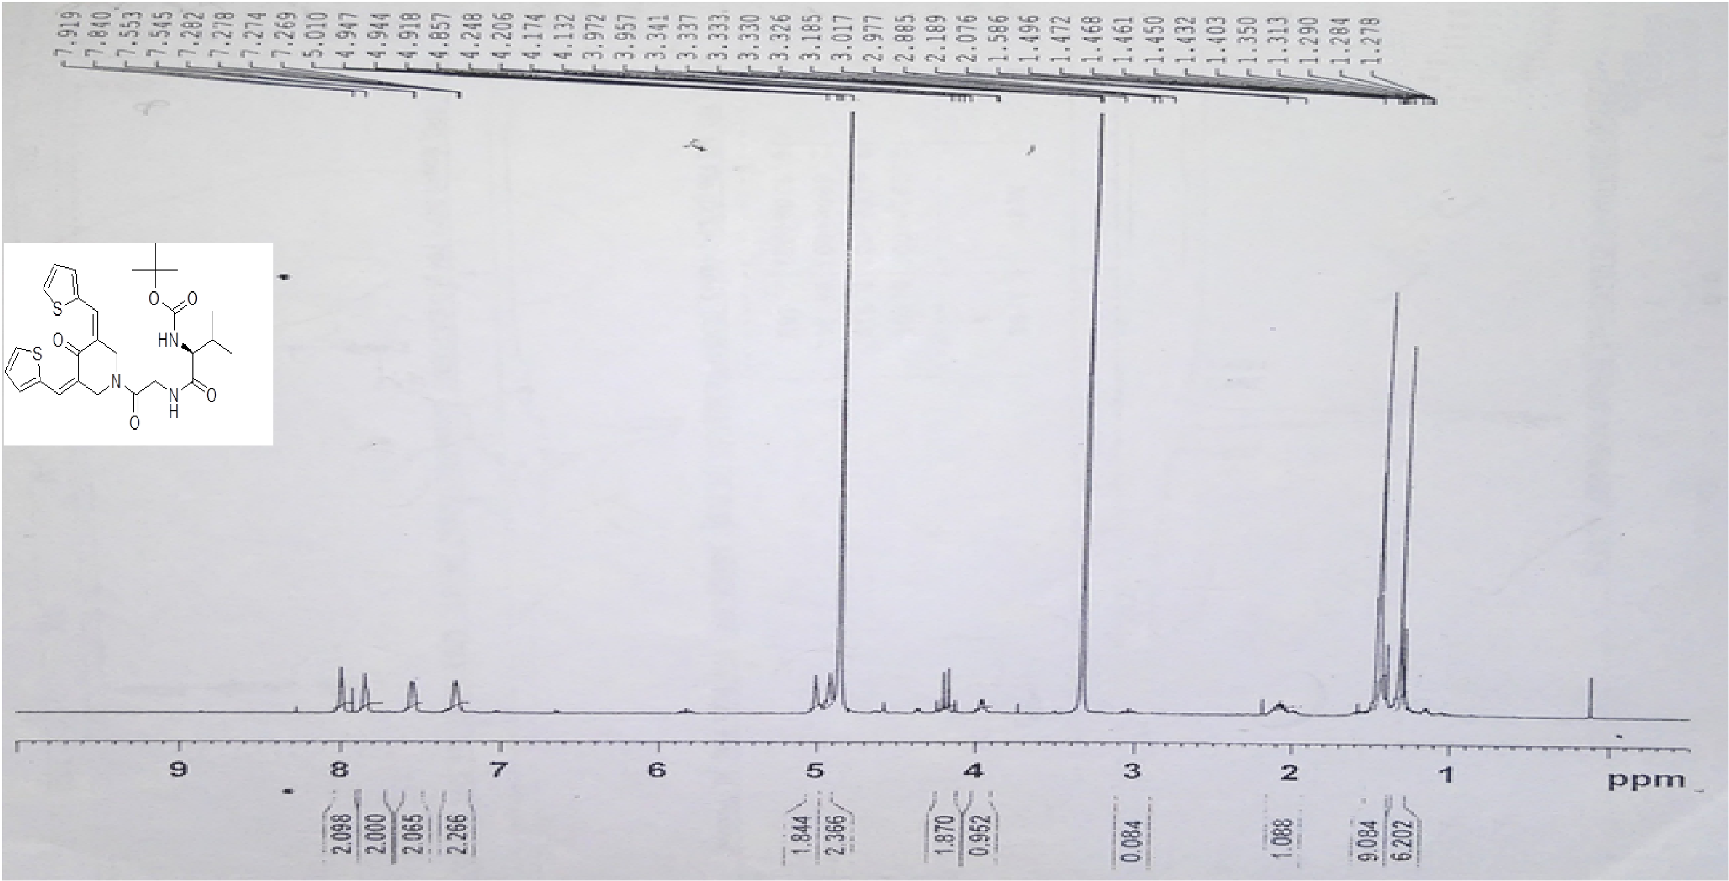
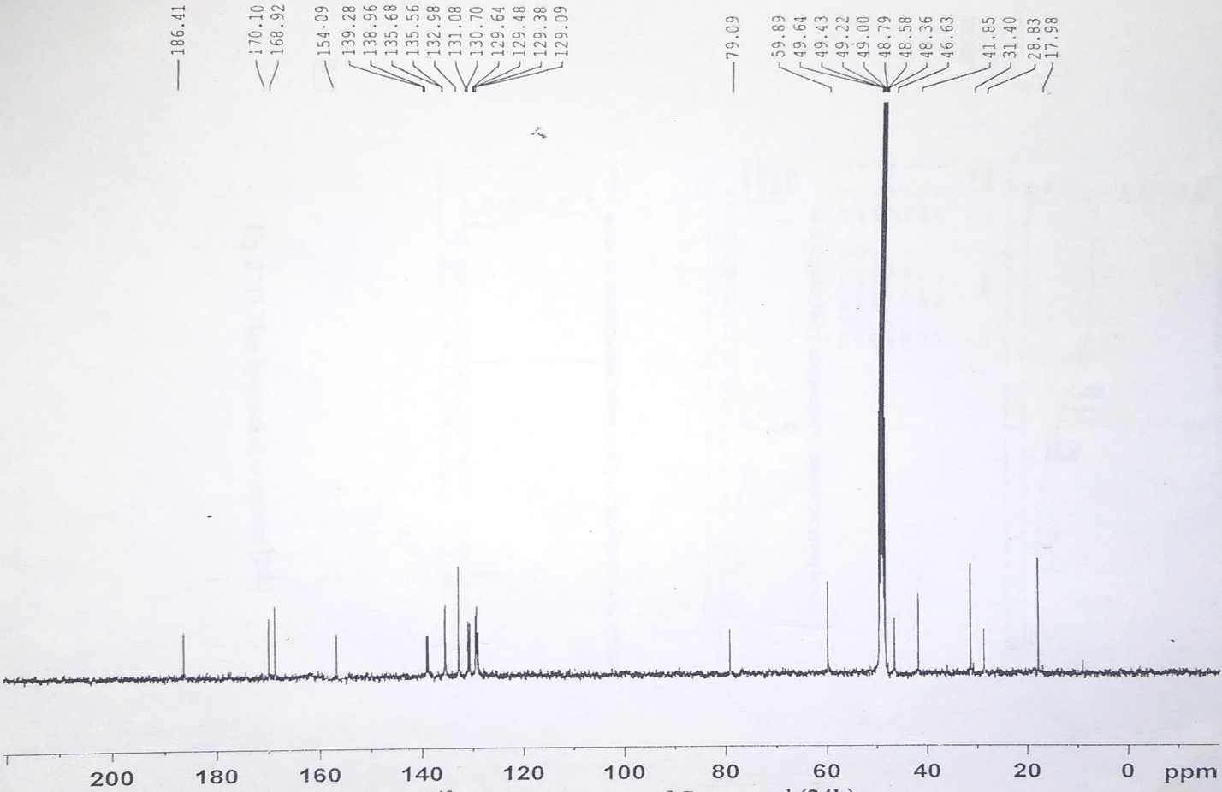
13. ¹H and ¹³C-NMR charts of compounds 8(a-b):
Compound 8a:
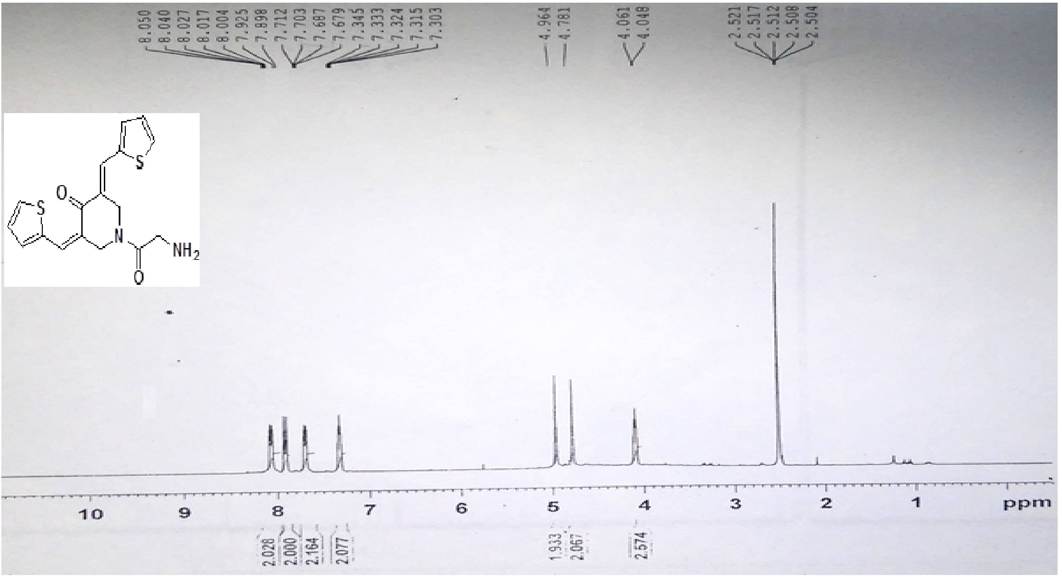
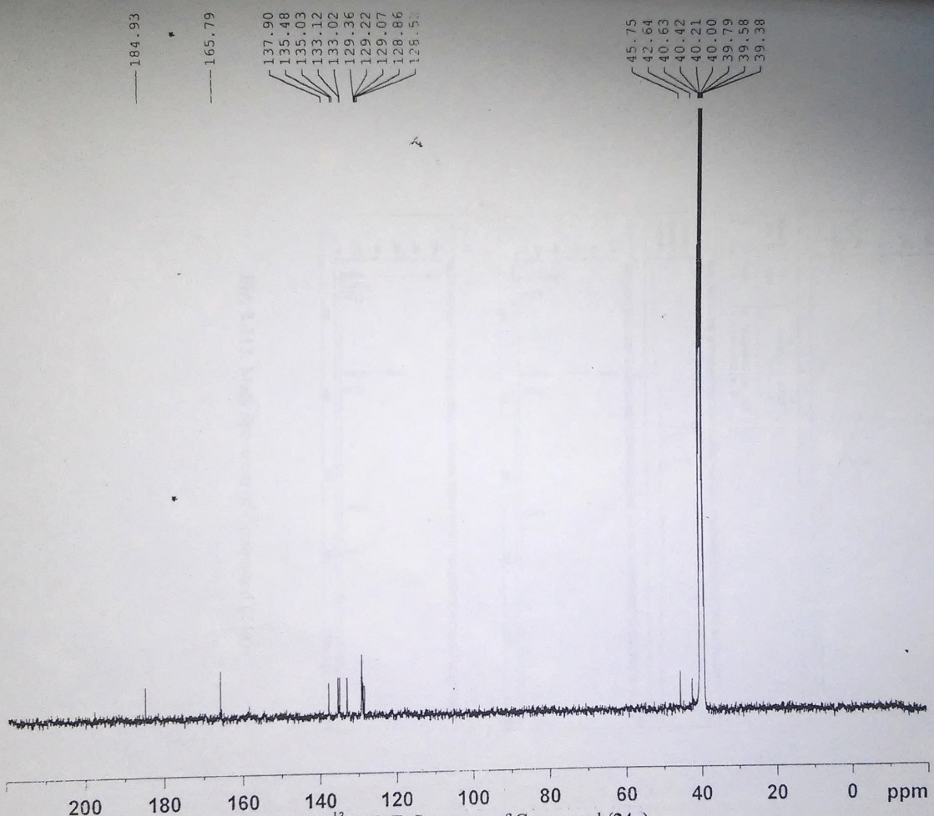
Compound 8b:
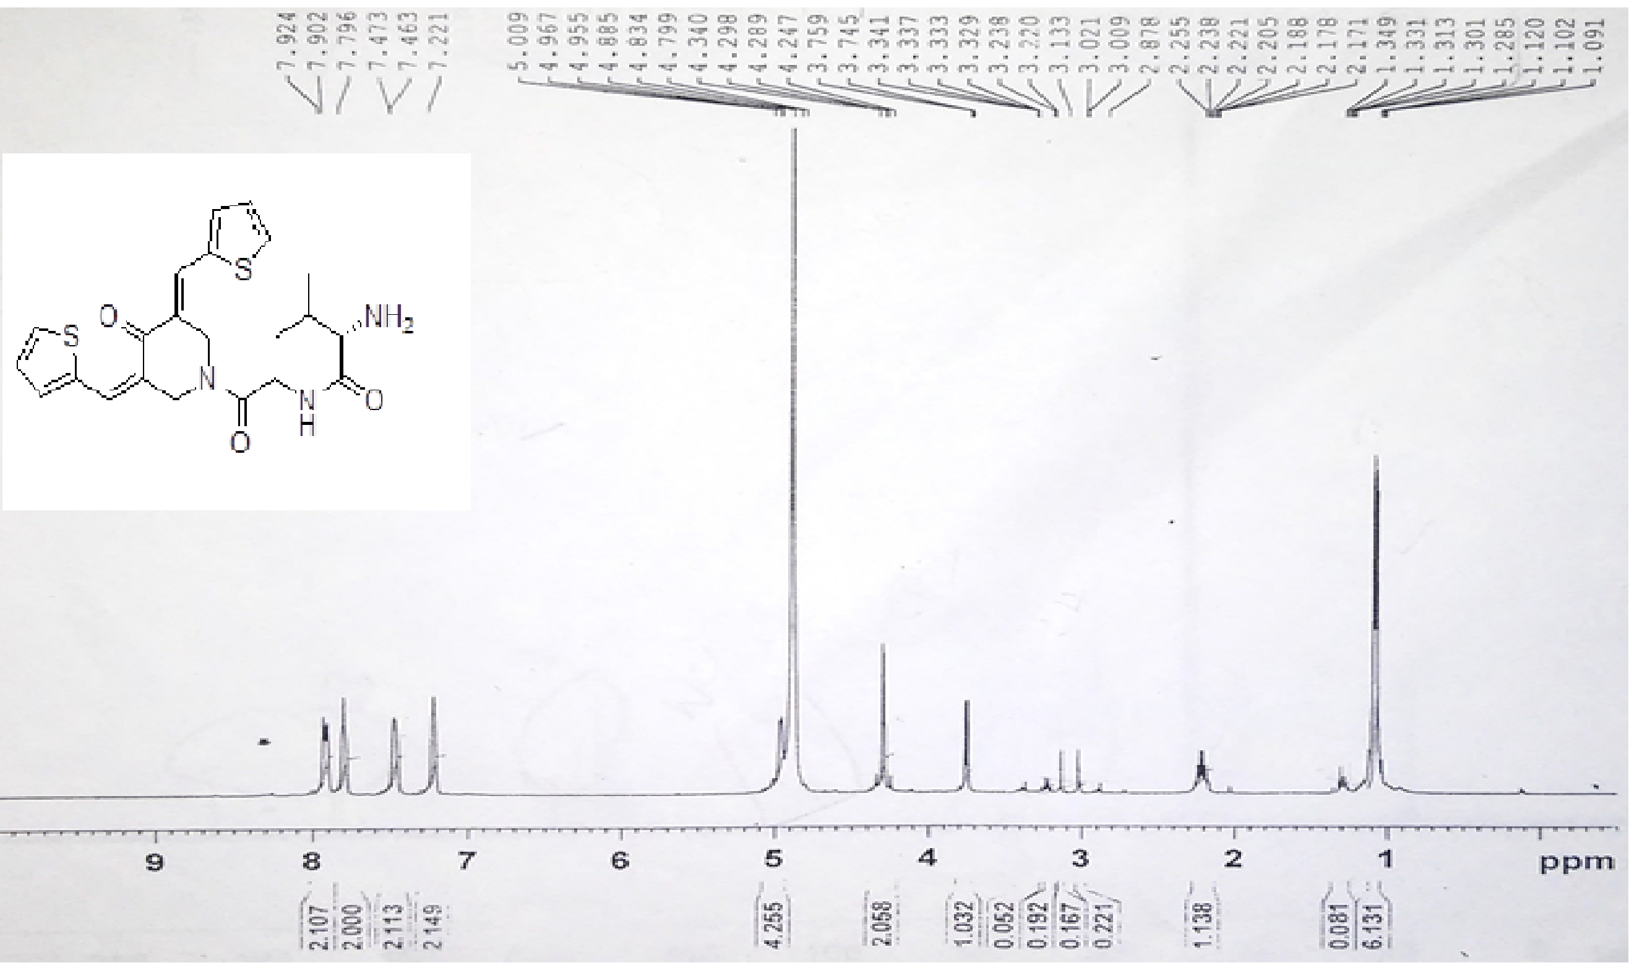
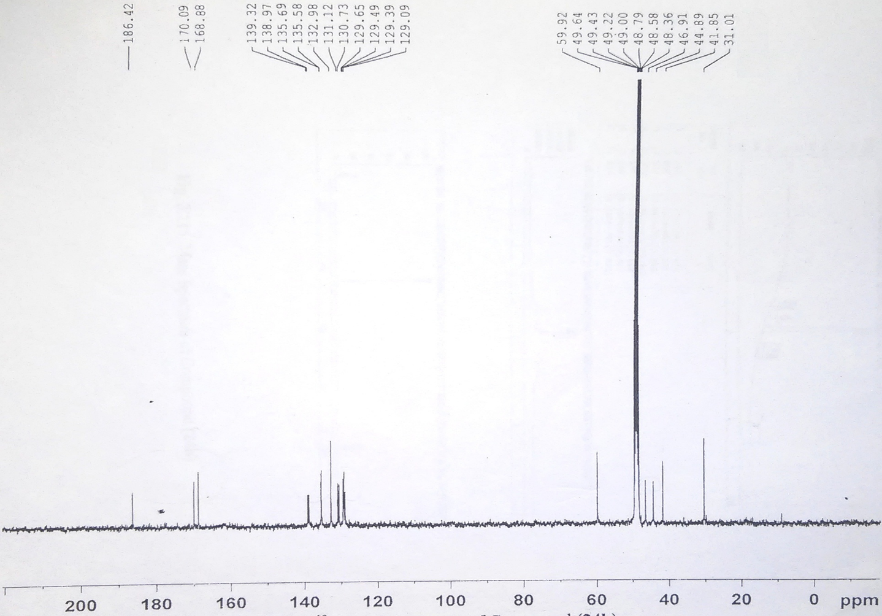
TABLE 1. Synthesis of compounds 3(a-f)
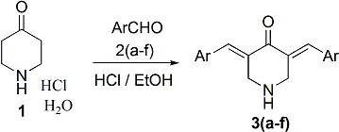
Entry | ArCHO | 3(a-f)
3a
3b
3c
3d
3e
3f

TABLE 2. Synthesis of compounds 5(a-f)
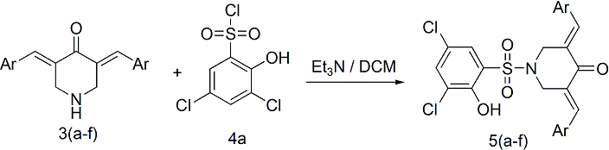
Entry | 3(a-f) | 5(a-f)
5a
5b
5c
5d
5e
5f

TABLE 3. Synthesis of compounds 5(g-l)
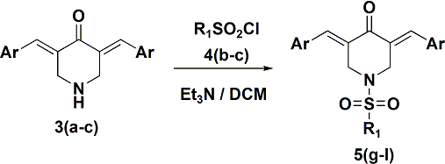
Entry | 3(a-c) | R₁SO₂Cl | 5(g-l)
5g
5h
5i
5j
5k
5l

TABLE 4. Synthesis of compounds 5(m-q)
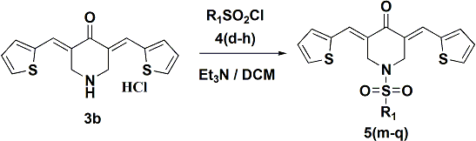
Entry | R₁SO₂Cl | 5(m-q)
5m
5n
5o
5p
5q

TABLE 5. Synthesis of compounds 7(a-b)
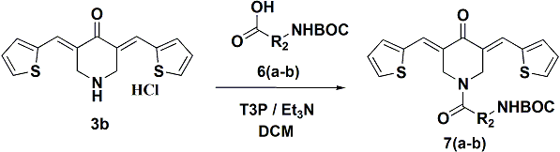
Entry | 6(a-b) | 7(a-b)
7a
7b

TABLE 6. Synthesis of compounds 8(a-b)
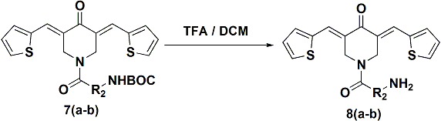
Entry | 7(a-b) | 8(a-b)
8a
8b

TABLE 7. In vitro antimicrobial activity of the compounds tested by the well-diffusion agar assay expressed as the diameter (mm) of the inhibition zone
Tested compound | Bacteria |  |  |  | Fungi
 | S.typhi | V.cholera | E.Coli | S.aureus | A. niger | A. fumigatus
3a | 13 | 14 | 8 | 12 | 18 | 17
3b | 14 | 8 | 9 | 8 | 12 | 16
3c | 10 | 8 | 8 | 7 | 11 | 13
3d | 11 | 17 | 11 | 12 | 15 | 11
3e | 12 | 14 | 15 | 10 | 17 | 14
3f | 14 | 15 | 13 | 11 | 16 | 13
5a | 16 | 15 | 7 | 11 | 18 | 15
5b | 20 | 18 | 9 | 10 | 20 | 18
5c | 16 | 10 | 7 | 8 | 17 | 12
5d | 11 | 10 | 12 | 17 | 19 | 13
5e | 22 | 18 | 15 | 21 | 26 | 24
5f | 10 | 14 | 16 | 14 | 18 | 14
5g | 14 | 12 | 9 | 11 | 15 | 11
5h | 12 | 14 | 9 | 10 | 16 | 12
5i | 12 | 10 | 9 | 10 | 14 | 13
5j | 14 | 12 | 8 | 11 | 15 | 13
5k | 8 | 8 | 9 | 8 | 12 | 9
5l | 9 | 8 | 9 | 8 | 13 | 9
5m | 11 | 11 | 10 | 10 | 14 | 11
5n | 12 | 10 | 10 | 10 | 14 | 13
5o | 12 | 11 | 10 | 12 | 14 | 12
5p | 18 | 12 | 11 | 11 | 20 | 14
5q | 12 | 10 | 11 | 10 | 14 | 14
7a | 11 | 10 | 13 | 10 | 14 | 13
7b | 10 | 11 | 12 | 11 | 13 | 12
8a | 11 | 12 | 13 | 14 | 14 | 12
8b | 18 | 14 | 13 | 12 | 20 | 16
Ciprofloxacin | 25 | 23 | 22 | 22 | - | -
Fluconazole | - | - | - | - | 25 | 26

