Figure 1. Synthesis of compound 1-16

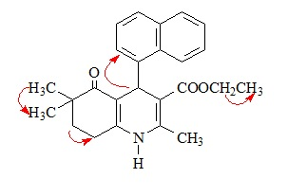
Figure 2. COSY correlations of compound 2

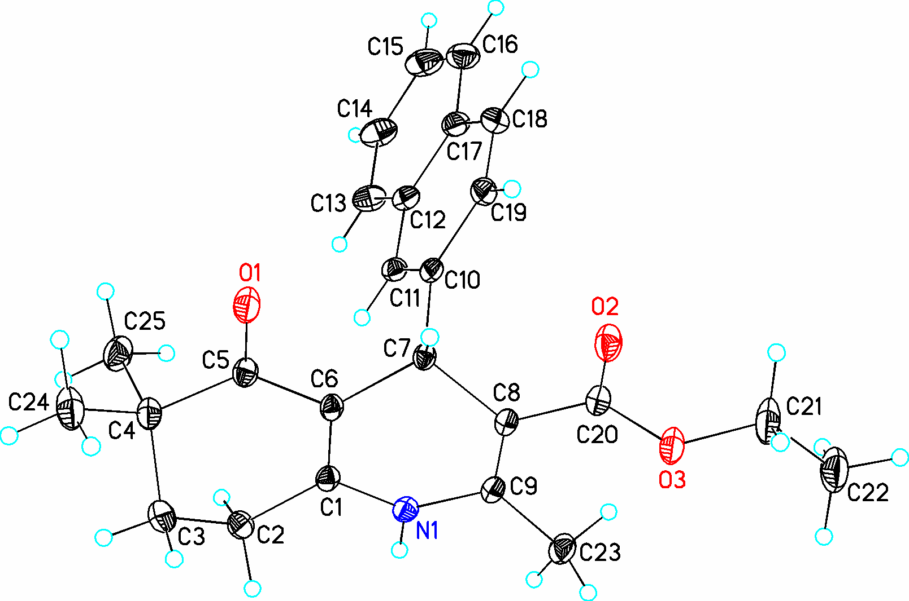
Figure 3. X-Ray molecular structure of compound 10 with the atom numbering scheme used in the crystallographic analysis

