Synthesis, Structural Characterization and Myorelaxant Activity of 4-Naphthyl-Hexahydroquinoline Derivatives Containing Different Ester Groups

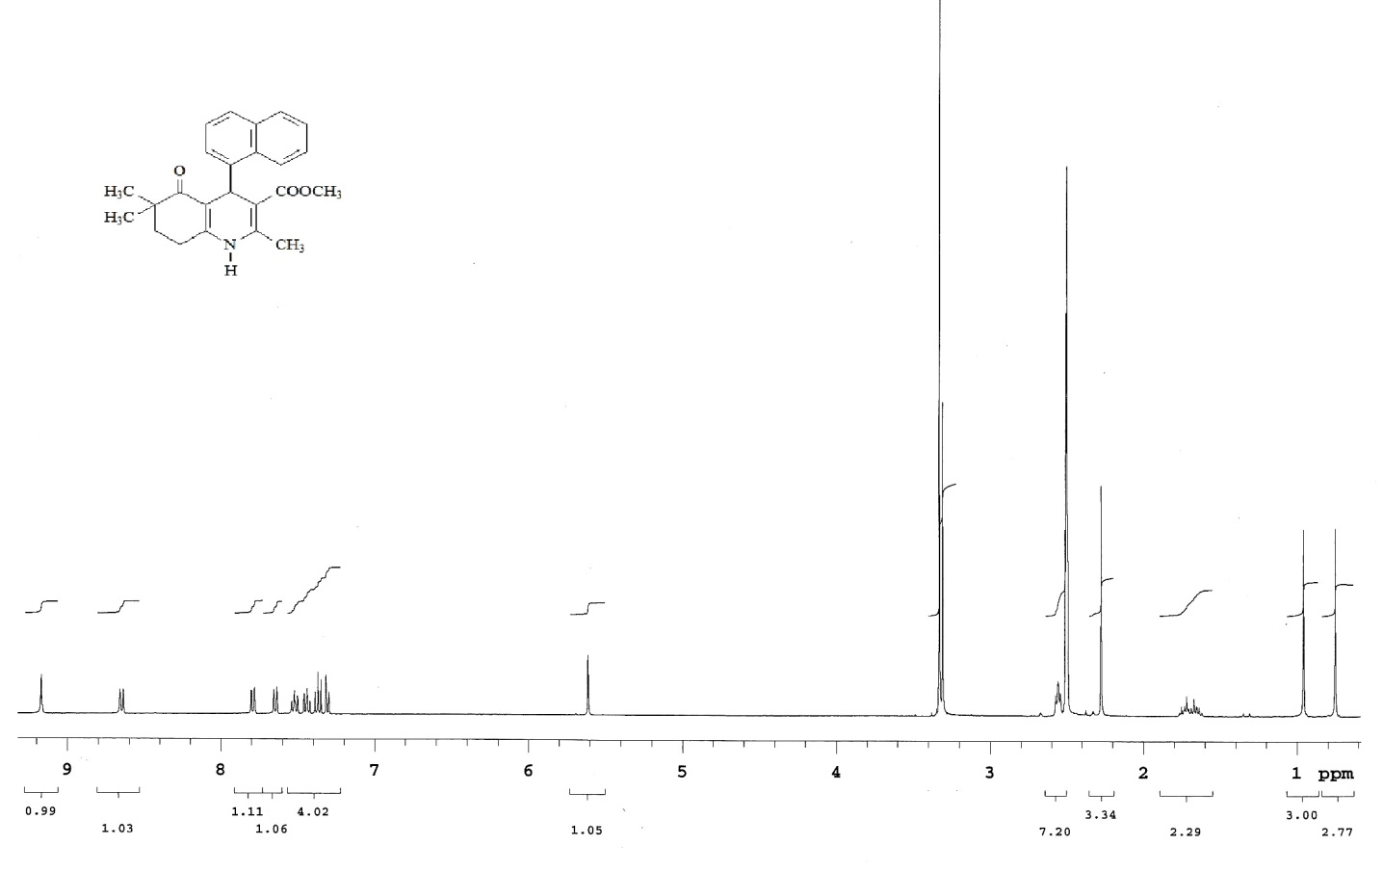
¹H-NMR spectrum of compound 1

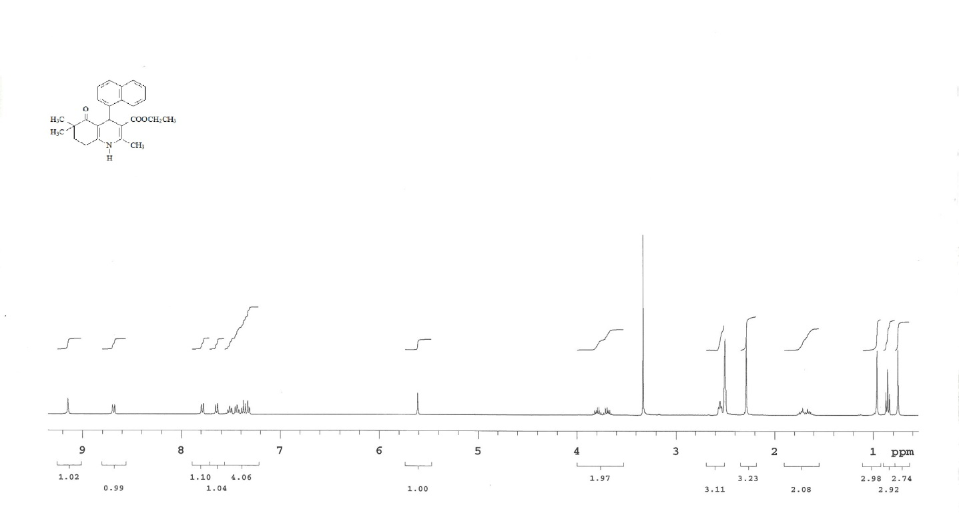
¹H-NMR spectrum of compound 2

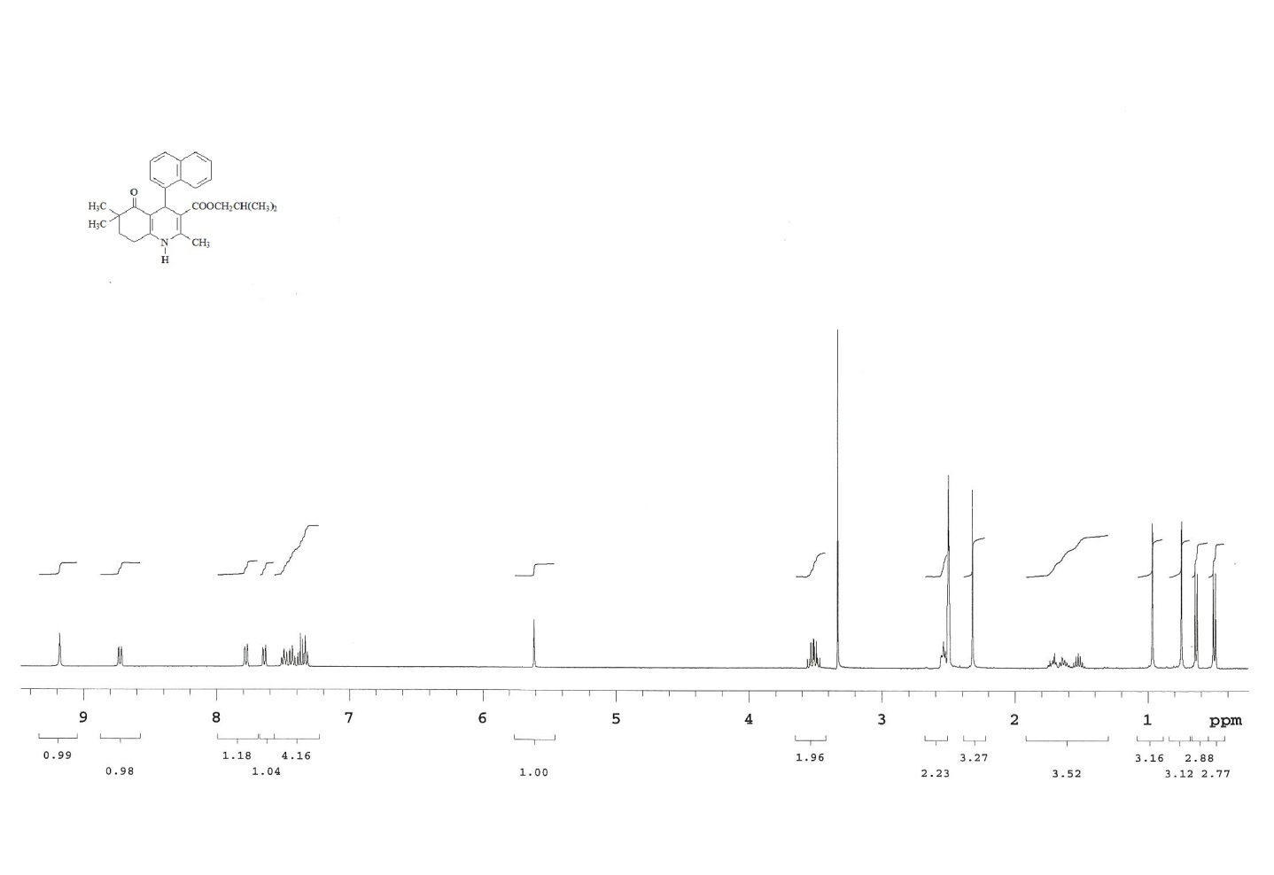
¹H-NMR spectrum of compound 4

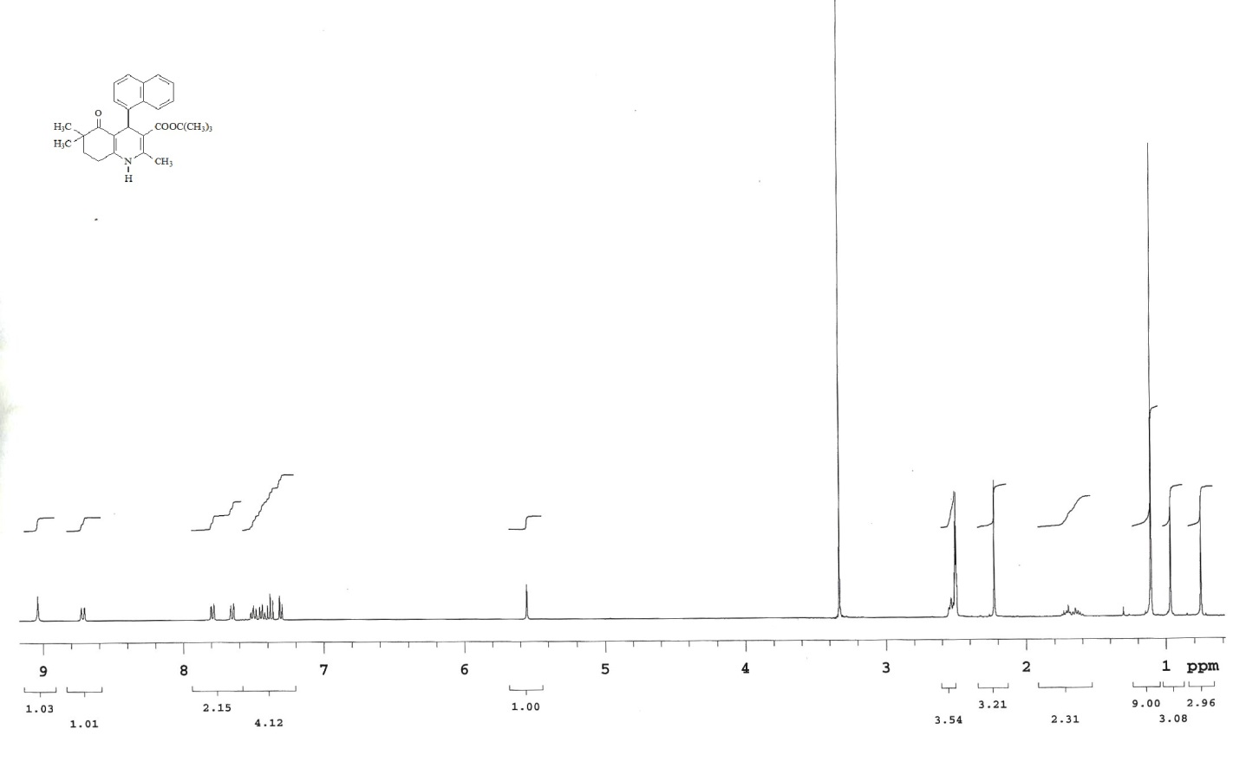
¹H-NMR spectrum of compound 5

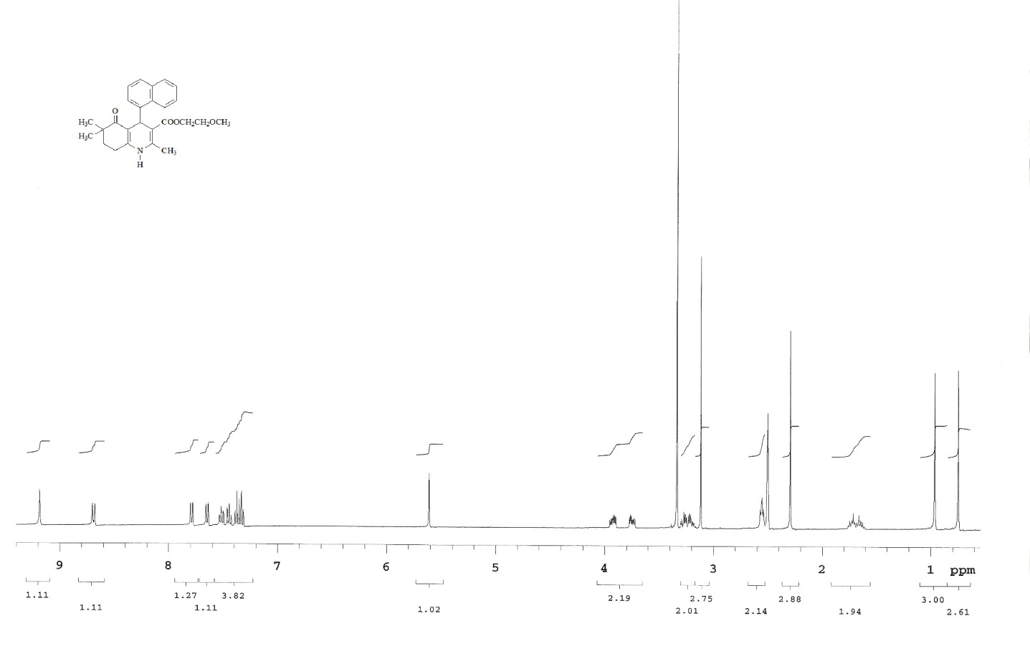
¹H-NMR spectrum of compound 6
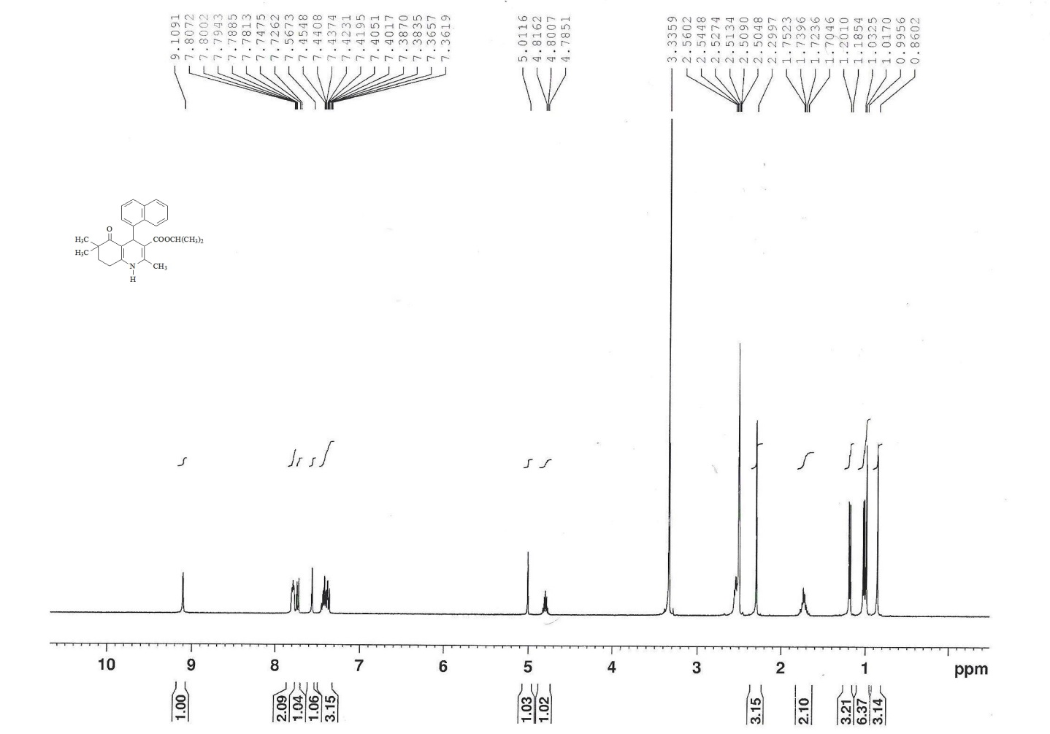
¹H-NMR spectrum of compound 11

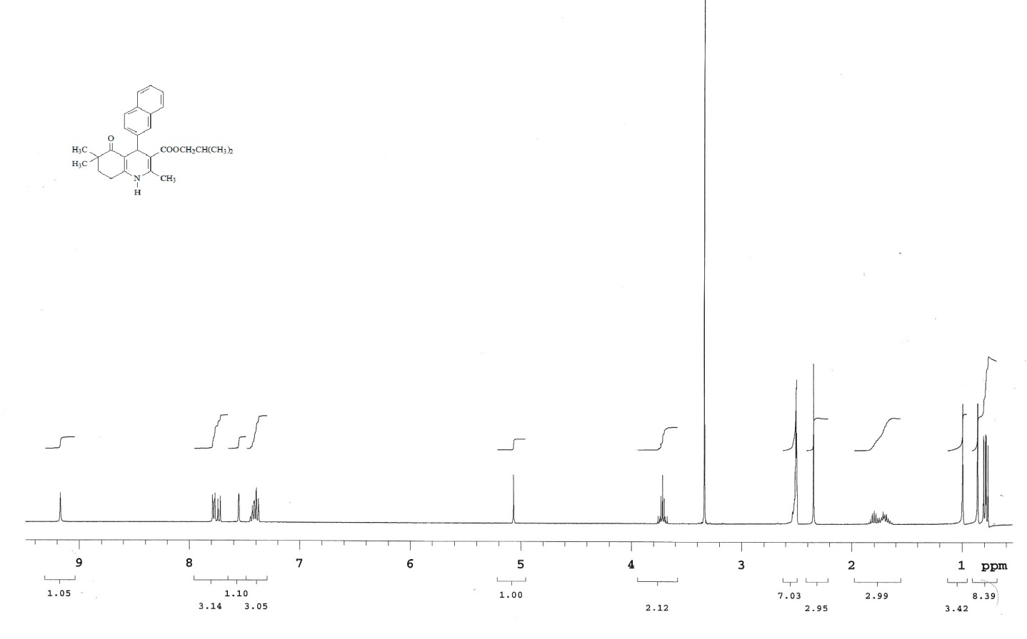
¹H-NMR spectrum of compound 12

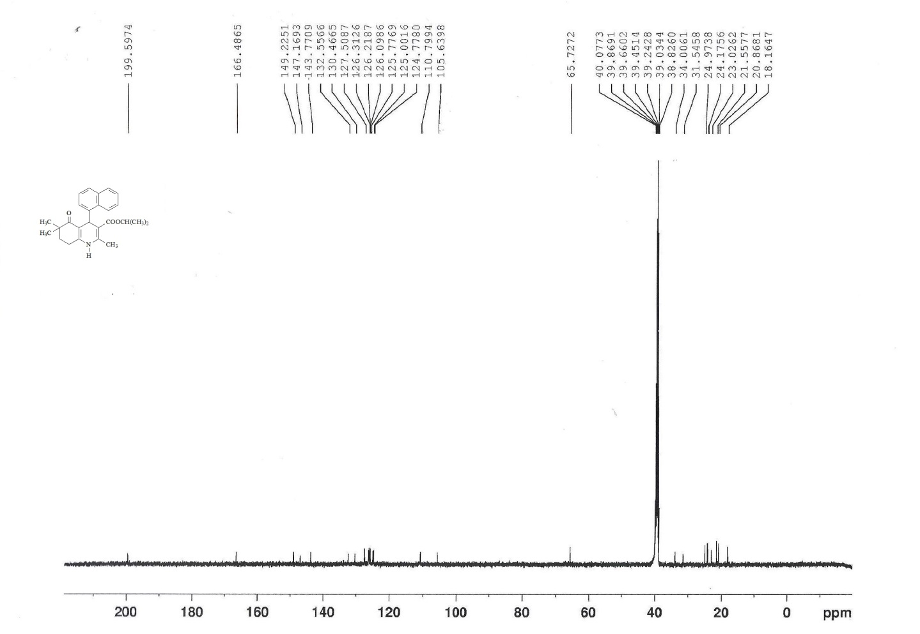
¹³C-NMR spectrum of compound 3

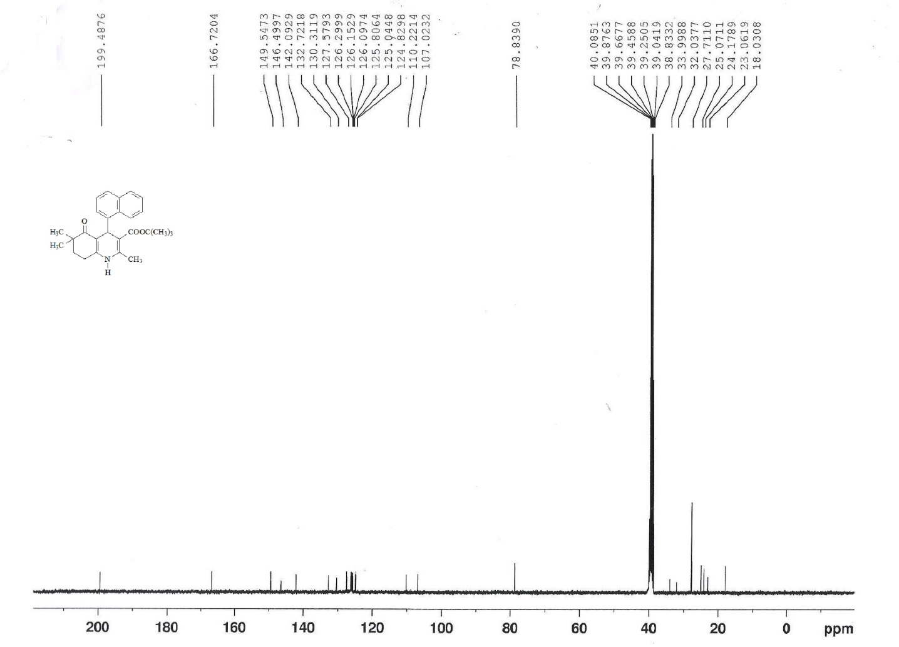
¹³C-NMR spectrum of compound 5

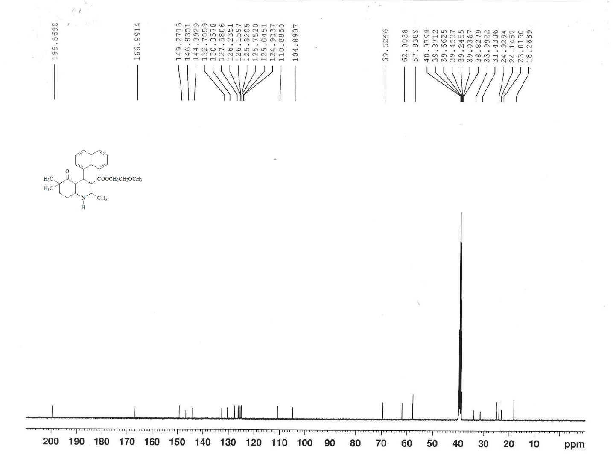
¹³C-NMR spectrum of compound 6

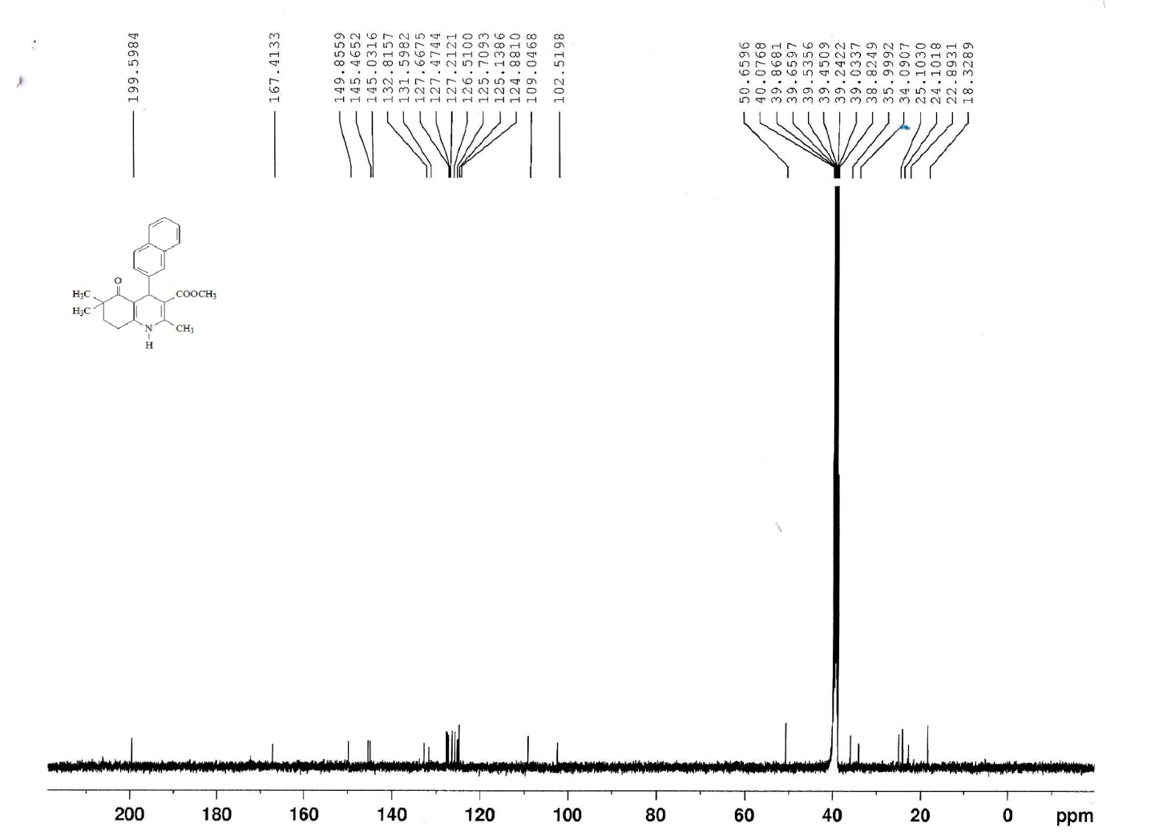
¹³C-NMR spectrum of compound 9

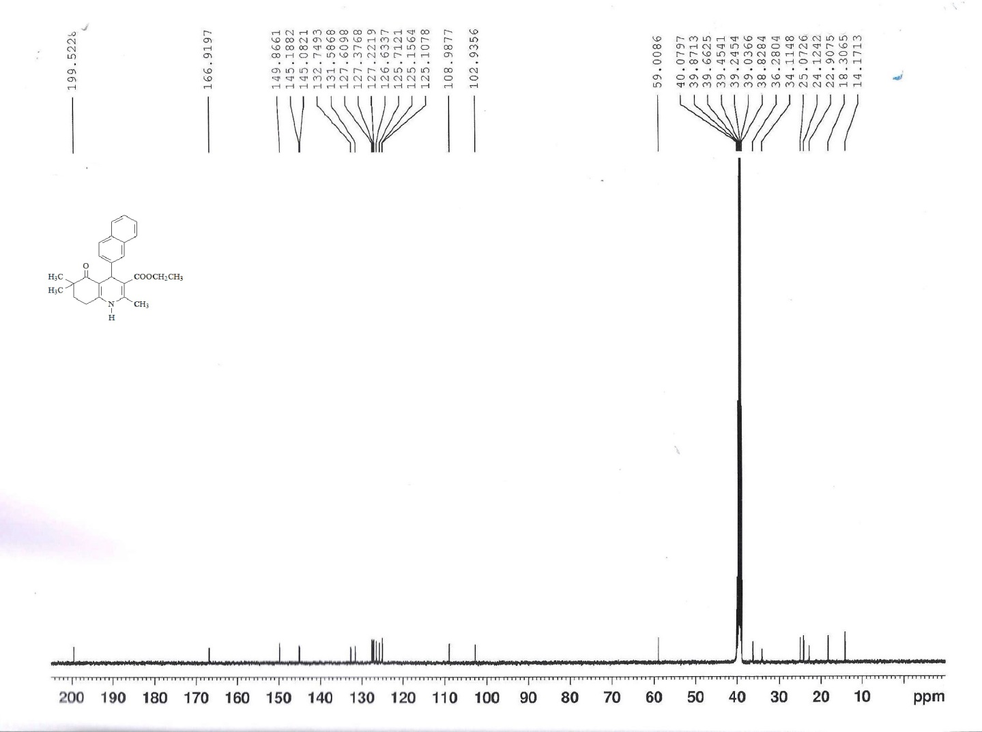
¹³C-NMR spectrum of compound 10

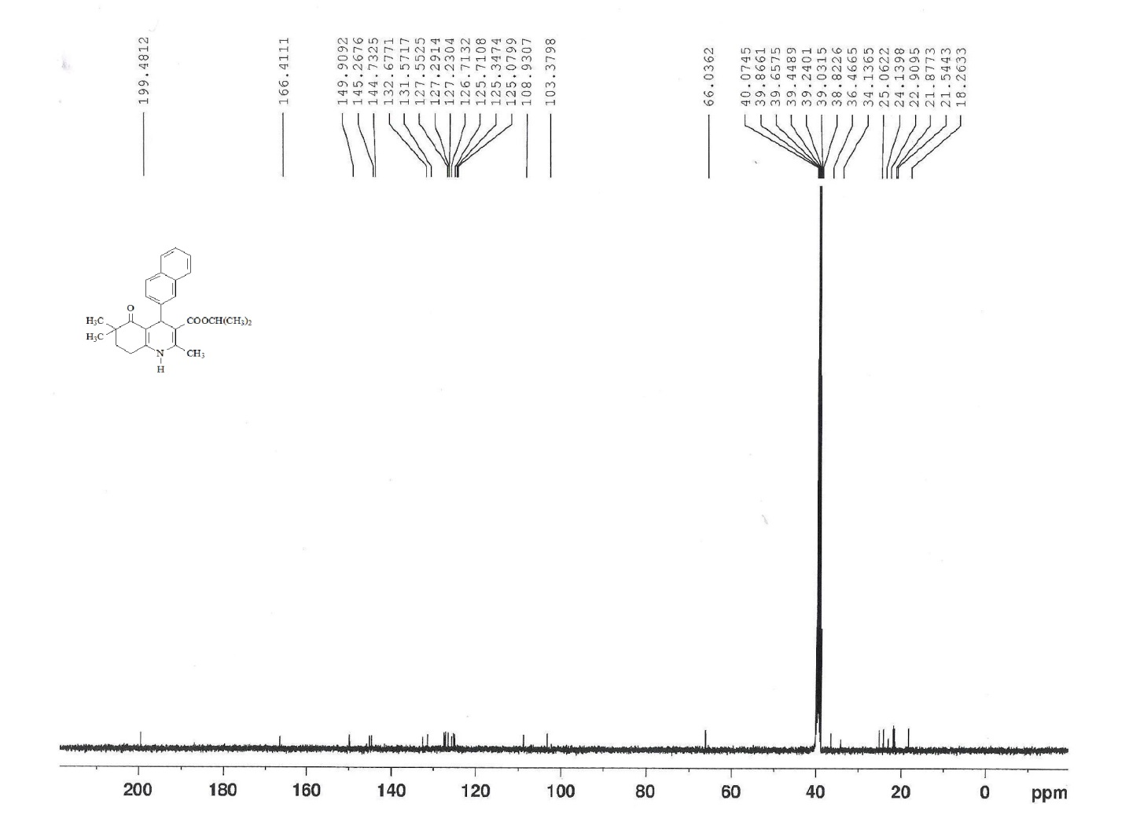
¹³C-NMR spectrum of compound 11

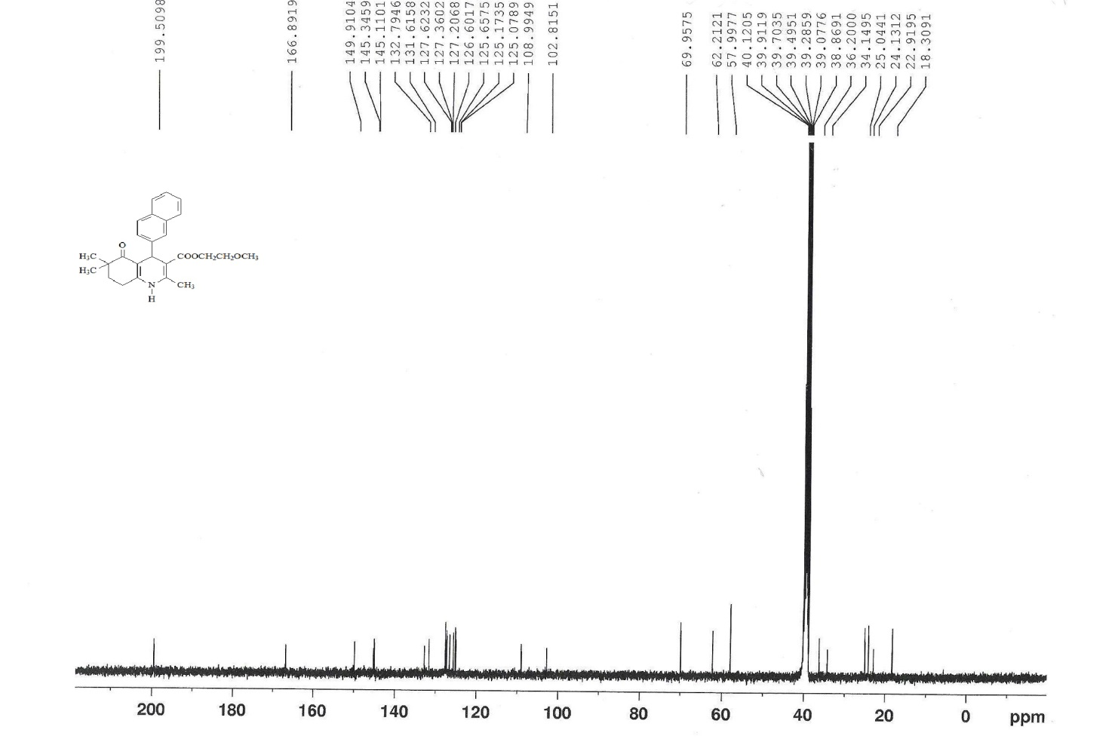
¹³C-NMR spectrum of compound 14

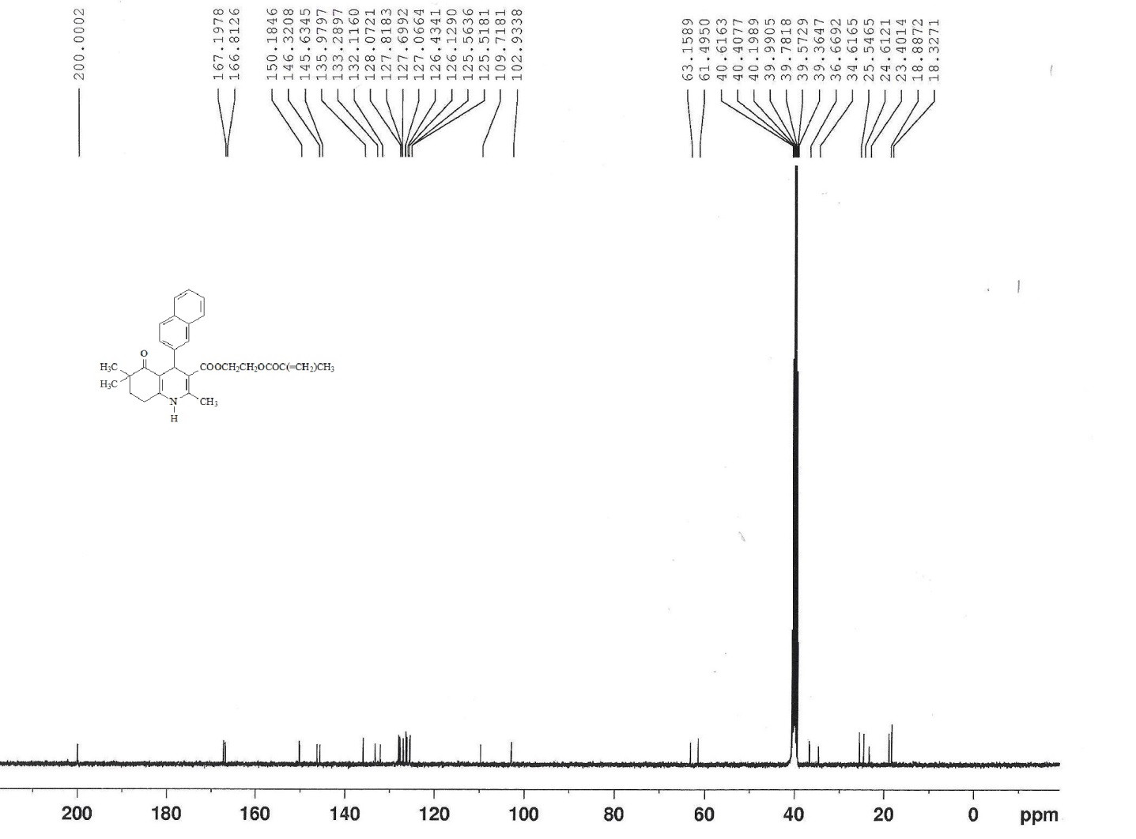
¹³C-NMR spectrum of compound 15

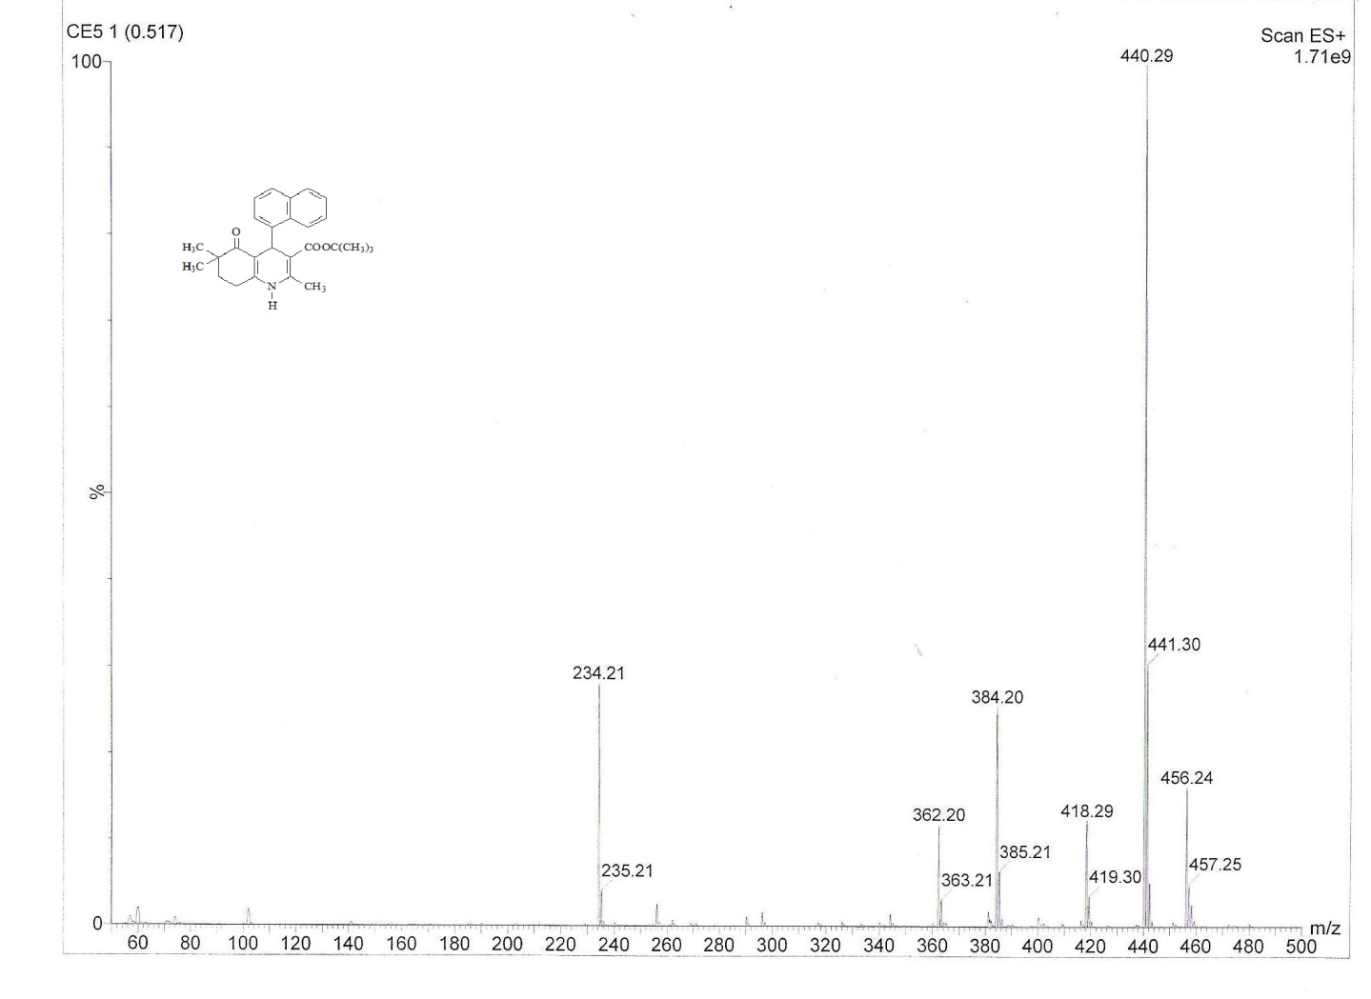
Mass spectrum of compound 5

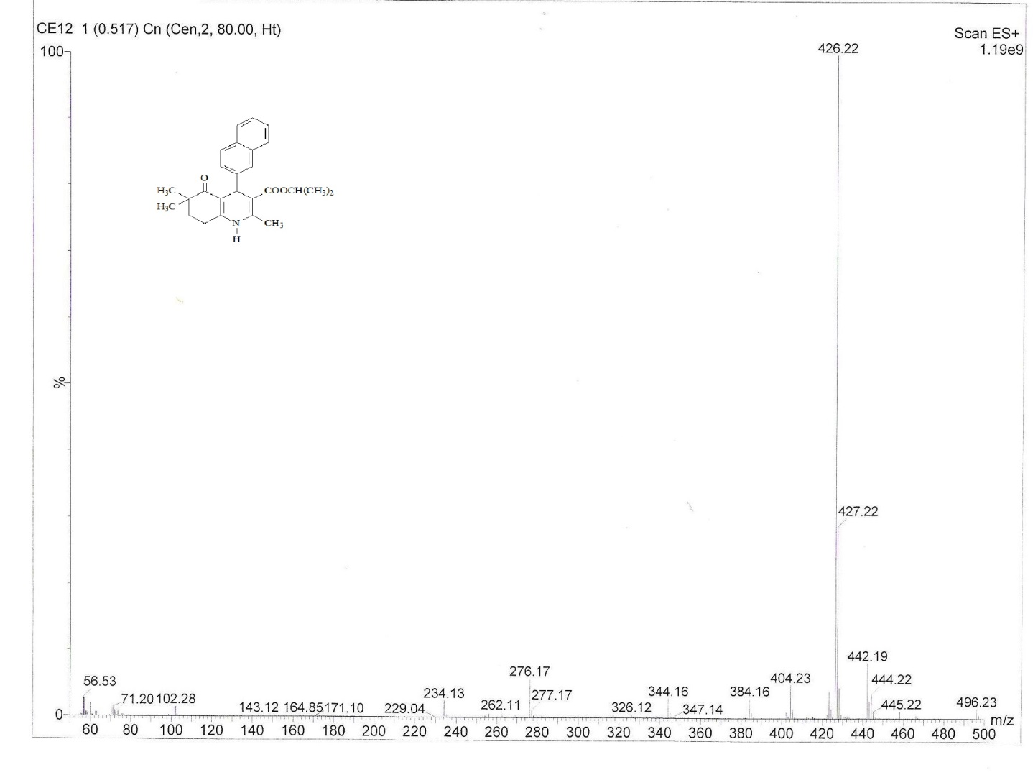
Mass spectrum of compound 11

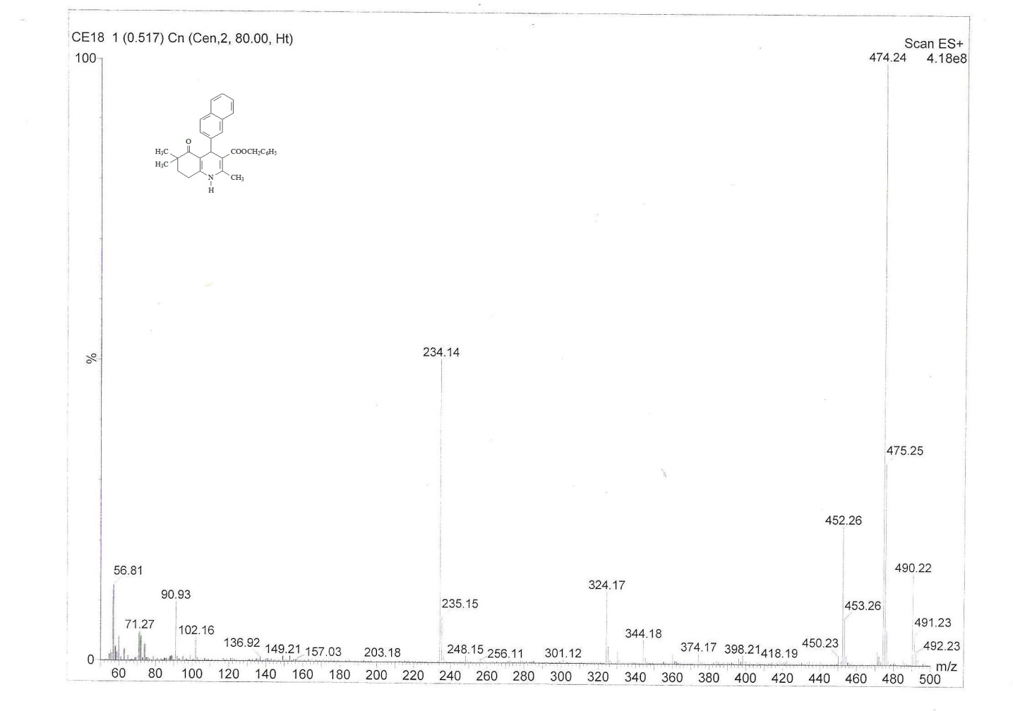
Mass spectrum of compound 16

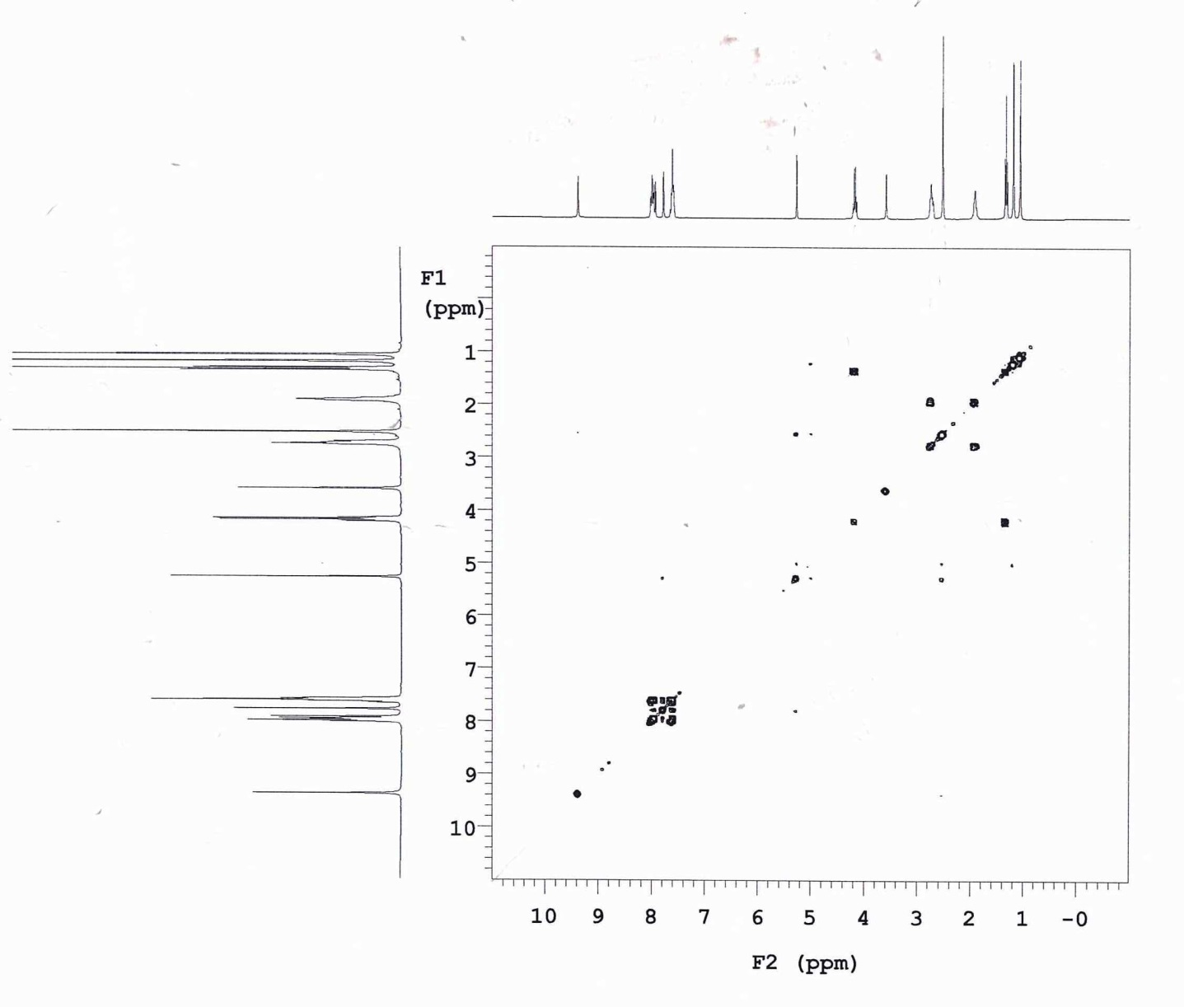
COSY spectrum of compound 2

Crystal data and details of the structure determination of compound 10
--------------------------------------------------------------------------------------------------------------
Formula | C₂₅H₂₇NO₃
Molecular weight | 389.48
Crystal system | Orthorhombic
Space group | Pbca
a (Å), b (Å), c(Å) | 10.5179 (2), 12.1144 (3), 33.6297 (8)
α (°), β (°), γ (°) | 90, 90, 90
Volume (Å³) | 4285.03 (18)
Z | 8
D (calculated) (gcm⁻³) | 1.207
F000 | 1664
Linear absorption coefficient (mm⁻¹) | 0.63
Absorption correction type | multi-scan
Crystal size (mm) | 0.50 x 0.35 x 0.30
Diffractions radiation type | CuK_{α}
λ (Å) | 1.54184
Monochromator | Graphite
Diffractions measurement device type | Xcalibur, Ruby, Gemini
Diffractions measurement device | ω scans
Total reflection number | 15413
Independent reflection number | 4374
Collected reflection for I > 2σ(I) | 3821
R_{int} | 0.029
h, k, l ranges | -12→12, -13→14, -38→41
θ_{min} , θ_{max} range (°) | -4.96, 75.64
Solution | Direct methods, SHELXS-97, SHELXL-97, SHELXTL
Least squares refine weighting details | w = 1/[σ²(Fo²) + (0.0764P)2 + 1.7455P]  where P = (Fo² + 2F_{c}²)/3
Number of variable | 270
R | 0.0479
wR | 0.1326
S(F²) | 1.043
Δρ_{max} , Δρ_{min} (e/Å³) | 0.39, —0.23
--------------------------------------------------------------------------------------------------------------

Selected bond lengths (Å), bond (°) and torsion angles (°).
----------------------------------------------------------------------------------------------------------------
O1—C5 | 1.2319 (19) | O3—C21 | 1.450 (2)
O2—C20 | 1.216 (2) | N1—C1 | 1.3642 (19)
O3—C20 | 1.3441 (18) | N1—C9 | 1.3905 (19)
C20—O3—C21 | 116.23 (13) | C11—C10—C7 | 121.60 (13)
C1—N1—C9 | 122.72 (13) | C19—C10—C7 | 119.49 (13)
N1—C1—C2 | 116.62 (13) | C10—C11—C12 | 121.39 (14)
O1—C5—C6 | 121.45 (13) | C15—C16—C17 | 120.98 (18)
O1—C5—C4 | 119.16 (13) | O2—C20—O3 | 122.15 (14)
C8—C9—N1 | 119.09 (13) | O2—C20—C8 | 123.13 (13)
C8—C9—C23 | 128.34 (14) | O3—C20—C8 | 114.71 (13)
N1—C9—C23 | 112.55 (13) | O3—C21—C22 | 107.31 (16)
C11—C10—C19 | 118.83 (14)
N1—C1—C2—C3 | 155.38 (13) | C1—N1—C9—C8 | −12.6 (2)
C1—C2—C3—C4 | 48.82 (17) | C1—N1—C9—C23 | 165.63 (14)
C3—C4—C5—O1 | −151.82 (14) | C21—O3—C20—O2 | −4.3 (2)
C25—C4—C5—O1 | 87.90 (17) | C21—O3—C20—C8 | 175.61 (16)
N1—C1—C6—C5 | −177.12 (13) | C9—C8—C20—O2 | −169.51 (15)
N1—C1—C6—C7 | 6.2 (2) | C7—C8—C20—O2 | 11.6 (2)
O1—C5—C6—C1 | 176.76 (14) | C9—C8—C20—O3 | 10.6 (2)
O1—C5—C6—C7 | −6.5 (2) | C7—C8—C20—O3 | −168.32 (13)
C20—C8—C9—N1 | 170.78 (13) | C20—O3—C21—C22 | −173.42 (18)
C7—C8—C9—N1 | −10.4 (2)
----------------------------------------------------------------------------------------------------------------

Hydrogen-bond geometry (Å, °)
-----------------------------------------------------------------------------------------------------------------
D—H···A | D—H | H···A | D···A | D—H···A
-----------------------------------------------------------------------------------------------------------------
C7—H7A···O2 | 0.98 | 2.45 | 2.8122(17) | 101.6
N1—H1N···O1^{i} | 0.83(2) | 1.99(2) | 2.8150(17) | 171.6(19)
C23—H23B···O1^{i} | 0.96 | 2.52 | 3.346(2) | 143.7
-----------------------------------------------------------------------------------------------------------------
Symmetry code: (i) −x+3/2, y+1/2, z.

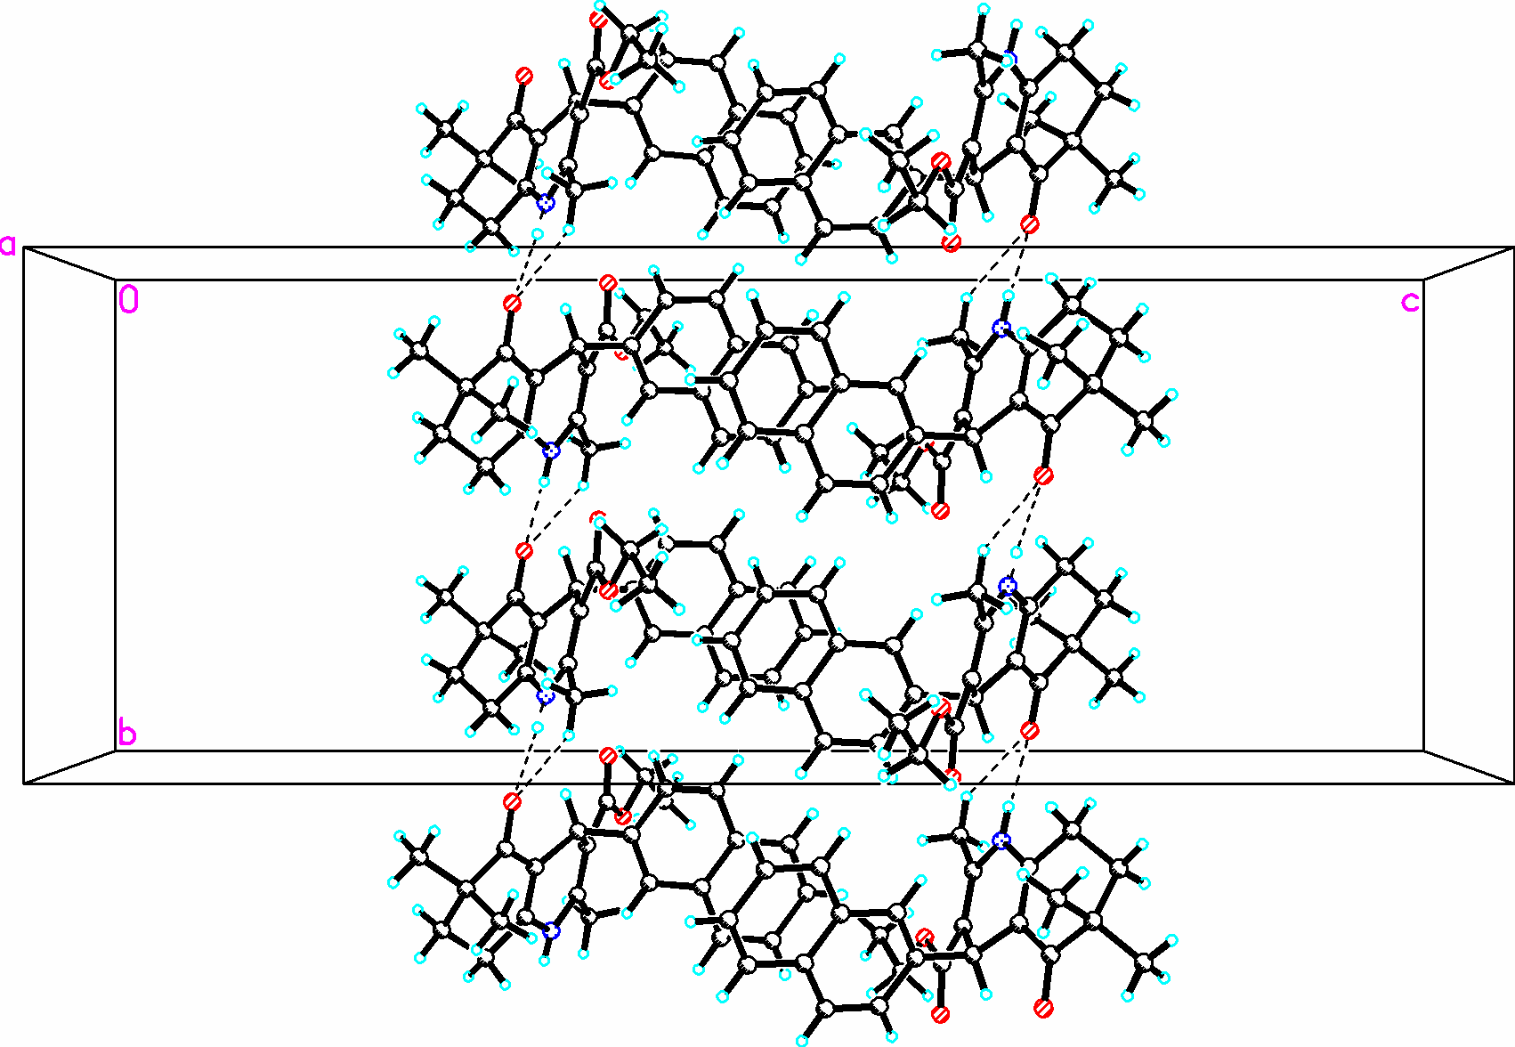
The packing and hydrogen bonding of compound 10 in the unit cell, viewed along the a axis. Hydrogen bonds are shown as dashed lines.

