Supporting Information
Synthesis of novel pyrazoline based bis 1,2,3-triazole scaffolds via click chemistry
DONGAMANTI ASHOK^{1,}*, KOTHURI KIRAN¹ and BODDU ANANDA RAO¹

Corresponding author: Dongamanti Ashok, Green and Medicinal Chemistry Laboratory, Department of Chemistry, Osmania University, Hyderabad, 500 007, Telangana, India.
E-mail: ashokdou@gmail.com
¹Green and Medicinal Chemistry Laboratory, Department of Chemistry, Osmania University, Hyderabad, 500007, Telangana, India.

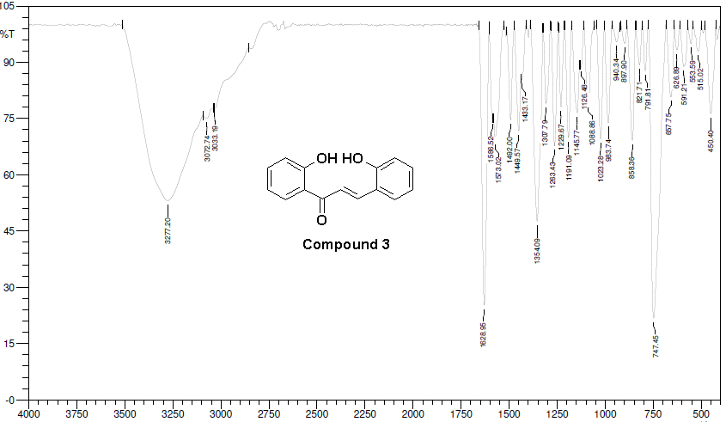
Figure S1: IR spectra of compound 3
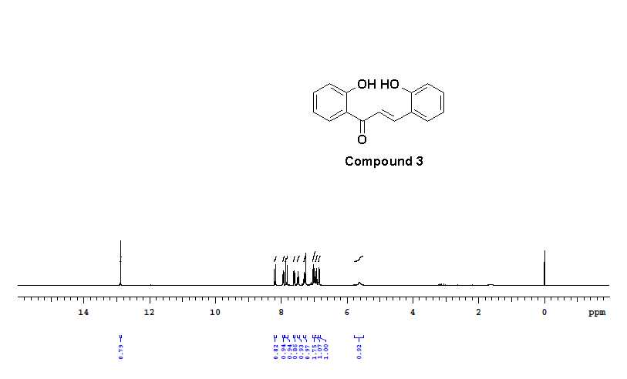
Figure S2: ¹H-NMR (400 MHz, CDCl₃) spectra of compound 3
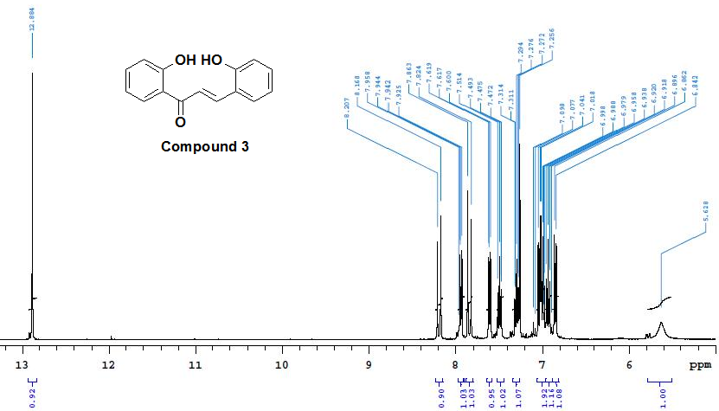
Figure S3: ¹H-NMR (400 MHz, CDCl₃) spectra of compound 3
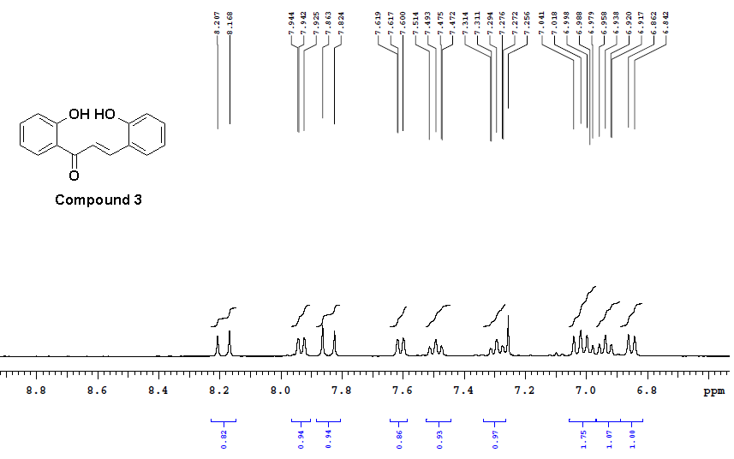
Figure S4: ¹H-NMR (400 MHz, CDCl₃) spectra of compound 3
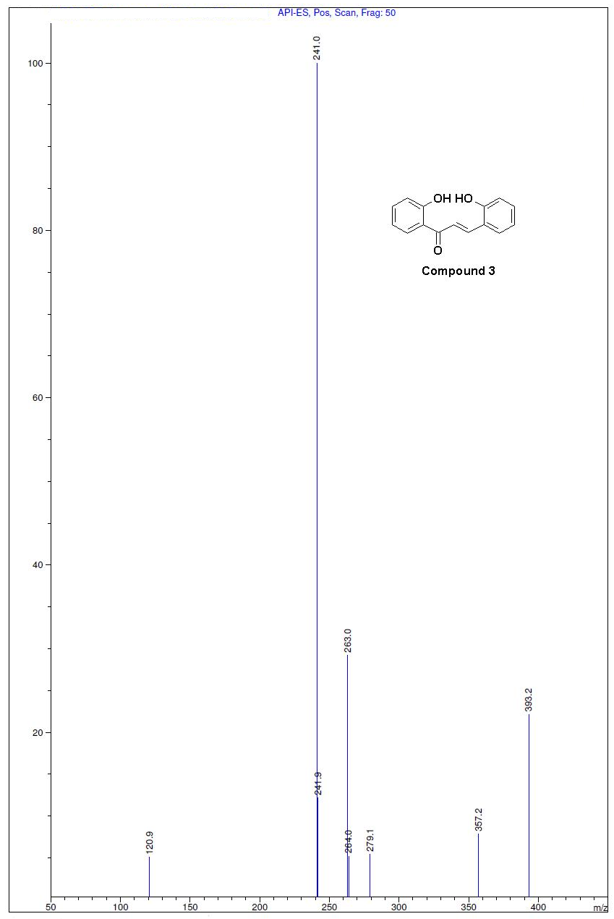
Figure S5: Mass spectra of compound 3

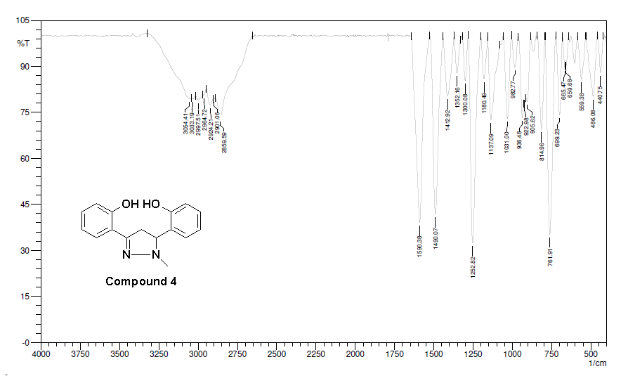
Figure S6: IR spectra of compound 4
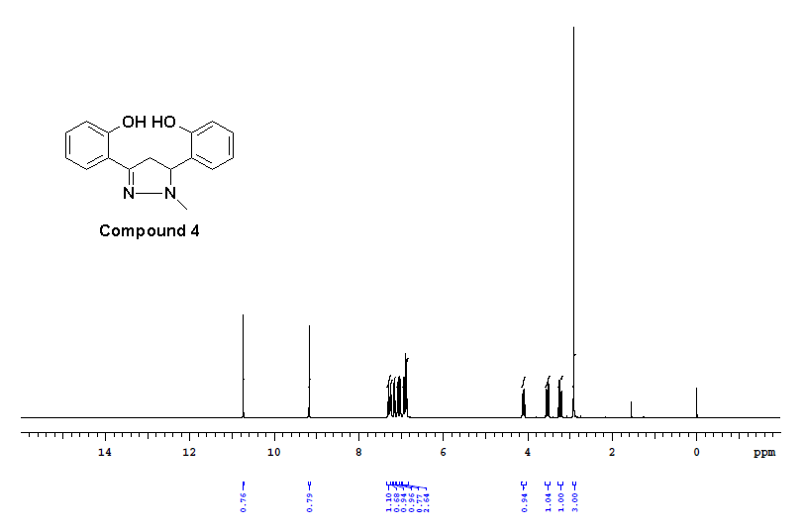
Figure S7: ¹H-NMR (400 MHz, CDCl₃) spectra of compound 4

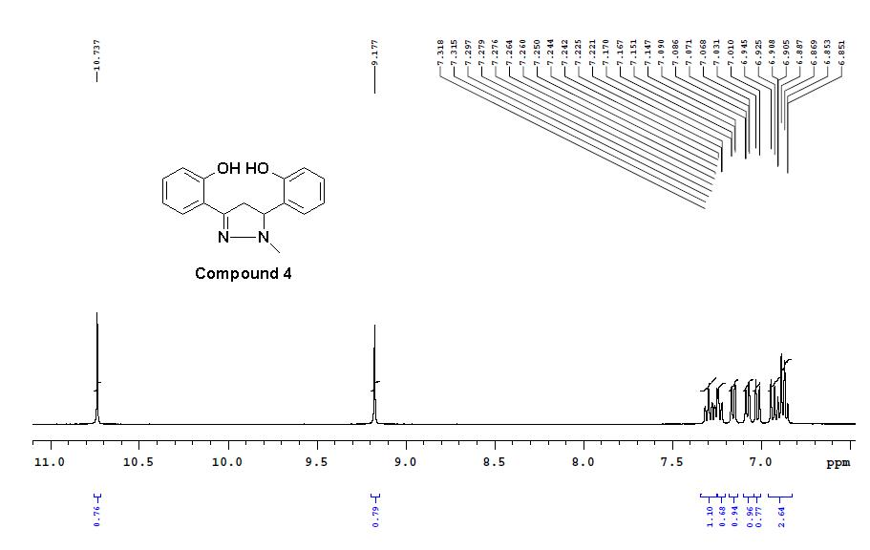
Figure S8: ¹H-NMR (400 MHz, CDCl₃) spectra of compound 4
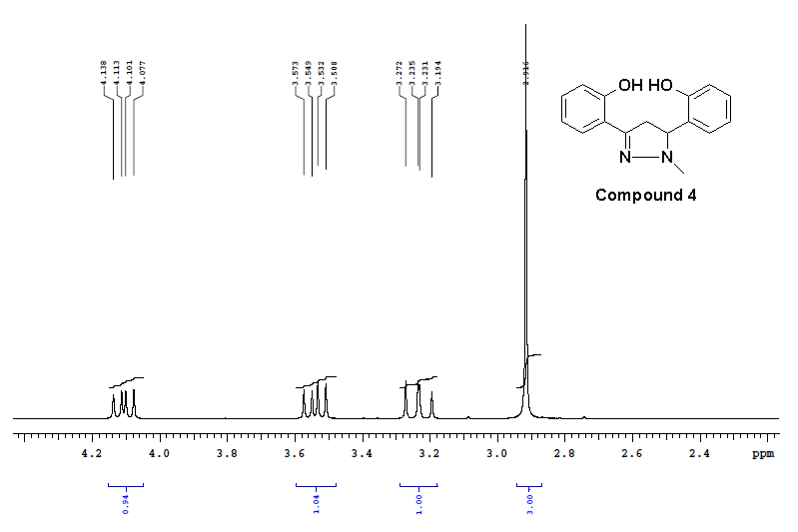
Figure S9: ¹H-NMR (400 MHz, CDCl₃) spectra of compound 4
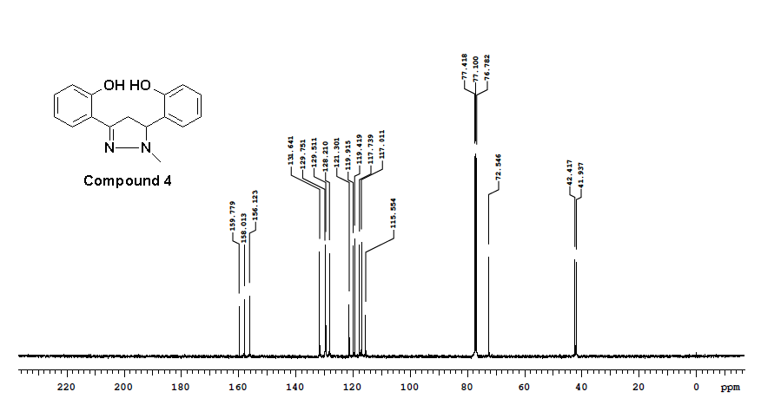
Figure S10: ¹³C NMR (100 MHz, CDCl₃) spectra of compound 4

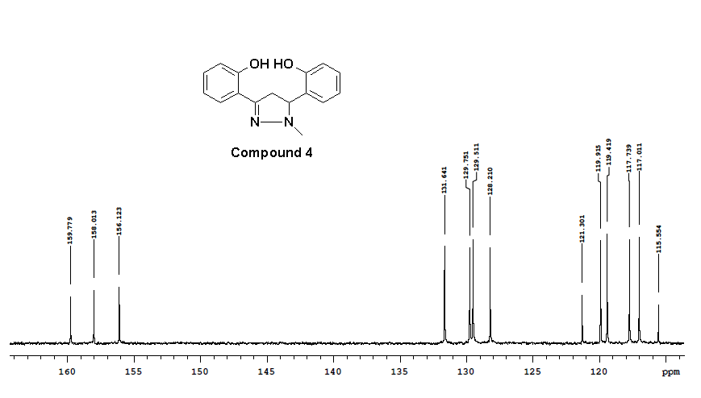
Figure S11: ¹³C NMR (100 MHz, CDCl₃) spectra of compound 4
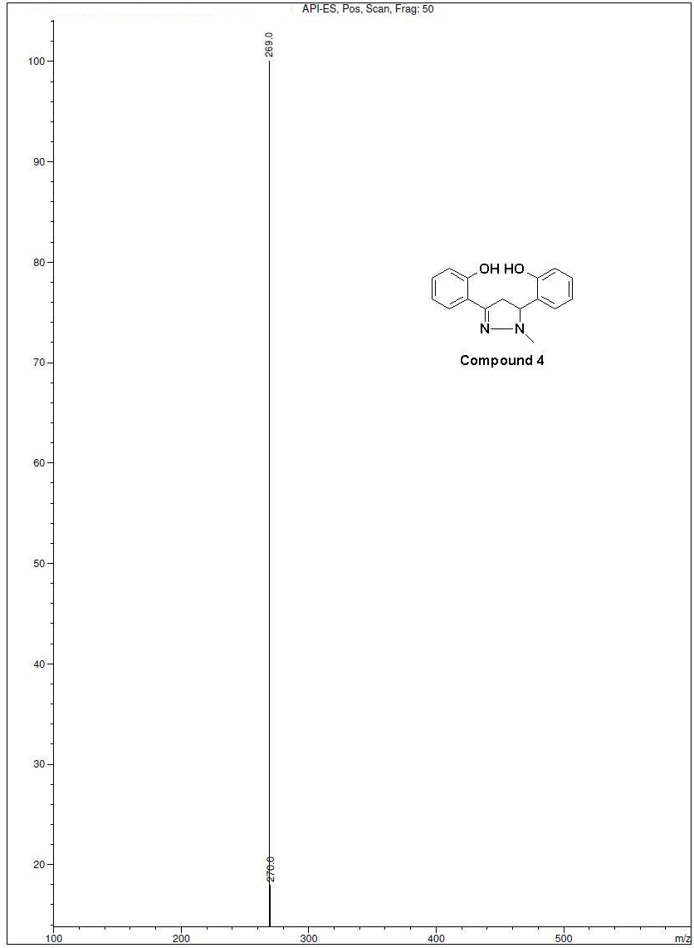
Figure S12: Mass spectra of compound 4
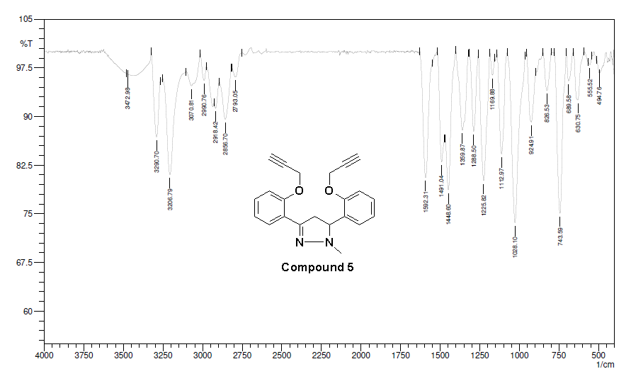
Figure S13: IR spectra of compound 5
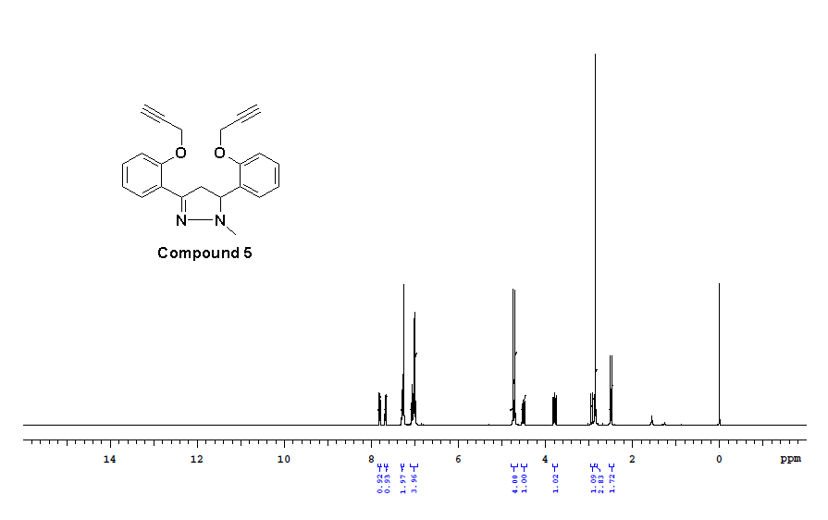
Figure S14: ¹H-NMR (400 MHz, CDCl₃) spectra of compound 5
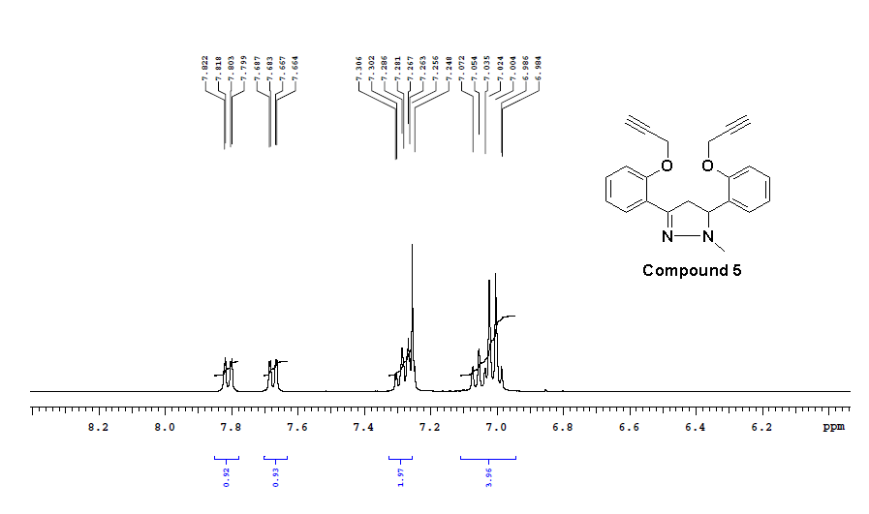
Figure S15: ¹H-NMR (400 MHz, CDCl₃) spectra of compound 5
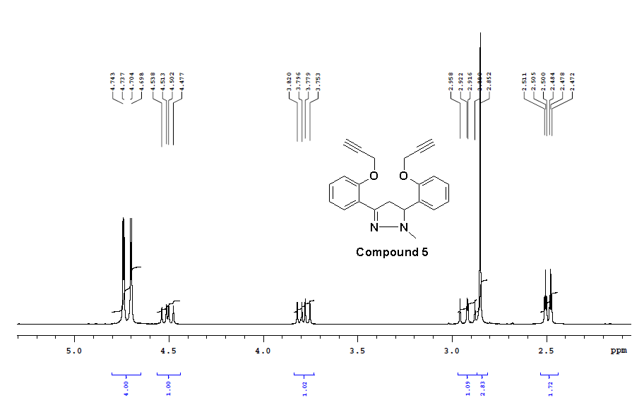
Figure S16: ¹H-NMR (400 MHz, CDCl₃) spectra of compound 5
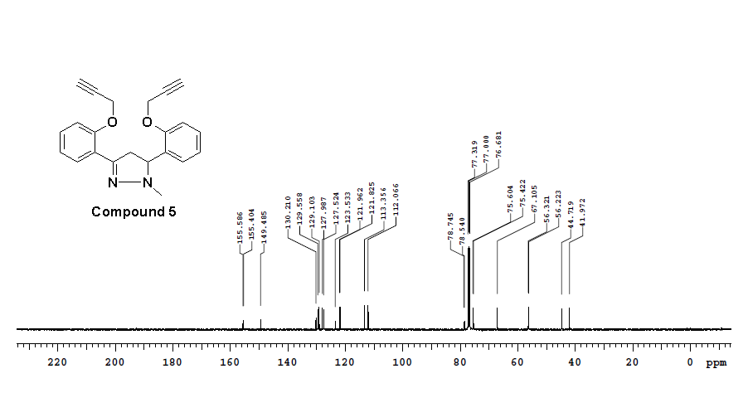
Figure S17: ¹³C NMR (100 MHz, CDCl₃) spectra of compound 5

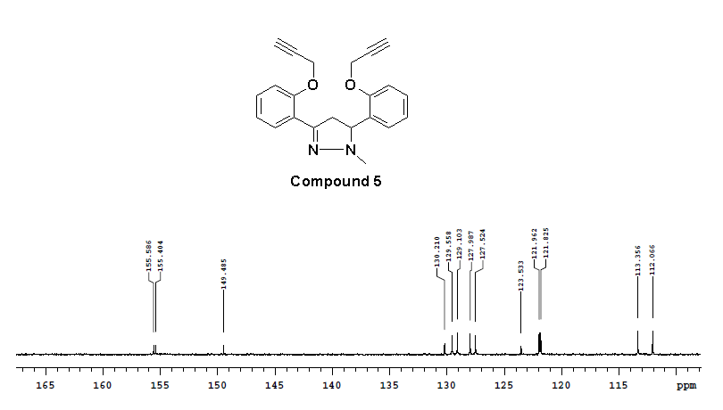
Figure S18: ¹³C NMR (100 MHz, CDCl₃) spectra of compound 5

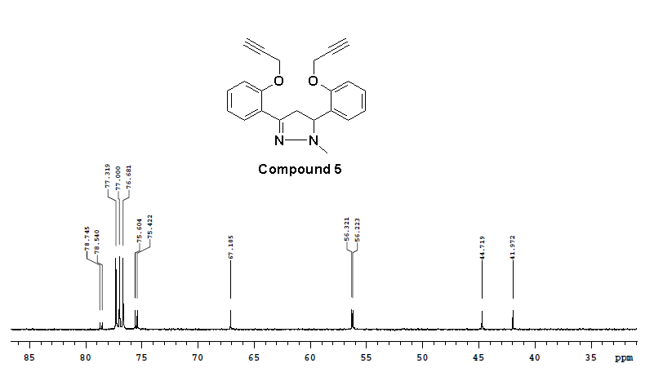
Figure S19: ¹³C NMR (100 MHz, CDCl₃) spectra of compound 5

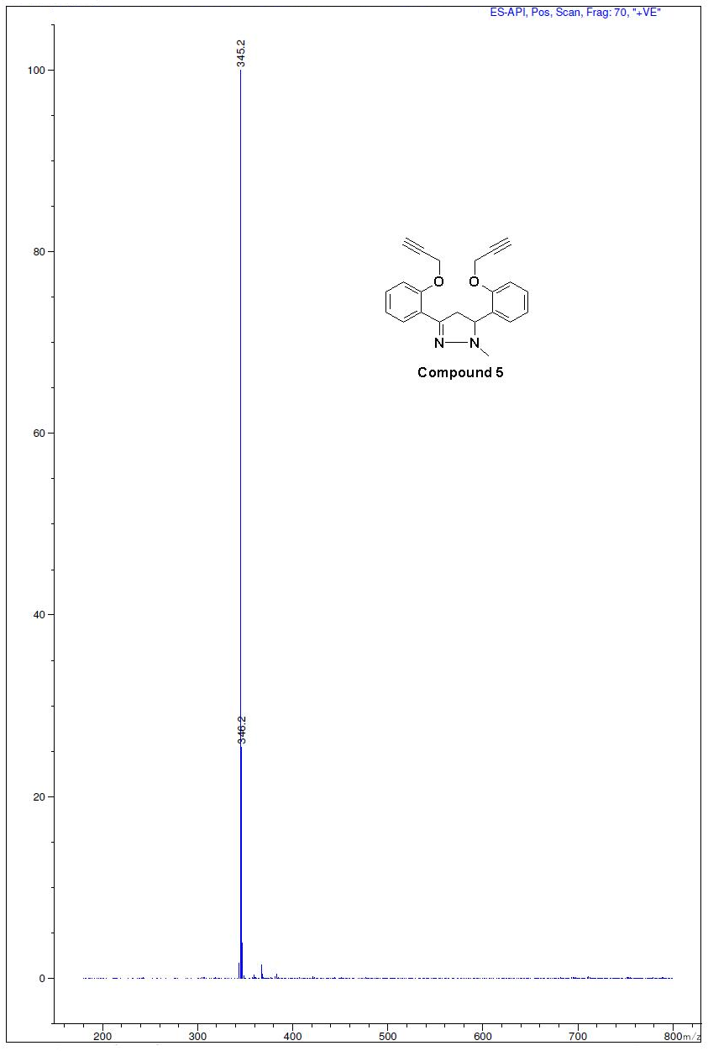
Figure S20: Mass spectra of compound 5
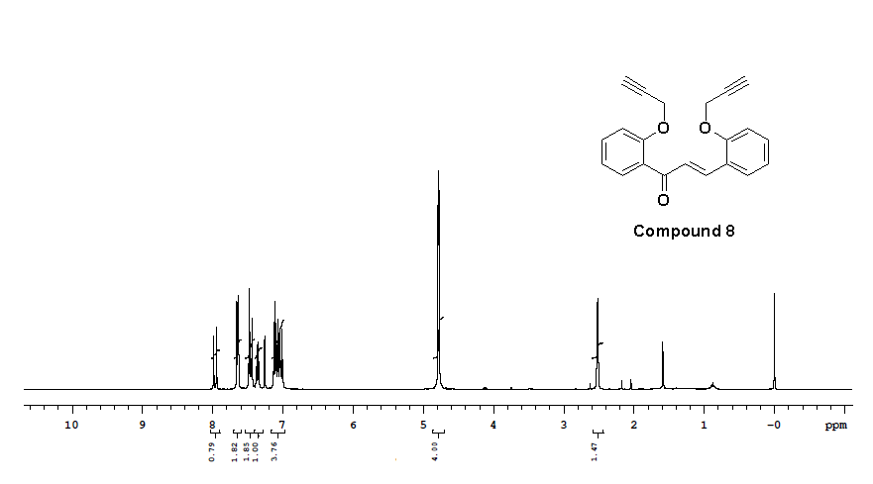
Figure S21: ¹H-NMR (400 MHz, CDCl₃) spectra of compound 8

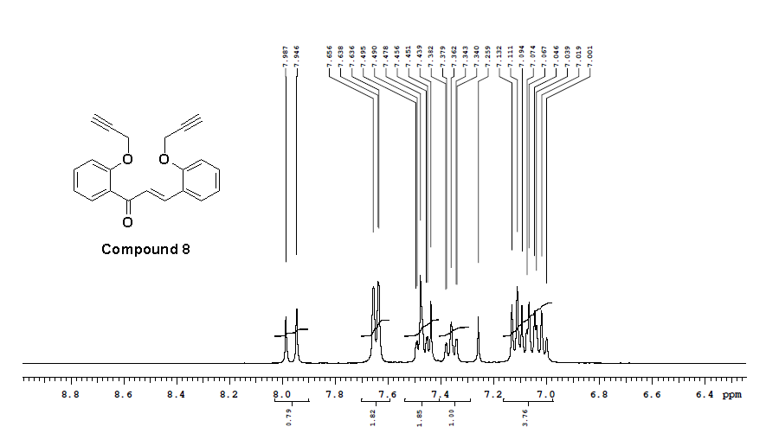
Figure S22: ¹H-NMR (400 MHz, CDCl₃) spectra of compound 8
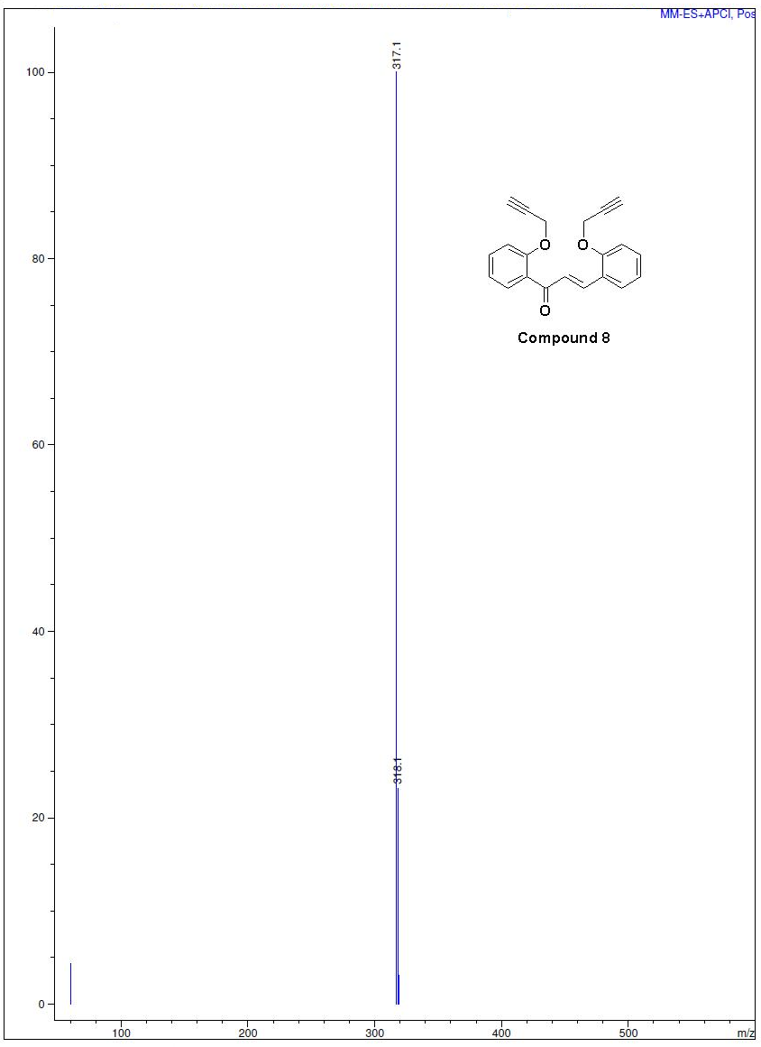
Figure S23: Mass spectra of compound 8
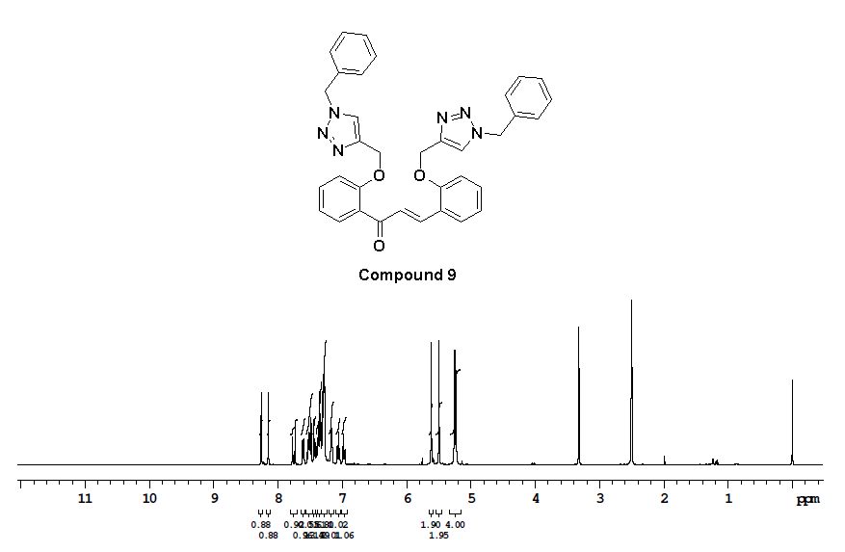
Figure S24: ¹H-NMR (400 MHz, DMSO-d₆) spectra of compound 9
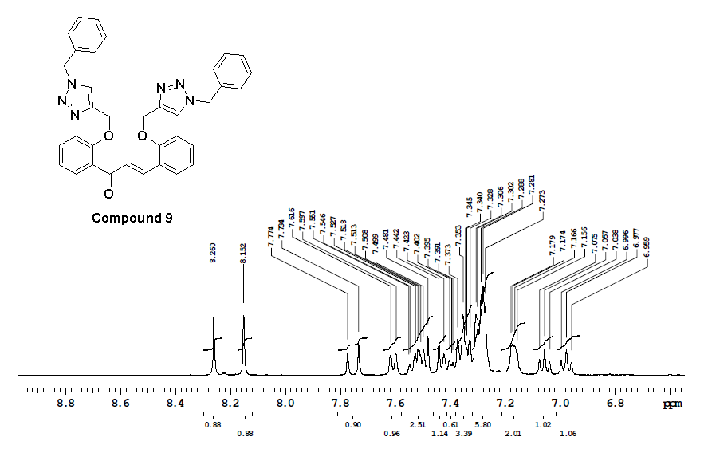
Figure S25: ¹H-NMR (400 MHz, DMSO-d₆) spectra of compound 9
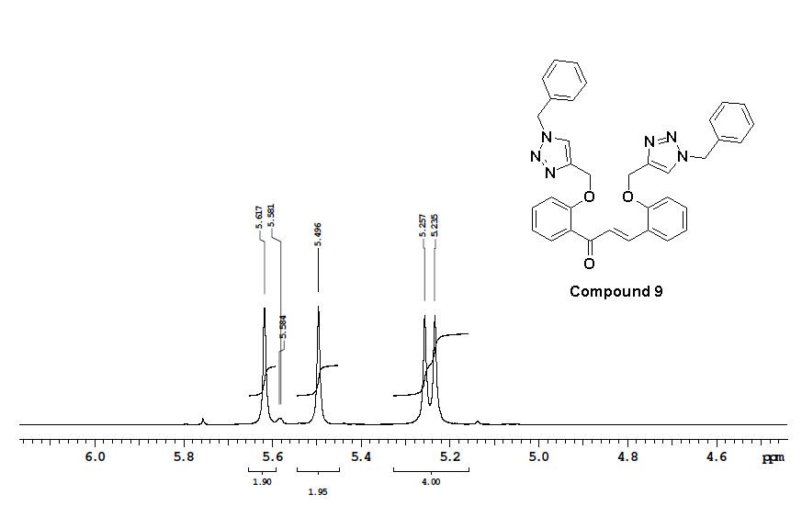
Figure S26: ¹H-NMR (400 MHz, DMSO-d₆) spectra of compound 9

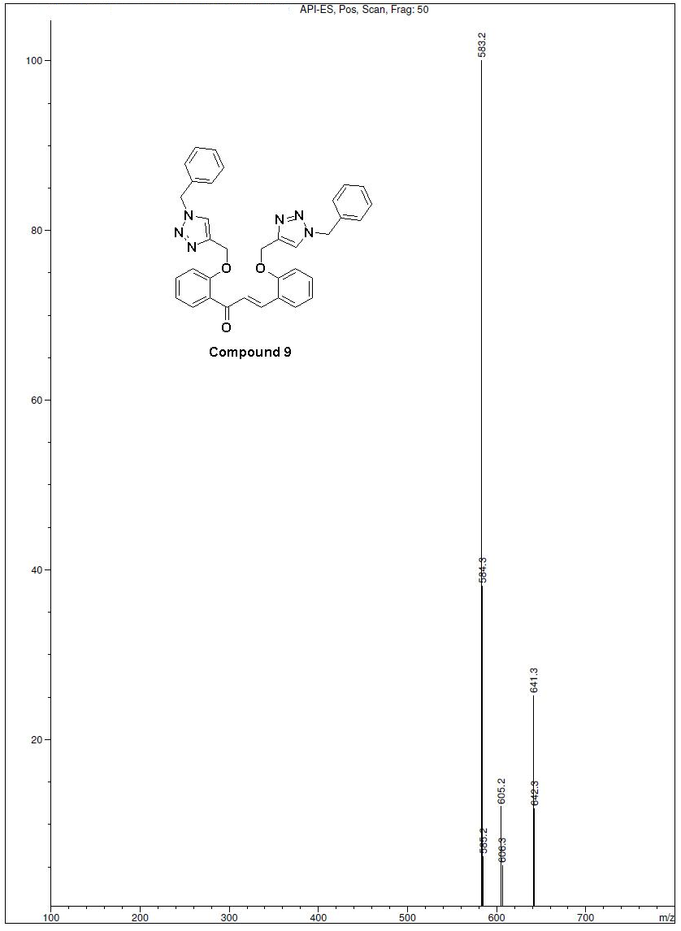
Figure S27: Mass spectra of compound 9

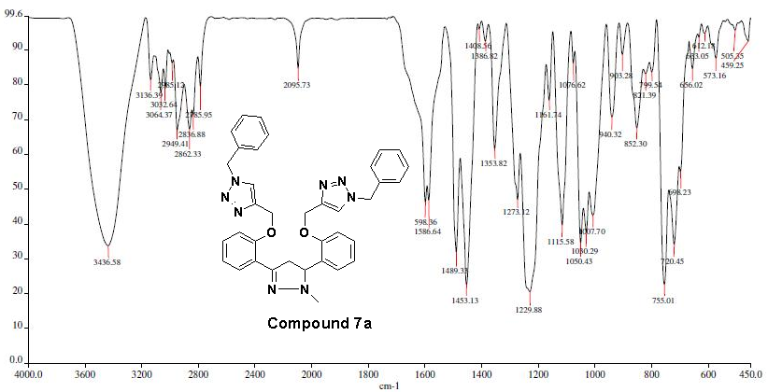
Figure S28: IR spectra of compound 7a
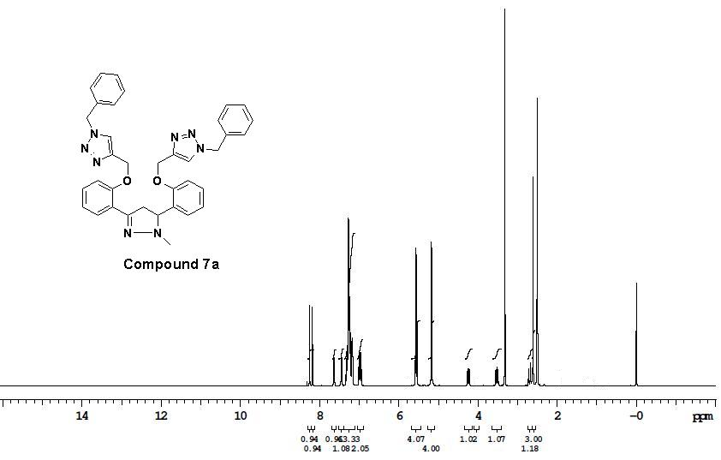
Figure S29: ¹H-NMR (400 MHz, DMSO-d₆) spectra of compound 7a

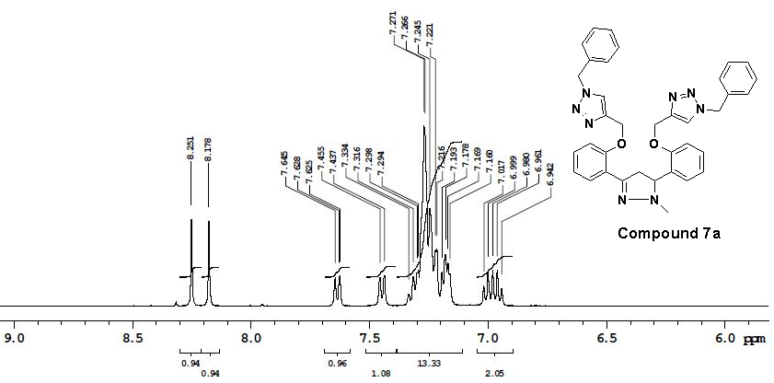
Figure S30: ¹H-NMR (400 MHz, DMSO-d₆) spectra of compound 7a

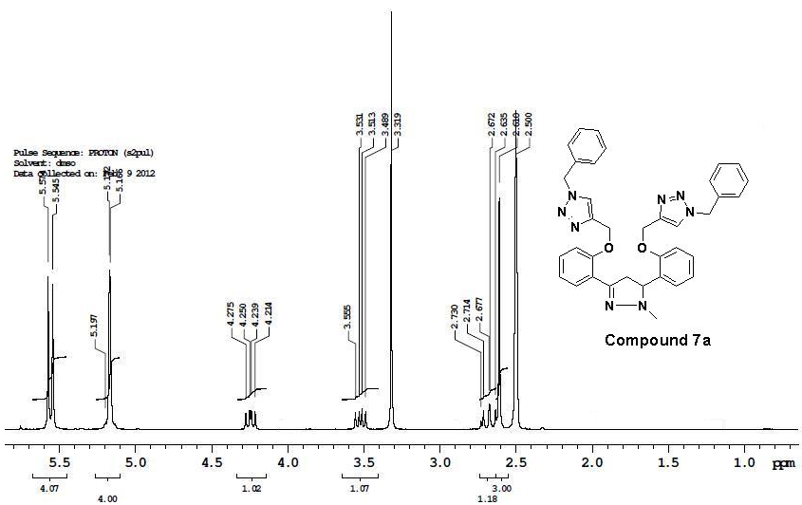
Figure S31: ¹H-NMR (400 MHz, DMSO-d₆) spectra of compound 7a
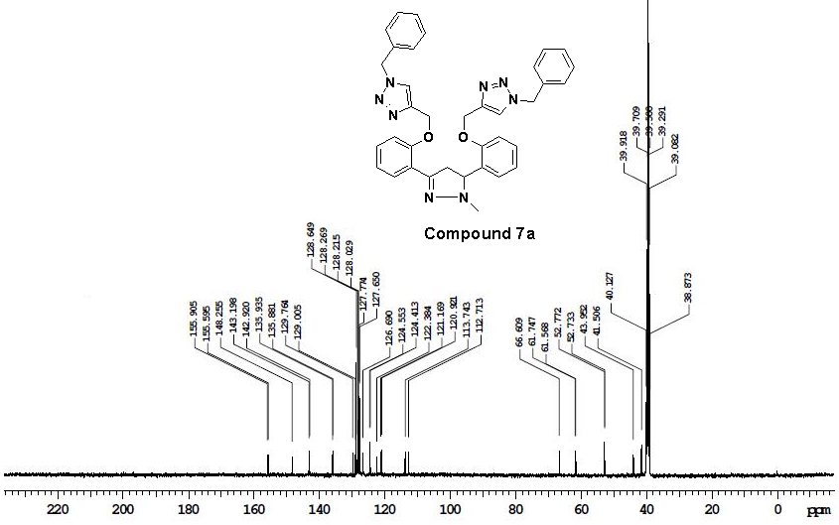
Figure S32: ¹³C NMR (100 MHz, DMSO-d₆) spectra of compound 7a

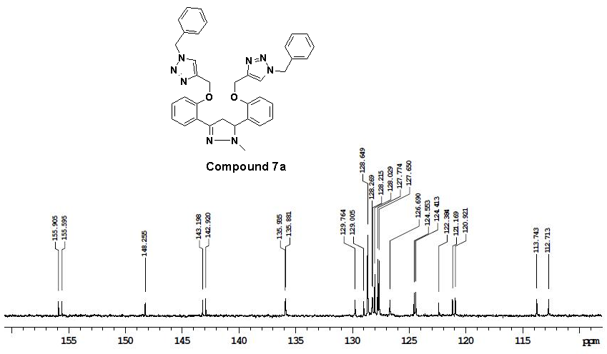
Figure S33: ¹³C NMR (100 MHz, DMSO-d₆) spectra of compound 7a

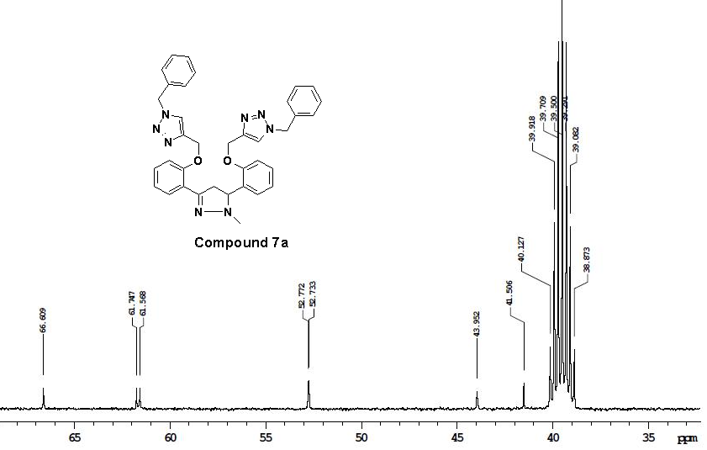
Figure S34: ¹³C NMR (100 MHz, DMSO-d₆) spectra of compound 7a

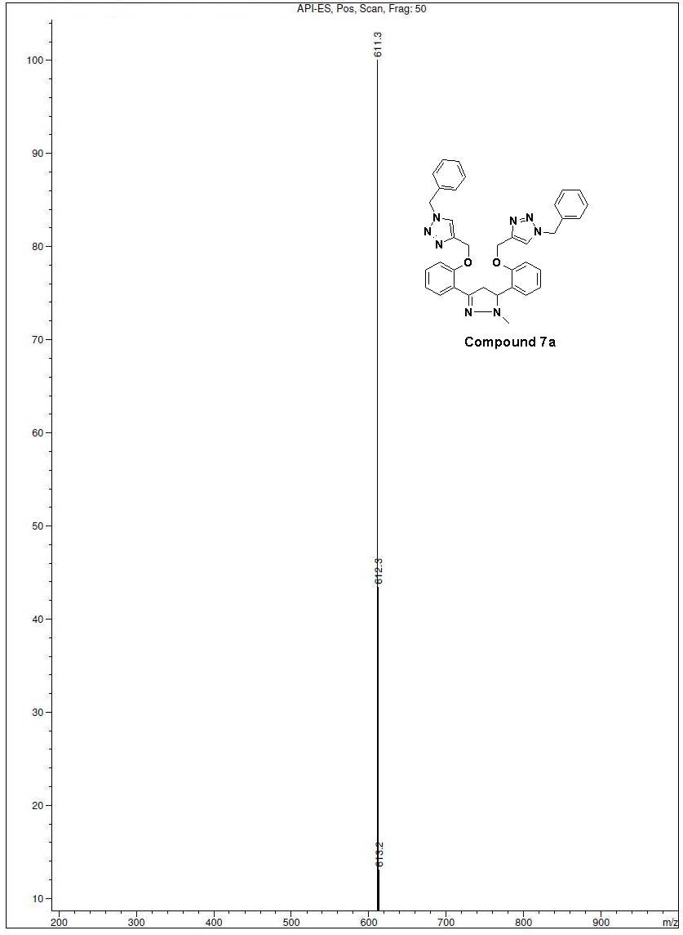
Figure S35: Mass spectra of compound 7a
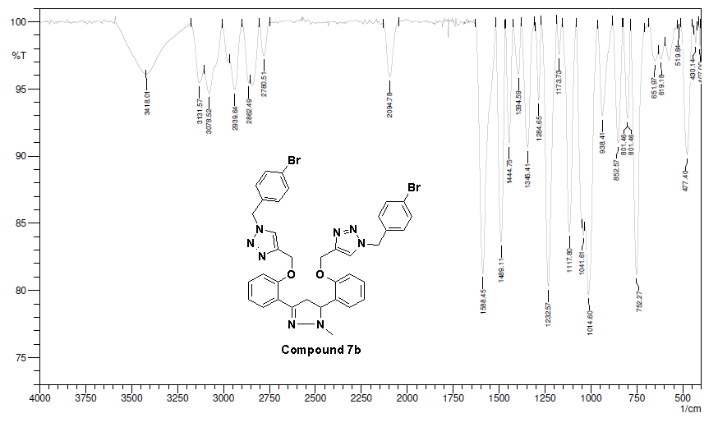
Figure S36: IR spectra of compound 7b
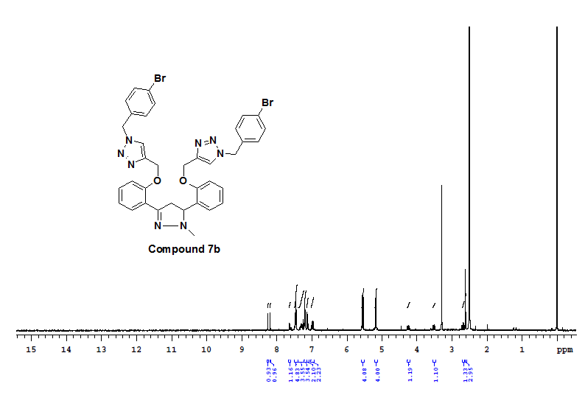
Figure S37: ¹H-NMR (400 MHz, DMSO-d₆) spectra of compound 7b
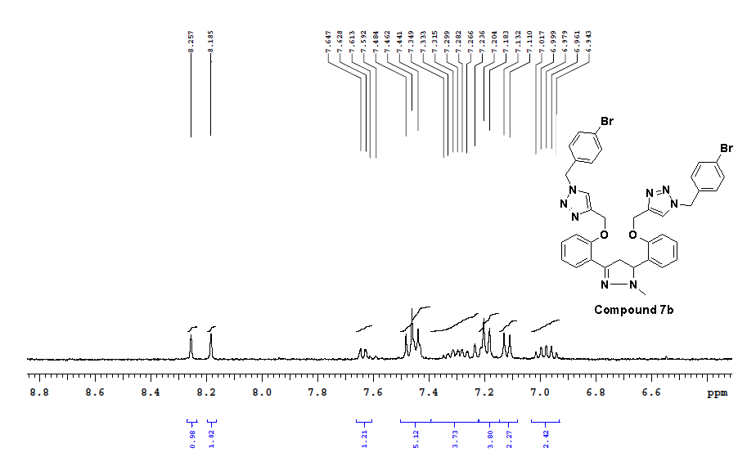
Figure S38: ¹H-NMR (400 MHz, DMSO-d₆) spectra of compound 7b
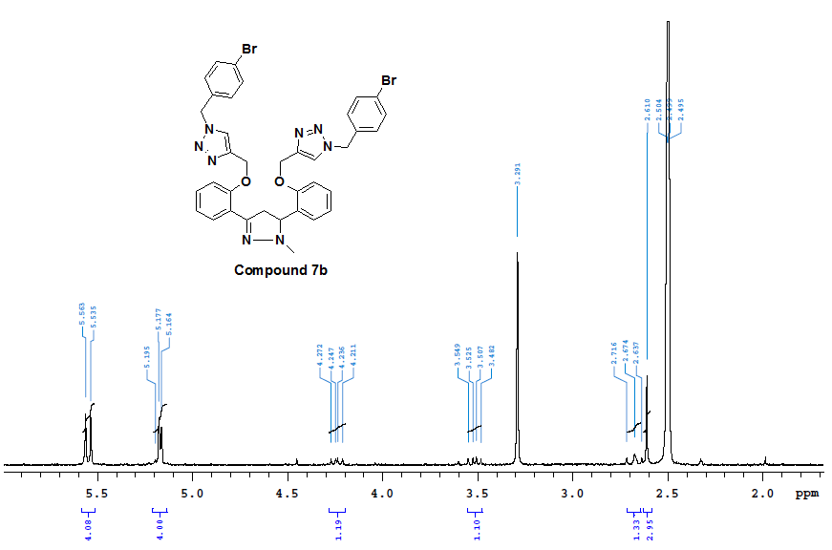
Figure S39: ¹H-NMR (400 MHz, DMSO-d₆) spectra of compound 7b
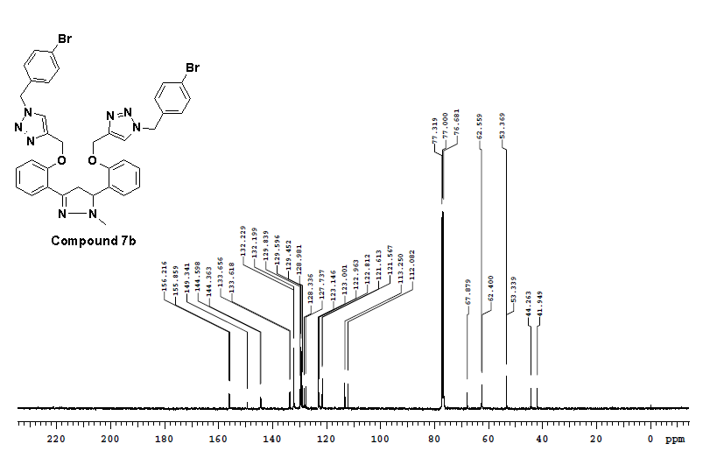
Figure S40: ¹³C NMR (100 MHz, CDCl₃) spectra of compound 7b
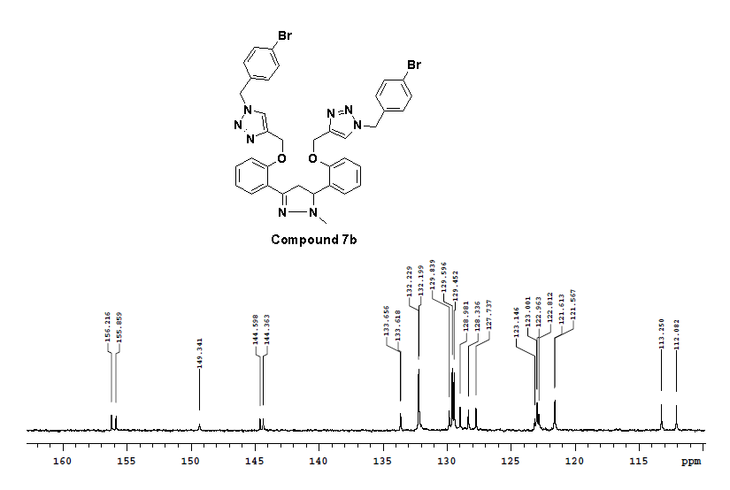
Figure S41: ¹³C NMR (100 MHz, CDCl₃) spectra of compound 7b
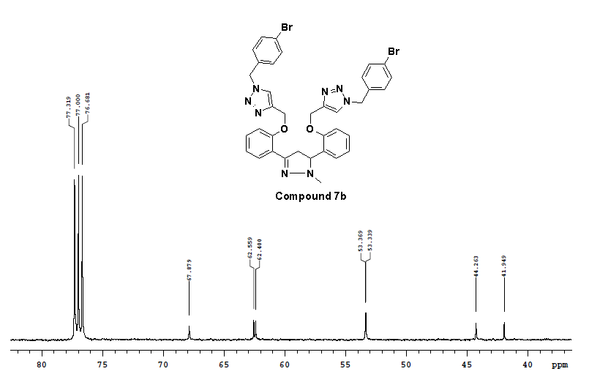
Figure S42: ¹³C NMR (100 MHz, CDCl₃) spectra of compound 7b

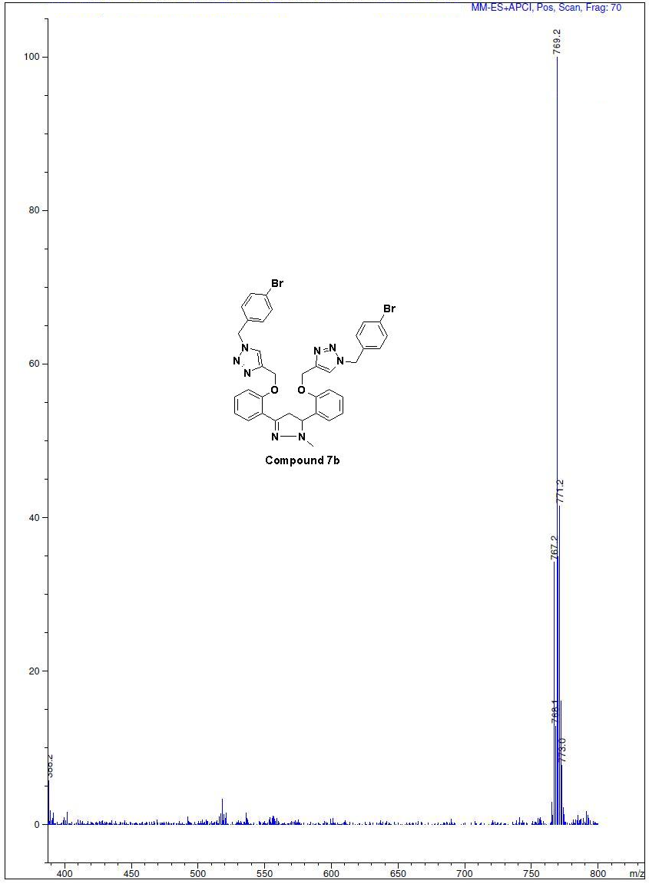
Figure S43: Mass spectra of compound 7b

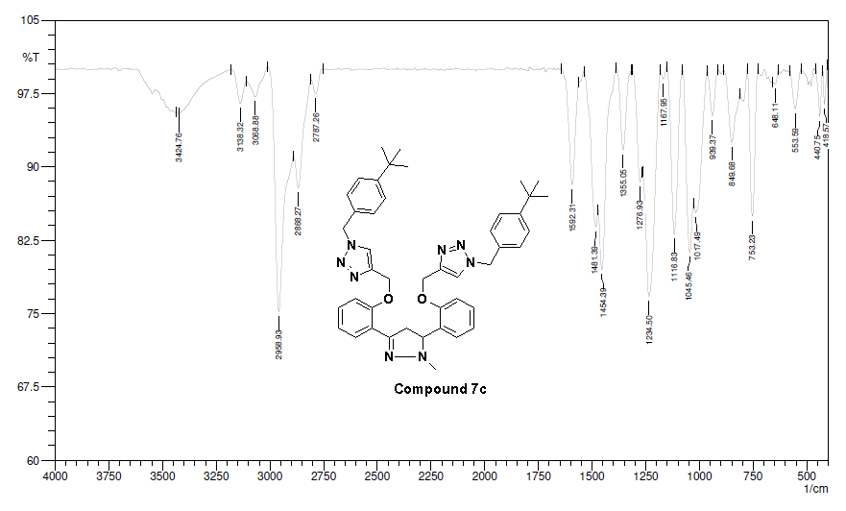
Figure S44: IR spectra of compound 7c
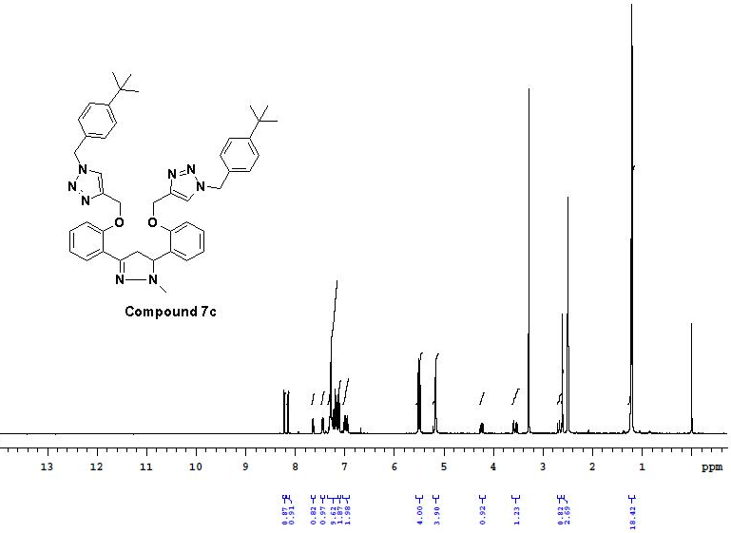
Figure S45: ¹H-NMR (400 MHz, DMSO-d₆) spectra of compound 7c
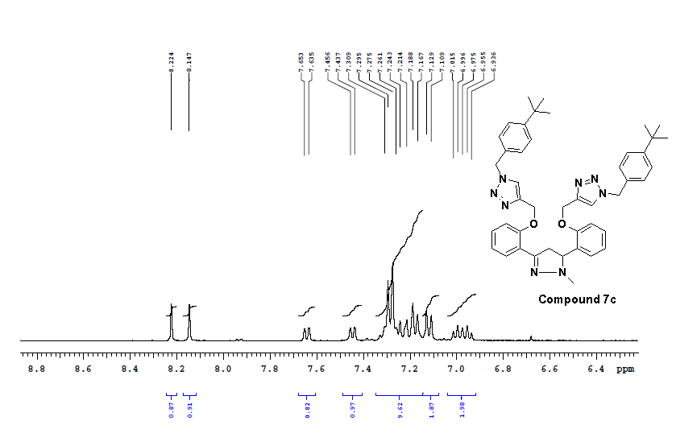
Figure S46: ¹H-NMR (400 MHz, DMSO-d₆) spectra of compound 7c
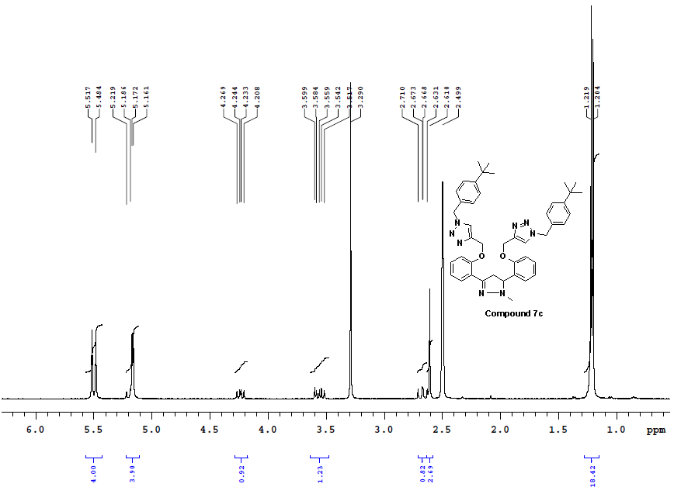
Figure S47: ¹H-NMR (400 MHz, DMSO-d₆) spectra of compound 7c
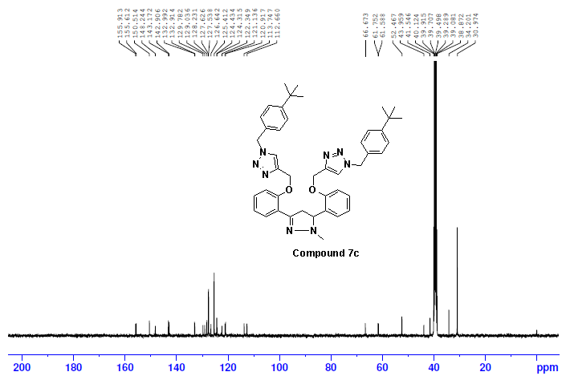
Figure S48: ¹³C NMR (100 MHz, DMSO-d₆) spectra of compound 7c
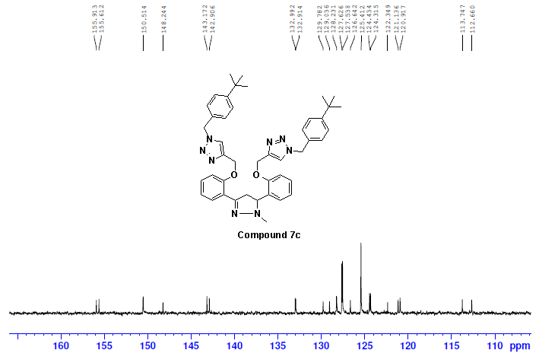
Figure S49: ¹³C NMR (100 MHz, DMSO-d₆) spectra of compound 7c
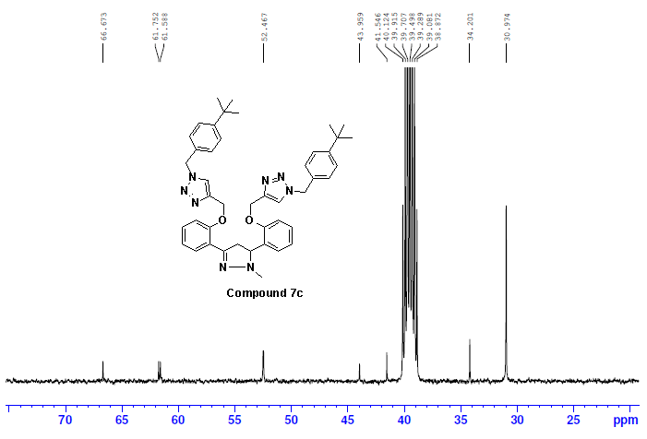
Figure S50: ¹³C NMR (100 MHz, DMSO-d₆) spectra of compound 7c

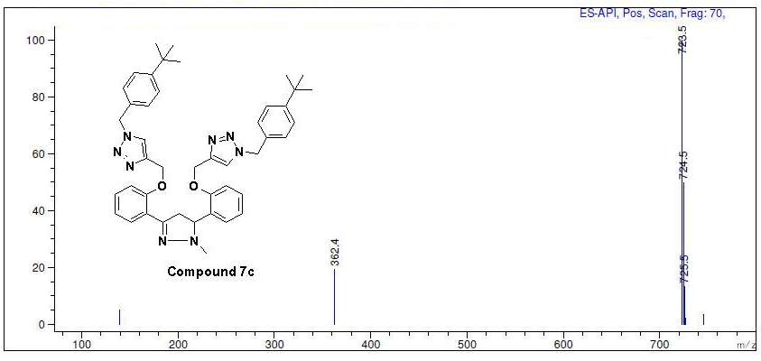
Figure S51: Mass spectra of compound 7c
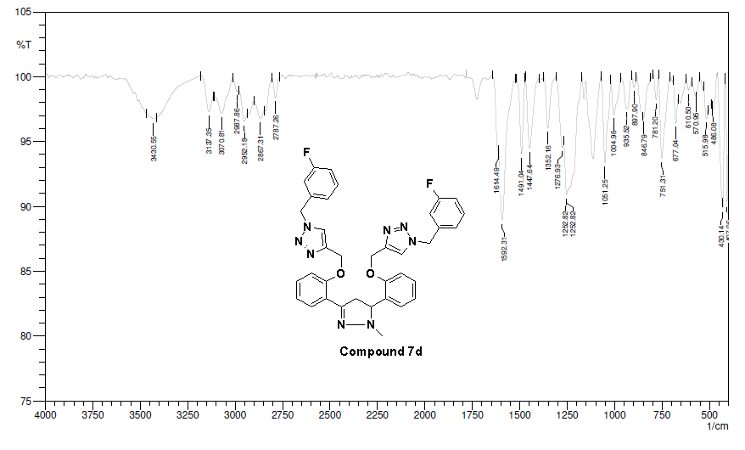
Figure S52: IR spectra of compound 7d
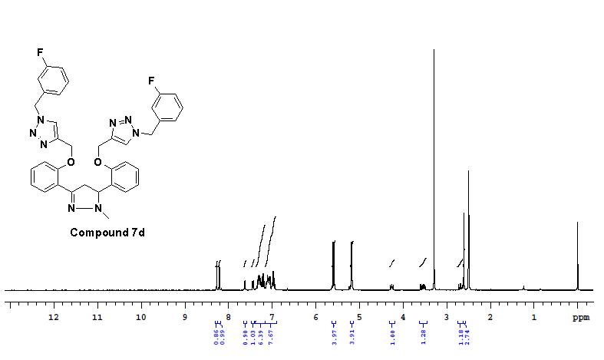
Figure S53: ¹H-NMR (400 MHz, DMSO-d₆) spectra of compound 7d
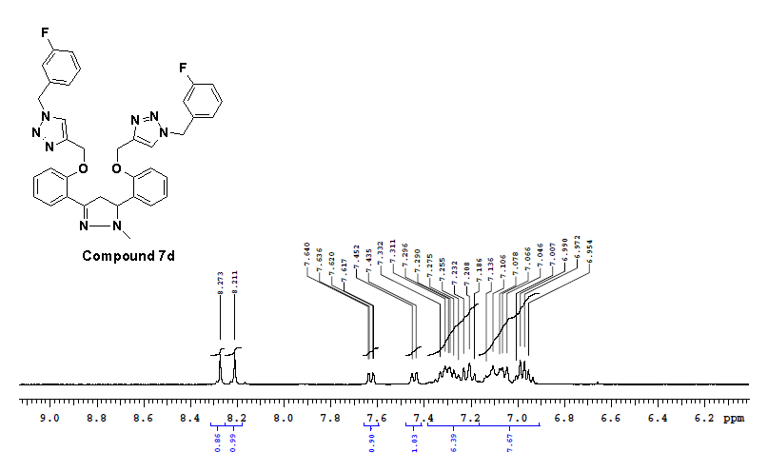
Figure S54: ¹H-NMR (400 MHz, DMSO-d₆) spectra of compound 7d
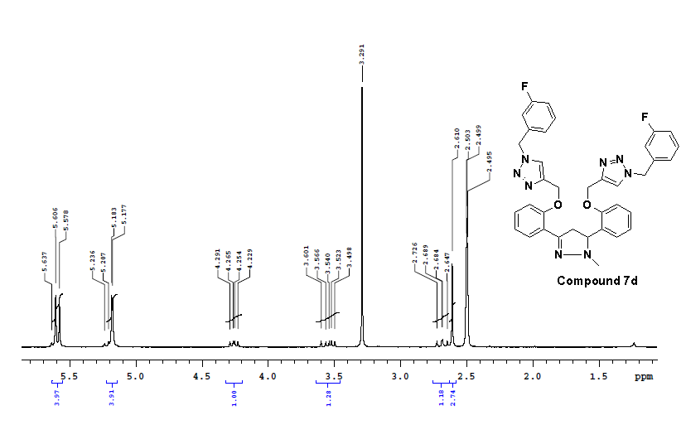
Figure S55: ¹H-NMR (400 MHz, DMSO-d₆) spectra of compound 7d
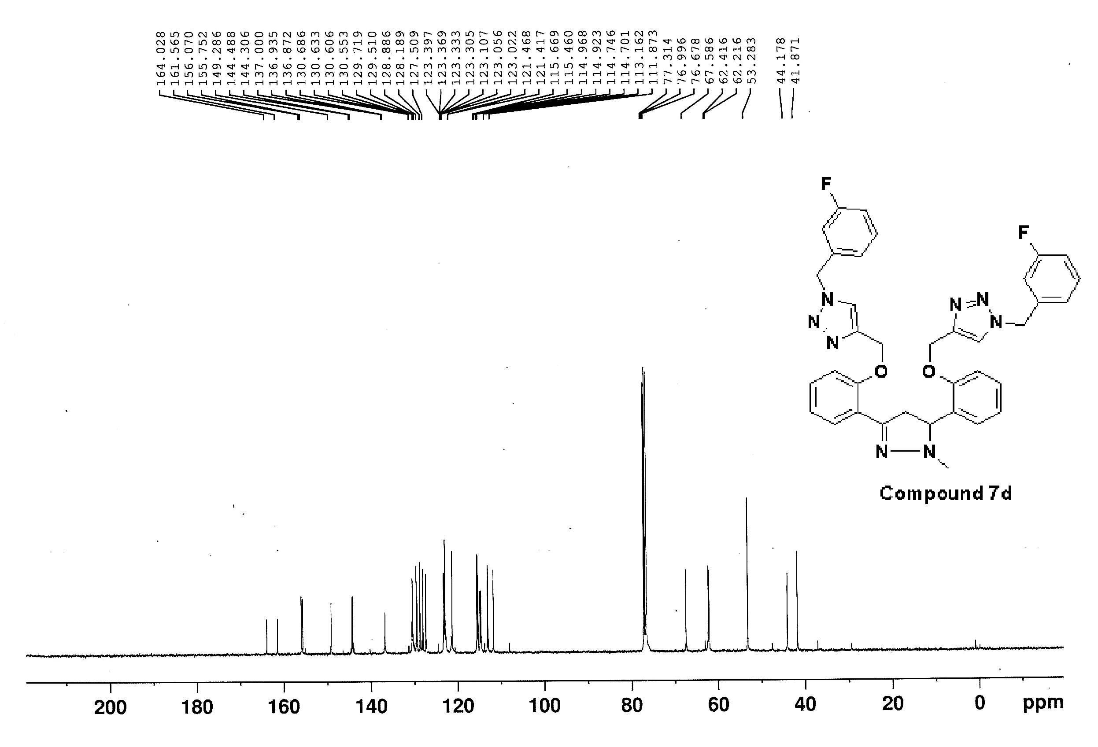
Figure S56: ¹³C NMR (100 MHz, CDCl₃) spectra of compound 7d

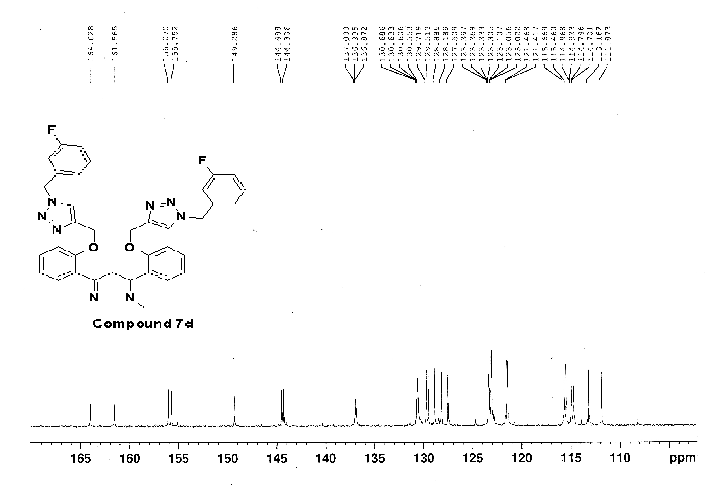
Figure S57: ¹³C NMR (100 MHz, CDCl₃) spectra of compound 7d
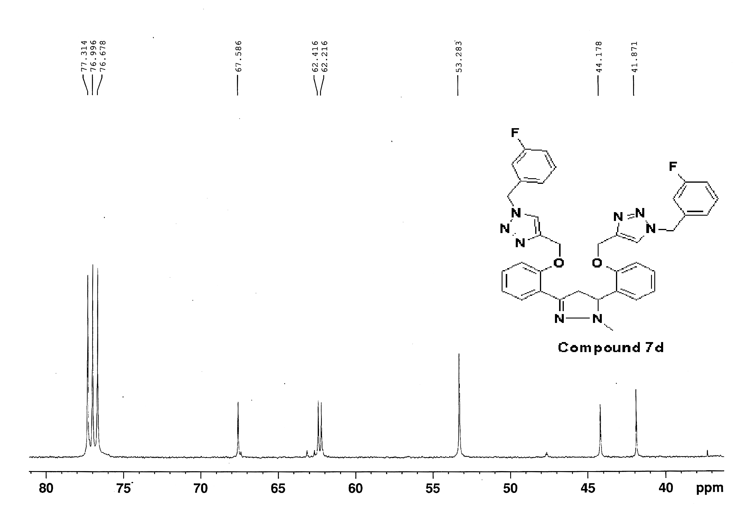
Figure S58: ¹³C NMR (100 MHz, CDCl₃) spectra of compound 7d
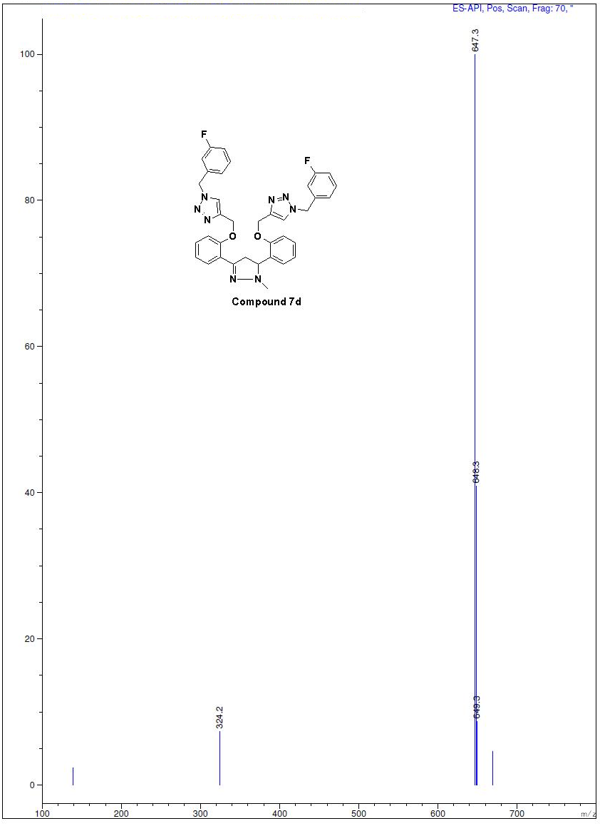
Figure S59: Mass spectra of compound 7d
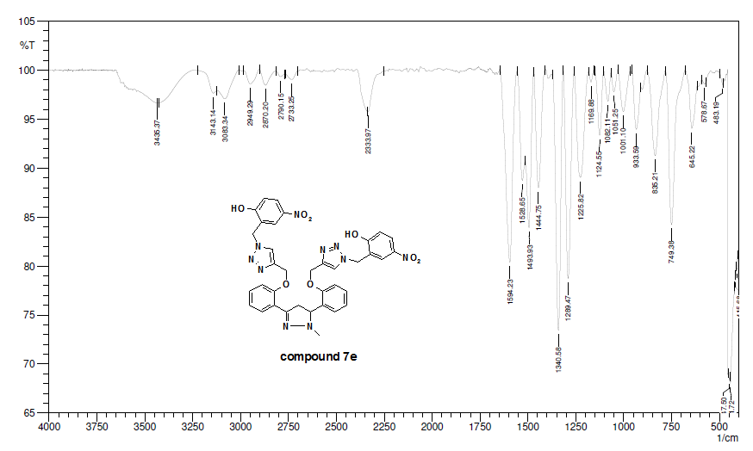
Figure S60: IR spectra of compound 7e
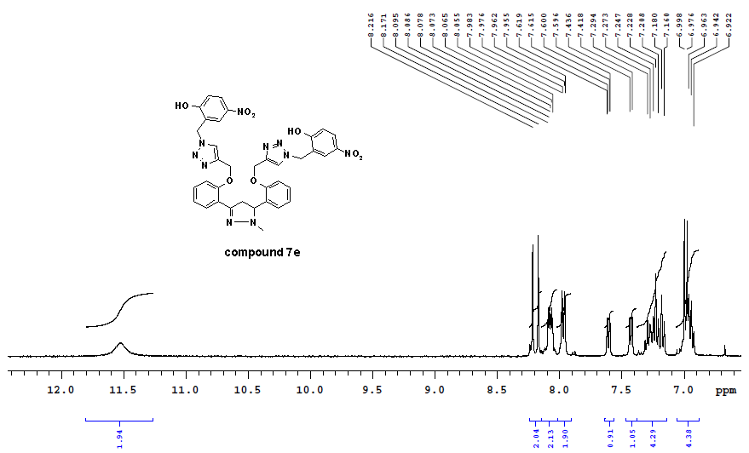
Figure S61: ¹H-NMR (400 MHz, DMSO-d₆) spectra of compound 7e
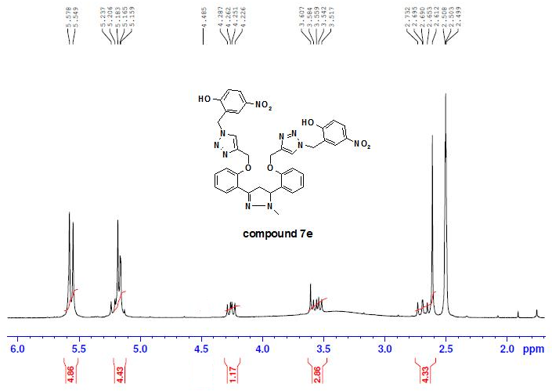
Figure S62: ¹H-NMR (400 MHz, DMSO-d₆) spectra of compound 7e
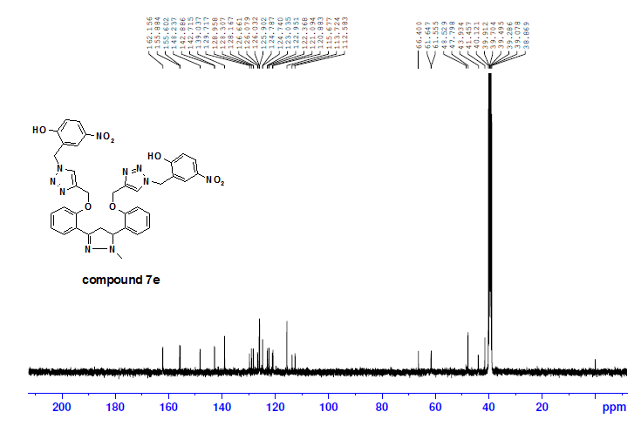
Figure S63: ¹³C NMR (100 MHz, DMSO-d₆) spectra of compound 7e
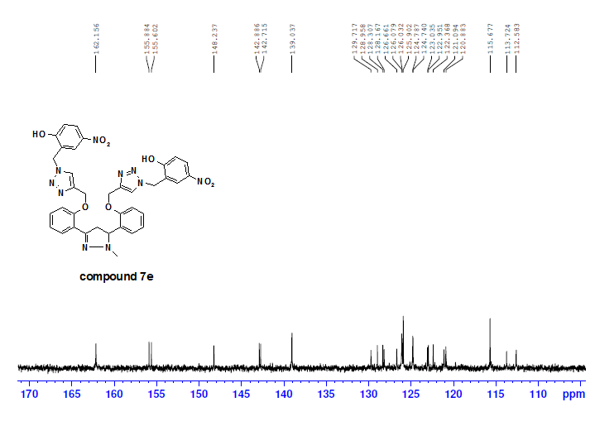
Figure S64: ¹³C NMR (100 MHz, DMSO-d₆) spectra of compound 7e
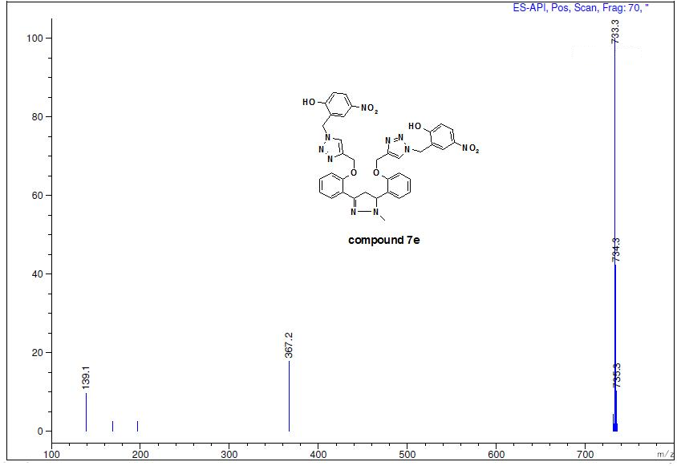
Figure S65: Mass spectra of compound 7e
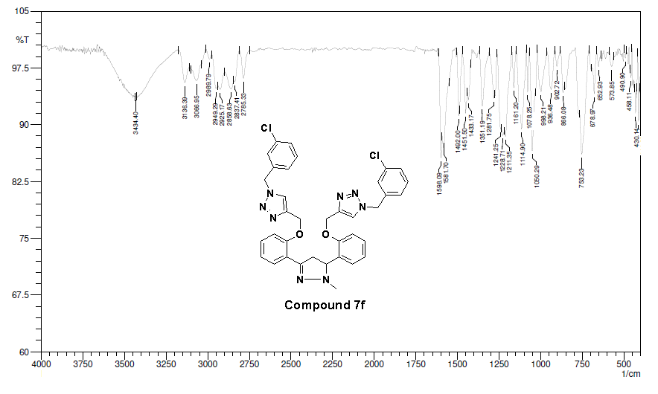
Figure S66: IR spectra of compound 7f
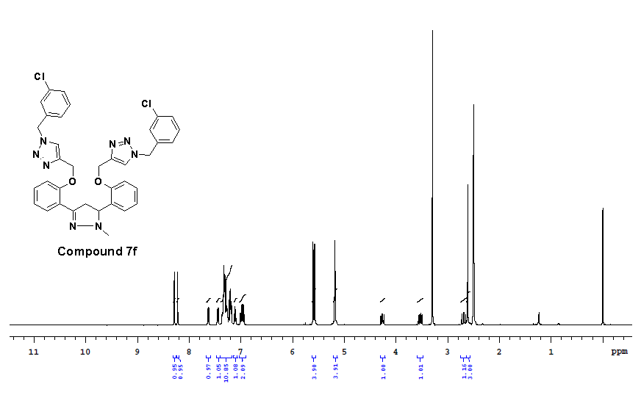
Figure S67: ¹H-NMR (400 MHz, DMSO-d₆) spectra of compound 7f
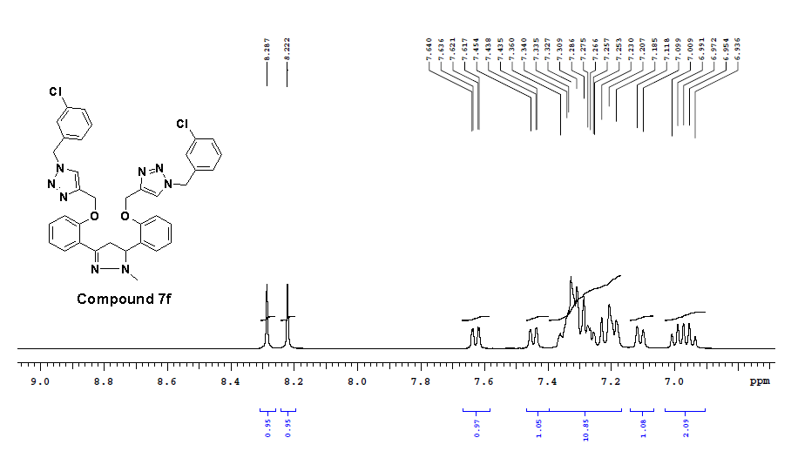
Figure S68: ¹H-NMR (400 MHz, DMSO-d₆) spectra of compound 7f
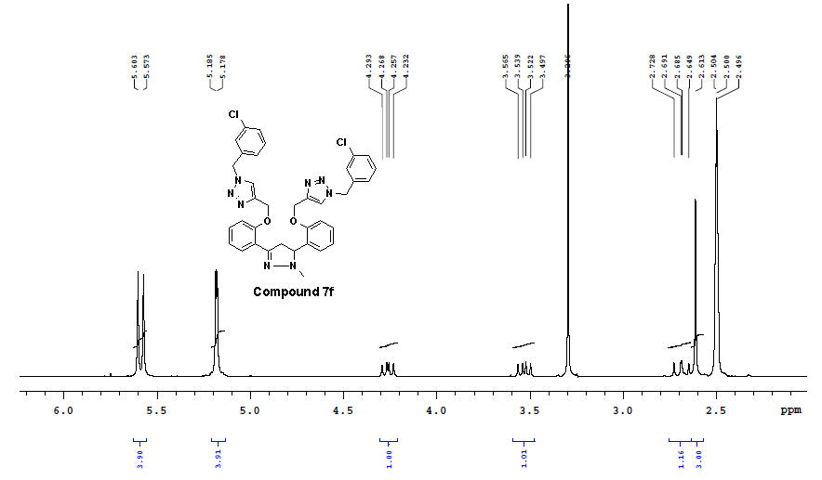
Figure S69: ¹H-NMR (400 MHz, DMSO-d₆) spectra of compound 7f

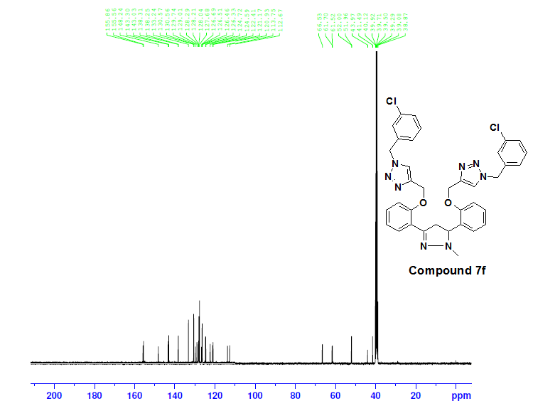
Figure S70: ¹³C NMR (100 MHz, DMSO-d₆) spectra of compound 7f

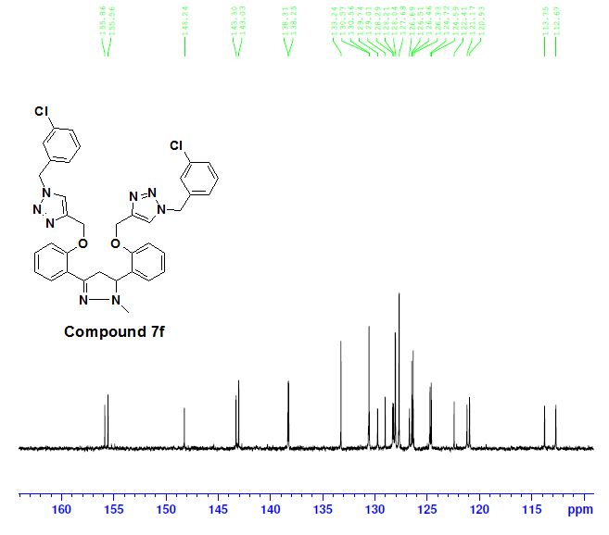
Figure S71: ¹³C NMR (100 MHz, DMSO-d₆) spectra of compound 7f

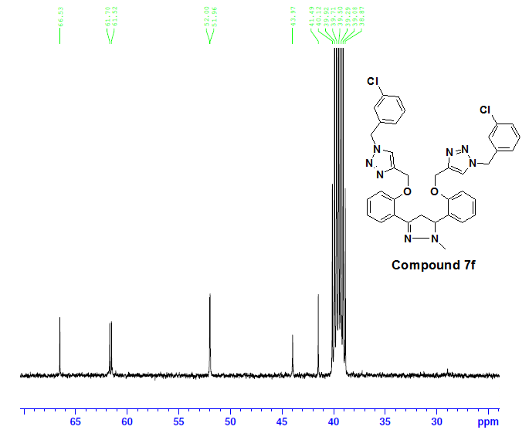
Figure S72: ¹³C NMR (100 MHz, DMSO-d₆) spectra of compound 7f

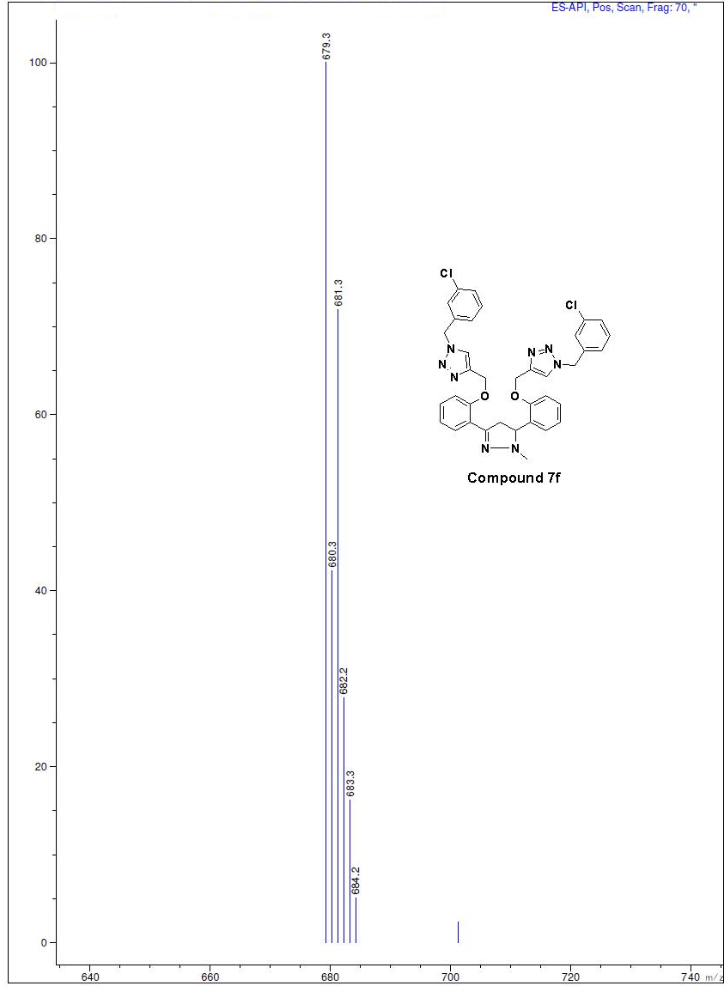
Figure S73: Mass spectra of compound 7f
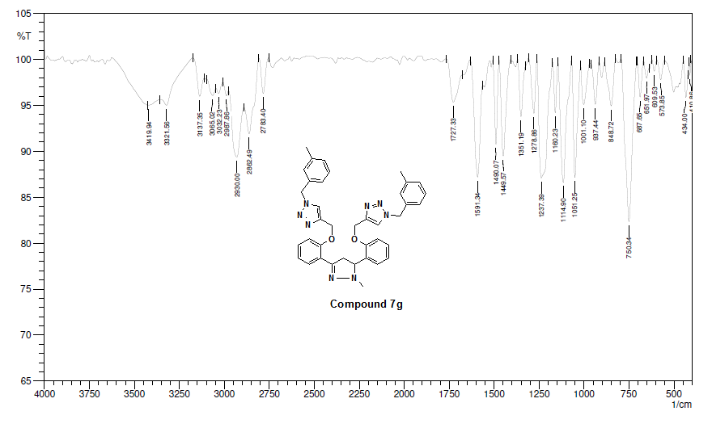
Figure S74: IR spectra of compound 7g
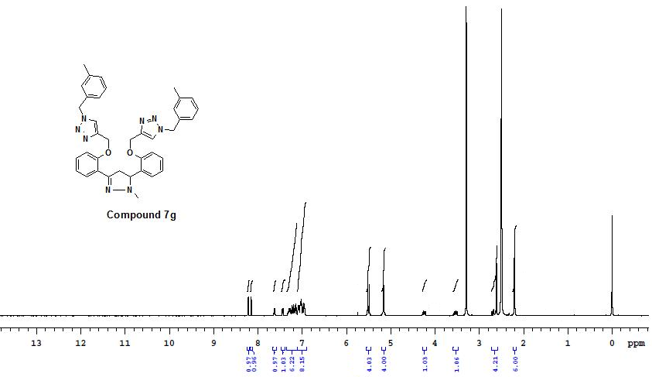
Figure S75: ¹H-NMR (400 MHz, DMSO-d₆) spectra of compound 7g
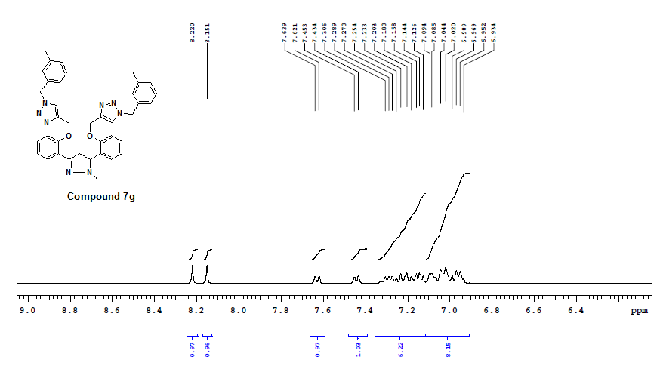
Figure S76: ¹H-NMR (400 MHz, DMSO-d₆) spectra of compound 7g
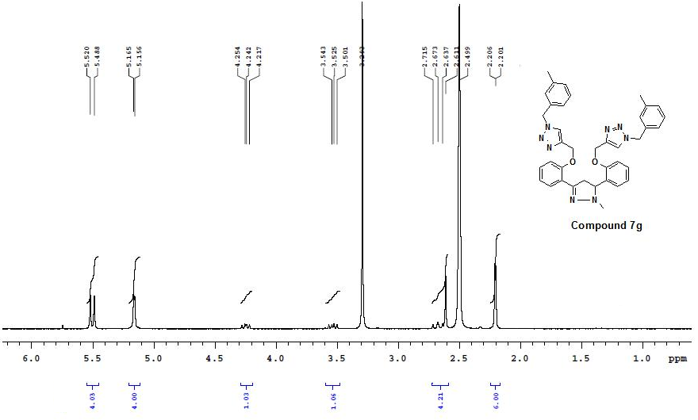
Figure S77: ¹H-NMR (400 MHz, DMSO-d₆) spectra of compound 7g

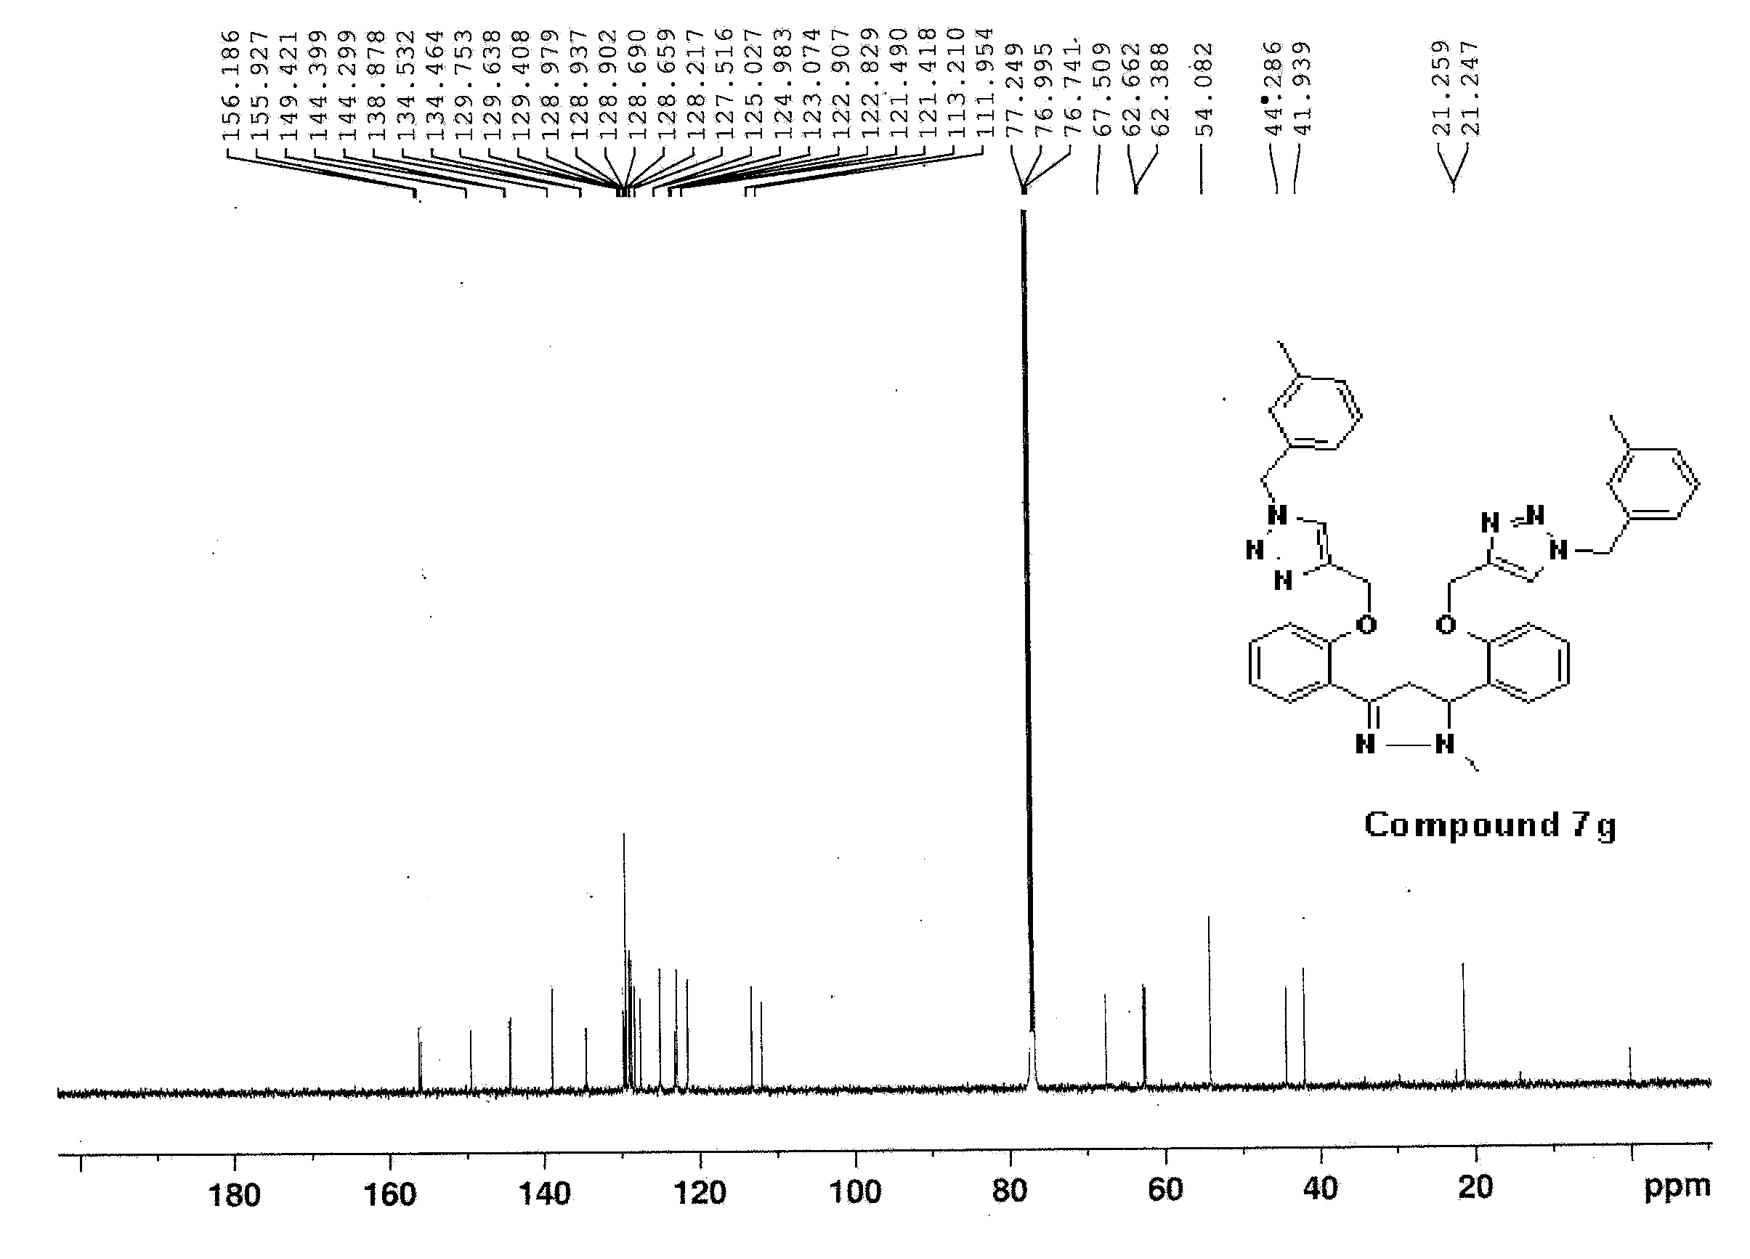
Figure S78: ¹³C NMR (125 MHz, CDCl₃) spectra of compound 7g

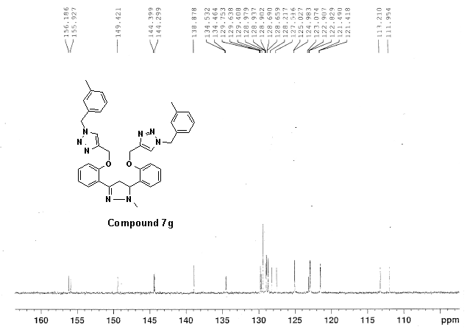
Figure S79: ¹³C NMR (125 MHz, CDCl₃) spectra of compound 7g
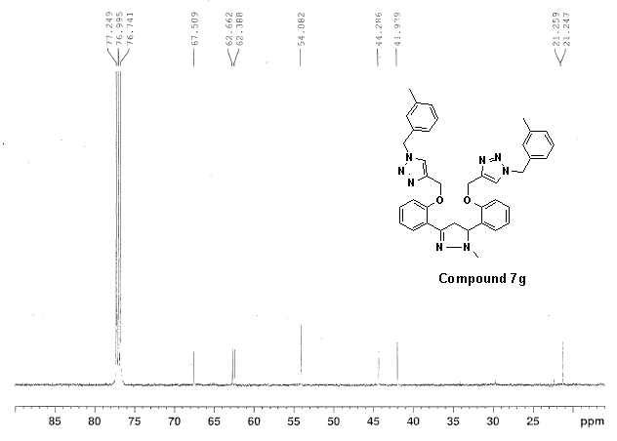
Figure S80: ¹³C NMR (125 MHz, CDCl₃) spectra of compound 7g
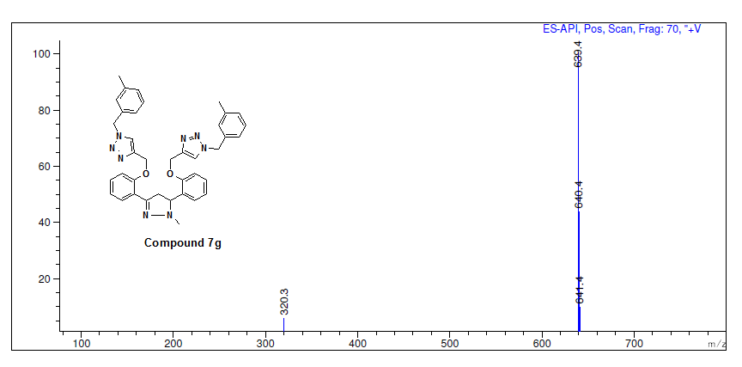
Figure S81: Mass spectra of compound 7g
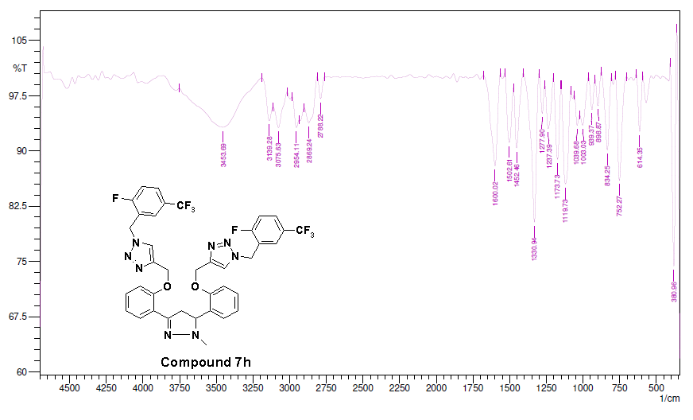
Figure S82: IR spectra of compound 7h
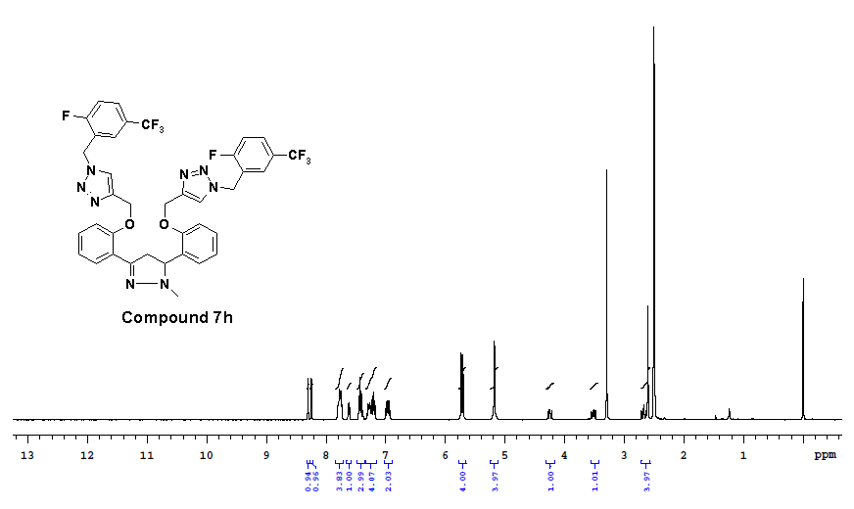
Figure S83: ¹H-NMR (400 MHz, DMSO-d₆) spectra of compound 7h
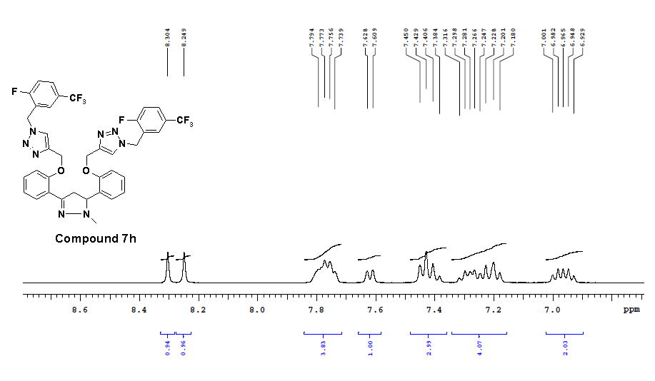
Figure S84: ¹H-NMR (400 MHz, DMSO-d₆) spectra of compound 7h
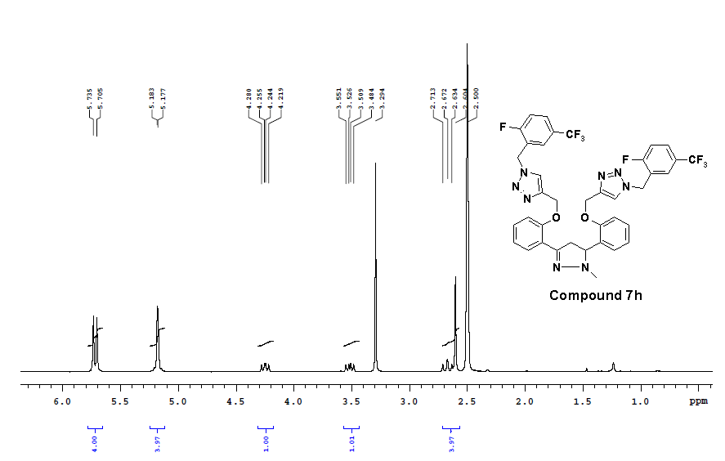
Figure S85: ¹H-NMR (400 MHz, DMSO-d₆) spectra of compound 7h
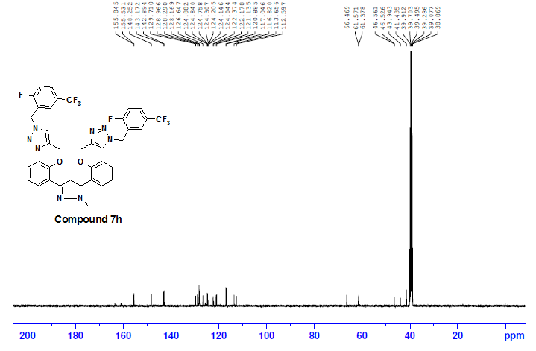
Figure S86: ¹³C NMR (100 MHz, DMSO-d₆) spectra of compound 7h
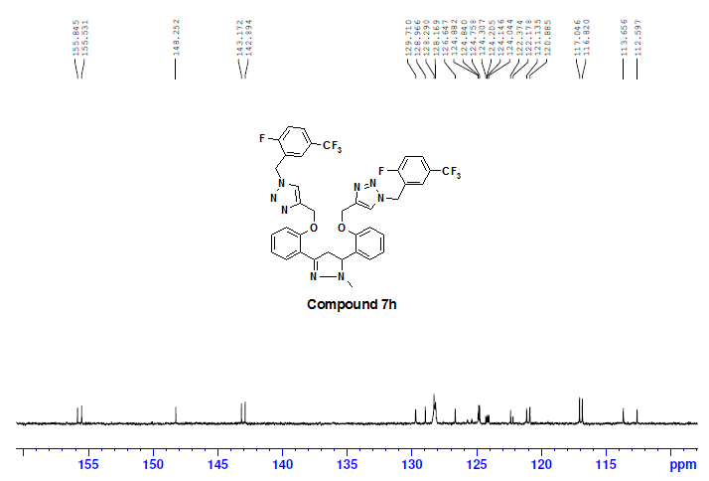
Figure S87: ¹³C NMR (100 MHz, DMSO-d₆) spectra of compound 7h
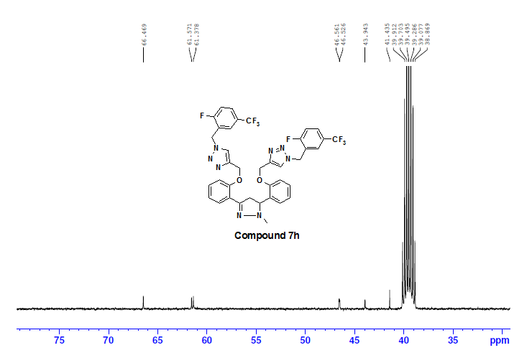
Figure S88: ¹³C NMR (100 MHz, DMSO-d₆) spectra of compound 7h
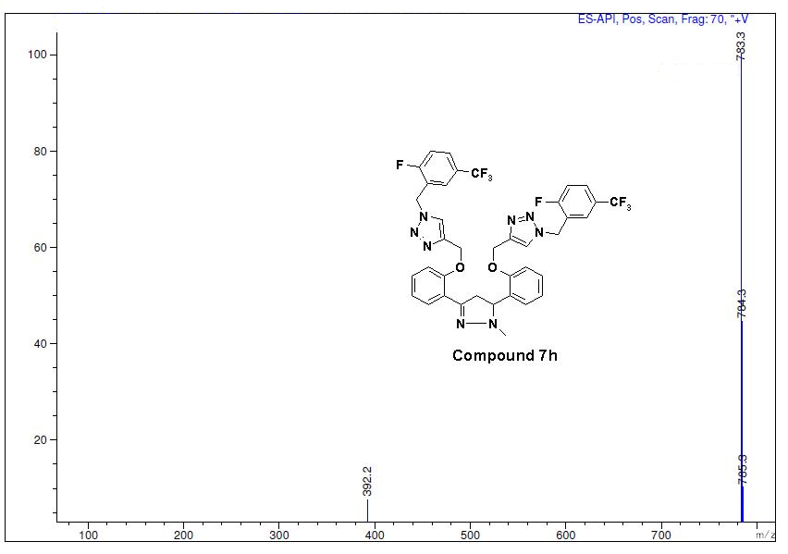
Figure S89: Mass spectra of compound 7h
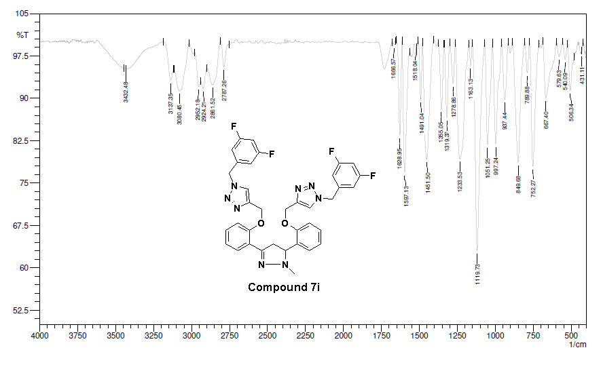
Figure S90: IR spectra of compound 7i
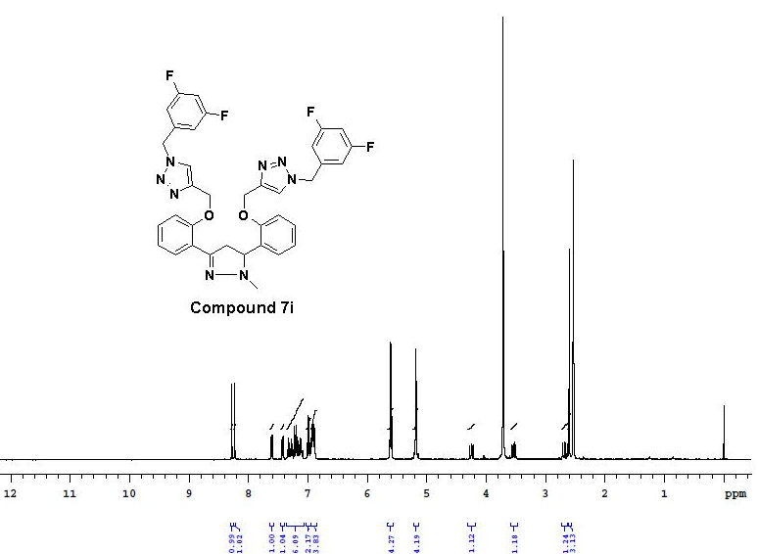
Figure S91: ¹H-NMR (400 MHz, DMSO-d₆) spectra of compound 7i
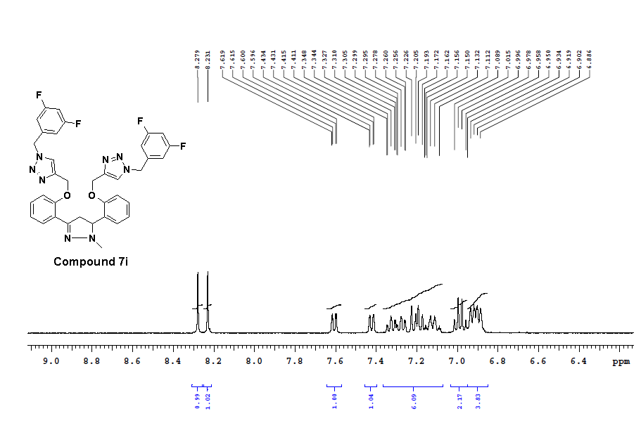
Figure S92: ¹H-NMR (400 MHz, DMSO-d₆) spectra of compound 7i
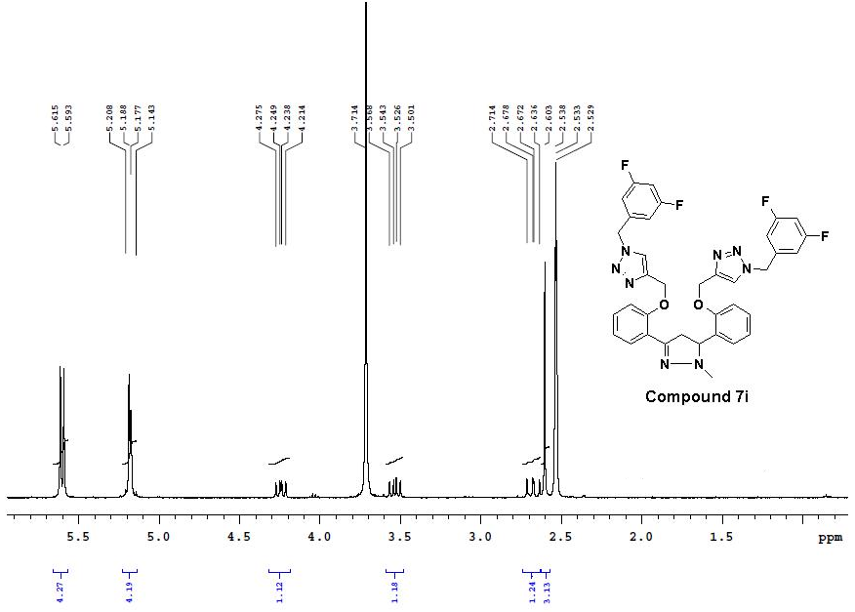
Figure S93: ¹H-NMR (400 MHz, DMSO-d₆) spectra of compound 7i
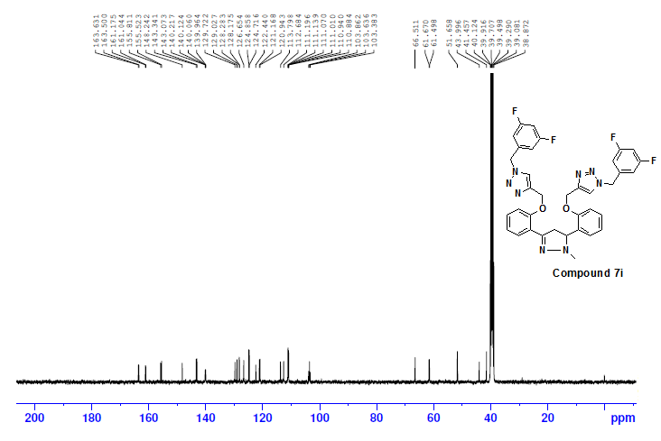
Figure S94: ¹³C NMR (100 MHz, DMSO-d₆) spectra of compound 7i
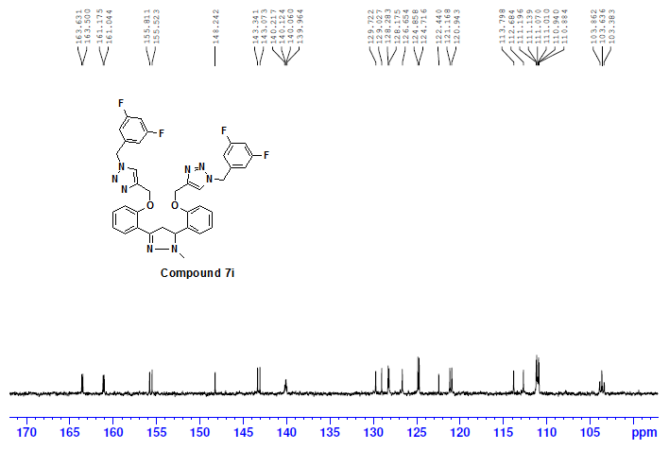
Figure S95: ¹³C NMR (100 MHz, DMSO-d₆) spectra of compound 7i
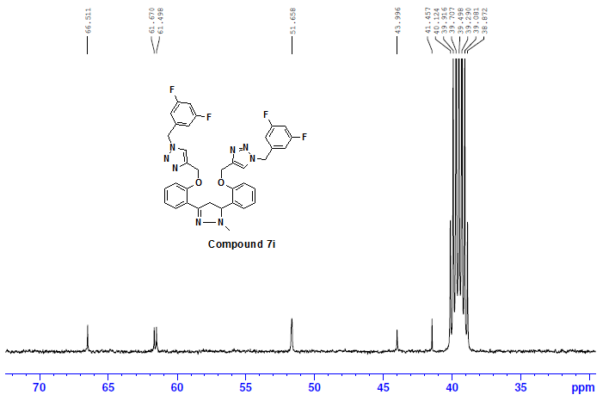
Figure S96: ¹³C NMR (100 MHz, DMSO-d₆) spectra of compound 7i

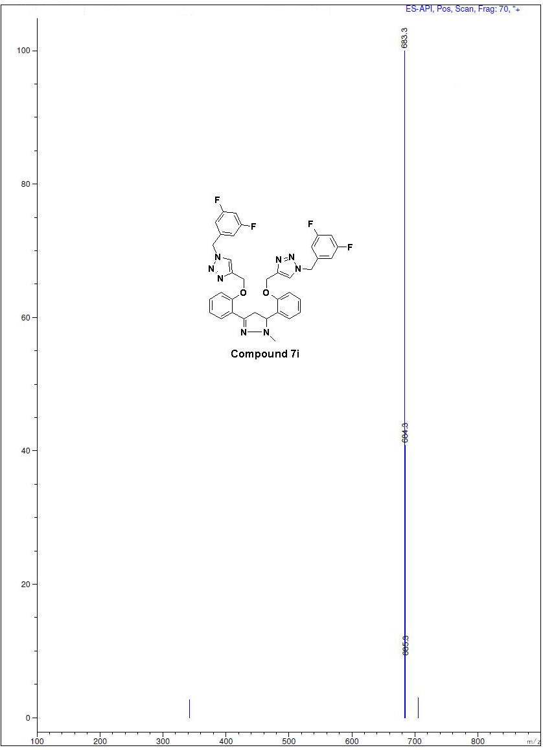
Figure S97: Mass spectra of compound 7i
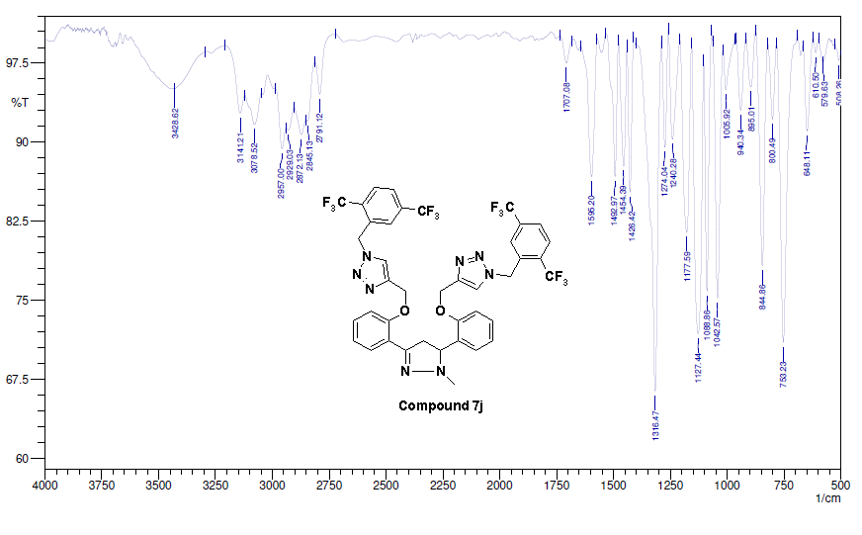
Figure S98: IR spectra of compound 7j
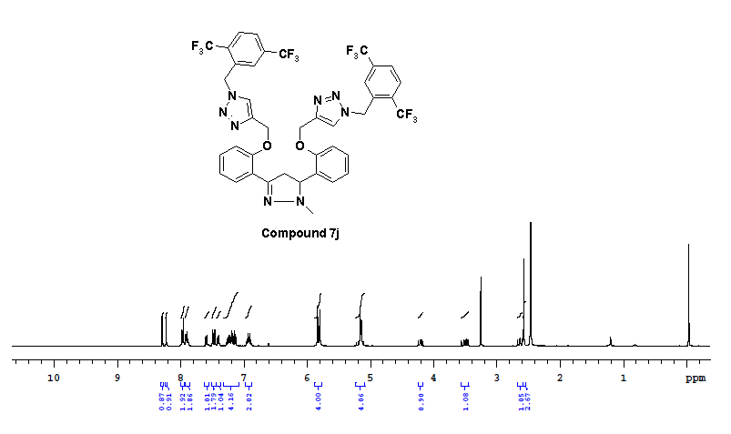
Figure S99: ¹H-NMR (400 MHz, DMSO-d₆) spectra of compound 7j
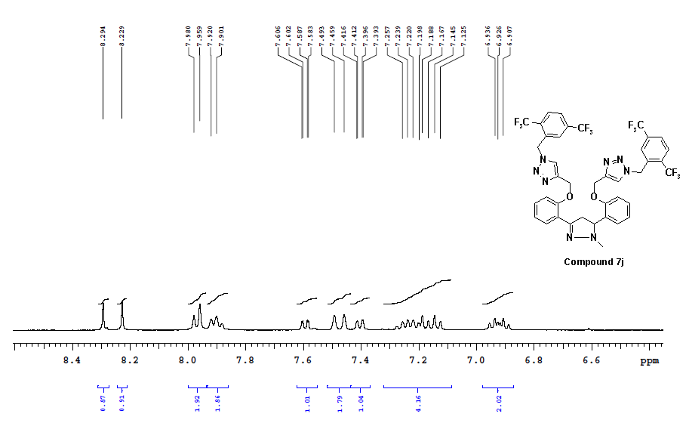
Figure S100: ¹H-NMR (400 MHz, DMSO-d₆) spectra of compound 7j
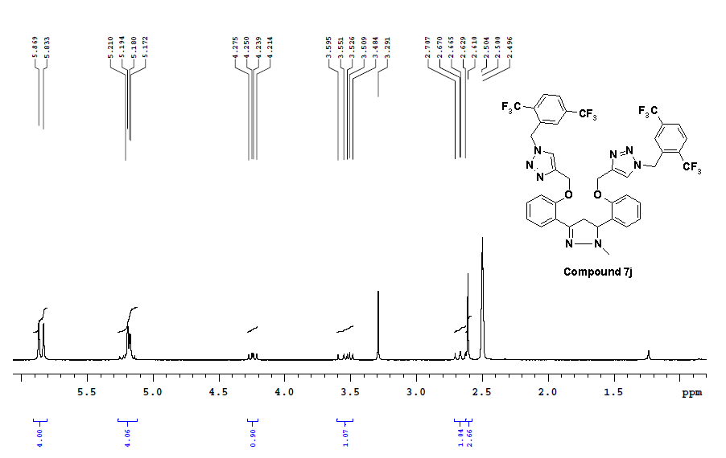
Figure S101: ¹H-NMR (400 MHz, DMSO-d₆) spectra of compound 7j
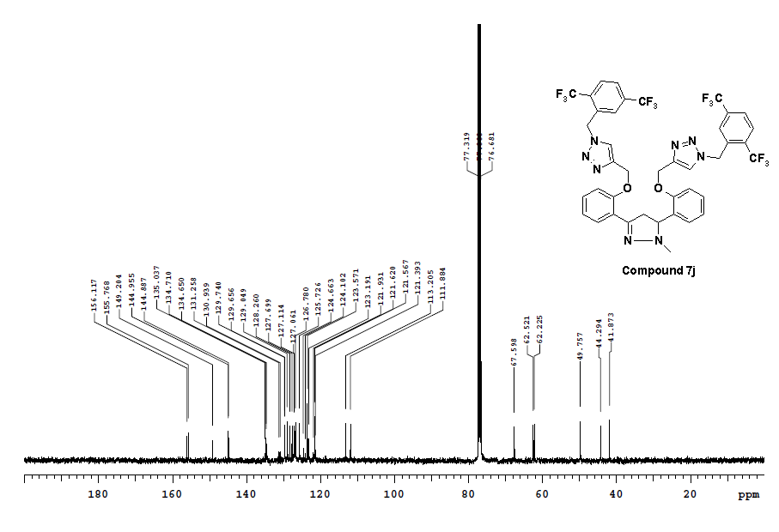
Figure S102: ¹³C NMR (100 MHz, CDCl₃) spectra of compound 7j
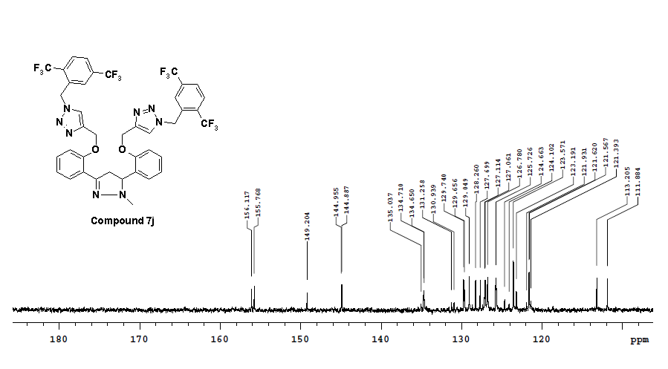
Figure S103: ¹³C NMR (100 MHz, CDCl₃) spectra of compound 7j
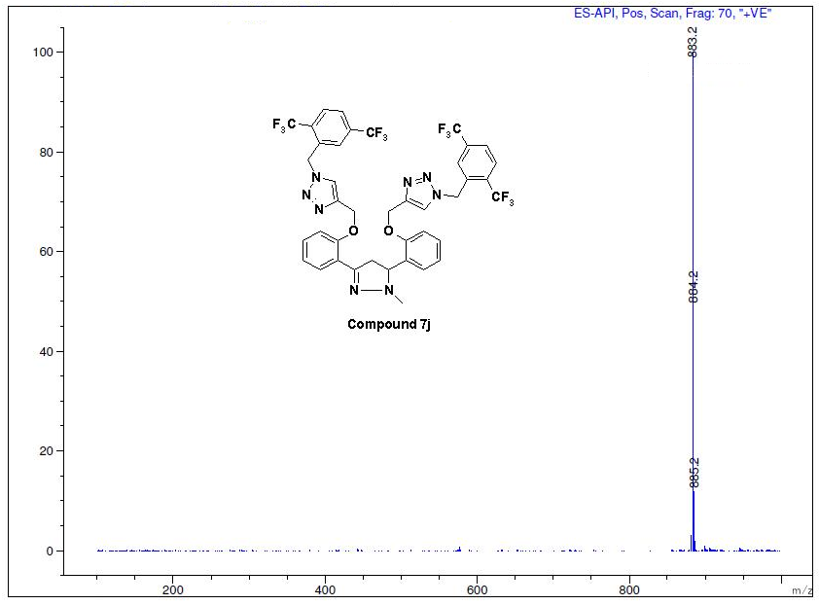
Figure S104: Mass spectra of compound 7j

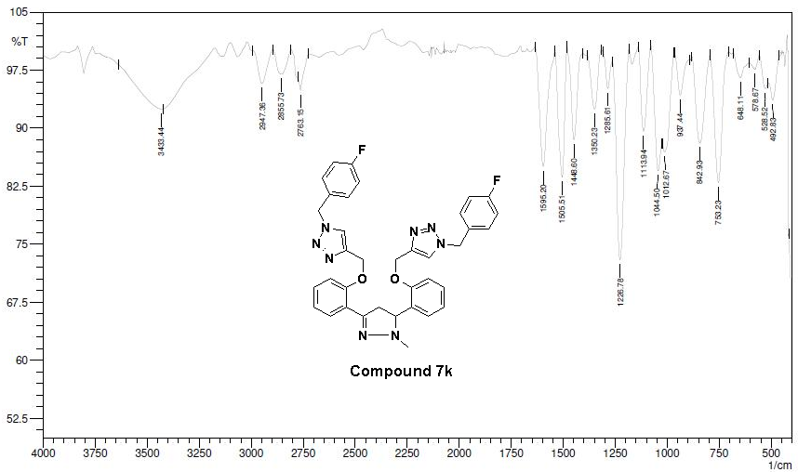
Figure S105: IR spectra of compound 7k
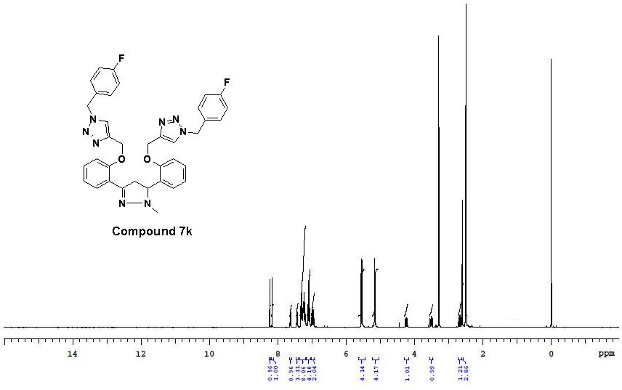
Figure S106: ¹H-NMR (400 MHz, DMSO-d₆) spectra of compound 7k
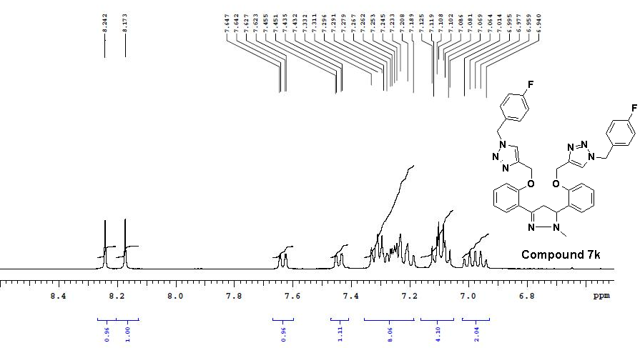
Figure S107: ¹H-NMR (400 MHz, DMSO-d₆) spectra of compound 7k
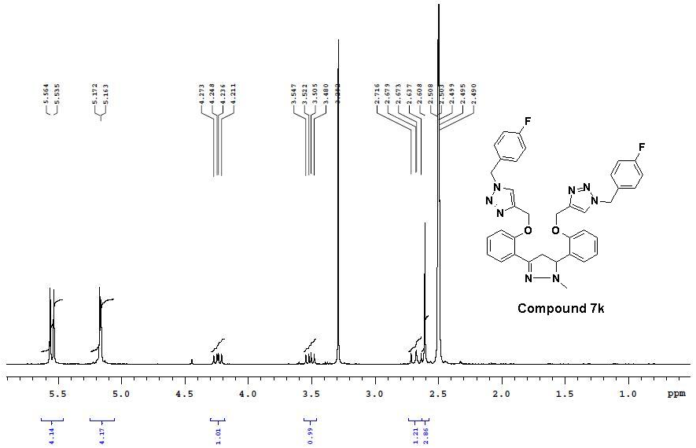
Figure S108: ¹H-NMR (400 MHz, DMSO-d₆) spectra of compound 7k

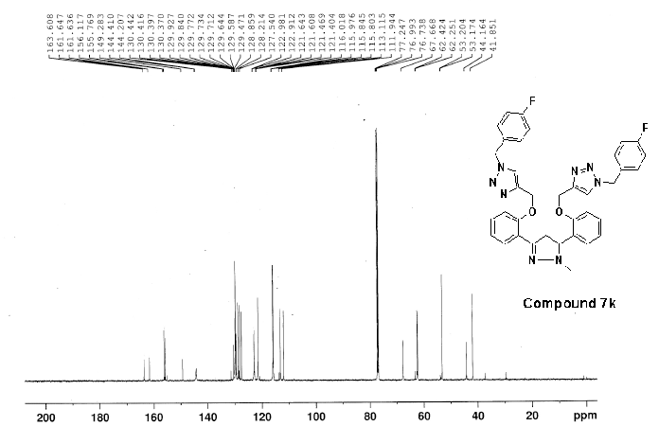
Figure S109: ¹³C NMR (125 MHz, CDCl₃) spectra of compound 7k

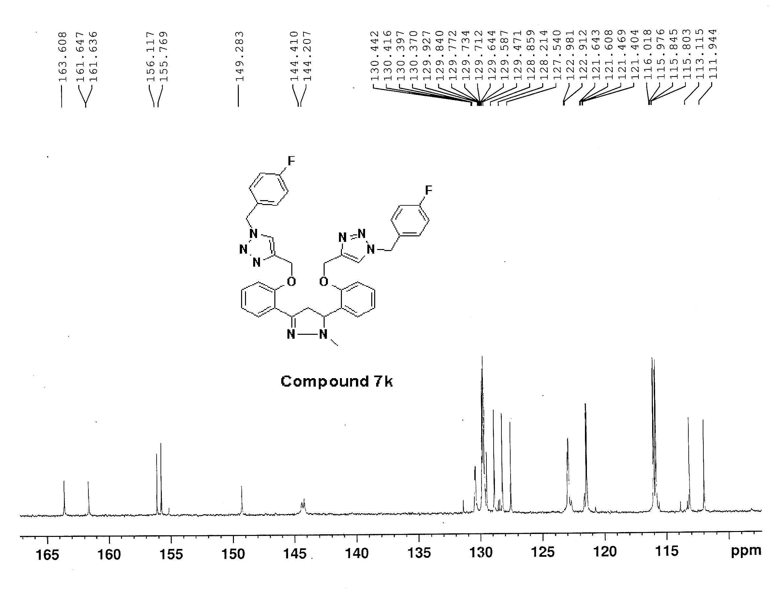
Figure S110: ¹³C NMR (125 MHz, CDCl₃) spectra of compound 7k
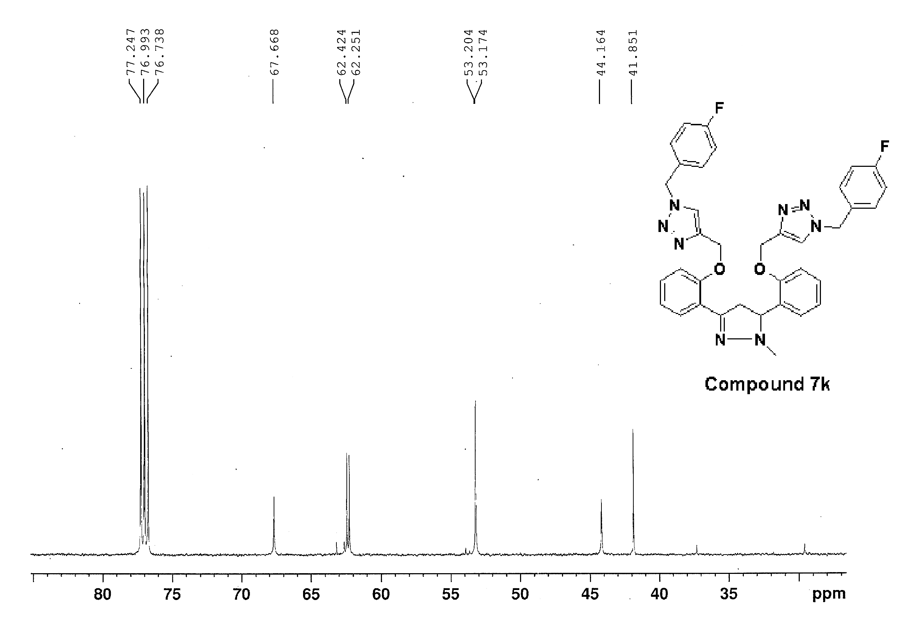
Figure S111: ¹³C NMR (125 MHz, CDCl₃) spectra of compound 7k
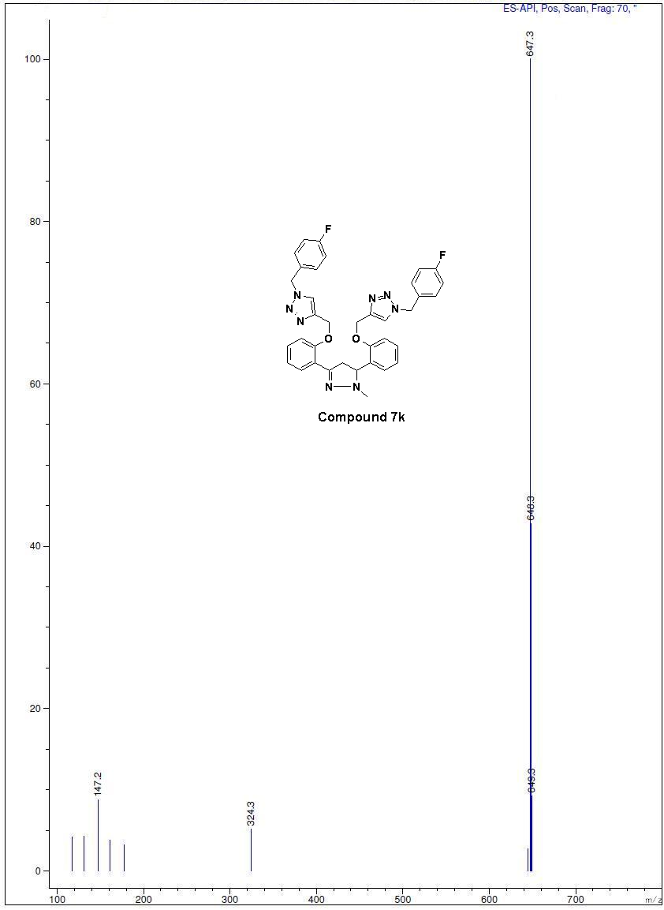 Figure S112: Mass spectra of compound 7k

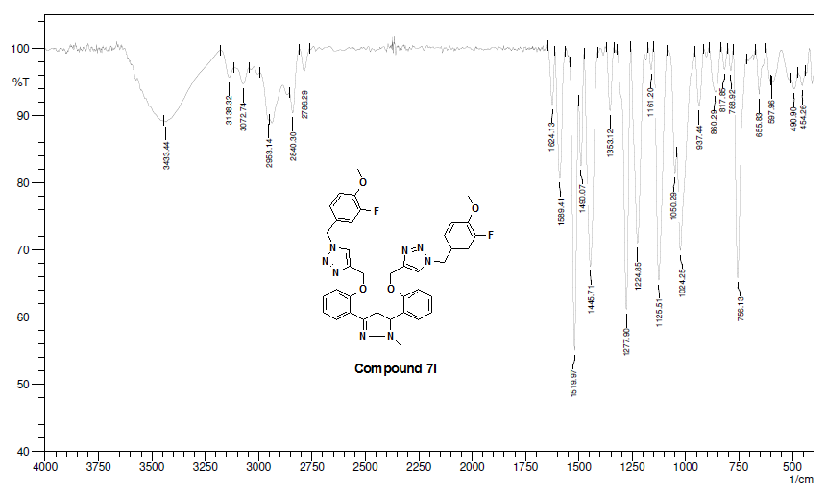
Figure S113: IR spectra of compound 7l
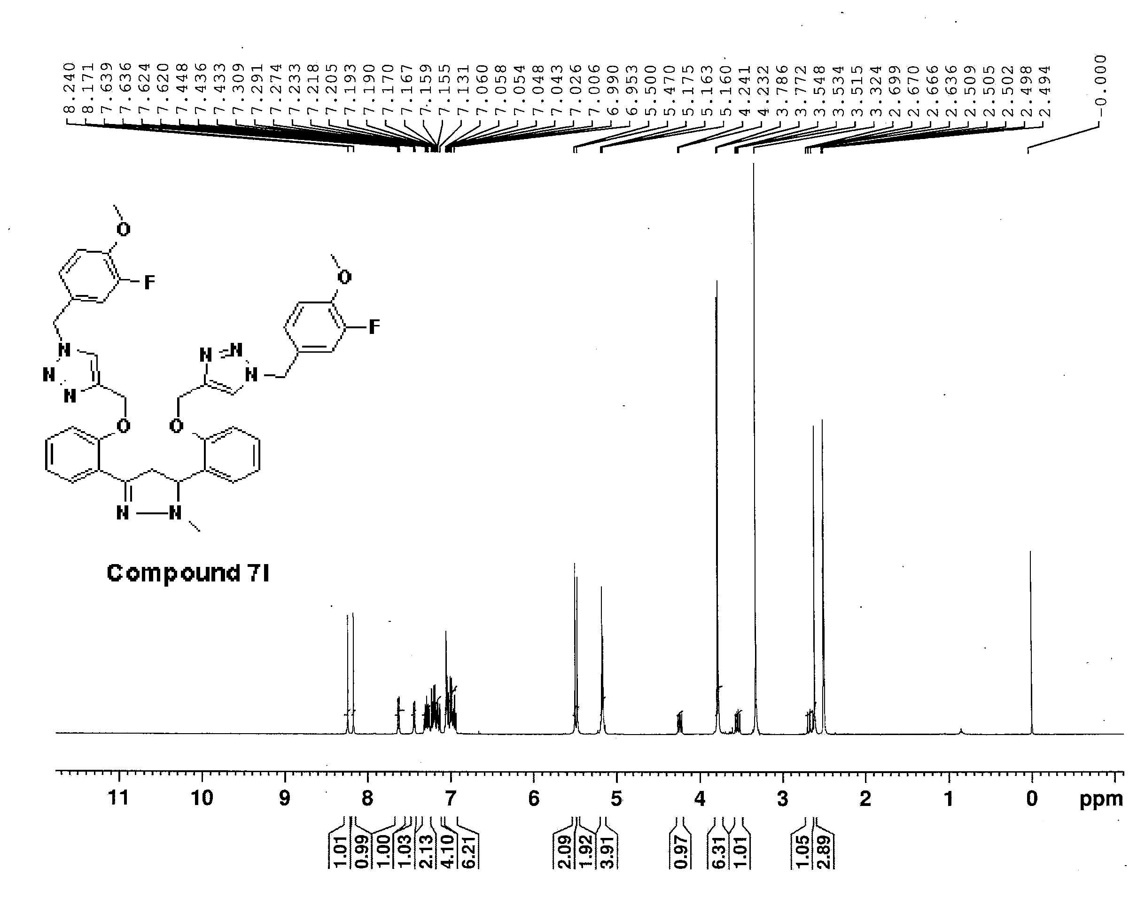
Figure S114: ¹H-NMR (500 MHz, DMSO-d₆) spectra of compound 7l
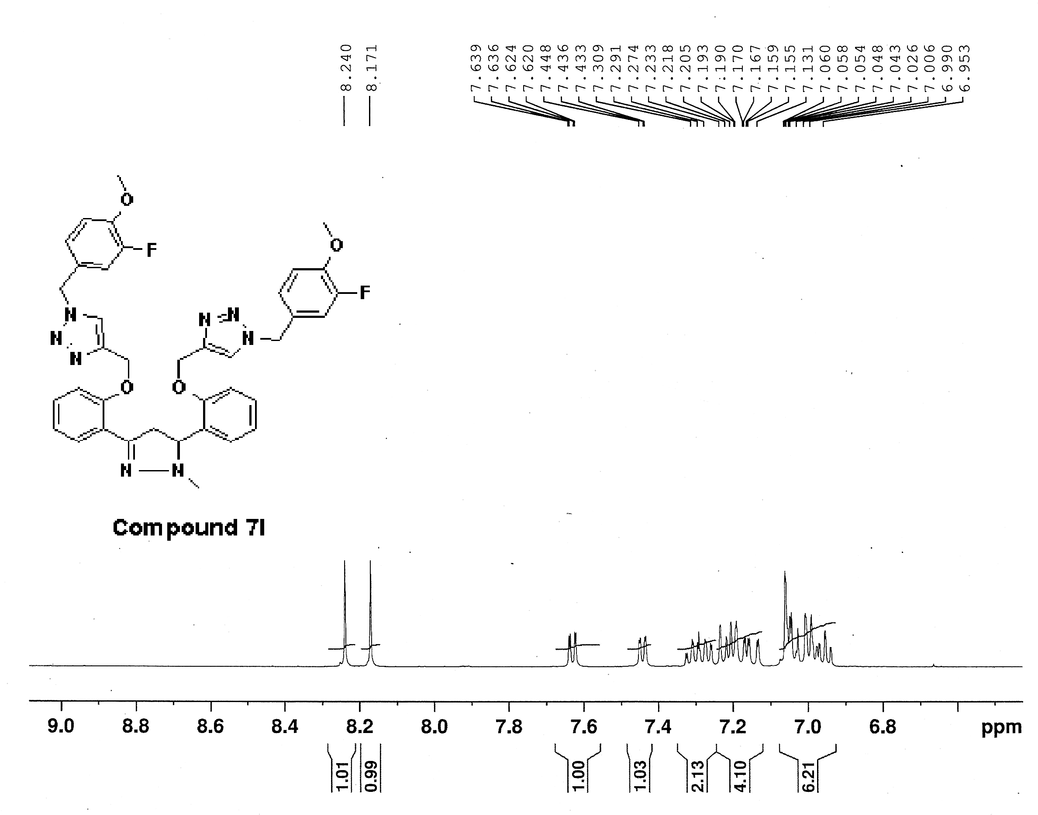
Figure S115: ¹H-NMR (500 MHz, DMSO-d₆) spectra of compound 7l

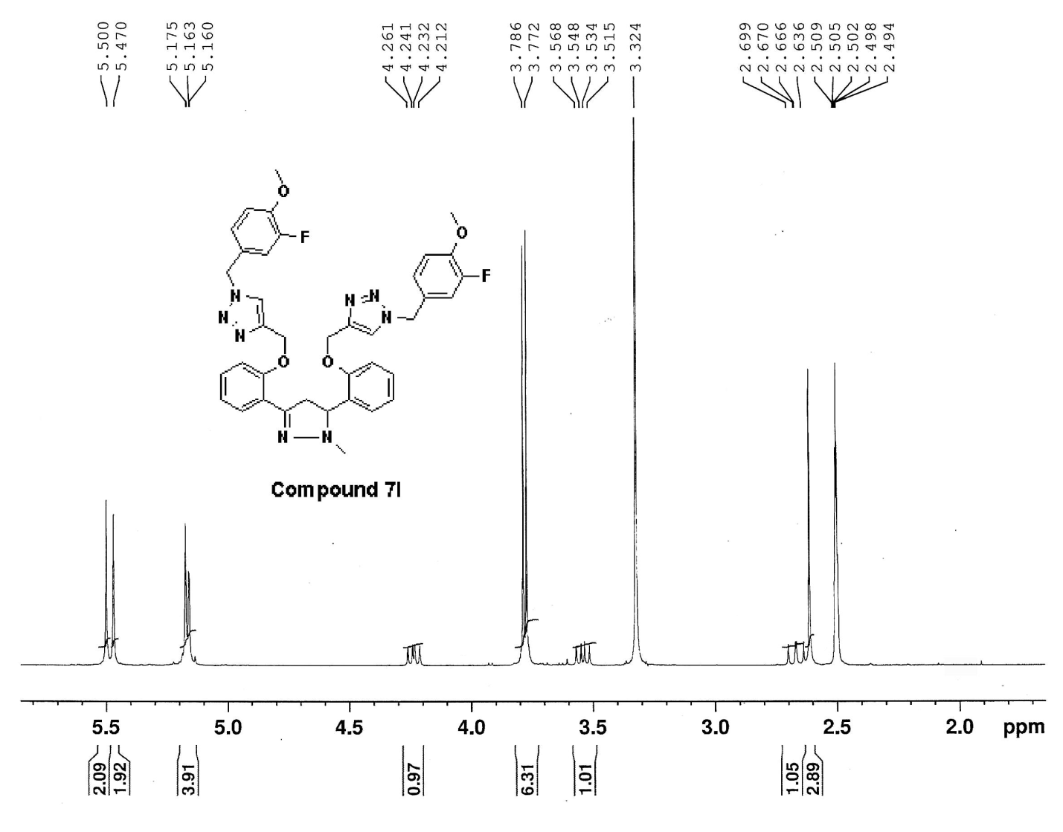
Figure S116: ¹H-NMR (500 MHz, DMSO-d₆) spectra of compound 7l

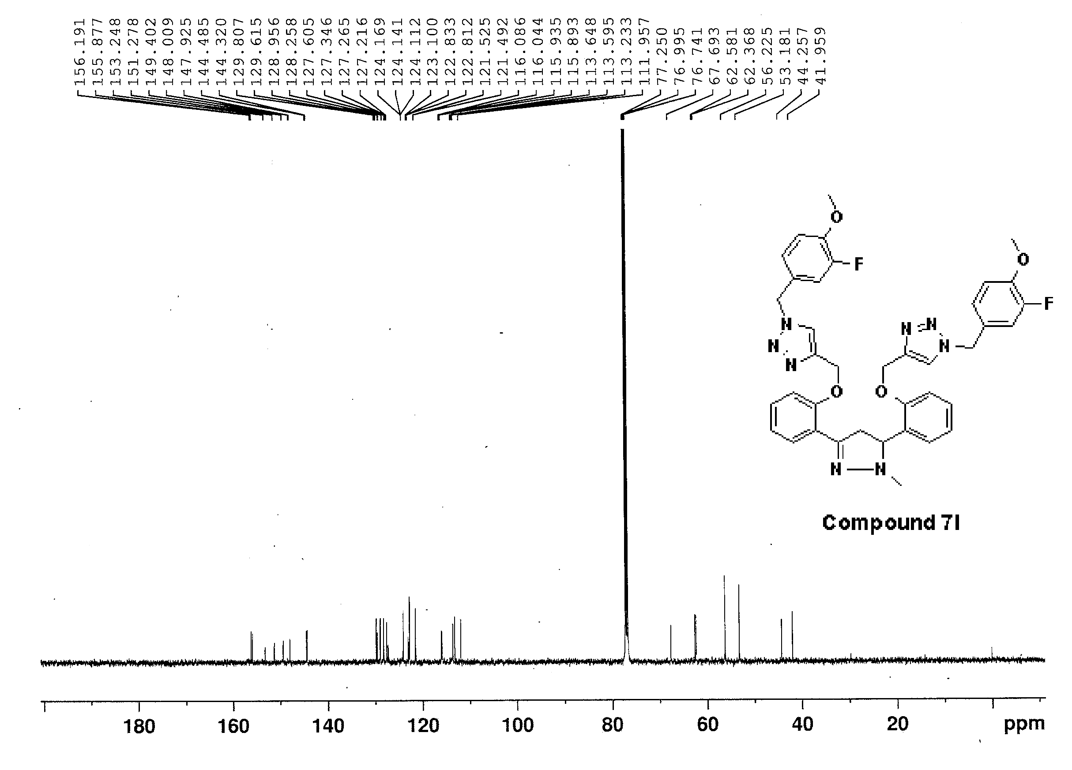
Figure S117: ¹³C NMR (125 MHz, CDCl₃) spectra of compound 7l
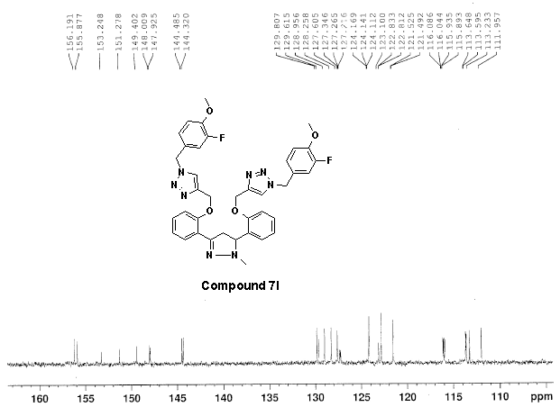
Figure S118: ¹³C NMR (125 MHz, CDCl₃) spectra of compound 7l

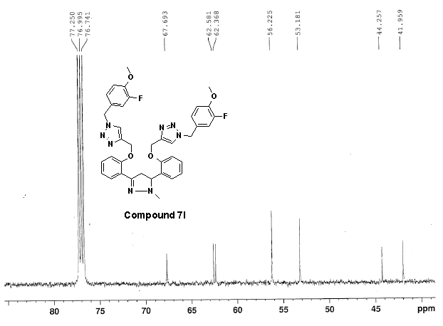
Figure S119: ¹³C NMR (125 MHz, CDCl₃) spectra of compound 7l
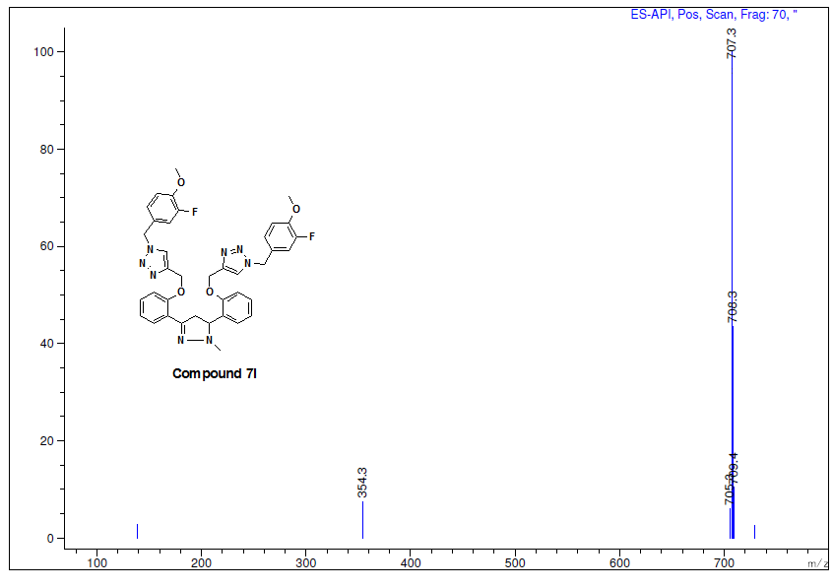
Figure S120: Mass spectra of compound 7l
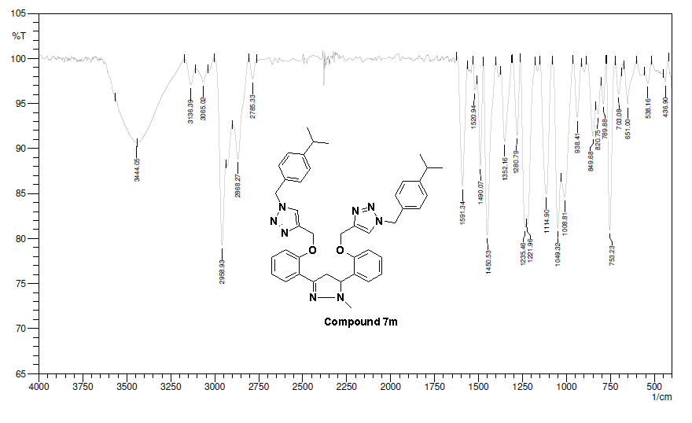
Figure S121: IR spectra of compound 7m
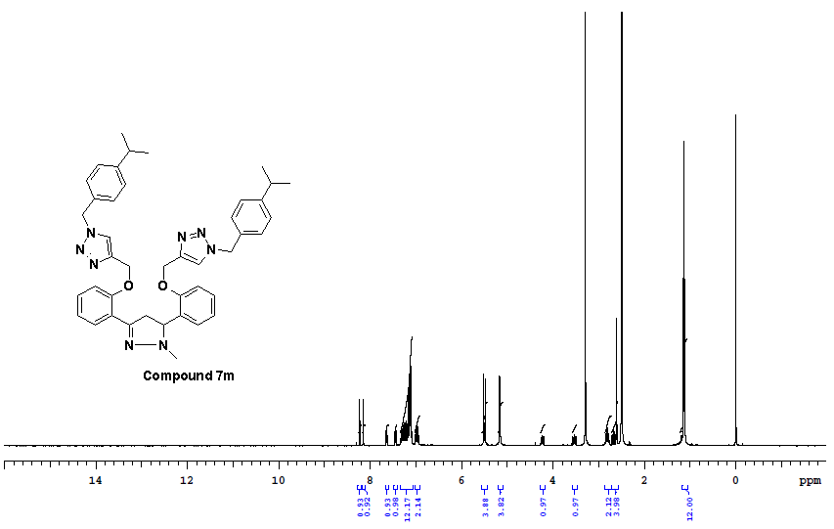
Figure S122: ¹H-NMR (400 MHz, DMSO-d₆) spectra of compound 7m
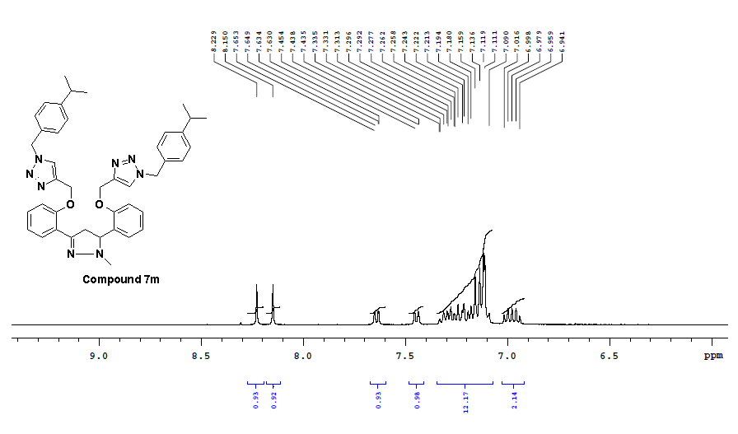
Figure S123: ¹H-NMR (400 MHz, DMSO-d₆) spectra of compound 7m
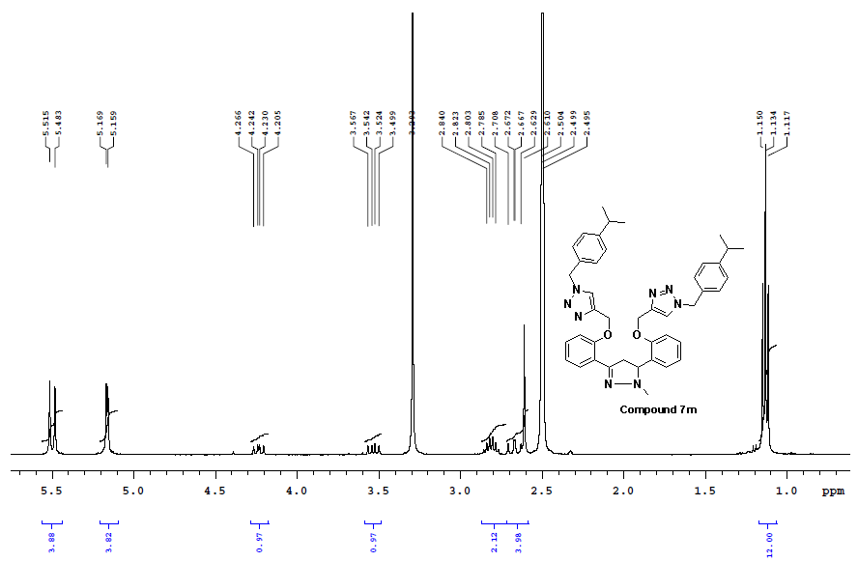

Figure S124: ¹H-NMR (400 MHz, DMSO-d₆) spectra of compound 7m

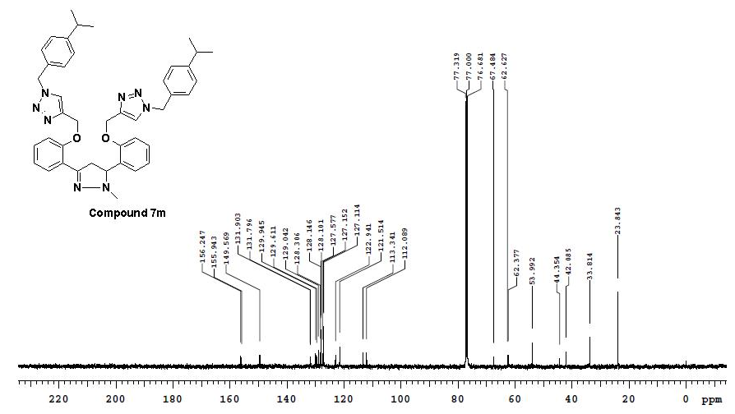
Figure S125: ¹³C NMR (100 MHz, CDCl₃) spectra of compound 7m

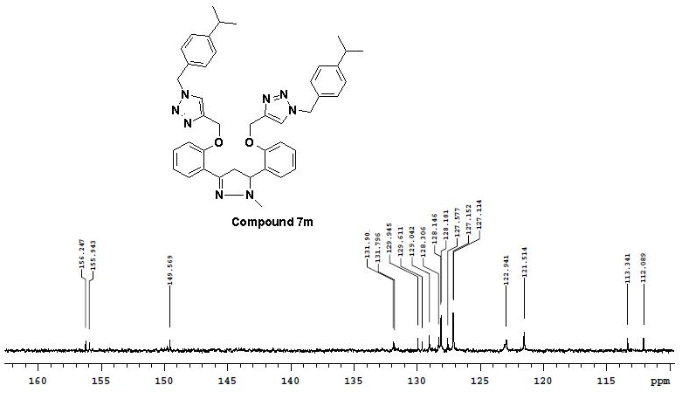
Figure S126: ¹³C NMR (100 MHz, CDCl₃) spectra of compound 7m

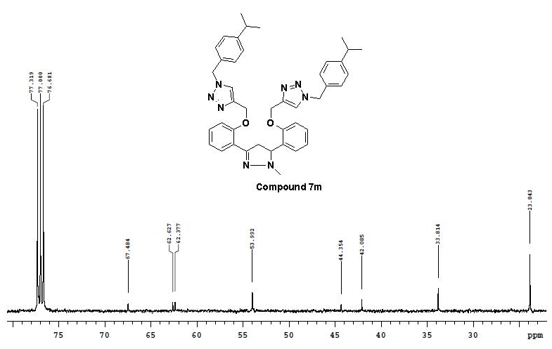
Figure S127: ¹³C NMR (100 MHz, CDCl₃) spectra of compound 7l
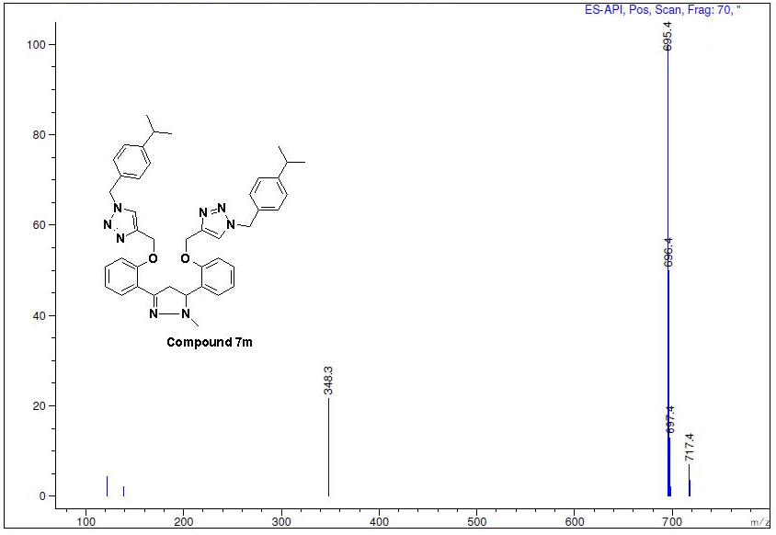
Figure S128: Mass spectra of compound 7m

