Supporting Information
Synthesis of novel pyrazoline based bis 1,2,3-triazole scaffolds via click chemistry
DONGAMANTI ASHOK*, KOTHURI KIRAN and BODDU ANANDA RAO

Corresponding author: Dongamanti Ashok, Green and Medicinal Chemistry Laboratory, Department of Chemistry, Osmania University, Hyderabad, 500 007, Telangana, India.
E-mail: ashokdou@gmail.com
Green and Medicinal Chemistry Laboratory, Department of Chemistry, Osmania University, Hyderabad, 500007, Telangana, India.

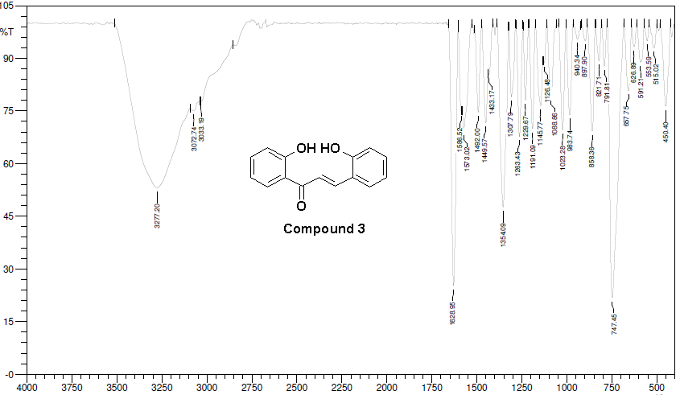
Figure S1: IR spectra of compound 3
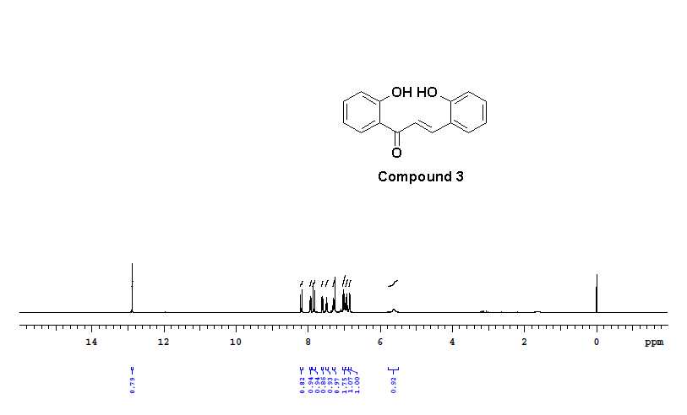
Figure S2: ¹H-NMR (400 MHz, CDCl₃) spectra of compound 3
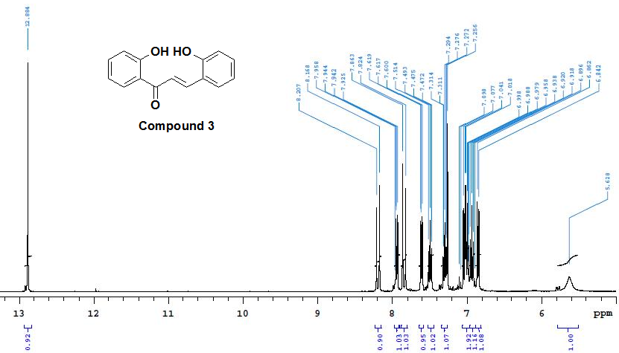
Figure S3: ¹H-NMR (400 MHz, CDCl₃) spectra of compound 3
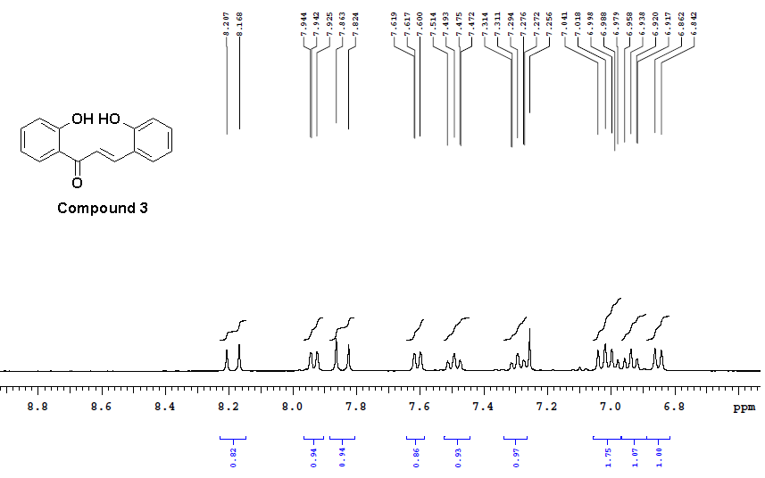
Figure S4: ¹H-NMR (400 MHz, CDCl₃) spectra of compound 3
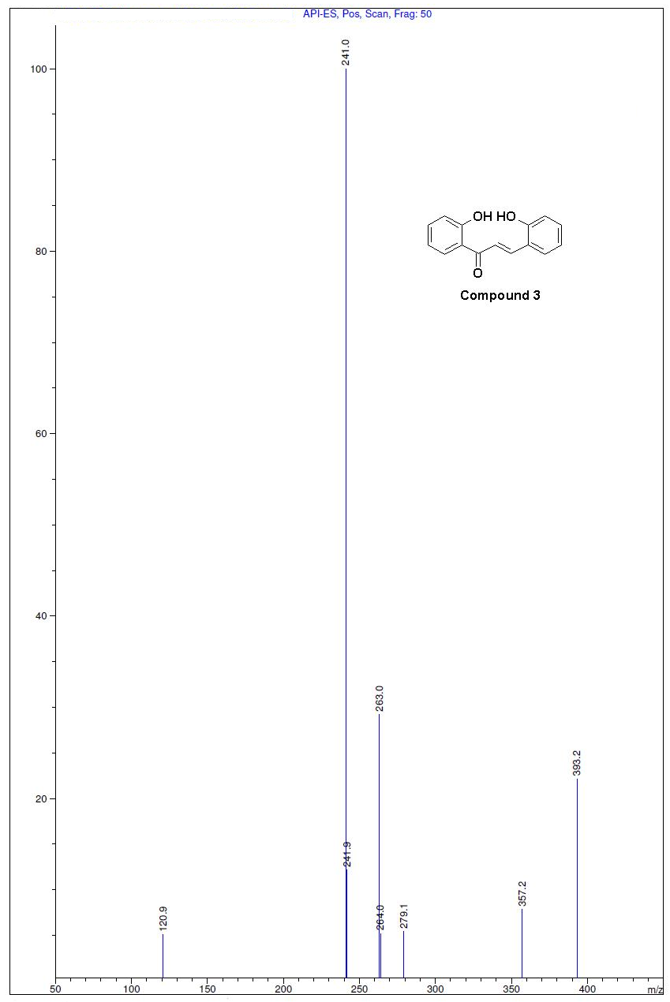
Figure S5: Mass spectra of compound 3

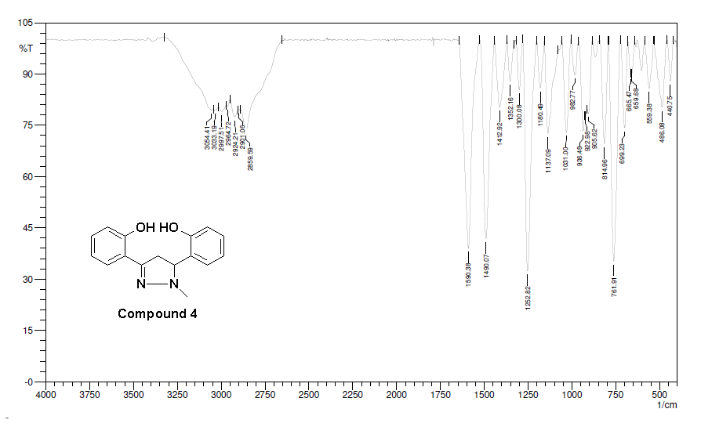
Figure S6: IR spectra of compound 4
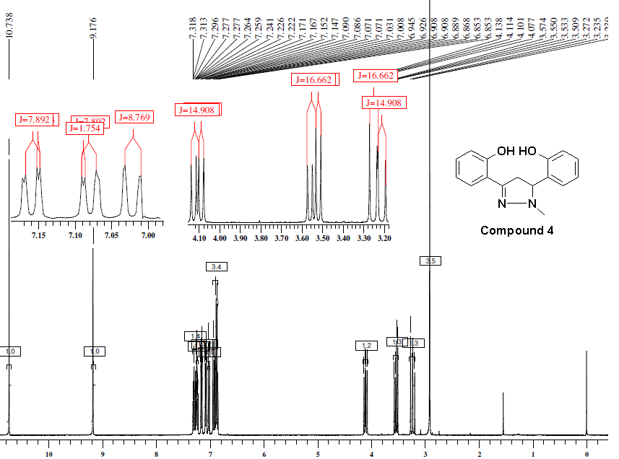
Figure S7: ¹H-NMR (400 MHz, CDCl₃) spectra of compound 4

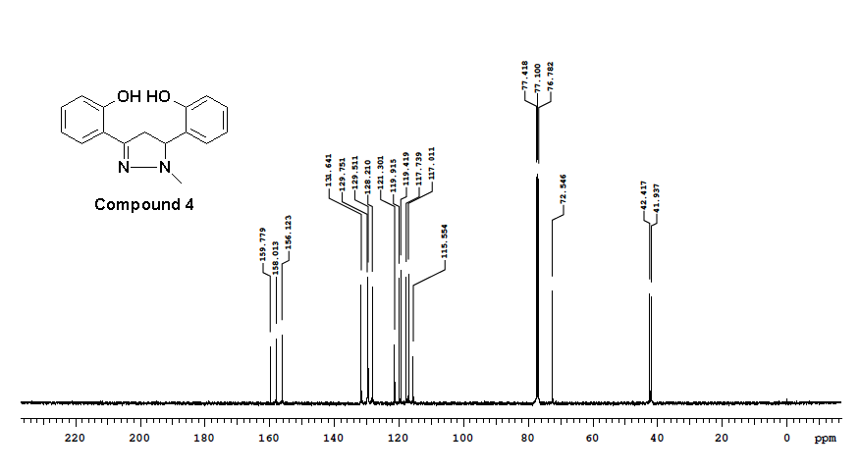
Figure S8: ¹³C NMR (100 MHz, CDCl₃) spectra of compound 4

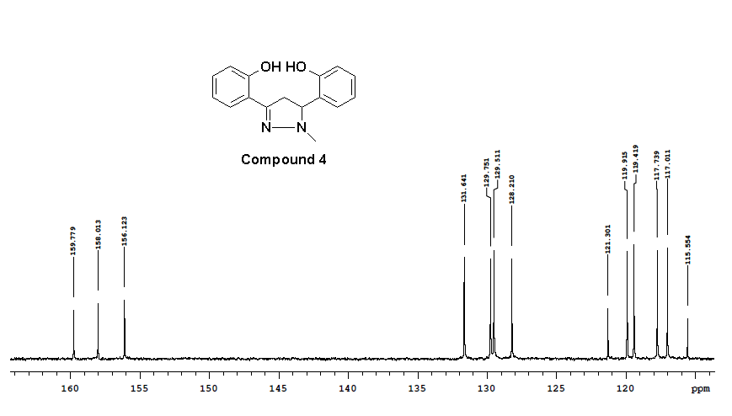
Figure S9: ¹³C NMR (100 MHz, CDCl₃) spectra of compound 4
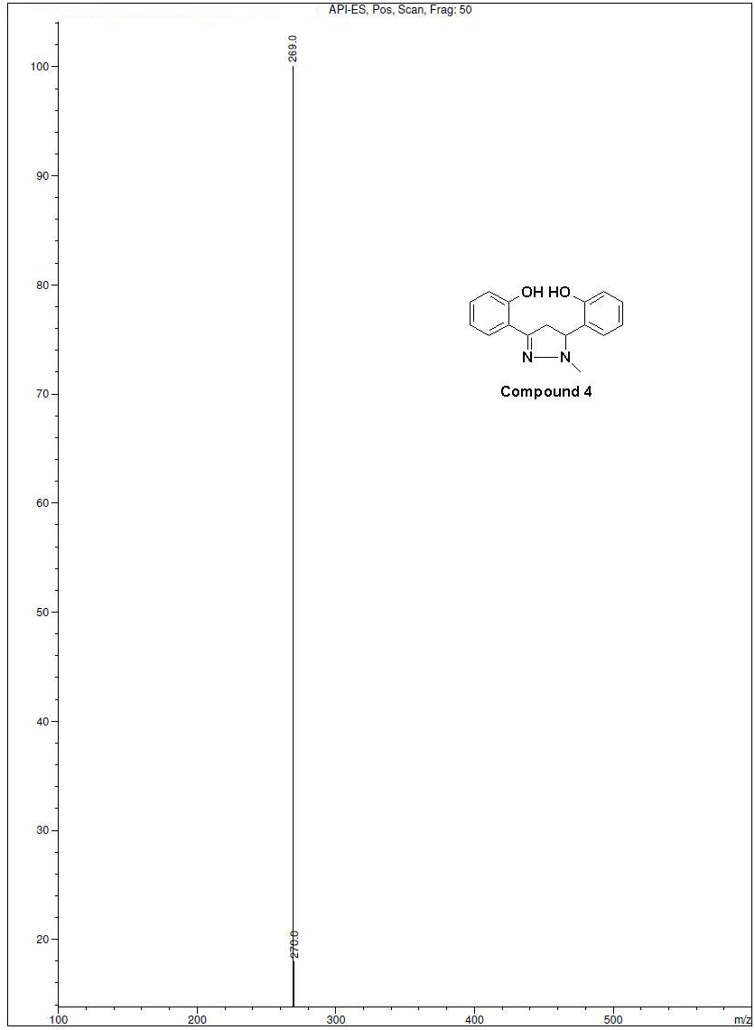
Figure S10: Mass spectra of compound 4
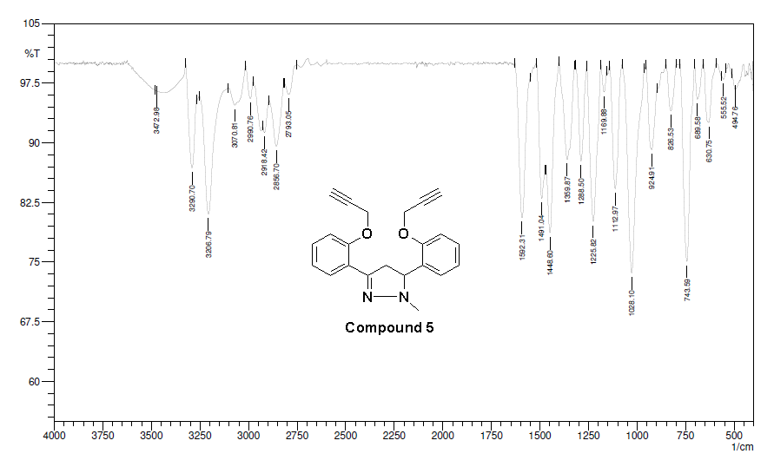
Figure S11: IR spectra of compound 5
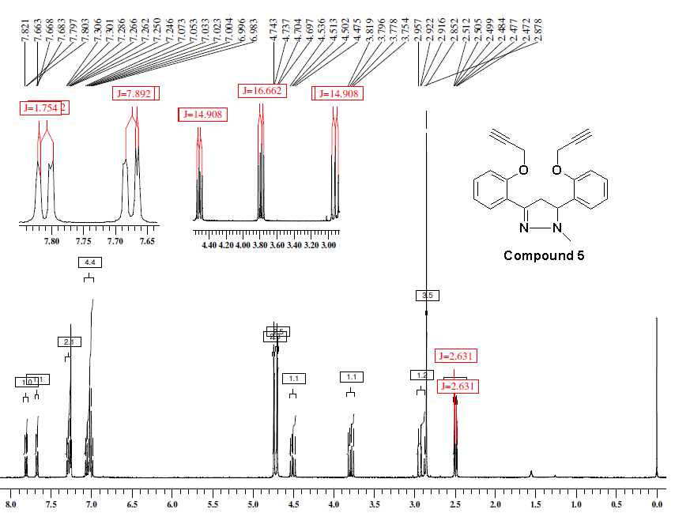
Figure S12: ¹H-NMR (400 MHz, CDCl₃) spectra of compound 5
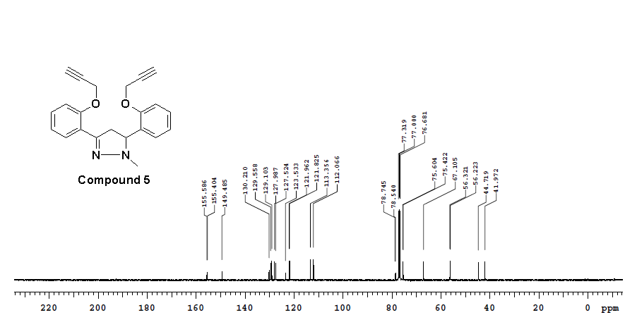
Figure S13: ¹³C NMR (100 MHz, CDCl₃) spectra of compound 5

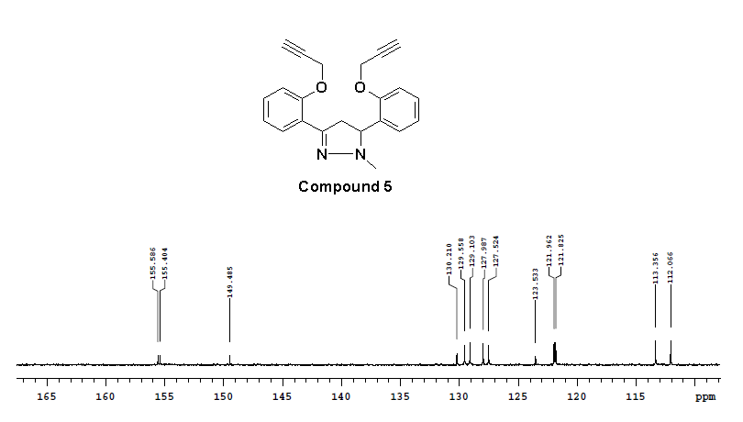
Figure S14: ¹³C NMR (100 MHz, CDCl₃) spectra of compound 5
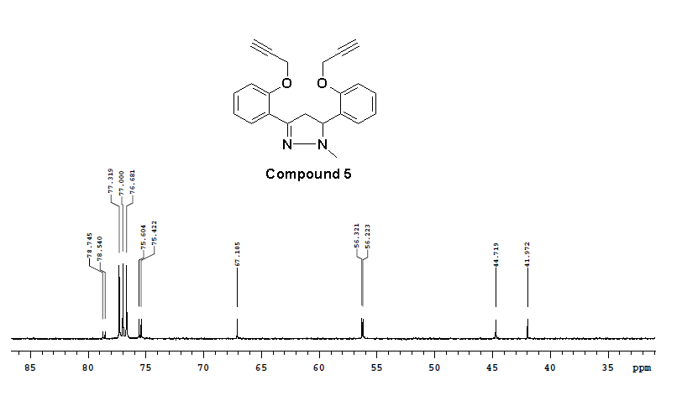
Figure S15: ¹³C NMR (100 MHz, CDCl₃) spectra of compound 5
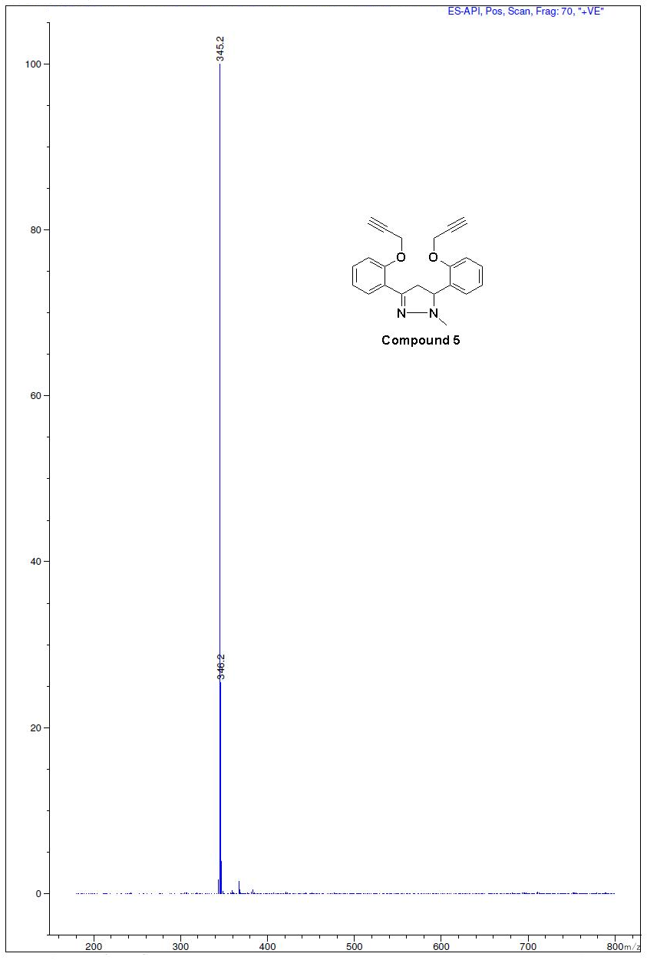
Figure S16: Mass spectra of compound 5
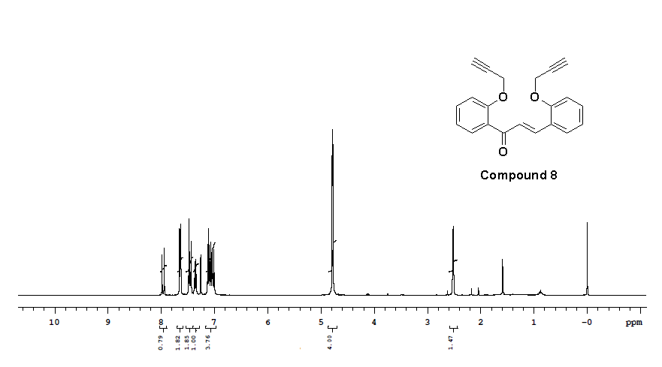
Figure S17: ¹H-NMR (400 MHz, CDCl₃) spectra of compound 8

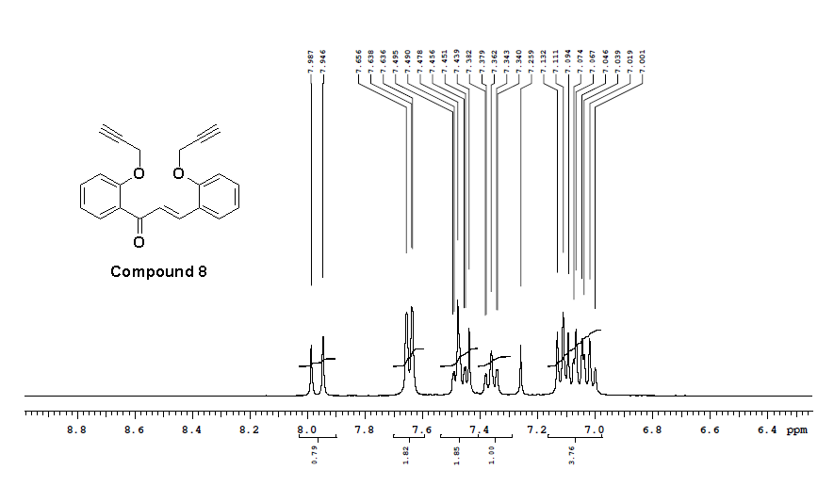
Figure S18: ¹H-NMR (400 MHz, CDCl₃) spectra of compound 8
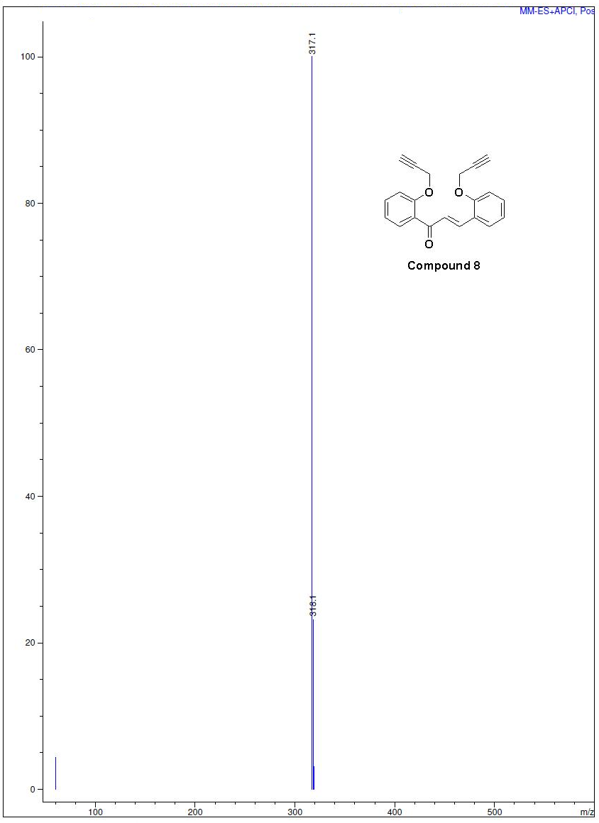
Figure S19: Mass spectra of compound 8
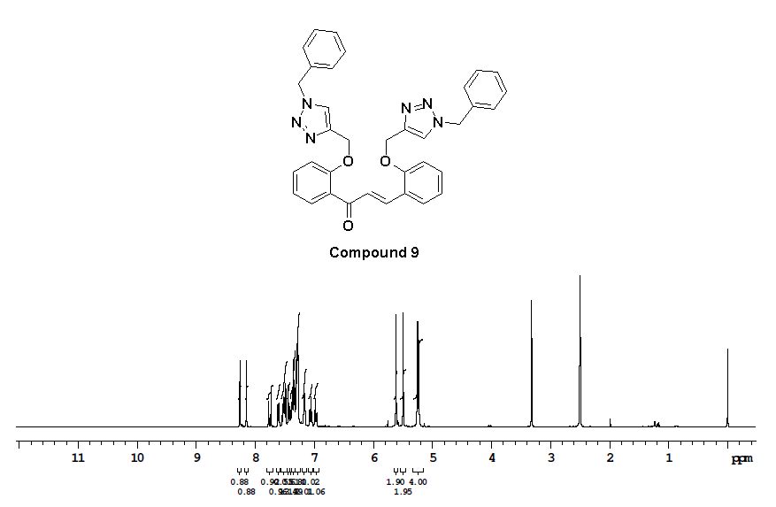
Figure S20: ¹H-NMR (400 MHz, DMSO-d₆) spectra of compound 9
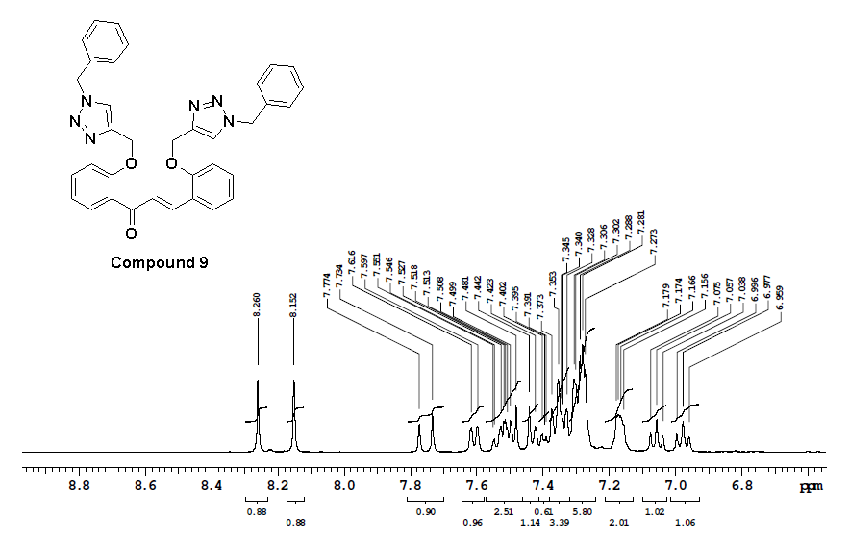
Figure S21: ¹H-NMR (400 MHz, DMSO-d₆) spectra of compound 9
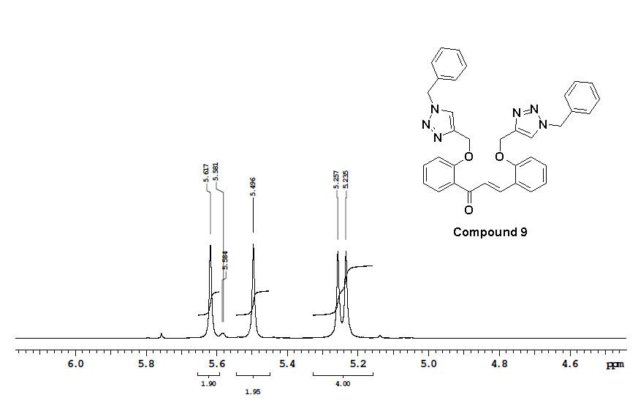
Figure S22: ¹H-NMR (400 MHz, DMSO-d₆) spectra of compound 9

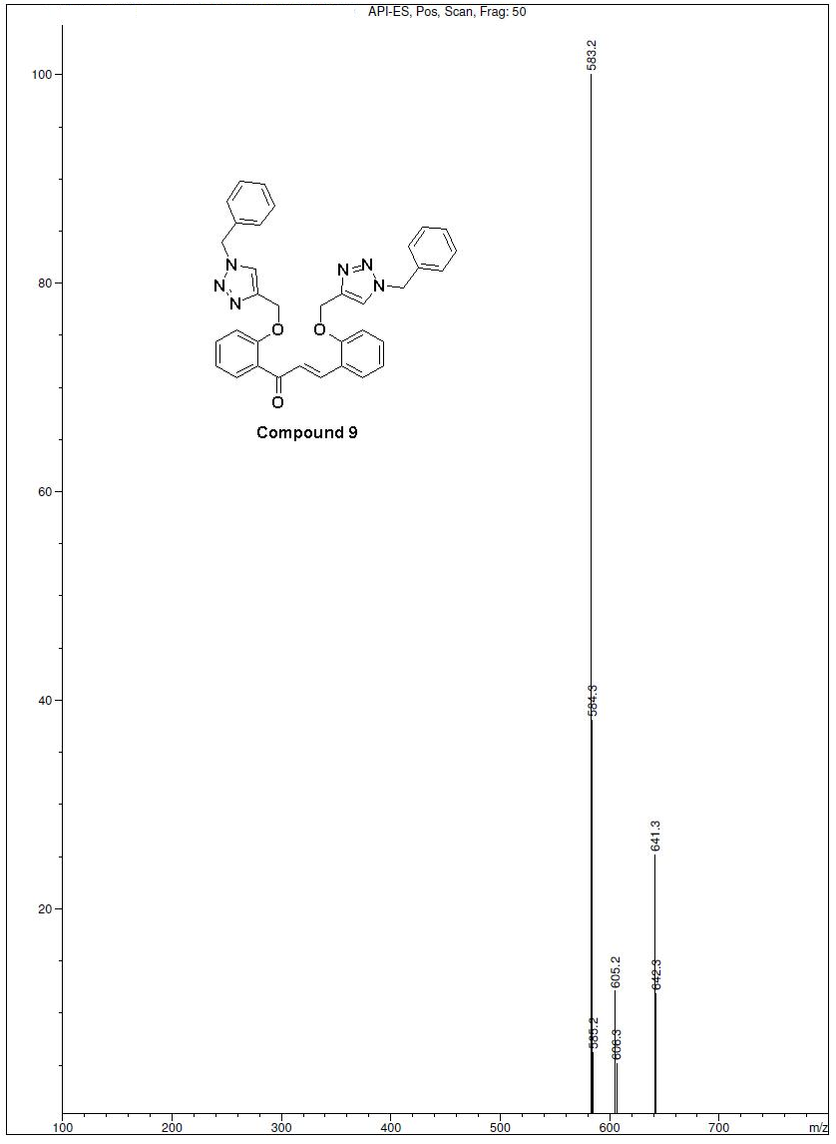
Figure S23: Mass spectra of compound 9

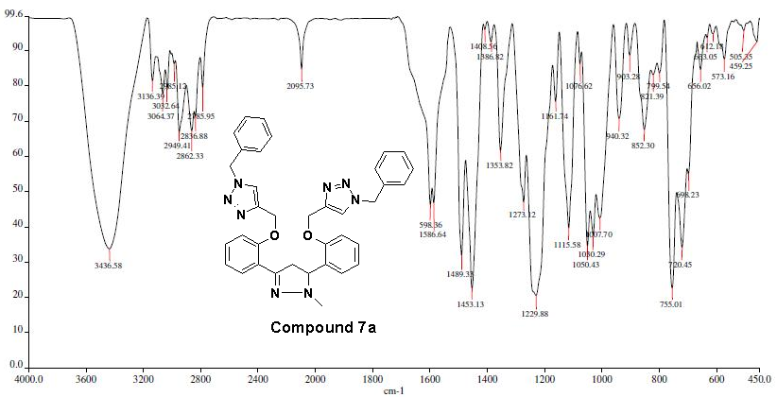
Figure S24: IR spectra of compound 7a
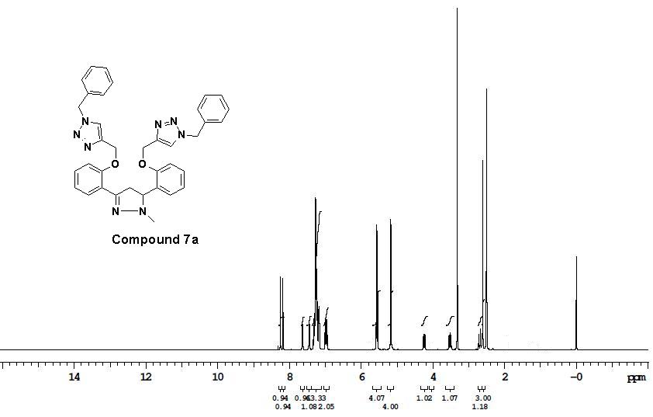
Figure S25: ¹H-NMR (400 MHz, DMSO-d₆) spectra of compound 7a

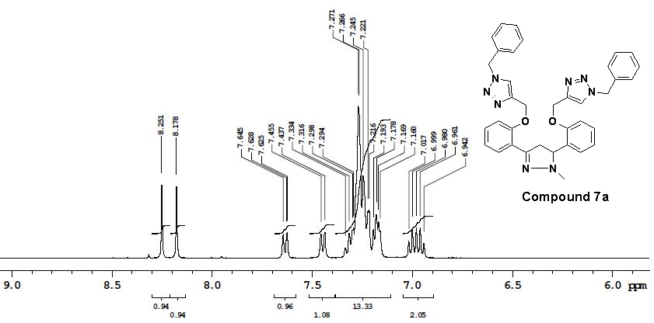
Figure S26: ¹H-NMR (400 MHz, DMSO-d₆) spectra of compound 7a

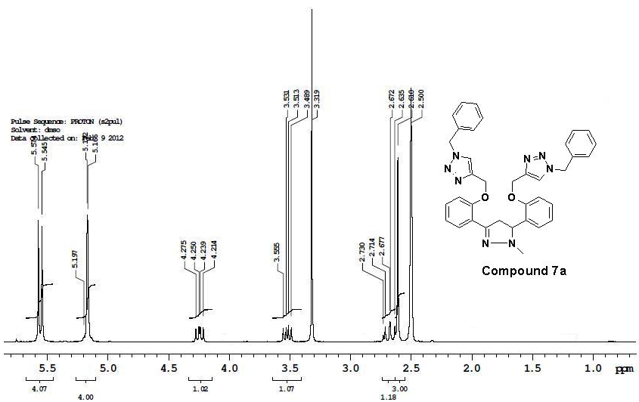
Figure S27: ¹H-NMR (400 MHz, DMSO-d₆) spectra of compound 7a
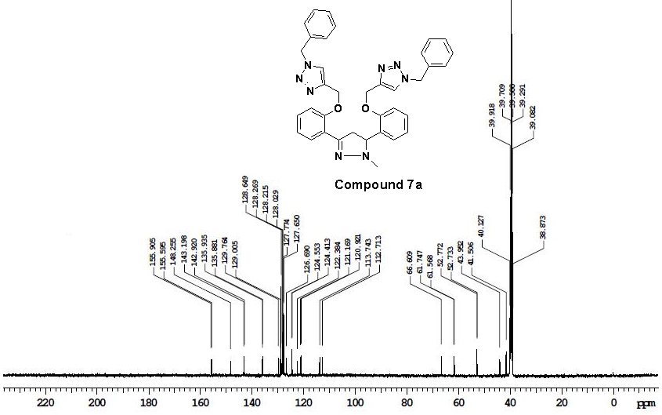
Figure S28: ¹³C NMR (100 MHz, DMSO-d₆) spectra of compound 7a

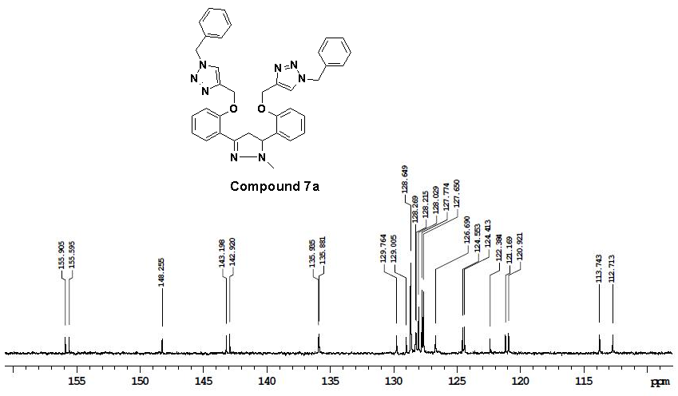
Figure S29: ¹³C NMR (100 MHz, DMSO-d₆) spectra of compound 7a

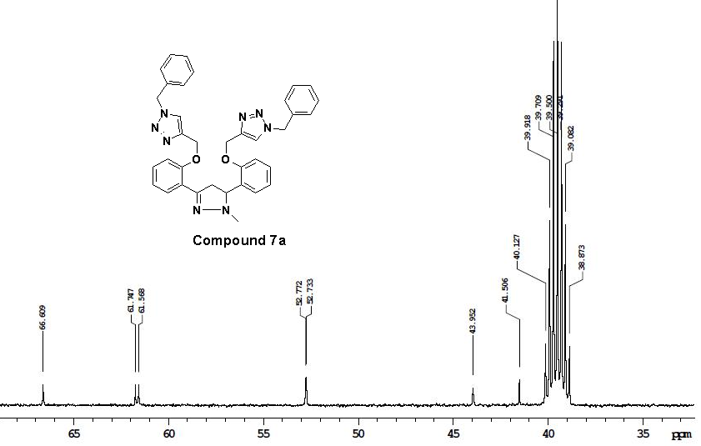
Figure S30: ¹³C NMR (100 MHz, DMSO-d₆) spectra of compound 7a

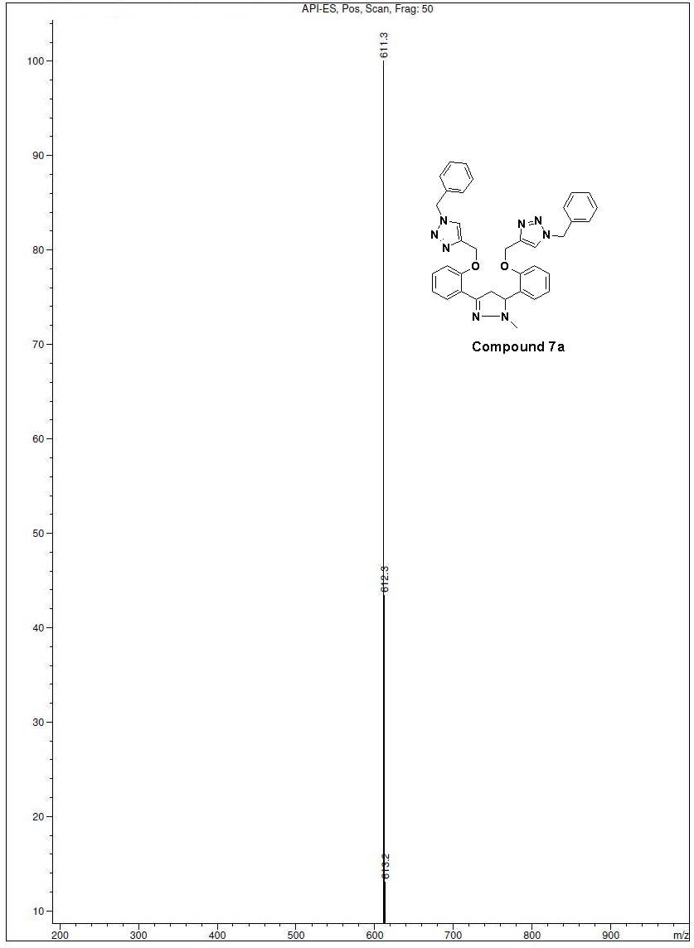
Figure S31: Mass spectra of compound 7a
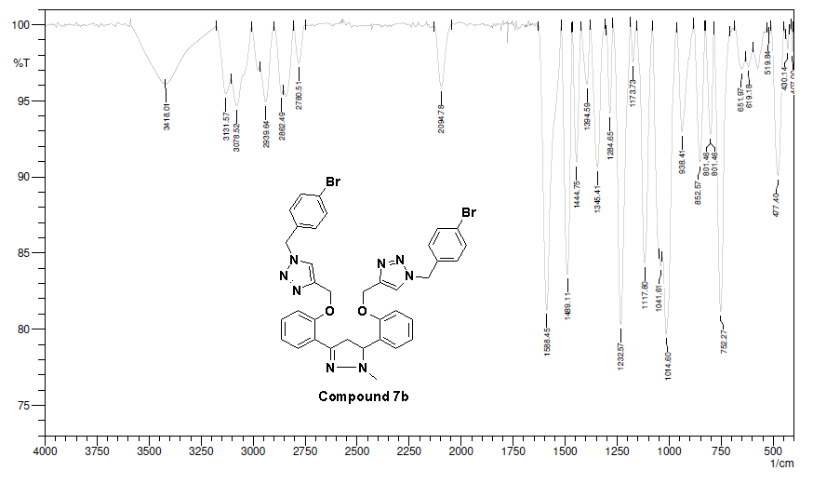
Figure S32: IR spectra of compound 7b
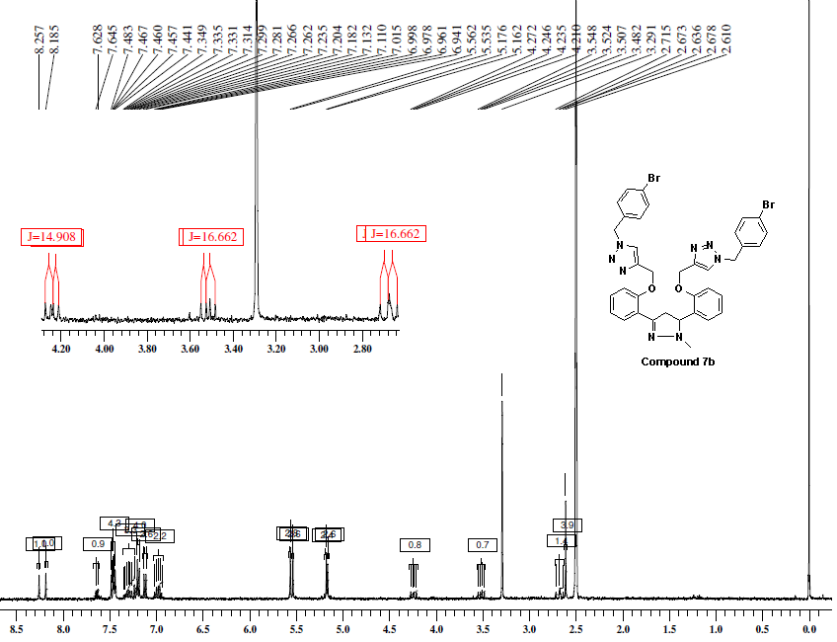
Figure S33: ¹H-NMR (400 MHz, DMSO-d₆) spectra of compound 7b
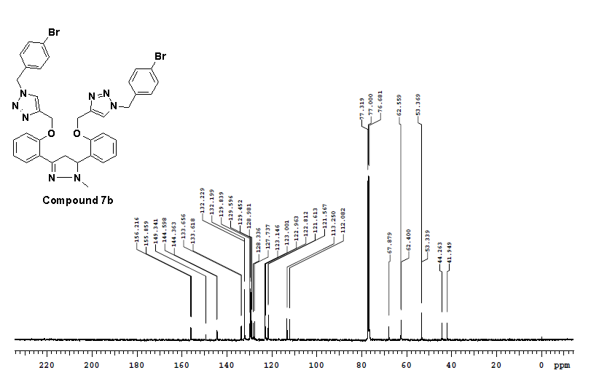
Figure S34: ¹³C NMR (100 MHz, CDCl₃) spectra of compound 7b
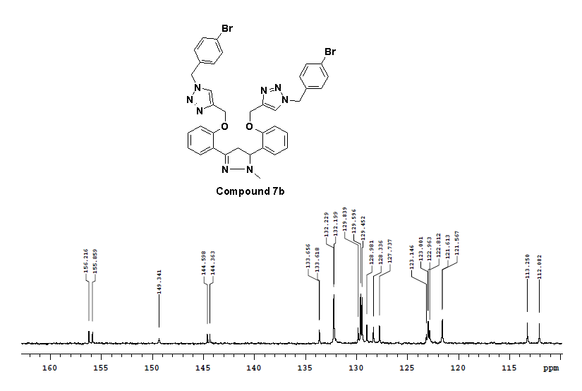
Figure S35: ¹³C NMR (100 MHz, CDCl₃) spectra of compound 7b
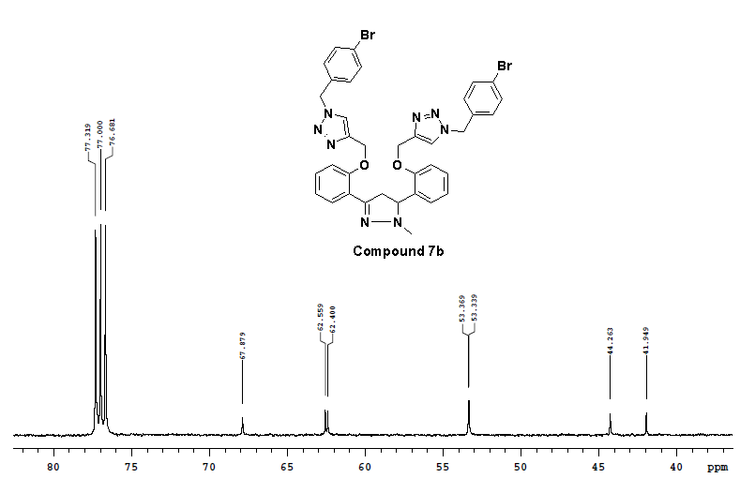
Figure S36: ¹³C NMR (100 MHz, CDCl₃) spectra of compound 7b

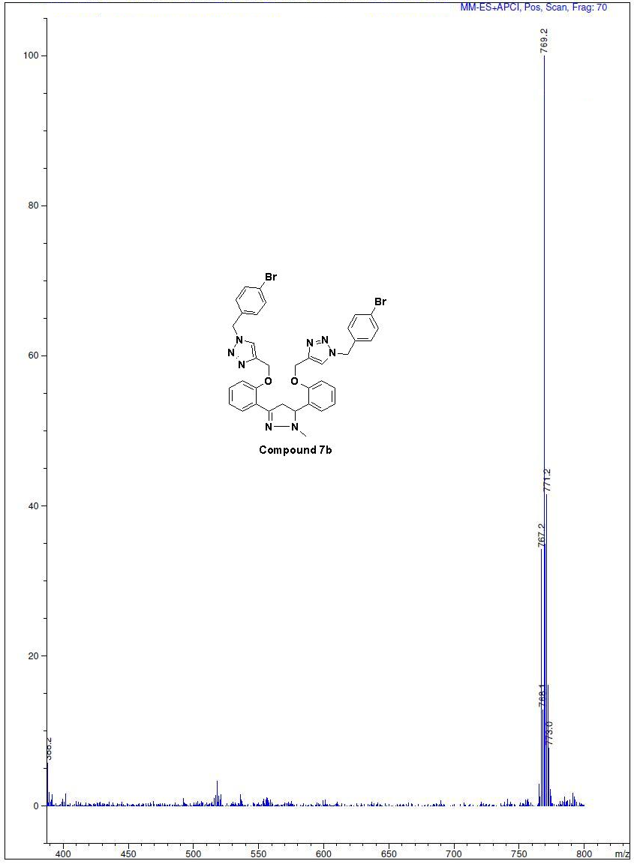
Figure S37: Mass spectra of compound 7b

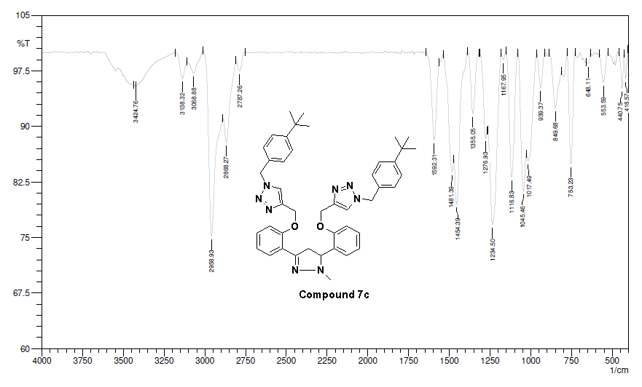
Figure S38: IR spectra of compound 7c
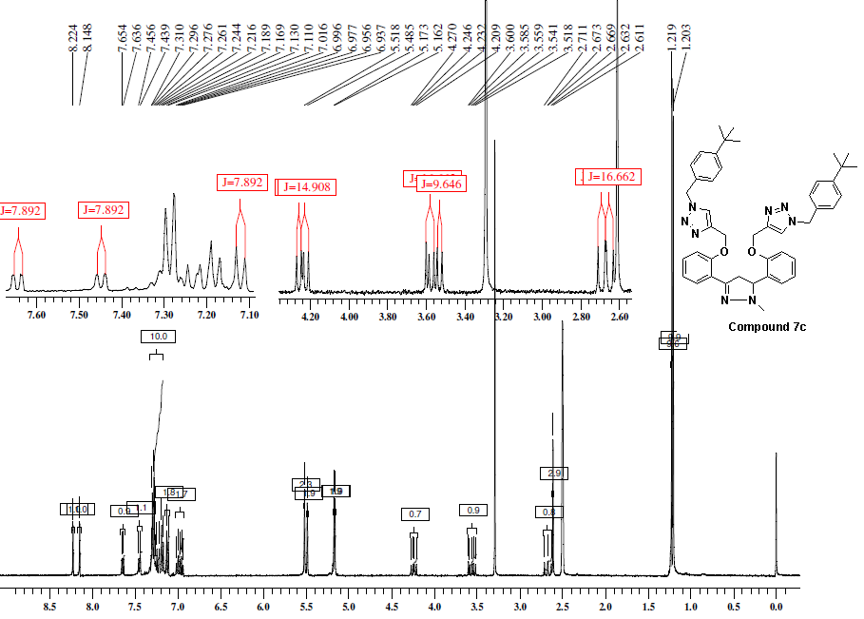
Figure S39: ¹H-NMR (400 MHz, DMSO-d₆) spectra of compound 7c

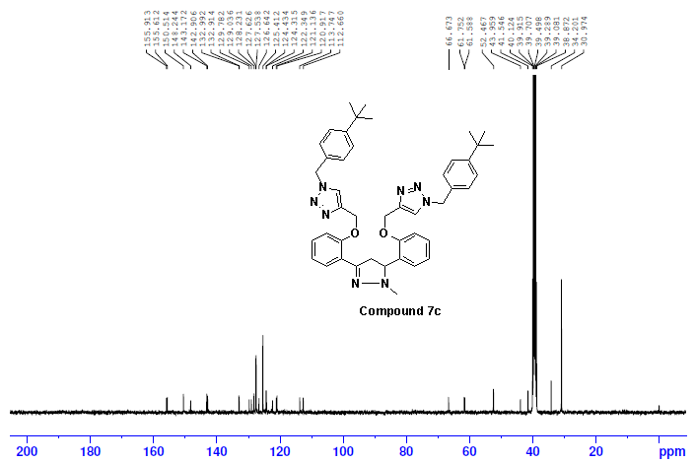
Figure S40: ¹³C NMR (100 MHz, DMSO-d₆) spectra of compound 7c
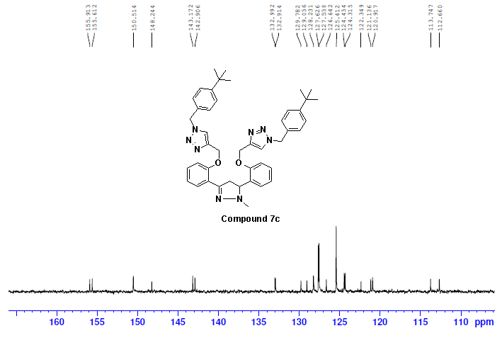
Figure S41: ¹³C NMR (100 MHz, DMSO-d₆) spectra of compound 7c
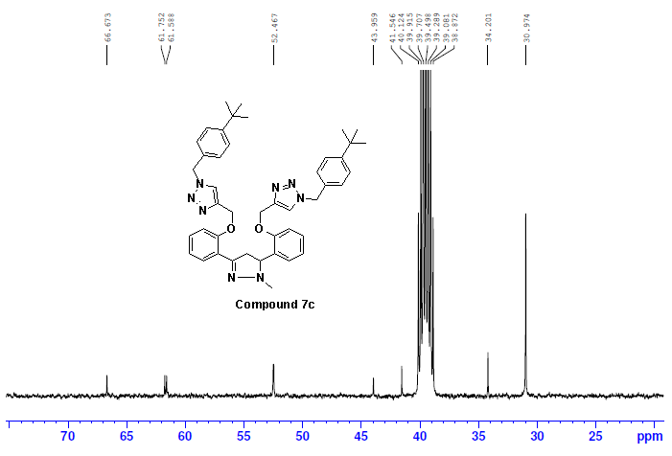
Figure S42: ¹³C NMR (100 MHz, DMSO-d₆) spectra of compound 7c

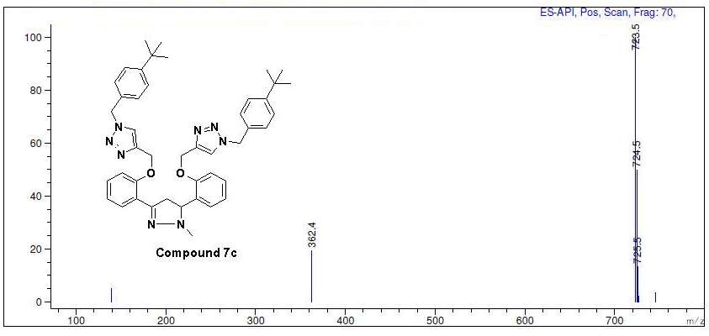
Figure S43: Mass spectra of compound 7c
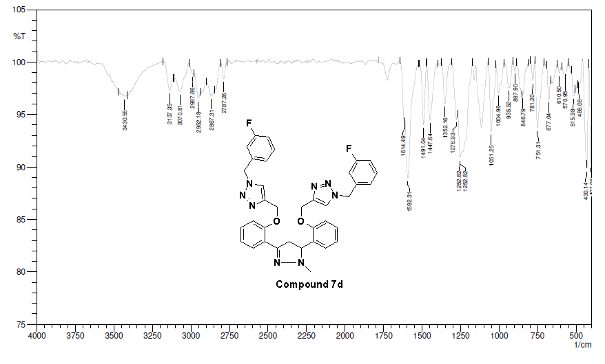
Figure S44: IR spectra of compound 7d
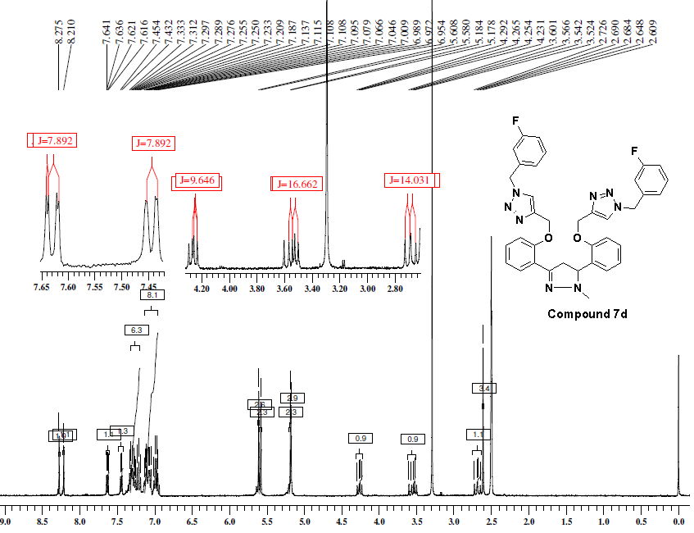
Figure S45: ¹H-NMR (400 MHz, DMSO-d₆) spectra of compound 7d
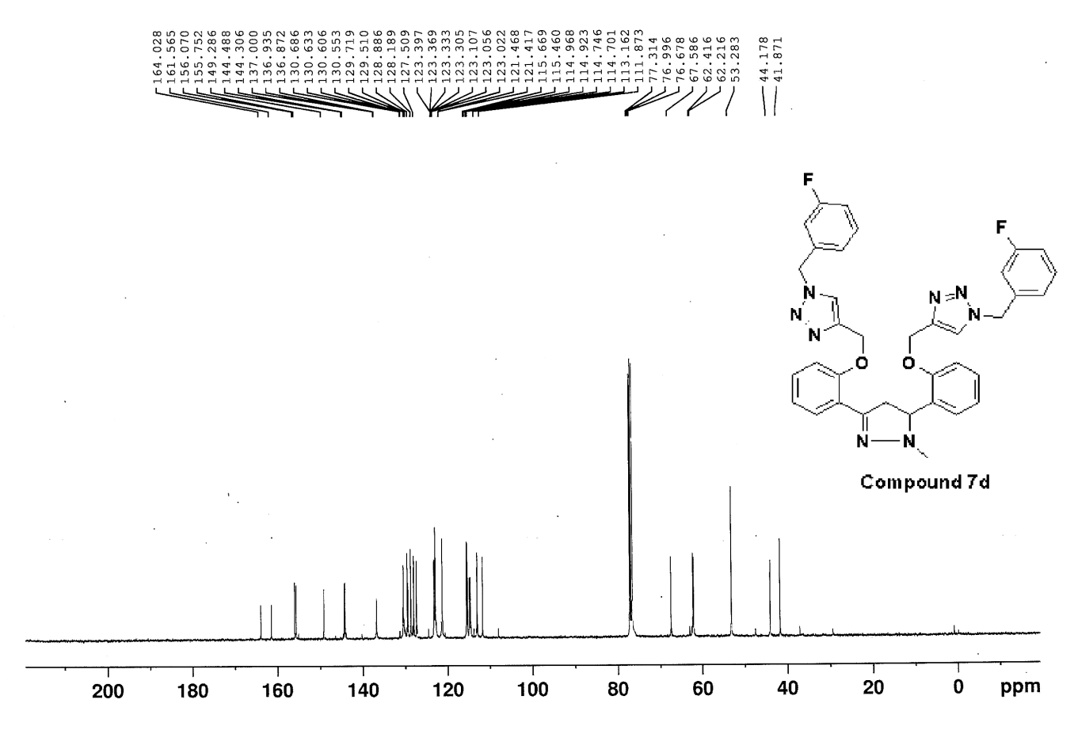
Figure S46: ¹³C NMR (100 MHz, CDCl₃) spectra of compound 7d

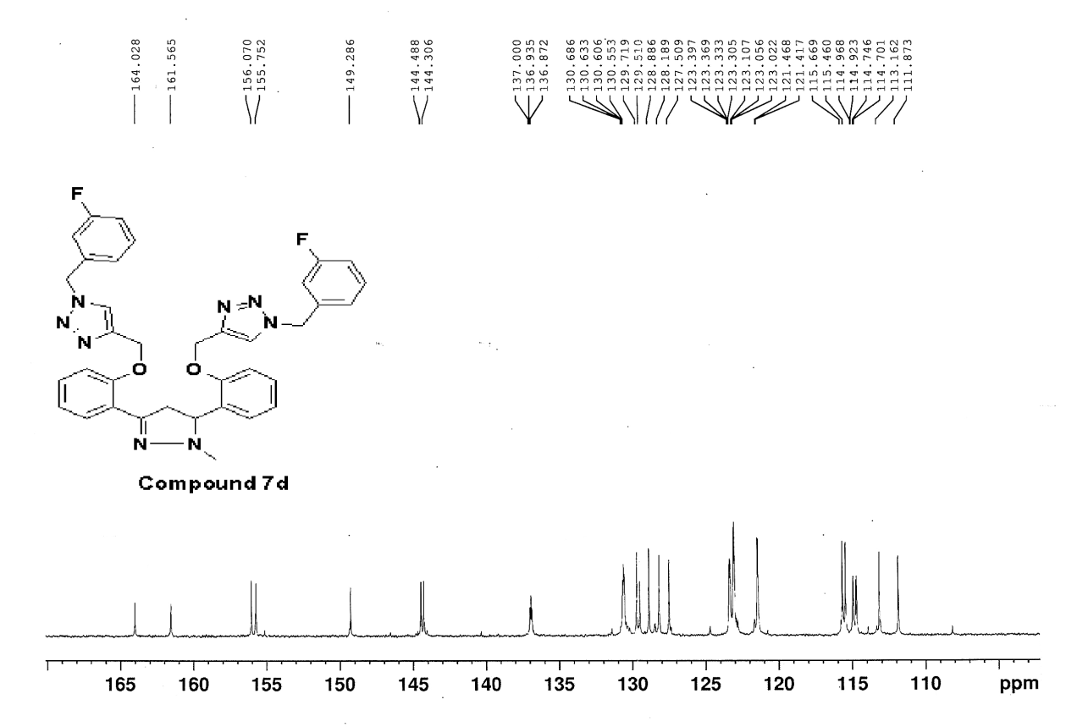
Figure S47: ¹³C NMR (100 MHz, CDCl₃) spectra of compound 7d
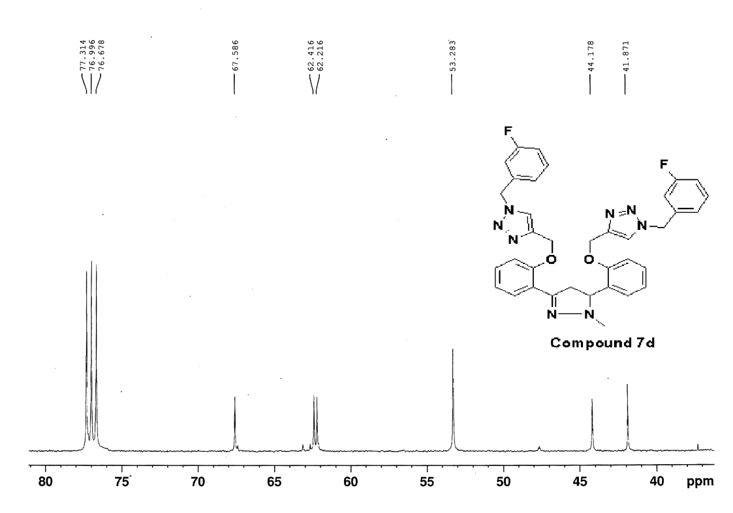
Figure S48: ¹³C NMR (100 MHz, CDCl₃) spectra of compound 7d
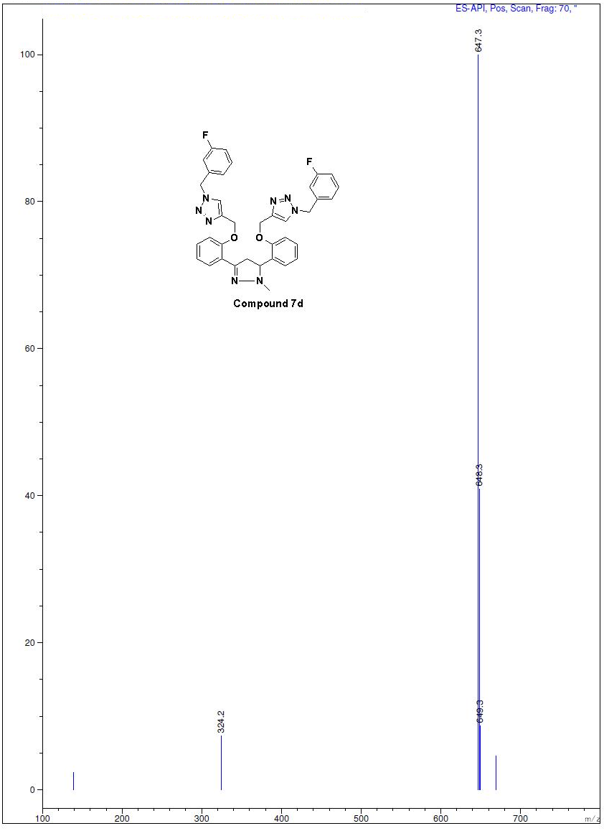
Figure S49: Mass spectra of compound 7d
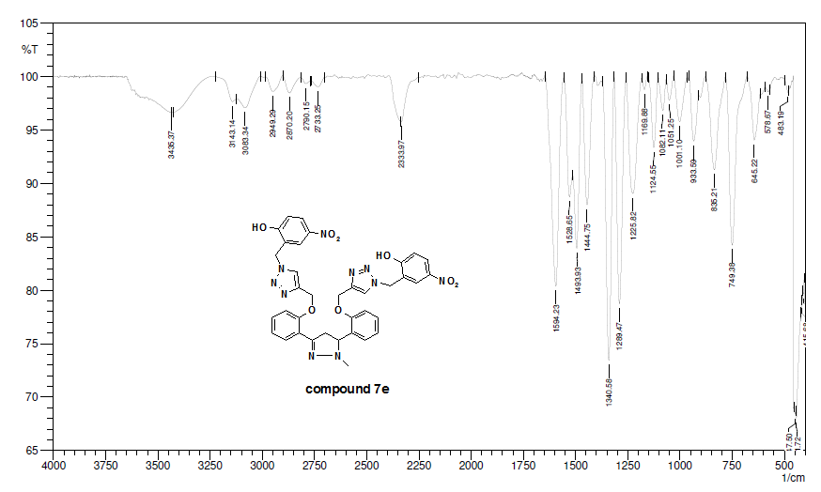
Figure S50: IR spectra of compound 7e
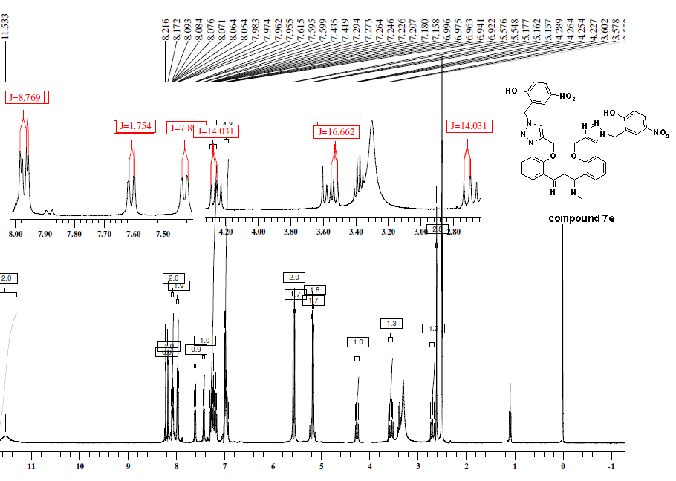
Figure S51: ¹H-NMR (400 MHz, DMSO-d₆) spectra of compound 7e
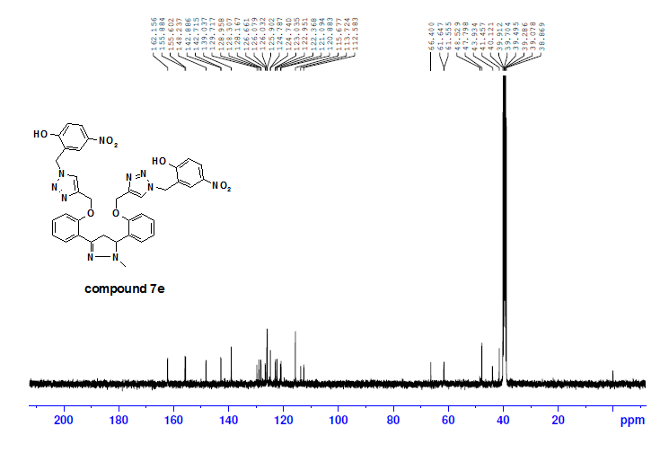
Figure S52: ¹³C NMR (100 MHz, DMSO-d₆) spectra of compound 7e
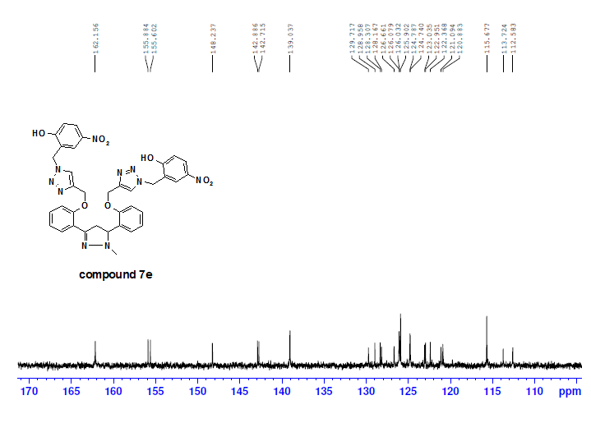
Figure S53: ¹³C NMR (100 MHz, DMSO-d₆) spectra of compound 7e
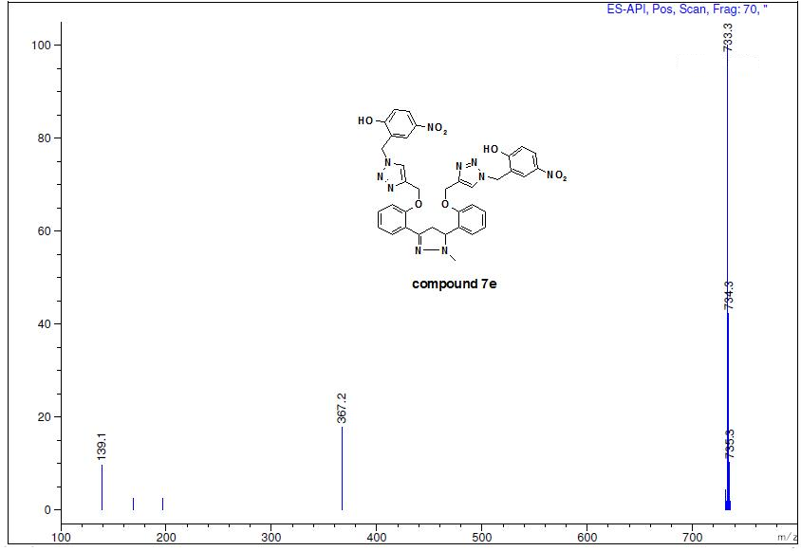
Figure S54: Mass spectra of compound 7e
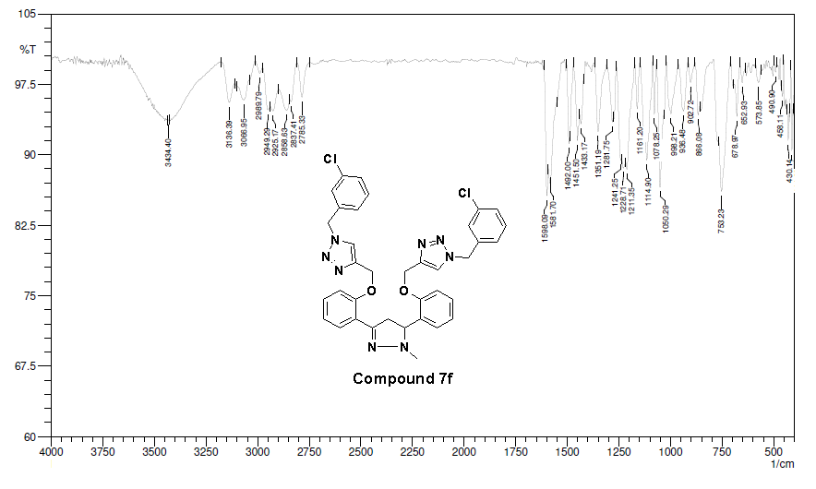
Figure S55: IR spectra of compound 7f
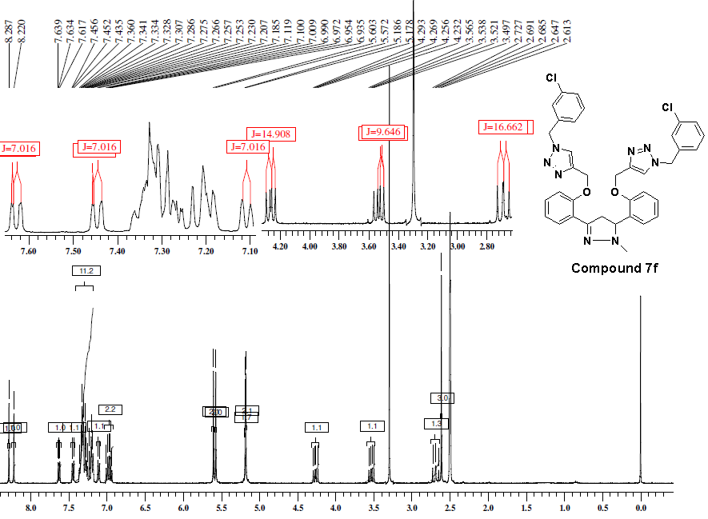
Figure S56: ¹H-NMR (400 MHz, DMSO-d₆) spectra of compound 7f

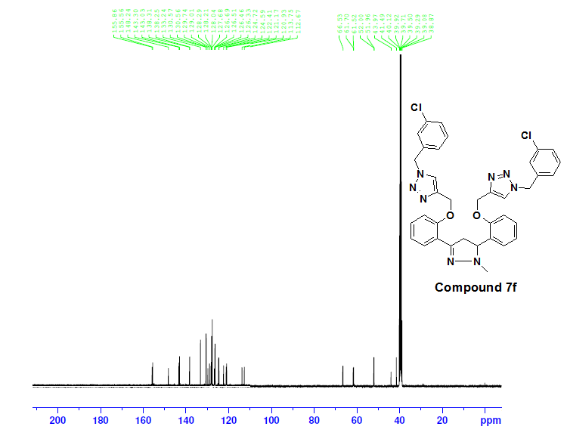
Figure S57: ¹³C NMR (100 MHz, DMSO-d₆) spectra of compound 7f

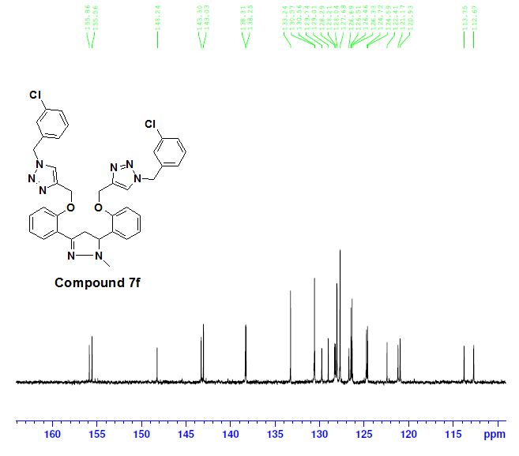
Figure S58: ¹³C NMR (100 MHz, DMSO-d₆) spectra of compound 7f

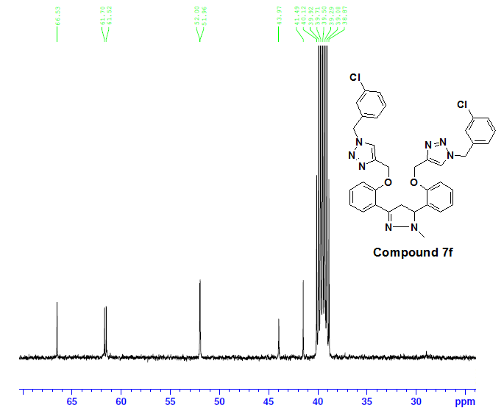
Figure S59: ¹³C NMR (100 MHz, DMSO-d₆) spectra of compound 7f

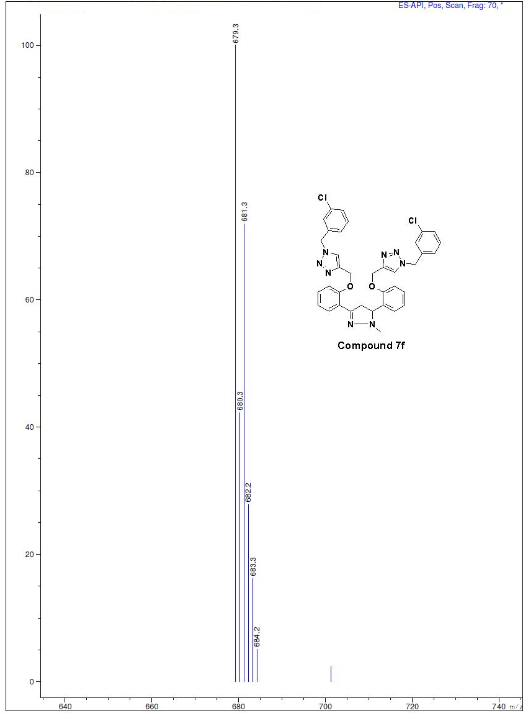
Figure S60: Mass spectra of compound 7f
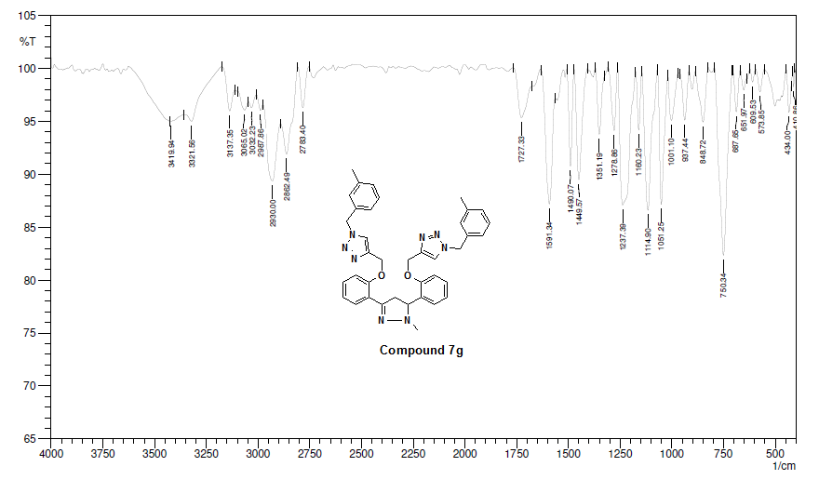
Figure S61: IR spectra of compound 7g
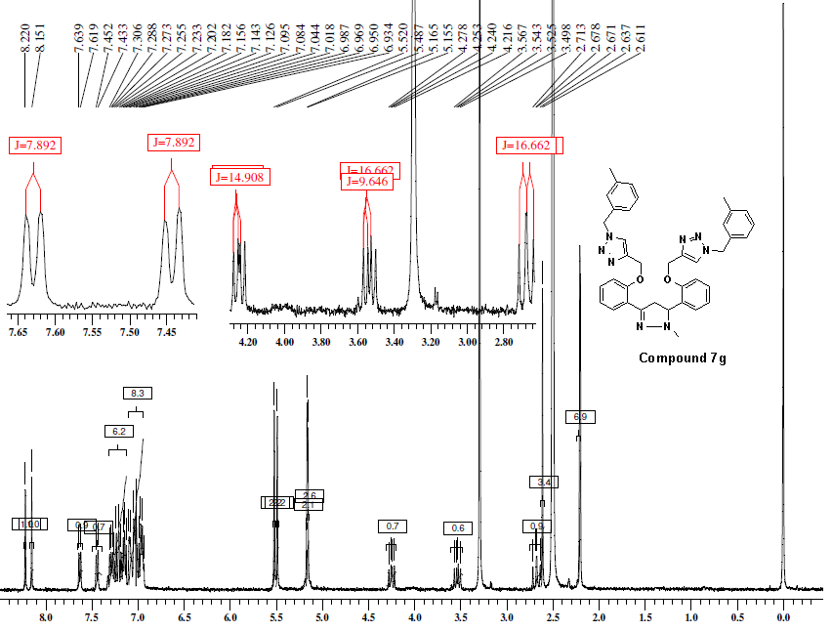
Figure S62: ¹H-NMR (400 MHz, DMSO-d₆) spectra of compound 7g

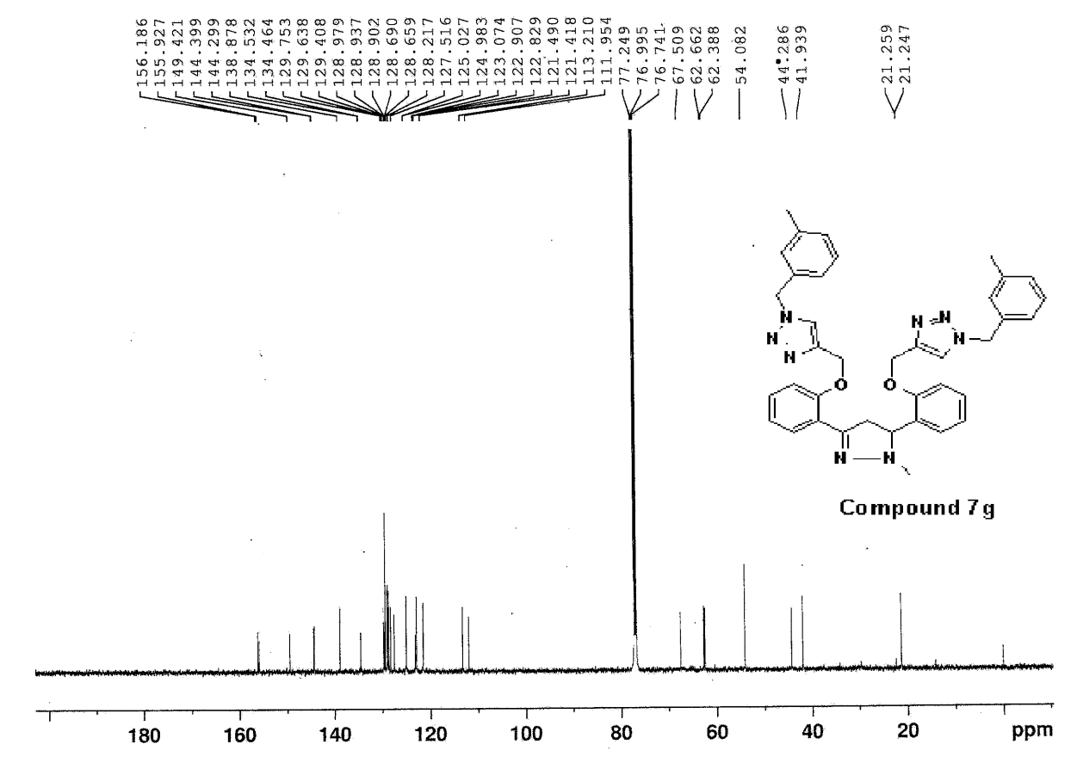
Figure S63: ¹³C NMR (125 MHz, CDCl₃) spectra of compound 7g

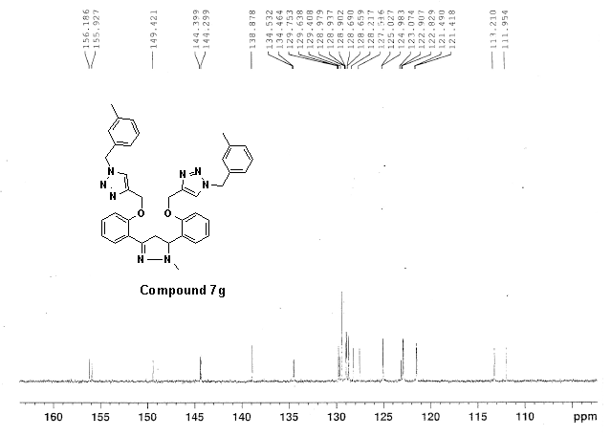
Figure S64: ¹³C NMR (125 MHz, CDCl₃) spectra of compound 7g
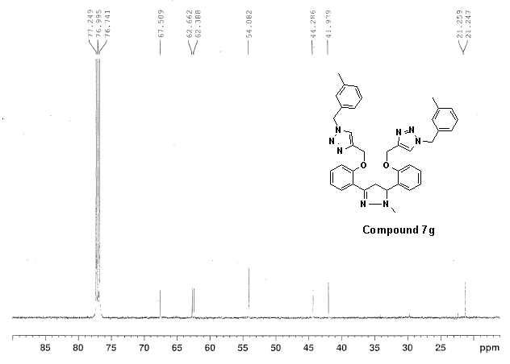
Figure S65: ¹³C NMR (125 MHz, CDCl₃) spectra of compound 7g
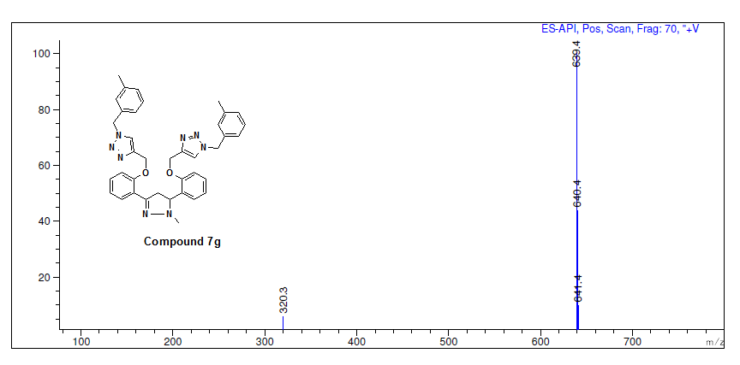
Figure S66: Mass spectra of compound 7g
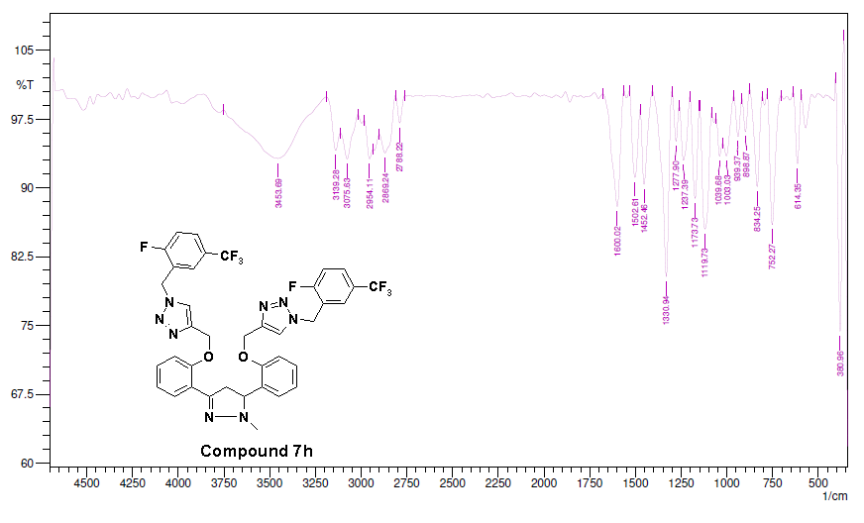
Figure S67: IR spectra of compound 7h
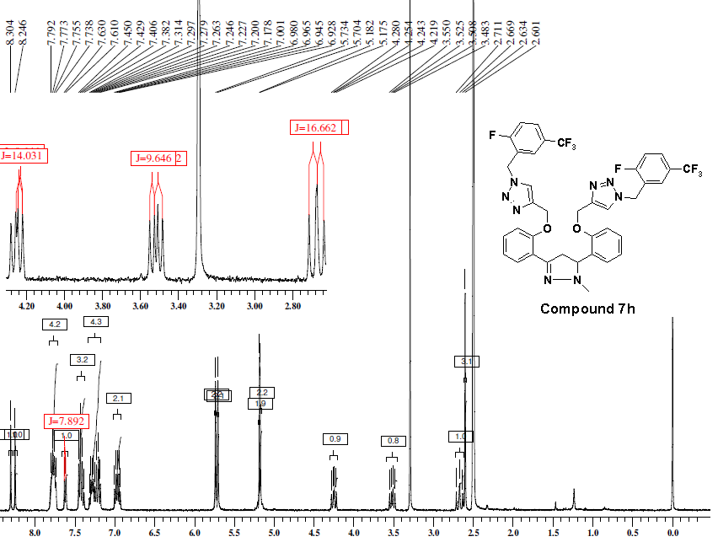
Figure S68: ¹H-NMR (400 MHz, DMSO-d₆) spectra of compound 7h
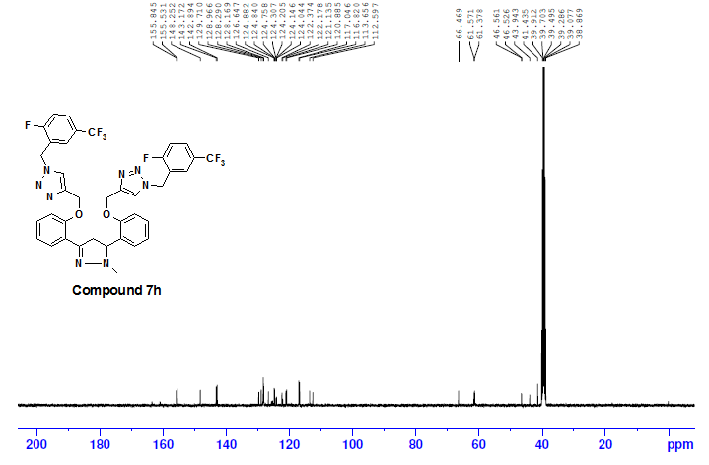
Figure S69: ¹³C NMR (100 MHz, DMSO-d₆) spectra of compound 7h
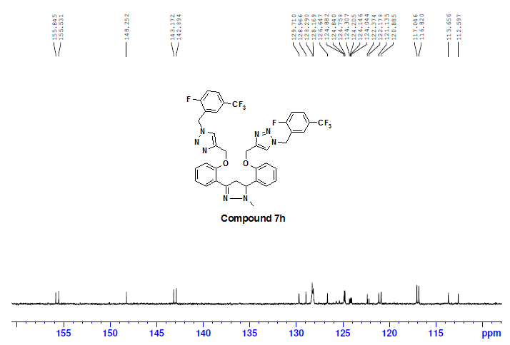
Figure S70: ¹³C NMR (100 MHz, DMSO-d₆) spectra of compound 7h
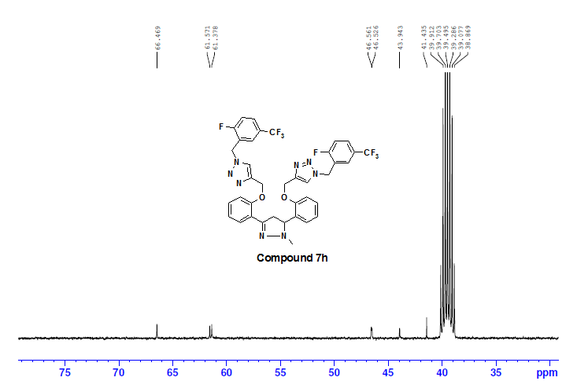
Figure S71: ¹³C NMR (100 MHz, DMSO-d₆) spectra of compound 7h
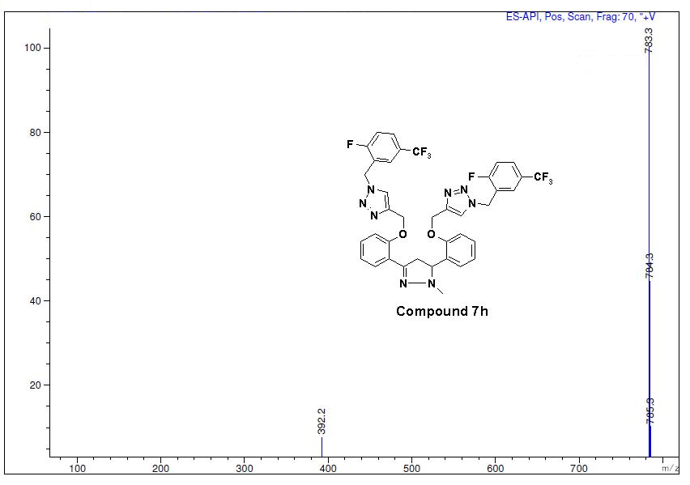
Figure S72: Mass spectra of compound 7h
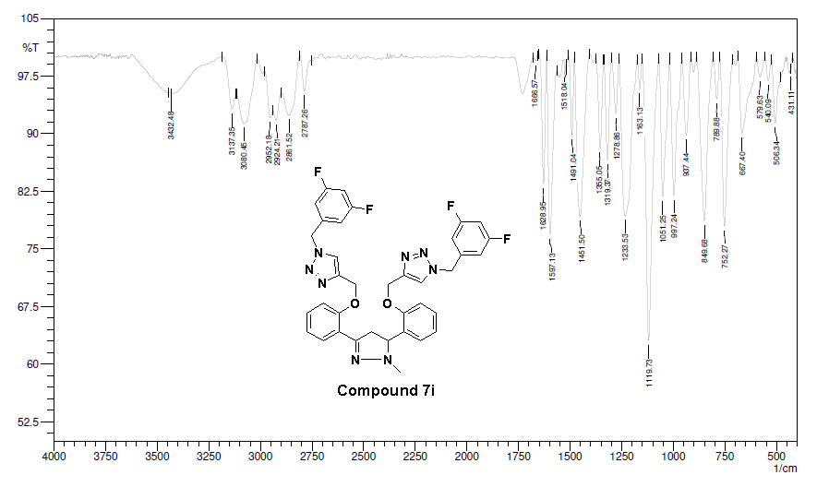
Figure S73: IR spectra of compound 7i
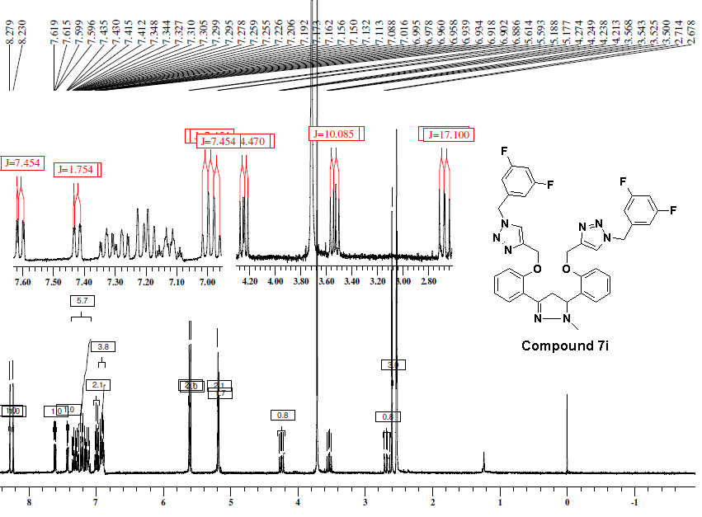
Figure S74: ¹H-NMR (400 MHz, DMSO-d₆) spectra of compound 7i
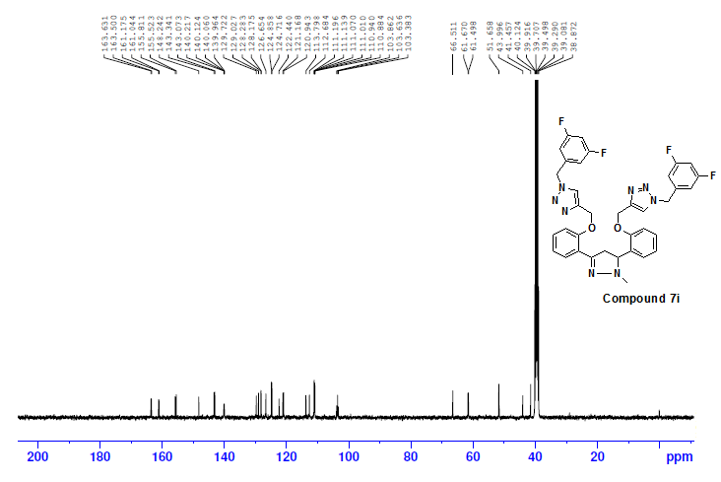
Figure S75: ¹³C NMR (100 MHz, DMSO-d₆) spectra of compound 7i
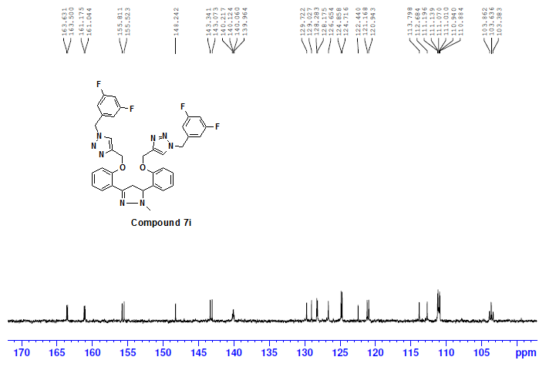
Figure S76: ¹³C NMR (100 MHz, DMSO-d₆) spectra of compound 7i
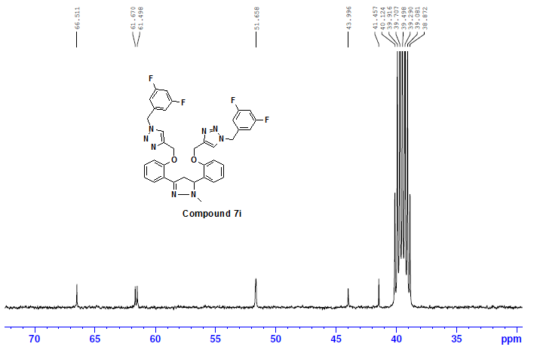
Figure S77: ¹³C NMR (100 MHz, DMSO-d₆) spectra of compound 7i

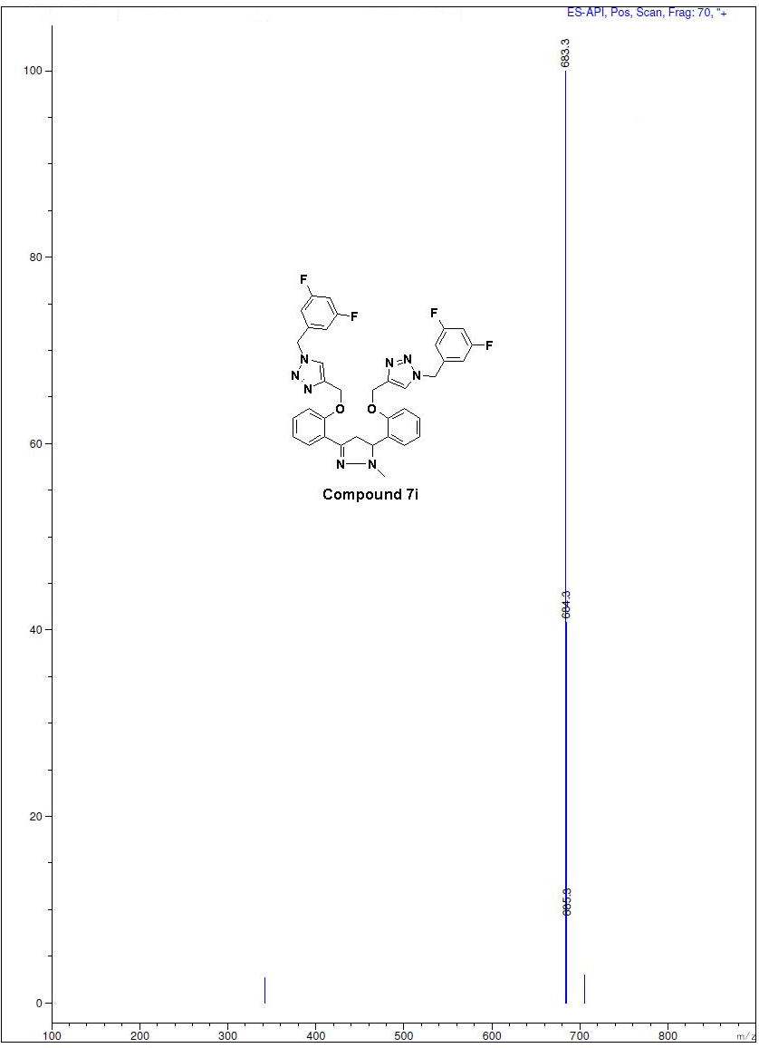
Figure S78: Mass spectra of compound 7i
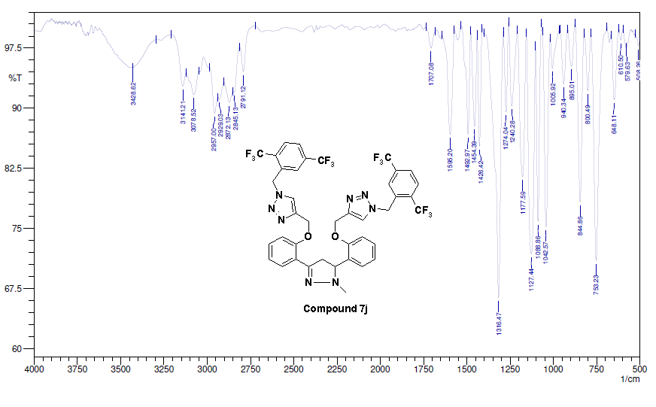
Figure S79: IR spectra of compound 7j
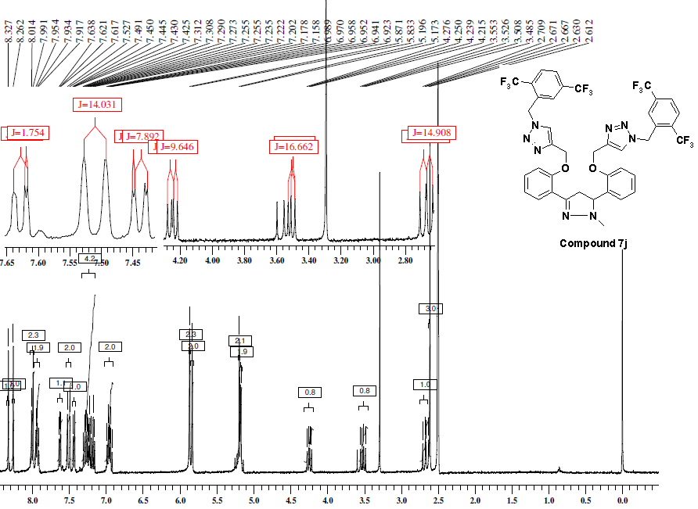
Figure S80: ¹H-NMR (400 MHz, DMSO-d₆) spectra of compound 7j
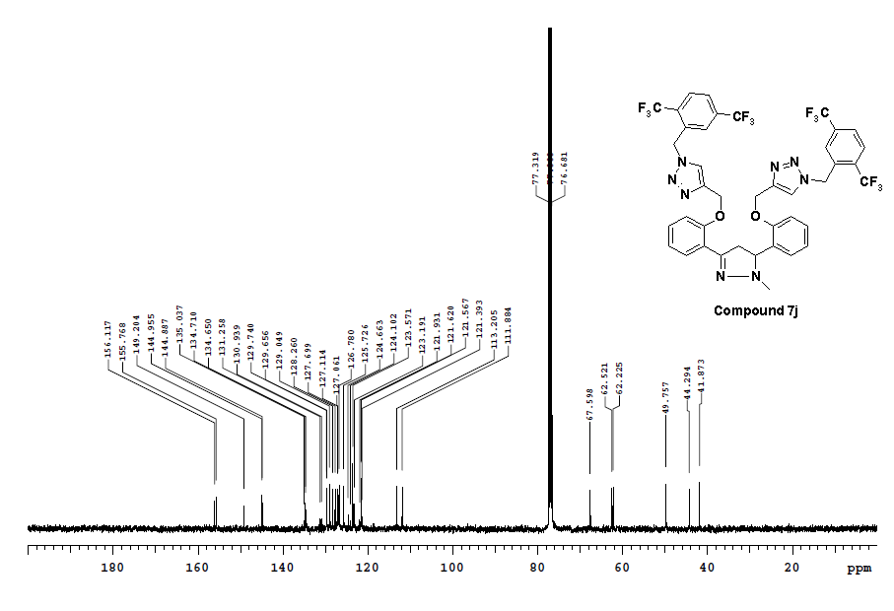
Figure S81: ¹³C NMR (100 MHz, CDCl₃) spectra of compound 7j
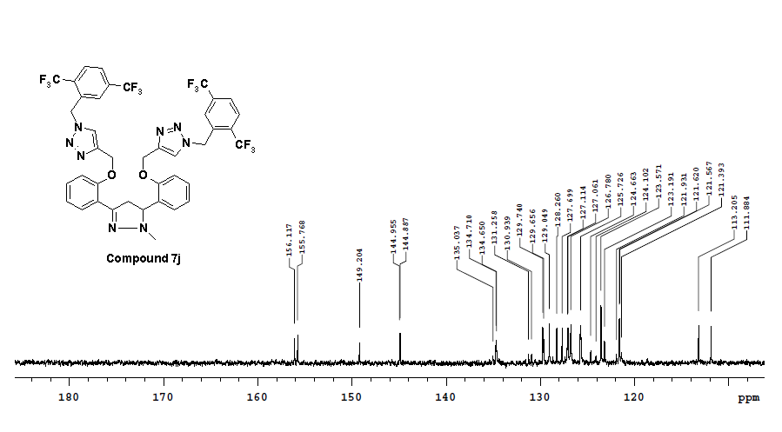
Figure S82: ¹³C NMR (100 MHz, CDCl₃) spectra of compound 7j
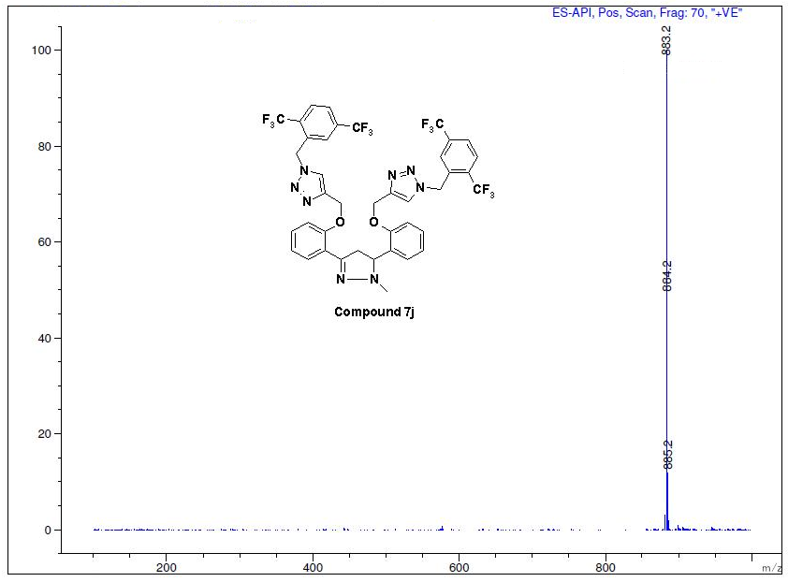
Figure S83: Mass spectra of compound 7j

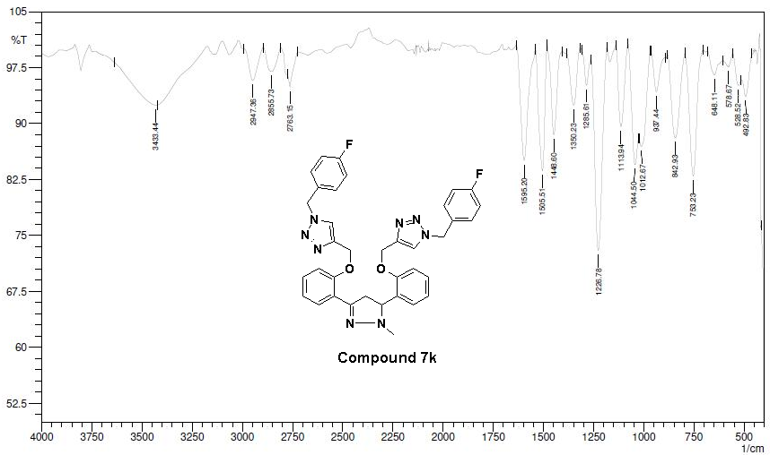
Figure S84: IR spectra of compound 7k
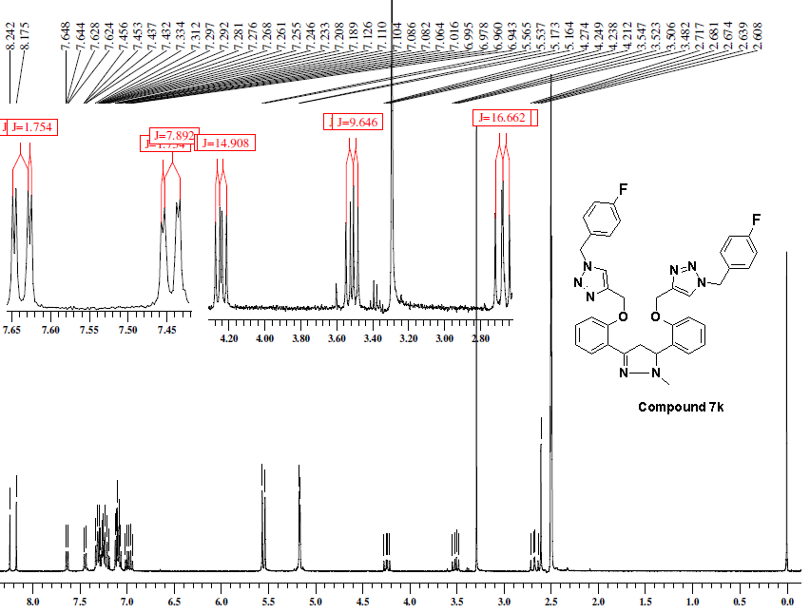
Figure S85: ¹H-NMR (400 MHz, DMSO-d₆) spectra of compound 7k

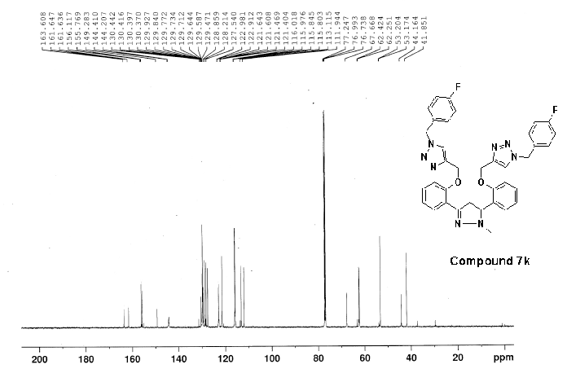
Figure S86: ¹³C NMR (125 MHz, CDCl₃) spectra of compound 7k

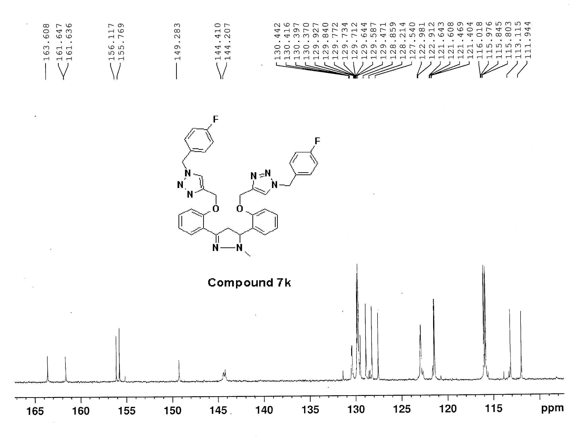
Figure S87: ¹³C NMR (125 MHz, CDCl₃) spectra of compound 7k
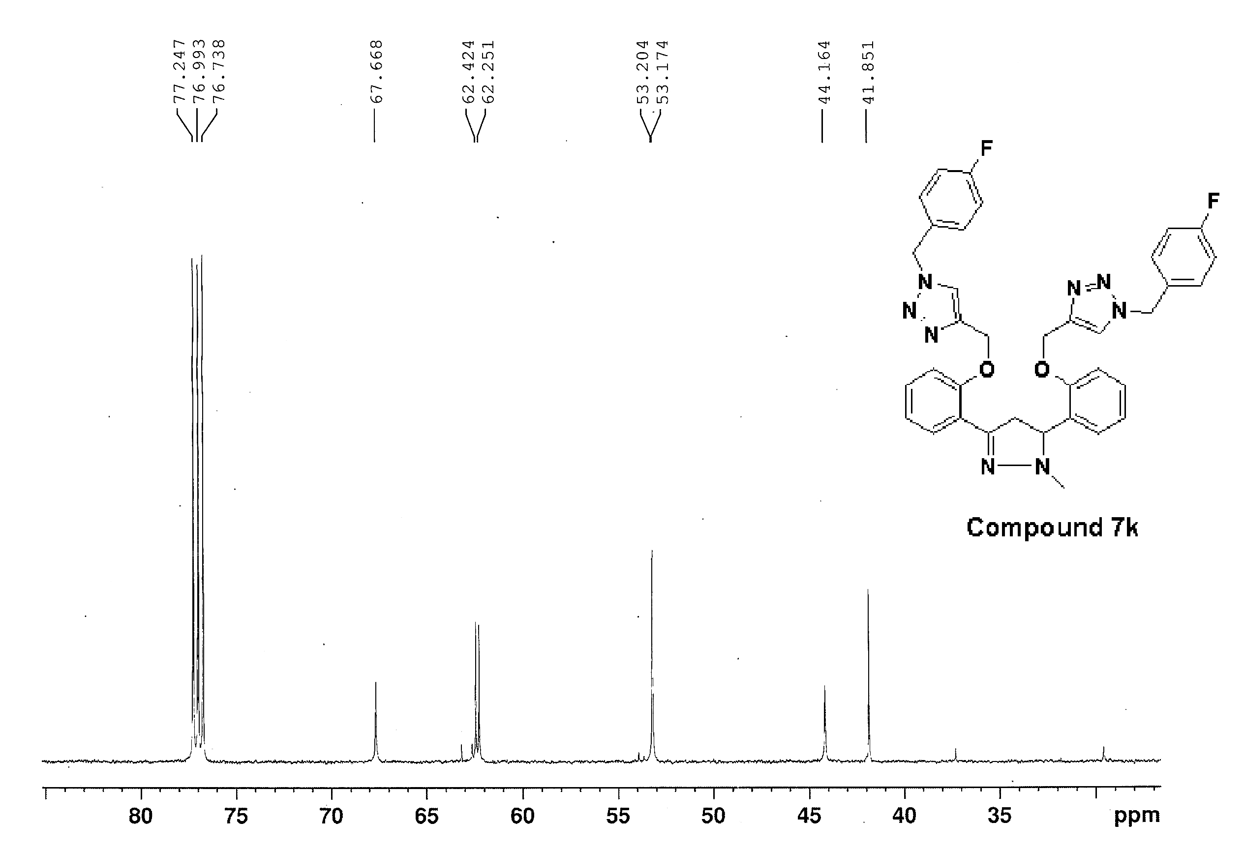
Figure S88: ¹³C NMR (125 MHz, CDCl₃) spectra of compound 7k
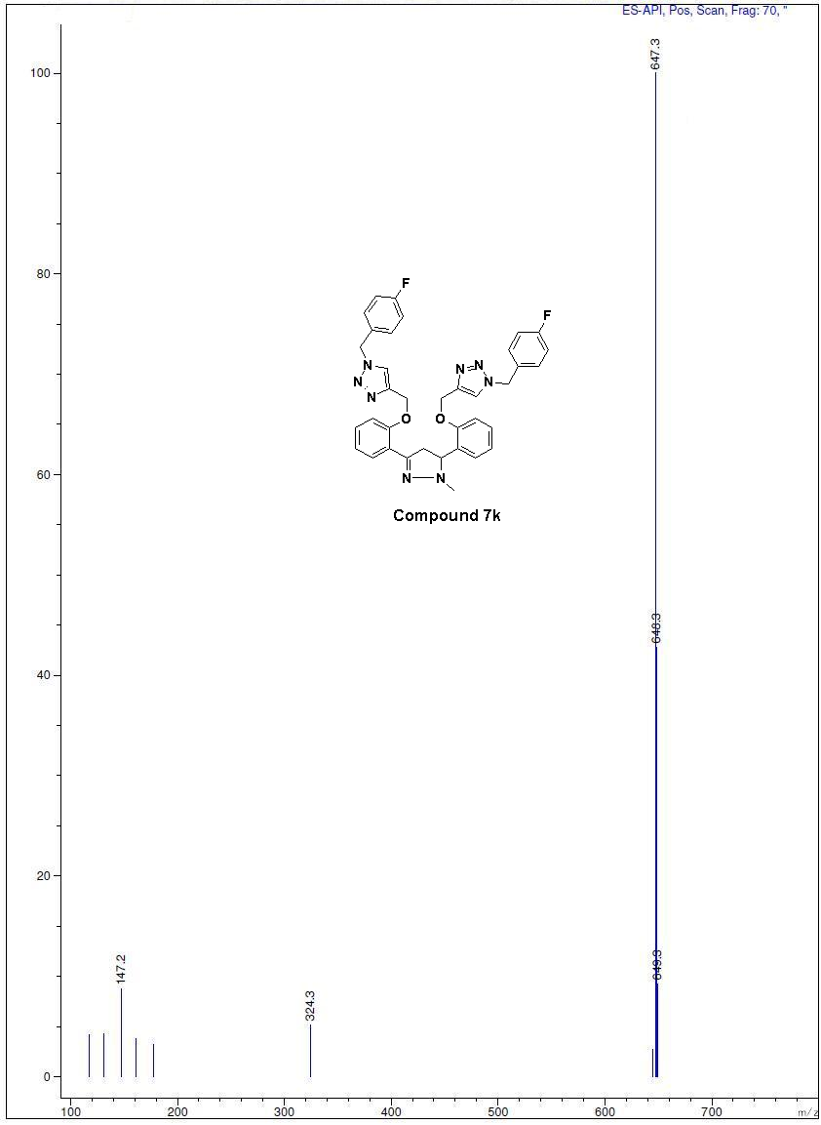 Figure S89: Mass spectra of compound 7k

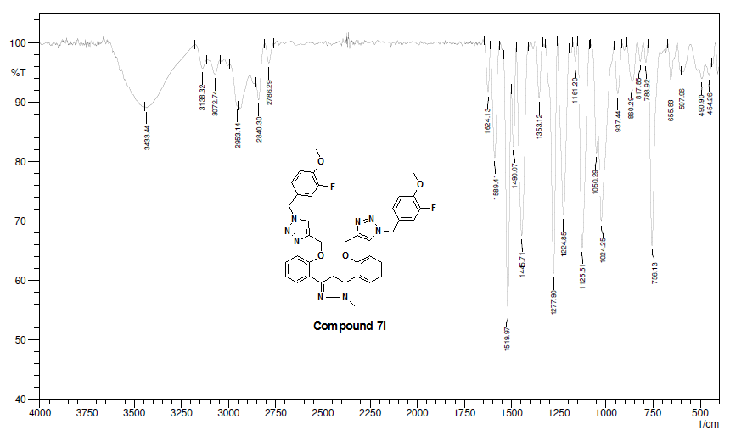
Figure S90: IR spectra of compound 7l
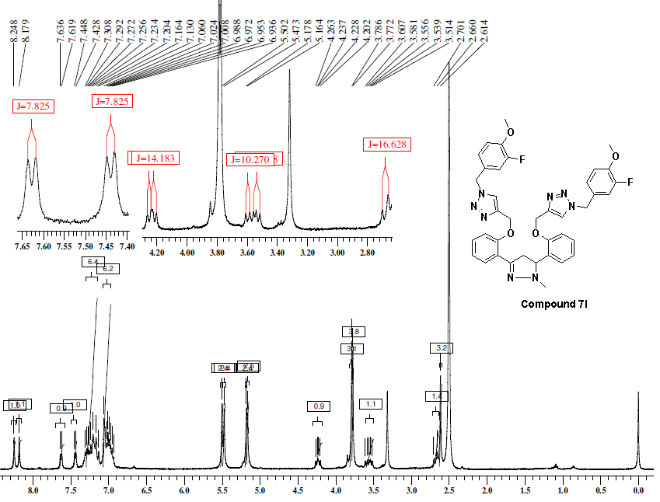
Figure S91: ¹H-NMR (500 MHz, DMSO-d₆) spectra of compound 7l

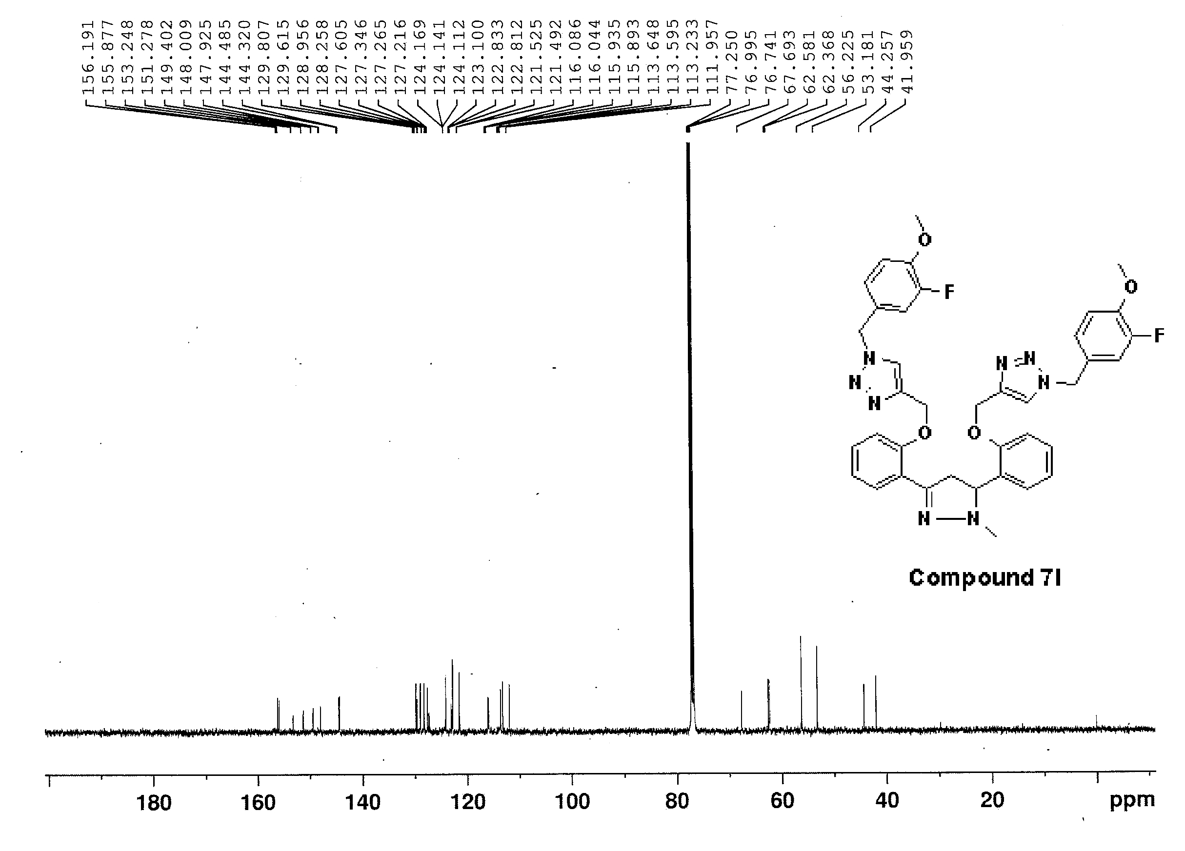
Figure S92: ¹³C NMR (125 MHz, CDCl₃) spectra of compound 7l
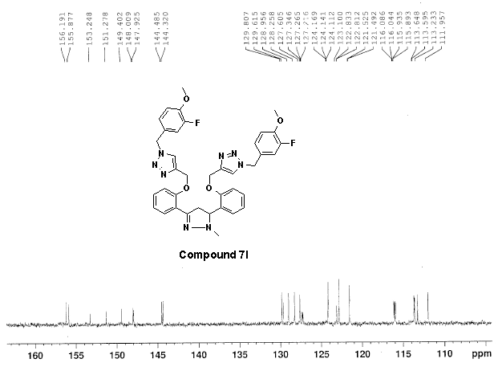
Figure S93: ¹³C NMR (125 MHz, CDCl₃) spectra of compound 7l

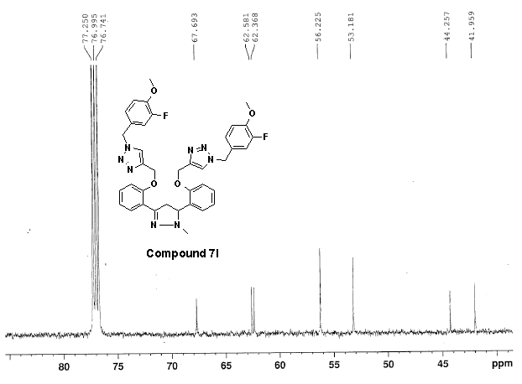
Figure S94: ¹³C NMR (125 MHz, CDCl₃) spectra of compound 7l
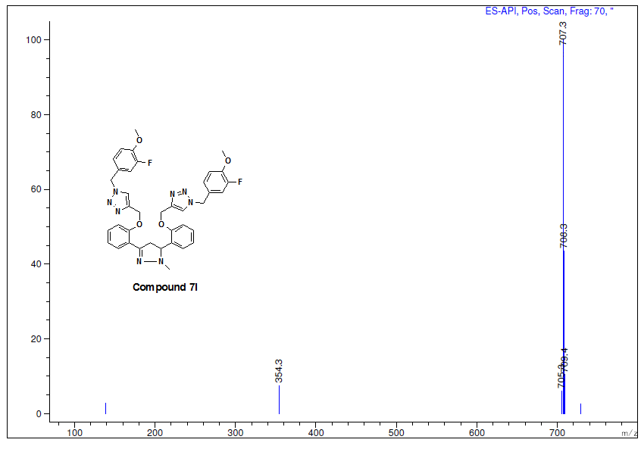
Figure S95: Mass spectra of compound 7l
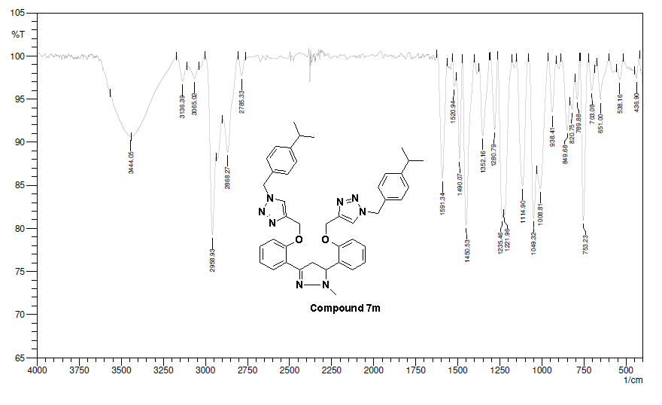
Figure S96: IR spectra of compound 7m
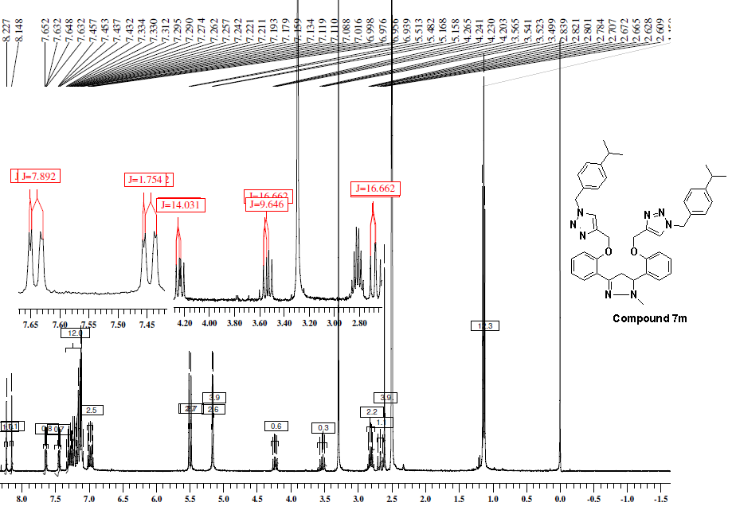
Figure S97: ¹H-NMR (400 MHz, DMSO-d₆) spectra of compound 7m

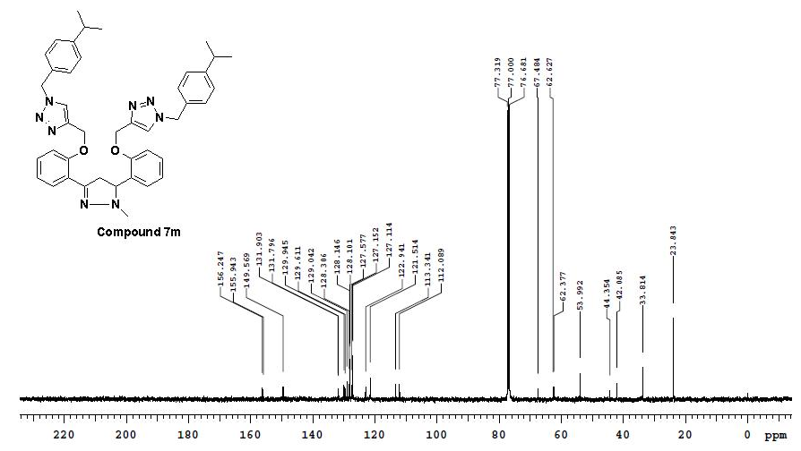
Figure S98: ¹³C NMR (100 MHz, CDCl₃) spectra of compound 7m

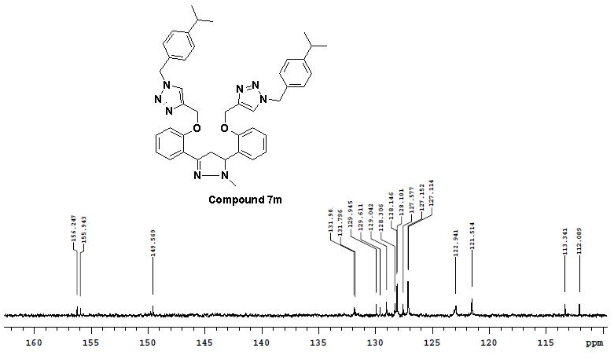
Figure S99: ¹³C NMR (100 MHz, CDCl₃) spectra of compound 7m

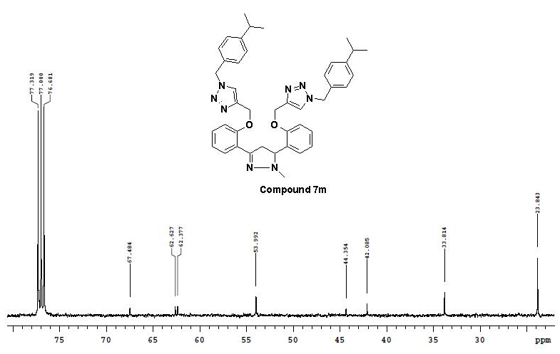
Figure S100: ¹³C NMR (100 MHz, CDCl₃) spectra of compound 7l
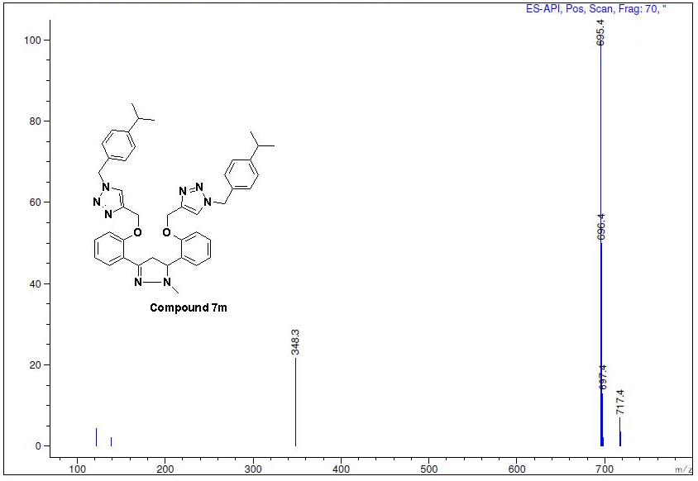
Figure S101: Mass spectra of compound 7m

