Supplementary Information

Facile and rapid synthesis of divers xanthene derivatives using Lanthanum(III) chloride/chloroacetic acid as an efficient and reusable catalytic system under solvent-free conditions
Behjat Pouramiriª, Maryam Shirvaniª and Esmat Tavakolinejad Kermani^{a*}
ªFaculty of Science, Depatrtment of Chemistry, Shahid Bahonar University of Kerman, Kerman, 76169, Iran.

Spectra
¹H NMR and ¹³C NMR of 9,9-dimethyl-12-phenyl-9,10-dihydro-8H-benzo[a]xanthen-11(12H)-one (5a):
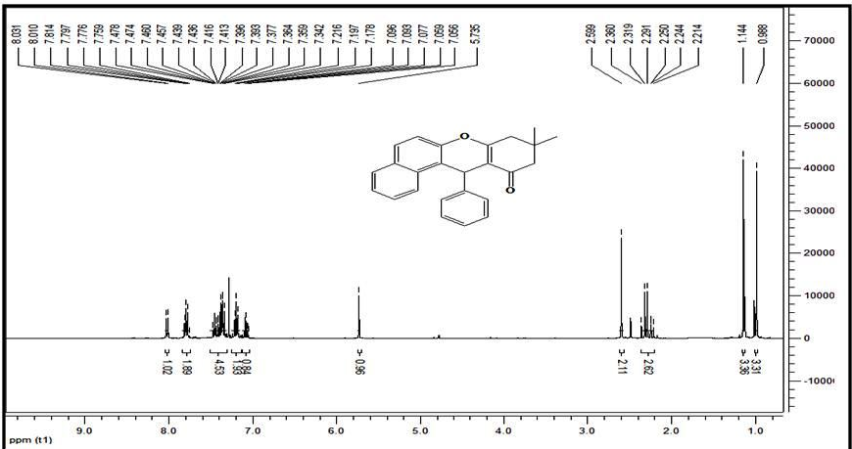

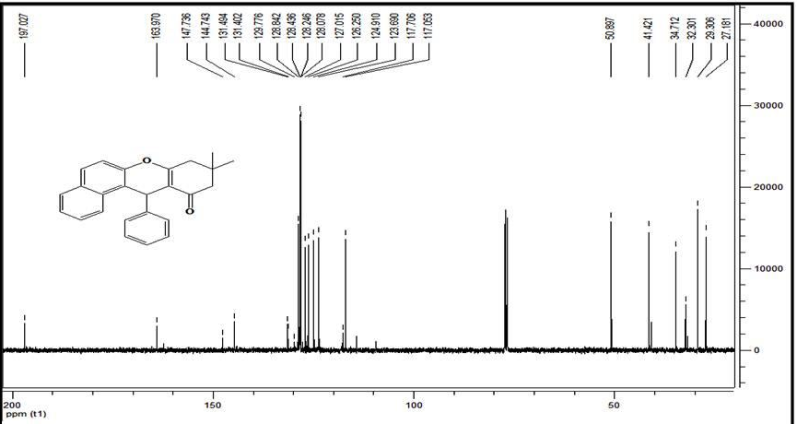

¹H NMR and ¹³C NMR of 12-(4-hydroxyphenyl)-9,9-dimethyl-9,10-dihydro-8H-benzo[a]xanthen-11(12H)-one (5b):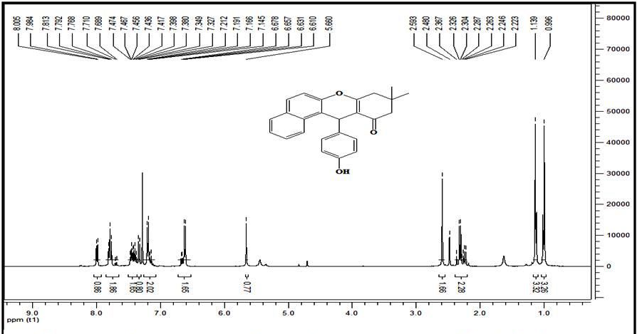

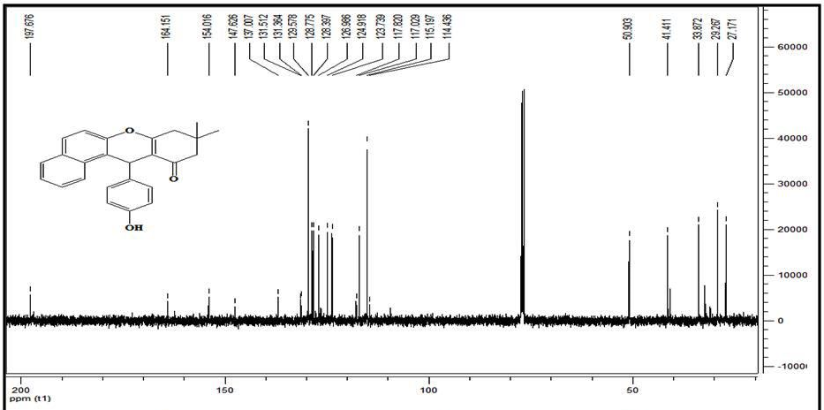

¹H NMR and ¹³C NMR of 12-phenyl-9,10-dihydro-8H-benzo[a]xanthen-11(12H)-one (5c):
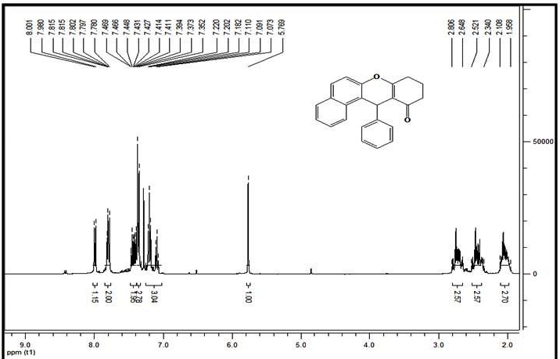
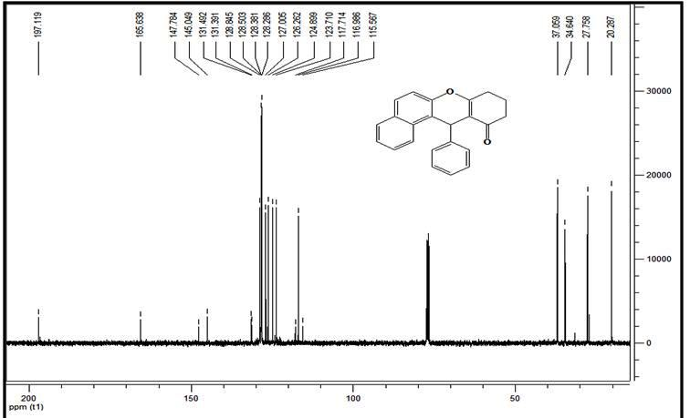

¹H NMR of 12-(3-nitrophenyl)-9,10-dihydro-8H-benzo[a]xanthen-11(12H)-one (5d)
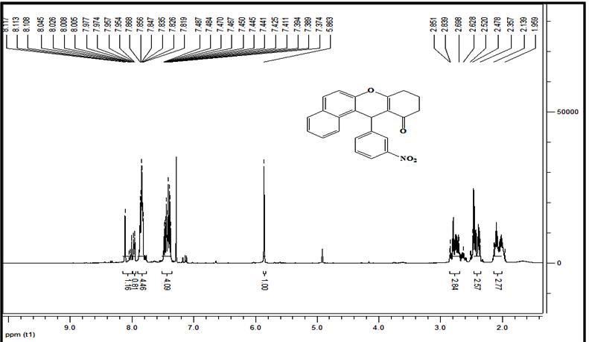

¹H NMR and ¹³C NMR of 12-(4-nitrophenyl)-9,10-dihydro-8H-benzo[a]xanthen-11(12H)-one (5e):
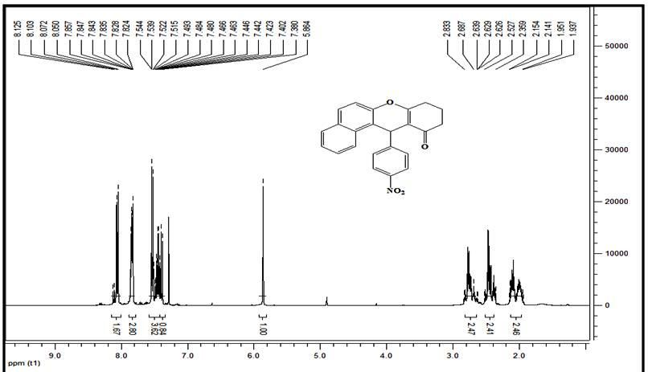

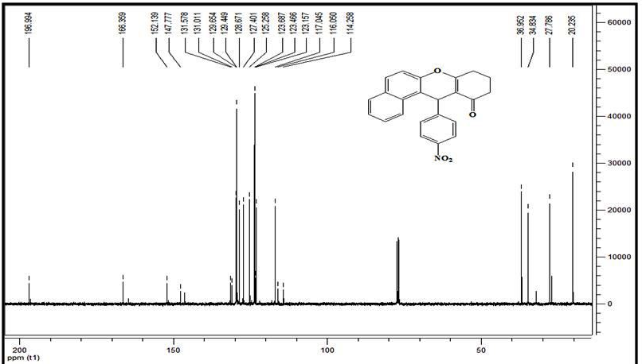

¹H NMR and ¹³C NMR of 9,10 -dihydro-12-(4-hydroxyphenyl)-8H-benzo[a]xanthene-11(12H)-one (5f):
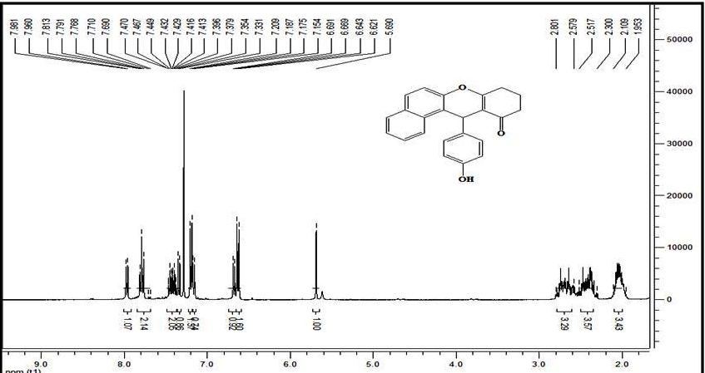

¹H NMR and ¹³C NMR of 3,4,7-tetrahydro-9-phenyl-2H-xanthene-1,8(5H,9H)-dione (6a) :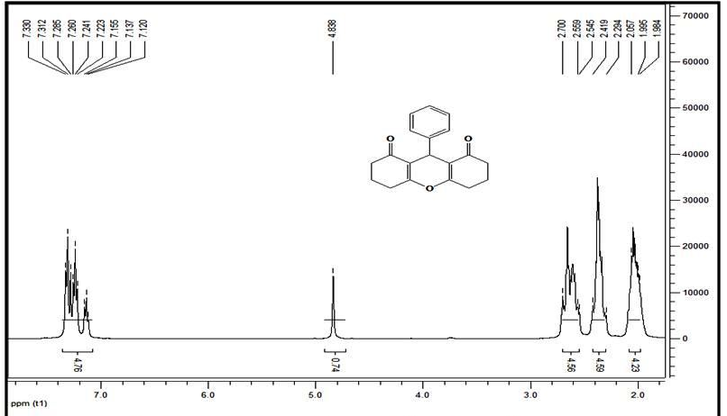

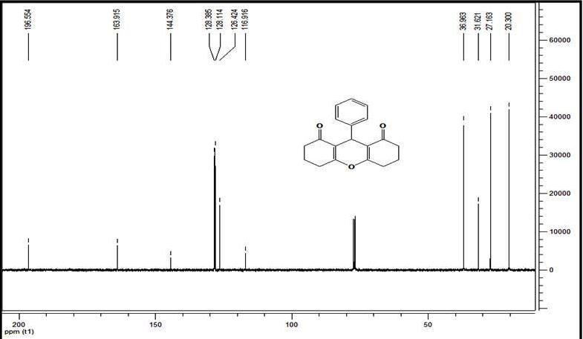

¹H NMR and ¹³C NMR of 9-(4-chiorophenyl)-3,4,6,7-tetrahydro-2H-xanthene-1,8(5H,9H)-dione (6b) :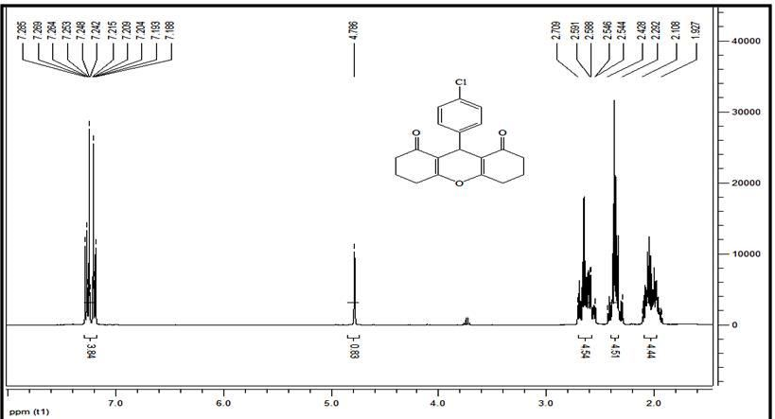

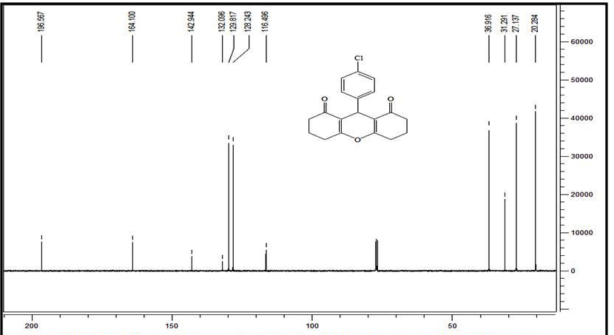

¹H NMR and ¹³C NMR of 3,4,7-tetrahydro-9-(4-hydroxyphenyl)-2H-xanthene-1,8(5H,9H)-dione (6c):
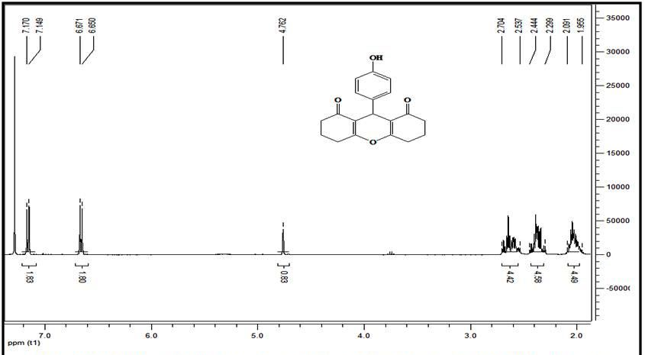

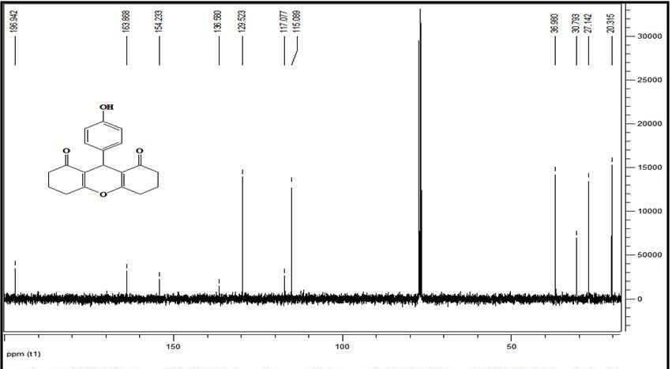

1H NMR and 13C NMR of 9-(p-tolyl)-3,4,5,6,7,9-hexahydro-1H-xanthene-1,8(2H)-dione (6d):
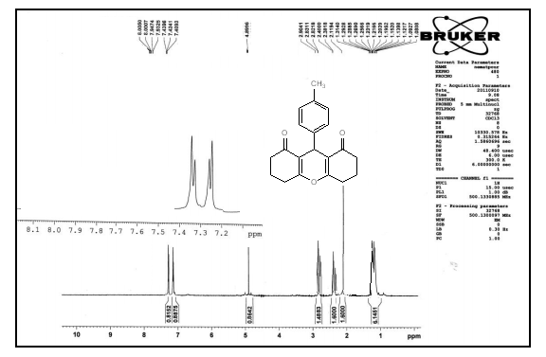

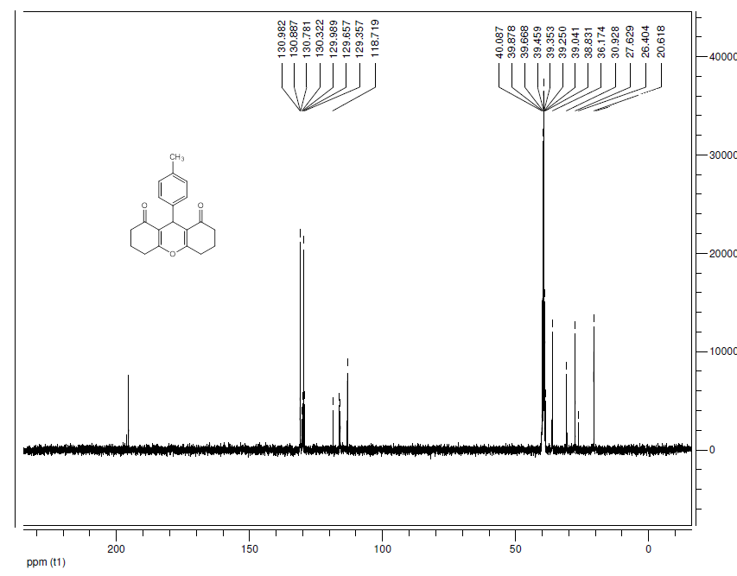
¹H NMR and ¹³C NMR of 3,4,6,7-tetrahydro-9-(4-nitrophenyl)-2H-xanthene-1,8(5H,9H)-dione (6e)
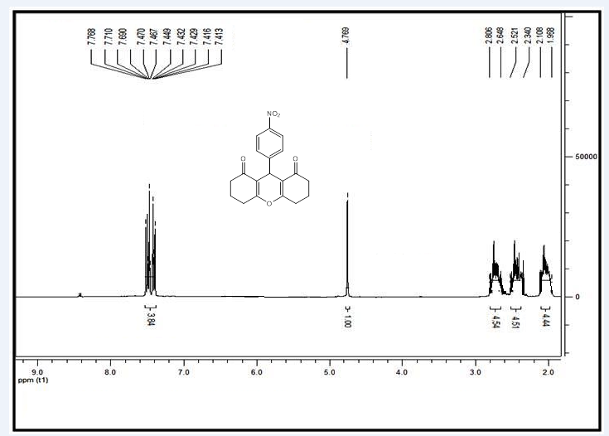

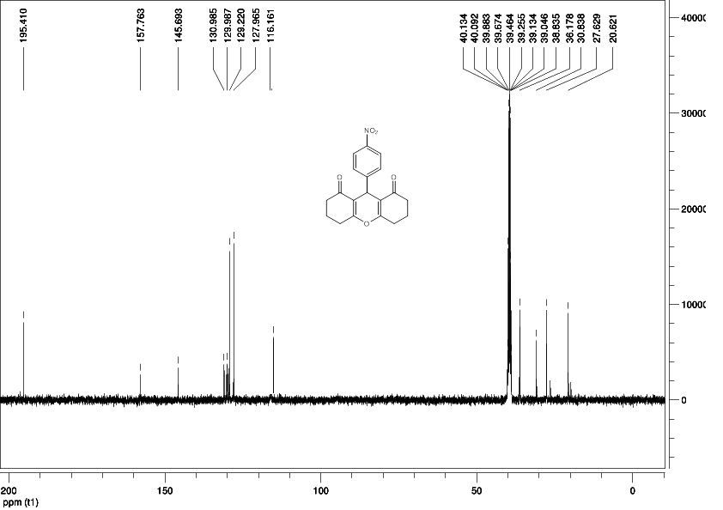

¹H NMR and ¹³C NMR of 9-(3-nitrophenyl)-3,4,5,6,7,9-hexahydro-1H-xanthene-1,8(2H)-dione (6f ):
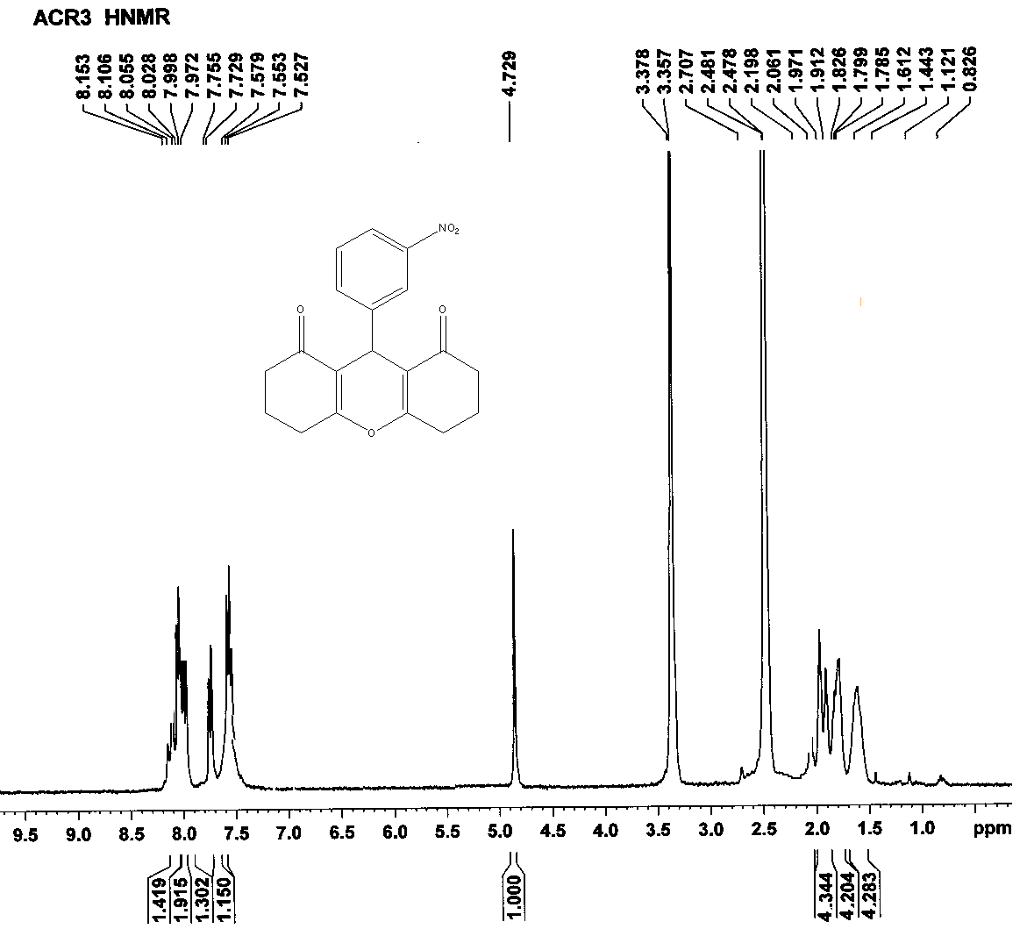

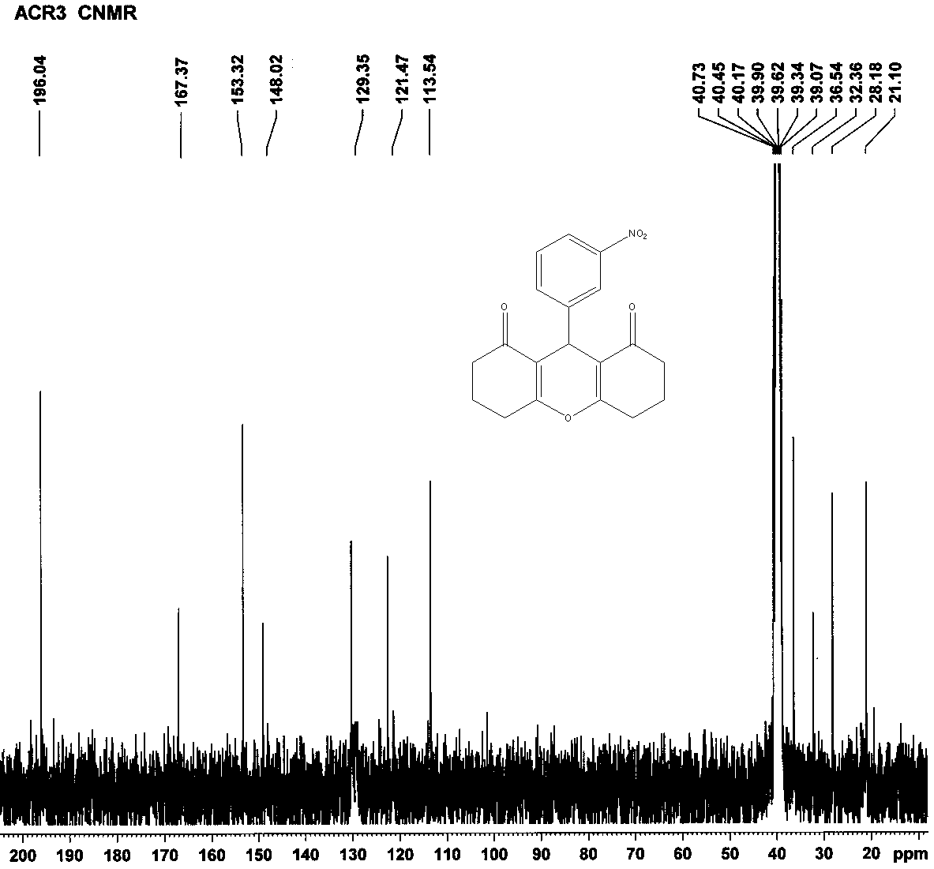
1H NMR and 13C NMR of 3,3,6,6-tetramethyl-9-phenyl-3,4,5,6,7,9-hexahydro-1H-xanthene-1,8(2H)-dione (6g):
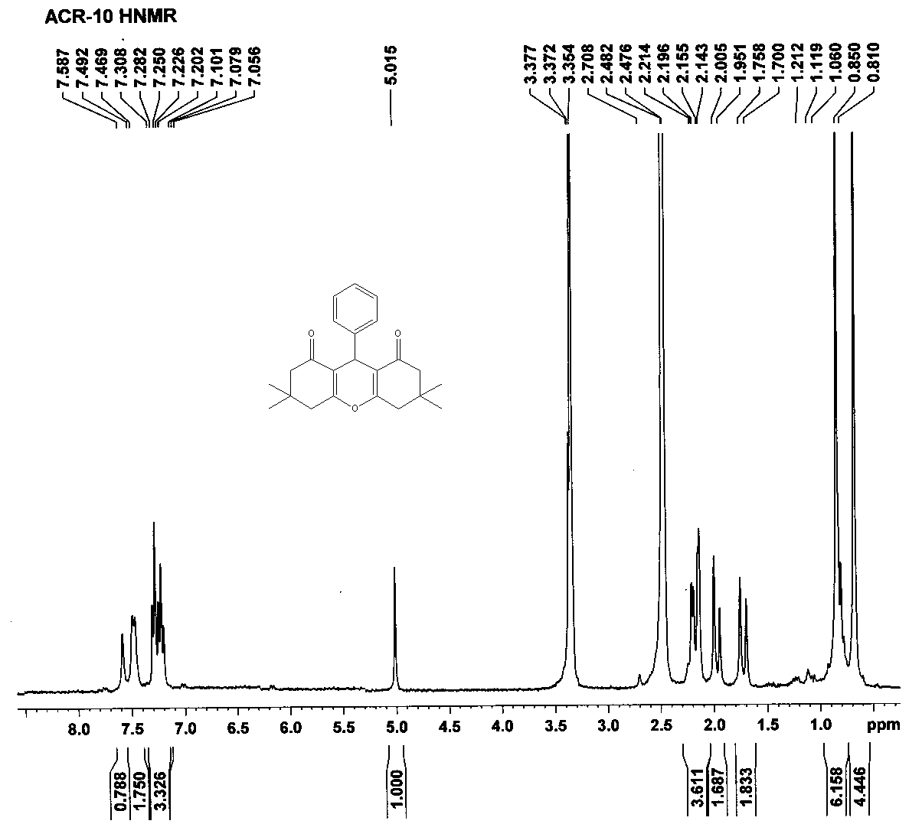
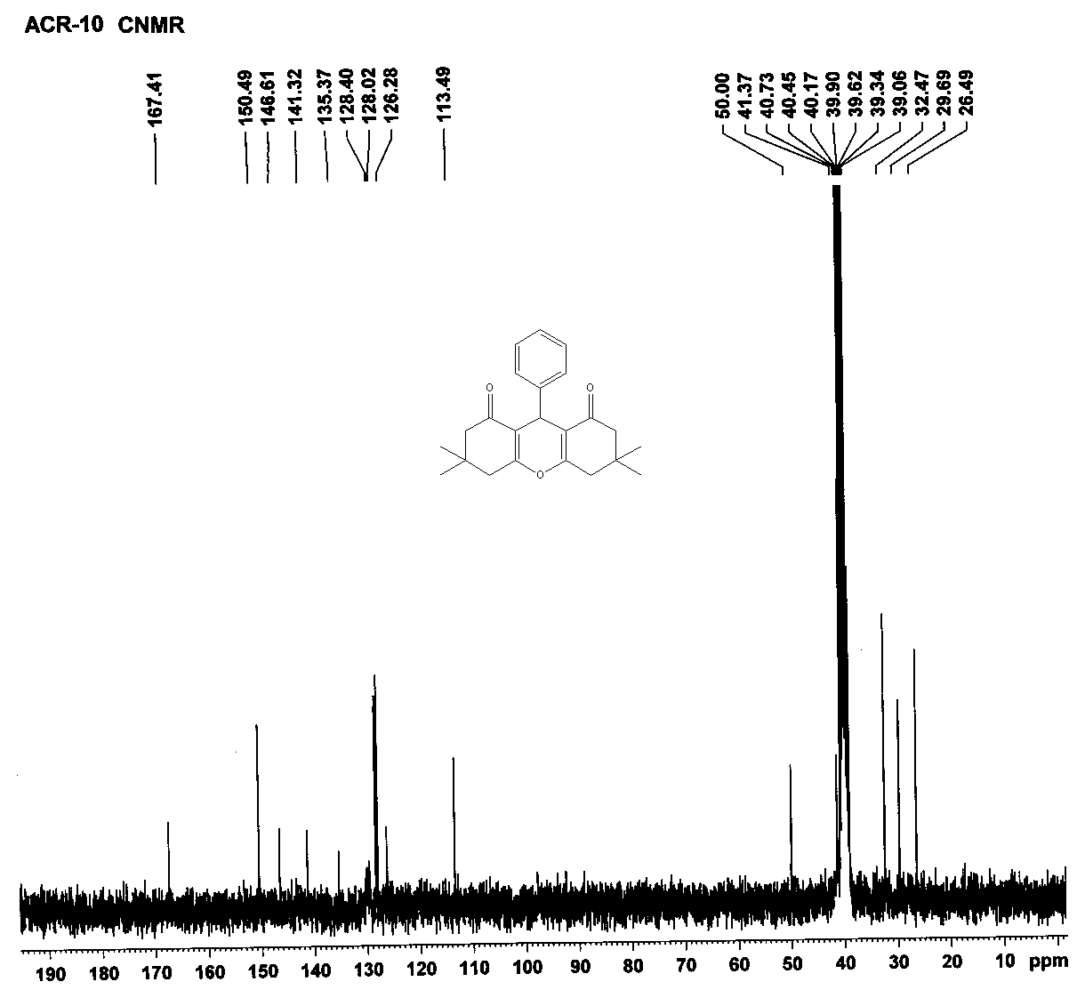

1H NMR and 13C NMR of 9-(4-chlorophenyl)-3,3,6,6-tetramethyl-3,4,5,6,7,9-hexahydro-1H-xanthene-1,8(2H)-dione (6h):
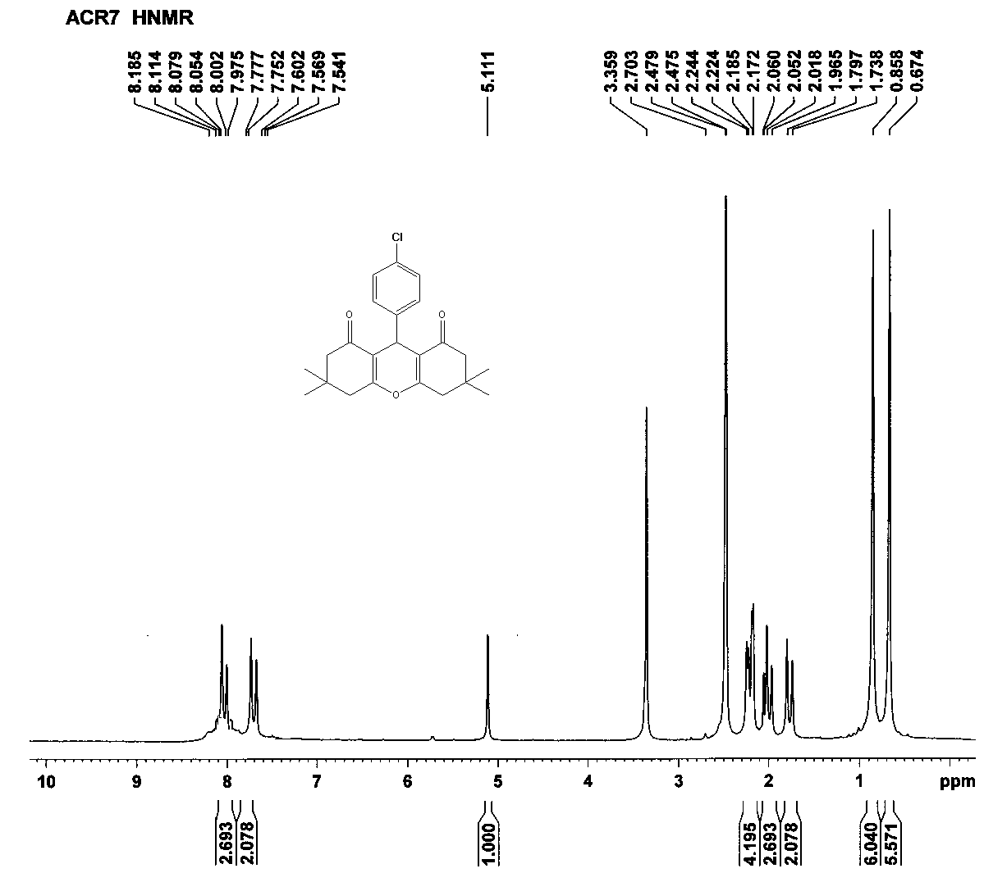
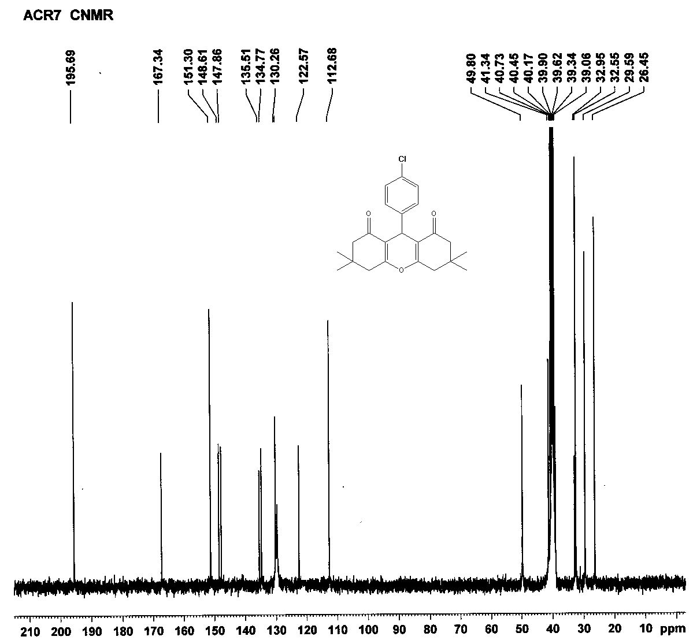

¹H NMR and ¹³C NMR of 11-phenyl-10H-diindeno[1,2-b:2',1'-e]pyran-10,12(11H)-dione
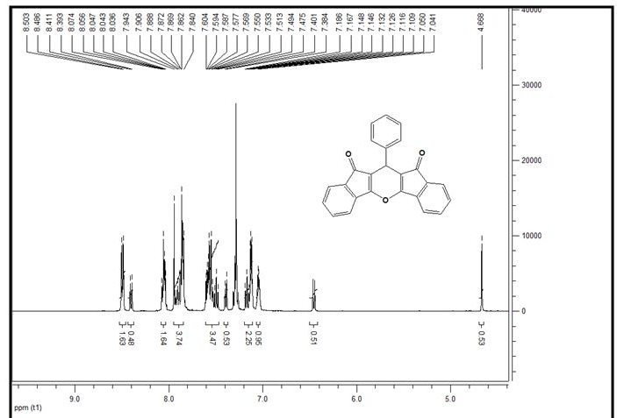

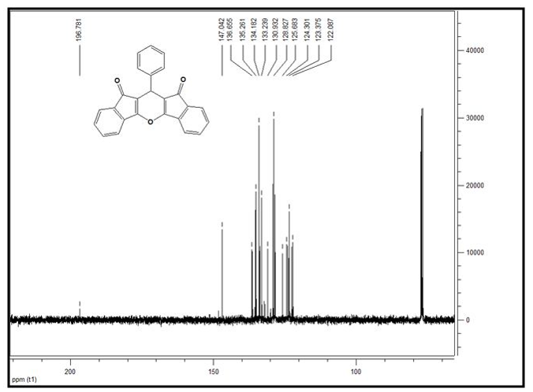

¹H NMR and ¹³C NMR of 11-(4-chlorophenyl)-10H-diindeno[1,2-b:2',1'-e]pyran-10,12(11H)-dione (7b):
