UNIVERSITY OF KERALA

DEPARTMENT OF CHEMISTRY

M. Priya Rani, Ph. D.
UGC Kothari PDF

COVER LETTER

Dear Sir:

I wish to submit the revised article entitled “Hindered phenolic aminothiazoles – Synthesis, α-glucosidase, α-amylase inhibitory and antioxidant activities” for favor of publication in Journal of the Serbian Chemical Society. All the corrections and modifications were done in the manuscript and in the supplementary material according to editor and reviewer comments. A list of queries and responses are also attached for your kind perusal. The Authors warranty that the manuscript submitted to the Journal is original, has been written by the stated authors and has not been published elsewhere; is currently not being considered for publication by any other journal and will not be submitted for such a review; the manuscript contains no libellous or other unlawful statements and does not contain any materials that violate any personal or proprietary rights of any other person or entity.
Thanking you and with warm regards
Sincerely,

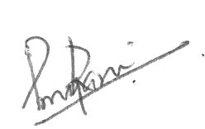
M. Priya Rani

