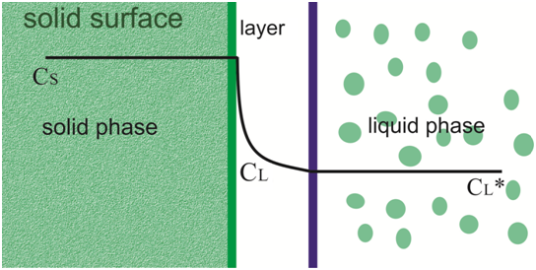

The chlorophyll was transferred from solid phase, i.e., surface of pandan leaf to the liquid phase, i.e. solvent. The correlation for the mass transfer using dimensionless number is described as $Sh=92.591 {\left[Re\right]}^{0.094}.{\left[Sc\right]}^{0.278}$

