SUPPLEMENTARY MATERIAL TO
Possibilities of assessing trace metal pollution using Betula pendula Roth. leaf and bark – experience in Serbia
DRAGANA PAVLOVIĆ ^{1*}, MARIJA PAVLOVIĆ ¹, MILICA MARKOVIĆ ¹, BRANKO KARADŽIĆ ¹, OLGA KOSTIĆ ¹, SNEŽANA JARIĆ ¹, MIROSLAVA MITROVIĆ ¹, IVAN GRŽETIĆ ² and PAVLE PAVLOVIĆ ¹
¹Department of Ecology, Institute for Biological Research “Siniša Stanković”, University of Belgrade, Bulevar despota Stefana 142, 11000 Belgrade, Serbia
²Faculty of Chemistry, University of Belgrade, Studentski trg 12-16, 11000 Belgrade, Serbia
E-mail: dragana.pavlovic@ibiss.bg.ac.rs

SOME EXPERIMENTAL DETAILS

Study area
Pančevo (44°54'00" north, 20°40'00" east, Hs 77 m) is an industrial city located in Vojvodina, the northern province of the Republic of Serbia with over 76 000 inhabitants. It lies at the confluence of the Tamiš and the Danube rivers (Figure 1a). The sampling site in Pančevo was the National Garden the main city park located in the southeast part of the city. Major sources of pollution are the oil refinery, nitric fertilizers factory and petrochemical industry in Pančevo.
Smederevo (40°39'00" north, 20°57'00" east, H_{s} 73 m) is city located in the north-east of the Republic of Serbia. It lies on the right bank of the Danube River (Figure 1b). The urban zone covers about 38 km² with over 62 000 inhabitants. The sampling site in Smederevo was the city park located in the central zone of the city. The main source of pollution in Smederevo is the steel manufacturing conglomerate “Železara Smederevo” located in the industrial zone 7 km southeast of the city center.
Obrenovac (44°39'00" north, 20°12'00" east, H_{s} 76 m) is one of the 17 municipalities of Belgrade located at the confluence of rivers Kolubara and Sava with about 25 000 inhabitants (Figure 1d). The largest thermoelectric power plant in Serbia, “Nikola Tesla A” (TENT-A), is located in the municipality of Obrenovac and produces the largest amount of fly ash (around 3.6 Mt a year) in Serbia.¹ The sampling site in Obrenovac was the main park located 4 km from the source of pollution (the thermoelectric power plant and fly ash disposal site).
Belgrade (44°49'14" north, 20°27'44" east, H_{s} 117 m) is the capital and largest city in Serbia, and has a population of around 1.7 million. It is situated in southeastern Europe on the Balkan Peninsula, at the confluence of the Sava and Danube rivers (Figure 1c). Two sites with regard to source of pollution were selected in Belgrade: the “Pioneer” park in the central zone of the city exposed to car exhaust pollution (polluted site), as one of the most polluted areas of the city² and the control site - the Arboretum of the Faculty of Forestry which is a protected natural area and a valuable archive of domestic and foreign tree species in Belgrade located in an area without a direct source of pollution; it is situated 10 km far from the city center within the zone of mixed Quercus frainetto and Quercus cerris forest.

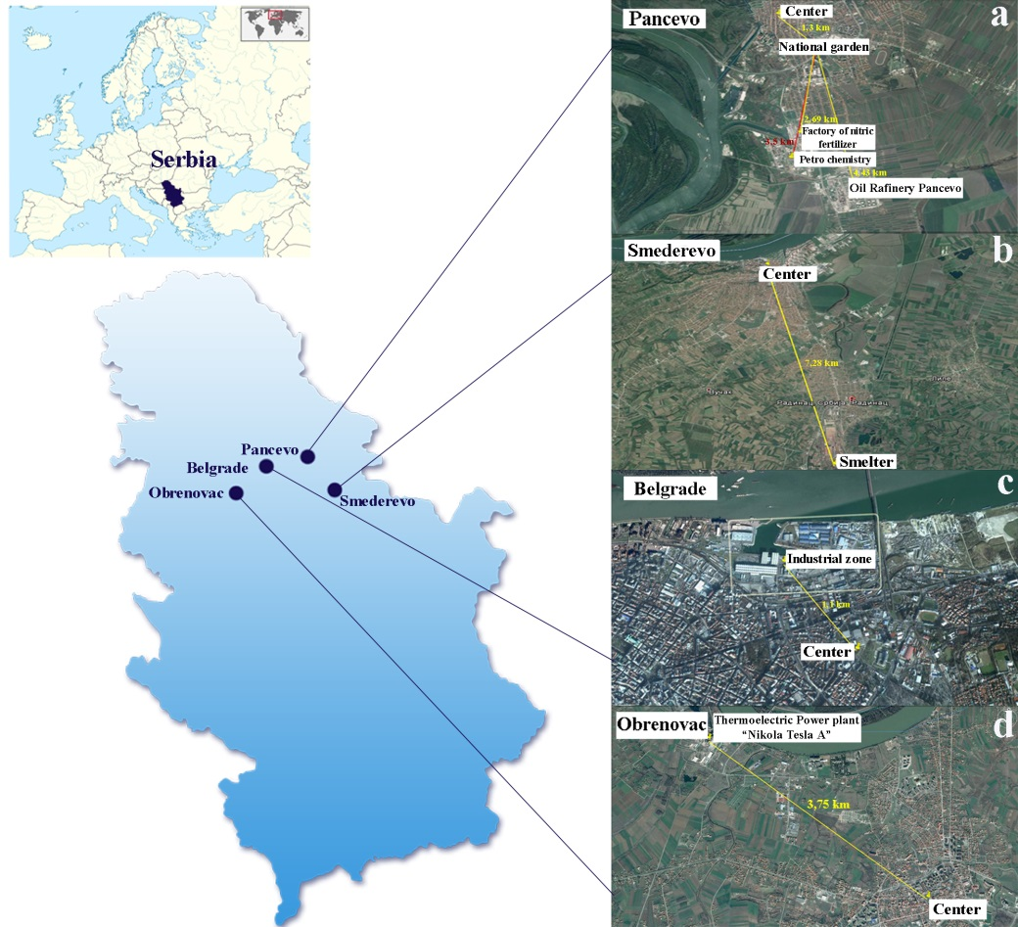
Fig 1. Urban sampling sites in Serbia: a) Pančevo, b) Smederevo, c) Belgrade, d) Obrenovac and distance from source of pollution
Species description
Silver birch (Betula pendula Roth.) belongs to the genus Betula L. which belongs to the family Betulaceae in the order Fagales. The genus Betula contains some 60 known taxa that are distributed throughout the southern temperate region. Silver birch is medium-sized deciduous tree, with golden-brown bark that later turns to white as a result of a papery tissue developing on the surface and peeling off in flakes. The bark remains smooth until the tree gets quite large, but in older trees, the bark thickens, becoming irregular, dark and rugged. The leaves are roughly triangular with broad, untoothed, wedge-shaped bases, slender pointed tips and coarsely double-toothed, serrated margins and, therefore, have the potential to be efficient particulate scavengers. Birch belongs to the Euro-Siberian floristic geographic element and grows naturally in most of Europe. It is widely planted in urban parks and gardens as a ruderal ornamental tree.³

Sampling
The research was carried out at three monthly intervals (June, August, October) during the year 2012. It should be mentioned that it was the warmest and the least rainy year (in relation to the 1981-2010 reference period), which surpassed the number of tropical days and nights since the beginning of their measurement in Serbia.⁴
Composite topsoil samples at 0-10 cm of depth were taken at 5 points around each tree using a stainless-steel shovel. Foreign objects and stones were removed by hand, and samples were packed in clean plastic bags.
Plant samples from selected individuals of trees commonly occurring at all examination sites were collected. Leaves were taken uniformly from the lower foliage and from different quarters of the tree crowns with stainless-steel scissors using polyethylene gloves, with an initial quantity of about 30 g of each sample. Flakes of the bark layer of about 4-5 mm thickness and maximum dimensions about 1×3 cm² were carefully cut with a stainless-steel knife at 1.2-1.5 m above ground level (in all directions around a tree).
References

- O. Kostić, M. Mitrović, M. Knežević, S. Jarić, G. Gajić, L. Djurdjević, P. Pavlović, Arch. Biol. Sci. 64 (2012) 145
- Institute of Public Health of the Republic of Serbia, Report on Air Pollution Caused by Substances from Exhaust Emissions, ISO Health Related Particle Sampling Conventions IS 7708, Belgrade ISO. 1994, 2004 (in Serbian)
- B. Jovanović, Dendrology, Faculty of Forestry University of Belgrade, Belgrade, 1985 (in Serbian)
- J. Smailagić, A. Savović, D. Nešić, M. Milenković, S. Zdravković, Climatological Analysis of Summer 2012. for Serbia, Seasonal Bulletin, Republic Hydrometeorological Service of Serbia, Belgrade, Republic of Serbia, 2012 (in Serbian)

