Dear Professor Branislav Ž. Nikolić

Thank you very much for your email on March 31, 2017 concerning our paper entitled" Mechanistic, Energetic and Structural Studies of Carbon Nanotubes Functionalized with Penicillamine " by Hosein Shaki, Ali Morsali, Heidar Raissi, Mohammad Hakimi and S. Ali Beyramabadi. Kindly finds attached the revised manuscript. Corrections in the manuscript have been specified in red and listed below.
I’d also like to express my appreciation to the referees who have reviewed the paper and made their valuable comments.

Yours Sincerely

Dr. Ali Morsali
Dept. of Chemistry
Faculty of Science
Azad University, Mashhad, Iran

Corrections:

Reviewer A:
1. It is not discussed why the authors employed unrestricted density functional theory. The additional discussion concerning this issue is necessary.

A: paragraph 2on page 3 (COMPUTATIONAL DETAILS):
Unrestricted methods are needed for chemical species with unpaired electrons such as configurations with odd numbers of electrons (NTCOOH and NTCOCl) and reactions such as bond dissociation ( covalent functionalization) .⁴⁶
46. J. B. Foresman, Æ. Frisch, Exploring Chemistry with Electronic Structure Methods, 3rd ed., Gaussian, Inc., Wallingford, CT, (2015).

2. Noncovalent interactions plays important role in this system. Yet, there are many functionals that overperform B3-LYP functional in modeling noncovalent interactions. I suggest that the authors select one structure and compute binding energies with different functionals suitable for
noncovalent interactions. The results could be compared with the B3-LYP value.

A: paragraph 2on page 5 :

To evaluate the quantities obtained from B3LYP functional, we calculated the binding energy of NTCOOH/PCA1R by using UM062X functional, which is suitable for noncovalent interaction.⁴⁹ The binding energy is equal to -47.31 kJ/mol (See supplementary material), being compatible with the quantity obtained from B3LYP functional.
49. Y. Zhao, D. G. Truhlar, Theor. Chem. Account. 120 (2008) 215

3. It is not clear from the manuscript why authors selected COOH and COCl anchoring groups as well water and DMF for solvent. An additional discussion and citations are needed.
A: paragraph 2 on page 9 :
NTCOCl is again converted to NTCOOH in the presence of water. Therefore, this process should take place in a solvent such as DMF.⁵⁰ Experimentally, it could be solved in water after replacement of Cl with drug. Water solvent was considered for NTCOOH, because water is the main solvent in the human body.
4. Did authors considered the structures in which penicillamine in parallel to carbon nanotube? What are the binding energies of these structures?

A: The object of this work was the investigation of interaction of PCA with COOH and COCl functional groups of nanotube (Hydrogen bonds). Parallel configurations are important in connection with pristine nanotube.

Reviewer B:
This manuscript describes computations that are intended to investigate the energetics and mechanism of the reaction of the drug Penicillamine with a nanotube functionalized with CO2H or COCl groups. The purpose is nominally to help with the design of drug delivery systems. Overall, the paper well written and organized and is of current interest. I reviewed the manuscript thoroughly. It will definitely be useful to the scientific community. This manuscript is recommended for publication in Journal of the Serbian Chemical Society after minor revision. My suggestions are given below.
1- The activation energies that are mentioned in the manuscript could be graphically plotted to better bring home the main points.
A: paragraph 1 on page 11
The energy profile for COOH and COCl mechanisms is shown in Fig. 8. The total activation energies for COCl/PCA1-3 mechanisms are lower than COOH/PCA1-3 mechanisms by 156.04 kJ mol-1, 93.63 kJ mol-1 and 122.99 kJ mol-1, respectively. Amongst COCl/PCA1-3 mechanisms, the contribution of COCl/PCA1 mechanism is higher.
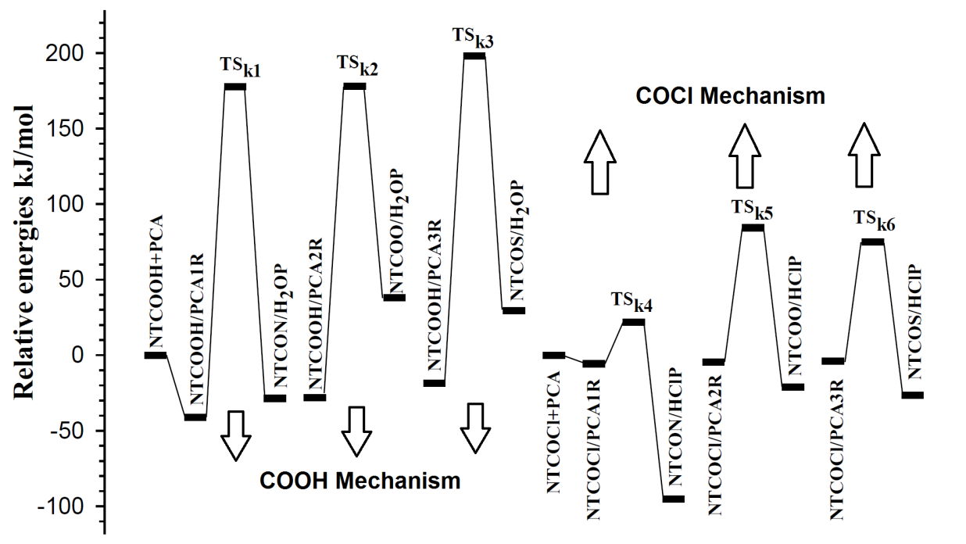
Fig. 8. Energy profile for COOH and COCl mechanisms.

2- Introduce the PCM method in COMPUTATIONAL DETAILS
A: paragraph 1 on page 3
The solvent play a key role in chemical systems explicitly³⁵⁻⁴³ or implicitly. Polarized continuum model (PCM)^{44,45} was used for the consideration of implicit effects of the solvent. In the PCM method, the molecular cavity is made up of the union of interlocking atomic spheres.
3- The whole paper should be reviewed for formatting issues, as well as the English language should be checked carefully for accurate and unambiguous expressions.
A: Done. Corrections in the manuscript have been specified in red.

Reviewer C:
I have reviewed the paper entitled ''Mechanistic, Energetic and Structural Studies of Carbon Nanotubes Functionalized with Penicillamine'' written by H. Shaki, A. Morsali, H. Raissi, M. Hakimi and S. Ali Beyramabadi. Although the results seem to be of interest, due to the style the paper was written I recommend a major revision. Here are my comments on the paper:

1. The Manuscript is not written in a clear and concise way. A major revision is obligatory.
Page 3:
Theory of "quantum molecular descriptors" was transferred from RESULTS AND DISCUSSION to COMPUTATIONAL DETAILS.

Quantum molecular descriptors such as hardness and electrophilicity index could be used to describe chemical reactivity and stability.
The global hardness () indicates the resistance of one molecule against the change in its electronic structure (Equation 2). Decrease in causes a decrease in the reactivity and an increase in the stability.
(2)
where and are the ionization potential and the electron affinity of the molecule, respectively.
Parr defined the electrophilicity index () as follows⁴⁸:
(3)

Page 7:
The calculated bond lengths are shown in Figs. 2, 4 and 5.

"Considering Figs. 2, 4 and 5, the N-H and C-O bond lengths increase (decrease) from 1.02 Å and 1.32 Å (3.86 Å and 4.06 Å) for NTCOOH/PCA1R (NTCON/H₂OP) to 1.17 Å and 1.88Å for TS_{k1}, respectively" was removed.
Page 8:
"Considering Figures 2, 4 and 5, the O-H (S-H) and C-O bond lengths increase from 0.98 Å and 1.34 Å (1.35 Å and 1.33 Å) for NTCOOH/PCA2R (NTCOOH/PCA3R) and decrease from 3.82 Å and 3.29 Å (4.14 Å and 3.68 Å) for NTCOO/H₂OP (NTCOS/H₂OP) to 1.50 Å and 1.77Å (1.88 and 1.73) for TS_{k2} (TS_{k3}), respectively" was removed.
Page 9:
The calculated bond lengths are presented in Figs. 3, 6 and 7.
"Considering Figs. 3,6 and 7, the C-Cl and N-H bond lengths increase (decrease) from 1.83 Å and 1.02 Å (3.23 Å and 3.98 Å) for NTCOCl/PCA1R (NTCON/HClP) to 2.10 Å and 1.05 Å for TS_{k4}, respectively" was removed.
Page 10:
"Considering Figs.3, 6 and 7, the O-H (S-H) and C-Cl bond lengths increase from 0.98 Å and 1.86 Å (1.35 Å and 1.84 Å) for NTCOCl/PCA2R (NTCOCl/PCA3R) and decrease from 3.37 Å and 4.17 Å (4.25 Å and 4.32 Å) for NTCOO/HClP (NTCOS/HClP) to 1.06 Å and 3.12Å (1.37 and 2.79) for TS_{k5} (TS_{k6}), respectively" was removed.

2. Please check the typing errors in the Manuscript. Missing space between words is abundant throughout the text.
A: Done.
3. Grammar revision is necessary.
A: Done. Corrections in the manuscript have been specified in red.
4. If the paper deals only with Single-Walled Carbon Nanotubes that should be stressed out in the paper title.
Title:
Mechanistic, Energetic and Structural Studies of Single-Walled Carbon Nanotubes Functionalized with Penicillamine

Yours Sincerely

Dr. Ali Morsali
Dept. of Chemistry
Faculty of Science
Azad University, Mashhad, Iran

