Supplemetary material
Experimental and theoretical study on solvent and substituent effect in 3-(4-substitutedanilino)isobenzofuran-1(3H)-ones

NEVENA Ž. PRLAINOVIĆ¹, MILICA P. RANČIĆ², IVANA STOJILJKOVIĆ², JASMINA B. NIKOLIĆ³*, SAŠA Ž. DRMANIĆ³, ISMAIL AJAJ⁴, and ALEKSANDAR D. MARINKOVIĆ³

¹Innovation Center, Faculty of Technology and Metallurgy, Karnegijeva 4, 11120 Belgrade, Serbia
²Faculty of Forestry, University of Belgrade, KnezaVišeslava 1, 11030 Belgrade, Serbia
³Faculty of Technology and Metallurgy, University of Belgrade, Karnegijeva 4, 11120 Belgrade, Serbia
⁴ Faculty of Arts And Science, The university of El-margeb, Mesallata, Libya

Table SI. Solvent parameters used in Kamlet–Taft equation^{1,2}

Solvent | π | β | α
1,2-Dichloroethane | 0.81 | 0.1 | 0
1-Decanol | 0.45 | 0.82 | 0.7
Dichloromethane | 0.82 | 0.1 | 0.13
Dioxolane | 0.69 | 0.45 | 0
Ethane-1,2-diol | 0.9 | 0.52 | 0.9
Ethanol | 0.54 | 0.75 | 0.86
Water | 1.09 | 0.47 | 1.17
Hexane | 0 | 0 | -0.04
2-Methyl-1-propanol | 0.4 | 0.84 | 0.79
2-Propanol | 0.48 | 0.84 | 0.76
Methanol | 0.6 | 0.66 | 0.98
1-Butanol | 0.47 | 0.84 | 0.84
1-Propanol | 0.52 | 0.9 | 0.84
2-Butanol | 0.4 | 0.8 | 0.69
2-Methyl-2-propanol | 0.41 | 0.93 | 0.41
Tetrahydofuran | 0.58 | 0.55 | 0

Table SII. Solvent parameters used in Catalán equation³

Solvent | SP | SdP | SA | SB
1,2-Dichloroethane | 0.77 | 0.74 | 0.03 | 0.13
1-Decanol | 0.72 | 0.38 | 0.26 | 0.91
Dichloromethane | 0.76 | 0.77 | 0.04 | 0.18
Dioxolane | 0.78 | 0.91 | 0.72 | 0.53
Ethane-1,2-diol | 0.63 | 0.78 | 0.4 | 0.66
Ethanol | 0.68 | 0.99 | 1.06 | 0.03
Water | 0.62 | 0 | 0 | 0.06
Hexane | 0.66 | 0.68 | 0.31 | 0.83
2-Methyl-1-propanol | 0.63 | 0.8 | 0.28 | 0.83
2-Propanol | 0.6 | 0.9 | 0.6 | 0.54
Methanol | 0.67 | 0.65 | 0.34 | 0.8
1-Butanol | 0.65 | 0.75 | 0.37 | 0.78
1-Propanol | 0.66 | 0.7 | 0.22 | 0.89
2-Butanol | 0.63 | 0.73 | 0.16 | 0.93
2-Methyl-2-propanol | 0.71 | 0.63 | 0 | 0.59

Table SIII. Structures and numbering of synthesized 3-((4-substituted)phenylamino)isobenzofuran-1(3H)-ones
1 | 2 | 3
4 | 5 | 6
7 | 8 | 9
10

Table SIV. Results of enerigies of optimized molecules by DFT/B3LYP 6-31G(d,p) method

Compound | Energy (Hartree)
1 | -745.3479
2 | -784.6680
3 | -859.8708
4 | -820.5657
5 | -844.5781
6 | -1204.9419
7 | -898.0002
8 | -949.8508
9 | -761.3929
10 | -761.3810

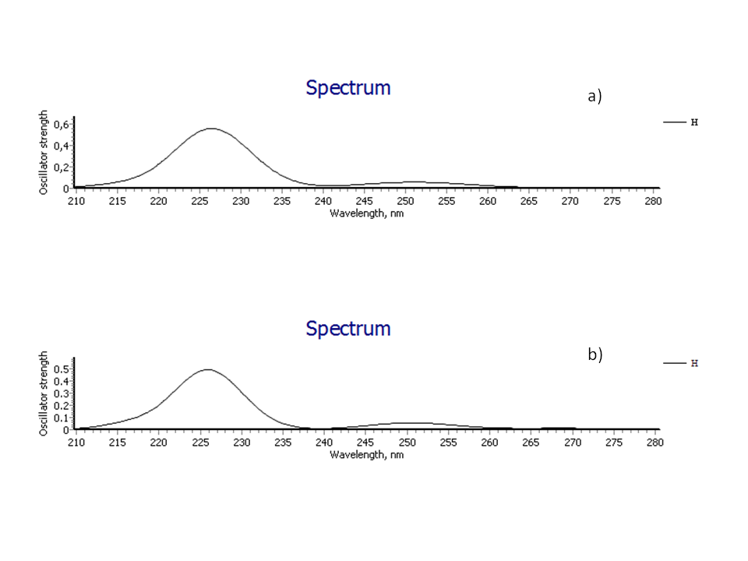
Figure SI. Calculated spectra for compound 1 base don optimized structures using a) DFT and b) MP2 method

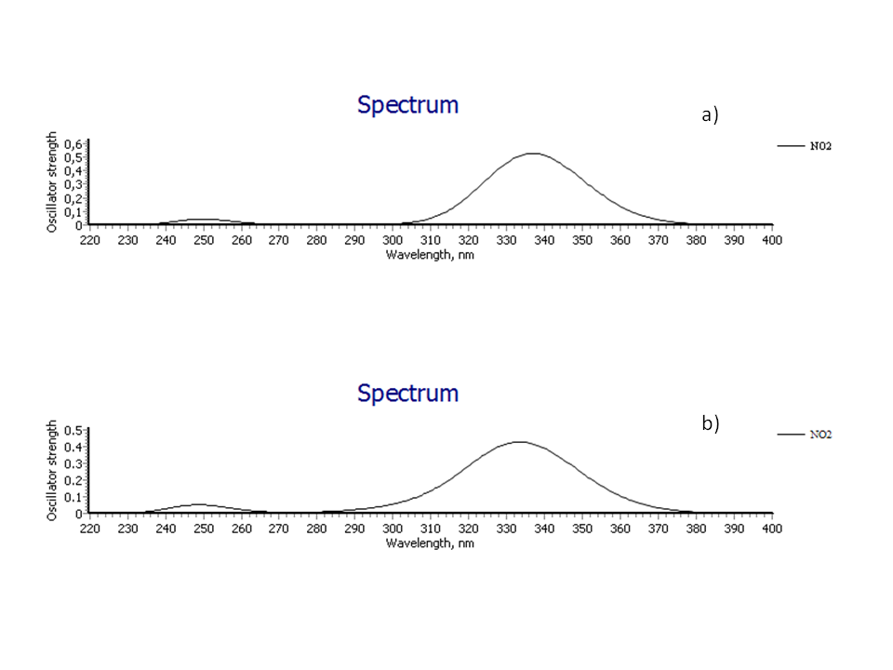

Figure SII. Calculated spectra for compound 8 based on optimized structures using a) DFT and b) MP2 method

References

- M.J. Kamlet, J.L.M. Abboud, M.H. Abraham, R. W.Taft,. J. Org. Chem.48 (1983) 2877
- Y.Marcus, Chem. Soc. Rev.22 (1993) 409
- J.Catalán,. J. Phys. Chem. B113 (2009) 5951

*corresponding author, e-mail: jasmina@tmf.bg.ac.rs

