Table S1. Calculated activation energies (ΔE #/kcal mol⁻¹), reaction energies (∆E_{r}/kcal mol⁻¹), activation Gibbs free energies (∆G#/kcal mol⁻¹), activation enthalpies (ΔH#/kcal mol⁻¹ ), and activation entropies (ΔS#/cal mol⁻¹K⁻¹) in gas phase at meta pathways of the 1,3-dipolar cycloaddition between TVE (1) and 3-oxo-1,2-pyrazolidinium ylides (2a-e) at the B3LYP/cc-pVDZ levels of theory.

Reaction | TSs | ΔE # | ΔE_{r} | ΔG # | ΔH# | ΔS#
1+2a→5a | TS3a | 27.20 | -11.14 | 34.07 | 26.98 | -42.19
1+2a→6a | TS4a | 15.86 | -11.12 | 26.54 | 13.80 | -40.84
1+2b→5b | TS3b | 22.82 | -10.53 | 29.08 | 16.93 | -40.73
1+2b→6b | TS4b | 14.32 | -10.53 | 26.86 | 17.00 | -47.37
1+2c→5c | TS3c | 20.54 | -11.46 | 33.49 | 20.75 | -42.72
1+2c→6c | TS4c | 13.99 | -11.61 | 26.82 | 16.13 | -47.03
1+2d→5d | TS3d | 20.65 | -11.38 | 33.41 | 20.90 | -41.97
1+2d→6d | TS4d | 14.19 | -11.54 | 26.77 | 16.21 | -45.34
1+2e→5e | TS3e | 20.75 | -11.16 | 33.63 | 21.00 | -42.35
1+2e→6e | TS4e | 14.80 | -11.36 | 27.69 | 16.33 | -48.83

Table S2. Calculated reaction Gibbs free energies (ΔG_{r}/ kcal mol⁻¹), reaction enthalpies (ΔH_{r}/ kcal mol⁻¹) and reaction entropies (ΔS_{r}/ cal mol⁻¹K⁻¹) in gas phase at ortho and meta pathways of the 1,3-dipolar cycloaddition between TVE (1) and 3-oxo-1,2-pyrazolidinium ylides (2a-2e) at the B3LYP/cc-pVDZ level of theory.

Reaction | TSs | ΔG_{r} | ΔH_{r} | ΔSr
1+2a→3a | TS1a | -2.45 | -16.59 | -47.43
1+2a→4a | TS2a | -2.75 | -16.62 | -46.56
1+2b→3b | TS1b | -2.08 | -15.94 | -41.06
1+2b→4b | TS2b | -2.11 | -16.10 | -42.06
1+2c→3c | TS1c | -2.69 | -16.95 | -47.83
1+2c→4c | TS2c | -2.57 | -16.89 | -48.06
1+2d→3d | TS1d | -2.77 | -16.84 | -47.20
1+2d→4d | TS2d | -2.60 | -16.80 | -47.50
1+2e→3e | TS1e | -2.49 | -16.57 | -47.23
1+2e→4e | TS2e | -2.06 | -16.44 | -48.27
1+2a→5a | TS3a | 2.63 | -11.38 | -47.00
1+2a→6a | TS4a | 2.51 | -11.48 | -46.97
1+2b→5b | TS3b | 2.97 | -10.76 | -40.51
1+2b→6b | TS4b | 2.05 | -10.76 | -40.41
1+2c→5c | TS3c | 1.86 | -11.69 | -45.46
1+2c→6c | TS4c | 2.01 | -11.96 | -46.86
1+2d→5d | TS3d | 1.96 | -11.60 | -45.52
1+2d→6d | TS4d | 1.86 | -11.86 | -46.04
1+2e→5e | TS3e | 2.81 | -11.42 | -47.75
1+2e→6e | TS4e | 2.11 | -11.67 | -46.23

Table S3. Calculated reaction Gibbs free energies (ΔG_{r}/ kcal mol⁻¹), reaction enthalpies (ΔH_{r}/ kcal mol⁻¹) and reaction entropies (ΔS_{r}/ cal mol⁻¹K⁻¹) in gas phase for the elemination of ethanol from cycloadduct 4 at the B3LYP/cc-pVDZ level of theory.

Reaction | TSs | ΔG_{r} | ΔH_{r} | ΔSr
4a→7a | TS5a | -12.16 | -13.08 | -3.08
4b →7b | TS5b | -10.83 | -11.94 | -3.25
4c →7c | TS5c | -10.74 | -11.46 | -2.40
4d →7d | TS5d | -10.75 | -11.26 | -1.69
4e →7e | TS5e | -10.32 | -10.80 | -1.58

Table S4- Calculated activation energies (ΔE # _{Sol} / kcal mol⁻¹) and reaction energies (∆E_{r Sol} / kcal mol⁻¹) in DMSO at orthoand meta pathways of the 1,3-dipolar cycloaddition between TVE (1) and 3-oxo-1,2-pyrazolidinium ylides (2a-2e) and the elemination of ethanol from cycloadduct 4 at the B3LYP/cc-pVDZ level of theory.

Reaction | TSs | ΔE #_{Sol} | ΔE_{r Sol}
1+2a→3a | TS1a | 21.10 | -12.66
1+2a→4a | TS2a | 7.99 | -11.62
1+2b→3b | TS1b | 20.62 | -14.17
1+2b→4b | TS2b | 6.14 | -13.50
1+2c→3c | TS1c | 23.41 | -12.56
1+2c→4c | TS2c | 9.81 | -11.49
1+2d→3d | TS1d | 23.38 | -12.48
1+2d→4d | TS2d | 10.08 | -11.36
1+2e→3e | TS1e | 24.03 | -11.77
1+2e→4e | TS2e | 11.49 | -10.76
1+2a→5a | TS3a | 33.65 | -17.16
1+2a→6a | TS4a | 19.48 | -18.81
1+2b→5b | TS3b | 23.05 | -16.44
1+2b→6b | TS4b | 19.52 | -18.33
1+2c→5c | TS3c | 30.07 | -14.48
1+2c→6c | TS4c | 22.06 | -16.25
1+2d→5d | TS3d | 29.79 | -14.86
1+2d→6d | TS4d | 21.92 | -16.52
1+2e→5e | TS3e | 30.00 | -14.61
1+2e→6e | TS4e | 22.92 | -16.14
4a→7a | TS5a | 23.68 | -7.94
4b →7b | TS5b | 24.06 | -6.46
4c →7c | TS5c | 25.72 | -6.68
4d →7d | TS5d | 27.66 | -6.71
4e →7e | TS5e | 26.23 | -5.79

Table S5. Calculated activation energies (ΔE #/kcal mol⁻¹), activation Gibbs free energies (∆G#/ kcal mol⁻¹), and reaction energies (∆E_{r}/kcal mol⁻¹) at ortho pathway of the 1,3-dipolar cycloaddition between TVE (1) and 3-oxo-1,2-pyrazolidinium ylides 2a-2e and the elemination of ethanol from cycloadduct 4 at the MPWB1K/cc-pVDZ level of theory.

ΔE_{r} | ΔG # | ΔE # |  |  | TSs |  | Reaction
-26.03 | 28.47 |  | 13.27 | TS1a |  | 1+2a→3a
-24.09 | 19.18 |  | 2.88 | TS2a |  | 1+2a→4a
-23.31 | 31.53 |  | 12.48 | TS1b |  | 1+2b→3b
-21.36 | 17.96 |  | 1.59 | TS2b |  | 1+2b→4b
-23.90 | 28.81 |  | 12.45 | TS1c |  | 1+2c→3c
-21.36 | 17.18 |  | 1.66 | TS2c |  | 1+2c→4c
-24.15 | 28.35 |  | 12.61 | TS1d |  | 1+2d→3d
-21.56 | 17.37 |  | 1.86 | TS2d |  | 1+2d→4d
-23.71 | 28.98 |  | 12.83 | TS1e |  | 1+2e→3e
-20.96 | 16.20 |  | 2.33 | TS2e |  | 1+2e→4e
-7.94 | 41.29 |  | 24.57 | TS5a |  | 4a→7a
-6.47 | 42.09 |  | 24.22 | TS5b |  | 4b →7b
-6.68 | 40.24 |  | 24.67 | TS5c |  | 4c →7c
-6.71 | 43.13 |  | 26.77 | TS5d |  | 4d →7d
-5.79 | 43.15 |  | 24.96 | TS5e |  | 4e→7e

Table S6. Calculated activation energies (ΔE #/kcal mol⁻¹) and reaction energies (∆E_{r}/kcal mol⁻¹) of the 1,3-dipolar cycloaddition between 1-ethoxybut-3-en-2-one 1a and 1-ethoxy-4,4,4-triflourobut-1-ene 1b with 3-oxo-1,2-pyrazolidinium ylide 2a at the B3LYP/cc-pVDZ level of theory.

ΔE_{r} | ΔE # |  | TSs |  | Reaction
-21.03 |  | 21.38 |  | TS1aa |  | 1a+2a→3aa
-19.92 |  | 17.81 |  | TS2aa |  | 1a+2a→4aa
-16.37 |  | 21.69 |  | TS3aa |  | 1a+2a→5aa
-14.47 |  | 22.08 |  | TS4aa |  | 1a+2a→6aa
-3.71 |  | 36.89 |  | TS5aa |  | 4aa→7aa
-13.16 |  | 23.63 |  | TS1ba |  | 1b+2a→3ba
-12.25 |  | 15.57 |  | TS2ba |  | 1b+2a→4ba
-9.35 |  | 29.85 |  | TS3ba |  | 1b+2a→5ba
-2.18 |  | 21.19 |  | TS4ba |  | 1b+2a→6ba
-2.42 |  | 37.26 |  | TS5ba |  | 4ba→7ba

 | 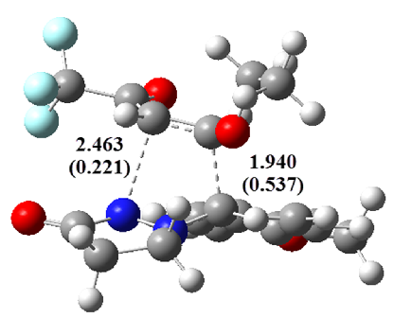 | 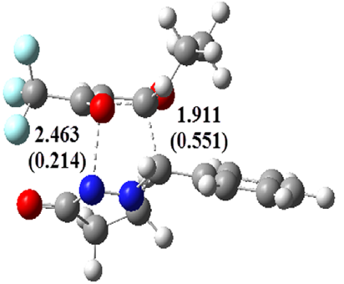 | 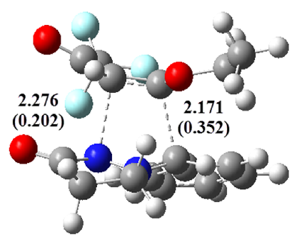
 | TS3b (GEDT=0.176) | TS4a (GEDT=0.149) | TS3a (GEDT=0.037)
 | 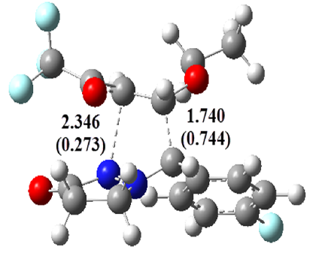 | 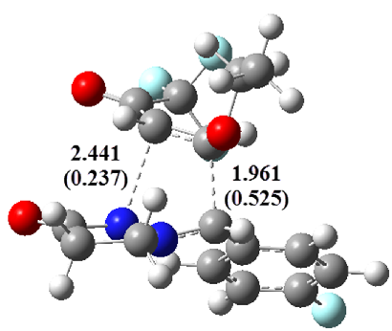 | 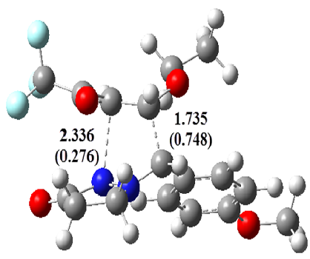
 | TS4c (GEDT=0.216) | TS3c (GEDT=0.172) | TS4b (GEDT=0.223)
 | 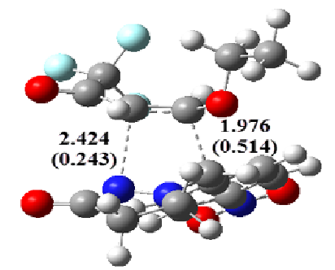 | 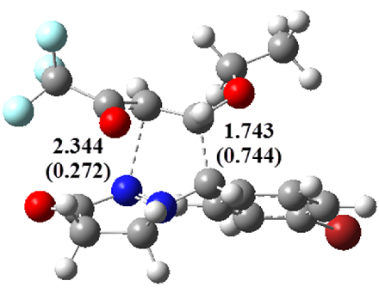 | 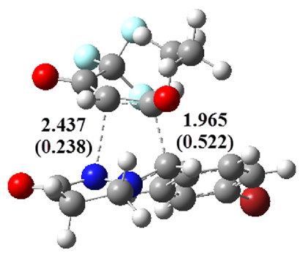
 | TS3e (GEDT=0.150) | TS4d (GEDT=0.211) | TS3d (GEDT=0.166)
 |  | 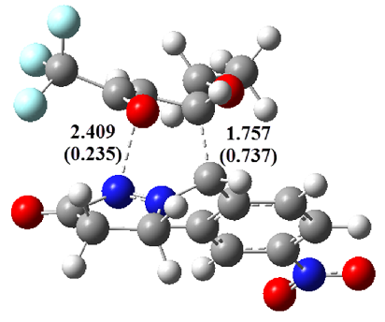
 |  | TS4e (GEDT=0.211)
Figure S1- The geometrical optimized of transition states for meta pathways of the 13DC reactions between TVE 1 and 3-oxo-1,2-pyrazolidinium ylieds 2a-2e at the B3LYP/cc-pVDZ level of theory. Bond distances are given in Å, wiberg bond indices are given in parenthesis and the natural charges (GEDT) of TSs are also given.

