The improvement in the diffraction efficiency of polymer using ionic liquid
¹Plasma BioScience Research Center / Department of Electrophysics, Kwangwoon University, Seoul, Korea 139-701.
²Department of Chemistry, Kwangwoon University, Seoul, Korea 139-701
Abstract: In this study, we have motivated on the photosensitive materials for the information storage devices. In order to synthesized the polymer and studied the surface relief-grating (SRG) fabrication using diode-pumped solid-state (DPSS) laser of 532 nm, and diffraction efficiency (DE) of polymer using low power DPSS laser at 633 nm. But, the diffraction efficiency of synthesized polymer is low even after 15 min exposure. Hence, to increase the efficiency and reduce the time of DE measurements for synthesized polymer, we have combined the polymer and ionic liquids (ILs). We have investigated various ILs such as 1-methylimidazolium chloride ([Mim]Cl) from imidazolium family IL and diethylammonium dihydrogen phosphate (DEAP), triethylammonium 4-aminotoluene-3-sulfonic acid (TASA) and tributylmethylammonium methyl sulfate (TBMS) from ammonium family ILs. For the first time, we observed that DE has increased dramatically for DEAP-polymer mixture in 4 min as compared to polymer (alone) and other polymer-IL mixtures. Therefore, DEAP IL can help in increasing the efficiency of DE measurements in less time.

Keywords: photosensitive materials; diode-pumped solid-state; diffraction efficiency; ionic liquids; imidazolium IL; ammonium IL.
RUNNING TITLE: IMPROVEMENT IN THE DIFFRACTION EFFICIENCY

INTRODUCTION
Here, we have focused on the methods of huge amount of data storage, generation, and transmission at fast transfer rates with low cost.¹ Multiple technologies are used now days for information storage, among them the most prevalent are photosensitive materials. Photosensitive material’s optical reflection can be modified by the laser action, either in metallic or polymeric form.^{1,2} Photopolymers and silver halide materials are used as holographic recording materials due to their high sensitivity and high resolution. Nevertheless, from few years; polymers have been the key area of research due to their potential applications in various fields.¹⁻³ The polymer film, possessing unique properties of photoinduced anisotropic effect and its nonlinearity is one of the promising holographic recording materials. There are many interesting properties of polymers such as photoinduced birefringence, photoinduced phase transition, surface photomechanical deformation of thin films, relief-grating (SRG) formation.⁴⁻⁹ That can be correlated with photoinduced anisotropic effect, where trans-form of azo group undergoes a transition to cis-form through excited states. Irradiation of interfering laser beams results in the appearance of sinusoidal surface patterns, which can lead to SRG formation on polymer films.^{2,6} The unusual response of polymers basically occurs as a result of the passage of polymeric chains, due to the free volume expansion in bulk driven by isomerization.¹⁰ The force due to the dipolar interaction with the optically induced electric field gradient, a translational worm like diffusion as a result of photoisomerization of the azobenzene chromophores, along with the molecular alignment developing in a mean-field force, and photomechanical effect occur commonly in thin films.¹¹⁻¹⁴ These properties of the polymer allow them to exploit for various applicative areas such as data storage devices.
On the other hand, polymers still lack in the high quality of the photoinduced anisotropy, which is essential for the practical use of optical storage. A large number of materials in combination with the peculiar properties of liquid crystal and azobenzene molecules, based on ionic interaction were proposed for this purpose for different applications in optics and information technologies.¹⁵⁻¹⁷ A stable photoinduced birefringence in an azopyridine liquid crystalline polymer was reported.¹⁸ Different excitation regimes of nonlinear absorption (NLA) are obtained for azo-containing ion liquid crystal polymer, reported in early work.¹⁹ Explored the photo-orientation properties of liquid crystalline azo-dendrimer films through pulsed irradiation are explored by Li et al.²⁰ ILs can be considered as classical molten salts having low-melting point.²¹⁻²⁴ Diverse chemical composition and structure are one of the biggest advantages offered by ILs, and thus the desired properties can be attained by coupling variety of organic cations, with a various inorganic or organic anions.²¹⁻²⁴ In recent years, an azo-containing IL-crystalline possesing reversibility and long-term optical storage was used by Pan et al.²⁵ While in another work, the azo-containing IL-crystalline polymer and the polymer film exhibited negligible nonlinear absorption and large nonlinear refraction.²⁶ Being influenced from both azo-containing IL-crystalline polymer and polymer research, we studied the interaction between the synthesized epoxy based polymer with ILs in early work.²⁷ In this study, we have used the imidazolium IL (1-methylimidazolium chloride) and ammonium ILs (diethylammonium dihydrogen phosphate (DEAP), triethylammonium 4-aminotoluene-3-sulfonic acid (TASA) and tributylmethylammonium methyl sulfate (TBMS)). And investigated the surface relief grating (SRG) and diffraction efficiency (DE) for polymer and polymer-ILs mixture.

EXPERIMENTAL
Materials
For all the other materials, reagents and solvents were purchased from the Sigma-Aldrich Korea Ltd., and used as received without further purification.
Characterization
AFM (Atomic Force Microscopy) images were obtained using an XE-100 AFM (Park systems, Korea) non-contact mode. Laser experiment was conducted at a diode-pumped solid state (DPSS) laser (Genesis CX-Series SLM; Coherent Lasers, Santa Clara, CA, USA).
The synthesis of the polymer and ILs are illustrated in our reported previous work.²⁷ The schematic depiction of polymer and ILs are shown in Fig. 1.
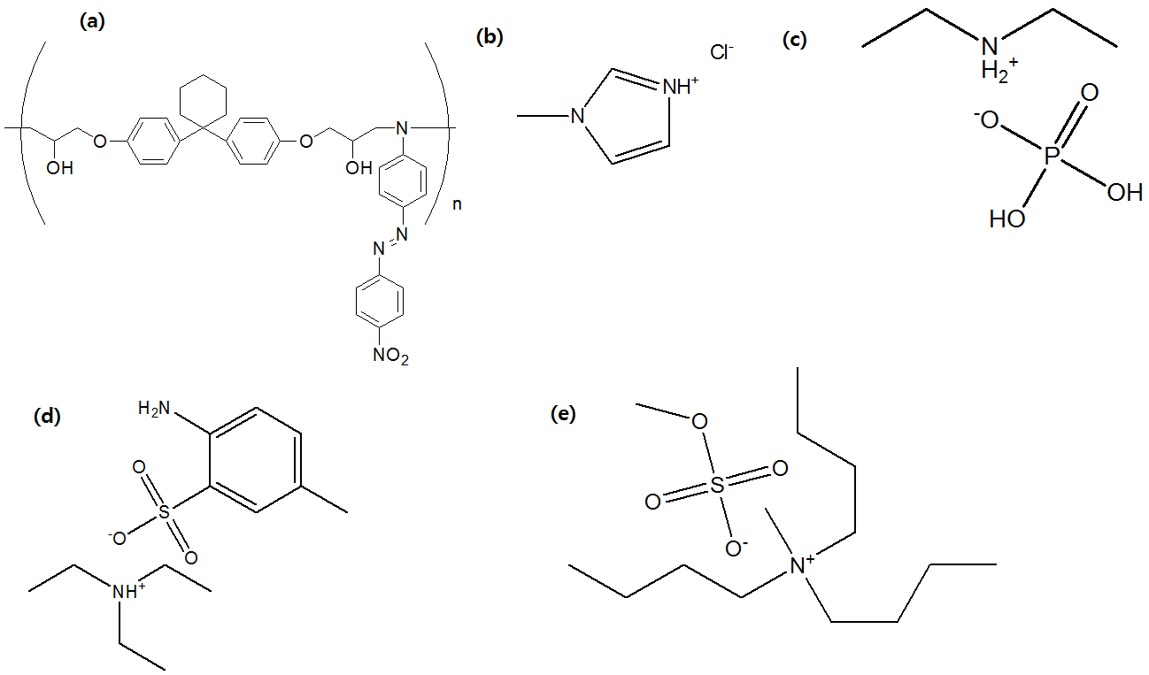
Fig. 1: Schematic representations of (a) polymers; (b) [Mim]Cl; (c) DEAP; (d) TASA and (e) TBMS.

Surface relief grating (SRG) formation and diffraction efficiency
Surface-relief-grating (SRG) measurements were carried out using previously reported procedure.^{6,28} The light source used was a linearly polarized diode-pumped solid state (DPSS) laser beam with a wavelength of 532 nm with 500 mW/cm² of light intensity (Fig. 2a). The laser beam, was split by a mirror and was spatially filtered, expanded, and collimated with the intensity of 250 mW/cm². Grating formation was monitored with a low power DPSS laser at 633 nm by measuring the power of the first-order diffracted beam in the reflection mode in a real time mode, during the writing process (Fig. 2b). The writing beam and read-out beam both are p-polarized. SRG engraving was carried out under ambient condition at room temperature. The surface relief structure of the gratings on polymer films was investigated by AFM. Diffraction efficiency (DE) was measured during SRG formation with respect to the light irradiation time⁶ as shown in Fig. 2b

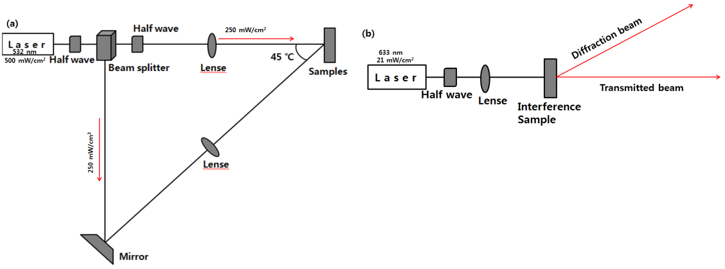
Fig. 2: Schematic diagram for determination of SRG and Diffraction efficiency

RESULTS AND DISCUSSION
SRG formation and DE of polymer
Polymer is synthesized according to our previous reported work.²⁷ We have checked the UV-vis spectroscopy of polymer, that shows the peak at ≈ 270 nm which corresponds to π–π* transitions and peak at ≈ 510 nm is due to the n-π* transition of azobenzene chromophores, as shown in Fig. 3a. SRG formation behavior of polymer was studied using inscribing light composed of DPSS laser, with the wavelength of 532 nm having intensity of 500 mW/cm².

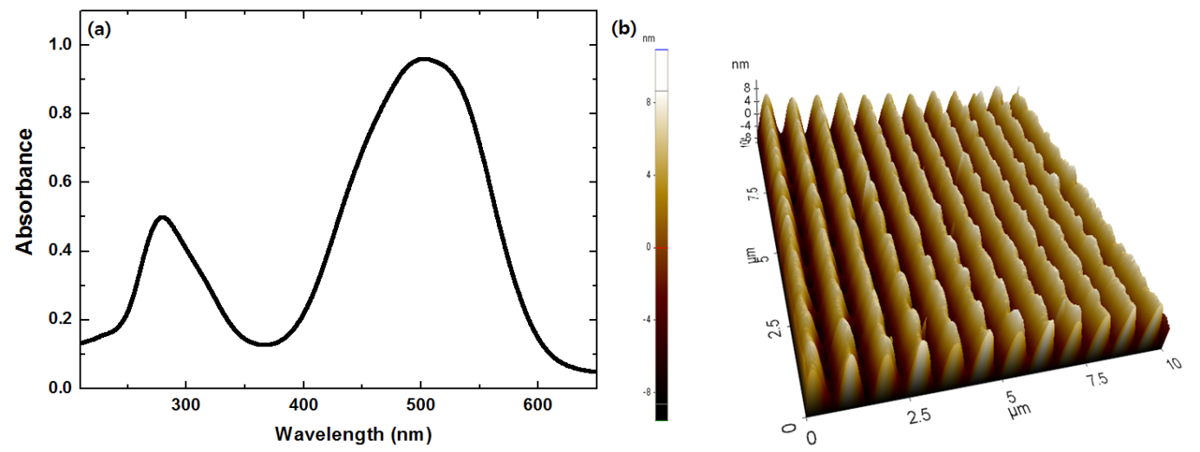
Fig. 3: (a) UV-visible absorption spectra of polymer and (b) AFM image of SRG formation on polymer film (The scan size for all images is 10 μm × 10 μm × 5 nm).

In order to prevent the destruction of SRG formation of the film, the exposure time was controlled as short as possible. The created interference patterns on the films were used to engraving SRGs is attributed to the two p-polarized laser beams at 532 nm wavelength. In this condition, SRG formation was observed on films of polymer. As a result, the exposure time of about 15~20 min showed the best SRG. Fig. 3b shows AFM images of the SRG formed on the films of polymer, which seem to be regularly spaced sinusoidal surface structures. The grating growth rates in the presence of interfering laser beams irradiation were used to analysed the SRG formation and also formed the basis for correlation studies with polymer structures and the irradiation wavelengths. The low power DPSS beam at 633 nm was used to probe SRG engraving in a real time mode. The SRG formation was studies at room temperature, under ambient condition.The thickness of the polymer film was 5 μm and depth of the groves was 5 nm. . Diffraction efficiency was measured during SRG formation with respect to the light irradiation time, as shown in Figure 4a. The DE is found to be 0.05 % after the 18 min and later it decreases with increase in exposure time of laser, as shown in Fig. 4a. So, in order to increase the DE and reduce the exposure time, we prepared the mixture of ILs with polymer, as per our reported work.²⁷ Now we have used this combination of ILs and polymer for the determining the SRG, diffraction efficiency (DE).
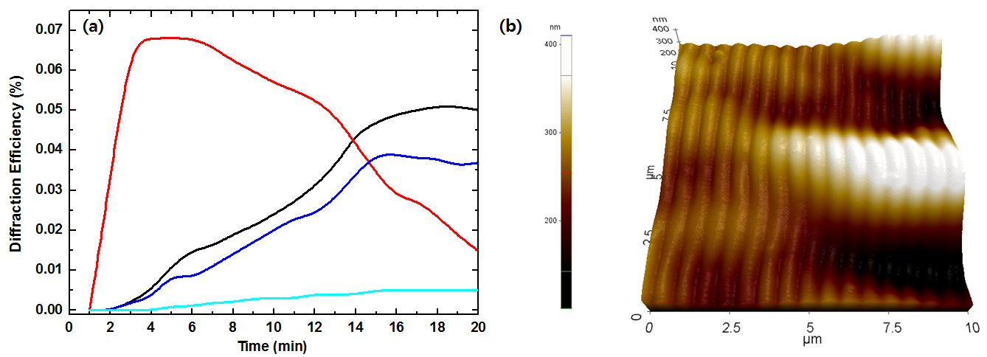
Fig. 4: (a) Diffraction efficiency of the polymer (black), polymer + DEAP (red), polymer + TASA (blue) and polymer + [Mim]Cl (cyan); and (b) AFM image of SRG formation on polymer + DEAP IL film (The scan size for all images is -10 μm × 10 μm × 280 nm).

SRG formation and DE for the combination of polymer and ILs
SRG formation behavior was investigated using spin-coated films of the polymer with ILs mixture using the same experimental setup, as used for the polymer alone (DPSS laser with the wavelength of 532 nm and the intensity of 500 mW/cm²). The exposure time was controlled as short as possible in order to prevent the destruction of SRG formation of the film. The diffraction efficiency of the first-order diffracted beam was measured in a real time mode and the SRGs formation was probed with a low power DPSS beam at 633 nm. The maximum efficiency of 0.04 % was observed for polymer + TASA in 15 min, later the efficiency started decreasing, as shown in Fig. 4.. Whereas, the efficiency for the [Mim]Cl + polymer was found to be 0.005 % in 15 min. Moreover, the TBMA + polymer didn’t exhibit any DE during the experiments. On the other hand, the maximum efficiency of 0.07 % at 4 min was observed in case of the protic IL DEAP which showed the strong interaction with polymer. But, later DE was decrease with the increase in light irradiation time.
This might be due to the fact that after the exposure of laser for more than 5 min, the interaction between the DEAP and polymer decreased because the longer exposure time of laser, can results in the heating effect that may breakdown the H-bonding between the polymer and DEAP. Further, we have further studied the atomic force microscopy (AFM). AFM studied showed that polymer had an average roughness (R_{a}) of 4.0 nm, while after the interaction with DEAP the R_{a} was ≈ 9.4 nm, as shown in Fig. 4b. Whereas, the R_{a} for the TASA, TBMA and [Mim]Cl were found to be 0.04 μm, 4.89 nm and 15.61 nm, as shown in Fig. 5.
The diffraction efficiency of the polymer (alone) was ≈ 0.05 % for 18 min exposure, with a low power DPSS beam at 633 nm. And the DE slightly deceases as function to laser exposure time (20 min). While, the DE of polymer + DEAP is highest DE among all the studied ILs in less exposure time. This property of polymer + DEAP confers advantages in terms of the fabrication of SRG using low intensity of light for a short time. The decrease in efficiency with increase in exposure time is might be due to the disturbance in H-bonding between DEAP and polymer. Moreover, the roughness is more in DEAP + polymer, as compared with TBMA + polymer, while less than [Mim]Cl + polymer and TASA + polymer. This shows that the roughness of film is not the important factor for DE. Hence, polymer + DEAP IL can be a good material to the holographic image. This is the first time we have shown that polymer + DEAP combination can increase the DE in lesser time as compared to polymer alone.
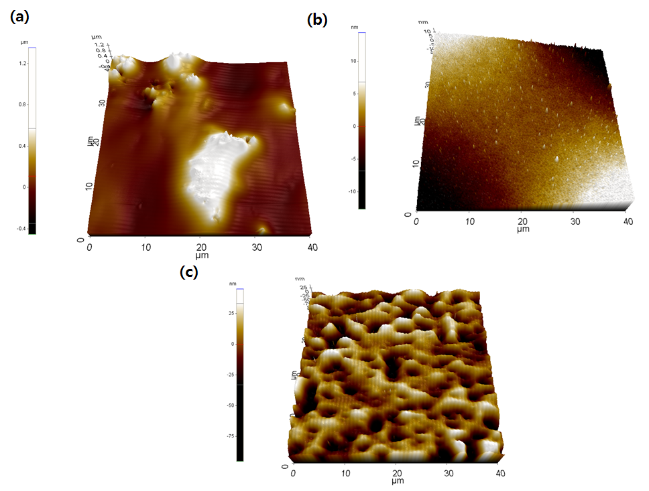
Fig. 5:
AFM image of SRG formation on polymer + (a) TASA (The scan size is 40 μm × 40 μm × 800 nm); (b) TBMA (The scan size is 40 μm × 40 μm × 8 nm) and (c) [Mim]Cl (The scan size is 40 μm × 40 μm × 20 nm) ILs film.

CONCLUSION
Our extensive experimental data illustrated that the SRG on the polymer film was photofabricated by using DPSS laser of 532 nm. The DE of polymer obtained by using 633 nm DPSS laser was found to be 0.05 % in 18 min. Furthermore, we have checked the DE analysis using polymer + ILs, we found that among all studied ILs the DEAP shows the highest DE of 0.07 % in 4 min. Hence, these results seem to be beneficial in the field of polymer chemistry and holographic research.

Acknowledgements: We gratefully acknowledge the Kwangwoon University 2017.

И З В О Д
НАСЛОВ РАДА
ПРВИ А. АУТОР, ДРУГИ Б. АУТОР¹ и ТРЕЋИ В. АУТОР²
Афилијација првог аутора
¹Афилијација другог аутора
²Афилијација трећег аутора
(Домаћи аутори морају доставити Извод (укључујући имена аутора и афилијацију) на српском језику, исписане ћирилицом, иза Захвалнице, а пре списка референци.) For authors outside Serbia, the Editorial Board will provide a Serbian translation of their English abstract.

REFERENCES
- J. A. Delaire, K. Nakatani, Chem. Rev. 100 (2000) 1817-1845.
- A. Natansohn, P. Rochon, Chem. Rev. 102 (2002) 4139-4175.
- T. Ikeda, J. Mamiya, Y. L. Yu, Angew. Chem. Int. Ed. 46 (2007) 506-528.
- T. Ikeda, S. Horiuchi, D. B. Karanjit, S. Kurihara, S. Tazuke, Macromolecules 23 (1990) 42-48.
- T. Todorov, L. Nikolova, N. Tomova, Appl. Opt. 23 (1984) 4309-4312.
- D. Y. Kim, S. K. Tripathy, L. Li, J. Kumar, Appl. Phys. Lett. 66 (1995) 1166-1168.
- M. H. Li, P. Keller, B. Li, X. G. Wang, M. Brunet, Adv. Mater. 15 (2003) 569-572.
- Y. L. Yu, M. Nakano, T. Ikeda, Nature 425 (2003) 145.
- M. Camacho-Lopez, H. Finkelmann, P. Palffy-Muhoray, M. Shelley, Nat. Mater. 3 (2004) 307-310.
- C. J. Barrett, A. L. Natansohn, P. L. Rochon, J. Phys. Chem. 100 (1996) 8836-8842.
- J. Kumar, L. Li, X. L. Jiang, D. Y. Kim, T. S. Lee, S. Tripathy, Appl. Phys. Lett. 72 (1998) 2096-2098.
- P. Lefin, C. Fiorini, J. M. Nunzi, Pure Appl. Opt. 7 (1998) 71-82.
- T. G. Pedersen, P. M. Johansen, N. C. R. Holme, P. S. Ramanujam, S. Hvilsted, Phys. Rev. Lett. 80 (1998) 89-92.
- O. M. Tanchak, C. J. Barrett, Macromolecules 38 (2005) 10566-10570.
- D. H. Han, X. Tong, Y. Zhao, T. Galstian, Y. Zhao, Macromolecules 43 (2010) 3664–3671.
- Y. Zakrevskyy, J. Stumpe, B. Smarsly, C. F. J. Faul, Phys. Rev. E 75 (2007) 031703.
- T. Ikeda, O. Tsutsumi, Science 268 (1995) 1873-1875.
- L. Cui, Y. Zhao, Chem. Mater. 16 (2004) 2076–2082.
- T. C. He, C. S. Wang, J. W. Zhang, X. Q. Zhang, X. M. Lu, Synth. Met. 160 (2010) 1896–1901.
- X. Li, X. M. Lu, Q. H. Lu, D. Y. Yan, Macromolecules 40 (2007) 3306–3312.
- P. Attri, E. H. Choi, PloS One 8 (2013) e75096.
- P. Attri, S. H. Lee, S. W. Hwang, J. I. Kim, S. W. Lee, G. C. Kwon, E. H. Choi, I. T. Kim, PloS One 8 (2013) e68970.
- P. Attri, K. Y. Baik, P. Venkatesu, I. T. Kim, E. H. Choi, PLoS One 9 (2014) e86530.
- P. Attri, P. Venkatesu, A. Kumar, Phys. Chem. Chem. Phys. 13 (2011) 2788–2796.
- X. Pan, S. Xiao, C. Wanga, P. Cai, X. Lu, Q. Lu, Optics Commun. 282 (2009) 763–768.
- F. Zhao, Z. Pan, C. Wang, Y. Zhou, M. Qin, Opt. Quant. Electron. 46 (2014) 1491–1498.
- I. T. Kim, G.-C. Kwon, E. H. Choi, S.-H. Lee, Y. S. Kim, J. H. Kim, J. H. Cha, S. H. Kim, P. Attri, Internat. J. Polym. Sci. 2015 (2015) Article ID 461974.
- P. Rochon, E. Batalla, A. Natansohn, Appl. Phys. Lett. 66 (1995)136-138.

