Supporting information
An efficient synthesis of novel triazoles incorporating barbituric motifs via [3+2] cycloaddition reaction: Expermimental and theoretical study
Mahdieh Darroudi, ª Yaghoub Sarrafi, ^{a,}* Mahshid Hamzehloueian ^{b}
ª Department of Organic Chemistry, Faculty of Chemistry, University of Mazandaran, 47416 Babolsar, Iran
^{b} Department of Chemistry, Jouybar Branch, Islamic Azad University, Jouybar, Iran

Contents:
experimental and spectral data
Spectra of products:
Cartesian coordinates for all optimized geometries
Supplementary Material
Electronic Supplementary Information (ESI) available: [details of any supplementary information available should be included here]. See DOI:WWW under http://dx.doi.org/10.1002/MS-number.

Experimental:
General information and apparatus
Melting points were measured on an Electrothermal 9100 apparatus. NMR spectra were recorded with a Bruker DRX-400 AVANCE instrument (400.1 MHz for ¹H, 100.6 MHz for 13C) with CDCl₃ as solvent. IR spectra were recorded on an FT-IR Bruker vector 22 spectrometer. Mass spectra were recorded on a Finnigan-Matt 8430 mass spectrometer operating at an ionization potential of 70 eV. Elemental analyses were carried with a Perkin-Elmer 2400II CHNS/O Elemental Analyzer

Propargylation of hydroxybenzaldehyde derivatives 2a – b
To a stirred solution of hydroxyl benaldehyde derivative 1a (5 mmol) and potassium carbonate (5mmol) in DMF (15ml) was added propargyl bromide (6mmol). After stirring for4–24 h, water was added and the precipitated solid was ﬁltered and washed with water.
2-(prop-2-yn-1-yloxy) benzaldehyde (2a). ⁷⁸ White solid, Yield: (93%), m.p. 69-70 ˚C;
4-(prop-2-yn-1-yloxy) benzaldehyde (2b). White solid, Yield: (90%), m.p. 68-69.5 ˚C; ¹H NMR (400 MHz, DMSO-d6): 2.59 (s 1H), 4.86 (s, 2H), 7.11 (d, J = 7.7 Hz, 2H), 7.9 (d, J =7.7 Hz, 2H), 10.5 (s, 1H) ppm.

General procedure for Knoevenagel condensation
Preparation of (4a-d): To a stirred solution of barbituric acid derivatives (1.2 mmol) in aqueous HCl (25 ml, 10%) were added propargylated aldehydes 2a–b (1 mmol) at room temperature. After stirring for 2–15 h, the pure substances was collected by filtration, and washing with hot ethanol. ⁷⁸
To a stirred solution of N,N-dimethylbarbituric acid (3c) (1.2 mmol) in water (20 ml) containing (NH₄)₂HPO₄ (20 mol%) was added propargylated aldehydes 2a–b(1 mmol) at room temperature. After stirring for 4–12 h, the yellow precipitated was ﬁltered and washed with water and ethanol.
5-(2-(prop-2-yn-1-yloxy)benzylidene)pyrimidine-2,4,6(1H,3H,5H)-trione (4a):⁷⁸ Yellow solid, yield 85%; mp 207–208.3 °C; IR (KBr, cm⁻¹) ν =3310, 3155, 3010, 1771, 1642.
5-(4-(prop-3-yn-1- yloxy)benzylidene)pyrimidine-2,4,6(1H,3H,5H)-trione (4b): Yellow solid, yield. 90%; mp 217.5–219.4 °C., IR (KBr, cm⁻¹) ν =3262, 2091, 1751, 1666. ¹H NMR (400 MHz, DMSO-d6): 11.17(s, 1H, NH), 10.97 (s, 1H, NH), 8.32 (m, 2H, ArH), 8.30 (s, 1H, CH), 7.10 (d, J= 8.4 Hz, 2H), 4.96 (s, 2H, CH2), 3.66 (s, 1H, CH) ppm. ; ¹³C NMR (100 MHz, DMSO-d6):161.02, 160.58, 159.21, 149.33, 136.58, 133.32, 128.28, 117.45, 115.06, 79.07, 56.21.
5-(2-(prop-2-yn-1-yloxy) benzylidene)-2-thioxodihydropyrimidine-4,6(1H,5H)-dione (4c): Yellow solid, yield. 80%; mp 228–230°C., IR (KBr, cm⁻¹) ν =3249, 2095, 1670; ¹H NMR (400 MHz, DMSO-d6): 11.41(1H, s, NH), 11.36 (1H, s, NH), 8.30 (s, 1H, CH), 7.71 (d, J=8.4 Hz, 2H, ArH), 7.21 (d, J= 8.4 Hz, 2H, ArH), 4.91 (s, 2H, CH2), 3.66 (s, 1H, CH) ppm. ; ¹³C NMR (100 MHz, DMSO-d6):173.02, 164.58, 162.21, 151.93, 150.58, 137.32, 126.28, 117.45, 115.06, 79.07, 56.21.
5-(4-(prop-3-yn-1- yloxy)benzylidene)-2-thioxodihydropyrimidine-4,6(1H,5H)-dione (4d): Yellow solid, yield 87%; mp 196–198 °C. IR (KBr, cm⁻¹) ν =3230, 2119, 1678; ¹H NMR (400 MHz, DMSO-d6): 11.37(1H, s, NH), 11.17 (1H, s, NH), 8.25 (s, 1H, CH), 7.83-7.80 (m, 2H, ArH), 7.22 (d, J= 8.4 Hz, 2H), 4.90 (s, 2H, CH2), 3.66 (s, 1H, CH) ppm. ; ¹³C NMR (100 MHz, DMSO-d6):173.02, 164.58, 162.21, 151.93, 150.58, 137.32, 126.28, 117.45, 115.06, 79.07, 56.21.;
1,3-dimethyl-5-(2-(prop-2-yn-1-yloxy)benzylidene)pyrimidine-2,4,6(1H,3H,5H)-trione (4e):⁷⁸ Yellow solid, yield 84%; mp, 141.5–143.0° C; IR (KBr, cm⁻¹) ν =3345, 1770, 1684.
5-(4-(prop-3-yn-1- yloxy)benzylidene)-1,3-dimethylpyrimidine-2,4,6(1H,3H,5H)-trione (4f): Yellow solid, yield 79%; mp: 172.5–173.8°C; IR (KBr, cm⁻¹) ν =3245, 2115, 16 84; ¹H NMR (400 MHz, DMSO-d6): δ= 8.33 (d, 2H, ArH), 8.30 (s, 1H, CH), 7.11 (d, J= 8.4 Hz, 2H, 2H), 4.95 (s, 2H, CH2), 3.66 (s, 1H, CH), 3.25 (s, 3H, CH3), 3.21 (s, 3H, CH3) ppm. ¹³C NMR (100 MHz, DMSO-d6): δ= 163.02, 161.58, 161.21, 155.93, 151.58, 137.36, 126.26, 116.45, 115.06, 79.34, 56.29, 29.10, 28.49.

Preparation of alkyl azide 6a-c
Sodium azide (1.2 mmol) was added to a solution of benzyl bromide derivatives 5a-c (1 mmol) in DMF. The mixture was heated at 100° C and, after completion (3h), was quenched with an aqueous solution of NH₄Cl (15 mL) and extracted with ethyl acetate (3 -20 mL). The organic extracts were washed with an aqueous solution of brine (3 -20 mL) and dried over MgSO₄. After evaporation of the solvent at reduced pressure, pure azides were isolate. ⁴²

General procedure for click cycloaddition reaction
Alkyne 4a-f (1.2 mmol) and benzyl azide 6a-c (1 mmol) were added at room temperature to a solution of CuSO₄ (0.2 equiv) DMSO (10 mL) in a capped ﬂask. The reaction mixture was stirred at 80°C and, after completion (12h), the reaction was quenched with a saturated aqueous solution of NH₄Cl (30 mL) and extracted with ethyl acetate (3- 40 mL). The organic extracts were washed with an aqueous solution of brine (3 -30 mL), dried over Na₂SO₄ and concentrated under vacuum.
5-(2-((1-benzyl-1H-1,2,3-triazol-4-yl)methoxy) benzylidene)pyrimidine-2,4,6(1H,3H,5H)-trione (7a): Yellow solid. Mp: 281.3-283.2 °C. IR (KBr, cm⁻¹) ν = 3438, 2925, 1677, 1597, 1159.¹H NMR (400 MHz, DMSO): δ= 10.99 (s, 1H, NH), 10.75 (s, 1H, NH), 8.32 (s, 1H, CH), 8.07 (s, 1H, CH), 7.86 (bs, 1H, ArH), 7.51-7.06 (m, 7H, ArH), 5.62 (s, 2H, OCH₂), 5.27 (s, 2H, CH₂) ppm. ¹³C NMR (100 MHz, DMSO): δ= 163.39, 162.79, 159.23, 148.05, 143.09, 136.41, 132.23, 131.71, 130.33, 129.24, 128.65, 128.27, 126.47, 125.43, 115.68, 115.44, 115.14, 61.92, 53.34 ppm. MS: m/z = 402.1 (M⁺). Anal. calcd. for C₂₁H₁₇N₅O₄ (403.4): C, 62.53; H, 4.25; N, 17.36; Found: C, 62.48; H, 4.22; N, 17.38.
5-(2-((1-(4-bromobenzyl)-1H-1,2,3-triazol-4-yl)methoxy)benzylidene)pyrimidine-2,4,6(1H,3H,5H)-trione (7b): Yellow solid. Mp: 279.2-280.3 °C. IR (KBr, cm⁻¹) ν = 3438, 2926, 1715, 1685, 1598, 1161. ¹H NMR (400 MHz, DMSO): δ= 11.20 (s, 1H, NH), 10.99 (s, 1H, NH), 8.35 (s, 1H, CH), 8.07 (s, 1H, CH), 7.87 (d, J=8Hz, 1H, ArH), 7.53-7.21 (m, 5H, ArH), 7.15-7.01 (m, 2H, ArH), 5.67 (s, 2H, OCH₂), 5.28 (s, 2H, CH₂) ppm. ¹³C NMR (100 MHz, DMSO): δ= 164.59, 163.37, 161.08, 148.08, 135.19, 132.23, 130.34, 129.87, 129.33, 129.25, 128.90, 128.79, 128.46, 128.06, 125.54, 115.73, 115.67, 61.89, 53.41 ppm. MS: m/z = 483.3 (M⁺). Anal. calcd. for C₂₁H₁₆BrN₅O₄ (482.3): C, 52.30; H, 3.34; N, 14.52; Found: C, 52.37; H, 3.37; N, 14.48.
5-(2-((1-benzyl-1H-1,2,3-triazol-4-yl)methoxy)benzylidene)-1,3-dimethylpyrimidine-2,4,6(1H,3H,5H)-trione (7c): Cream solid. Mp: 289-290.5 °C. IR (KBr, cm⁻¹) ν = 3439, 2956, 1629, 1524, 1144. ¹H NMR (400 MHz, DMSO): δ= 8.37 (s, 1H, CH), 8.07 (s, 1H, CH), 7.87 (d, J=8.8 Hz, 2H, ArH), 7.52 (t, J=8.8 Hz, 1H, ArH), 7.42 (m, 1H, ArH), 7.23 (d, J=8.4 Hz, 1H, ArH), 7.18-7.11 (m, 2H, ArH),7.10-7.06 (m, 1H, ArH), 7.01 (m, 1H, ArH), 5.65 (s, 2H, OCH₂), 5.28 (s, 2H, CH₂), 3.23 (s, 3H, CH₃), 3.21 (s, 3H, CH₃) ppm. ¹³C NMR (100 MHz, DMSO): δ= 163.37, 161.58, 161.21, 155.95, 137.64, 132.22, 131.30, 130.35, 128.27, 126.27, 125.60, 124.52, 116.45, 115.69, 115.19, 115.06, 61.91, 52.63, 29.09, 28.49 ppm. MS: m/z = 430.0 (M⁺). Anal. calcd. for C₂₃H₂₁N₅O₄ (431.5): C, 64.03; H, 4.91; N, 16.23; Found: C, 64.08; H, 4.93; N, 16.25.
5-(2-((1-(3-fluorobenzyl)-1H-1,2,3-triazol-4-yl)methoxy)benzylidene)-1,3-dimethyl pyrimidine-2,4,6(1H,3H,5H)-trione (7d): Yellow solid. Mp: 273.2-274.9 °C. IR (KBr, cm⁻¹) ν = 3427, 2926, 1602, 1485, 1127. ¹H NMR (400 MHz, DMSO): δ= 8.37 (s, 1H, CH), 8.06(s,1H, CH), 7.96 (s, 1H, ArH), 7.87 (bs, 2H, ArH), 7.36- 7.33 (m, 3H, ArH), 7.23-7.16 (m, 2H, ArH), 5.67 (s, 2H, OCH₂), 5.29 (s, 2H, CH₂), 2.88 (s, 3H, CH₃), 2.72(s, 3H, CH₃) ppm. ¹³C NMR (100 MHz, DMSO): δ= 163.01, 161.58, 161.21, 148.46, 136.32, 135.60, 132.23, 130.48, 130.34, 129.25, 128.68, 128.61, 128.47, 127.99, 115.75, 115.68, 115.44, 62.39, 56.57, 36.25, 31.23 ppm. MS: m/z = 451.0 (M⁺). Anal. calcd. for C₂₃H₂₀FN₅O₄ (449.4): C, 61.47; H, 4.49; N, 15.58; Found: C, 61.50; H, 4.53; N, 15.54.
5-(2-((1-benzyl-1H-1,2,3-triazol-4-yl)methoxy)benzylidene)-2-thioxodihydro pyrimidine-4,6(1H,5H)-dione (7e): Yellow solid. Mp: 251.6-252.9 °C. IR (KBr, cm⁻¹) ν = 3439, 2924, 1710, 1660, 1597, 1220, 1166. ¹H NMR (400 MHz, DMSO): δ= 11.22 (s, 1H, NH), 11.08 (s, 1H, NH), 8.39 (s, 1H, CH), 8.24 (s, 1H, CH), 7.66 (d, J=7.6 Hz, 1H, ArH), 7.37-7.34 (m, 3H, ArH), 7.32-7.29 (m, 2H, ArH), 7.29-7.24 (m, 2H, ArH), 6.98 (t, J=7.2 Hz, 1H, ArH), 5.62 (s, 2H, OCH₂), 5.21 (s, 2H, CH₂) ppm. ¹³C NMR (100 MHz, DMSO): δ= 168.04, 163.37, 156.06, 143.85, 137.39, 136.46, 131.13, 129.22, 128.60, 128.34, 126.83, 125.93, 125.22, 121.90, 121.61, 115.73, 113.88, 62.31, 53.32 ppm. MS: m/z = 420.1 (M⁺). Anal. calcd. for C₂₁H₁₇N₅O₃S (419.4): C, 60.13; H, 4.09; N, 16.70; Found: C, 60.08; H, 4.07; N, 16.72.
5-(2-((1-(3-fluorobenzyl)-1H-1,2,3-triazol-4-yl)methoxy)benzylidene)-2-thioxodihydropyrimidine-4,6(1H,5H)-dione (7f): Yellow solid. Mp: 271.7-273.2 °C. IR (KBr, cm⁻¹) ν = 3441, 2920, 1726, 1627, 1597, 1250, 1166. ¹H NMR (400 MHz, DMSO): δ= 11.82 (s,1H, NH), 11.22 (s, 1H, NH), 8.35 (s, 1H, CH), 8.24 (s, 1H, CH), 7.66 (d, J=7.6 Hz, 1H, ArH), 7.43-7.31 (m, 2H, ArH), 7.25 (d, J=8.0 Hz, 1H, ArH), 7.19-7.08 (m, 3H, ArH), 6.98 (t, J=7.6 Hz, 1H, ArH), 5.65 (s, 2H, OCH₂), 5.22 (s, 2H, CH₂) ppm. ¹³C NMR (100 MHz, DMSO): δ= 163.10, 159.28, 156.69, 154.10, 146.84, 137.83, 136.45, 131.13, 125.92, 125.41, 124.44, 121.62, 120.78, 119.89, 115.61, 115.34, 115.12, 114.96, 113.88, 113.23, 63.49, 52.63 ppm. MS: m/z = 438.1 (M⁺). Anal. calcd. for C₂₁H₁₆FN₅O₃S (437.5): C, 57.66; H, 3.69; N, 16.01; Found: C, 57.70; H, 3.71; N, 15.97.
5-(2-((1-(4-bromobenzyl)-1H-1,2,3-triazol-4-yl)methoxy)benzylidene)-2-thioxodihydro pyrimidine-4,6(1H,5H)-dione (7g): Yellow solid. Mp: 275.0 -276.9 °C. IR (KBr, cm⁻¹) ν = 3439, 2925, 1729, 1627, 1485, 1238, 1166. ¹H NMR (400 MHz, DMSO): δ= 11.47 (s, 1H, NH), 11.10 (s, 1H, NH), 8.40 (s, 1H, CH), 8.23 (s, 1H, CH), 7.84 (d, J=8.8Hz, 2H, ArH), 7.44-7.41 (m, 1H, ArH), 7.39-7.27 (m, 2H, ArH), 7.18 (d, J-8.8Hz, 2H, ArH), 7.07 (m, 1H, ArH), 5.60 (s, 2H, OCH₂), 5.20 (s, 2H, CH₂) ppm. ¹³C NMR (100 MHz, DMSO): δ= 167.53, 161.35, 159.73, 138.82, 131.37, 131.29, 130.29, 126.51, 125.71, 125.51, 125.48, 124.45, 124.42, 117.69, 115.60, 115.40, 115.34, 115.12, 113.50, 63.13, 52.67 ppm. MS: m/z = 497.4 (M⁺). Anal. calcd. for C₂₁H₁₆BrN₅O₃S (498.3): C, 50.61; H, 3.24; N, 14.05. Found: C, 50.67; H, 3.27; N, 14.02.
5-(4-((1-benzyl-1H-1,2,3-triazol-4-yl)methoxy)benzylidene)pyrimidine-2,4,6(1H,3H,5H)-trione (8a): Yellow solid. Mp: 254-255.1 °C. IR (KBr, cm⁻¹) ν = 3439, 2924, 1718, 1680, 1597, 1166. ¹H NMR (400 MHz, DMSO): δ= 10.99 (s, 1H, NH), 10.97 (s, 1H, NH), 8.37 (s, 1H, CH), 8.06 (s, 1H, CH), 7.87 (d, J=8.8 Hz, 2H, ArH), 7.72 (d, J=8.8 Hz, 2H, ArH), 7.39-7.25 (m, 3H, ArH), 7.22 (d, J=8.8 Hz, 2H, ArH), 5.71 (s, 2H, OCH₂), 5.22 (s, 2H, CH₂) ppm. ¹³C NMR (100 MHz, DMSO): δ= 163.32, 162.79, 159.23, 148.03, 137.39, 137.23, 132.22, 131.36, 130.20, 129.12, 128.29, 126.47, 115.76, 115.68, 61.89, 52.04 ppm. MS: m/z = 402.2 (M⁺) Anal. calcd. for C₂₁H₁₇N₅O₄ (403.4): C, 62.53; H, 4.25; N, 17.36; Found: C, 62.41; H, 4.15; N, 17.46.
5-(4-((1-(2-chlorobenzyl)-1H-1,2,3-triazol-4-yl)methoxy)benzylidene)pyrimidine-2,4,6(1H,3H,5H)-trione. (8b): Yellow solid. Mp: 241.5-243.2 °C. IR (KBr, cm⁻¹) ν = 3503, 2923, 1715, 1628, 1593, 1170. ¹H NMR (400 MHz, DMSO): δ= 11.02 (s, 1H, NH), 10.97 (s, 1H, NH), 8.35 (s, 1H, CH), 8.06 (s, 1H, CH), 7.87 (d, J=8.0 Hz, 2H, ArH), 7.52 (d, J=7.2 Hz, 1H, ArH), 7.35-7.42 (m, 1H, ArH), 7.24 (d.d, J=12.8, 8.0 Hz, 2H, ArH), 6.99-7.05 (m, 2H, ArH), 5.74 (s, 2H, OCH₂), 5.32 (s, 2H, CH₂) ppm. ¹³C NMR (100 MHz, DMSO): δ= 163.49, 162.21, 159.37, 159.28, 133.49, 133.14, 132.06, 131.87, 131.05, 130.84, 130.55, 130.13, 128.27, 128.22, 128.15, 115.71, 115.49, 62.49, 51.32 ppm. MS: m/z = 437.0 (M⁺) Anal. calcd. for C₂₁H₁₆ClN₅O₄ (437.9): C, 57.61; H, 3.68; N, 16.00; Found: C, 57.65; H, 3.71; N, 16.05.
5-(4-((1-(3-fluorobenzyl)-1H-1,2,3-triazol-4-yl)methoxy)benzylidene)pyrimidine-2,4,6(1H,3H,5H)-trione. (8c): Yellow solid. Mp: 259.2-260.1 °C. IR (KBr, cm⁻¹) ν = 3461, 2932, 1684, 1502, 1159. ¹H NMR (400 MHz, DMSO): δ= 11.07 (s, 1H, NH), 10.97 (s, 1H, NH), 8.37 (s, 1H, CH), 8.08 (s, 1H, CH), 7.87 (d, J=8.4 Hz, 2H, ArH), 7.43-7.35 (m, 1H, ArH), 7.23 (d, J=8.8 Hz, 2H, ArH), 7.20-7.14 (m, 3H, ArH), 5.65 (s, 2H, OCH₂), 5.29 (s, 2H, CH₂) ppm. ¹³C NMR (100 MHz, DMSO): δ= 163.80, 163.36, 161.37, 142.93, 139.07, 138.99, 132.24, 131.39, 131.31, 125.60, 124.55, 124.52, 116.30, 115.68, 115.64, 115.42, 61.88, 52.65 ppm. MS: m/z = 421.2 (M⁺). Anal. calcd. for C₂₁H₁₆FN₅O₄ (421.4): C, 59.86; H, 3.83; N, 16.62; Found: C, 59.91; H, 3.88; N, 16.56.
5-(4-((1-(4-bromobenzyl)-1H-1,2,3-triazol-4-yl)methoxy)benzylidene)pyrimidine-2,4,6(1H,3H,5H)-trione. (8d): Yellow solid. Mp: 235.5-237 °C. IR (KBr, cm⁻¹) ν = 3440, 2918, 1761, 1650, 1156. ¹H NMR (400 MHz, DMSO): δ= 11.23 (s, 1H, NH), 11.19(s, 1H, NH), 8.33 (s, 1H, CH), 8.23 (s, 1H, CH), 7.67 (d, J=8.4 Hz, 2H, ArH), 7.58 (d, J=8.0 Hz, 2H, ArH), 7.34 (d, J=8.0 Hz, 2H, ArH), 7.26 (d, J=8.4 Hz, 2H, ArH), 5.61 (s, 2H, OCH₂), 5.33 (s, 2H, CH₂) ppm. ¹³C NMR (100 MHz, DMSO): δ= 168.53, 164.90, 163.37, 149.86, 138.90, 135.19, 132.23, 130.34, 129.06, 128.46, 128.05, 125.54, 125.06, 115.73, 115.57, 63.03, 52.64 ppm. MS: m/z = 481.3 (M⁺). Anal. calcd. for C₂₁H₁₆BrN₅O₄ (482.3): C, 52.30; H, 3.34; N, 14.52; Found: C, 52.24; H, 3.41; N, 14.58.
5-(4-((1-(2-chlorobenzyl)-1H-1,2,3-triazol-4-yl)methoxy)benzylidene)-1,3-dimethylpyrimidine-2,4,6 (1H,3H,5H)-trione (8e): Yellow solid. Mp: 246.5-248.2 °C. IR (KBr, cm⁻¹) ν = 3447, 2923, 1670, 1597, 1178. ¹H NMR (400 MHz, DMSO): δ= 8.38 (s, 1H, CH), 7.97 (s, 1H, CH), 7.87 (m, 2H, ArH), 7.28-7.15 (m, 4H, ArH), 7.06-6.88 (m, 2H, ArH), 5.66 (s, 2H, OCH₂), 5.10 (s, 2H, CH₂), 2.87 (s, 3H, CH₃), 2.71 (s, 3H, CH₃) ppm. ¹³C NMR (100 MHz, DMSO): δ= 162.79, 161.24 159.45, 147.39, 137.39, 132.23, 131.96, 131.36, 130.68, 129.19, 128.97, 128.28, 126.47, 115.91, 115.76, 61.59, 52.51, 35.25, 33.21 ppm. MS: m/z = 465.3 (M⁺). Anal. calcd. for C₂₃H₂₀ClN₅O₄ (465.9): C, 59.30; H, 4.33; N, 15.03; Found C, 59.21; H, 4.30; N, 15.11.
5-(4-((1-benzyl-1H-1,2,3-triazol-4-yl)methoxy)benzylidene)-2-thioxodihydro pyrimidine-4,6(1H,5H)-dione (8f): Yellow solid. Mp: 229.9-231.5 °C. IR (KBr, cm⁻¹) ν = 3438, 2925, 1677, 1597, 1159. ¹H NMR (400 MHz, DMSO): δ= 11.06 (s, 1H, NH), 10.98 (s, 1H, NH), 8.34 (s, 1H, CH), 8.06 (s, 1H, CH), 7.87 (d, J=8.4 Hz, 2H, ArH), 7.57 (d, J=8.0 Hz, 2H, ArH), 7.51 (t, J=8.4 Hz, 1H, ArH), 7.22 (d, J=8.0 Hz, 2H, ArH), 7.04 (d, J=8.4 Hz, 2H, ArH), 5.60 (s, 2H, OCH₂), 5.27 (s, 2H, CH₂) ppm. ¹³C NMR (100 MHz, DMSO): δ= 176.80, 163.37, 159.28, 148.04, 135.83, 135.79, 132.23, 132.17, 130.71, 130.69 130.33, 128.27, 126.42, 121.94, 115.67, 61.91, 52.60 ppm. MS: m/z = 421.1 (M⁺). Anal. calcd. for C₂₁H₁₇N₅O₄ (419.4): C, 60.13; H, 4.09; N, 16.70; Found: C, 60.19 ; H, 4.13; N, 16.81.
5-(4-((1-(4-bromobenzyl)-1H-1,2,3-triazol-4-yl)methoxy)benzylidene)-2-thioxodihydropyrimidine-4,6(1H,5H)-dione (8g): Yellow solid. Mp: 267.3-269.5 °C. IR (KBr, cm⁻¹) ν = 3439, 2925, 1728, 1627, 1238, 1130. ¹H NMR (400 MHz, DMSO): δ= 11.47 (s, 1H, NH), 11.44(s, 1H, NH), 8.37 (s, 1H, CH), 8.16 (s, 1H, CH), 7.74 (d, J=8.0 Hz, 2H, ArH), 7.57 (d, J=8.0 Hz, 2H, ArH), 7.45-7.42 (m, 2H, ArH), 7.26 (d, J=8.8 Hz, 2H, ArH), 5.61 (s, 2H, OCH₂), 5.23 (s, 2H, CH₂) ppm. ¹³C NMR (100 MHz, DMSO): δ= 177.41, 162.19, 155.72, 142.69, 138.88, 136.85, 133.36, 132.15, 131.77, 130.59, 127.94, 125.35, 124.25, 121.89, 116.52, 113.50, 62.68, 52.56 ppm. MS: m/z = 497.0 (M⁺). Anal. calcd. for C₂₁H₁₆BrN₅O₃S (498.3): C, 50.61; H, 3.24; N, 14.05; Found: C, 50.55; H, 3.18; N, 14.13.

Index
- ¹H-NMR spectrum of 8a
- ¹³C-NMR spectrum of 8a
- Mass spectrum of 8a
- ¹H-NMR spectrum of 8b
- ¹³C-NMR spectrum of 8b
- Mass spectrum of 8b
- ¹H-NMR spectrum of 8c
- ¹³C-NMR spectrum of 8c
- Mass spectrum of 8c
- ¹H-NMR spectrum of 8d
- ¹³C-NMR spectrum of 8d
- Mass spectrum of 8d
- ¹H-NMR spectrum of 8e
- ¹³C-NMR spectrum of 8e
- Mass spectrum of 8e
- ¹H-NMR spectrum of 8f
- ¹³C-NMR spectrum of 8f
- Mass spectrum of 8f
- ¹H-NMR spectrum of 8g
- ¹³C-NMR spectrum of 8g
- Mass spectrum of 8g
- ¹H-NMR spectrum of 7a
- ¹³C-NMR spectrum of 7a
- Mass spectrum of 7a
- ¹H-NMR spectrum of 7b
- ¹³C -NMR spectrum of 7b
- Mass spectrum of 7b
- ¹H-NMR spectrum of 7c
- ¹³C-NMR spectrum of 7c
- Mass spectrum of 7c
- ¹H-NMR spectrum of 7d
- ¹³C -NMR spectrum of 7d
- ¹H-NMR spectrum of 7e
- ¹³C-NMR spectrum of 7e
- Mass spectrum of 7e
- ¹H-NMR spectrum of 7f
- ¹³C-NMR spectrum of 7f
- Mass spectrum of 7f
- ¹H-NMR spectrum of 7g
- Mass spectrum of 7g
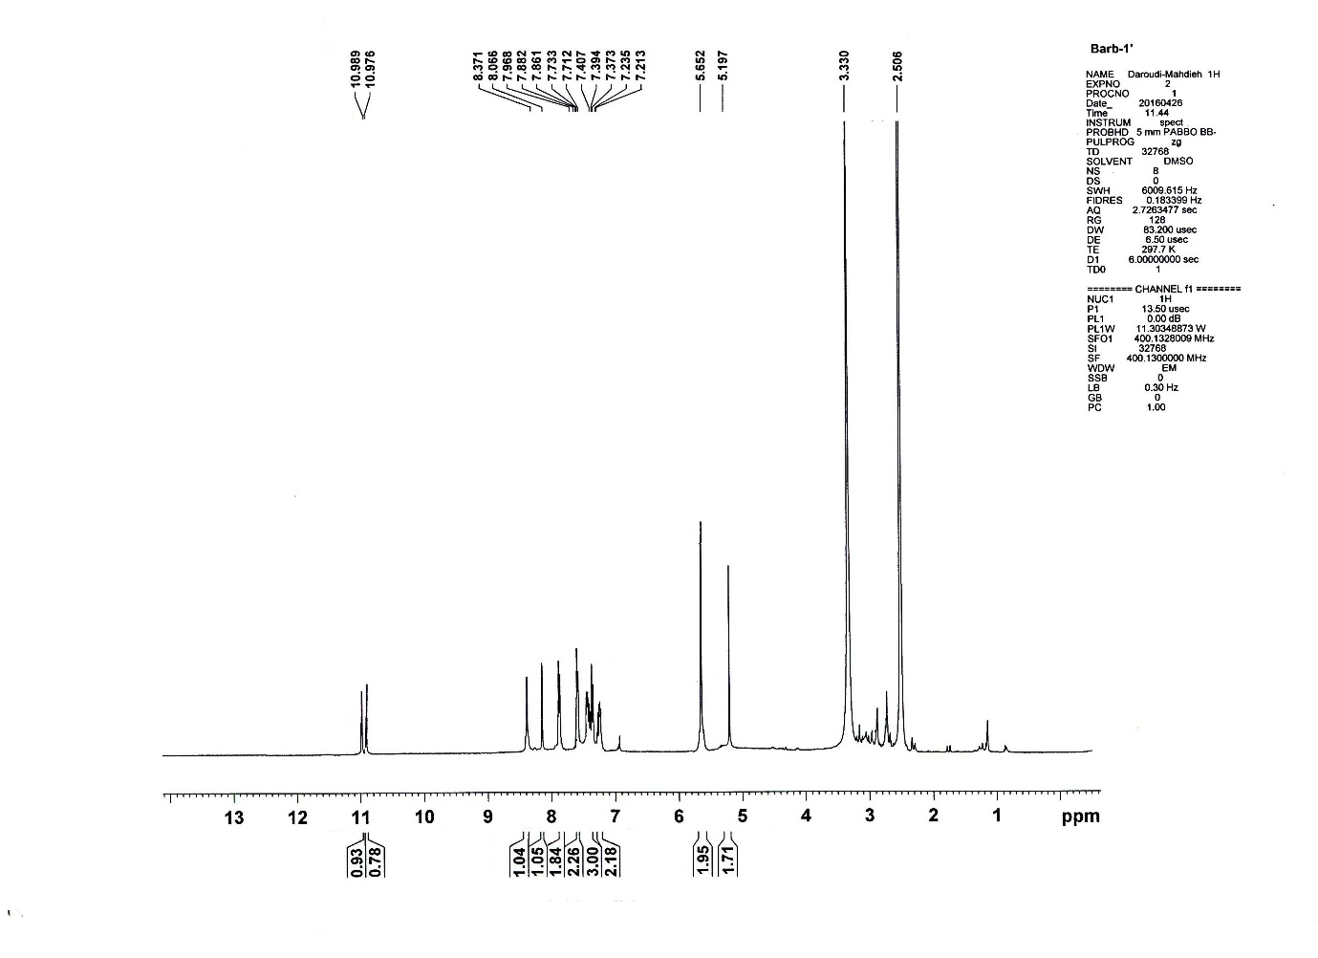
¹H-NMR spectrum of 8a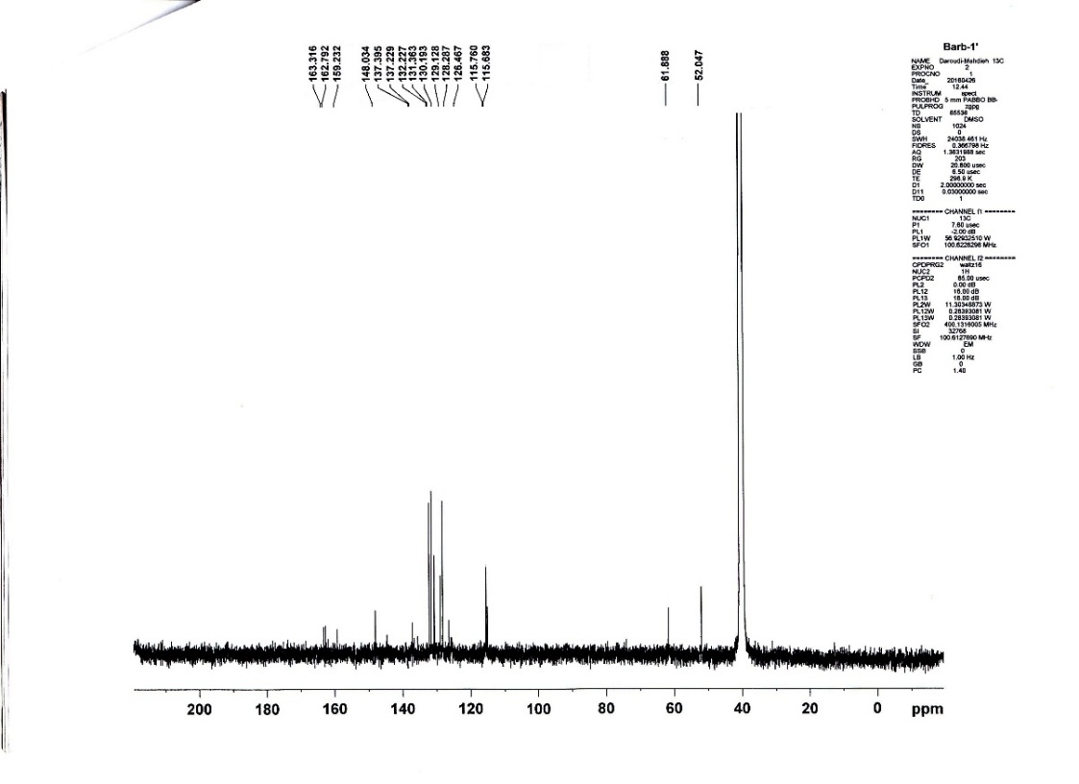
¹³C-NMR spectrum of 8a
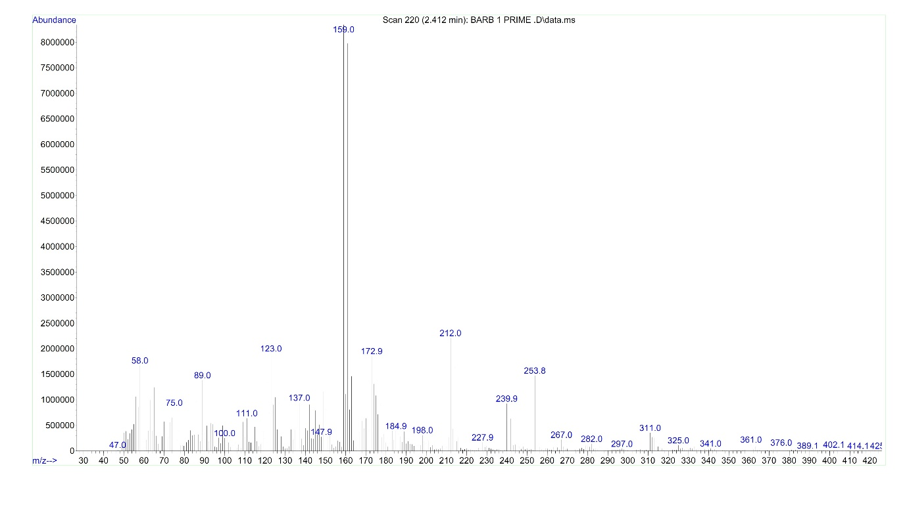
Mass spectrum of 8a
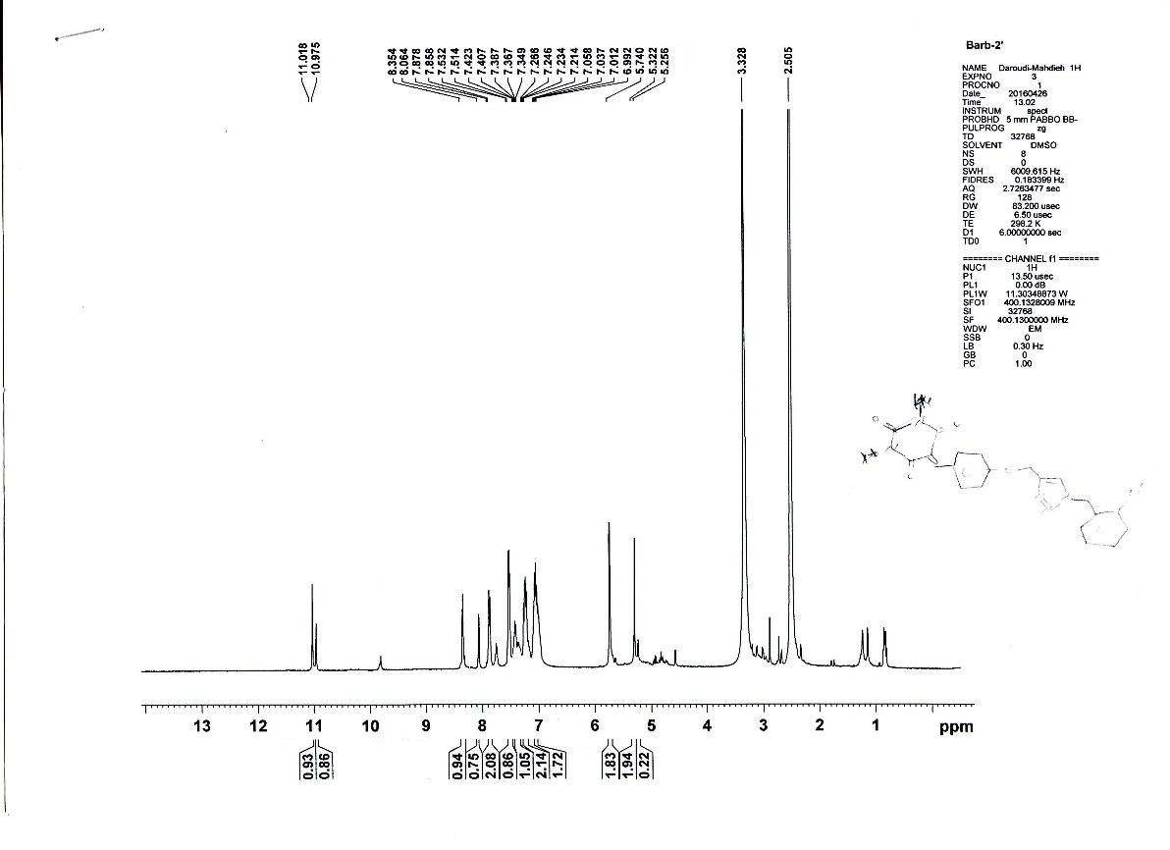
¹H-NMR spectrum of 8b
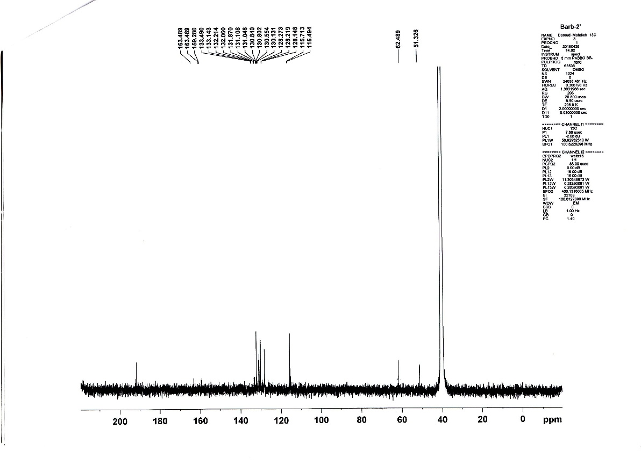
¹³C-NMR spectrum of 8b
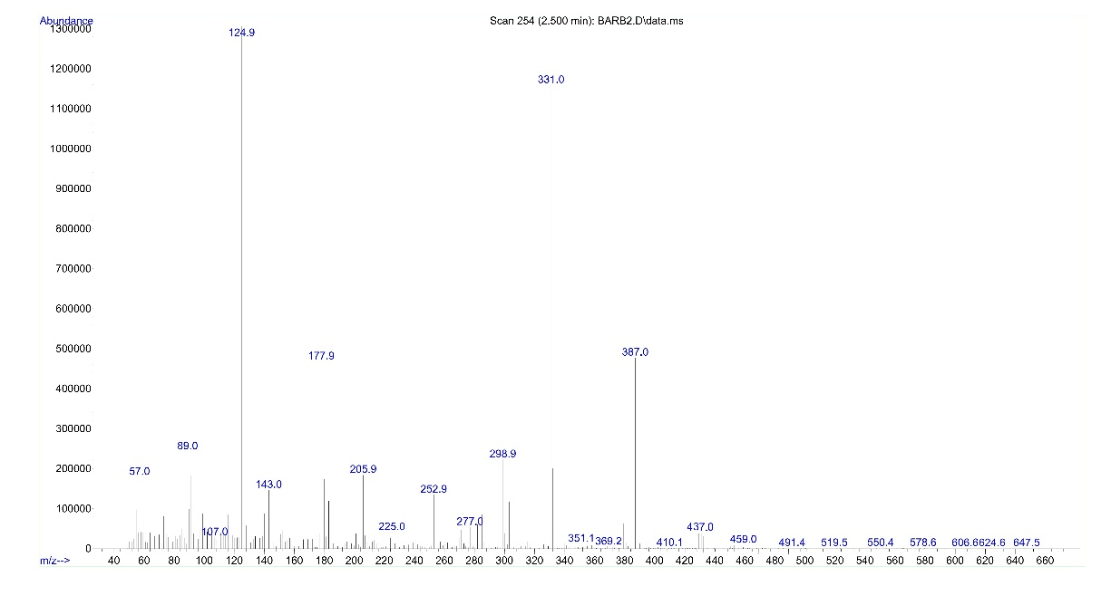
Mass spectrum of 8b
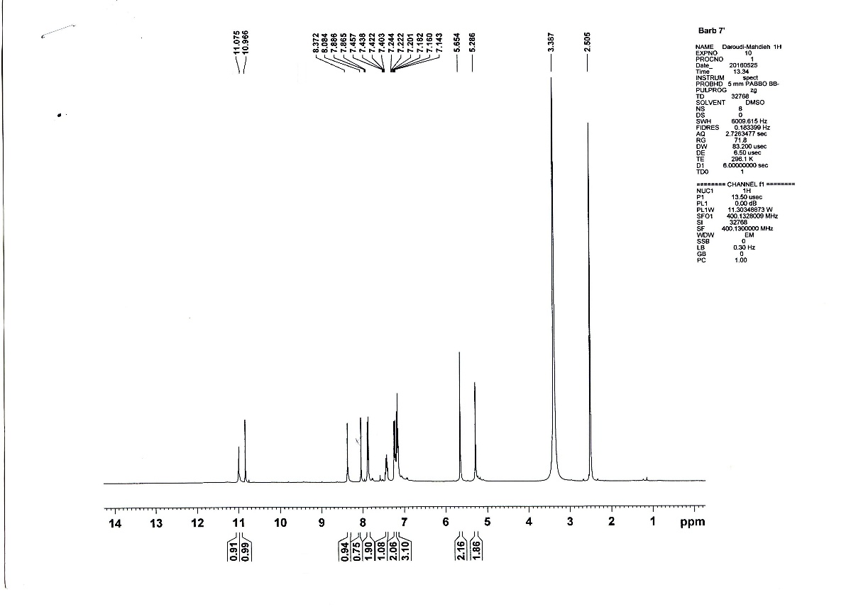
¹H-NMR spectrum of 8c
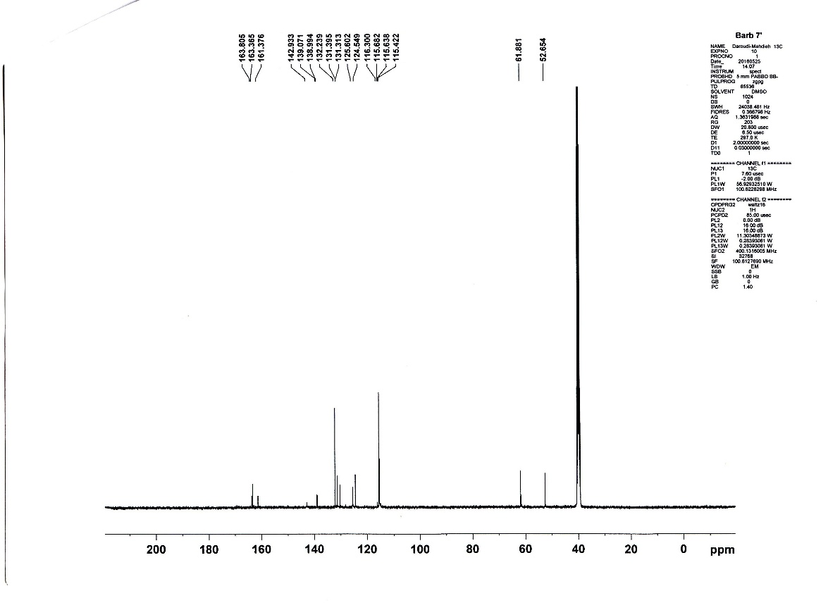
¹³C-NMR spectrum of 8c
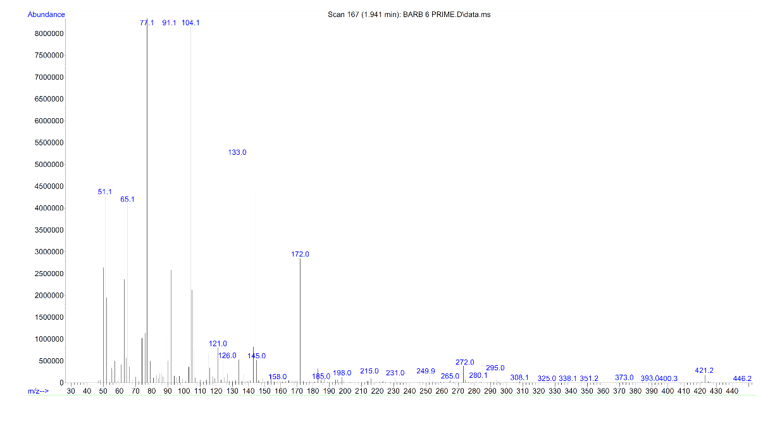
Mass spectrum of 8c
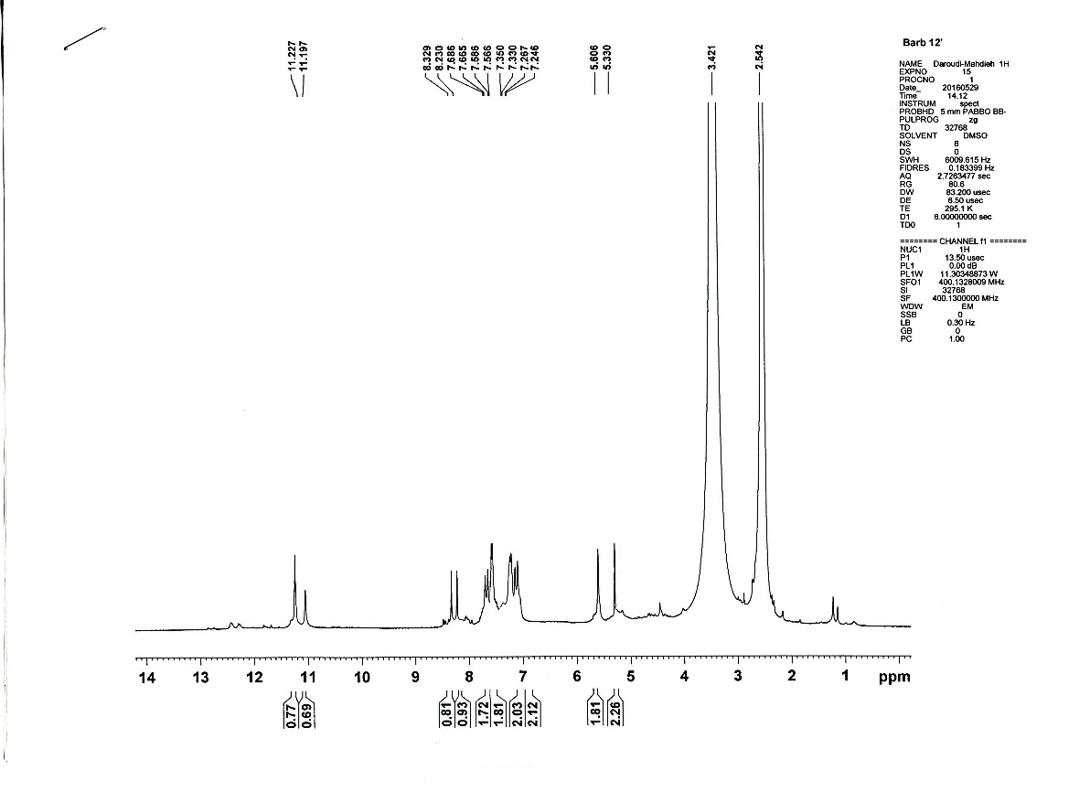
¹H-NMR spectrum of 8d
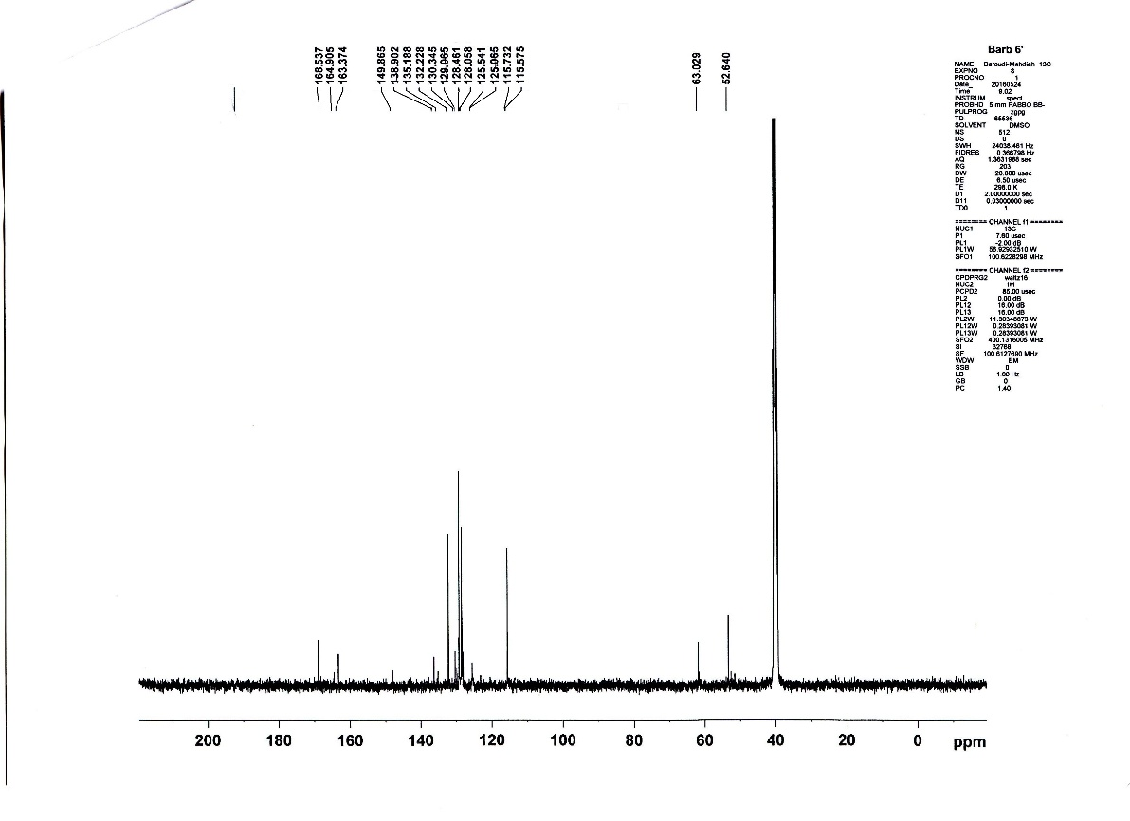
¹³C-NMR spectrum of 8d
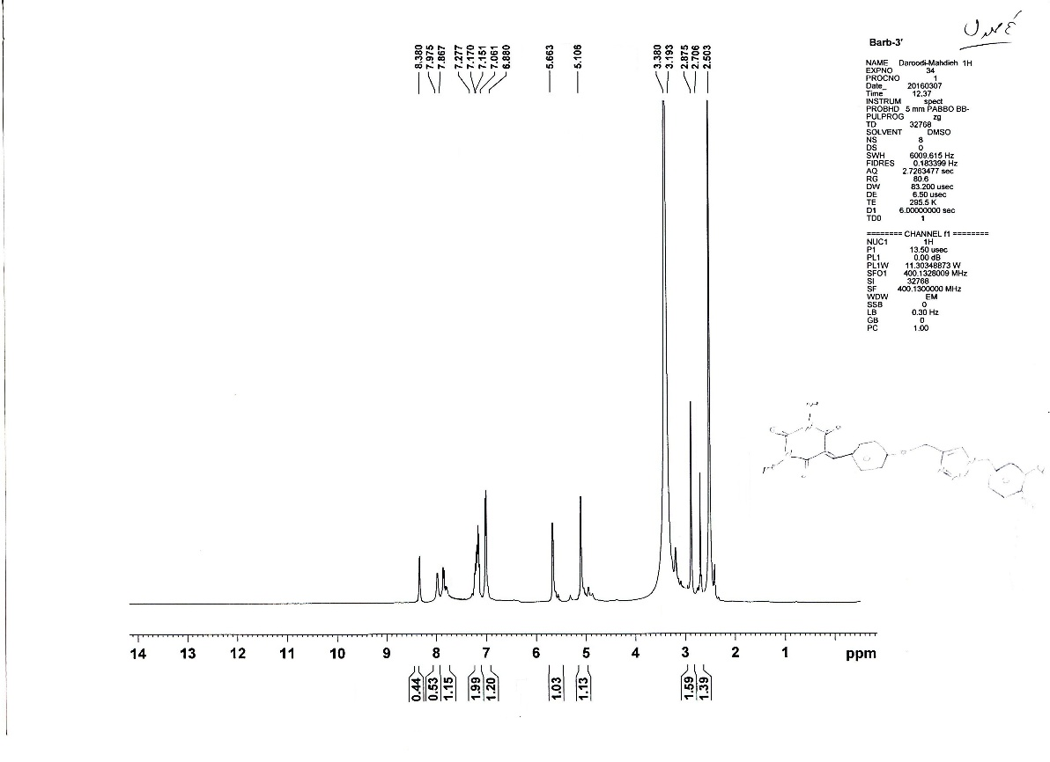
¹H-NMR spectrum of 8e

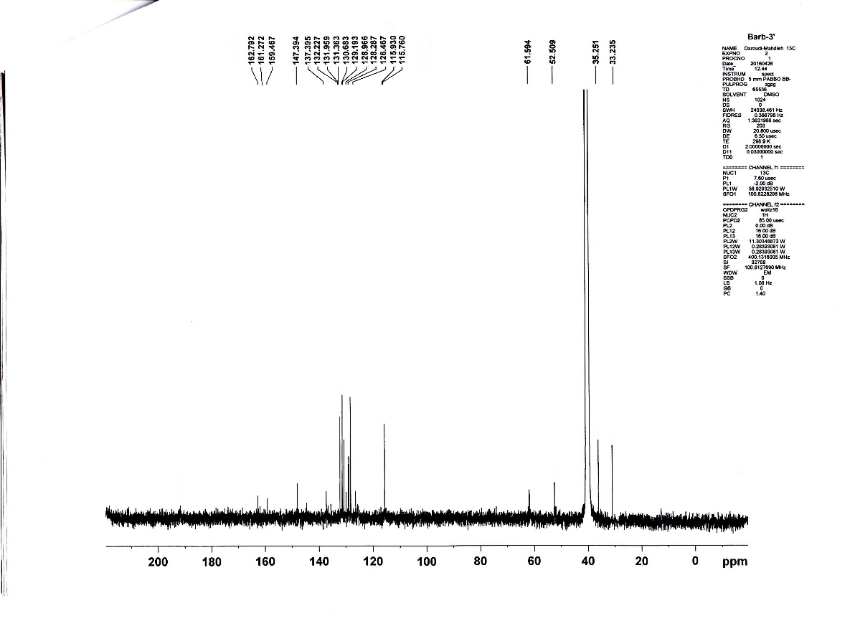
¹³C-NMR spectrum of 8e
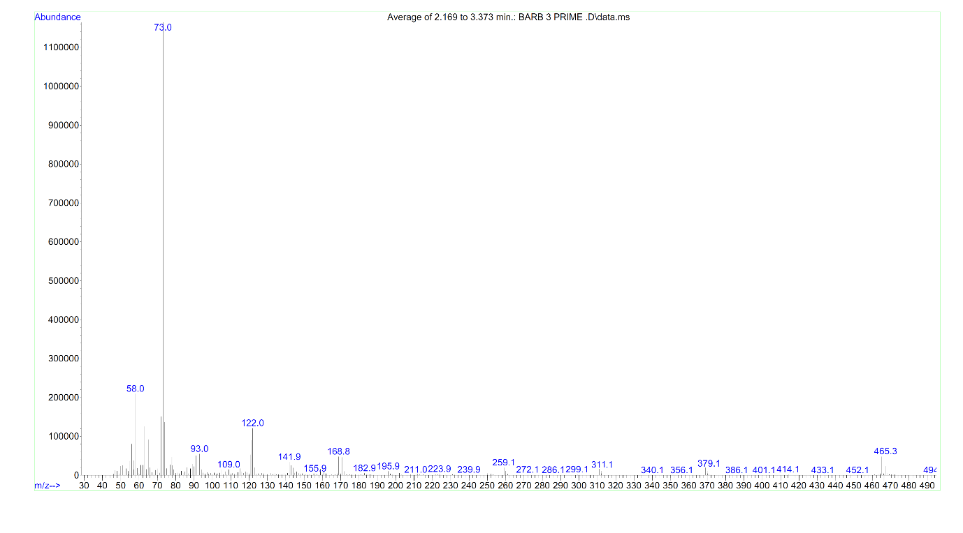
Mass spectrum of 8e
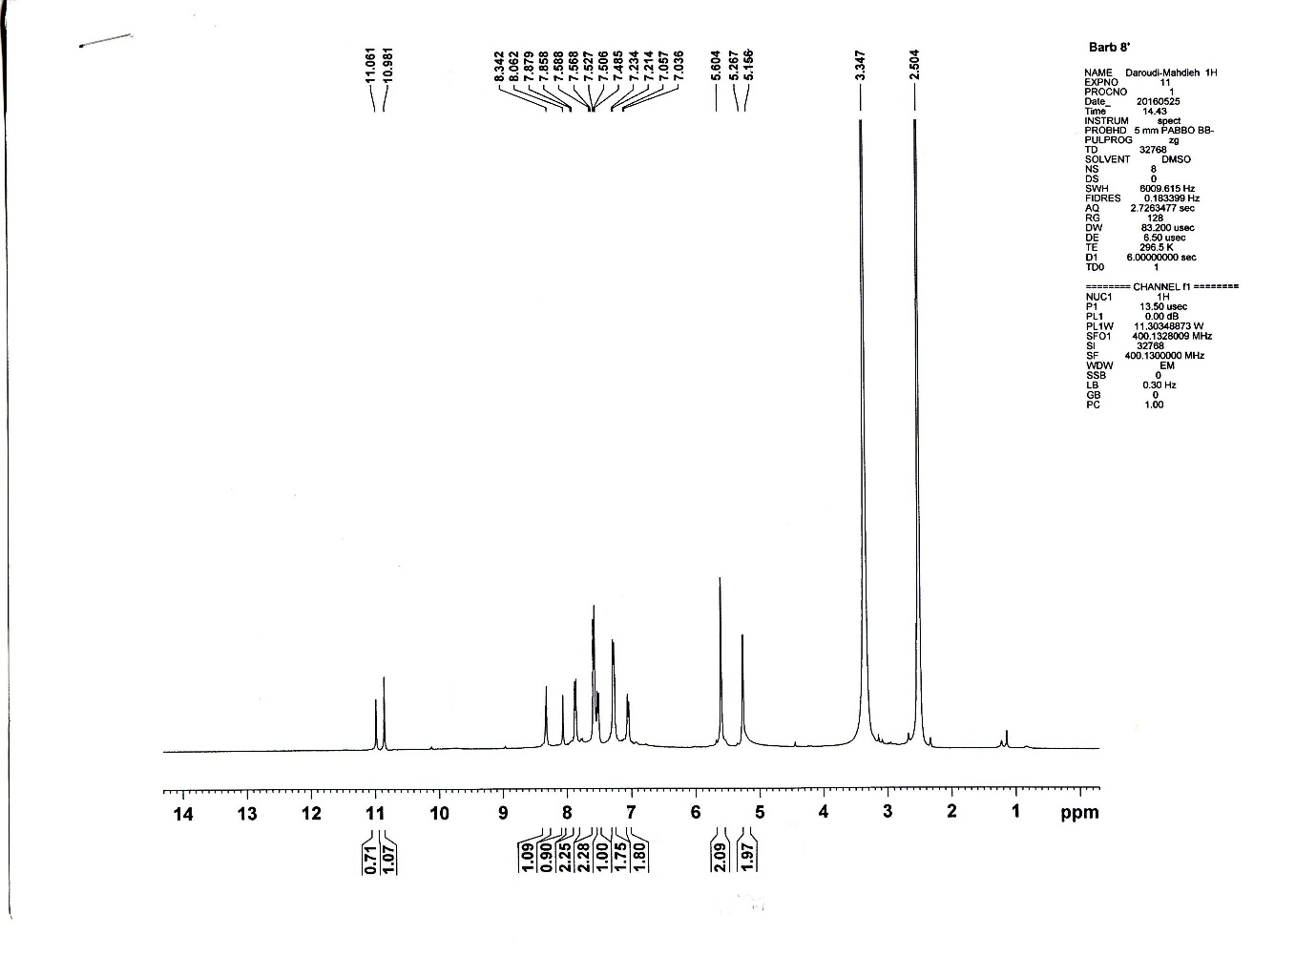
¹H-NMR spectrum of 8f
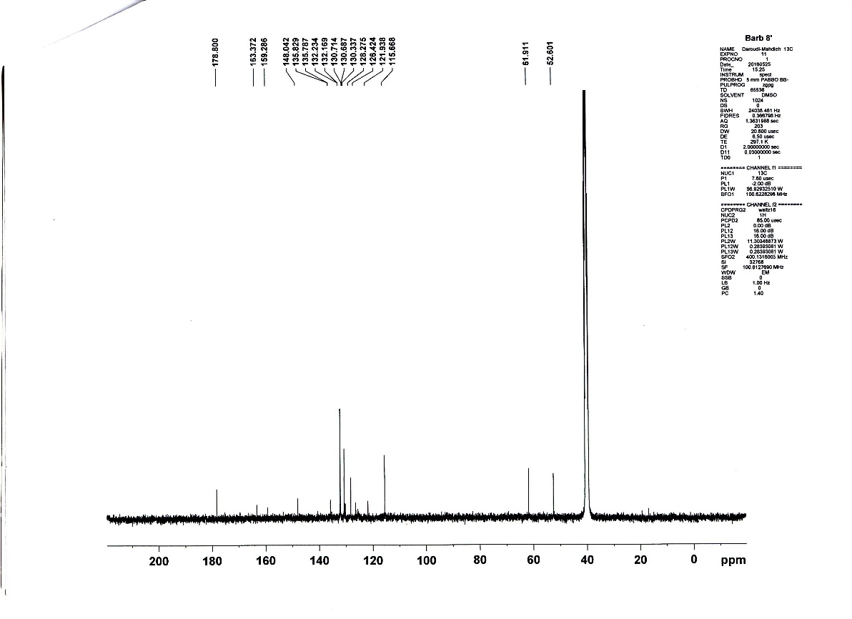
¹³C-NMR spectrum of 8f
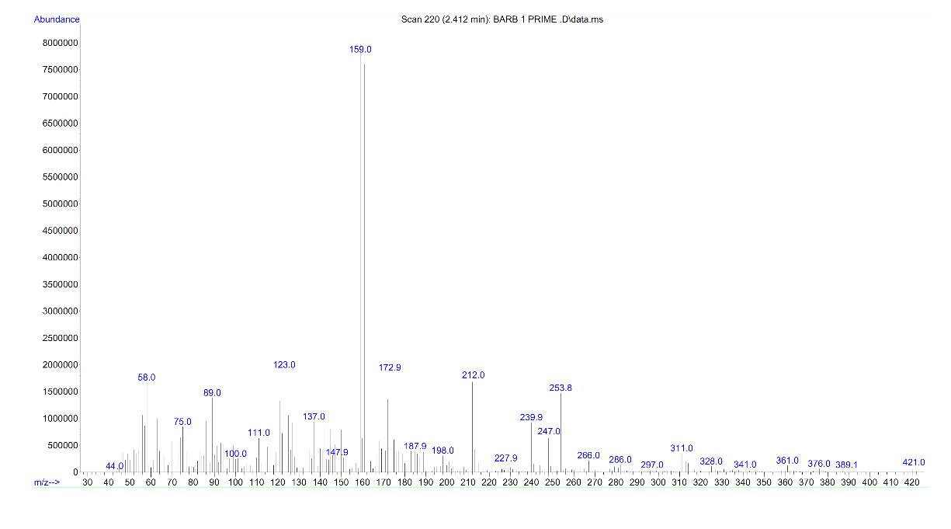
Mass spectrum of 8f
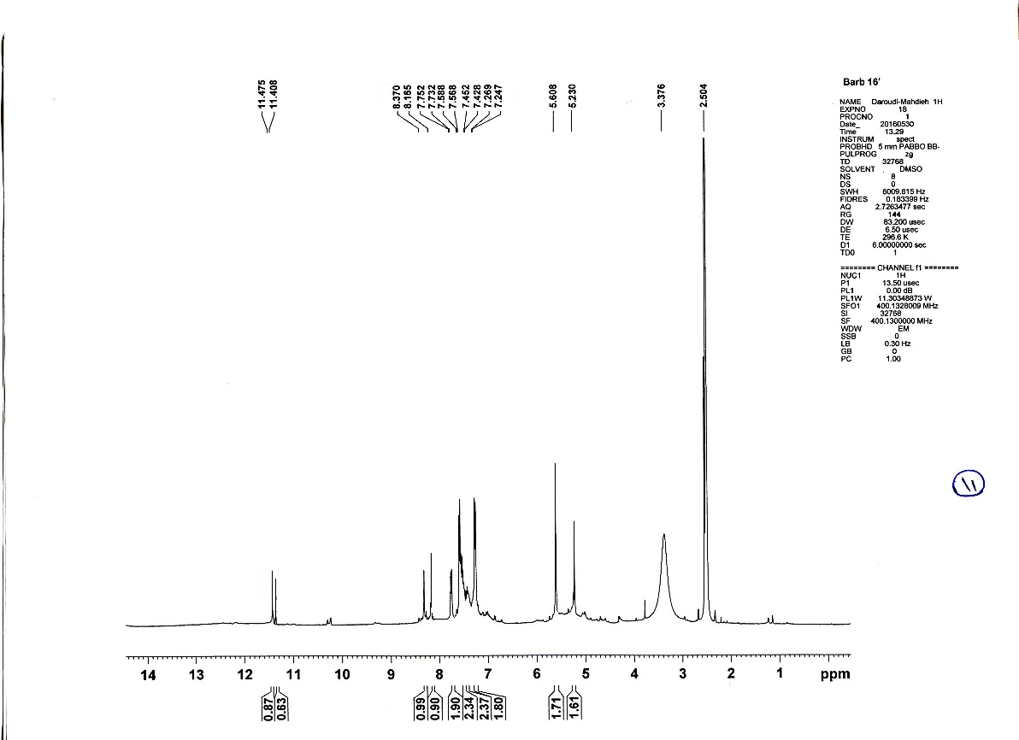
¹H-NMR spectrum of 8g
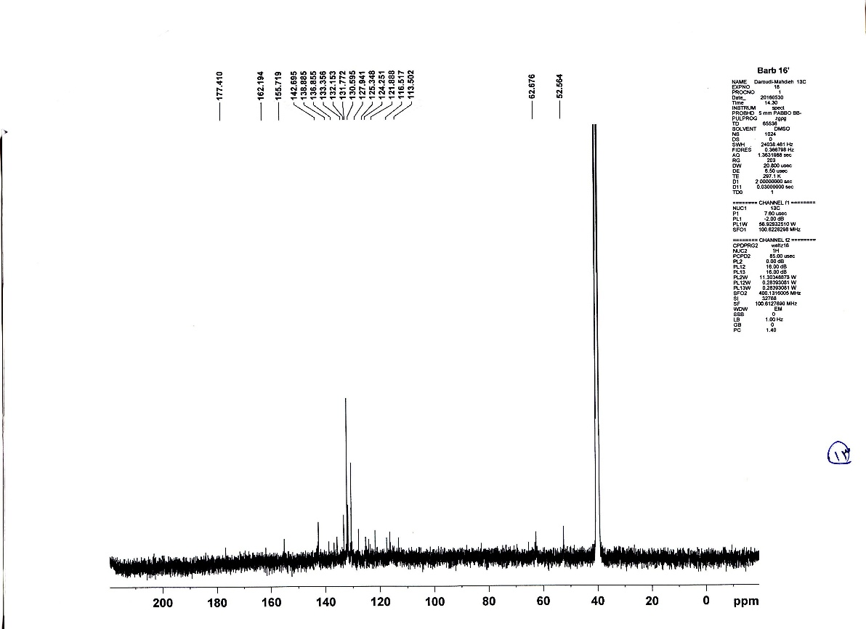
¹³C-NMR spectrum of 8g
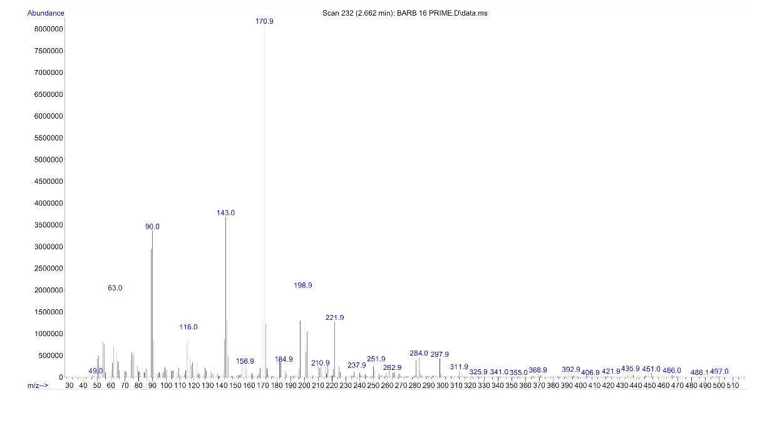
Mass spectrum of 8g
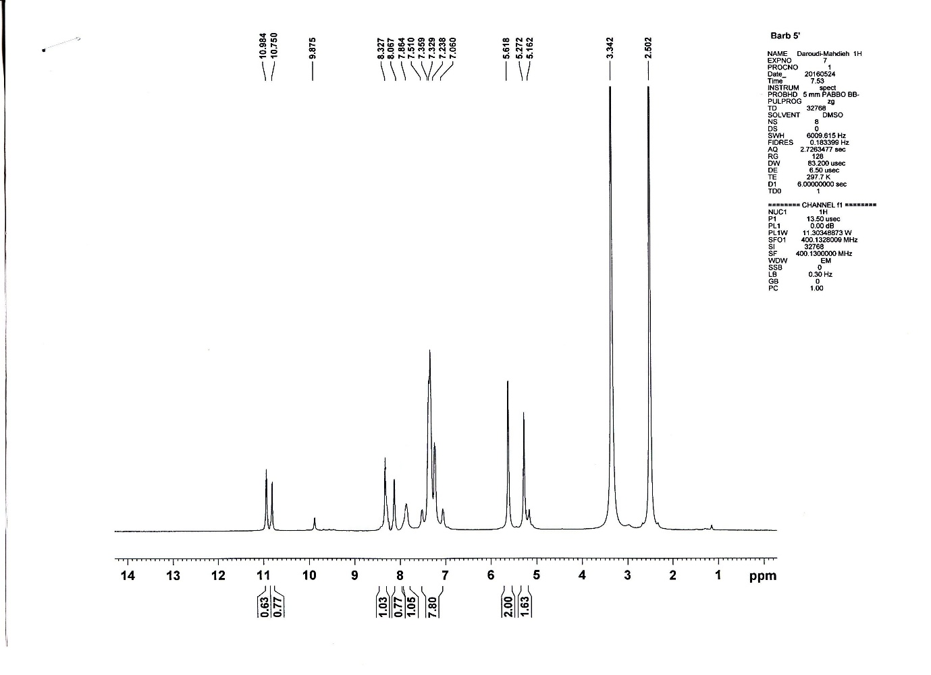
¹H-NMR spectrum of 7a
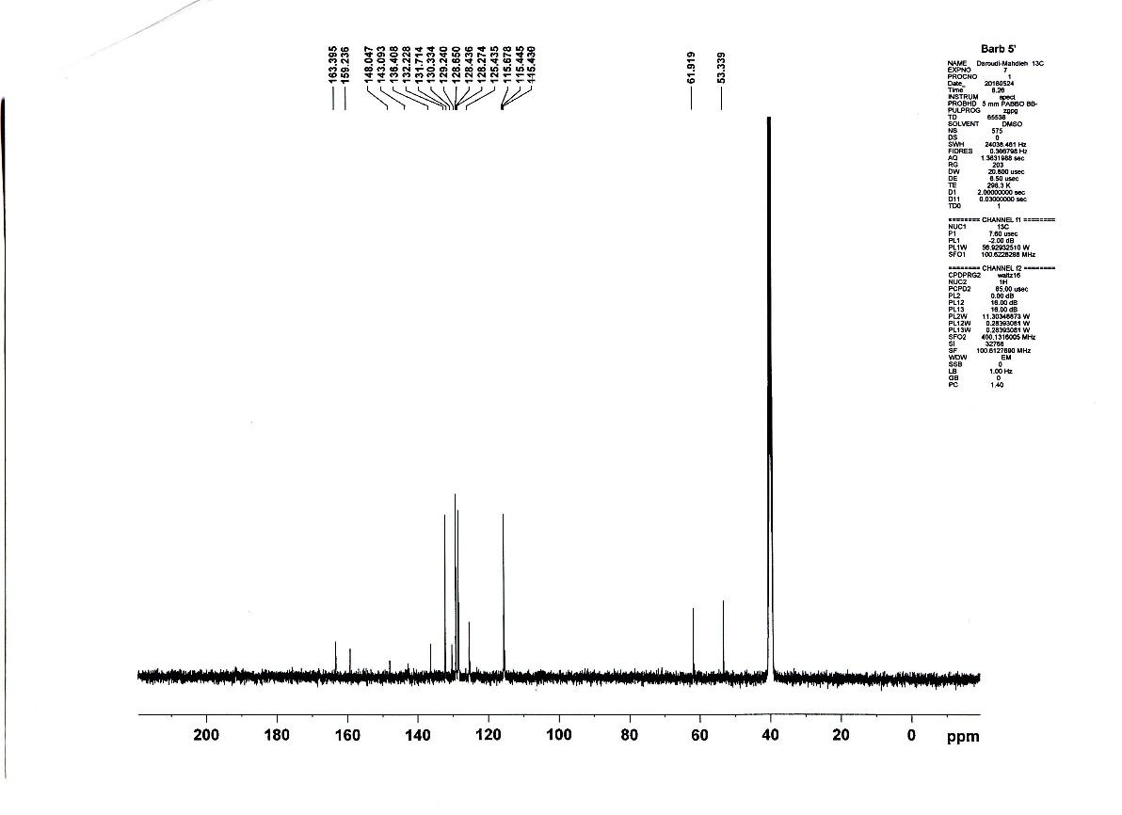
¹³C-NMR spectrum of 7a
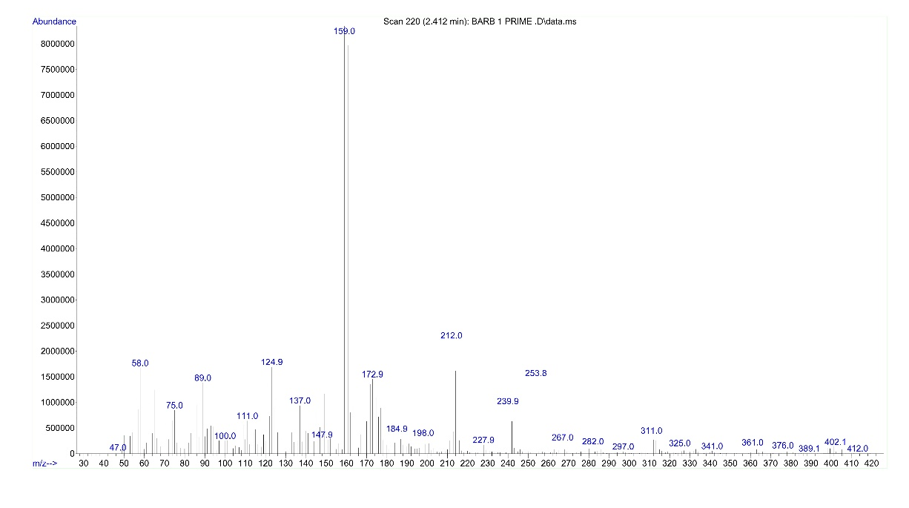
Mass spectrum of 7a
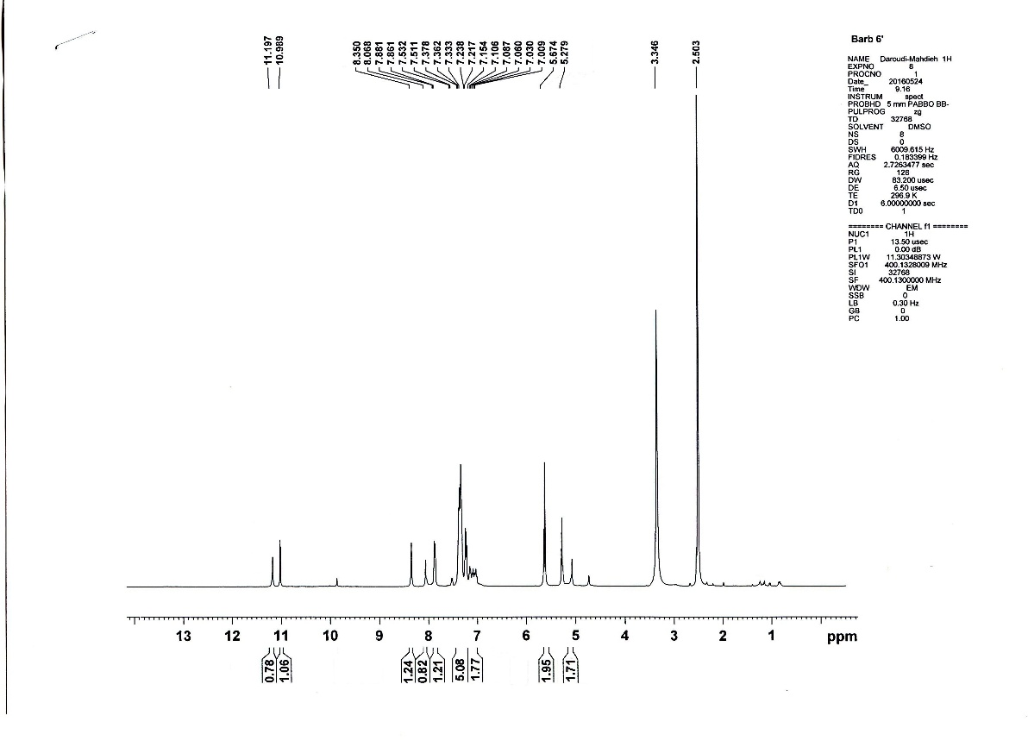
¹H-NMR spectrum of 7b
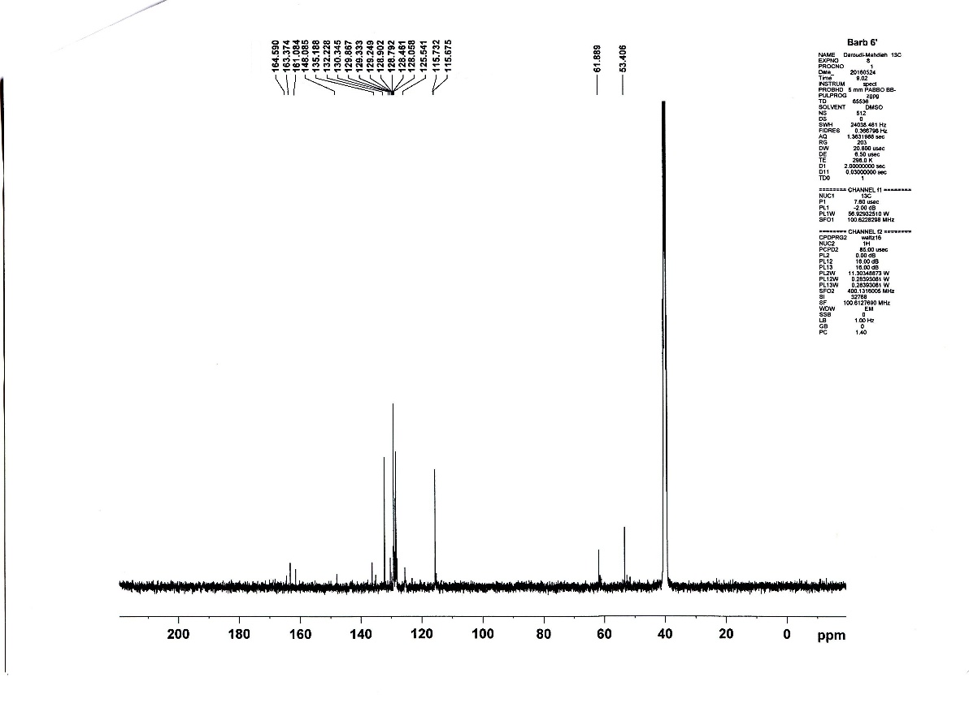
¹³C -NMR spectrum of 7b
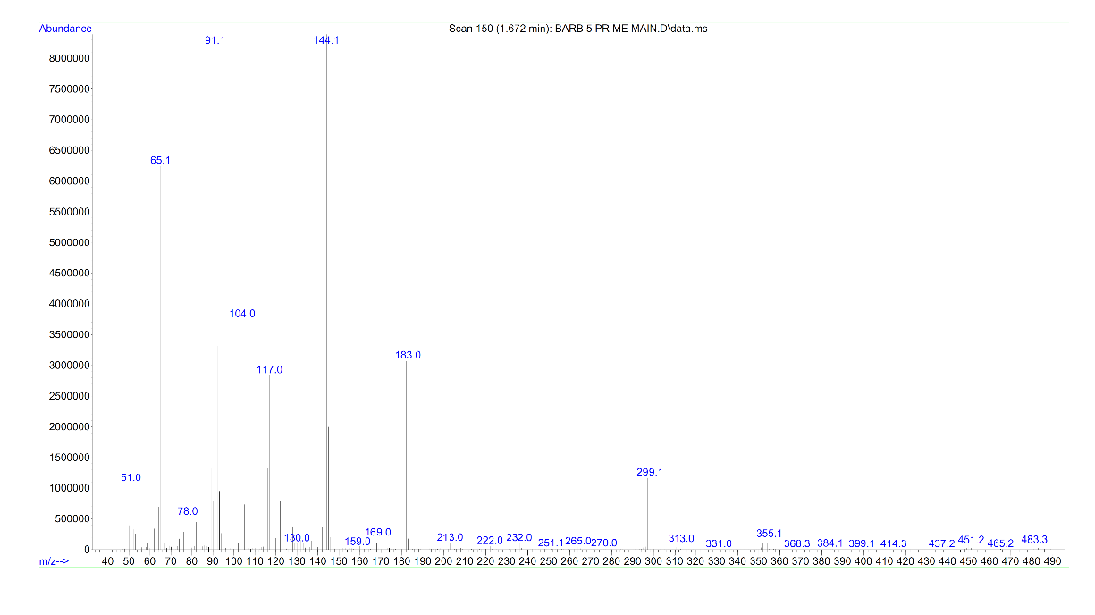
Mass spectrum of 7b
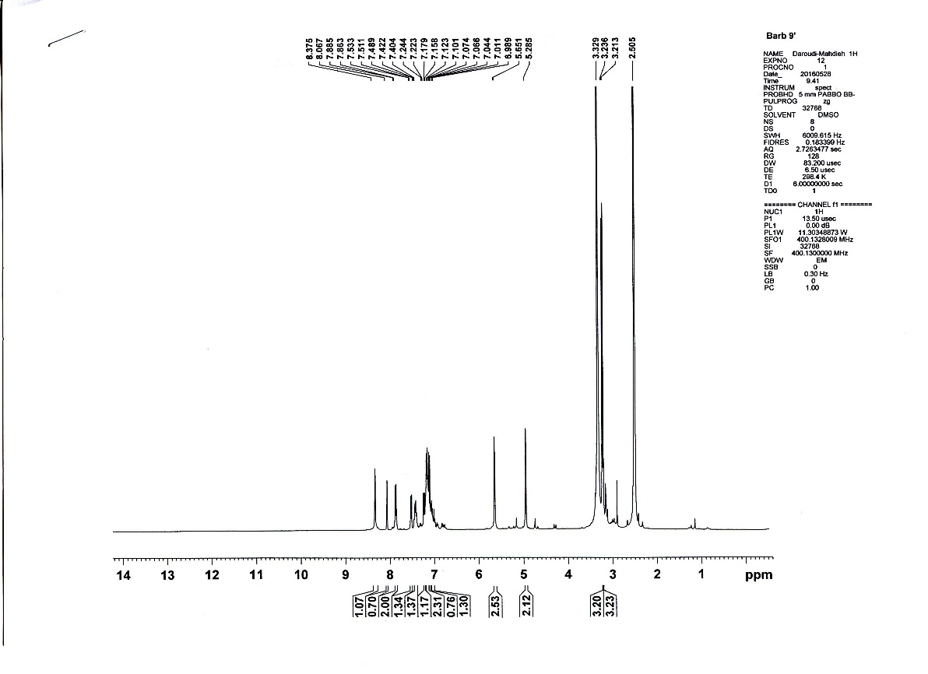
¹H-NMR spectrum of 7c
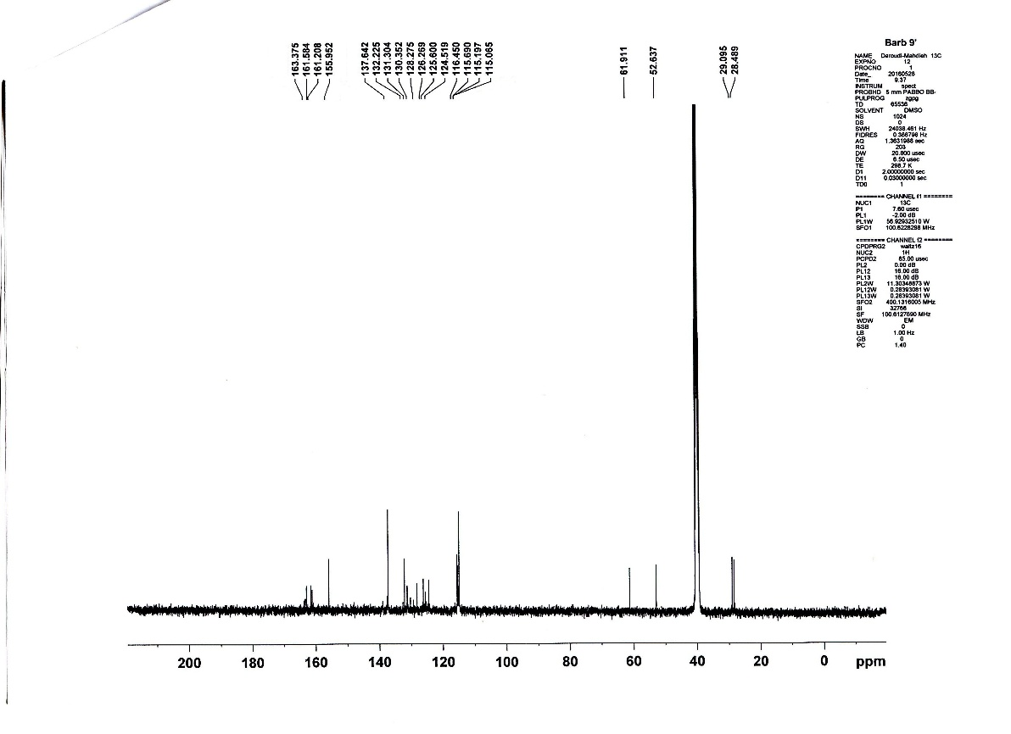
¹³C-NMR spectrum of 7c
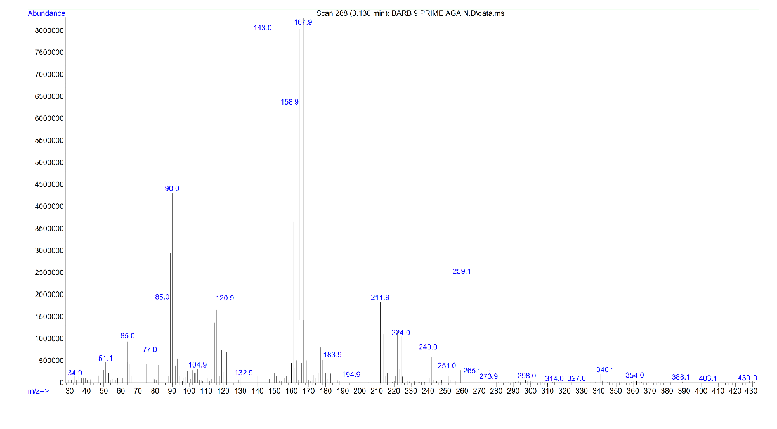
Mass spectrum of 7c
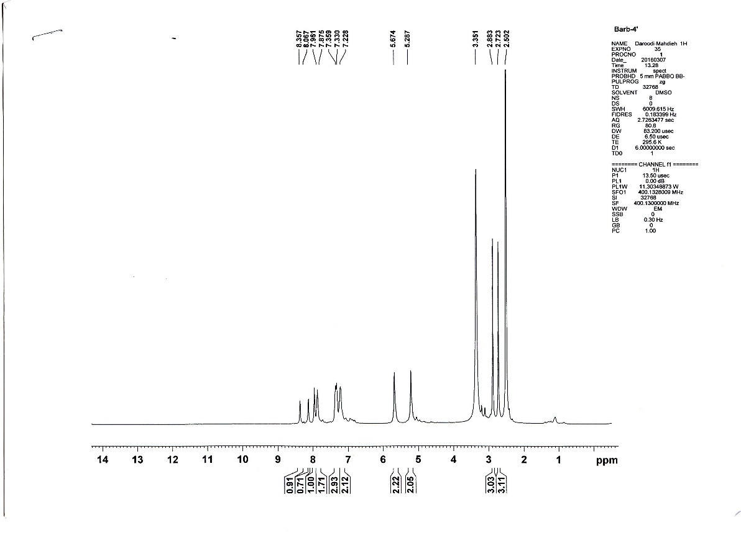
¹H-NMR spectrum of 7d
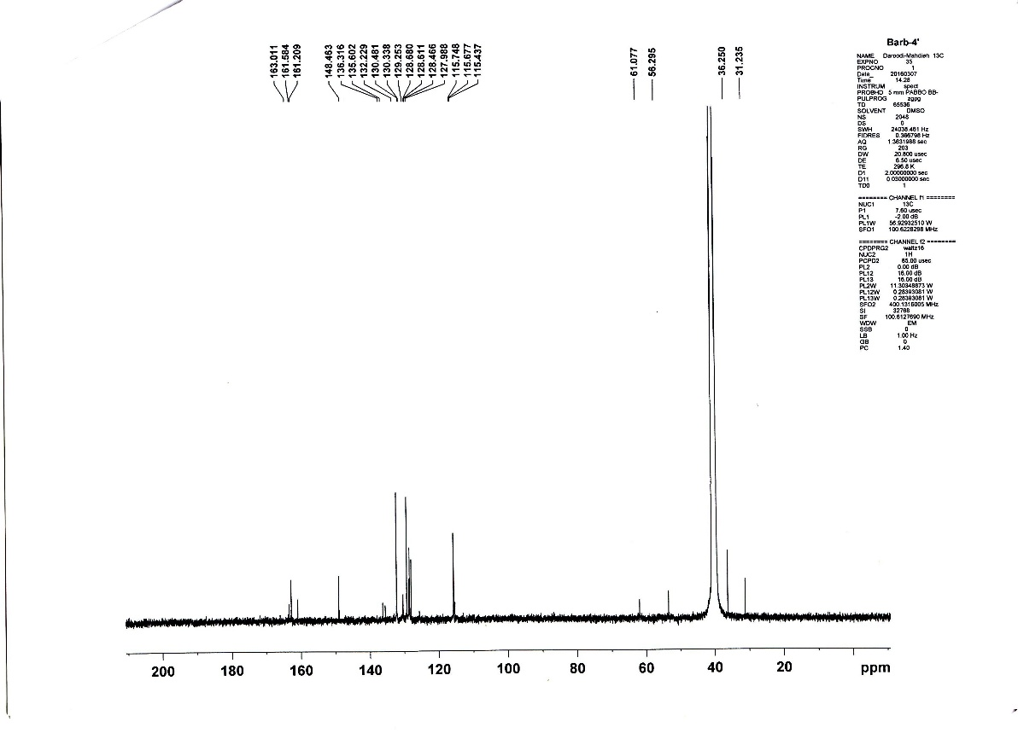
¹³C -NMR spectrum of 7d
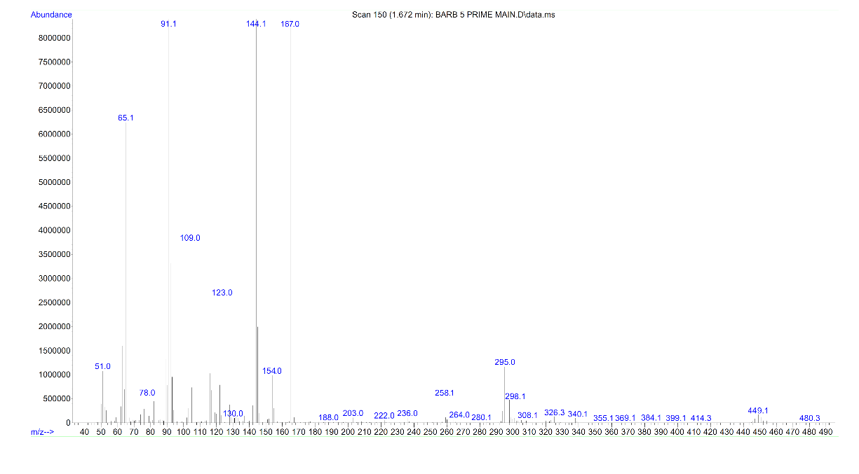 Mass spectrum of 7d
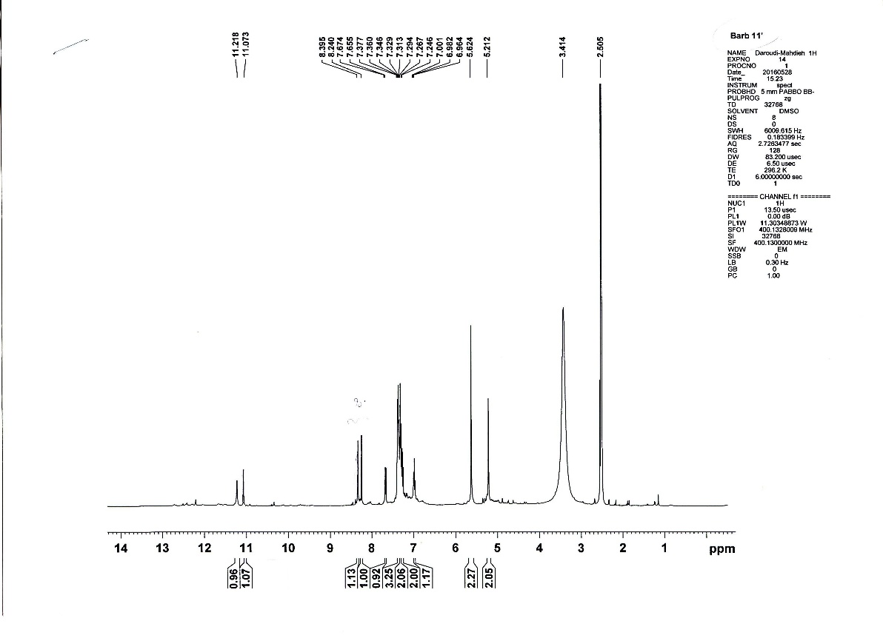
¹H-NMR spectrum of 7e
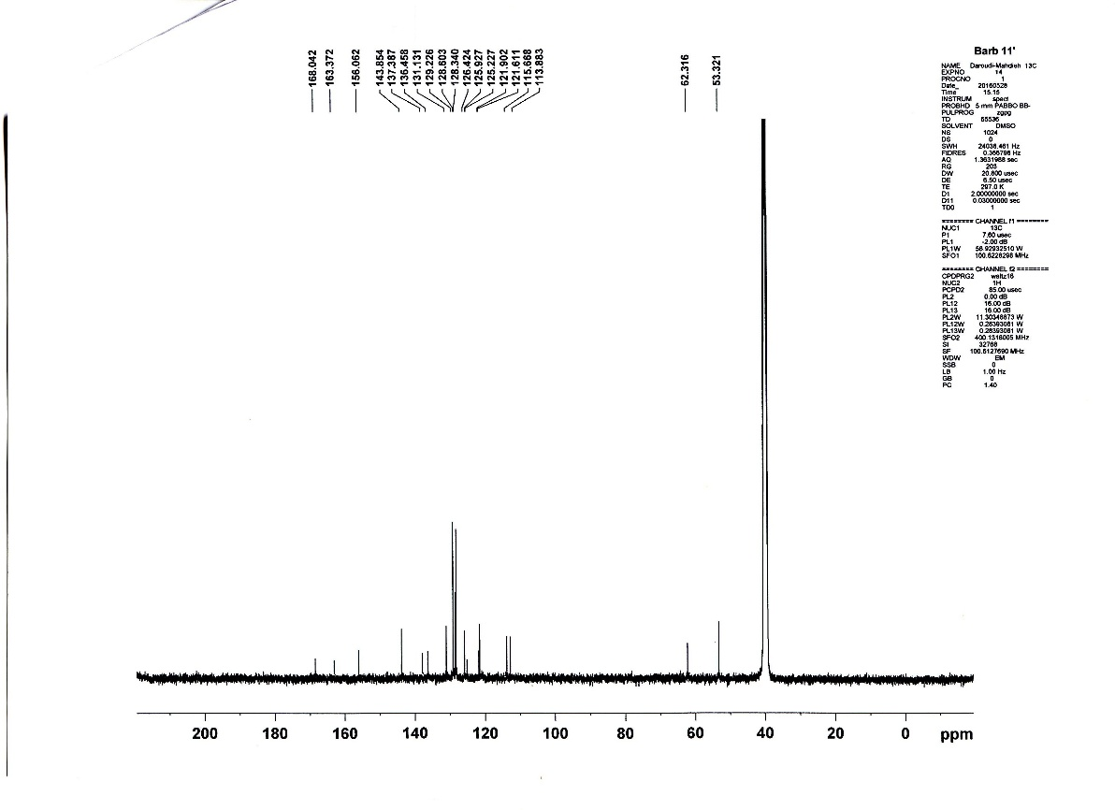
¹³C-NMR spectrum of 7e
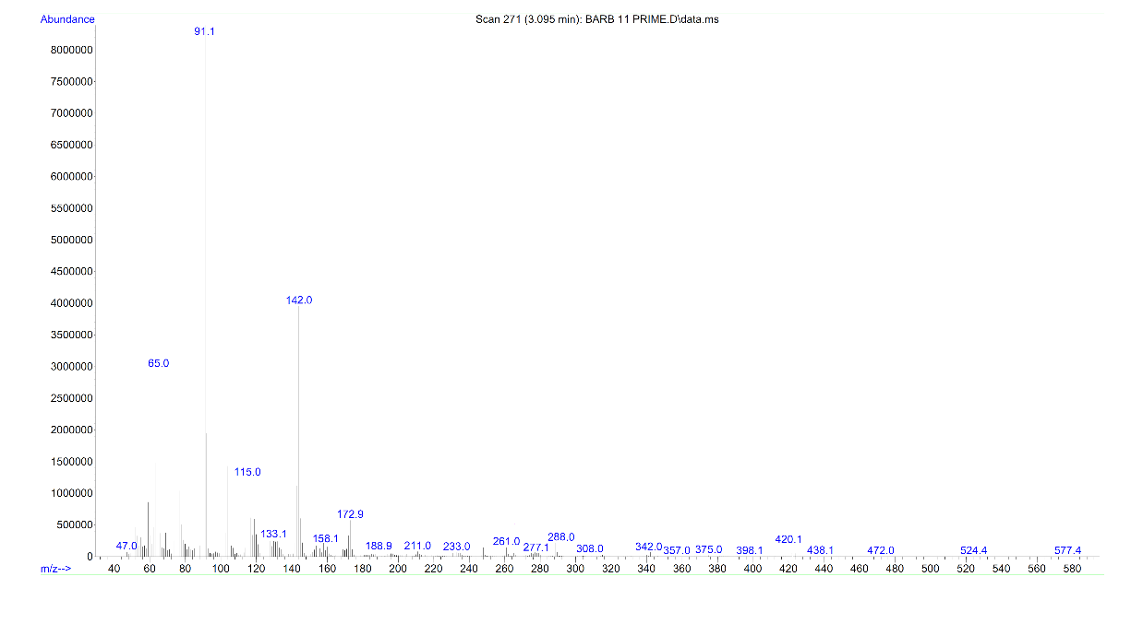
Mass spectrum of 7e
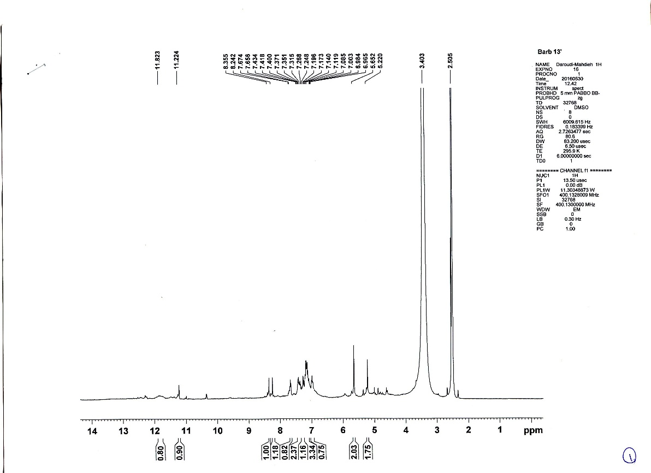
¹H-NMR spectrum of 7f
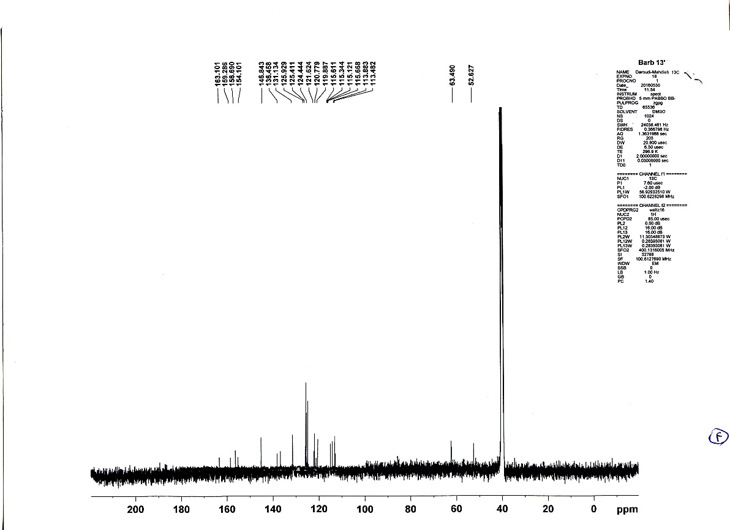
¹³C-NMR spectrum of 7f
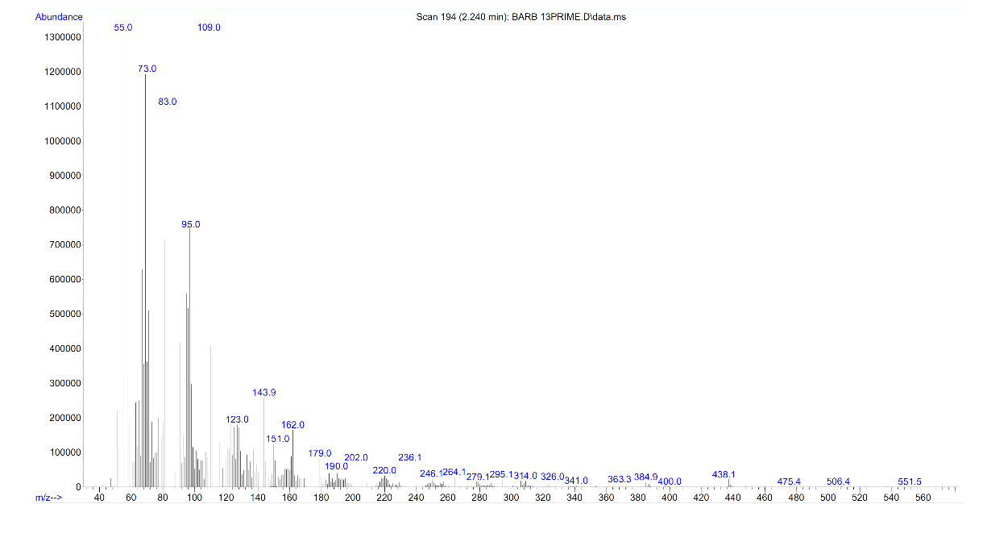
Mass spectrum of 7f
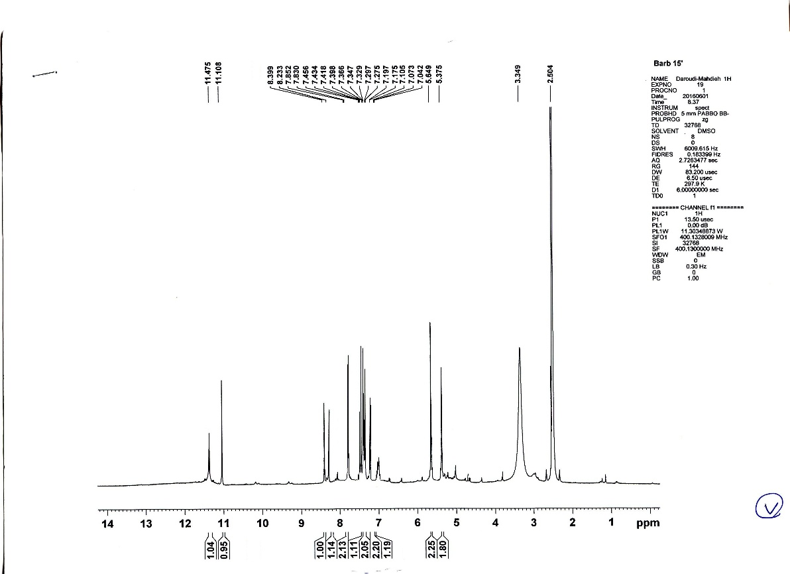
¹H-NMR spectrum of 7g

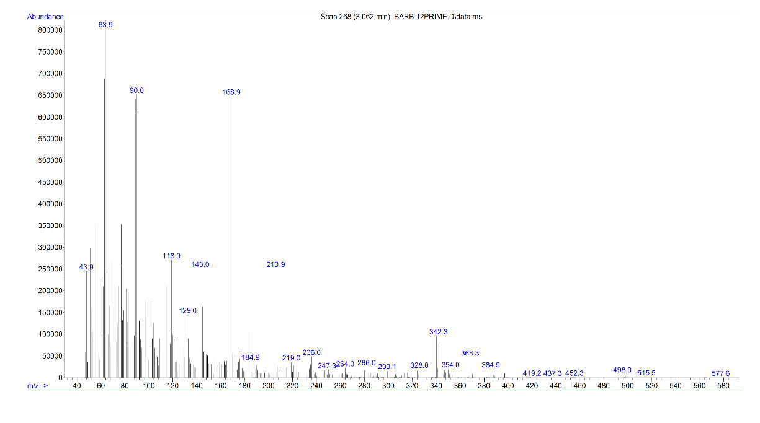
Mass spectrum of 7g

4
Input orientation:
---------------------------------------------------------------------
Center Atomic Atomic Coordinates (Angstroms)
Number Number Type X Y Z
---------------------------------------------------------------------
1 6 0 2.444973 -0.113785 0.254637
2 6 0 1.219982 0.790956 0.229594
3 6 0 1.426398 2.299438 0.270596
4 6 0 3.835253 1.892306 0.595793
5 7 0 2.780049 2.870306 0.218750
6 1 0 2.806734 3.644736 0.850846
7 7 0 3.797997 0.458488 0.202275
8 1 0 4.144078 0.395078 -0.733784
9 8 0 4.823413 2.304858 1.256785
10 8 0 0.430087 3.063134 0.358360
11 8 0 2.297582 -1.361279 0.329507
12 6 0 -0.028144 0.264400 0.191033
13 1 0 -0.881205 0.910229 0.181456
14 6 0 -0.801079 -1.066960 0.150383
15 6 0 -0.103453 -2.282372 0.146754
16 6 0 -2.202077 -1.063085 0.117024
17 6 0 -0.806824 -3.493909 0.109765
18 1 0 0.966240 -2.285330 0.172222
19 6 0 -2.905448 -2.274623 0.080035
20 6 0 -2.207822 -3.490035 0.076407
21 1 0 -0.274171 -4.421903 0.106995
22 1 0 -3.975141 -2.271665 0.054564
23 1 0 -2.744861 -4.415071 0.048169
24 8 0 -2.913941 0.177131 0.120725
25 6 0 -4.319375 -0.078986 0.057020
26 1 0 -4.616229 -0.653456 0.909524
27 1 0 -4.542365 -0.624630 -0.835979
28 6 0 -5.084733 1.257323 0.046701
29 6 0 -5.681712 2.299644 0.038651
30 1 0 -6.213486 3.228118 0.031481
---------------------------------------------------------------------
4a
Input orientation:
---------------------------------------------------------------------
Center Atomic Atomic Coordinates (Angstroms)
Number Number Type X Y Z
---------------------------------------------------------------------
1 6 0 4.161627 -0.501760 1.024770
2 6 0 3.066947 -0.516105 0.031644
3 6 0 2.563484 -1.829383 -0.443948
4 6 0 4.224615 -2.962477 0.956830
5 7 0 3.198391 -2.940420 0.055192
6 1 0 2.876781 -3.829830 -0.269528
7 7 0 4.646383 -1.738777 1.392002
8 1 0 5.383321 -1.744744 2.067984
9 8 0 4.718223 -3.986029 1.341787
10 8 0 1.660012 -1.965766 -1.225276
11 8 0 4.624858 0.479420 1.535991
12 6 0 2.402496 0.564967 -0.425943
13 1 0 1.550263 0.317872 -1.030037
14 6 0 2.607720 2.006682 -0.266439
15 6 0 3.860317 2.617173 -0.291641
16 6 0 1.460126 2.819493 -0.220224
17 6 0 3.983867 3.995246 -0.258537
18 1 0 4.738627 2.008710 -0.357164
19 6 0 1.578481 4.200553 -0.159494
20 6 0 2.841118 4.777031 -0.181438
21 1 0 4.956031 4.450873 -0.291367
22 1 0 0.712885 4.830154 -0.100858
23 1 0 2.923961 5.848098 -0.141786
24 8 0 0.283770 2.165599 -0.217357
25 6 0 -0.931772 2.883182 -0.220973
26 1 0 -0.976049 3.545971 -1.075709
27 1 0 -1.017746 3.469049 0.684516
28 6 0 -2.035232 1.909384 -0.306676
29 6 0 -3.013164 1.200801 -0.451469
30 29 0 -1.906696 -0.069816 0.916000
31 29 0 -4.669058 0.170679 -0.822115
32 8 0 -1.114206 -1.505982 2.171005
33 1 0 -0.887531 -1.260512 3.062233
34 8 0 -6.388126 -0.858909 -1.217864
35 1 0 -7.094160 -0.420015 -1.681861
36 1 0 -0.396840 -2.042638 1.848933
37 1 0 -6.329401 -1.736010 -1.583455
---------------------------------------------------------------------
6a
Input orientation:
---------------------------------------------------------------------
Center Atomic Atomic Coordinates (Angstroms)
Number Number Type X Y Z
---------------------------------------------------------------------
1 6 0 -2.667601 -0.152009 -0.210094
2 6 0 -1.304931 -0.150994 0.117125
3 6 0 -0.610319 1.061650 0.221618
4 6 0 -1.278371 2.273273 -0.001065
5 6 0 -2.641037 2.272253 -0.328252
6 6 0 -3.335649 1.059615 -0.432786
7 1 0 -3.197964 -1.077886 -0.289903
8 1 0 -0.794866 -1.076096 0.287190
9 1 0 -0.748026 3.199151 0.078727
10 1 0 -3.151111 3.197351 -0.498254
11 1 0 -4.376072 1.058845 -0.682637
12 6 0 0.887125 1.062781 0.581143
13 1 0 1.125855 1.960761 1.111738
14 1 0 1.106763 0.215642 1.196778
15 7 0 1.686782 0.994030 -0.650414
16 7 0 2.281290 0.942967 -1.564991
17 7 0 3.043473 0.877503 -2.737505
---------------------------------------------------------------------
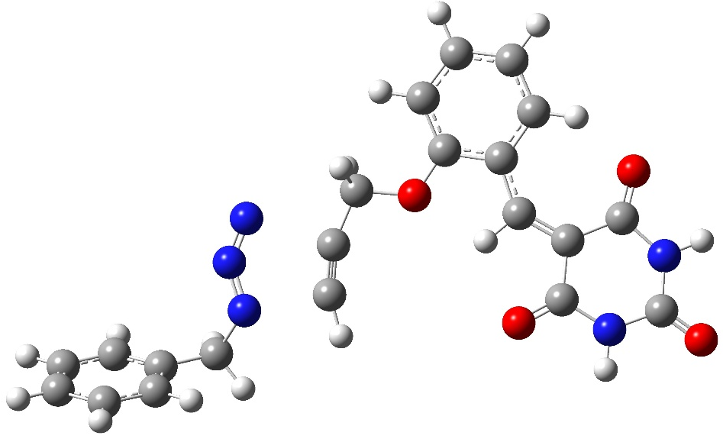
A
Input orientation:
--------------------------------------------------------------------
enter Atomic Atomic Coordinates (Angstroms)
umber Number Type X Y Z
--------------------------------------------------------------------
1 6 0 -1.517226 0.749869 -0.219263
2 7 0 -3.413687 1.968669 -0.181507
3 7 0 -4.120746 1.044465 -0.282906
4 7 0 -4.083387 -0.211455 -0.260570
5 6 0 -0.594812 1.880843 -0.119967
6 8 0 0.756912 1.372573 -0.126750
7 1 0 -0.768955 2.445544 0.803504
8 6 0 1.787053 2.234570 0.058533
9 6 0 3.092514 1.649853 0.177405
10 6 0 1.622573 3.622704 0.117659
11 6 0 3.153114 0.207203 0.193353
12 6 0 4.187504 2.525660 0.358547
13 6 0 2.733055 4.445064 0.301437
14 1 0 0.641580 4.069413 0.017016
15 6 0 4.122003 -0.763728 0.103557
16 1 0 2.170839 -0.242019 0.313971
17 6 0 4.014747 3.900830 0.426670
18 1 0 5.173574 2.094328 0.448123
19 1 0 2.590119 5.521125 0.344415
20 6 0 5.556703 -0.581335 -0.188413
21 6 0 3.598103 -2.152588 0.259507
22 1 0 4.872639 4.548695 0.576200
23 7 0 6.308735 -1.755004 -0.269594
24 8 0 6.132879 0.485146 -0.378965
25 7 0 4.529030 -3.179201 0.144301
26 8 0 2.425972 -2.434230 0.483476
27 6 0 5.881404 -3.060932 -0.116525
28 1 0 7.294455 -1.633426 -0.474686
29 1 0 4.176442 -4.123109 0.257844
30 8 0 6.629595 -4.020484 -0.204808
31 1 0 -0.733920 2.564142 -0.965789
32 6 0 -1.947741 -0.404112 -0.314976
33 1 0 -1.957652 -1.471378 -0.385399
34 6 0 -5.084320 -0.993408 -1.017296
35 6 0 -6.459800 -0.975328 -0.380216
36 1 0 -5.131727 -0.647358 -2.055800
37 6 0 -6.684715 -1.614070 0.847447
38 6 0 -7.521135 -0.313383 -1.007139
39 6 0 -7.948483 -1.589233 1.436619
40 1 0 -5.865363 -2.130044 1.342283
41 6 0 -8.789471 -0.290316 -0.420185
42 1 0 -7.356888 0.184187 -1.960014
43 6 0 -9.005117 -0.927030 0.803041
44 1 0 -8.111192 -2.089772 2.387293
45 1 0 -9.605616 0.224907 -0.919325
46 1 0 -9.990346 -0.910307 1.260886
47 1 0 -4.676178 -2.008096 -1.020990
--------------------------------------------------------------------

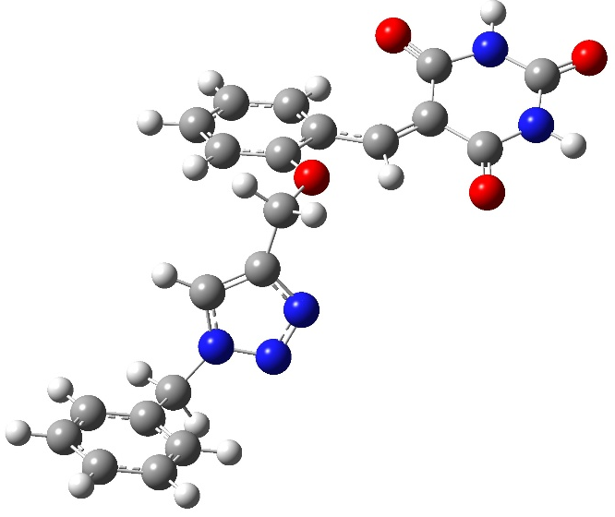
B
Standard orientation:
---------------------------------------------------------------------
Center Atomic Atomic Coordinates (Angstroms)
Number Number Type X Y Z
---------------------------------------------------------------------
1 6 0 -2.979199 0.419689 0.317463
2 6 0 -1.859264 -0.278925 0.722211
3 6 0 -0.897704 -0.002710 1.834919
4 8 0 0.455778 0.199544 1.376364
5 1 0 -1.227715 0.842815 2.444923
6 6 0 0.807994 1.330769 0.712349
7 6 0 2.106368 1.317633 0.109336
8 6 0 0.004804 2.473027 0.637977
9 6 0 2.819139 0.059636 0.128008
10 6 0 2.536860 2.486412 -0.557543
11 6 0 0.468462 3.603224 -0.033071
12 1 0 -0.972876 2.495658 1.101147
13 6 0 4.121981 -0.338057 -0.036161
14 1 0 2.164860 -0.788651 0.313374
15 6 0 1.729568 3.612256 -0.637471
16 1 0 3.513264 2.484450 -1.019183
17 1 0 -0.165641 4.484003 -0.081016
18 6 0 5.309194 0.535182 -0.124658
19 6 0 4.318931 -1.815832 -0.016923
20 1 0 2.076364 4.493036 -1.168502
21 7 0 6.535610 -0.127066 -0.207181
22 8 0 5.310491 1.761244 -0.108796
23 7 0 5.632408 -2.260925 -0.120747
24 8 0 3.414124 -2.637702 0.075559
25 6 0 6.776019 -1.488975 -0.213933
26 1 0 7.355930 0.466875 -0.261007
27 1 0 5.770862 -3.265437 -0.117098
28 8 0 7.895968 -1.965862 -0.294511
29 1 0 -0.809495 -0.874758 2.485855
30 7 0 -3.467149 -0.292279 -0.724010
31 7 0 -2.697724 -1.378675 -0.960329
32 7 0 -1.726593 -1.373106 -0.086018
33 1 0 -3.449254 1.322198 0.677150
34 6 0 -4.671083 -0.048952 -1.529028
35 6 0 -5.954225 -0.320119 -0.768499
36 1 0 -4.570830 -0.707278 -2.395489
37 6 0 -6.250306 -1.613572 -0.315615
38 6 0 -6.860388 0.715671 -0.518266
39 6 0 -7.433295 -1.863717 0.378721
40 1 0 -5.549754 -2.423135 -0.505402
41 6 0 -8.048860 0.465151 0.173445
42 1 0 -6.638699 1.721422 -0.866878
43 6 0 -8.336272 -0.823985 0.624059
44 1 0 -7.653392 -2.869612 0.725447
45 1 0 -8.745489 1.277615 0.360406
46 1 0 -9.258917 -1.020233 1.163182
47 1 0 -4.638319 0.984743 -1.881766
---------------------------------------------------------------------

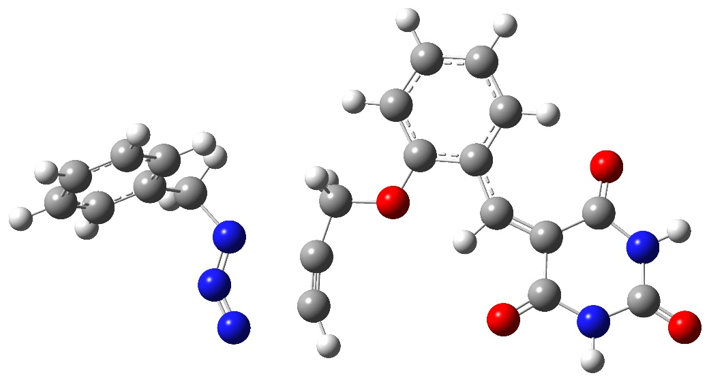
C
Input orientation:
---------------------------------------------------------------------
Center Atomic Atomic Coordinates (Angstroms)
Number Number Type X Y Z
---------------------------------------------------------------------
1 6 0 -1.559039 -1.218181 -0.690037
2 7 0 -3.767715 -0.928762 -1.078410
3 7 0 -4.026079 -2.154836 -1.069743
4 7 0 -3.447758 -3.171173 -0.928999
5 6 0 -1.209454 0.205303 -0.682716
6 8 0 0.213421 0.299552 -0.482619
7 1 0 -1.733674 0.729658 0.124668
8 6 0 0.778556 1.527036 -0.348389
9 6 0 2.179888 1.546960 -0.048579
10 6 0 0.067744 2.720587 -0.508312
11 6 0 2.808974 0.269211 0.198139
12 6 0 2.802819 2.808062 0.085087
13 6 0 0.725242 3.941744 -0.363979
14 1 0 -0.988228 2.711420 -0.747389
15 6 0 4.092443 -0.213339 0.268781
16 1 0 2.084953 -0.521074 0.379571
17 6 0 2.089253 3.989559 -0.062621
18 1 0 3.857852 2.834759 0.313885
19 1 0 0.161350 4.861510 -0.490943
20 6 0 5.337101 0.505676 -0.067270
21 6 0 4.179887 -1.653434 0.649098
22 1 0 2.590671 4.944721 0.056725
23 7 0 6.509362 -0.246549 0.026356
24 8 0 5.426335 1.673048 -0.432809
25 7 0 5.456356 -2.203806 0.684347
26 8 0 3.217464 -2.358717 0.930444
27 6 0 6.651020 -1.573718 0.388168
28 1 0 7.366684 0.241288 -0.209433
29 1 0 5.520024 -3.180251 0.950393
30 8 0 7.731900 -2.136709 0.440685
31 1 0 -1.479333 0.677031 -1.634355
32 6 0 -1.515738 -2.451383 -0.633577
33 6 0 -4.830437 0.072337 -1.305885
34 6 0 -5.850848 0.140537 -0.187084
35 1 0 -5.318582 -0.123803 -2.267117
36 6 0 -7.089273 -0.499187 -0.319750
37 6 0 -5.561733 0.822379 1.002772
38 6 0 -8.023180 -0.461242 0.718550
39 1 0 -7.325687 -1.026434 -1.241130
40 6 0 -6.492162 0.860765 2.041952
41 1 0 -4.604850 1.327195 1.114152
42 6 0 -7.725699 0.217797 1.901989
43 1 0 -8.982035 -0.958725 0.600893
44 1 0 -6.257266 1.395765 2.958131
45 1 0 -8.451811 0.249958 2.709671
46 1 0 -4.296908 1.021758 -1.397708
47 1 0 -1.057439 -3.411108 -0.518504
---------------------------------------------------------------------
D
Input orientation:
---------------------------------------------------------------------
Center Atomic Atomic Coordinates (Angstroms)
Number Number Type X Y Z
---------------------------------------------------------------------
1 6 0 4.092263 2.284715 0.131647
2 6 0 3.117946 1.332882 -0.098419
3 6 0 2.211225 1.093983 -1.264472
4 8 0 0.824449 1.010230 -0.892762
5 1 0 2.366882 1.862596 -2.025733
6 6 0 0.069830 2.128842 -0.712165
7 6 0 -1.324822 1.912070 -0.449117
8 6 0 0.590031 3.423691 -0.766682
9 6 0 -1.772744 0.539319 -0.452506
10 6 0 -2.139280 3.053630 -0.266746
11 6 0 -0.254068 4.518288 -0.584382
12 1 0 1.645316 3.590997 -0.937287
13 6 0 -2.908198 -0.166209 -0.131549
14 1 0 -0.998695 -0.136334 -0.803789
15 6 0 -1.618174 4.337607 -0.339354
16 1 0 -3.189760 2.898134 -0.068776
17 1 0 0.165509 5.519146 -0.630120
18 6 0 -4.166660 0.347882 0.442606
19 6 0 -2.782434 -1.635905 -0.365344
20 1 0 -2.268296 5.195761 -0.201398
21 7 0 -5.147099 -0.611407 0.702281
22 8 0 -4.421849 1.516599 0.716542
23 7 0 -3.889841 -2.409621 -0.042269
24 8 0 -1.783536 -2.188064 -0.817256
25 6 0 -5.090014 -1.976484 0.492063
26 1 0 -6.012054 -0.260402 1.098862
27 1 0 -3.806406 -3.407317 -0.203292
28 8 0 -6.012765 -2.729857 0.753674
29 1 0 2.415039 0.120972 -1.717746
30 7 0 4.678744 2.038973 1.333333
31 7 0 4.115212 0.982379 1.866513
32 7 0 3.171509 0.540652 1.009571
33 1 0 4.394347 3.112386 -0.494701
34 6 0 2.399593 -0.664646 1.338658
35 6 0 2.788730 -1.868582 0.500552
36 1 0 1.339721 -0.434476 1.217526
37 6 0 4.124637 -2.289282 0.437117
38 6 0 1.809968 -2.588234 -0.194816
39 6 0 4.475374 -3.412500 -0.311112
40 1 0 4.889538 -1.734136 0.974157
41 6 0 2.162026 -3.718018 -0.939757
42 1 0 0.769910 -2.273273 -0.155478
43 6 0 3.493365 -4.130916 -1.000817
44 1 0 5.513686 -3.729542 -0.354596
45 1 0 1.394023 -4.269382 -1.475081
46 1 0 3.767239 -5.006616 -1.582794
47 1 0 2.592377 -0.839419 2.400230
---------------------------------------------------------------------

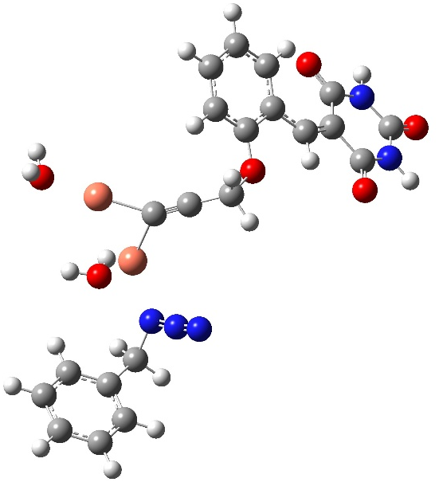
E
Standard orientation:
---------------------------------------------------------------------
Center Atomic Atomic Coordinates (Angstroms)
Number Number Type X Y Z
---------------------------------------------------------------------
1 6 0 1.291851 1.298692 -0.401535
2 6 0 0.401186 0.947998 -1.179051
3 7 0 3.497501 -1.464053 0.036791
4 7 0 3.344964 -1.783368 -1.155502
5 7 0 3.140556 -2.006065 -2.251824
6 29 0 2.485515 0.236492 0.772913
7 29 0 2.181417 2.787674 0.400908
8 8 0 3.052631 -0.031058 2.772937
9 1 0 3.644231 0.680501 3.073532
10 1 0 2.283045 0.014366 3.366508
11 8 0 3.042931 4.361779 1.176632
12 1 0 2.452458 4.912366 1.720802
13 1 0 3.436820 4.964525 0.521239
14 6 0 -0.648266 0.509156 -2.094769
15 8 0 -1.932794 0.352604 -1.461860
16 1 0 -0.733146 1.187184 -2.952877
17 6 0 -2.706672 1.444604 -1.218465
18 6 0 -4.034952 1.181772 -0.749198
19 6 0 -2.260196 2.758547 -1.390188
20 6 0 -4.441331 -0.204663 -0.694011
21 6 0 -4.867702 2.292380 -0.482076
22 6 0 -3.119547 3.823044 -1.118723
23 1 0 -1.248603 2.962395 -1.717938
24 6 0 -5.460780 -0.926051 -0.123168
25 1 0 -3.772300 -0.853786 -1.253024
26 6 0 -4.424074 3.594183 -0.670564
27 1 0 -5.871166 2.104886 -0.129971
28 1 0 -2.759654 4.838649 -1.257324
29 6 0 -6.481871 -0.437348 0.824399
30 6 0 -5.442510 -2.377997 -0.467908
31 1 0 -5.088215 4.428489 -0.468514
32 7 0 -7.369034 -1.403355 1.302684
33 8 0 -6.603689 0.712943 1.233284
34 7 0 -6.429302 -3.162033 0.119446
35 8 0 -4.632869 -2.903651 -1.224041
36 6 0 -7.410596 -2.753345 1.004310
37 1 0 -8.068971 -1.073942 1.958563
38 1 0 -6.425200 -4.147508 -0.119418
39 8 0 -8.237572 -3.514148 1.479469
40 1 0 -0.418966 -0.487119 -2.483001
41 6 0 4.497487 -2.292731 0.805189
42 6 0 5.912717 -2.103235 0.314400
43 1 0 4.191327 -3.342112 0.749362
44 6 0 6.638829 -0.956252 0.669550
45 6 0 6.511503 -3.059809 -0.515802
46 6 0 7.938240 -0.768471 0.198466
47 1 0 6.185289 -0.212195 1.320080
48 6 0 7.813980 -2.873603 -0.986761
49 1 0 5.961749 -3.957704 -0.787510
50 6 0 8.528061 -1.727433 -0.631776
51 1 0 8.493031 0.121260 0.482943
52 1 0 8.269231 -3.624765 -1.626035
53 1 0 9.541493 -1.582597 -0.995530
54 1 0 4.372483 -1.945981 1.830847
---------------------------------------------------------------------
F
Standard orientation:
---------------------------------------------------------------------
Center Atomic Atomic Coordinates (Angstroms)
Number Number Type X Y Z
---------------------------------------------------------------------
1 6 0 1.828151 -1.716749 0.575559
2 6 0 0.915357 -1.448621 1.360346
3 7 0 2.697589 1.194375 -0.936899
4 7 0 1.628680 1.613681 -0.461657
5 7 0 0.624293 1.878112 0.002625
6 29 0 3.166204 -0.869967 -0.594047
7 29 0 2.616042 -3.326139 -0.121204
8 8 0 4.905342 -0.830931 -1.704881
9 1 0 5.624530 -1.331070 -1.281343
10 1 0 4.787837 -1.245807 -2.577322
11 8 0 3.325621 -5.032176 -0.775267
12 1 0 2.717074 -5.519009 -1.358973
13 1 0 3.576399 -5.658376 -0.073363
14 6 0 -0.158866 -1.112591 2.292053
15 8 0 -1.416379 -0.837567 1.646446
16 1 0 -0.289316 -1.897973 3.045778
17 6 0 -2.127104 -1.850155 1.080322
18 6 0 -3.317616 -1.463788 0.384124
19 6 0 -1.767335 -3.197861 1.179380
20 6 0 -3.551617 -0.044465 0.233721
21 6 0 -4.104695 -2.487347 -0.190340
22 6 0 -2.573967 -4.174022 0.594614
23 1 0 -0.867164 -3.497031 1.701127
24 6 0 -4.616797 0.758716 -0.089320
25 1 0 -2.657843 0.546089 0.417694
26 6 0 -3.739186 -3.823157 -0.094176
27 1 0 -5.004061 -2.206220 -0.717796
28 1 0 -2.284324 -5.217451 0.681863
29 6 0 -6.026671 0.348758 -0.246295
30 6 0 -4.277404 2.208112 -0.190700
31 1 0 -4.355102 -4.589100 -0.554523
32 7 0 -6.929478 1.385541 -0.489371
33 8 0 -6.464783 -0.793784 -0.161762
34 7 0 -5.336520 3.070296 -0.451658
35 8 0 -3.148133 2.669339 -0.065776
36 6 0 -6.670552 2.739291 -0.606057
37 1 0 -7.900742 1.110949 -0.588620
38 1 0 -5.108967 4.055515 -0.527588
39 8 0 -7.540318 3.566078 -0.825982
40 1 0 0.073924 -0.185573 2.822860
41 6 0 3.631302 2.245321 -1.478710
42 6 0 4.143647 3.179086 -0.408255
43 1 0 3.113514 2.791949 -2.273287
44 6 0 5.177041 2.773135 0.449681
45 6 0 3.580227 4.451307 -0.244503
46 6 0 5.634718 3.623799 1.456129
47 1 0 5.625076 1.790215 0.323364
48 6 0 4.039078 5.304829 0.762421
49 1 0 2.786710 4.779089 -0.911841
50 6 0 5.065278 4.891630 1.614611
51 1 0 6.438390 3.301566 2.112376
52 1 0 3.597549 6.290782 0.877113
53 1 0 5.424262 5.555179 2.396409
54 1 0 4.436414 1.660285 -1.922768
---------------------------------------------------------------------
G
Standard orientation:
---------------------------------------------------------------------
Center Atomic Atomic Coordinates (Angstroms)
Number Number Type X Y Z
---------------------------------------------------------------------
1 6 0 1.718796 1.201375 0.758062
2 6 0 0.686396 0.834255 1.386924
3 7 0 2.340869 -1.579531 0.099843
4 7 0 1.288639 -1.701351 0.797052
5 7 0 0.494777 -1.071783 1.404672
6 29 0 3.072206 0.290087 -0.255132
7 29 0 2.731811 2.770318 0.317142
8 8 0 4.730495 0.199345 -1.398056
9 1 0 5.076248 -0.709763 -1.506762
10 1 0 4.604112 0.546579 -2.298239
11 8 0 3.683438 4.439115 -0.050265
12 1 0 3.210958 5.062926 -0.629526
13 1 0 3.935804 4.947733 0.740673
14 6 0 -0.524301 1.214290 2.164729
15 8 0 -1.741970 0.935900 1.462590
16 1 0 -0.593646 0.609577 3.070083
17 6 0 -2.184533 1.768778 0.482169
18 6 0 -3.444338 1.423563 -0.106709
19 6 0 -1.481333 2.895811 0.045814
20 6 0 -4.149145 0.302361 0.474861
21 6 0 -3.945482 2.264749 -1.125804
22 6 0 -2.017600 3.699572 -0.960241
23 1 0 -0.519071 3.149655 0.471170
24 6 0 -5.192131 -0.514053 0.114191
25 1 0 -3.763032 0.031594 1.454168
26 6 0 -3.249779 3.391009 -1.544153
27 1 0 -4.895799 2.014957 -1.573653
28 1 0 -1.461094 4.573015 -1.288494
29 6 0 -5.872815 -0.567420 -1.194918
30 6 0 -5.586684 -1.496130 1.166204
31 1 0 -3.662567 4.026595 -2.321065
32 7 0 -6.858195 -1.548380 -1.319400
33 8 0 -5.637991 0.144700 -2.165747
34 7 0 -6.604869 -2.381262 0.829835
35 8 0 -5.082380 -1.560807 2.281929
36 6 0 -7.276353 -2.469522 -0.376085
37 1 0 -7.324115 -1.594781 -2.219049
38 1 0 -6.881665 -3.044710 1.545012
39 8 0 -8.157347 -3.286128 -0.589386
40 1 0 -0.473911 2.269900 2.447464
41 6 0 2.885960 -2.813709 -0.521666
42 6 0 4.394366 -2.866220 -0.399112
43 1 0 2.592169 -2.833778 -1.576700
44 6 0 5.195000 -2.985097 -1.545556
45 6 0 5.013479 -2.804649 0.858645
46 6 0 6.590436 -3.040805 -1.437047
47 1 0 4.725752 -3.048627 -2.524898
48 6 0 6.403392 -2.860663 0.966510
49 1 0 4.403635 -2.712448 1.753490
50 6 0 7.195791 -2.976812 -0.180640
51 1 0 7.196753 -3.134107 -2.333301
52 1 0 6.869606 -2.814367 1.946604
53 1 0 8.277595 -3.018457 -0.093918
54 1 0 2.428539 -3.678203 -0.030938
---------------------------------------------------------------------

H
Standard orientation:
---------------------------------------------------------------------
Center Atomic Atomic Coordinates (Angstroms)
Number Number Type X Y Z
---------------------------------------------------------------------
1 6 0 -2.929099 -0.379280 0.196293
2 6 0 -1.730852 0.151193 0.424685
3 7 0 -3.116810 1.408074 -1.551761
4 7 0 -2.009687 1.804129 -1.249211
5 7 0 -1.250867 1.302847 -0.278378
6 29 0 -4.358228 0.083493 -0.927552
7 29 0 -3.973369 -1.799603 0.917307
8 8 0 -6.199297 -0.004958 -1.730719
9 1 0 -6.741545 0.786336 -1.566677
10 1 0 -6.209188 -0.134762 -2.695239
11 8 0 -5.062976 -3.252720 1.647843
12 1 0 -4.718899 -4.145610 1.467636
13 1 0 -5.199325 -3.209138 2.610977
14 6 0 -0.791866 -0.413174 1.485188
15 8 0 0.512743 -0.732902 0.985349
16 1 0 -0.607892 0.329872 2.265548
17 6 0 0.771119 -1.924888 0.375399
18 6 0 2.144337 -2.173407 0.061649
19 6 0 -0.215144 -2.857462 0.046108
20 6 0 3.111165 -1.204812 0.533443
21 6 0 2.462510 -3.394424 -0.573021
22 6 0 0.145096 -4.052928 -0.576619
23 1 0 -1.258213 -2.656952 0.253495
24 6 0 4.404904 -0.873566 0.223330
25 1 0 2.725143 -0.581678 1.336250
26 6 0 1.481406 -4.327708 -0.881183
27 1 0 3.496949 -3.596537 -0.808309
28 1 0 -0.631335 -4.769888 -0.828294
29 6 0 5.199185 -1.374409 -0.917043
30 6 0 4.993403 0.180369 1.100387
31 1 0 1.753617 -5.264195 -1.357389
32 7 0 6.466930 -0.807795 -1.058041
33 8 0 4.838002 -2.207348 -1.741172
34 7 0 6.283212 0.591062 0.784005
35 8 0 4.421186 0.684913 2.060036
36 6 0 7.069747 0.153762 -0.266765
37 1 0 7.015257 -1.140774 -1.843637
38 1 0 6.691145 1.302049 1.381001
39 8 0 8.193899 0.578080 -0.477471
40 1 0 -1.249252 -1.284123 1.954459
41 6 0 0.046100 2.001412 -0.082427
42 6 0 -0.115252 3.500056 0.064857
43 1 0 0.698184 1.762588 -0.927538
44 6 0 -0.828063 4.043723 1.143716
45 6 0 0.476309 4.363168 -0.864100
46 6 0 -0.950810 5.426012 1.284354
47 1 0 -1.289962 3.384201 1.874381
48 6 0 0.360356 5.748724 -0.720595
49 1 0 1.030754 3.950551 -1.703323
50 6 0 -0.355091 6.282719 0.352475
51 1 0 -1.505754 5.835410 2.123944
52 1 0 0.825671 6.406943 -1.449023
53 1 0 -0.448718 7.359280 0.464643
54 1 0 0.505024 1.574412 0.806187
---------------------------------------------------------------------

I
Standard orientation:
---------------------------------------------------------------------
Center Atomic Atomic Coordinates (Angstroms)
Number Number Type X Y Z
---------------------------------------------------------------------
1 29 0 -3.205964 0.299240 1.328498
2 6 0 -1.497175 0.774336 0.652759
3 6 0 -1.154679 1.659959 -0.344371
4 29 0 -0.270564 -0.073280 1.811235
5 7 0 -1.770804 1.718327 -1.573926
6 7 0 -2.570559 -0.329638 -1.086700
7 7 0 -2.555500 0.738526 -1.888536
8 6 0 0.015788 2.613224 -0.242437
9 8 0 1.246358 1.869150 -0.453884
10 1 0 -0.081813 3.380721 -1.017091
11 6 0 2.429792 2.507497 -0.317541
12 6 0 3.596404 1.677296 -0.236952
13 6 0 2.553292 3.902662 -0.284210
14 6 0 3.381999 0.260122 -0.084217
15 6 0 4.858081 2.312573 -0.147850
16 6 0 3.815378 4.484020 -0.185133
17 1 0 1.676528 4.534467 -0.348946
18 6 0 4.153111 -0.868303 -0.253660
19 1 0 2.378427 0.027211 0.262970
20 6 0 4.969783 3.693997 -0.115315
21 1 0 5.742204 1.695677 -0.083071
22 1 0 3.896255 5.567250 -0.166177
23 6 0 5.450451 -0.934182 -0.957119
24 6 0 3.536763 -2.130510 0.210703
25 1 0 5.946698 4.158587 -0.028244
26 7 0 5.971929 -2.218419 -1.136276
27 8 0 6.074585 0.016186 -1.413729
28 7 0 4.217666 -3.297614 -0.071111
29 8 0 2.467249 -2.215027 0.828975
30 6 0 5.430769 -3.422873 -0.734821
31 1 0 6.853729 -2.271678 -1.634827
32 1 0 3.799486 -4.160497 0.260191
33 8 0 5.962765 -4.500649 -0.935664
34 1 0 0.075258 3.089759 0.740890
35 8 0 -4.985737 -0.303788 1.966964
36 1 0 -4.948284 -0.903637 2.733017
37 8 0 1.088670 -1.050093 2.843207
38 1 0 0.726183 -1.760706 3.400000
39 1 0 1.677684 -1.490777 2.177029
40 1 0 -5.434840 -0.806570 1.256469
41 6 0 -3.542132 -1.229578 -1.092307
42 6 0 -4.963615 -1.005573 -1.264562
43 1 0 -3.248497 -2.199151 -0.693161
44 6 0 -5.858186 -2.046367 -0.896766
45 6 0 -5.531089 0.215400 -1.709245
46 6 0 -7.238816 -1.881515 -0.988824
47 1 0 -5.449835 -2.993247 -0.549257
48 6 0 -6.914236 0.369271 -1.796458
49 1 0 -4.874384 1.025782 -2.002987
50 6 0 -7.778876 -0.671785 -1.442143
51 1 0 -7.895876 -2.699308 -0.704019
52 1 0 -7.321747 1.314072 -2.148056
53 1 0 -8.854939 -0.543331 -1.515275
---------------------------------------------------------------------

J
Standard orientation:
---------------------------------------------------------------------
Center Atomic Atomic Coordinates (Angstroms)
Number Number Type X Y Z
---------------------------------------------------------------------
1 6 0 -2.012312 0.030385 -0.163792
2 6 0 -0.693736 -0.357935 0.132066
3 6 0 0.133159 -0.040044 1.348285
4 8 0 1.523066 0.146575 1.047716
5 1 0 -0.273949 0.820114 1.888819
6 6 0 1.950352 1.240766 0.363623
7 6 0 3.296700 1.186904 -0.115768
8 6 0 1.171471 2.384168 0.163184
9 6 0 3.985731 -0.077863 0.023029
10 6 0 3.802539 2.319651 -0.792062
11 6 0 1.708135 3.478496 -0.514249
12 1 0 0.156522 2.434213 0.536191
13 6 0 5.291642 -0.496560 0.002479
14 1 0 3.303149 -0.910082 0.176521
15 6 0 3.020103 3.447820 -0.998257
16 1 0 4.817347 2.287807 -1.160414
17 1 0 1.092796 4.361936 -0.660657
18 6 0 6.495174 0.359155 -0.008518
19 6 0 5.462672 -1.974635 0.102781
20 1 0 3.426068 4.299768 -1.534203
21 7 0 7.713220 -0.319477 0.062030
22 8 0 6.512829 1.584616 -0.050465
23 7 0 6.772786 -2.438361 0.149846
24 8 0 4.539791 -2.780916 0.139150
25 6 0 7.931801 -1.683436 0.137811
26 1 0 8.544187 0.262012 0.063431
27 1 0 6.895047 -3.443228 0.209078
28 8 0 9.046882 -2.175791 0.189982
29 1 0 0.136523 -0.889059 2.036868
30 7 0 -2.216471 -0.626775 -1.367994
31 7 0 -1.145907 -1.323997 -1.755673
32 7 0 -0.210839 -1.167920 -0.845360
33 29 0 -3.481578 -0.289786 1.149093
34 8 0 -4.874875 -0.881941 2.408901
35 1 0 -5.257030 -0.165027 2.945458
36 1 0 -5.624998 -1.282455 1.925210
37 29 0 -2.703085 1.860873 0.105910
38 8 0 -3.197321 3.751967 0.259603
39 1 0 -3.645310 4.114791 -0.525156
40 1 0 -3.779422 3.953247 1.013708
41 6 0 -3.435643 -0.665423 -2.190798
42 6 0 -4.628323 -1.211412 -1.428744
43 1 0 -3.184810 -1.296243 -3.046835
44 6 0 -4.613169 -2.526259 -0.932792
45 6 0 -5.760159 -0.412847 -1.214461
46 6 0 -5.707228 -3.026905 -0.225530
47 1 0 -3.744115 -3.156548 -1.103206
48 6 0 -6.859315 -0.914728 -0.509599
49 1 0 -5.781280 0.603792 -1.597823
50 6 0 -6.834199 -2.221121 -0.010233
51 1 0 -5.686641 -4.045454 0.150666
52 1 0 -7.731456 -0.287212 -0.351769
53 1 0 -7.691002 -2.616097 0.528314
54 1 0 -3.641260 0.342748 -2.559063
---------------------------------------------------------------------

