Supplementary Material
Nitrogen-modified nanoporous activated carbon from eucalyptus leaves for ultrasound-assisted removal of basic dyes using derivative spectrophotometric method

AISAN KHALIGH ^{1*}, HASSAN ZAVVAR MOUSAVI¹, ALIMORAD RASHIDI² and HAMID SHIRKHANLOO³

¹ Department of Chemistry, Semnan University, Semnan 35131-1911, Iran.
² Nanotechnology Research Center, Research Institute of Petroleum Industry (RIPI), West Entrance Blvd., Olympic Village, Tehran 14857-33111, Iran.
³ Research Institute of Petroleum Industry (RIPI), West Entrance Blvd., Olympic Village, Tehran 14857-33111, Iran

*Corresponding author: A. Khaligh; Tel: +98 23 3366194; Fax: +98 23 3354110.
E-mail address: akhalighv@gmail.com

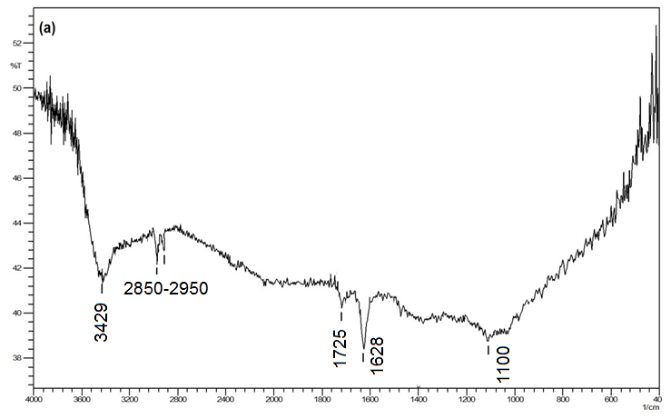
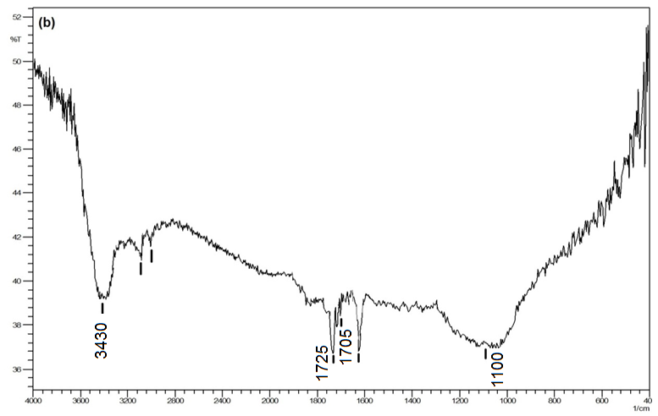
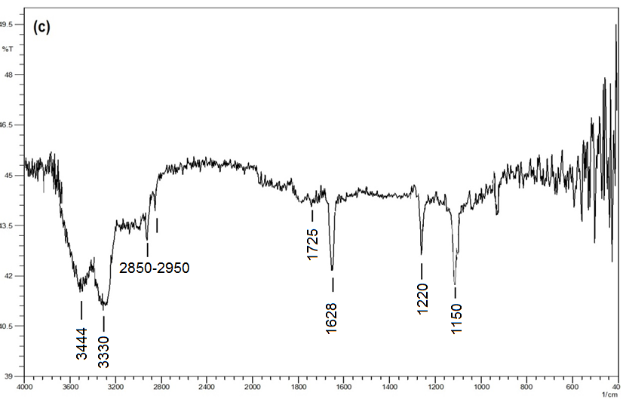
Fig. S-1. FTIR spectra of (a) nanoporous AC, (b) oxidized AC and (c) nitrogen-modified AC.

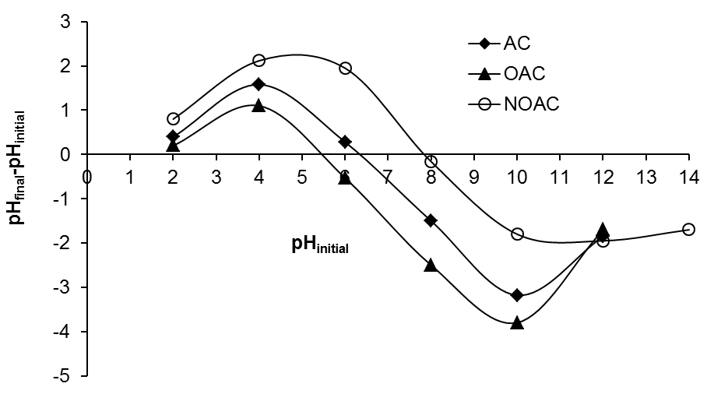
Fig. S-2. Final pH versus initial pH plots for pristine, oxidized and nitrogen modified AC samples.

Fig. S-3. Effect of initial dye concentration on the adsorption of BY13 and BR46 dyes onto NOAC (Conditions: 100 mL of 150 mg L⁻¹ dyes solution, pH=9, m=30 mg, t= 8 min, T=25 ºC).

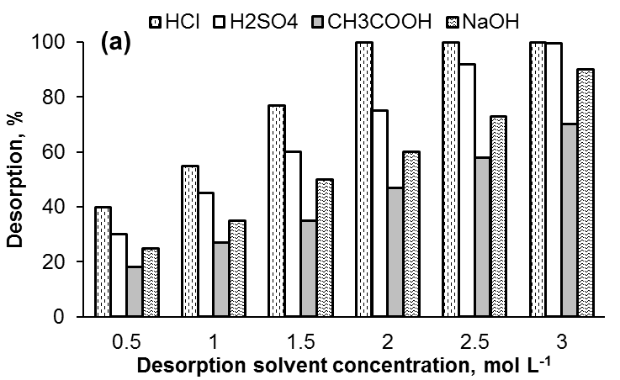

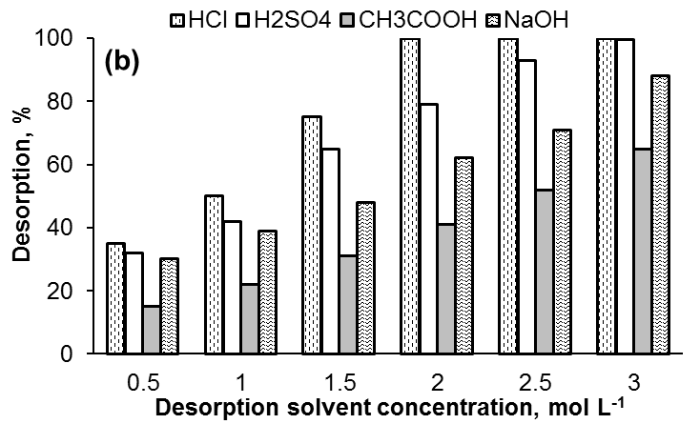
Fig. S-4. Effect of solvent type and concentration on the desorption of (a) BY13 and (b) BR46 dyes from loaded NAC (desorption solvent volume 100 mL, spent NOAC 30 mg, t=8 min, T=25 ºC).

TABLE S-1. Chemical structure and properties of basic dyes used in this study.
Chemical structure | Commercial name | C. I. number | λ_{max} | Molecular weigth, g mol⁻¹
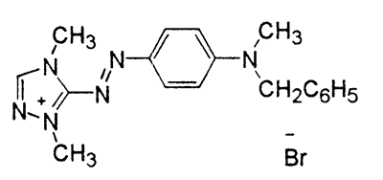 | Basic Red 46 | 110825 | 530 | 401.3
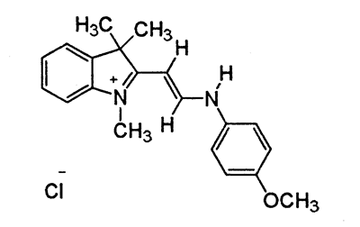 | Basic Yellow 13 | 48056 | 411 | 342.86

TABLE S-2. Initial dye concentrations in single and binary systems.
Single system |  |  | Binary System (1) |  |  | Binary System (2)
C₀, _{BR46} /  mg L⁻¹ | C₀, _{BY13} /  mg L⁻¹ |  | C₀, _{BR46} /  mg L⁻¹ | C₀, _{BY13} /  mg L⁻¹ |  | C₀, _{BR46} /  mg L⁻¹ | C₀, _{BY13} /  mg L⁻¹
200-400 | 200-400 |  | - 150-350  - 150 | - 150  - 150-350 |  | 150-350 | 150-350

TABLE S-III. Determination of percentage recovery and error values for BR46 and BY13 in binary mixture by zero and first order derivative spectra methods.
Error, % |  |  | Recovery, % |  |  | C_{m} / mg L⁻¹ |  |  | C_{t} / mg L⁻¹
C_{BR} | C_{BY} |  | C_{BR} | C_{BY} |  | C_{BR} | C_{BY} |  | C_{BR} | C_{BY}
+1.20 | -3.40 |  | 101.20 | 96.60 |  | 5.06 | 4.83 |  | 5 | 5
+2.5 | -2.75 |  | 102.50 | 97.25 |  | 8.20 | 7.78 |  | 8 | 8
-3.50 | +2.00 |  | 96.50 | 102.00 |  | 9.65 | 10.20 |  | 10 | 10
-2.00 | -1.20 |  | 98.00 | 101.20 |  | 14.70 | 15.18 |  | 15 | 15
-3.33 | -4.22 |  | 96.67 | 95.78 |  | 17.40 | 17.24 |  | 18 | 18
+1.90 | +1.25 |  | 101.90 | 101.25 |  | 20.38 | 20.25 |  | 20 | 20

TABLE S-IV. R_{L} values for BY13 and BR46 dyes in single and binary solutions.
C₀ / mg L⁻¹ | R_{L} of BY13 |  | R_{L} of BR46
 | Single | Binary | Single | Binary
150 | ----- | 0.020 | ----- | 0.020
200 | 0.026 | 0.015 | 0.026 | 0.014
250 | 0.021 | 0.012 | 0.020 | 0.011
300 | 0.018 | 0.010 | 0.017 | 0.009
350 | 0.015 | 0.008 | 0.015 | 0.008
400 | 0.013 | ----- | 0.013 | -----

