SUPPLEMENTARY MATERIAL TO
Determination of enol form of asymmetric 1,3-dicarbonyl compounds: 2D NMR data and DFT calculations
MELTEM TAN, İSHAK BİLDİRİCİ and NURETTİN MENGES
Faculty of Pharmacy, Yüzüncü Yil University, 65080, Van, Turkey

Table of Contents
General procedures and methods…………………………………………………………….page 3
Synthesis of 1-10…………………………………………………………………………….page 3
NMR spectra (¹H, ¹³C)……………………………………………………………………….page 8
FT-IR spectra……………………………………………………………………………….page 18
HR-MS spectra……………………………………………………………………………..page 23
Dihedral angle scanning of the compounds…………………………………………………page 28
HMBC spectra……………………………………………………………………………...page 31

Experimental Section
General Methods: NMR spectra were recorded on a 400 MHz spectrometer. Infrared (IR) spectra were recorded in the range 4000-600 cm⁻¹ via ATR diamond. Melting points were determined using a melting point apparatus and were uncorrected. Mass spectra were recorded by LC-MS TOF electrospray ionization technique. Column chromatography was performed on silica gel (60-mesh), TLC was carried out on 0.2 mm silica gel 60 F254 analytical aluminium plates. Evaporation of solvents was performed at reduced pressure, using a rotary vacuum evaporator.
Syntheses:

General procedure for synthesis of the compounds 1-10:
Acetyl ketone (1 equiv) was added to dry 1,4-dioxane and NaH (60% oil suspension, 5 equiv) was added by pieces to the mixture at ice-bath. It was stirred at room temperature for 1 h. Related ester (5 equiv) was added to the mixture and refluxed for 1 h. After cooling 10% HCl solution was added to the reaction mixture and extracted with CH₂Cl₂ (3×20 mL). Crude product dried on MgSO₄. Recrystallization or column chromatography gave the product, which was dried in vacuo (25 °C, 0.5 mbar), affording spectroscopically pure product.¹

Synthesis of 1-(2,6-dimethoxyphenyl)-3-phenylpropane-1,3-dione (1)
1-(2,6- dimethoxphenyl)ethanone (0.72 g, 4 mmol) and ethyl benzoate (2,8 mL, 20 mmol) reacted according to general procedure. Column chromatography heksan/ethyl acetate (5:1) gave the product as a white crystals in 95% yield (1,113 g). Mp: 85-88 ºC.²
¹H-NMR (400 MHz, CDCl₃) δ 16.13 (bs, 1H, OH), 7.92-7.90 (m, 2H, Ar-H), 7.53-7.49 (m, 1H, Ar-H), 7.47-7.42 (m, 2H, Ar-H), 7.33 (t, J_{5,4}=8.4 Hz, 1H, H-5), 6.61 (d, J_{4,5}=8.4 Hz, 2H, H-4 and H-6), 6.4 (s, 1H, H-13), 3.83 (s, 6H, H-8 and H-12); ¹³C-NMR (100 MHz, CDCl₃) δ 189.4, 181.5, 157.7, 135.0, 132.1, 131.2, 128.5, 127.1, 117.2, 104.2, 100.6, 56.1; IR (ATR, cm⁻¹) 2921, 2989, 1681, 1598, 1582, 1495, 1469, 1453, 1424, 1323, 1287, 1247, 1176, 1111, 1071; HR-MS m/z (M+H)⁺ (C₁₇H₁₇O₄) theoretical: 285.1121; experimental: 285.1119.

Synthesis of 1-phenyl-3-(2,4,6-trimethoxyphenyl)propane-1,3-dione (2)
1-(2,4,6-trimethoxyphenyl)ethanone (0.84 g, 4 mmol) and ethyl benzoate (2,8 mL, 20 mmol) reacted according to general procedure. Column chromatography heksan/ethyl acetate (5:1) gave the product as a honey yellow crystals in 87% yield (1,09 g). Mp: 95-98 ºC.³
¹H-NMR (400 MHz, CDCl3) δ 16.23 (bs, 1H, OH), 7.91-7.89 (m, 2H, Ar-H), 7.52-7.48 (m, 1H, Ar-H), 7.46-7.42 (m, 2H, Ar-H), 6.41 (s, 1H, H-15), 6.16 (s, 2H, H-4 and H-6), 3.85 (s, 3H, H-14), 3.82 (s, 6H, H-8 and H-12); ¹³C-NMR (100 MHz, CDCl3) δ 188.7, 181.3, 162.8, 159.1, 135.3, 131.9, 128.5, 127.0, 110.3, 101.0, 90.8, 56.1, 55.5; IR (ATR, cm-1) 2969, 2940, 2838, 1698, 1682, 1585, 1490, 1452, 1411, 1331, 1274, 1226, 1203, 1185, 1154, 1123; HR-MS m/z (M+H)⁺ (C₁₈H₁₉O₅) theoretical: 315.1227; experimental: 315.1224.

Synthesis of 1-(2,6-dimethoxyphenyl)butane-1,3-dione (3)
1-(2,6-dimethoxyphenyl)ethanone (0.54 g, 3 mmol) and ethyl acetate (1,47 mL, 15 mmol) reacted according to general procedure. Column chromatography heksan/ethyl acetate (5:1) gave the product as a bright gel-like in 54% yield (0,852 g).⁴
¹H-NMR (400 MHz, CDCl₃) δ 15.54 (bs, 0.8 H, OH), 7.32-7.27 (m, 1.75 H, keto and enol H-5), 6.59-6.55 (m, 3H, keto and enol H-4 ve H-6), 5.71 (s, 0.8 H, enol H-13), 3.88 (s, 0.8 H, keto H-13), 3.81 (s, 8.5 H, keto and enol H-8 and H-12), 2.29 (s, 1H, keto H-16), 2.12 (s, 3H, H-16); ¹³C-NMR (100 MHz, CDCl₃) δ 189.5, 186.8, 157.6, 131.1, 116.4, 104.1, 104.0, 56.0, 24.6 (enol form), 201.8, 197.3, 157.0, 131.7, 119.2, 104.1, 60.1, 55.8, 30.2 (keto form); HR-MS m/z (M+H)⁺ (C₁₂H₁₅O₄) theoretical: 223.0965; experimental: 223.0964.

Synthesis of 1-(2,4,6-trimethoxyphenyl)butane-1,3-dione (4)
1-(2,4,6-trimethoxyphenyl)ethanone (0.63 g, 3 mmol) and ethyl acetate (1,47 mL, 15 mmol) reacted according to general procedure. Column chromatography heksan/ethyl acetate (5:1) gave the product as a light yellow solid in 86% yield (0,653 g). Mp: 99-102 ºC.⁵
¹H-NMR (400 MHz, CDCl₃) δ 15.65 (bs, 1H, OH), 6.12 (s, 2H,enol H-4 ve H-6), 6.09 (s, 1H, keto H-4 and H-6), 5.71 (s, 1H, enol H-15), 3.85 (s, 1H, keto H-15), 3.83 (s, 5 H, keto and enol H-14), 3.80 (s, 10H, keto and enol H-8 ve H-12), 2.26 (s, 1.5H, keto H-18), 2.10 (s, 3H, enol H-18); ¹³C-NMR (100 MHz, CDCl₃) δ 189.5, 186.0, 162.6, 159.0, 104.3, 90.8, 90.6, 56.0, 55.8, 24.8 (enol form), 202.4, 195.9, 163.3, 159.1, 112.4, 109.6, 60.5, 55.5, 55.4, 30.1 (keto form); HRMS m/z (M+H)⁺ (C₁₃H₁₇O₅) theoretical: 253.1071; experimental: 253.1064.

Synthesis of 1,3-di(naphthalen-1-yl)propane-1,3-dione (5)
1-acetyl naphthalene (0.3 mL, 2 mmol) and ethyl-1-naftoat (1,8 mL, 10 mmol) reacted according to general procedure. Column chromatography heksan/ethyl acetate (8:1) gave the product as a light yellow crystal in 89% yield (0,58 g). Mp: 104-108 ºC.⁶
¹H-NMR (400 MHz, CDCl₃ ) δ 8.61 (d, 2H, Ar-H), 8.00 (d, 2H, Ar-H), 7.92 (d, 2H, Ar-H), 7.84 (dd, 2H, Ar-H), 7.64-7.58 (m, 3H, Ar-H), 7.56-7.53 (m, 3H, Ar-H), 6.60 (s, 1H, H-13); ¹³C-NMR (100 MHz, CDCl₃ ) δ 188.2, 133.4, 132.9, 130.9, 129.2, 127.6, 126.4, 126.3, 125.4, 124.6, 123.8, 102.1; IR (ATR, cm⁻¹) 3041, 1708, 1673, 1593, 1574, 1527, 1506, 1459, 1423, 1384, 1364, 1338, 1290, 1278, 1243, 1194, 1123, 1065; HRMS m/z (M+H)⁺ (C₂₃H₁₇O₂) theoretical: 325.1223; experimental: 325.1219.

Synthesis of 1-(naphthalen-1-yl)butane-1,3-dione (6)
1-acetyl naphthalene (0.75 mL, 5 mmol) and ethyl acetate (2.45 mL, 25 mmol) reacted according to general procedure. Column chromatography heksan/ethyl acetate (5:1) gave the product in 81% yield (0,766 g).⁷
¹H-NMR (400 MHz, CDCl₃) δ 16.12 (bs, 1H, OH), 8.46 (m, 1H, Ar-H), 7.96 (m, 1H, Ar-H), 7.89 (m, 1H, Ar-H), 7.72 (m, 1H, Ar-H), 7.59-7.48 (m, 3H, Ar-H), 6.04 (s, 1H, H-13), 2.22 (s, 3H, H-16); ¹³C-NMR (100 MHz, CDCl3) δ 191.4, 187.3, 133.3, 132.8, 130.6, 129.1, 127.5, 126.2, 125,9, 125.3, 124.5, 123.7, 100.7, 24.4; IR (ATR, cm-1) 3048, 1717, 1575, 1508, 1418, 1392, 1363, 1339, 1280, 1244, 1210, 1173, 1123, 1068; HRMS m/z (M+H)+ (C14H13O2) theoretical: 213.0910; experimental: 213.0905.

Synthesis of 1-(naphthalen-1-yl)-3-phenylpropane-1,3-dione (7)
Acetophenone (0.58 mL, 5 mmol) and ethyl-1-naftoate (4.5 mL, 25 mmol) reacted according to general procedure. Column chromatography heksan/ethyl acetate (8:1) gave the product as a yellow crystal in 80% yield (1 g). Mp: 60-63 ºC.⁸
¹H-NMR (400 MHz, CDCl₃) δ 8.53 (m, 1H, Naf-H), 8.01-7.98 (m, 3H, Ar-H, Naf-H), 7.92 (m, 1H, Naf-H), 7.83 (m, 1H, Naf-H), 7.62-7.54 (m, 4H, Ar-H, Naf-H), 7.52-7.48 (m, 2H, Ar-H), 6.73 (s, 1H, H-13); ¹³C-NMR (100 MHz, CDCl₃) δ 188.5, 182.4, 133.1, 133.0, 131.8, 130.5, 129.7, 128.1, 126.7, 126.5, 125.3, 125.2, 125.0, 124.4, 123.6, 122.8, 96.2; IR (ATR, cm⁻¹) 3045, 2952, 2922, 2853, 1722, 1603, 1590, 1542, 1508, 1462, 1420, 1388, 1287, 1256, 1229, 1210, 1178, 1157, 1123, 1086, 1066; HRMS m/z (M+H)⁺ (C₁₉H₁₅O₂) for theoretical: 275.1067; experimental: 275. 1064.

Synthesis of 1-(3-bromothiophene-2-yl)butane-1,3-dione (8)
3-bromo-2-acetyl thiophene (1.025 g, 5 mmol) and ethyl acetate (2.45 mL, 25 mmol) reacted according to general procedure. Column chromatography heksan/ethyl acetate (4:1) gave the product as a yellow solid in 53% yield (0.65 g). Mp: 55-58 ºC.
¹H-NMR (400 MHz, CDCl₃) δ 15.88 (bs, 1H, OH), 7.51 (d, J_{2,3}=5.2 Hz, 1H, H-2), 7.10 (d, J_{3,2}=5.2 Hz, 1H, H-3), 6.56 (s, 1H, H-9), 2.19 (s, 3H, H-12); ¹³C-NMR (100 MHz, CDCl₃) δ 190.9, 178.8, 135.4, 133.5, 130.8, 112.6, 97.9, 24.9; IR (ATR, cm⁻¹) 3101, 2915, 1716, 1698, 1559, 1540, 1499, 1458, 1398, 1363, 1350, 1255, 1179, 1151; HRMS m/z (M+Na)⁺ (C₈H₇BrNaO₂S) theoretical: 268.9242; experimental: 268.9242.

Synthesis of 1,3-di(thiophen-2-yl)propane-1,3-dione (9)
1-(thiophen-2-yl)ethanone (0.43 mL, 4 mmol) and ethyl thiophene-2-carboxylate (2.7 mL, 20 mmol) reacted according to general procedure. Column chromatography heksan/ethyl acetate (5:1) gave the product as a lemon yellow solid in 78% yield (0.736 g). Mp: 99-101 ºC.⁹
¹H-NMR (400 MHz, CDCl₃) δ 16.18 (bs, 1H, OH), 7.78 (dd, J_{4,2}=1.2 Hz, J_{4,3}=3.8 Hz, 2H, H-4), 7.62 (dd, J_{2,3}=4.9 Hz, J_{2,4}=1.2 Hz, 2H, H-2), 7.17 (t, J_{3,2}=4.9 Hz, J_{3,4}=3.8 Hz, 2H, H-3), 6.54 (s, 1H, H-8); ¹³C-NMR (100 MHz) δ 176.3, 138.2, 129.5, 127.5, 125.8, 90.2; IR (ATR, cm⁻¹) 3102, 3080, 1526, 1406, 1336, 1276, 1228; HR-MS m/z (M+H)⁺ (C₁₁H₉O₂S₂) theoretical: 237.0038; experimental: 237.0037.

Synthesis of 1-(thiophen-2-yl)butane-1,3-dione (10)
2-acetyl thiophene (0.54 mL, 5 mmol) and ethyl acetate (2.45 mL, 25 mmol) reacted according to general procedure. Column chromatography heksan/ethyl acetate (5:1) gave the product as a brick red solid in 90% yield (0.80 g). Mp: 44-48 ºC.¹⁰
¹H-NMR (400 MHz, CDCl₃) δ 15.65 (bs, 1H, OH) 7.69 (dd, J_{4,2}=1.2 Hz, J_{4,3}=3.8 Hz, 1H, H-4), 7.60 (dd, J_{2,3}=4.9 Hz, J_{2,4}=1.2 Hz, 1H, H-2), 7.13 (t, J_{3,2}=4.9 Hz, J_{3,4}=3.8 Hz, 1H, H-3), 6.03 (s, 1H, H-8), 2.14 (s, 3H, H-11); ¹³C-NMR (100 MHz, CDCl₃ ) δ 187.3, 181.7, 141.7, 132.3, 130.2, 128.2, 96.5, 23.9; IR (ATR, cm⁻¹) 3105, 1698, 1558, 1515, 1425, 1404, 1368, 1354, 1268, 1236; HRMS m/z (M+Na)⁺ (C₈H₈NaO₂S) theoretical: 191.0137; experimental: 191.0137.

REFERENCES

1. J. Berger, L. A. Flippin, R. Greenhouse, S. Jaime-Figueroa, Y. Liu, A. K. Miller, D. G.
Putman, K. K. Weinhardt, S.H. Zhao, United States Patent, 5.863.924 (1999).
2. J. Zawadiak, M. Mrzyczek, Spectrochim Acta A. 96 (2012) 815
3. T. Emilewicz, S. Kostanecki, J. Tambor, Chem. Ber. 32 (1899) 2448.
4. K. Ahluwalia, Indian J. Chem. B 15 (1977) 514.
5. E. Jochum, S. Kostanecki, Chem. Ber. 37 (1904) 2099.
6. N.V. Dubrovina, V.L. Tararov, A. Monsees, R. Kadyrov, C. Fischer, A. Börner, Tetrahedron- Asymmetr. 14 (2003) 2739.
7. A.M. El-Metwally, Egypt. J. Chem. 54 (2011) 129.
8. E.V. Gukhman, V.A. Reutov, Russ. J. Gen. Chem. 69 (1999) 1608.
9. S.R. Harris, R. Levine, J. Am. Chem. Soc. 70 (1948) 3360.
10. G. Rai, C.J. Thomas, W. Leister, D.J. Maloney, Tetrahedron Lett. 50 (2009) 1710.

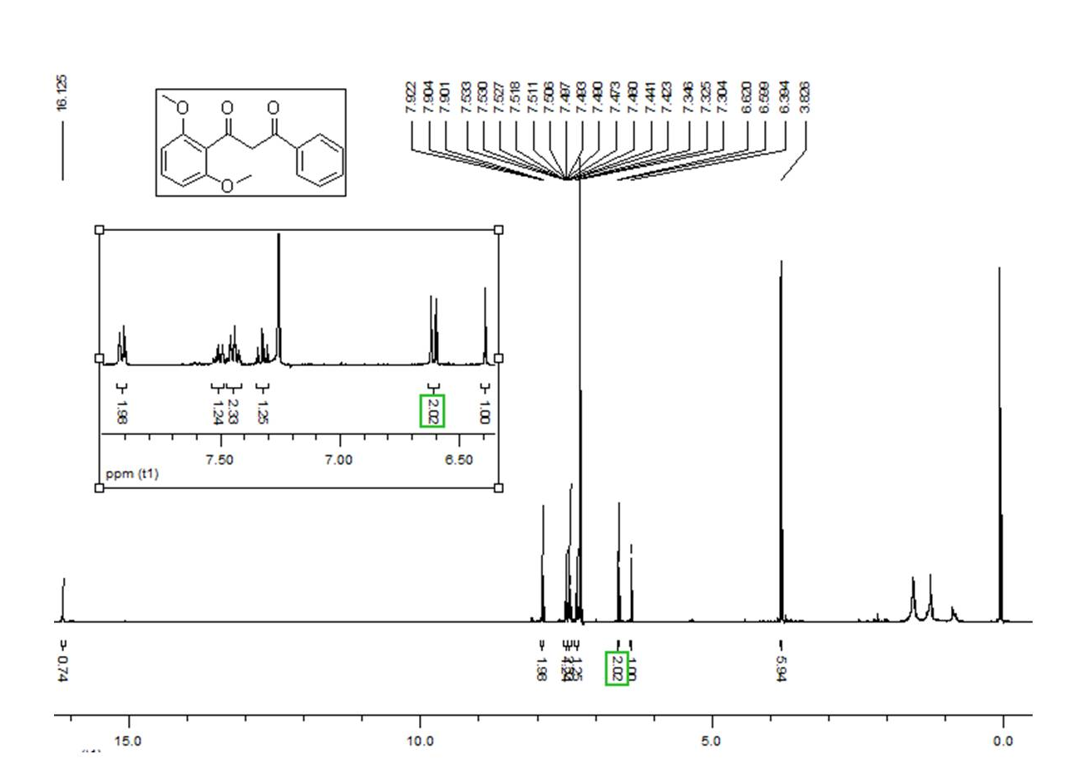
Fig. S1. ¹H NMR (400 MHz, CDCl₃) spectrum of 1.
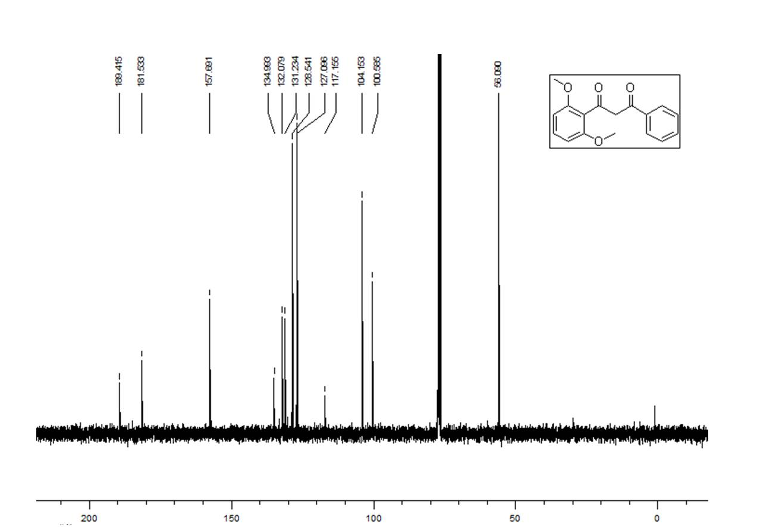
Fig. S2. ¹³C NMR (100 MHz, CDCl₃) spectrum of 1.

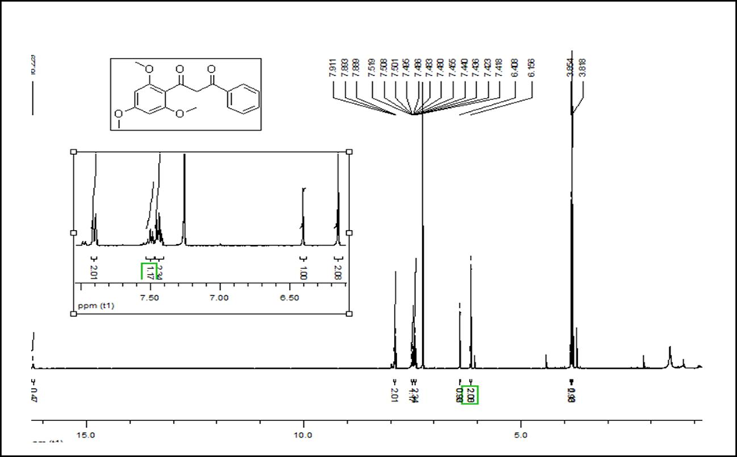
Fig. S3. ¹H NMR (400 MHz, CDCl₃) spectrum of 2.

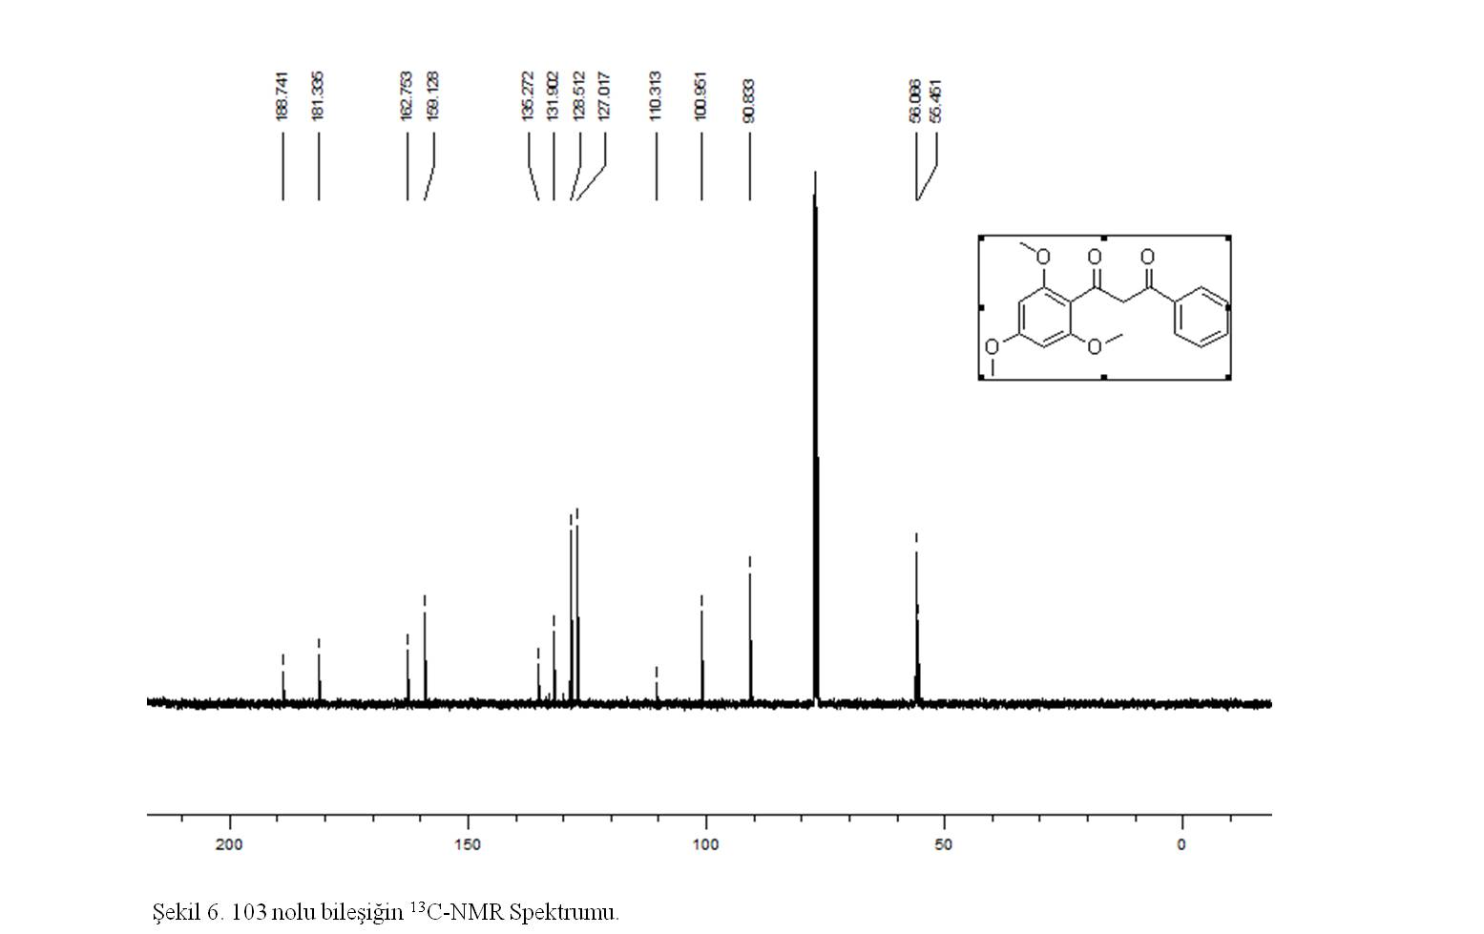
Fig. S4. ¹³C NMR (400 MHz, CDCl₃) spectrum of 2
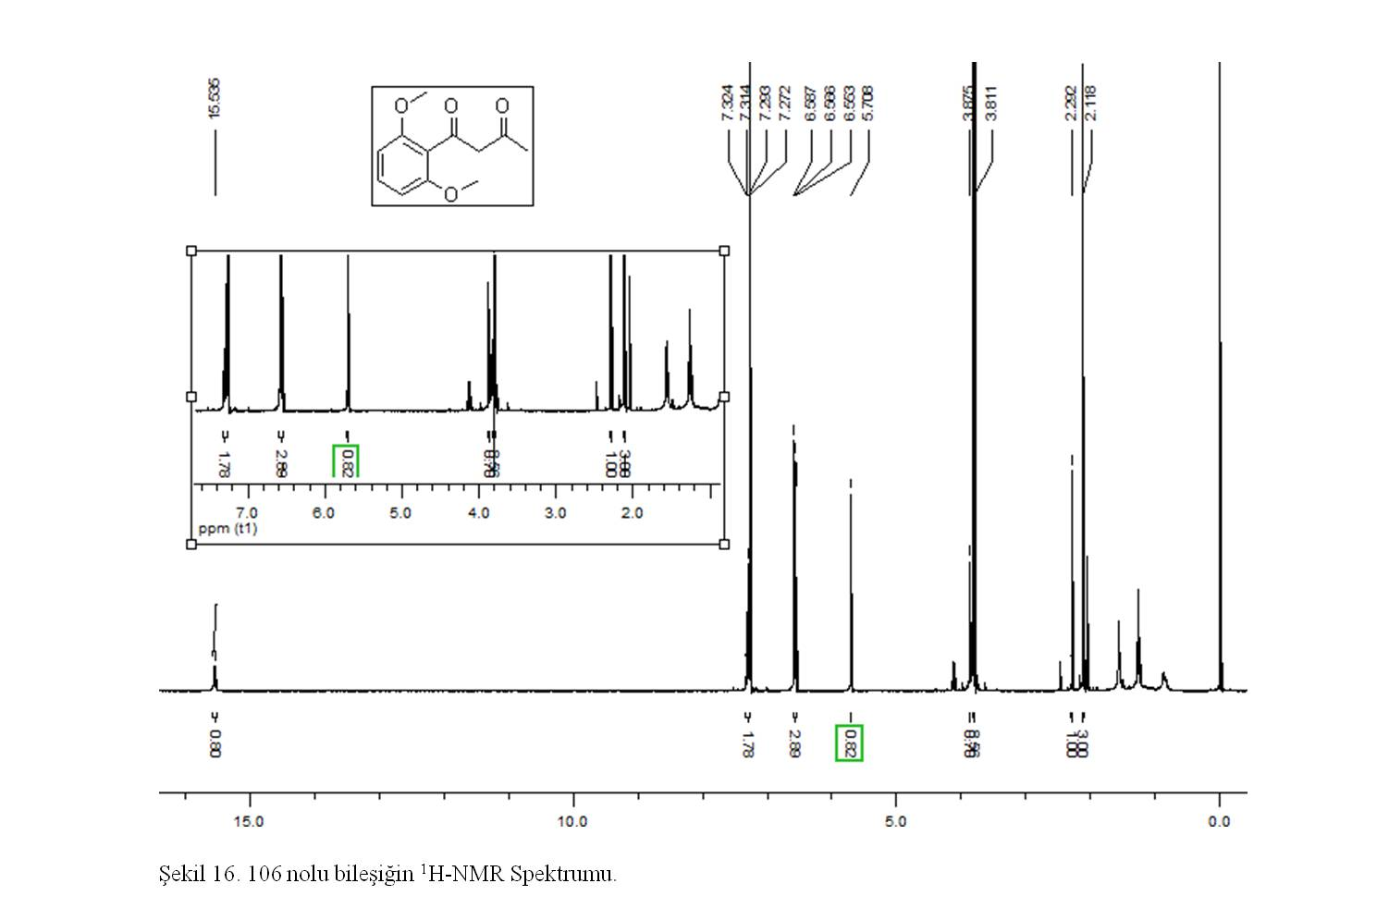
Fig. S5. 1H NMR (400 MHz, CDCl₃) spectrum of 3.
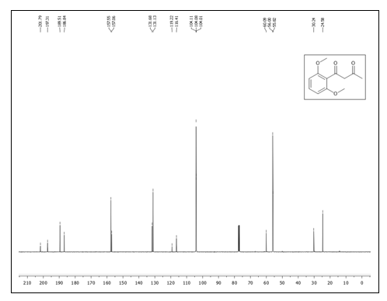
Fig. S6. ¹³C NMR (100 MHz, CDCl₃) spectrum of 3.
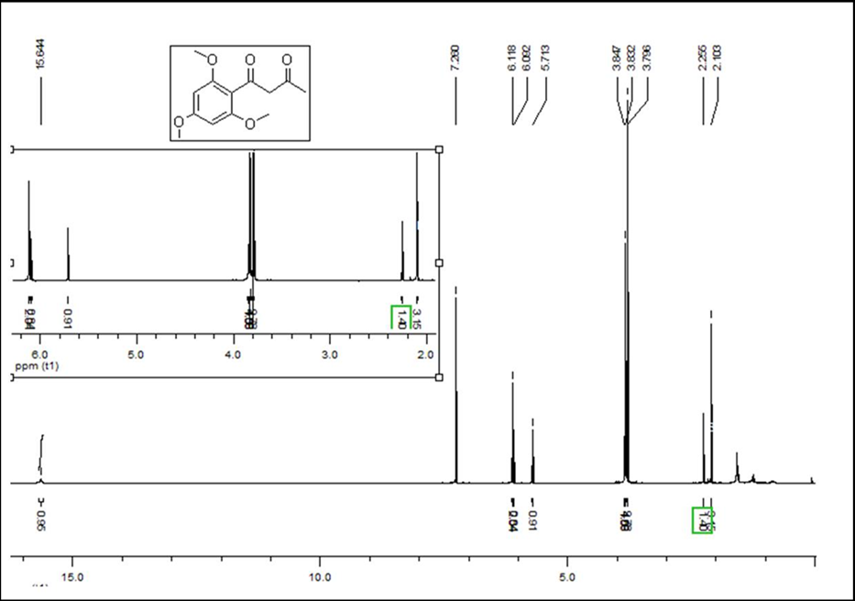
Fig. S7. ¹H NMR (400 MHz, CDCl₃) spectrum of 4.
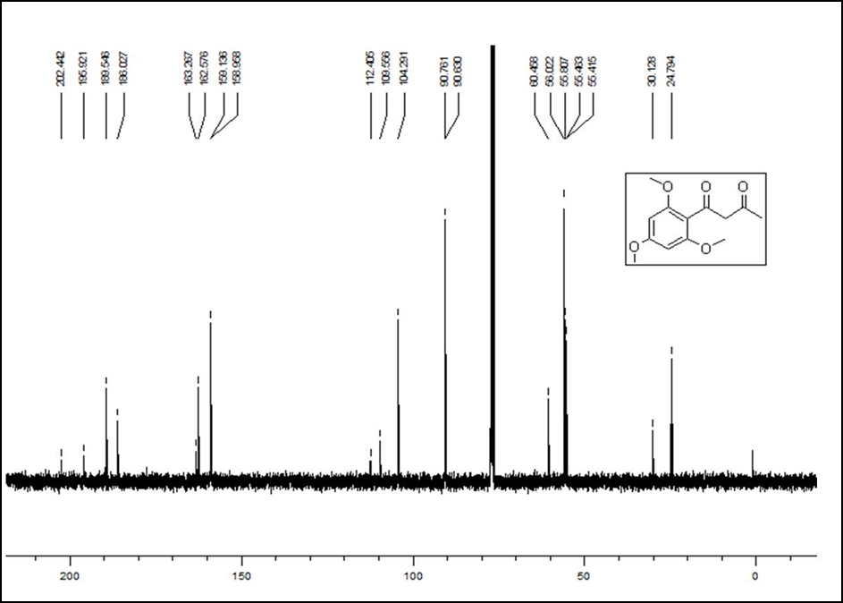
Fig. S8. ¹³C NMR (100 MHz, CDCl₃) spectrum of 4.
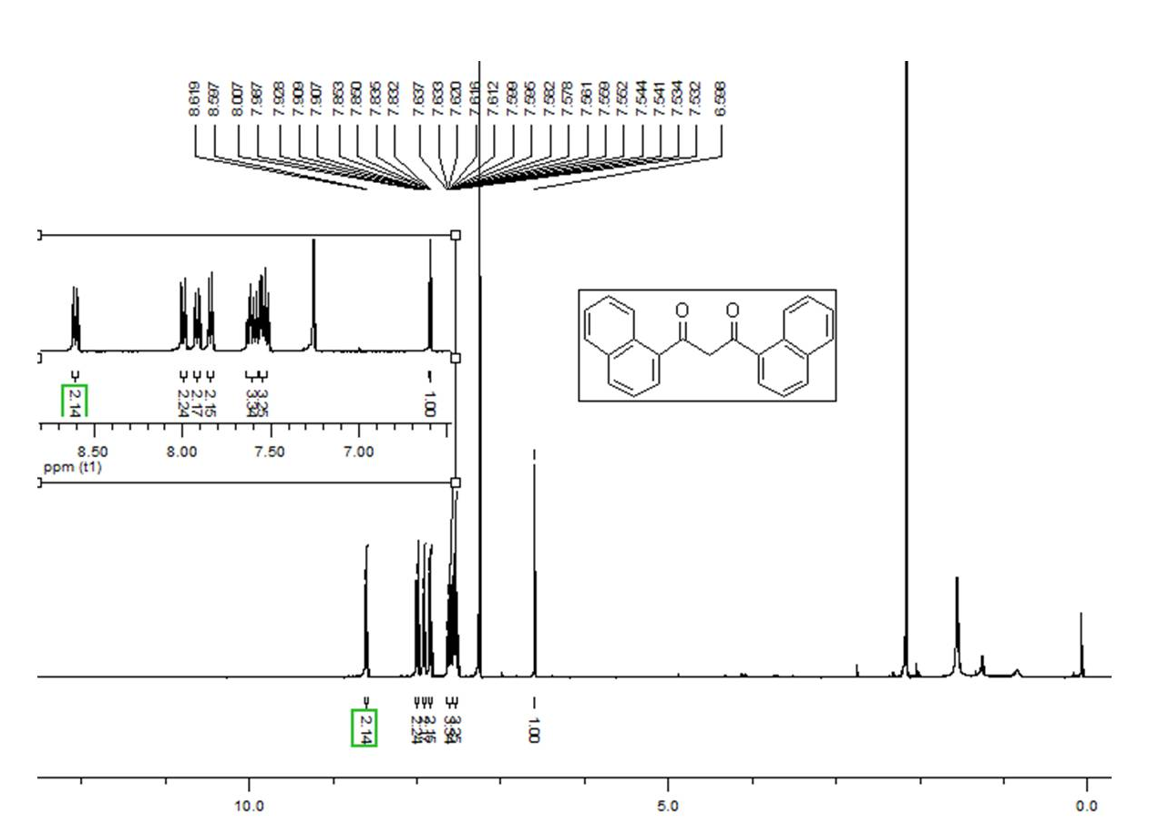
Fig. S9. ¹H NMR (400 MHz, CDCl₃) spectrum of 5.
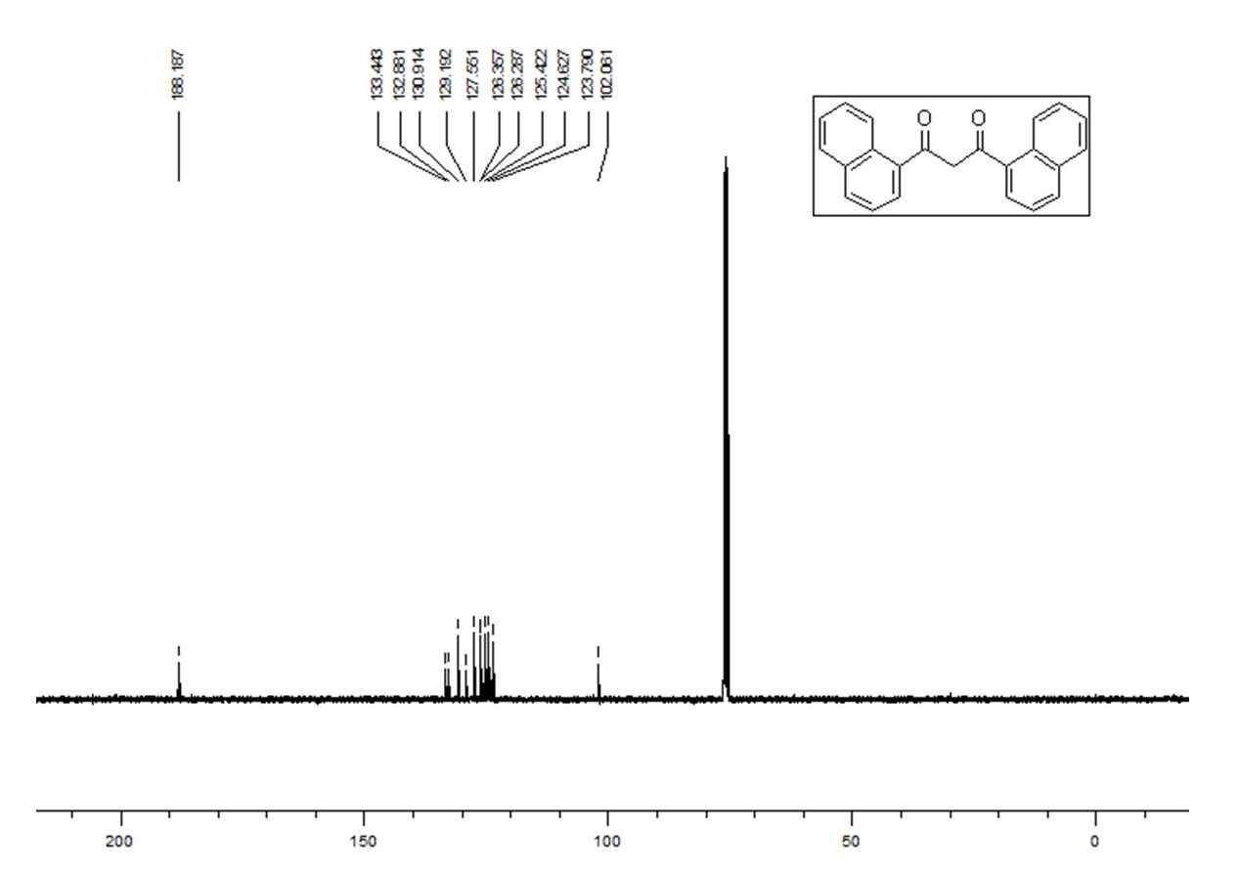
Fig. S10. ¹³C NMR (100 MHz, CDCl₃) spectrum of 5.
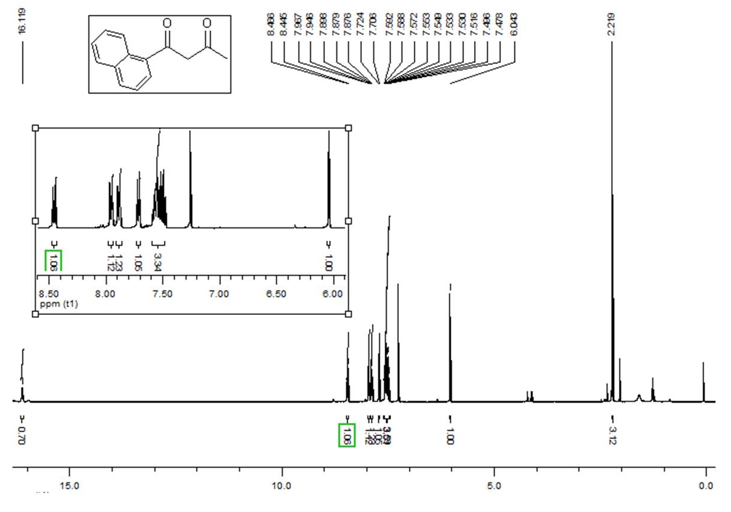
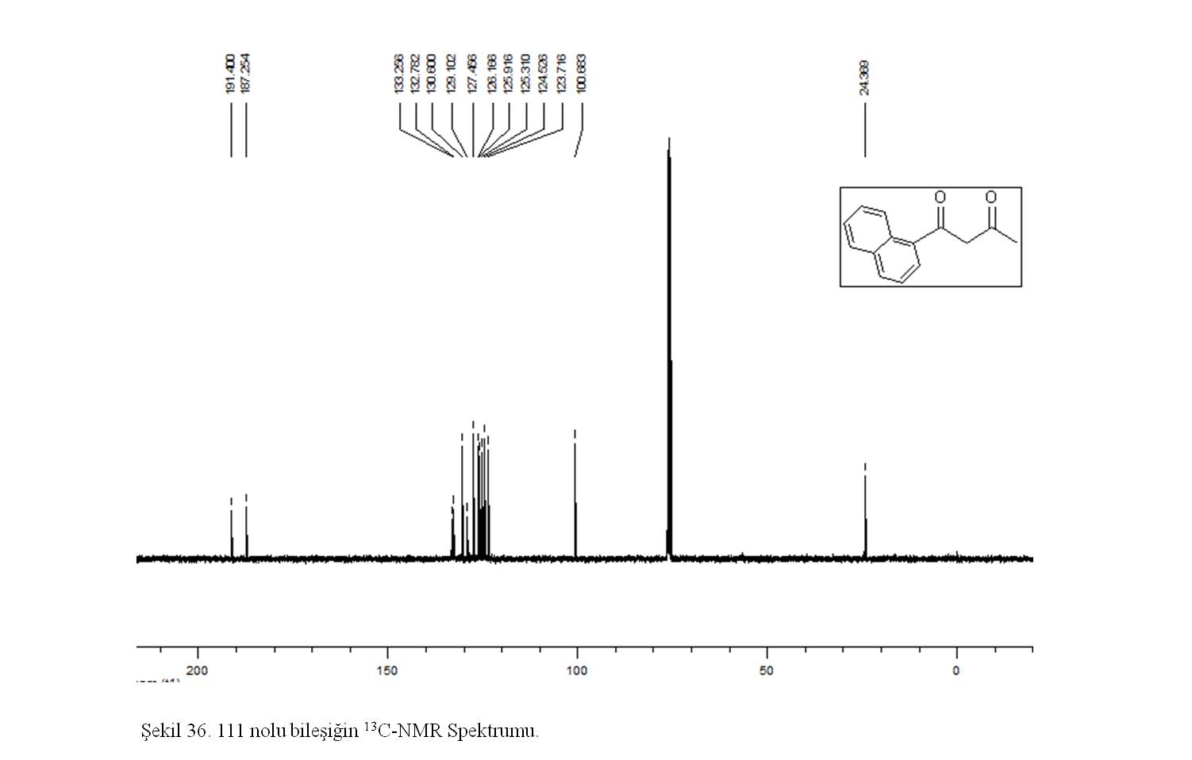
Fig. S11. ¹H NMR (400 MHz, CDCl₃) spectrum of 6.
Fig. S12. ¹³C NMR (100 MHz, CDCl₃) spectrum of 6.
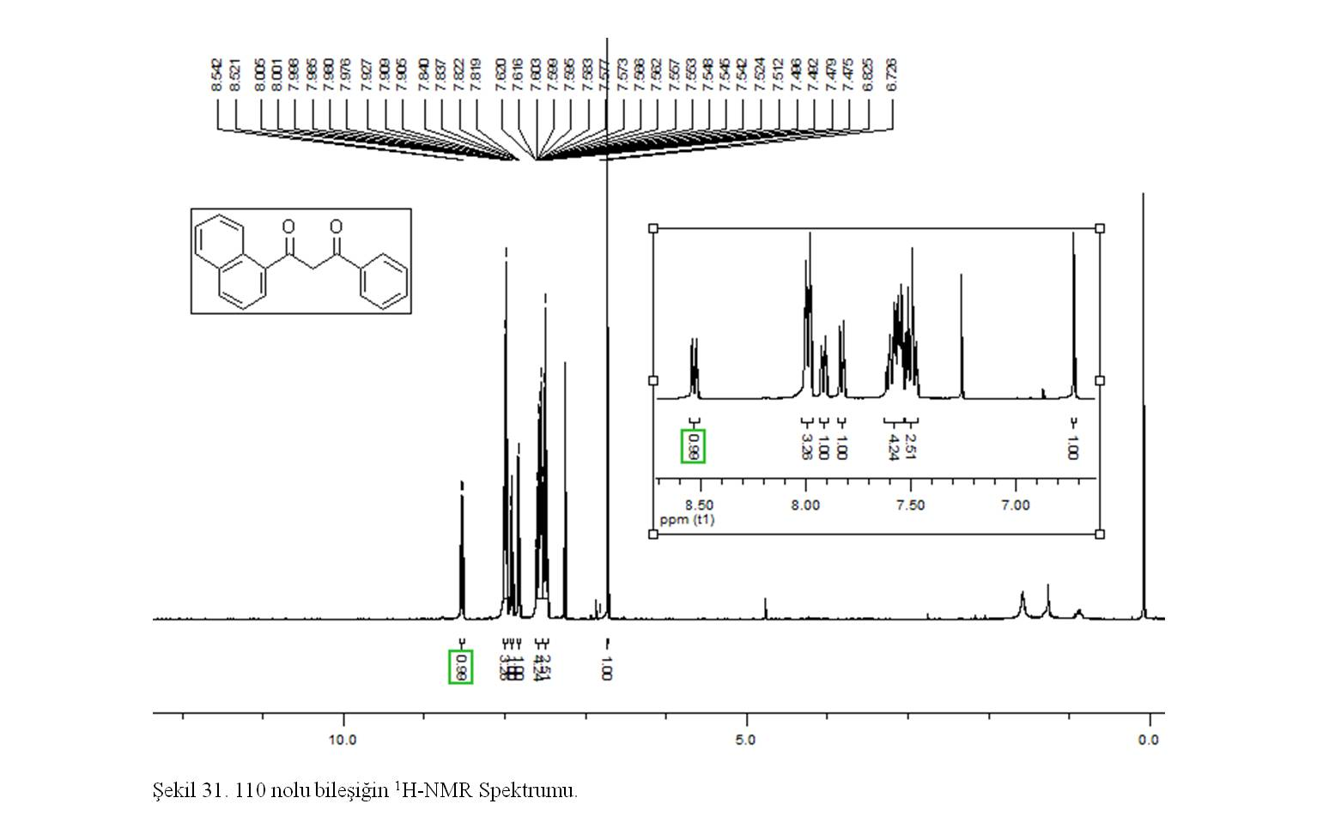
Fig. S13. ¹H NMR (400 MHz, CDCl₃) spectrum of 7.
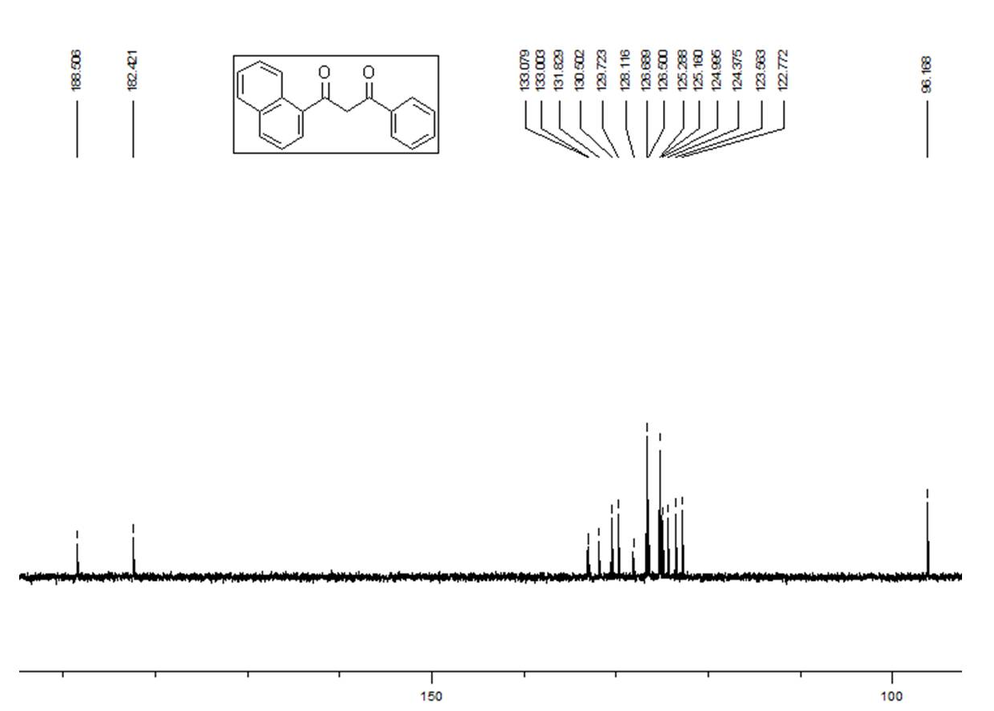
Fig. S14. ¹³C NMR (100 MHz, CDCl₃) spectrum of 7.
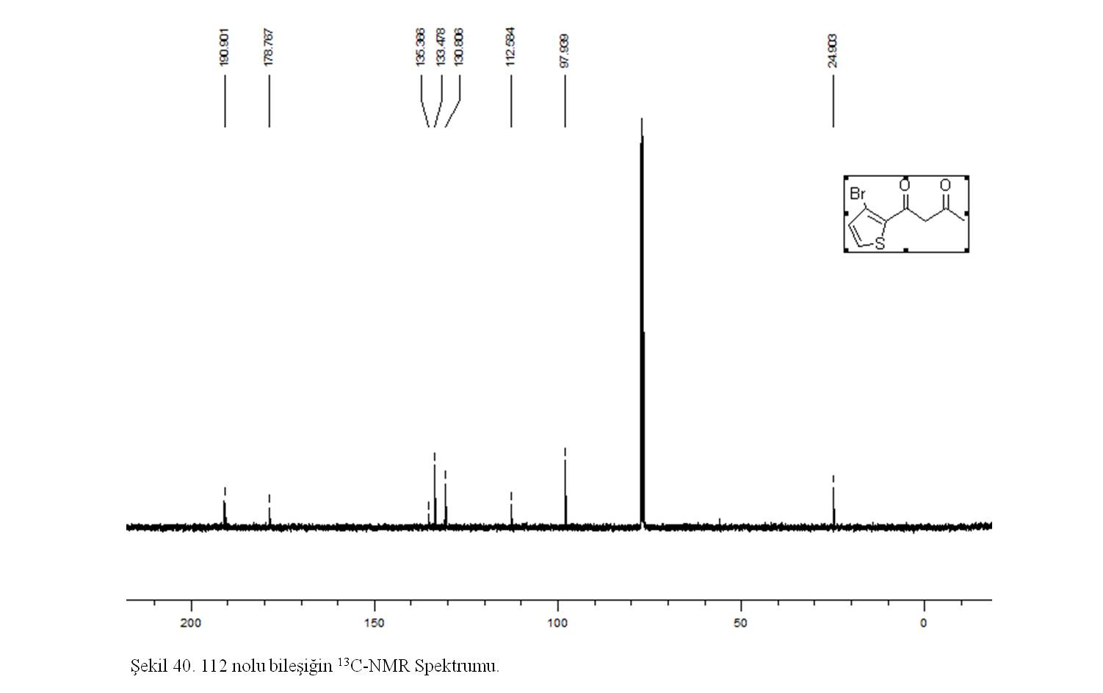
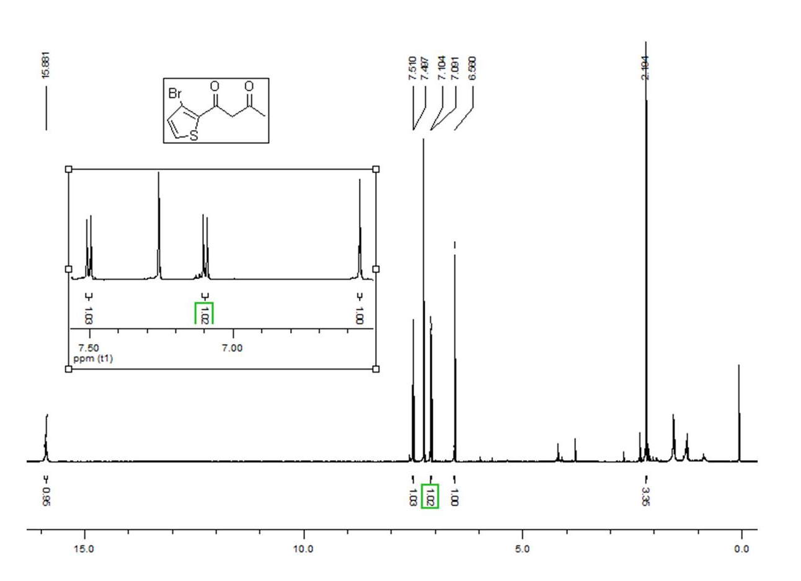
Fig. S15. ¹H NMR (400 MHz, CDCl₃) spectrum of 8.
Fig. S16. ¹³C NMR (100 MHz, CDCl₃) spectrum of 8
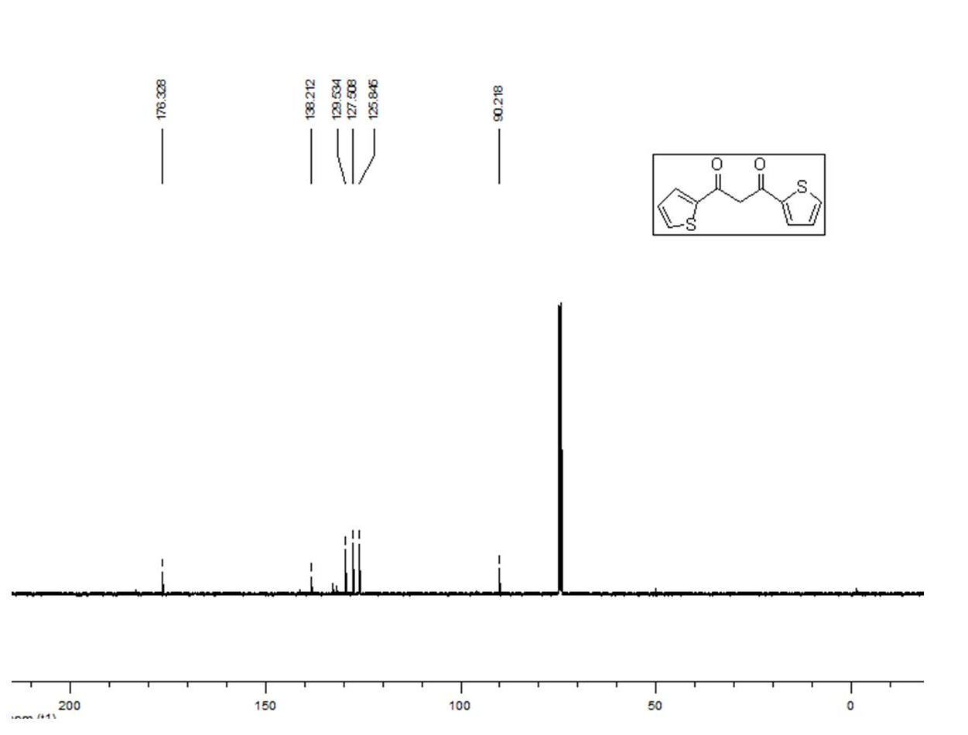
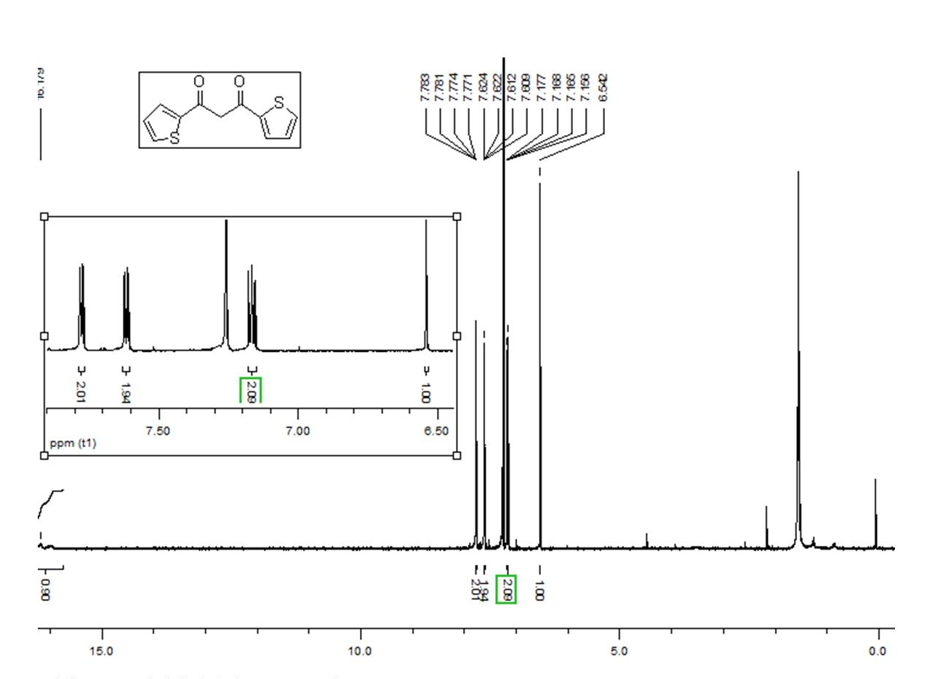
Fig. S17. ¹H NMR (400 MHz, CDCl₃) spectrum of 9.
Fig. S18. ¹³C NMR (100 MHz, CDCl₃) spectrum of 9.
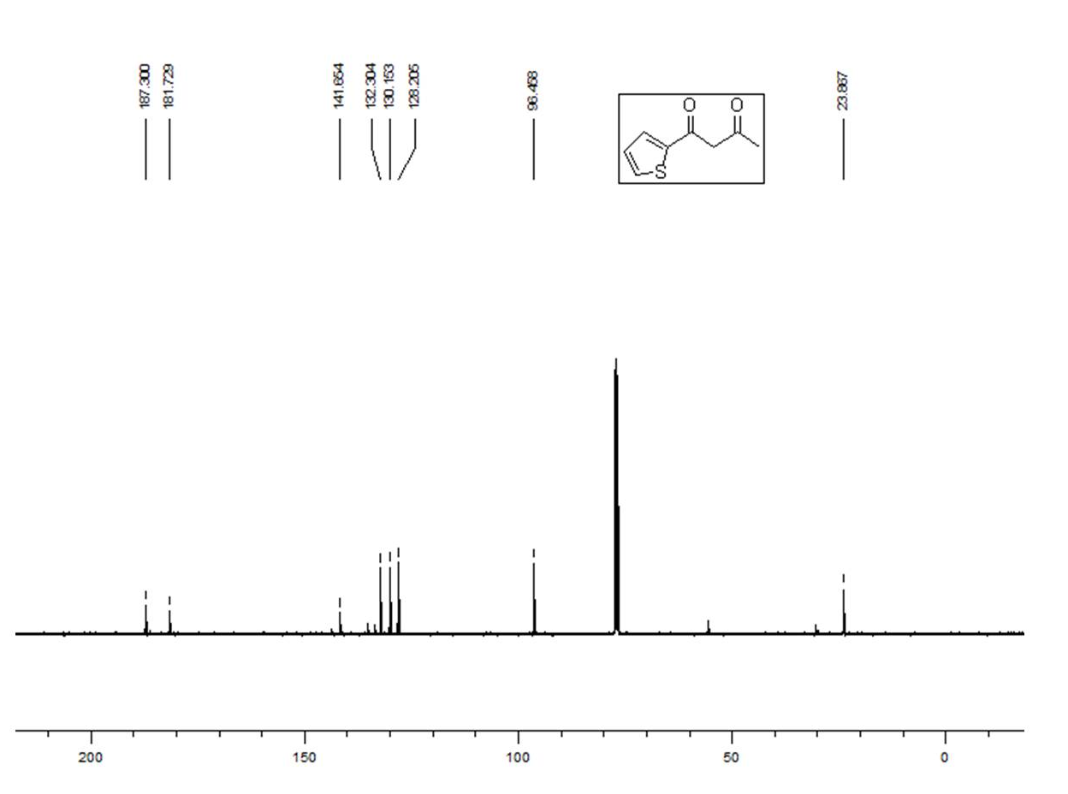
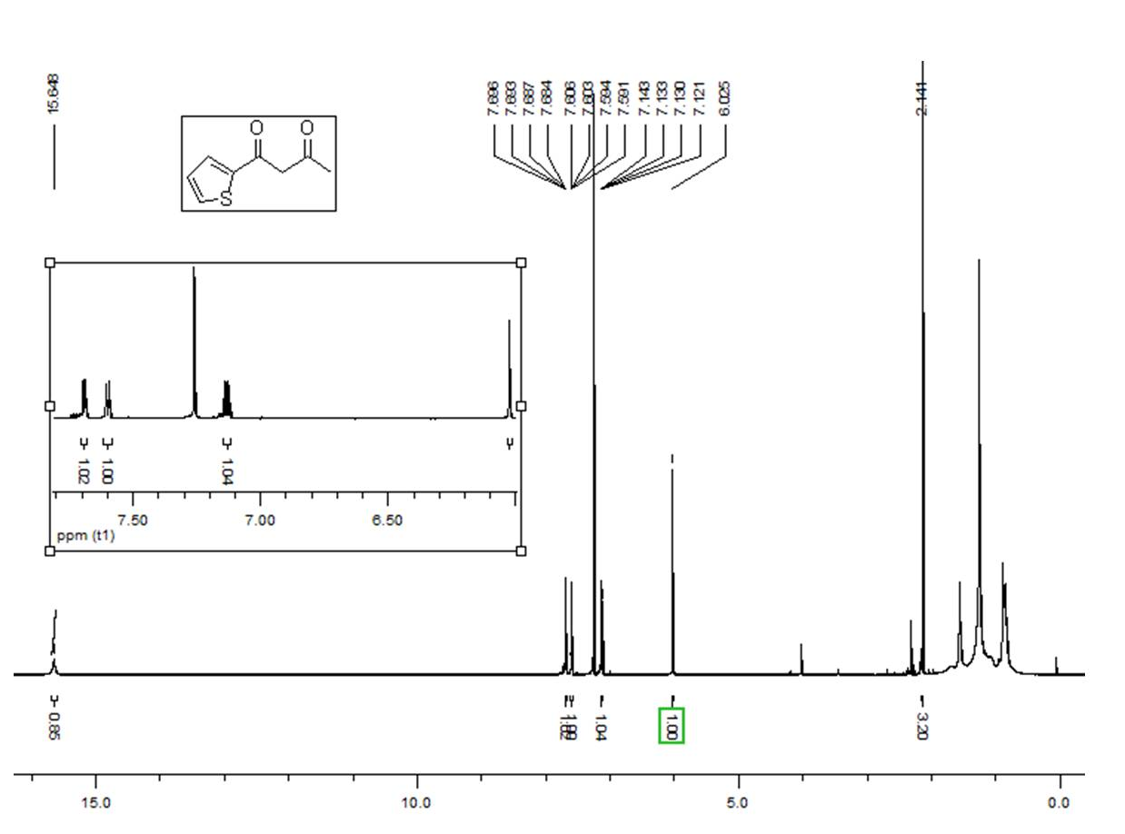
Fig. S19. ¹H NMR (400 MHz, CDCl₃) spectrum of 10.
Fig. S20. ¹³C NMR (100 MHz, CDCl₃) spectrum of 10
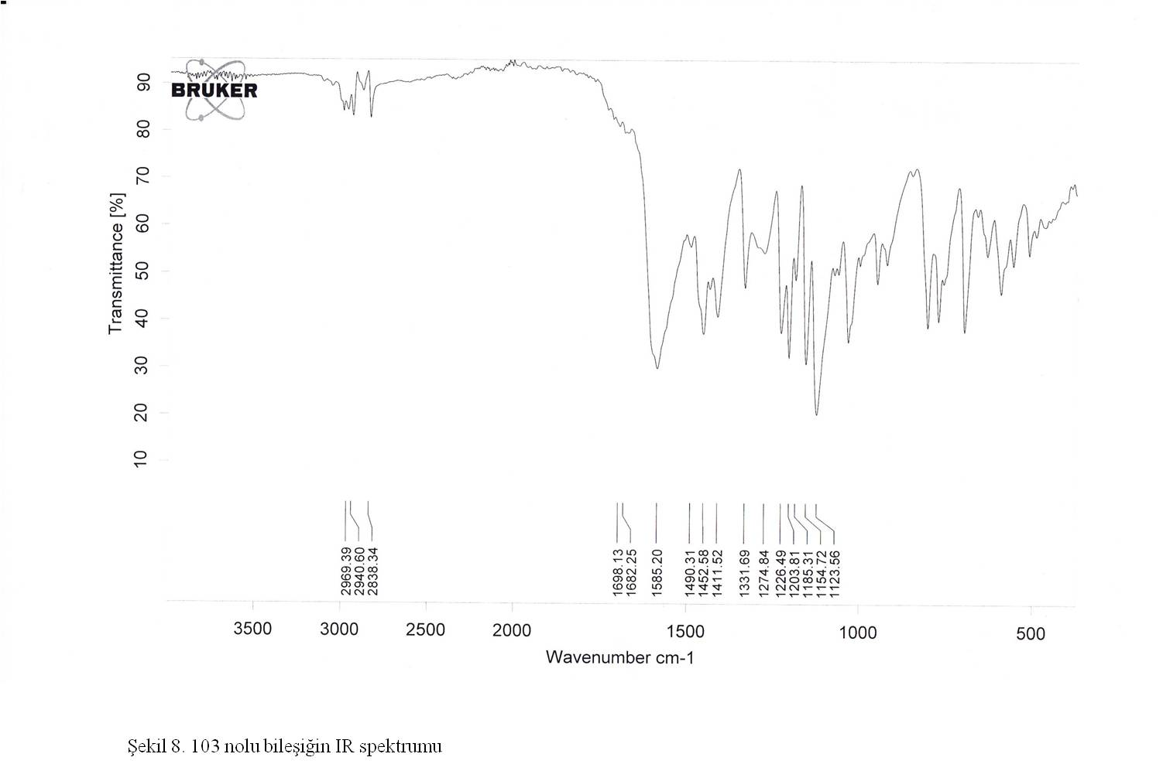
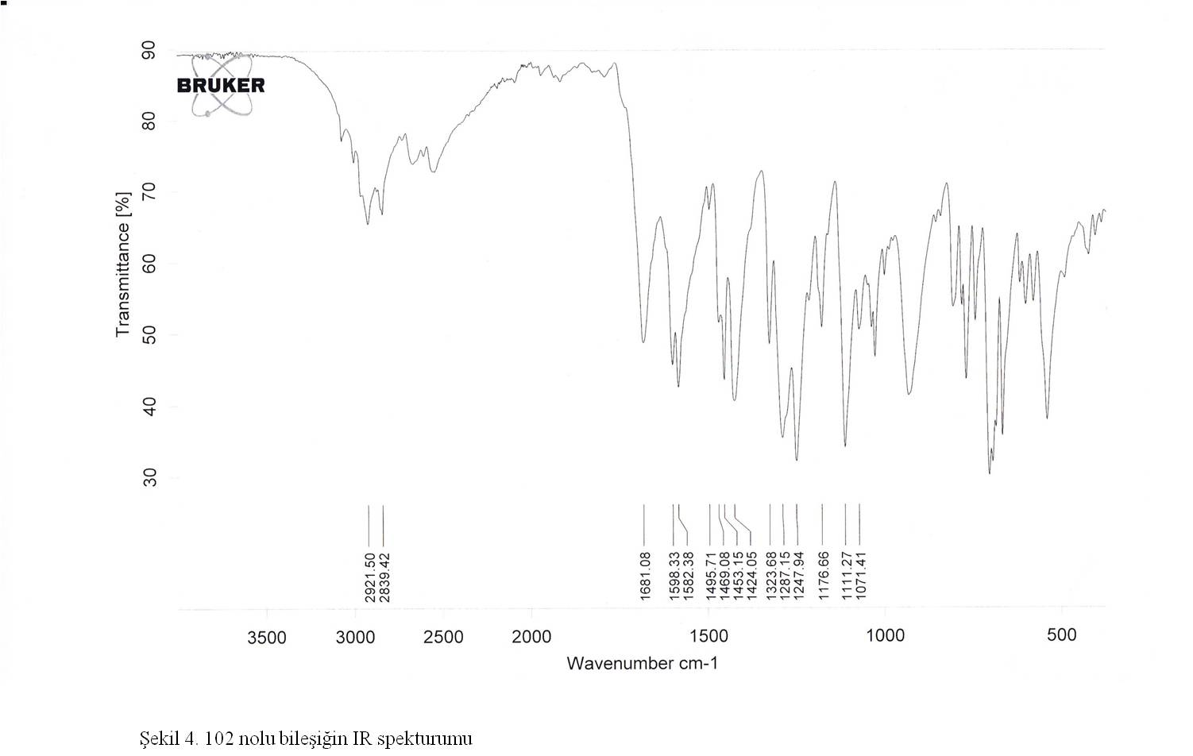
Fig. S21. IR (ATR, cm⁻¹) spectrum of 1.
Fig. S22. IR (ATR, cm⁻¹) spectrum of 2.
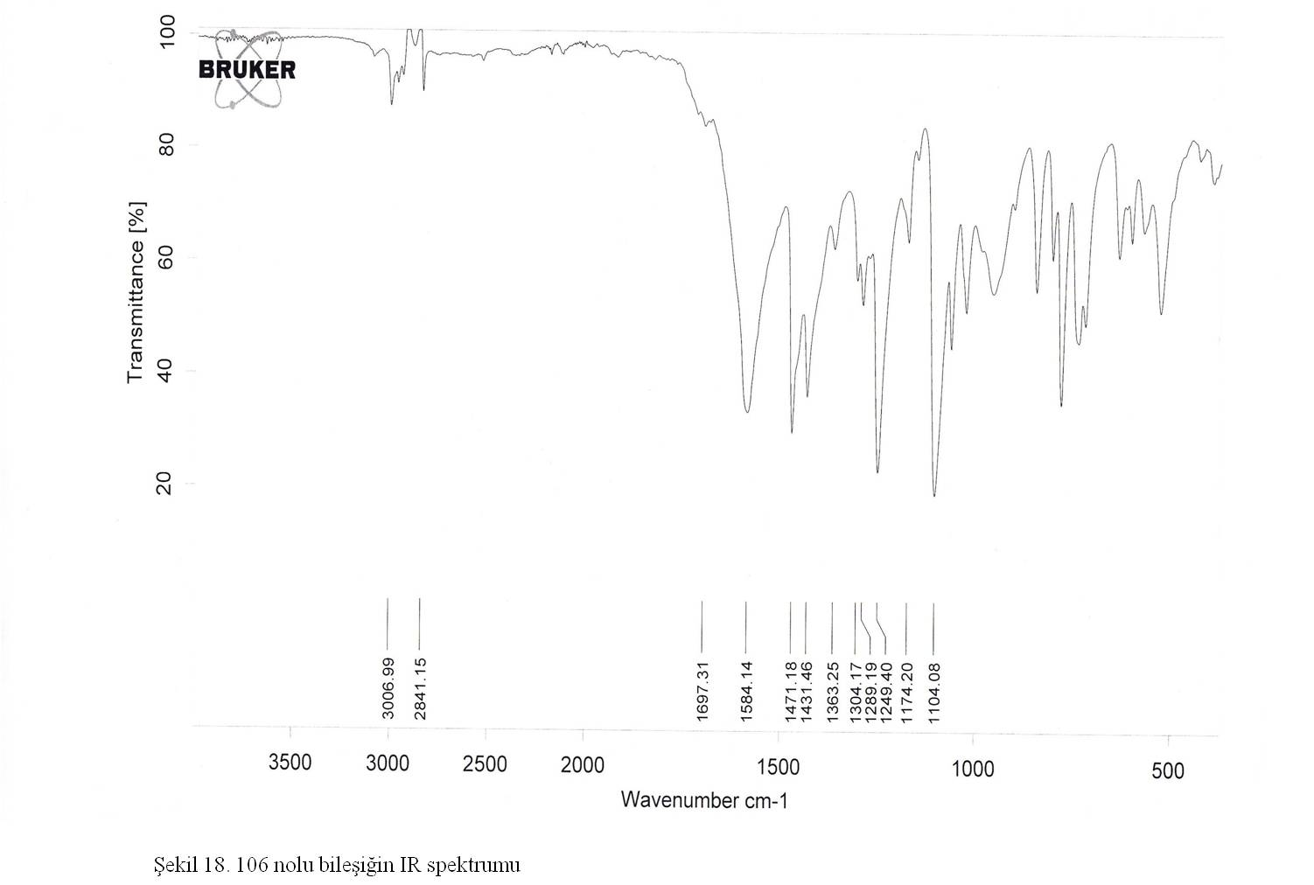
Fig. S23. IR (ATR, cm⁻¹) spectrum of 3.

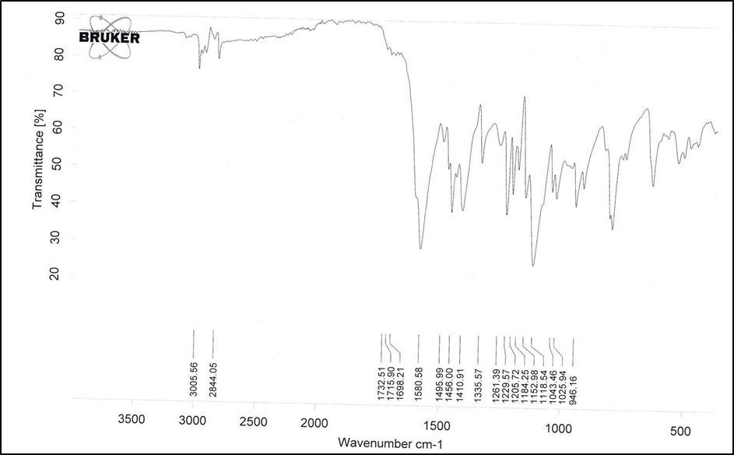
Fig. S24. IR (ATR, cm⁻¹) spectrum of 4.
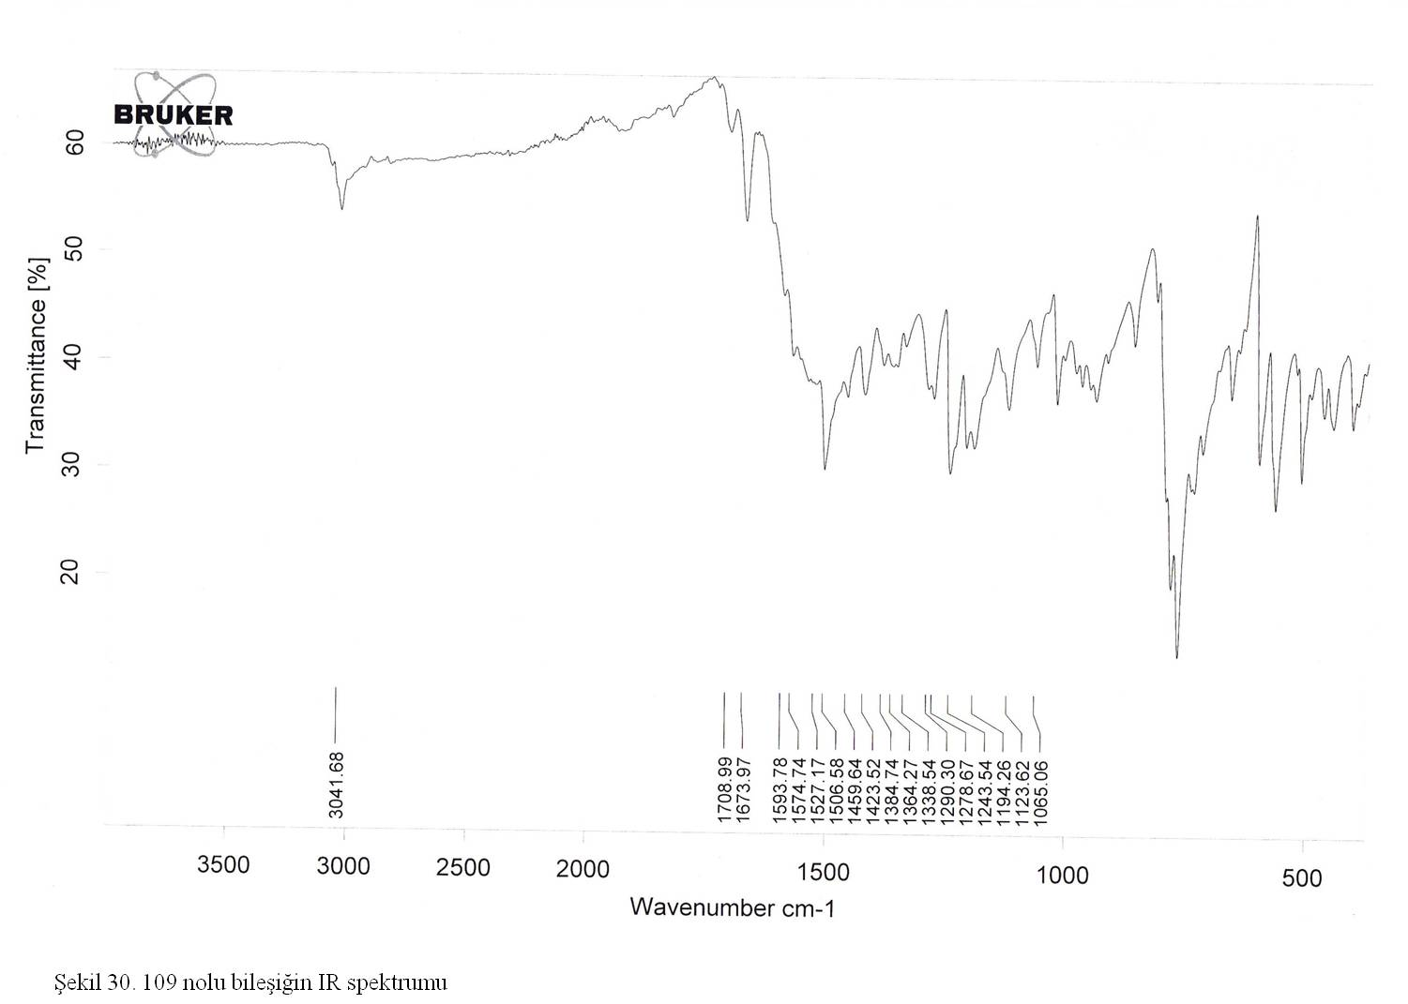
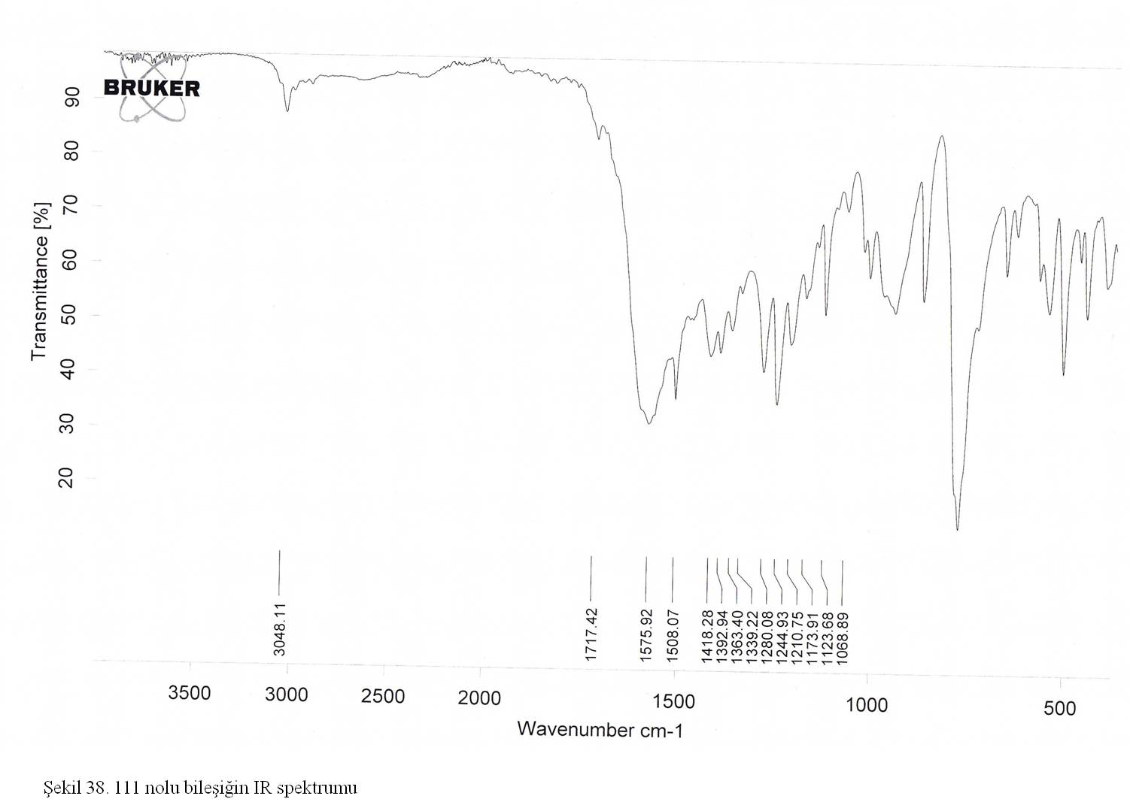
Fig. S25. IR (ATR, cm⁻¹) spectrum of 5.
Fig. S26. IR (ATR, cm⁻¹) spectrum of 6.
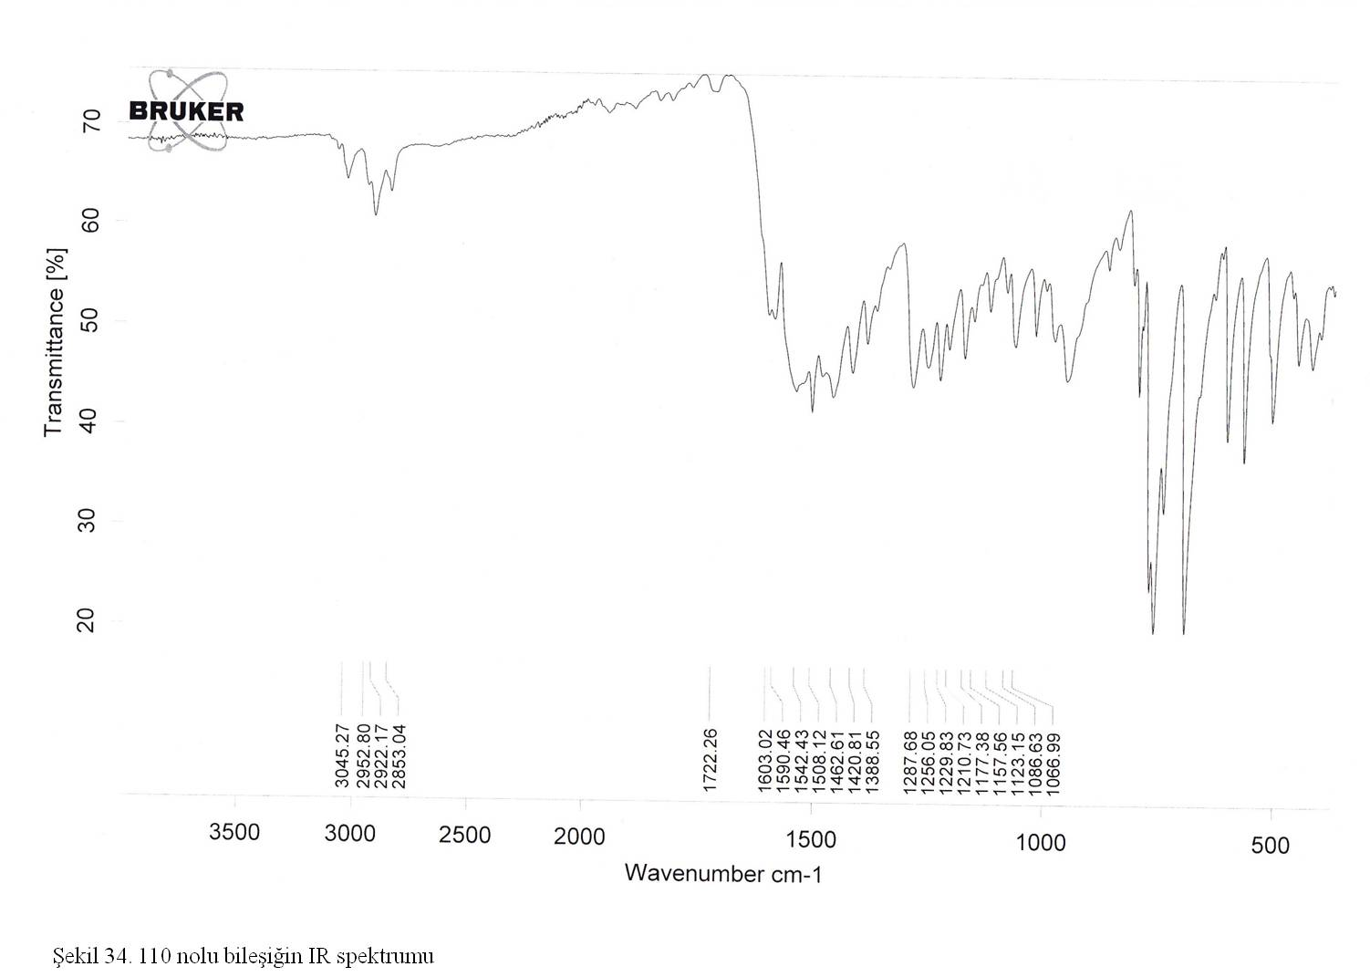
Fig. S27. IR (ATR, cm⁻¹) spectrum of 7.
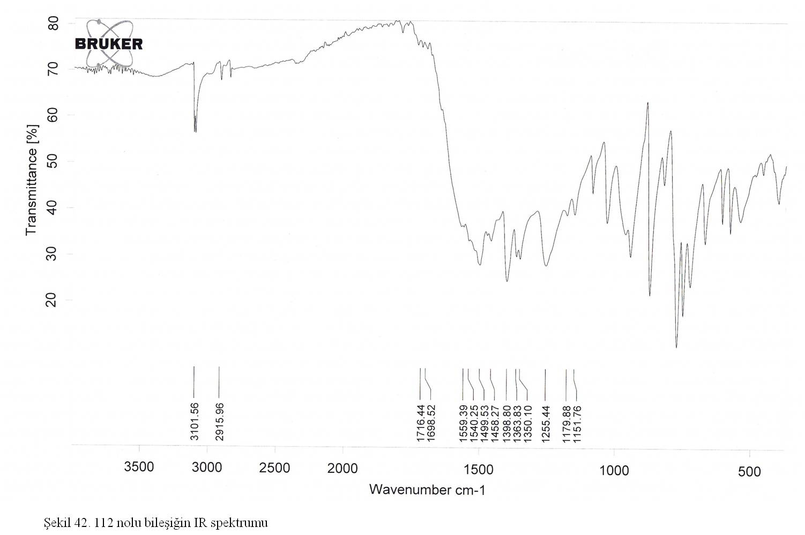
Fig. S28. IR (ATR, cm⁻¹) spectrum of 8.
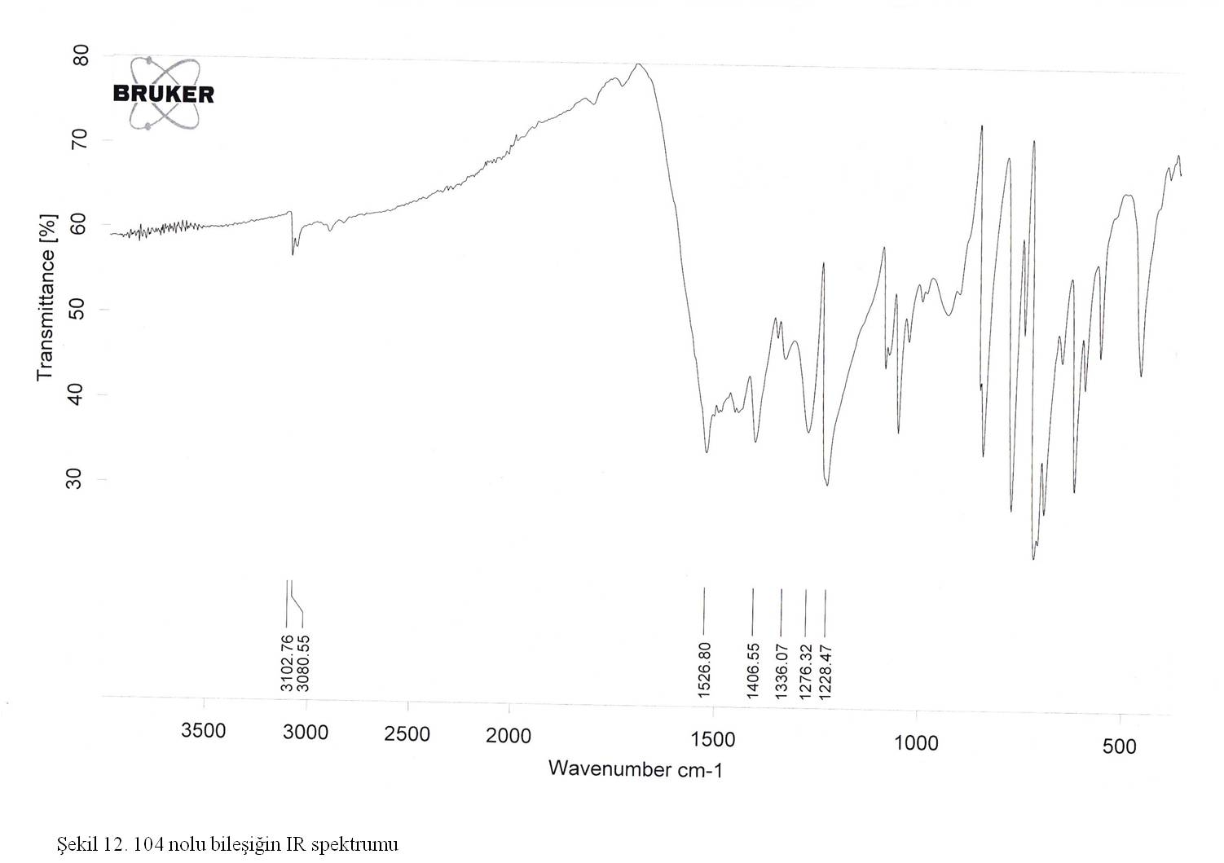
Fig. S29. IR (ATR, cm⁻¹) spectrum of 9.
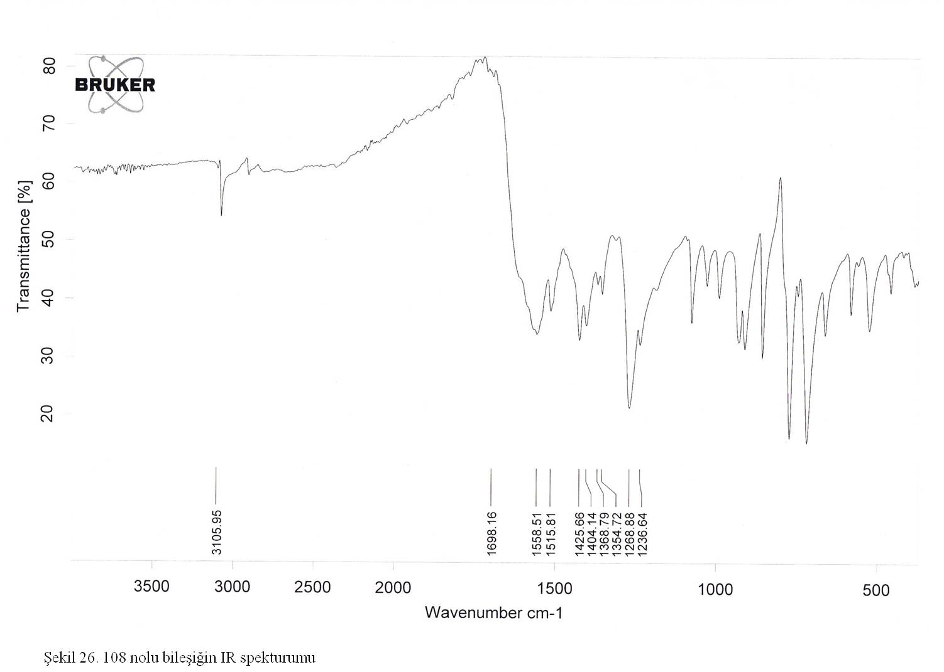
Fig. S30. IR (ATR, cm⁻¹) spectrum of 10.
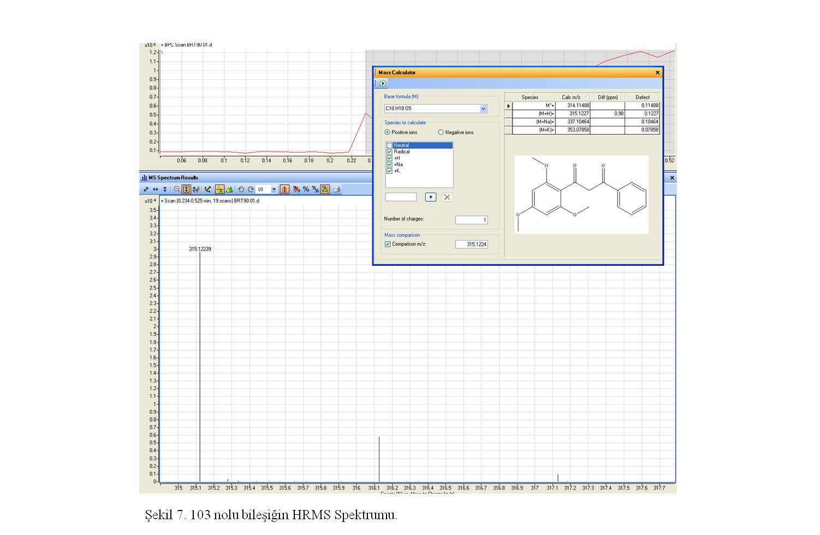
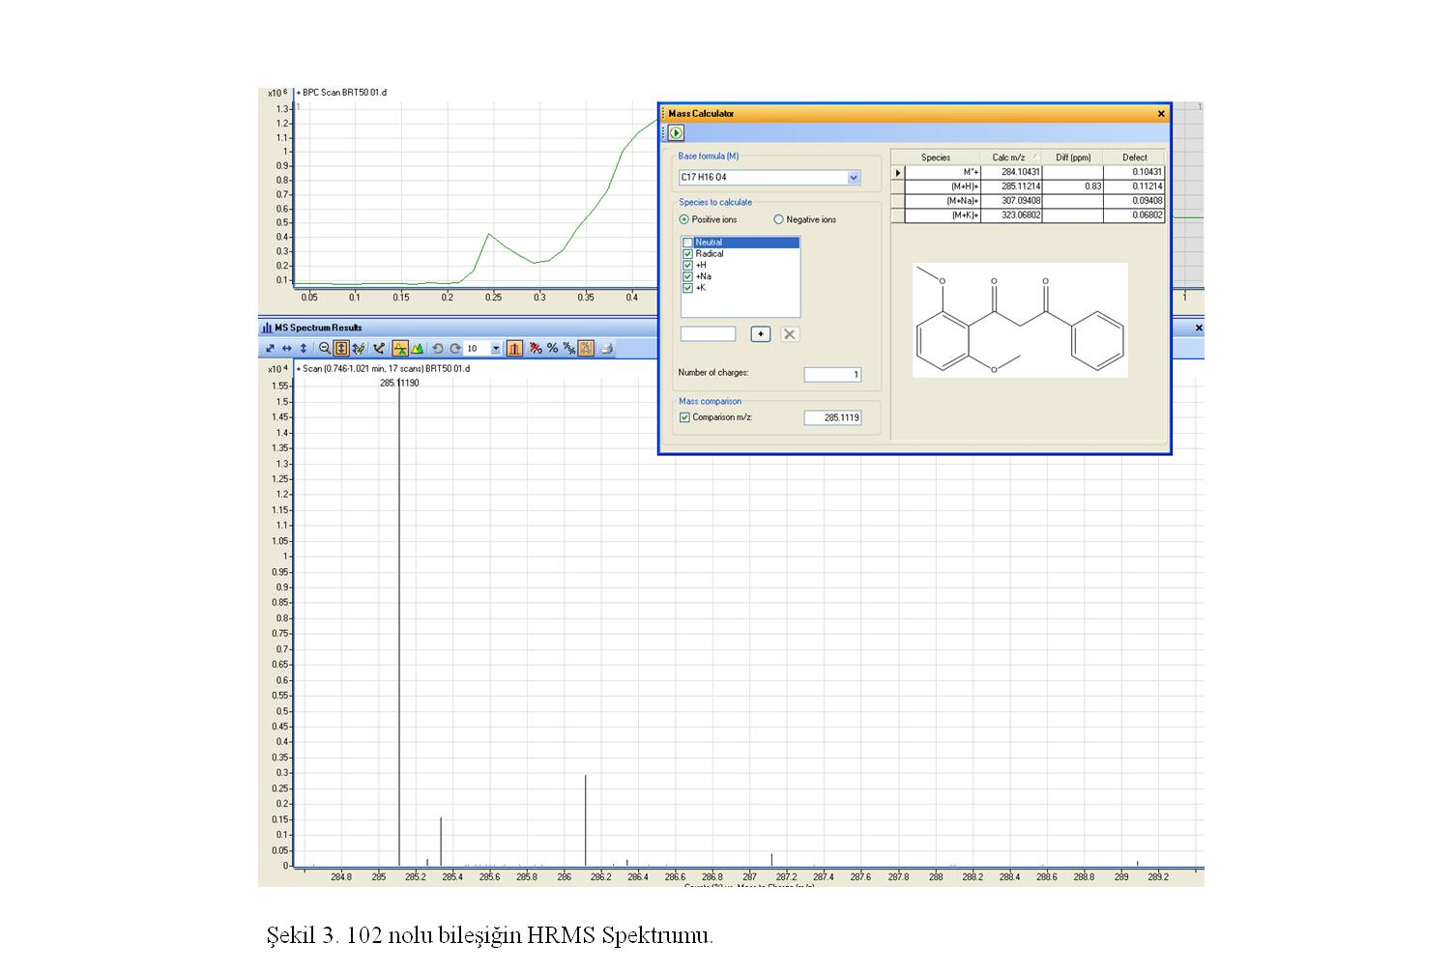
Fig. S31. HR-MS (m/z (M+H)⁺) spectrum of 1.
Fig. S32. HR-MS (m/z (M+H)⁺) spectrum of 2.
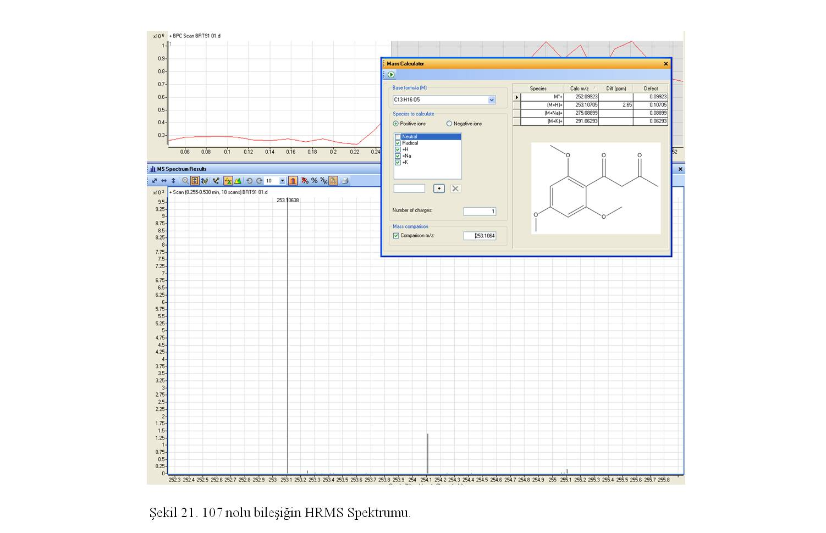
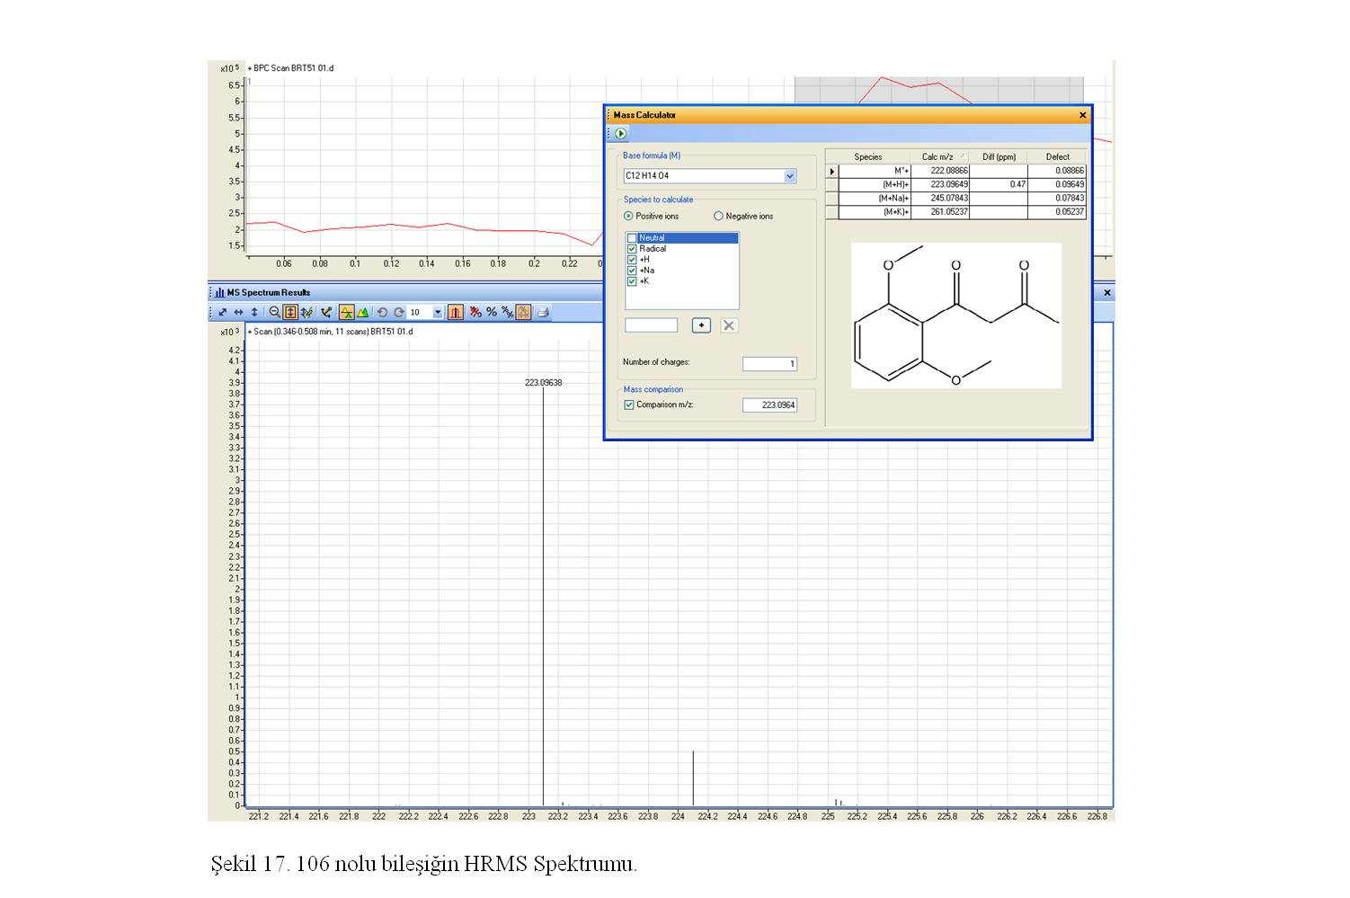
Fig. S33. HR-MS (m/z (M+H)⁺) spectrum of 3.
Fig. S34. HR-MS (m/z (M+H)⁺) spectrum of 4.
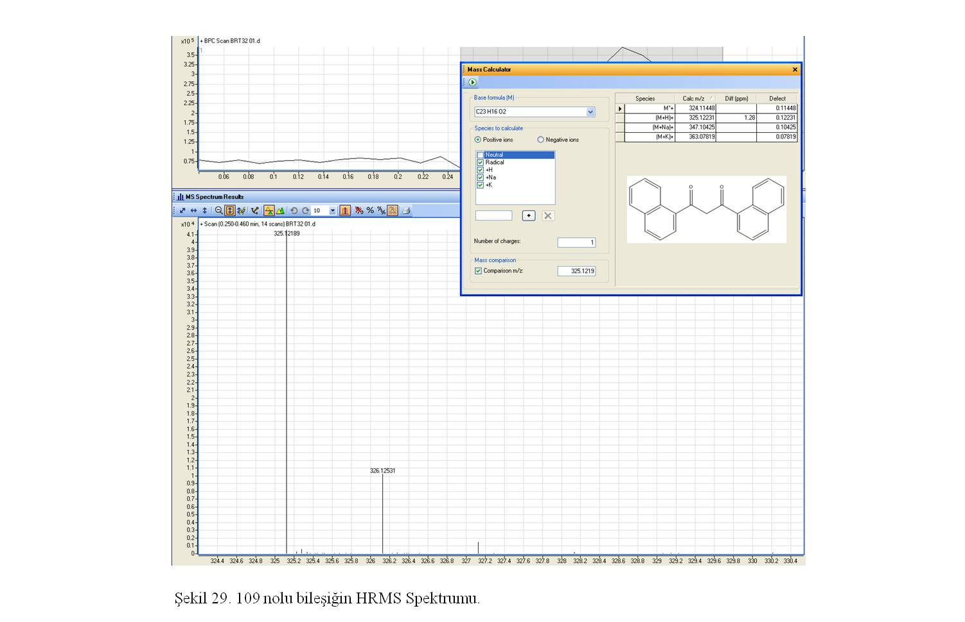
Fig. S35. HR-MS (m/z (M+H)⁺) spectrum of 5.
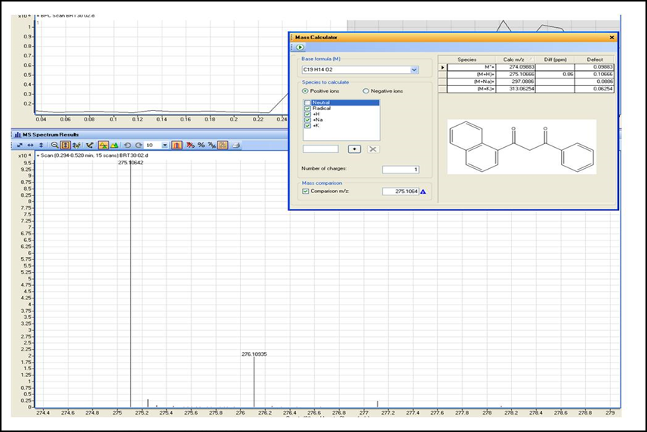
Fig. S36. HR-MS (m/z (M+H)⁺) spectrum of 6.
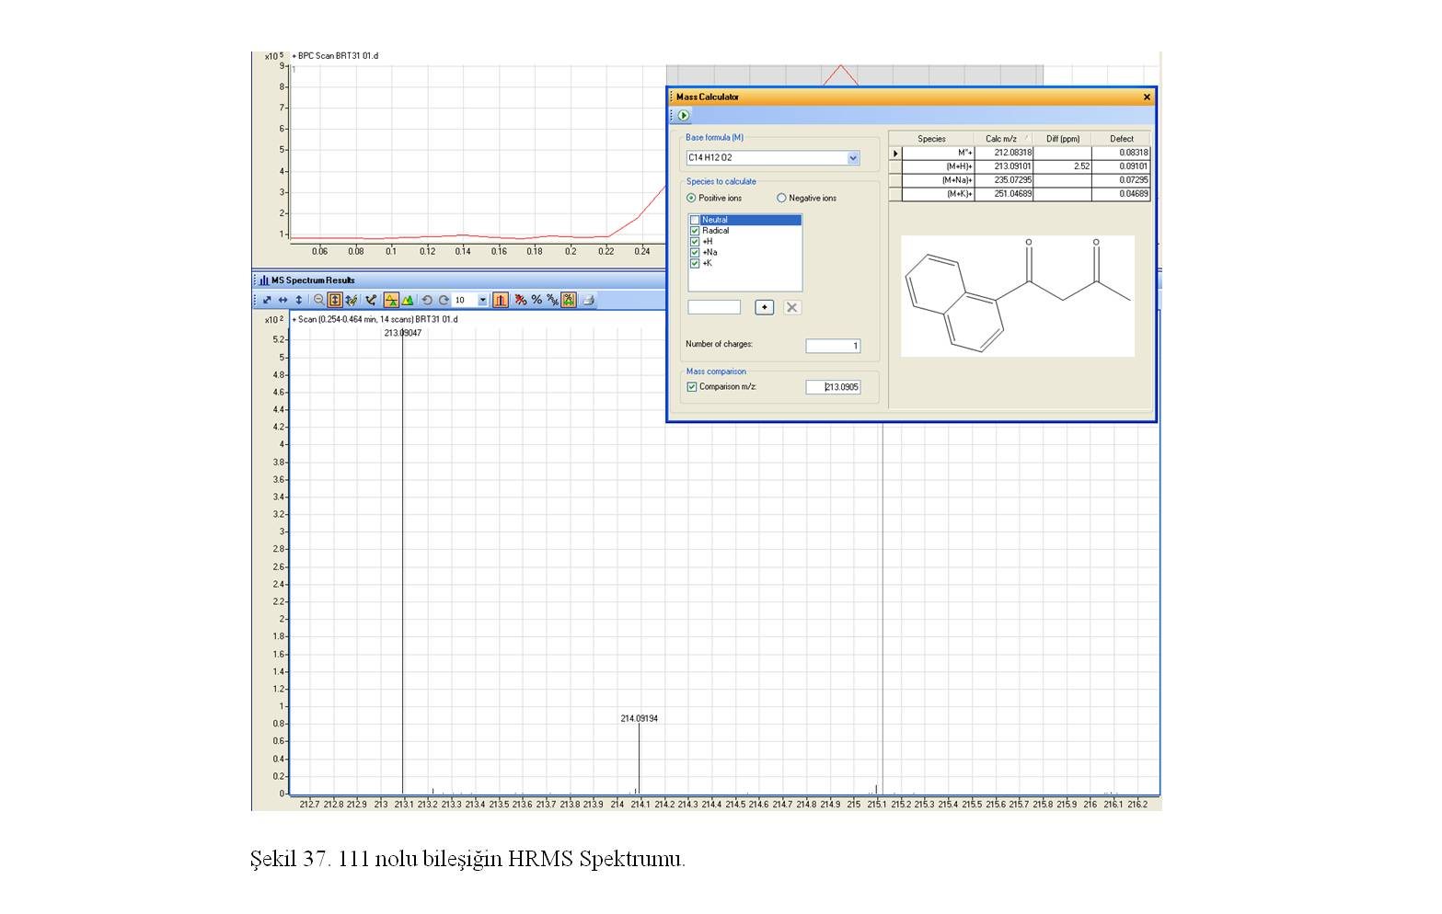
Fig. S37. HR-MS (m/z (M+H)⁺) spectrum of 7.
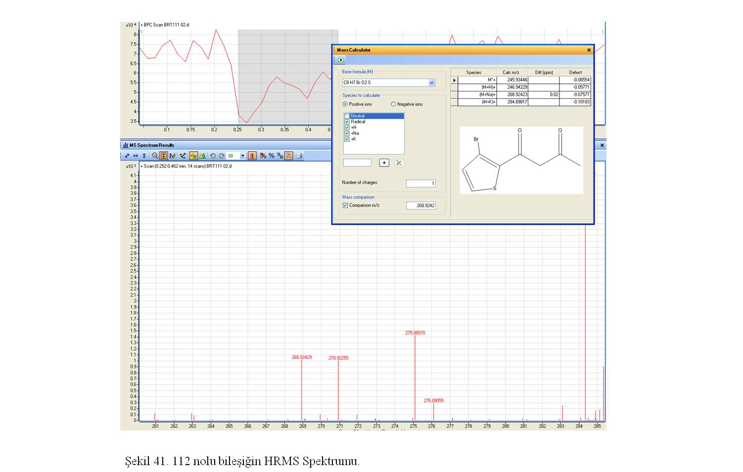
Fig. S38. HR-MS (m/z (M+Na)⁺) spectrum of 8.
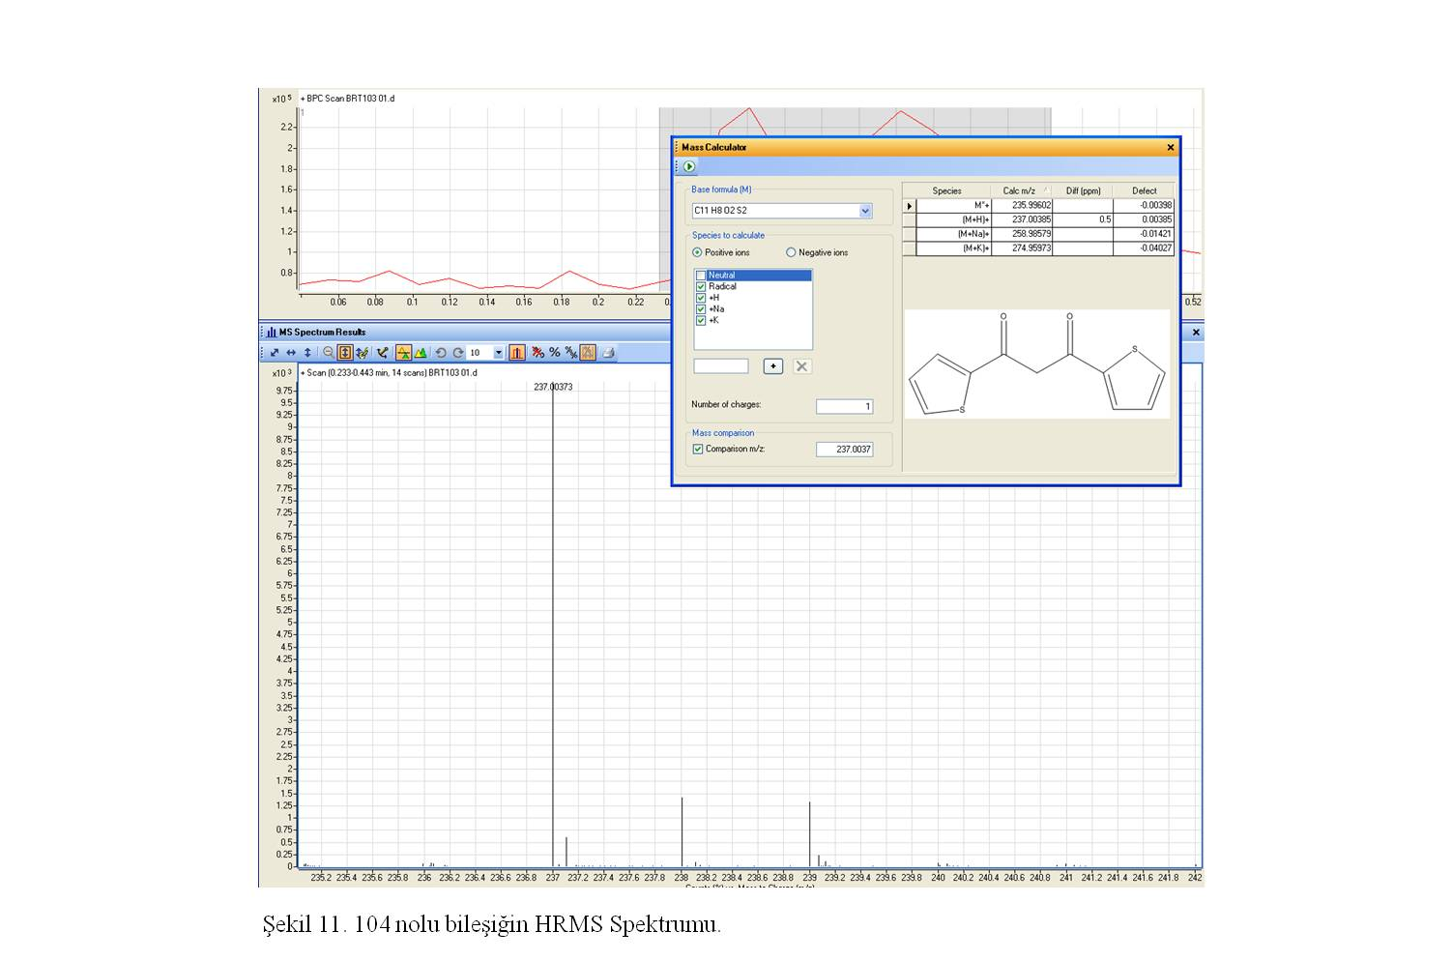
Fig. S39. HR-MS (m/z (M+H)⁺) spectrum of 9.
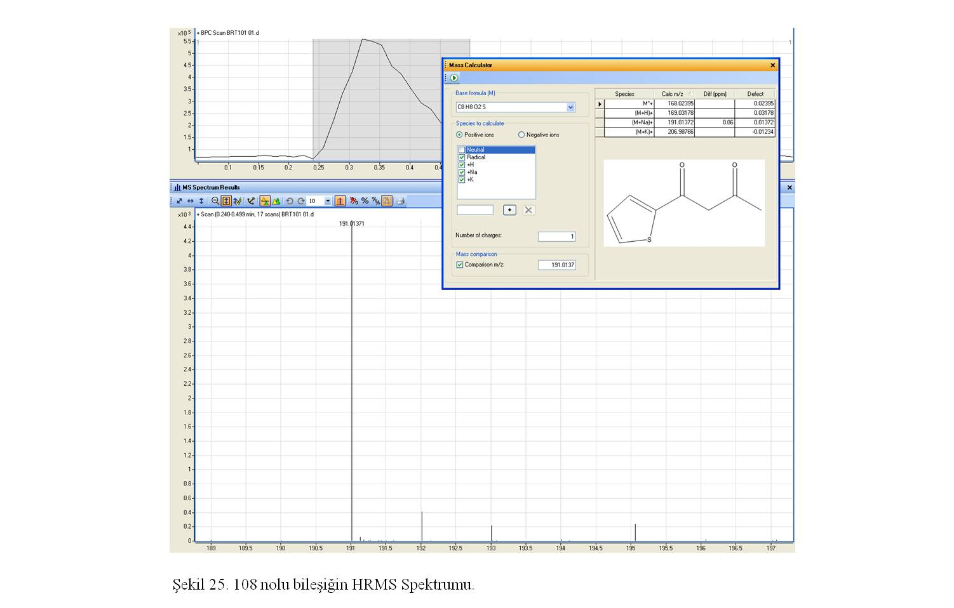
Fig. S40. HR-MS (m/z (M+Na)⁺) spectrum of 10.
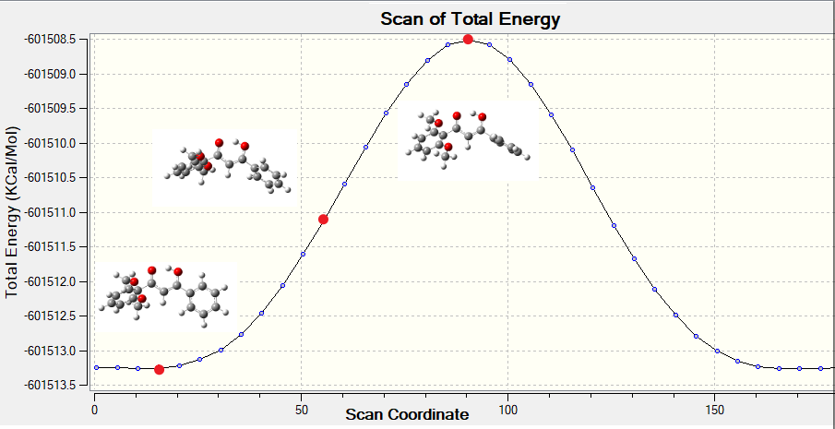
a.

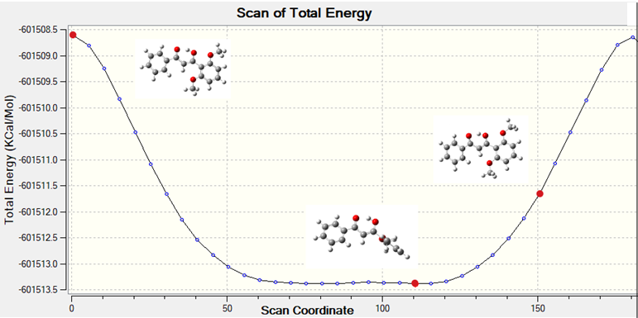
b.

Fig. S41. a. Dihedral angle scanning of the enol form 1a (most and least stable conformers); b. Dihedral angle scanning of the enol form 1b (most and least stable conformers).
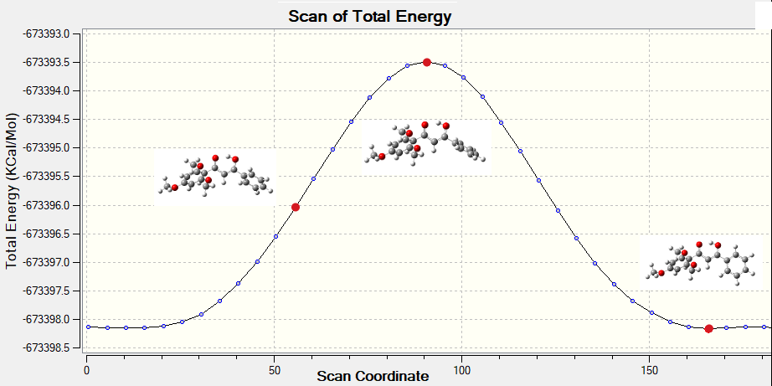
a.

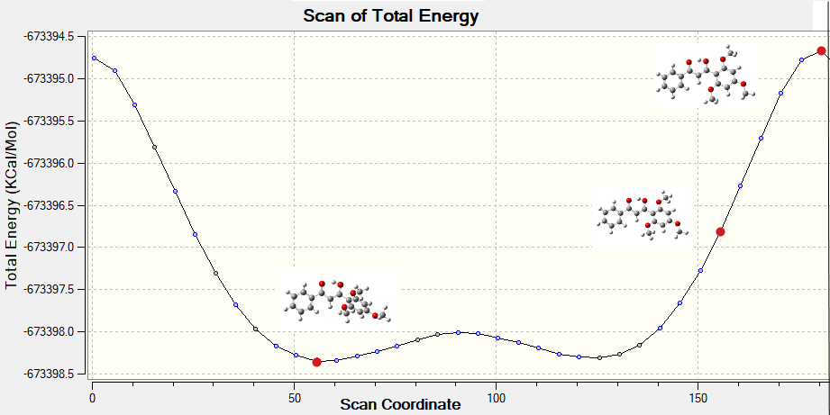
b.

Fig. S42. a. Dihedral angle scanning of the enol form 2a (most and least stable conformers); b. Dihedral angle scanning of the enol form 2b (most and least stable conformers).
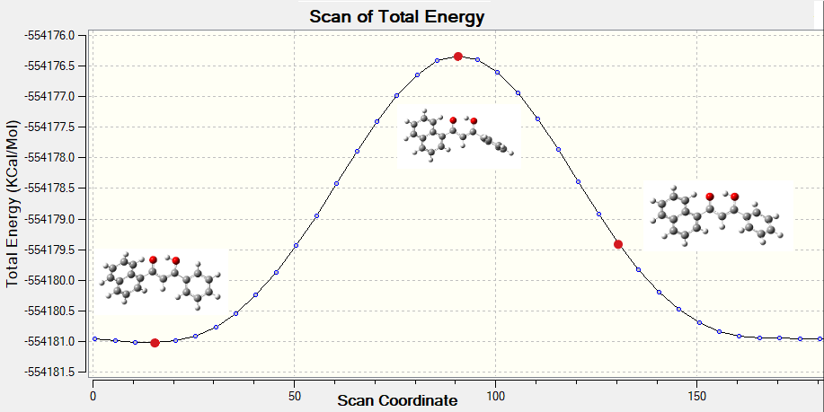
a.

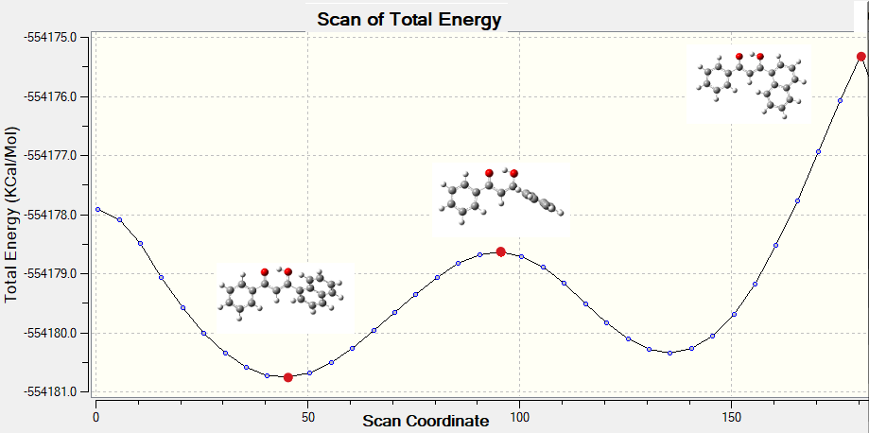
b.

Fig. S43. a. Dihedral angle scanning of the enol form 7a (most and least stable conformers); b. Dihedral angle scanning of the enol form 7b (most and least stable conformers).
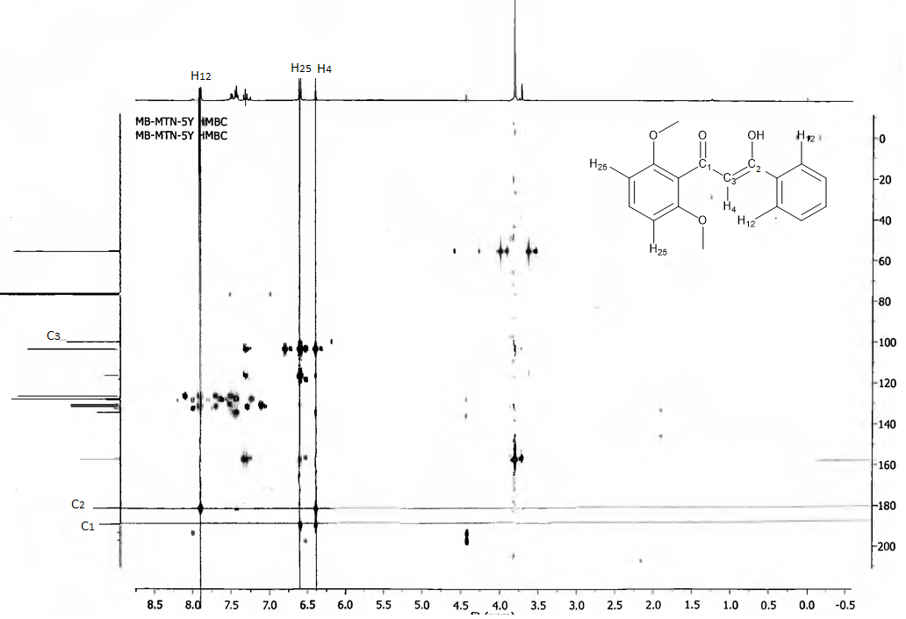
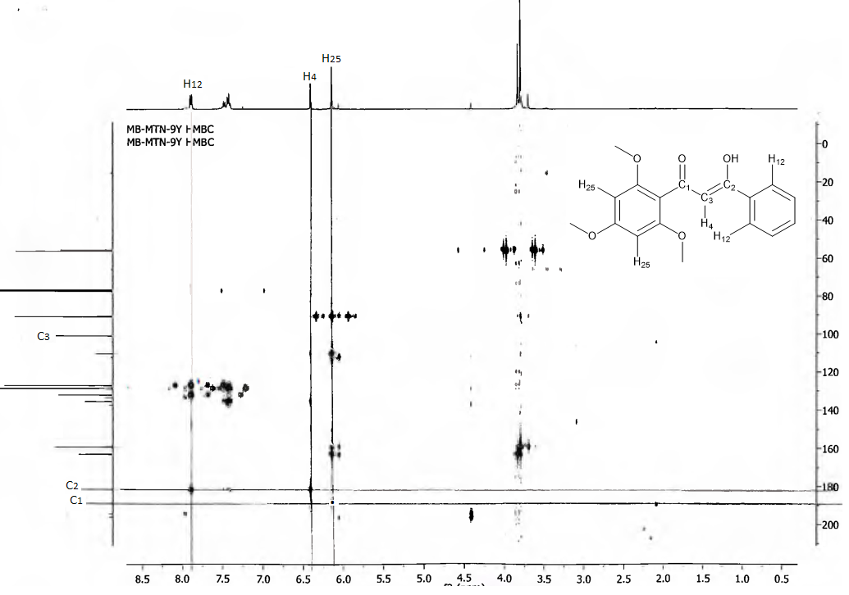
Fig. S44. HMBC spectrum of the compound 1.
Fig. S45. HMBC spectrum of the compound 2.
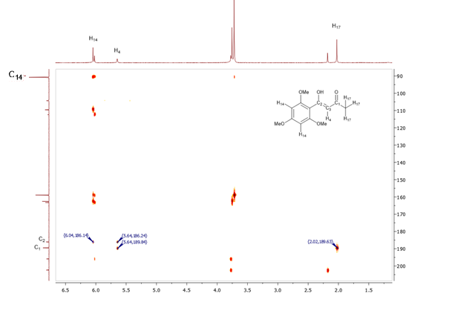
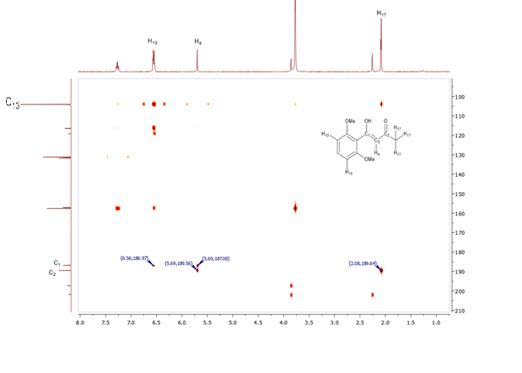
Fig. S46. HMBC spectrum of the compound 3.
Fig. S47. HMBC spectrum of the compound 4.
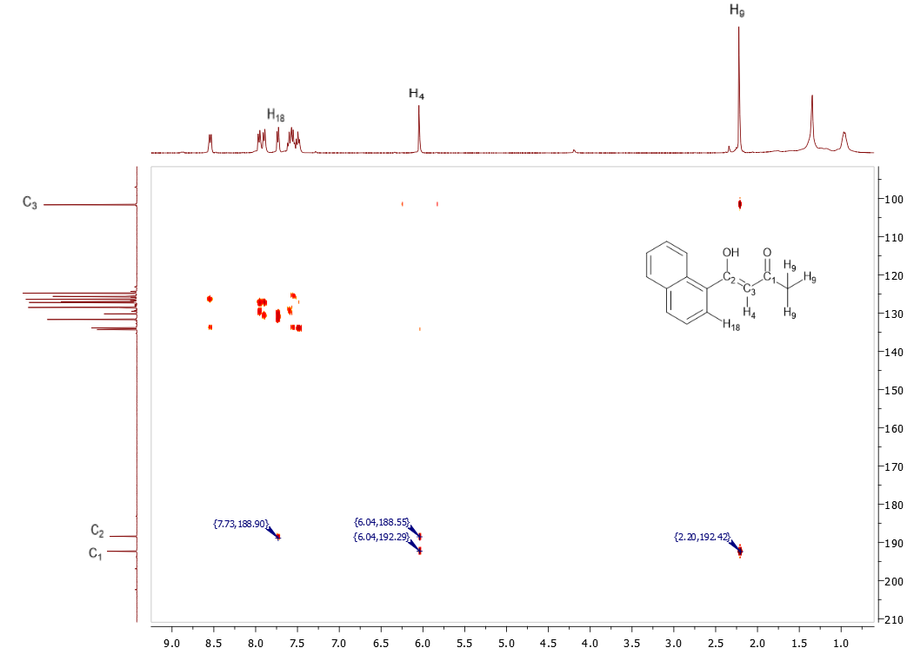
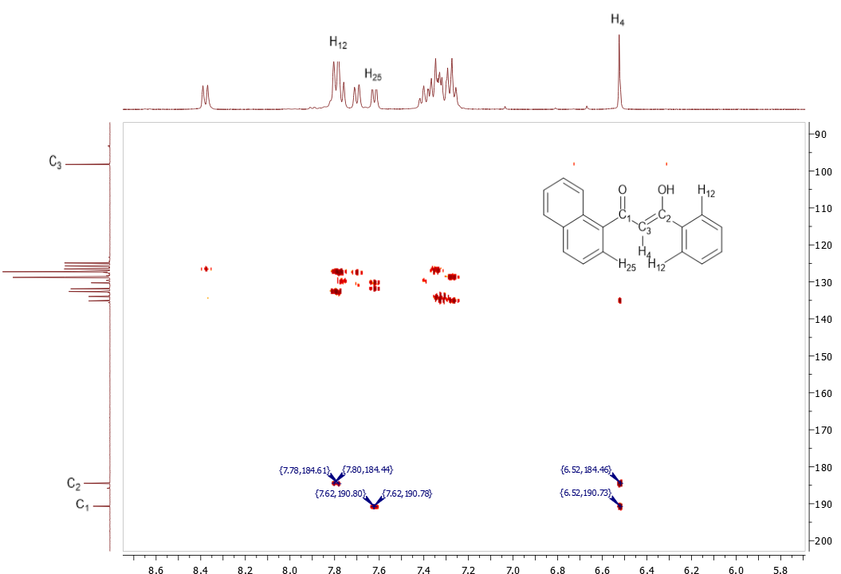
Fig. S48. HMBC spectrum of the compound 6.
Fig. S49. HMBC spectrum of the compound 7.

