RESPONSES FOR REVIEWER #A

We would like to thank you for your comments and criticisms. We appreciate your collaboration concerning our manuscript.

We have carefully revised the manuscript based on your comments and we believe that many improvements have been made.

Answers to your comments are detailed bellow.

EIS analysis
Comment a
a) The equivalent circuit (Fig. 5) that was used to fit the impedance
spectra is obviously not correct. Theoretically, R3||Q3 should be connected
in series with R2, not with Q2. Therefore, the extracted parameters cannot
be regarded valid (Table II and the table in the Supporting Information).
Answer a
We agree with your remark. The R₃||Q₃ should be connected in series with R₂ as follows:
Uncorrected equivalent circuit corrected equivalent circuit

The extracted parameters deduced from this model are presented in the table below (Table 1).

Table 1: Impedance parameters obtained for copper electrode in tin acid solutions without and with TU using R₁(Q₂[R₂(Q₃R₃)]) equivalent circuit.
TU Conc  (M) | R₁  (Ohm cm²) | Y₂  F cm⁻² s^{(a-1)} | α₂ | R₂  (Ohm cm²) | Y₃  F cm⁻² s^{(a-1)} | α₃ | R₃  (Ohm cm²) | χ²
0 | 1.9 | 0.0015 | 1 | 6.68 | 2.81E⁻³ | 0.57 | 64.31 | 6.08
0.01 | 1.25 | 0.11 | 0.57 | 0.6 | 0.85 | 0.5 | 9.39 | 0.13
0.1 | 1.82 | 0.28 | 0.76 | 0.54 | 2.74 | 0.41 | 3.04 | 0.10
1 | 2.56 | 0.044 | 0.62 | 0.35 | 1.02 | 0.82 | 4.9 | 0.69

Furthermore, we have re-fitted our results using 2CPE model consisting of two R||CPE subcircuits connected in series as shown in Figure below.
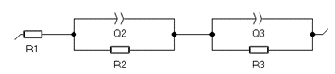
2CPE model used for fitting the experimental impedance data

The extracted parameters deduced from 2CPE model are presented in the table below (Table S1).

Table S1: Impedance parameters obtained for copper electrode in tin acid solutions without and with TU using 2CPE equivalent circuit model.
TU Conc  (M) | R₁  (Ohm cm²) | Y₂  F cm⁻² s^{(a-1)} | α₂ | R₂  (Ohm cm²) | Y₃  F cm⁻² s^{(a-1)} | α₃ | R₃  (Ohm cm²) | χ²
0 | 1.95 | 0.014 | 0.83 | 6.07 | 1.15 | 0.53 | 83.04 | 2.92
0.01 | 1.22 | 0.21 | 0.61 | 0.69 | 1.11 | 0.39 | 7.85 | 0.10
0.1 | 1.89 | 0.009 | 1 | 0.21 | 2.16 | 0.56 | 4.63 | 0.15
1 | 2.58 | 0.022 | 0.70 | 0.41 | 2.51 | 0.59 | 6.25 | 0.40

Although the reliability of the two models are good, the values of the reliability obtained with most concentrations, using 2CPE model is lower than that obtained by R₁(Q₂[R₂(Q₃R₃)]) equivalent circuit. For this raison, we presented in Round 2 revised manuscript the results of 2CPE circuit.
Comment b
b) The adsorption response is normally observed at frequencies that are
lower than those corresponding to charge transfer resistance [A,B]. If the
model in Fig. 5 was appropriate (even after connecting R2 in series with
R3||Q3), this would imply that R2||Q2 relates to charge transfer resistance
(HF) and R3||Q3 to the adsorption effects (LF). However, as I explained
earlier, the LF semicircle is obviously related to Rct, which means that the
proposed circuit is not adequate. I agree that TU adsorption most certainly
affects the HF semicircle, but it does not seem correct to define R2 as
adsorption resistance. Consistently, it is misleading to state in the text
that “the first semicircle at high frequency (HF) could be associated to
the adsorption of electroactive species”. Please revise the discussion.

REFERENCES
[A] Journal of Electroanalytical Chemistry and Interfacial Electrochimistry 39(1)(1972)81-90.
[B] Electrochimica Acta 32(12)(1987)1703-1712.
Answer b
Again we agree with the comment of the reviewer. The statement “the first semicircle at high frequency (HF) could be associated to the adsorption of electroactive species” is not correct. In the round 2 revised manuscript, we corrected this misleading. We presented an adequate circuit using 2CPE equivalent circuit. In this case, the R₂ is defined as a solid electrolyte interface film (SEI).
This statement was included in the Round 2 revised manuscript.

Comment c
The R3 values that are given in the table in the Supporting Information
are completely different from the Rct values presented in Table II, although
the authors claim in the text that R3 = Rct. The paper is not carefully
prepared for submission.
Answer c
Here again we agree with the reviewer. In fact, the main problem was linked to our equivalent circuit. In the Round 2 revised manuscript we have presented quantitative results deduced from 2CPE equivalent circuit. We can easily see that R₃ values (Table II) are very close to Rct values when we use the 2CPE equivalent circuit model.

Comment d
Although the authors presented some parameters in their response to my
Comment 1.f (see table), it is fairly obvious that they did not actually
make an effort to fit the impedance spectra using the 2CPE model. For
instance, the HF and LF semicircles in the Nyquist curves are well separated
for all investigated TU concentrations (as seen in Fig. 4), so similar
values of parameters R2 and R3 should be obtained no matter which of the two
models is applied (the one in Fig. 5 or the 2CPE model). However, the
presented values of these parameters differ greatly (see the table in the
Supporting Information and the table under Answer 1.f). Moreover, the R2
values of 33.1 and 100 Ω cm2 (HF semicircle) that are found for 0 and 0.1 M
TU, respectively, allegedly using the 2CPE model are obviously
overestimated, as easily seen from Fig. 4. Please perform modeling using the
2CPE circuit properly and provide true parameter values.
Answer d
In the Round 2 revised manuscript, we provided new values of the different parameters by re-fit the impedance spectra using the 2CPE equivalent circuit (see Table S1 given above in answer c). The results of the new fitting well indicated that 2CPE equivalent circuit is the most appropriate. After perform fitting, the R₂ values for 0 M and 0.1M were corrected.

Comment e
Circuit parameters obtained for different TU concentrations, and
especially for c(TU) = 0.1 M, are obviously not accurate and correct (Table
in the Supporting Information). For instance, it can be seen from Fig. 4
that the diameter of the HF semicircle for 0.1 M TU amounts to ca. 0.4 Ω
cm2, while it is presented in the table that R2 = 11.02 Ω cm2 for this TU
concentration. Moreover, Fig. 4 clearly shows that the fitted curve poorly
agrees with the experimental points acquired in the TU-free solution (hollow
black squares). In fact, this fitted curve is characterized by three time
constants (three semicircles). How is this possible when the model in Fig. 5
predicts only two semicircles? Please, re-fit the impedance spectra using an
appropriate model (2CPE) and show correct parameter values. I suggest also
that you exclude the last three points obtained at the lowest frequencies
when you fit the Nyquist curve for 0 M TU.
Answer e
We agree with your comment. The re-fit by 2CPE model has given a value of R2 equal to 0.21 Ω cm2 for 0.1M (Table S1). We have also refitted spectra for 0 M after excluding the last three points obtained at lowest frequencies and the results are presented in new Fig .4

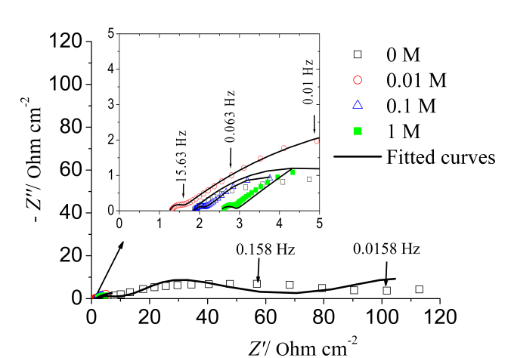

Old Fig. 4 New Fig. 4

Comment f
The correct units for R1, R2 and R3 are “Ω cm2”, not “Ω
cm–2”. Please revise throughout the manuscript and tables within.
Answer f
In Round 2 revised manuscript we have corrected this mistake.

MINOR COMMENTS:
Comment 2a
Page 6:“Comparison between cathodic peak courant density ipc values (Table II)
shows that a higher decrease in ipc after addition of 1 M TU which pointed
out the predominance of inhibition by adsorption TU molecules on active
sites.”
The meaning of this statement is not clear. Please rephrase.
Answer 2a
In the revised manuscript, we rephrased this statement as:
“The comparison between cathodic peak current density values ipc (Table II) shows that the lower value of i_{pc} is obtained at 1 M which indicated that the inhibition effect of TU at this concentration is predominant. This inhibition is probably due to the adsorption of TU molecules on active sites of electrode area”.

Comment 2b
Instead of “courant” should be “current”.
Answer 2b
In the revised manuscript, we have corrected this mistake.

Comment 3
Page 5: Instead of “Nyquist plots (Fig.4) show that” should be “Nyquist plots
(Fig.4)show”.
Answer 3
In revised manuscript, we have corrected this mistake.

Comment 4
Please make a reference in the main text to the table given in the
Supporting Information (containing circuit parameters). Please denote it by
“Table S1”.
Answer 4
In the Round 2 revised manuscript, we have made a reference in the main text to the table given in the Supporting Information. We denoted it by “Table S1”.

Comment 5
Please insert a label “(d)” in Fig. 10d.
Answer 5
In the revised manuscript, we have inserted a label (d) in Fig.10d. The new Fig.10d is presented below.
Fig.10d

