RESPONSES FOR REVIEWER #B

We would like to thank you for your comments and criticisms. We appreciate your collaboration concerning our manuscript.

We have carefully revised the manuscript based on your comments and we believe that many improvements have been made.

Answers to your comments are detailed bellow.

QUESTION 1
Comment 3
Line 90: Are you sure of this? Many references indicate that the shoulder
peak is attributed to direct oxidation of Sn to Sn 4+. Moreover, the
intensity of this peak (involved charge) indicate that the layer of CuSn
should be very thick and, thus, the diffusion of Sn in Cu lattice is easy
even with a low applied potential.
Answer 3
Yes, some references attributed the shoulder to the oxidation of Sn to Sn+4
especially in sulfate baths. However, there is no confirmation about this.
Furthermore, the potential standard of Sn2+/Sn4+ is subject to divergence
[1,2]. Other authors attributed the shoulder to the oxidation of
intermetallic CuSn phases (Cu6Sn5) metallic tin compounds [3,4,5]. Oxidation
potential of Cu6Sn5 should be occurs between those of oxidation potential of
tin metal (∼ -0.45 V) and the oxidation potential of copper metal (-0.1
V). This was verified on CV voltammograms (Oxidation potential of Cu6Sn5 is
∼ -0.2 V). DRX analysis confirms also the formation of Cu6Sn5. For this
consideration, we rather accept that the shoulder corresponds to the
oxidation of Cu6Sn5 than to the direct oxidation of Sn to Sn 4+.
[1] Tama´s Gajda, Pa´l Sipos, Heinz Gamsja¨ger, Monatsh. Chem. 140(2009)1293
http://dx.doi.org/10.1007/s00706-009-0188-5
[2] A. Collazo et al, Surf & Caot. Technol. 280 (2015) 8
http://dx.doi.org/10.1016/j.surfcoat.2015.08.052
[3] E. Rudnik, J. Electroanal. Chem. 726 (2014)
http://dx.doi.org/10.1016/j.jelechem.2014.05.021
[4] C. Meudre, J. Mater. Environ. Sci.7 (2015) 1834 ISSN : 1503-1755
[5] F. C. Walsh, C.T. J. Low, Surf & Coat. Technol. 304 (2016) 246-262
http://dx.doi.org/10.1016/j.surfacoat.2016.06.065
Please, review the references, You have indicate references which make a
electrodeposition of Sn-Cu layers using Cu(II) solution and Sn(II) solution,
not using a metallic copper substrate as in your work, so in these
references a thick layer of metallic compound is obtained and stripping
appear at anodic scan. Please provide a reference to identify the peaks and
revise the discussion of results accordingly.

REPLY 1
We have taken all the time to understand your point of view for this point. Effectively, it seems that XRD results we have obtained cannot be used to attribute the shoulder for the dissolution of copper-tin intermetallic compounds. We have arrived at the same conclusion proposed by some literature which attributed the shoulder to the oxidation of Sn to Sn⁺⁴ [1]. We think that E-pH diagrams also support this explanation. In the Round 2 revised manuscript, we have revised this discussion as follows:

OLD paragraph
The small shoulder following the anodic peak at -0.2 V can be attributed to the dissolution of tin-copper compound³³. The anodic peak current observed at -0.1 V corresponds to the oxidation of copper substrate. Moreover, the hysteresis recorded during the return scan of voltammograms (Fig. 1) is a characteristic of a three-dimensional (3D) nucleation process. The XRD spectra (Fig.2) confirm that the deposits were mainly consisted of tin metal with the presence of Cu₆Sn₅ phase. This later indicated a solid solution formed between tin and copper substrate. The shoulder observed on CV curve most likely corresponds to the dissolution of Cu₆Sn₅.

NEW paragraph
The small shoulder following the anodic peak at -0.2 V can be attributed to the oxidation of Sn to Sn⁴⁺ [1]. The anodic peak current observed at -0.1 V corresponds to the oxidation of copper substrate. Moreover, the hysteresis recorded during the return scan of voltammograms (Fig. 1) is a characteristic of a three-dimensional (3D) nucleation process. The XRD spectra (Fig.2) confirm that the deposits were mainly consisted of tin metal with the presence of Cu₆Sn₅ phase.

[1] H. M. Maltanava, T. N. Vorobyova, O. N. Vrublevskaya, Surf. Coat. Technol. 254 (2014) 388 http://dx.doi.org/10.1016/j.surfcoat.2014.06.04
Remark: The above reference [1] becomes reference [33] in the round 2 revised manuscript.

QUESTION 2
Comment 6
Line 110: In the test is indicated that the interaction of tin-TN making
reference to Figure 3, however it not show the spectra of TU and SO4 without
Sn, since, Tu and SO4 could to show absorbance at different wavelength.
Answer 6
The UV spectrum of TU and SO2-4 compared to that of TU only (Figure below)
does not show significant change upon 250 nm which indicates that changes in
Figure 3 is attributed to the interaction between tin and TU. UV–vis absorption spectra of TU solution in absence (black line) and presence of H2SO4 (red line)
Question a
It is very difficult to identify the attribution of the peaks. You indicated
“The addition of TU shows two new absorption bands at 226 nm and 239 nm
which could be assigned to intermolecular charge-transfer transition in TU
molecule”, however the UV–vis spectra of TU show the same peaks. Please
consider the revision of the peaks attributions.
Question b
How is the UV–vis spectra of H2SO4 without TU and without Sn(II)?
Moreover you indicate ”A further, insight reveals a decreasing in the
shoulder absorbance with TU (as shown in the inset of Fig.3)”
The shoulder was correlated with “ligand-to-metal charge transfer
transition in the [Sn(SO4)2] 2”
If the signal of Sn(SO4)2 disappear, How it can indicate a weak interaction
between tin ions and TU?
Reply 2
a)
Yes, the UV-Vis spectra of TU and SnCl₂+H₂SO₄+TU solutions show two same peaks at about 226 nm and 239 nm. These two peaks could be assigned to π- π* transition in TU molecule [2].
[2] H. Hosoya, J. Tanaka and S. Nagakura, Bulletin of the Chemical Society of Japan, 33 (1960) 850 (https://doi.org/10.1246/bcsj.33.850)
Remark: The above reference [2] becomes reference [34] in the round 2 revised manuscript.

b)
In the Figure below, we presented the UV–vis spectra of H₂SO₄ without TU and without Sn(II). It is characterized by a peak at about 270 nm. After addition of SnCl₂, the absorbance of the peak decreases which probably indicates the complexation between tin and sulfate ions.

UV-vis spectra of different solutions

In fact, the signal of Sn(SO₄)⁻²₂ does not disappear, its absorbance decreases with TU (as shown in the inset of Fig.3. This means that the possibility of coordination between tin ions and TU molecules by a replacement of TU with sulfates ions. We agree with your remark, there is no need to speculate about the degree (strong or weak) of interaction between tin ions and TU molecules.

QUESTION 3
As Reviewer A suggested, you have added the fitting curves to the Nyquist
plot, however, there are large deviation between experimental and fitted
curve for 0M of TU probably due to the use of an inadequate equivalent
circuit. Moreover the EIS fitting parameters χ2 =228 so it is a very bad
fit. Please consider to use other equivalent circuit in this case and review
the obtained result.

Reply 3
We agree with your comment. In Round 2 revised manuscript we used other model defined as 2CPE model which consisting of two R||CPE subcircuits connected in series as:
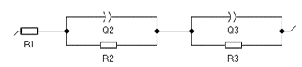
2CPE equivalent circuit model

The re-fit result obtained by using 2CPE model is presented in Table S1. The new Fig.4 obtained after re-fit is presented below.

Table S1: Impedance parameters obtained for copper electrode in tin acid solutions without and with TU using 2CPE equivalent circuit model.
TU Conc  (M) | R₁  (Ohm cm²) | Y₂  F cm⁻² s^{(a-1)} | α₂ | R₂  (Ohm cm²) | Y₃  F cm⁻² s^{(a-1)} | α₃ | R₃  (Ohm cm²) | χ²
0 | 1.95 | 0.014 | 0.83 | 6.07 | 1.15 | 0.53 | 83.04 | 2.92
0.01 | 1.22 | 0.21 | 0.61 | 0.69 | 1.11 | 0.39 | 7.85 | 0.10
0.1 | 1.89 | 0.009 | 1 | 0.21 | 2.16 | 0.56 | 4.63 | 0.15
1 | 2.58 | 0.022 | 0.70 | 0.41 | 2.51 | 0.59 | 6.25 | 0.40

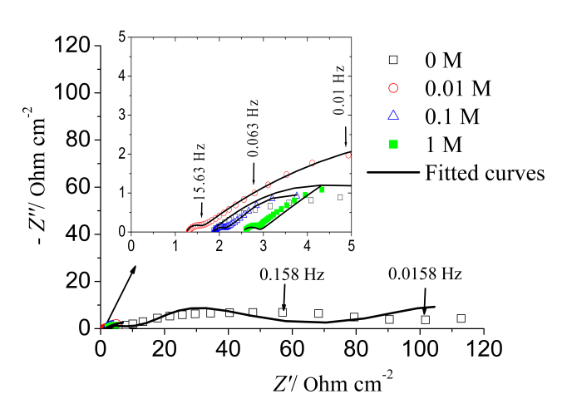

Old Fig.4 New Fig.4

