Electronic Supplementary Information

Morphology dependent photocatalytic efficacy of Zinc Ferrite probed for Methyl Orange degradation
HUAN-YAN XU*, BO LI and PING LI
School of Materials Science and Engineering, Harbin University of Science and Technology, Harbin 150040, P. R. China

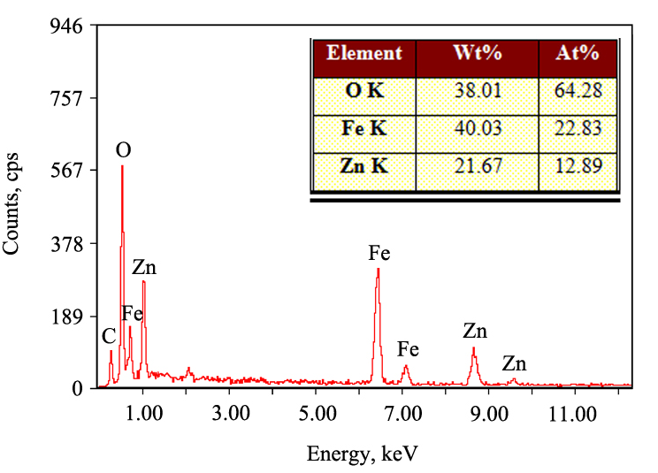
Fig. 1S. EDS pattern of NZFO sample.

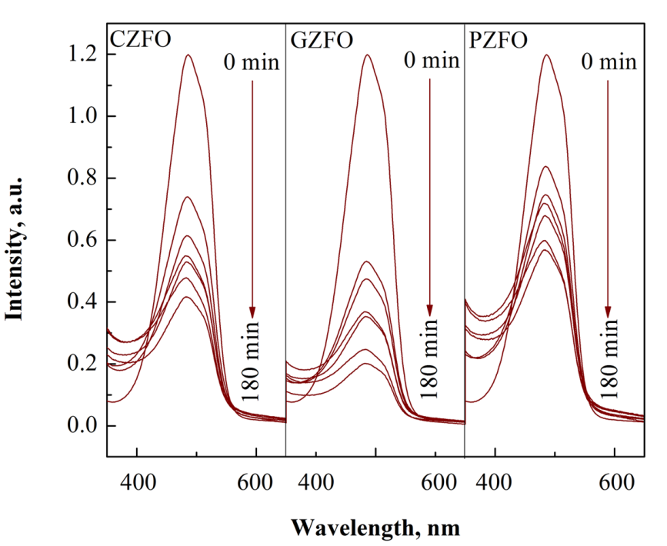
Fig. 2S. UV-Vis absorption spectra of MO solution after different reaction periods over different samples.

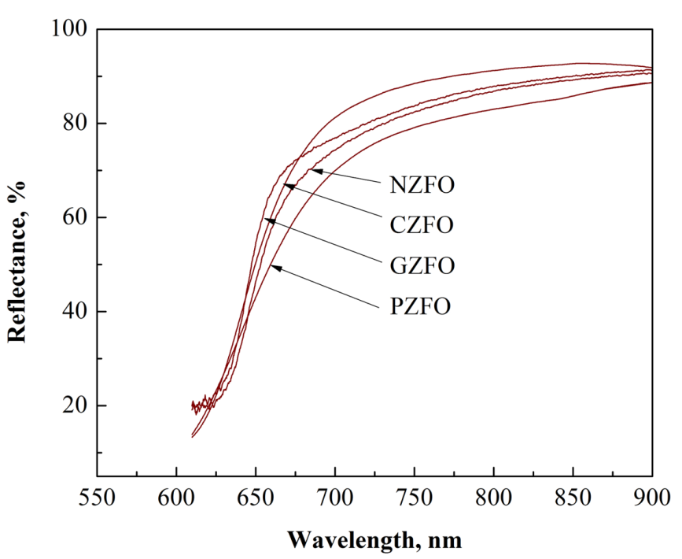
Fig. 3S. UV-vis DRS spectra of the obtained samples.
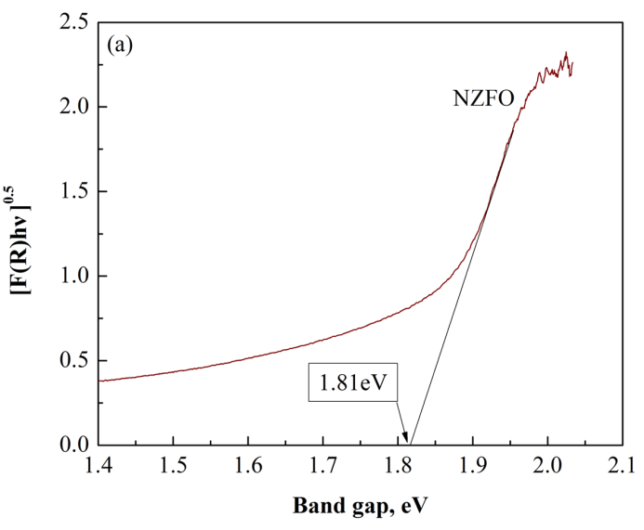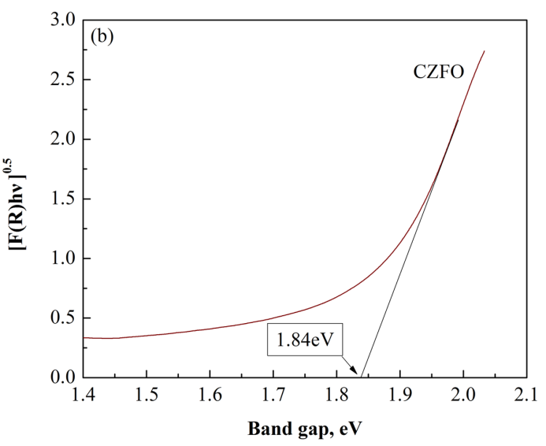
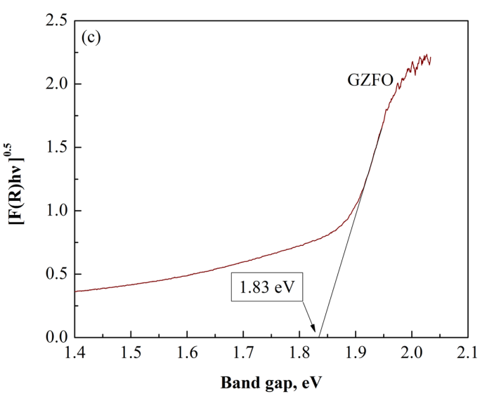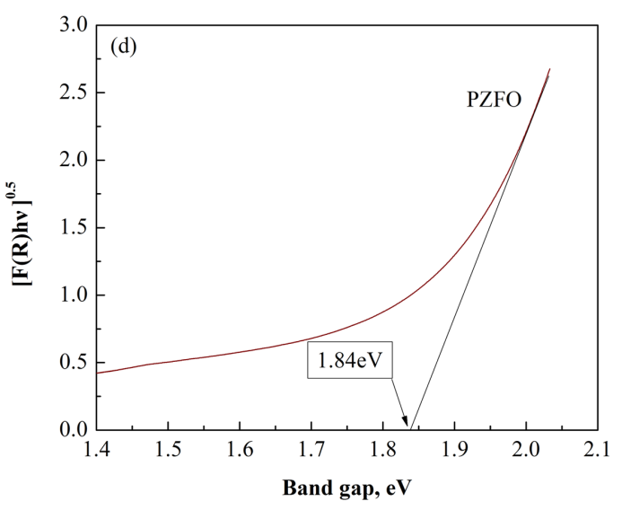
Fig. 4S. The relationships between [F(R)·hυ]^{0.5} and band gap of (a) NZFO, (b) CZFO, (c) GZFO and (d) PZFO.

*Corresponding author. E-mail: xuhuanyan@hrbust.edu.cn

