Response to Reviewers
Tuning the copper cluster´s size on HOPG by electrodeposition from perchlorate aqueous solutions. An AFM study.
DIANA ELIZABETH GARCIA-RODRIGUEZ, CLARA HILDA RIOS REYES, LUIS HUMBERTO MENDOZA HUIZAR*.

Referee comments: First of all, the experimental results shown in Figure 2 are unclear and wrongly interpreted. A set of current transients obtained from aqueous solution 0.01M Cu(ClO4)2 + 0.02 M NaClO4 (pH=5) onto a GCE are done with very bad sensitivity and therefore the maximum in the current transients is not recorded. The strong recommendation is to repeat this experiment with improved sensitivity (sample time/s parameter must be carefully selected and adapted to experimental conditions). In accordance with the new experiments, the results shown in Figure 3 also require new explanations.

Answer:
We thank the referee’s comments, in this sense the transients with the features requested by the referee have been previously reported by our research group. Please, see Figure 3b in D. E. García-Rodríguez, C. H. Mendoza-Huizar, Luis Humberto, Rios-Reyes, M. A. Alatorre-Ordaz, Química, Quim. Nov. 35 (2012) 699–704. From these transients, it is clear that at the potential value of -0.175 V; the maximum of the current density appears at 5 s approx. Here, it is important to mention that it is well known that the overlapping of nuclei is obtained after the maximum. Thus, at t ≤ 5 s, it is possible to synthesize disperse copper clusters. In order to clarify this statement, we have added a new Figure in the manuscript. Now, in Figure 2, of the revised version, is specified the region of the transient in where is possible synthesize disperse copper clusters and the zone where the overlapping of nuclei is expected.
Also, the transients reported in the original Figure 2, were repeated with improved sensitivity. Now each transient was recorded with a sensitivity of 500 points per second. The scale was corrected because by mistake, the previous one was incorrectly labeled. Additionally, it is important highlight that to obtain disperse copper nuclei on the electrode surface, the associated transients must be recorded at t ≤ 5 s, for example, if the transient recorded at -0.175 V is stopped at t > 5 s, the copper clusters will be overlapped onto the HOPG electrode and a thin film of copper instead clusters might be obtained. Therefore, in the present system, it is critical to stop the transients at t ≤ 5 s to obtain disperse copper clusters. Thus, the transients reported in the original Figure 2 (Figure 3 in the revised version), were updated with the transients recorded with a major sensitivity; when we used the equations (1) and (2) to analyze the new transients, see Figure 4 in the revised version, we obtained the same results reported in the original version.

Thus, considering the above mentioned, we have modified the manuscript, now it is possible to read on page 5, line 102.

It is possible to synthesize metallic clusters employing the chronoamperometric technique, however, it is necessary to know the potential value, and the duration of the potential pulse applied on the electrode surface. Here, it is important to mention that from j vs t plots is possible to infer the experimental potential values where is possible to form disperse clusters. In this work, the transients were obtained by applying an initial potential of 0.600 V on the electrode surface. After the application of this initial potential, a step of negative potential was varied on the electrode surface in the range [-0.075 - -0.175] V. In this sense, the formation of a current density maximum in a transient may serve to identify the regions in where it is possible synthesize, either disperse or overlapped clusters. Thus, before this maximum it is possible to synthesize clusters because the nucleation process is separated from the overlapping process.³⁵ In Figure 2, it is reported a chronoamperogram obtained from the HOPG/0.01M Cu(ClO₄)₂ + 0.02 NaClO₄ (pH=5) system at -0.175 v vs. Ag/AgCl for 30 s. Note that this potential value corresponds to the extreme of the potential range analyzed in the present work. This transient is similar to those reported previously for the copper electrodeposition of copper onto HOPG electrodes by our research group.¹⁹ Moreover, in the transients reported in the previous work, is clear that the transients obtained at more negative potentials than -0.175 V, show diffusion limitations which become significant and may alter the getting of disperse clusters. Thus, we selected the potential range in the present work as [-0.075 - -0.175] V to carry out the present study, because in this range it is possible to control adequately the influence of the applied potential involved in the formation of copper clusters. Also, from Figure 2 it is possible to note that the current density maximum is obtained at 5 s, therefore, at this applied potential value the formation of copper clusters should be obtained at t ≤ 5 s, and at t > 5 s is expected the overlapping of the copper clusters.
Figure 2. Chronoamperogram obtained with the potentiostatic technique from the HOPG/0.01M Cu(ClO₄)₂ + 0.02 NaClO₄ (pH=5) system at -0.175 v vs. Ag/AgCl.

Thus, in the present work, in all cases, the potential pulse was finalized at 5 seconds to avoid the overlapping of nuclei (clusters) on the electrode surface, see Figure 3. Transients obtained at the potentials values reported in Figure 3 but at t > 30 s, have already been reported previously by our research group.¹⁹

Also, Figure 3 (Figure 2 in the original version) is reported on page 7, line 138.
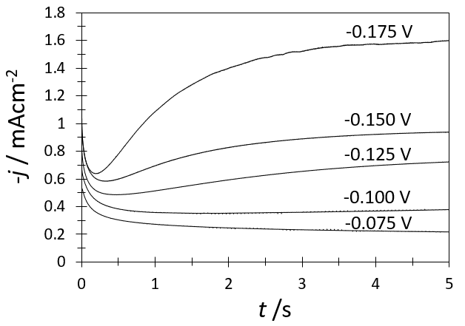
Figure 3. A set of current transients obtained from aqueous solution 0.01M Cu(ClO₄)₂ + 0.02 NaClO₄ (pH=5) onto a HOPG by means of the potential step technique for different potential step values (mV) indicated in the figure. In all the cases, the initial potential was 0.600 V.

and the new non-dimensional curves are reported in Figure 4, page 9, line 165.

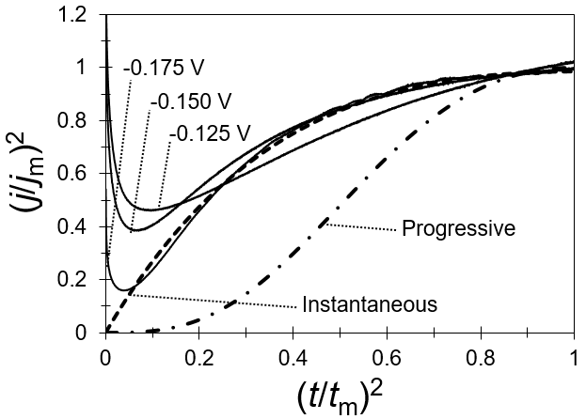
Figure 4. Comparison of experimental transients obtained at different potential values normalized through the coordinates of its respective local maximum (t_{m}, j_{m}), with the theoretical non-dimensional curves corresponding to 3D instantaneous nucleation (Equation 1) and 3D progressive nucleation (Equation 2).

Referee comments: The AFM images shown in Figure 4 are of good quality, however, both on 3D (Surface plot) and 2D (Top View) images, values for the Z axis are not shown.
Answer:
We agree, and we have modified Figure 5 (Figure 4 in the original manuscript), now it is possible to read the values in the xyz axes, page 10, line 185.
Figure 5. AFM images of the copper clusters electrodeposited on HOPG electrode at a) -0.100 V, b) -0.125 V, c) -0.150 V and d) -0.175 V from a plating bath containing 0.01 M CuClO₄ + 0.02 M NaClO₄ at pH=5.

Referee comments: In order to explain differences in AFM images of the copper clusters electrodeposited on HOPG electrode at different potentials, for all images the RMS parameter would be very useful and should be calculated.
Answer:
We agree with this referee’s comment, and we have calculated the RMS parameter in each Figure reported in Figure 5 and 7
For Figure 5 where the area analyzed is 3x3 μm², it is possible to read on page 11, line 191:
……………… Also, the roughness of HOPG substrate in an area of 3.0 × 3.0 μm², covered with copper clusters, was measured; resulting 0.35, 0.39, 0.51, 0.83 and 0.89 nm for the deposits obtained at -0.075, -0.100, -0.125, -0.150 and -0.175 V, respectively. Note that the roughness becomes higher as the number of nuclei or clusters increases due to the changes on the surface morphology.………………………

while, for Figure 7, where the area analyzed is 1x1 μm², it is possible to read on page 12, line 213:

………………The RMS associated with these electrodeposits were 0.35, 0.31, 0.27, 0.35, and 0.45 nm.…………………………….

Referee comments: In order to analyze the copper cluster’s size distribution obtained at each potential, authors measured the clusters’ size from the AFM images. Whether the clusters were randomly chosen from the recorded areas or all the observed clusters were taken into account? The authors should indicate how many clusters are measured in each image. It would be very useful to present distribution of cluster’s size as function of number of clusters (N/Ntotal) with clusters size (d(nm)).

Answer:
We agree with this referee’s comment; in each case all the observed clusters are taken into account during the analysis of the AFM images. Also the histogram that shows the distribution of clusters vs height is reported in Figure 6.

Now, it is possible to read on page 13, line 227:
…………From Figure 7, the number of clusters obtained for -0.075, -0.100, -0.125, -0.150, and -0.175 V were 62, 84, 135, 167, and 248 per μm², respectively. It is clear that the population of nuclei is increased when the applied potential is more negative than -0.075 V. Also, observe that this increment follows an exponential tendency with the applied potential, see Figure 8, which may be represented by the following equation.

Referee comments: Figure 5. shows 2D and 3D AFM images of copper clusters obtained at the chosen potentials, not average cluster’s sizes and therefore must be corrected.

Answer:
We thank the referee’s comments, effectively as pointed by the referee, the original analysis is wrong, we have analyzed the figures following the referee’s recommendations, now the right average cluster’s size is reported.

Now, it is possible to read on page 11, line 189:
In order to determine the average cluster’s size of the copper clusters obtained at each potential; we plotted the distribution of cluster’s size as function of their height employing the WSxM software.³⁹ Also, the roughness of the HOPG substrate in an area of 3.0 × 3.0 μm², covered with copper clusters, was measured; resulting 0.35, 0.39, 0.51, 0.83 and 0.89 nm for the deposits obtained at -0.075, -0.100, -0.125, -0.150 and -0.175 V, respectively. Note that the roughness becomes higher as the number of nuclei or clusters increases due to the changes on the surface morphology. The average cluster’s size at each case was evaluated considering a Gaussian distribution. In Figure 6, it is reported the histogram for the number of copper clusters deposited at -0.100 V and its corresponding Gaussian distribution, for this potential value, the average cluster’s size is 3.3 nm. A similar analysis was carried out for the other cases, and the average size is 3.6, 3.1, 2.4, and 2.3 nm for -0.075, -0.125, -0.150 and -0.175 V, respectively. Also, note in Figure 6, that according to the three-sigma rule, 68% of the cluster’s size is in the range of 2.06-4.63 nm, 95% in the range 0.8-5.91 nm and 99.7% in the range 0-7.20 nm. Thus, copper clusters bigger than 7.2 nm are few and their influence is negligible in the Gaussian distribution.

The representative histogram (Figure 6) is reported on page 11, line 203.
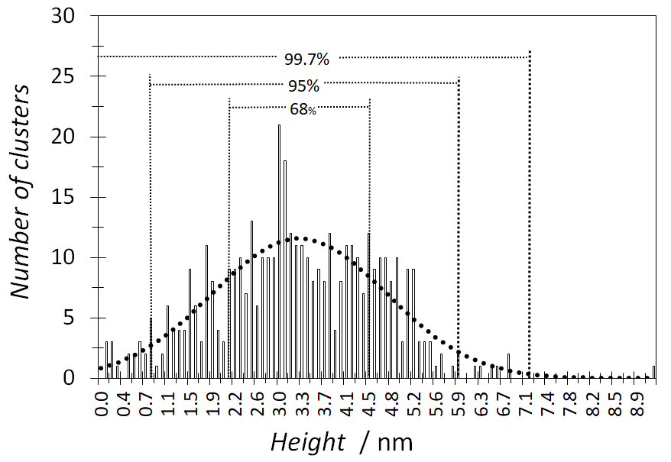
Figure 6. Histogram of the height distribution of copper clusters deposited at -0.100 V potential value and its corresponding Gaussian distribution. Also, height cluster distribution is depicted according to the three-sigma rule.

and the average cluster’s size for the deposits obtained at each potential are reported on page 12, line 207.
Considering the above mentioned, we selected different zones of the AFM images reported in Figure 5, where the copper cluster’s size is into the 95% of the Gaussian distribution, to avoid the influence of the clusters which are not significant in the analysis. In Figure 7, we report these zones, from each image reported in this figure, we carried out a similar analysis to that shown in Figure 6. The results obtained indicates that the average cluster’s size for -0.075, -0.100, -0.125, -0.150 and -0.175 V applied potentials values are 2.84, 2.77, 2.69, 2.65, and 1.98 nm, respectively. The RMS associated with these electrodeposits were 0.35, 0.31, 0.27, 0.35, and 0.45 nm. Also, to determine the diameter of the copper clusters we used the OTSU thresholding method as implemented in the software Gwyddion.⁴⁰ Thus, for -0.075, -0.100, -0.125, -0.150 and -0.175 V the average diameters are 14.3, 13.71, 11.41, 11.05 and 11.02 nm, respectively. These results are indicating that the cluster’s size increases as the applied potential is augmented.

Referee comments: Figure 7. must contain values for X, Y and Z axes.
Answer:
We agree, we have added the value for x, y and z axes in Figure 9, now it is possible to read on page 16, line 264.
Figure 9. Simulation of the distribution of the copper cluster nuclei according to equation (3) at the potential values of -0.075, -0.100, -0.125, -0.150, -0.175, -0.200 and -0.225 V considering a random distribution of the nuclei on the HOPG surface with an area of 1 μm².
Also, two new references were added.

39. I. Horcas, R. Fernández, Rev. Sci. Instrument. 78 (2007) 013705-1 - 013705-8 (https://doi.org/10.1063/1.2432410).
40. D. Nečas, P. Klapetek, Cent. Eur. J. Phys. 10 (2012) 181–188 (https://doi.org/10.2478/s11534-011-0096-2).

*Corresponding author. E-mail: hhuizar@uaeh.edu.mx

