Supplementary material
The impact of coal ash and slag dump on the quality of surface and ground waters – a case study
IVANA ĆIPRANIĆ, RADMILA MARKOVIĆ¹, STEFAN ĐORĐIEVSKI¹, ZORAN STEVANOVIĆ¹, MARIJA STEVANOVIĆ²
University of Montenegro, Faculty of Civil Engineering, Bulevar Džordža Vašingtona bb, 81000 Podgorica, Montenegro
¹Mining and Metallurgy Institute Bor, Zeleni bulevar 35, 19210 Bor, Serbia
² JP EPS, EPS Jagodina, 7. jula 62, 35000 Jagodina, Serbia

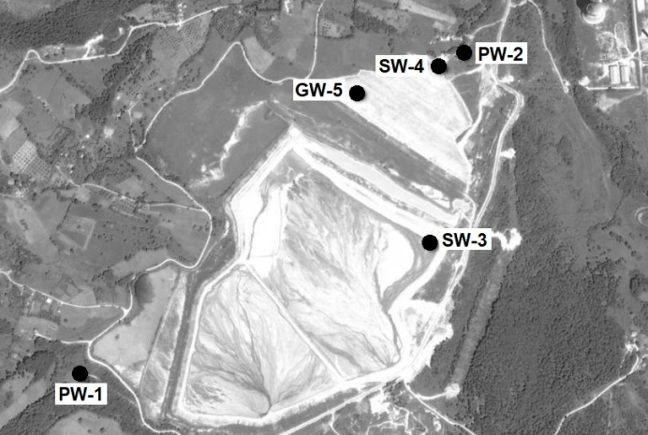
Fig S-1. Map showing sampling points: PW-1 Water sampling from Paleški Creek, upstream of the dump, PW-2 Water sampling from Paleški Creek, downstream of the dump, SW-3 Surface water sampling from the dump, SW-4 Water sampling from the borehole 4 (5 m depth) GW-5 Water sampling from the borehole 5, (21 m depth)

Corresponding author. E-mail: radmila.markovic@irmbor.co.rs

