SUPPLEMENTARY MATERIAL TO

Oxovanadium(IV) complexes of the pyridoxal Schiff bases: Synthesis, experimental and theoretical characterizations, QTAIM analysis and antioxidant activity

PARISA GHORBANI¹, S. ALI BEYRAMABADI^{2,}*, MASOUD HOMAYOUNI-TABRIZI^{3,*}, PARICHEHREH YAGHMAEI¹
¹Department of Biology, Science and Research Branch, Islamic Azad University, Tehran, Iran.
²Department of Chemistry, Mashhad Branch, Islamic Azad University, Mashhad, Iran
³Department of Biology, Mashhad Branch, Islamic Azad University, Mashhad, Iran

Page S2: Figure S1. Optimized geometries of the H₂A and H₂B Schiff bases.

Page S3: Figure S2. QTAIM molecular graph of the H₂A and H₂B Schiff bases. Small green spheres and lines correspond to the bond critical points (BCP) and the bond paths, respectively.

Page S4: Table S1. Selected experimental and theoretical IR vibrational frequencies (cm⁻¹) and their computed intensity (km.mol⁻¹) for the [VO(A)] and [VO(B)] complexes.

Page S6: Table S2. The DPPH and ABTS radicals scavenging activities (%) of the [VO(A)] and [VO(B)] complexes together with the BHA.

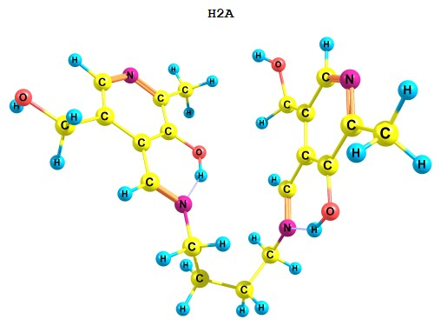
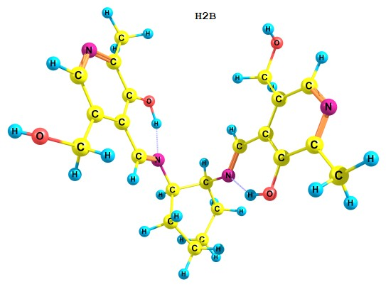
Figure S1. Optimized geometries of the H₂A and H₂B Schiff bases.

Figure S2. QTAIM molecular graph of the H₂A and H₂B Schiff bases. Small green spheres and lines correspond to the bond critical points (BCP) and the bond paths, respectively.

Table S1. Selected experimental and theoretical IR vibrational frequencies (cm⁻¹) and their computed intensity (km.mol⁻¹) for the [VO(A)] and [VO(B)] complexes.
[VO(A)] |  |  | [VO(B)] |  |  | Vibrational assignment
Exp. | Theo. |  | Exp. | Theo.
 | Frequency | IR Intensity |  | Frequency | IR Intensity
542 (w) | 511 | 39 | 556 (w) | 539 | 61 | υ_{asym}(N2-V-N4)
646 (w) | 601 | 88 | 616 (m) | 621 | 7 | υ_{asym}(O1-V-O2)
 | 619 | 18 |  | 637 | 11 | υ_{sym}(O1-V-O2)+ υ_{sym}(N2-V-N4)
745 (w) | 727 | 51 | 759 (w) | 739 | 39 | Breathing of the pyridine ring
974 (m) | 979 | 88 | 970 (m) | 977 | 92 | υ_{sym}(C5-C16-O4, C11-C13-O3)
1023 (m) | 1006 | 19 | 1058 (vs) | 1005 | 35 | υ(C17-N2, C19-N4)
 | 1013 | 106 |  | 1021 | 170 | υ(V-O5)
 | 1031 | 108 |  | 1033 | 118 | υ(C16-O4, C13-O3)
 | 1075 | 27 |  | 1072 | 42 | υ_{asym}(C5-C16-O4, C11-C13-O3)
 | - | - |  | 1063 | 23 | υ(C-C) cyclohexane ring
1189 (m) | 1176, 1152 | 128, 142 | 1133 (s,sh) | 1175 | 183 | υ(C=C, C=N) of the pyridine ring
1265 (m) | 1242 | 57 |  | 1240 | 64 | δ_{ip}(H1, H4) pyridine ring
 | 1294 | 172 | 1324 (m) | 1300 | 180 | υ(py-C)
 | 1329 | 28 |  | 1323 | 42 | δ_{wag}(CH₂) cyclohexane ring
1390 (vs) | 1353 | 49 |  | 1353 | 67 | δ(CH₃) Methyl
 | 1400, 1383 | 118, 323 | 1386 (s) | 1400, 1388, 1378 | 103, 149, 246 | υ(C1-O1, C7-O2)
 | - | - |  | 1438 | 11 | δ_{sci}(CH₂) cyclohexane ring
1512 (s) | 1449 | 93 |  | - | - | δ_{sci}(CH₂) butane bridge
 | 1551-1489 | 10-86 | 1545 (m) | 1552-1490 | 19-108 | υ(C=C, C=N) of the pyridine rings
1609 (s) | 1578 | 500 | 1633 (s) | 1586 | 585 | υ(C10-N4)
 | 1595 | 260 |  | 1601 | 250 | υ(C6-N2)
2856 (m) | 2847 | 49 | 2851 (m,br) | 2844 | 58 | υ_{sym}(CH₂) of –CH₂OH
 | 2868 | 34 |  | 2867 | 35 | υ_{asym}(CH₂) of –CH₂OH
 | - | - |  | 2906-2894 | 38-18 | υ_{sym}(CH₂) cyclohexane ring
2925 (s) | 2893 | 13 |  | - | - | υ_{sym}(CH₂) butane bridge
 | 2917 | 14 | 2938 (vs,br) | 2914 | 19 | υ_{sym}(CH) methyl
 | - | - |  | 2953-2946 | 42-54 | υ_{asym}(CH₂) cyclohexane ring
 | 2958-2933 | 21-48 |  | - | - | υ_{asym}(CH₂) butane bridge
3163 (s,br) | 2966 |  |  | 3009 | 20 | υ(C6-H2, C10-H3)
 | 3014, 2961 | 15, 14 |  | 3015, 2961 | 15, 18 | υ_{asym}(CH) methyl
3468 (s) | 3089 | 2 | 3416 (s) | 3090 | 2 | υ(C4-H1, C12-H4) aromatic
 | 3708 | 64 |  | 3709 | 60 | υ(O-H) of –CH₂OH
Abbreviation: wag, wagging; sci, scissoring; sym, symmetric; asym, asymmetric; ip, in-plane; w, weak; m, medium; s, strong; vs, very strong; sh, shoulder; br, broad.

Table S2. The DPPH and ABTS radicals scavenging activities (%) of the [VO(A)] and [VO(B)] complexes together with the BHA.
Concentration (µg/mL) | 62.5 | 125 | 250 | 500
DPPH radical
BHA | 76.0 | 81.4 | 85.9 | 95.3
[VO(A)] | 76.0 | 82.2 | 87.7 | 93.8
[VO(B)] | 81.9 | 88.1 | 95.7 | 97.5
ABTS radical
BHA | 81.7 | 96.1 | 93.2 | 96.1
[VO(A)] | 85.0 | 87.2 | 94.3 | 97.0
[VO(B)] | 87.9 | 92.1 | 95.5 | 97.8

