Supplementary Materials

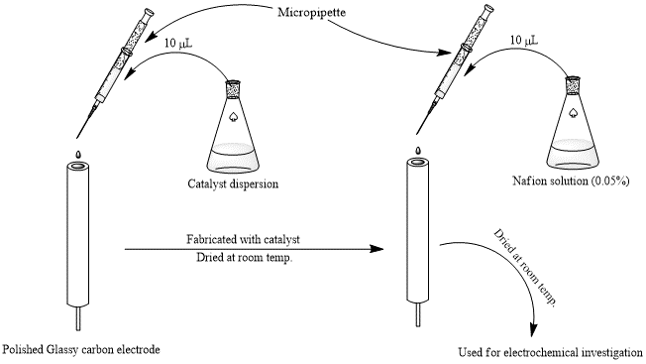
Figure S1. Schematic diagram showing fabrication of GCE by drop cast method

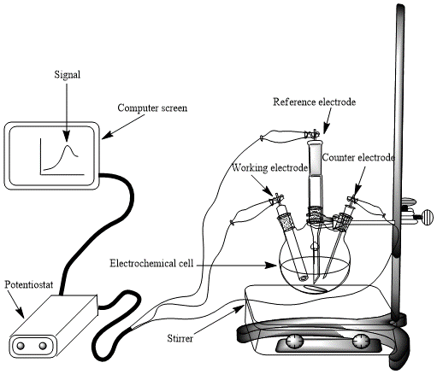
Figure S2. Experimental setup for electrochemical investigations.

Figure S3. EDS spectrum of the commercial Pt/C (ETEK) catalyst

Figure S4 Cyclic voltammogram of platinum-based electrode showing different regions
Figure S5. CV scan considered for the ECSA determination of Pt nano particles. Inset shows integrated area for hydrogen adsorption charge.
Figure S6. Comparison of cyclic voltammograms of Pt-Cu catalyst VS Pt/C (E-TEK) catalyst. CV scans taken in 0.5 M H₂SO₄ at 50 mV.s⁻¹

Figure S7. Forward scans of cyclic voltammograms showing onset potentials of Pt-Cu and Pt/C catalysts

