Supplementary material
Sulfate radicals based degradation of the antraquinone textile dye in a plug flow photoreactor
JELENA MITROVIĆ¹*, MILJANA RADOVIĆ VUČIĆ¹, MILOŠ KOSTIĆ¹, NENA VELINOV¹, SLOBODAN NAJDANOVIĆ¹, DANIJELA BOJIĆ¹ and ALEKSANDAR BOJIĆ¹
¹University of Niš, Faculty of Sciences and Mathematics, Višegradska 33, 18 000 Niš, Serbia

TABLE I. General characteristic of RB 19 dye
Properties | Dye
Commercial name | Remazol Brilliant Blue R
C. I. number | 61200
Apparent color | Blue
Purity | ~ 50 %
Molecular weight | 626 g mol⁻¹
Molecular formula | C₂₂H₁₆N₂Na₂O₁₁S₃
Chemical structure
Maximum absorption wavelength | 592 nm
Water solubility | 10 g dm⁻³

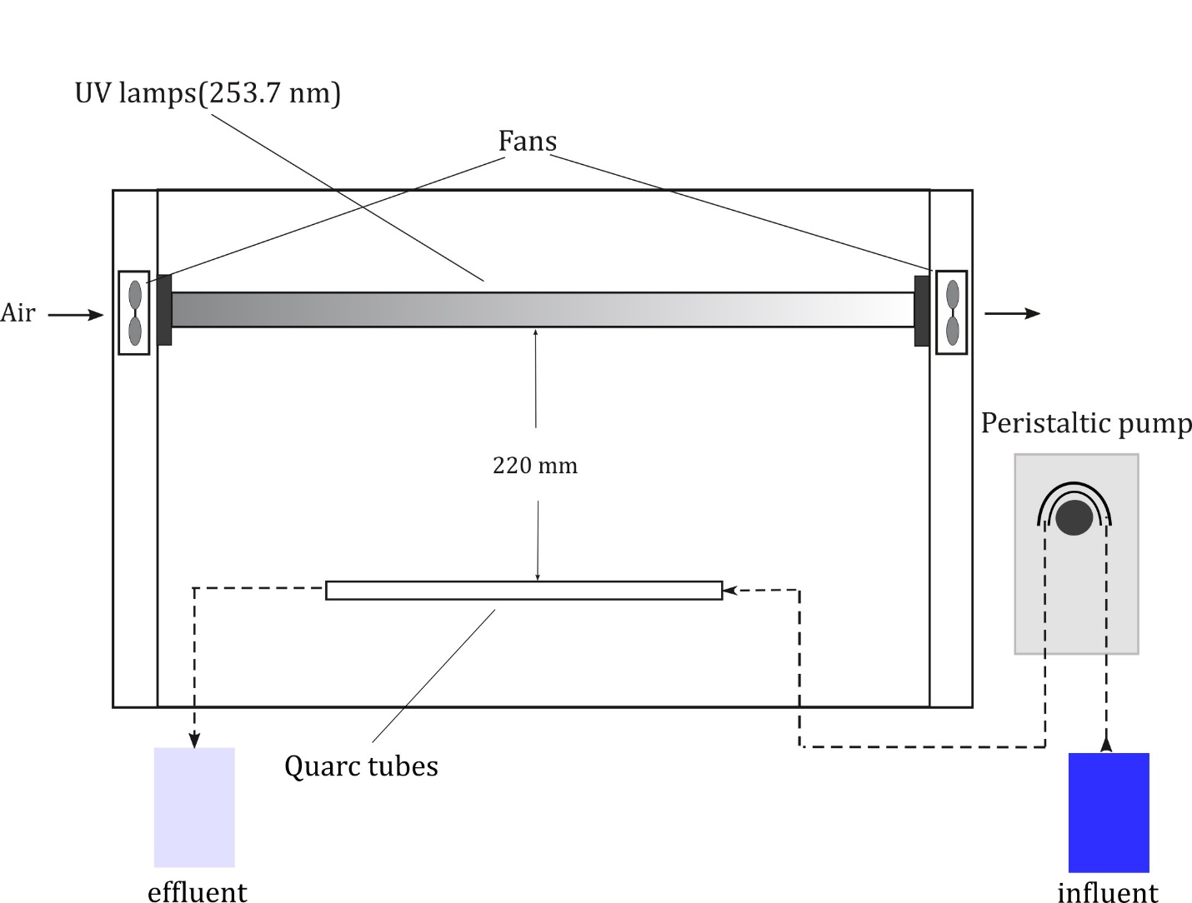
Figure 1. Scheme of irradiation system with plug flow reactor

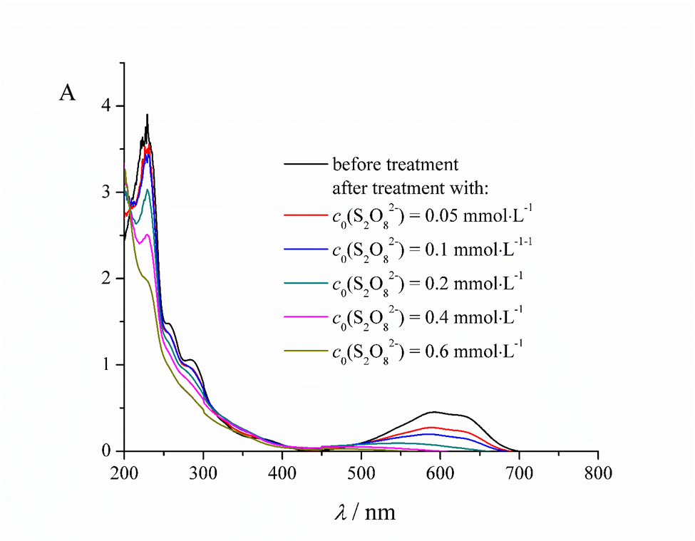
Figure 2. UV/Visible spectral changes during UV/S₂O₈²⁻ treatment of RB 19 dye. c₀(RB 19) = 50 mg∙L⁻¹, initial S₂O₈²⁻ concentration: a) before treatment, and after treatment with: b) 0.05, c) 0.1, d) 0.2, e) 0.4 and f) 0.6 mmol∙L⁻¹, flow rate = 7 mL∙min⁻¹, pH 3.0 ±0.1, UV light intensity = 1950 μW∙cm^{–2}, temperature = 25 ± 0.5 º C

Figure 3. COD changes before and after UV/S₂O₈²⁻ treatment. c₀(RB 19) = 50 mg∙L⁻¹, c₀(S₂O₈²⁻) = 1 mmol∙L⁻¹, flow rate = 1.5 mL∙min⁻¹, pH 3 ± 0.1, UV light intensity = 1950 μW∙cm^{–2}, temperature = 25 ± 0.5 ºC.

Figure 4. The influence of flow rate on RB 19 dye degradation (inset represents changes of k at different flow rates). c₀(RB 19) = 50 mg∙L⁻¹, c₀(S₂O₈²⁻) = 0.1 mmol∙L⁻¹, native pH (3.8 ± 0.1) , UV light intensity = 1950 μW∙cm^{–2}, temperature = 25 ± 0.5 ºC.

Figure 5. The influence of different initial RB 19 concentration on the its degradation (inset represents changes of k at different dye concentrations). c₀(S₂O₈²⁻) = 0.1 mmol∙L⁻¹, flow rate = 7 mL∙min⁻¹, pH native (3.8 ± 0.1), UV light intensity = 1950 μW∙cm^{–2}, temperature = 25 ± 0.5 º C

Figure 6. The influence of different carbonate and bicarbonate anions concentrations on the removal efficiency of RB 19. c₀(RB 19)= 50 mg∙L⁻¹, c₀(S₂O₈²⁻) = 0.1 mmol∙L⁻¹, flow rate = 7 mL∙min⁻¹, pH 8.0±0.1 (for bicarbonate) 12±0.1 (for carbonate), UV light intensity = 1950 μW∙cm^{–2}

Figure 7. The influence of different chloride anions concentrations on the removal efficiency of RB 19. c₀(RB 19) = 50 mg∙L⁻¹, c₀(S₂O₈²⁻) = 0.1 mmol∙L⁻¹, flow rate = 7 mL∙min⁻¹, pH native (3.8 ± 0.1), UV light intensity = 1950 μW∙cm^{–2}

Example of k calculation according to equation 4:
Experimental conditions:
- initial pH value = 3.00 ±0.1
- initial S₂O₈²⁻ concentration = 0.1 mmol∙L⁻¹
- flow rate = 7 mL∙min⁻¹,
- UV light intensity = 1950 μW∙cm^{–2}
- c₀(RB 19) = 50 mg∙L⁻¹ (before treatment)
- c (RB 19) = 1.64 mg∙L⁻¹ (after treatment)
- τ = 22 min
k = 1/22min∙ln50/1.64 = 0.155 min⁻¹

*Corresponding author. E-mail: jelenam81@gmail.com

