SUPPLEMENTARY MATERIAL TO
Chemical and sensory characterization of plum spirits obtained from
CV Čačanska Rodna and its parent cultivars
BRANKO T. POPOVIĆ¹, OLGA V. MITROVIĆ¹, ALEKSANDAR P. LEPOSAVIĆ¹, SVETLANA A. PAUNOVIĆ¹, DARKO R. JEVREMOVIĆ¹, NINOSLAV J. NIKIĆEVIĆ² and VELE V. TEŠEVIĆ³
¹Fruit Research Institute Čačak, Kralja Petra I 9, 32000 Čačak, Serbia
²Faculty of Agriculture University in Belgrade, Nemanjina 6, 11080 Zemun, Serbia
³Faculty of Chemistry University in Belgrade, Studentski trg 12-16, 11000 Beograd, Serbia

CHARACTERISTICS OF PLUM CULTIVARS FOR SPIRIT PRODUCTION
In the production of plum spirits with distinctive aromatic characteristics, old widespread plum cultivars (such as plum cultivars Požegača) have been traditionally used.^{1,2} Depending on the country in which it is grown, cultivar Požegača has various synonyms: Hauszwetschge, Bistrica, Bistriţa, Bystricka, Кюстендилска синя, Wegierka zwyykla, Besztercei, Quetsche and German Prune. In recent years, in some countries and areas, some previously rarely used autochthonous, introduced or newly developed plum cultivars have been used more intensively as a raw material in the production of spirits. The main reasons are: (i) replacement of old cultivars with cultivars that are more resistant or tolerant to plant diseases; (ii) utilization of market surpluses of fruit cultivars, primarily intended for fresh consumption or processing into other products; (iii) satisfying modern consumers' needs for the spirits with specific varietal and regional features. The suitability of less widespread and rarely used plum cultivars for spirit production is usually determined experimentally, based on the content of the volatile compounds and sensory characteristics of distillates obtained.³⁻⁸
Traditional plum spirit production in Serbia includes the processing of plums with stones. Plum stones contain cyanogenic glycoside amygdalin, which is a precursor of toxic HCN and benzaldehyde. Removing of stones (destoning) during processing of plums is the simplest way to decrease the contents of these ingredients in plum spirit.^{9,10} Since benzaldehyde and HCN have a specific bitter almond odour, processing of plums with or without stone may affect the occurrence of differences in sensory characteristics of the spirits produced. Still, whether the spirit obtained from mash with or without stones will be consumer acceptable, it depends on the cultivar. Spirits produced from Požegača fruits with stones always have significantly higher sensory grades than the plum spirits obtained from fruits destoned prior to fermentation.¹¹ On the other hand, Schehl et al.¹⁰ found that the presence or absence of stones during processing of the plum cultivar Ersinger had no significant influence on the assessors’ preference and plum spirit attractiveness, but it was the matter of personal taste of each assessor. Effect of the presence or absence of stones during processing of the Čačanska Rodna and Stanley cultivars on sensory characteristics of plum spirits has not been investigated so far.

EXPERIMENTAL DETAILS

Plum fruits collection and its characteristics
The fruits of the plum cultivars Čačanska Rodna (ČR), Stanley (ST) and Požegača (PO) were harvested at full maturity from the same age trees in an experimental orchard of the Fruit Research Institute Čačak, at site Preljinsko brdo (43°92′41″N, 20°44′75″E) in two consecutive years – 2011 (Year 1) and 2012 (Year 2). All the trees in the orchard were checked every year during June, to control the presence of plum pox virus. The fruits for the experiment were taken exclusively from the healthy trees. About 140 kg of the fruits of each cultivar were picked from six randomly selected trees in a row. Fruit processing was done immediately after harvesting. Only healthy and undamaged fruits were used.
On a randomly selected sample of 30 fruits of each cultivar, basic characteristics of plums (fruit weight, stone ratio, soluble solid content and pH value) were determined (TABLE S-I) according to the standard methods.¹²

TABLE S-I. Basic characteristics of plums for spirit production
Characteristics | Year | Cultivar
 |  | Čačanska  Rodna | Stanley | Požegača
Fruit weight, g | 1 | 35.71 | 39.40 | 20.17
 | 2 | 32.97 | 46.28 | 19.33
Stone ratio, % | 1 | 3.80 | 5.72 | 4.30
 | 2 | 4.78 | 5.15 | 4.53
Soluble solids content, % | 1 | 20.0 | 18.5 | 22.0
 | 2 | 25.1 | 17.8 | 21.0
pH | 1 | 3.60 | 3.56 | 3.86
 | 2 | 3.44 | 3.66 | 3.72

Plum spirits production
For the processing with stones (W), 60 kg of fruit of each cultivar was used. Twenty kilograms of whole plum fruits with stones were placed in three 30 L polyethylene (PE) vessels for alcoholic fermentation (three replications). For the processing without stones (WO), the stone was removed manually from every single fruit. In the majority of the fruits, fruit halves remained together after destoning thus enabling the mashes without stones characteristics similar to the mash with stone. Upon manual removing of stones, 20 kg of fruits were distributed in three 30 L polyethylene (PE) vessels (three replications) for alcoholic fermentation.
Spontaneous alcoholic fermentation of plum mashes was conducted by the indigenous microflora of plum fruits. During alcoholic fermentation in the open vessels, surface layers of mashes were in constant contact with air. Mash temperature during fermentation was 20 ± 2 °C. Each day a reduction of soluble solids content (SSC) was measured in the mash, using 3828 Carl Zeiss manual refractometer. Alcoholic fermentation was considered completed if there was no decrease of soluble solids content in the mash during the two consecutive days. Table S-II shows soluble solids contents in the unfermented and fermented mashes and duration of fermentation.

TABLE S-II. Soluble solid content (mean±standard deviation, %) in unfermented and fermented mashes and the duration of alcohol fermentation (days)
Characteristics | Year | W |  |  |  | WO
 |  | ČR | ST | PO |  | ČR | ST | PO
SSC in unfermented | 1 | 20.0± | 18.5± | 22.0± |  | 20.0± | 18.5± | 22.0±
mash, % |  | 0.0 | 0.0 | 0.0 |  | 0.0 | 0.0 | 0.0
 | 2 | 25.1± | 17.8± | 21.0± |  | 25.1± | 17.8± | 21.0±
 |  | 0.0 | 0.0 | 0.0 |  | 0.0 | 0.0 | 0.0
SSC in fermented | 1 | 10.7± | 9.5± | 10.6± |  | 9.8± | 9.6± | 10.6±
mash, % |  | 0.8 | 0.0 | 0.1 |  | 0.3 | 0.4 | 0.1
 | 2 | 12.8± | 9.1± | 11.4± |  | 13.0± | 10.6± | 11.3±
 |  | 0.2 | 0.4 | 0.7 |  | 0.1 | 0.6 | 0.7
Duration of alcoholic | 1 | 11 | 11 | 11 |  | 9 | 8 | 9
fermentation, days | 2 | 10 | 9 | 11 |  | 10 | 9 | 11
SSC – soluble solid content, W – processing with stones, WO – processing without stones
ČR – Čačanska rodna, ST – Stanley, PO – Požegača

A double distillation, traditionally used in the production of plum spirits in Serbia, was performed. The first distillation - fermented mashes were distilled immediately after completion of alcoholic fermentation. A 25 L copper pilot pot still of traditional construction (alembic) was used for distillation. A gas burner was used for direct heating of the boiler. During the distillation of fermented mash, no fractions were being separated. The ethanol contents in the obtained distillates were 28.0 ± 0.3 % (v/v). The second distillation (redistillation) - distillates containing ethanol 28.0 ± 0.3 % (v/v) were distilled in the same alembic, with three fractions separated: head (1 % of the amounts of the first distillate placed in the pot to redistill), heart (with an ethanol content of 60.0 ± 0.3 % v/v) and tail. For the analysis of volatile compounds and sensory analysis only middle fractions (hearts) were used.
Chemicals and reagents
Chemicals of analytical grade of the manufacturers Merck (Darmstadt, Germany), Sigma-Aldrich (Steinheim, Germany), Fluka (Buchs, Switzerland) and Carl Roth (Karlsruhe, Germany) were used.
GC analysis of volatile compounds
The quantification of the major volatile compounds (methanol, 1-propanol, 1-butanol, 2-butanol, 2-methyl-1-propanol, 2-methyl-1-butanol, 3-methyl-1-butanol, ethyl acetate, ethyl butyrate, ethyl hexanoate, ethyl octanoate, isoamyl acetate, acetaldehyde and benzaldehyde,) has been performed using the headspace method.^{10,13} Briefly, a head space gas chromatograph (model HS 40, GC 8420 Perkin Elmer, Überlingen) equipped with a packed crossbond phenylmethyl-polysiloxane column (Rtx volatiles; 60 m × 0.32 mm i.d. film thickness 1.5 μm, Resteck GmbH, Bad Homburg, Germany), a flame ionisation detector (FID), and a CLASS VP 4.2 integrator (Shimadzu, Duisburg) was used. Setting the headspace injector: the quantity of sample 3 ml; transfer line temperature 90 °C; time of pressure rise 3 min; sample temperature 70 °C; GC cycle time 45 min; retention time 0.5 min; needle temperature 90 °C; thermostat time 30 min; injection time 0.08 min. Temperature program of gas chromatograph oven: 2 min at 60 °C; 2 °C/min to 70 °C; 8 °C/min to 160 °C; 2 min at 160 °C; 4 °C/min to 200 °C; 15 °C/min to 250 °C; 10 min at 250 °C. Injector temperature was 260 °C and detector temperature was 270 °C. Carrier gas was helium (115 kPa). Gases for combustion were hydrogen (100 kPa) and synthetic air (160 kPa). As an internal standard, 2-pentanol was used.
The quantitative analysis of 2-phenylethanol, 1-hexanol, ethyl decanoate, ethyl dodecanoate, ethyl tetradecanoate, ethyl lactate, diethyl succinate, hexanoic acid, octanoic acid and decanoic acid was performed using polar column (HP-INNOWax column (30 m × 0.32 mm i.d., film thickness 0.25 μm, Agilent Technologie) with direct injection gas chromatography.¹³ Briefly, a gas chromatograph Shimazu (model AOC-20, GC 17) equipped with a flame ionisation detector (FID), and a CLASS VP 4.2 integrator (Shimadzu, Duisburg) was used. Temperature program: 2 min at 60 °C; 5 °C/min to 100 °C; 10 °C/min to 250 °C; 10 min at 250 °C. Injector temperature was 260 °C and detector temperature was 280 °C. Carrier gas was helium (50 kPa). Gases for combustion were hydrogen (60 kPa) and the synthetic air (80 kPa). As an internal standard, 2-ethyl butyric acid was used. All samples of the plum spirit were analysed in triplicate.
Sensory analysis
For sensory analysis, ethanol content in middle fractions (hearts) was diluted with deionized water from 60.0±0.3 vol.% to 45.0±0.3 vol.%. Sensory analysis of the produced plum spirits was carried out by 5 members of the expert panel. Panel members are highly experienced (between 10 and 30 years) in the sensory evaluation of fruit spirits.
Statistical analysis
A statistical package program Statistica 7 (StatSoft Inc., Tulsa, OK, USA) was used for statistical analysis. Results of the gas chromatographic analysis and sensory analysis of the spirits were subjected to one-way analysis of variance (ANOVA). Spirits produced in the same manner (with or without stones) from the plums of Čačanska Rodna and its parent cultivars, during the same year, were compared. For plum spirit ingredients or sensory characteristics by which ANOVA showed statistically significant differences, a comparison was performed using Duncan’s test (p ≤ 0.05).
For determining similarities and differences among plum spirits, a cluster analysis was performed as well, using the same statistical package. As results of the cluster analysis, appropriate dendrograms were obtained (Figs. S-1 and S-2). Plots were scaled to a standardized scale D_{link} D_{max}⁻¹ 10² (D – distance, link – linkage, max – maximum of linkage Euclidean distance), and that ratio on the ordinate axis is a quantitative measurement of dissimilarities among plum spirits (expressed in %). Based on the content of volatile compounds, all experimentally produced plum spirits (12 samples) can be grouped into three main clusters (Fig. S-1).

Figure S-1. Dendrogram obtained by the cluster analysis for all 12 plum spirits based on the contents of 24 volatile components
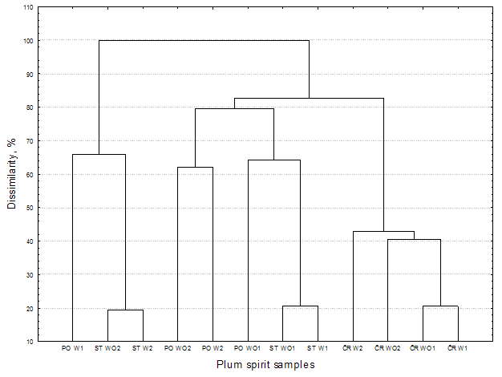
ČR – Čačanska Rodna, ST – Stanley, PO – Požegača; W – processing with stones, WO – processing without stones; 1 – Year 1, 2 – Year 2

The first cluster includes all plum spirits produced from the fruits of the Čačanska Rodna cultivar. Results indicate that, according to the contents of analysed volatile compounds, Čačanska Rodna spirits were different from those produced from parent cultivars. In the third cluster, which contains plum spirits with the highest contents of methanol and ethyl lactate, two subclasters were observed: in the first were ST W2 and ST WO2, and the second subclaster included plum spirit from Požegača (PO W1). Dendrogram based on the cluster analysis of sensory grades of the plum spirits produced (Fig. S-2) differs from the dendrogram based on the content of volatile compounds.

Fig. S-2. Dendrogram obtained by the cluster analysis based on the sensory characteristics of 12 plum spirits
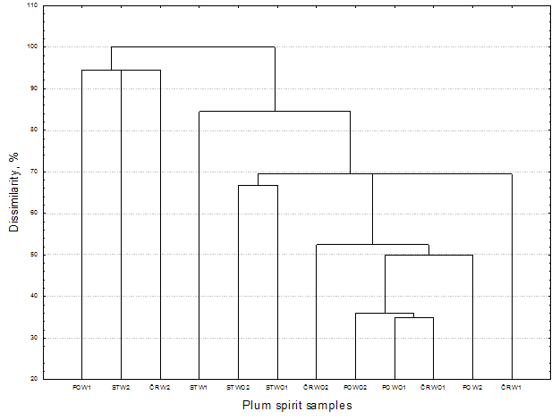
ČR – Čačanska Rodna, ST – Stanley, PO – Požegača; W – processing with stones, WO – processing without stones; 1 – Year 1, 2 – Year 2

The spirit samples are more grouped in clusters based on the processing method (with or without stones) than on the cultivar used for their production. Cluster 1 contained all samples produced without stones, but also the two spirits produced with stones (PO W2 and ČR W1) in which the presence of stones in mashes did not show a negative impact on the sensory characteristics of spirit. All the plum spirits of cluster 1 were distinguished by the pleasant fruity odour; sensory grades in this cluster ranged from 17.33 to 17.88. The spirits in other clusters were characterized with fruity odour, although less pronounced, and partially or strongly masked by the stone-like ton: cluster 2 (ST W1) and cluster 3 (ST W2, ČR W2 and PO W1). Such sensory characteristics are common for plum spirits obtained by spontaneous alcoholic fermentation of mashes with stones. Because of heavy odour, sensory grades of the plum spirits in this group ranged from 16.93 to 17.48.

REFERENCES

1. W. Hartmann, Farbatlas alte obstsorten, Eugen Ulmer, Stuttgart, 2000, p. 32-307
2. J. Ledauphin, C. le Milbeau, D. Barillier, D. Hennequin, J. Agric. Food Chem. 58 (2010) 7782 https://doi.org/10.1021/jf9045667
3. M. Gössinger, H. Sämann, Kleinbrennerei 54 (2002) 7
4. H. Jacob, Acta Hortic. 734 (2007) 347 https://doi.org/10.17660/ActaHortic.2007.734.49
5. B. Popović, N. Nikićević, V. Tešević, O. Mitrović, M. Kandić, N. Milošević, I. S. Glišić, J. Mt. Agric. Balk. 19 (2016) 131
6. P. Satora, M. Kostrz, P. Sroka, T. Tarko, Eur. Food Res. Technol. 243 (2017) 489 https://doi.org/10.1007/s00217-016-2762-5
7. J. Schmidt, G. Scholten, Kleinbrennerei 48 (1996) 150
8. O. Vyviurska, F. Matura, K. Furdikova, I. Španik, J. Food Sci. Technol. 54 (2017) 4284 https://doi.org/10.1007/s13197-017-2900-5
9. M. Ljekočević, Review of Research Work at the Faculty of Agriculture 38 (1993) 119
10. B. Schehl, D. Lachenmeier, T. Senn, J. J. Heinisch, J. Agric. Food Chem. 53 (2005) 8230 https://doi.org/10.1021/jf0511392
11. N. Nikićević, Aromatični sastojci šljive Požegače i šljivove prepečenice proizvedene od istoimene sorte, Poljoprivredni fakultet, Univerzitet u Beogradu, Beograd, 2010, p. 181-285
12. H. Tanner, H. R. Brunner, Getränke-analytik, Verlag Heller, Schwäbisch Hall, 1987, p. 23-38
13. T. Senn, Getränkeindustrie 4 (1998) 220

Corresponding author. E-mail: vtesevic@chem.bg.ac.rs

