SUPPLEMENTARY MATERIAL TO
Expression, purification and characterization of cellobiose dehydrogenase mutants from Phanerochaete chrysosporium in Pichia pastoris KM71H strain
ANA MARIJA J. BALAŽ¹, MARIJA B. BLAŽIĆ¹, NIKOLINA POPOVIĆ², OLIVERA L. PRODANOVIĆ³, RALUCA V. OSTAFE⁴, RAINER FISCHER⁵ and RADIVOJE M. PRODANOVIĆ²*
¹Institute of Chemistry, Technology and Metallurgy, University of Belgrade, Njegoseva 12, 11000 Belgrade, Serbia
²Faculty of Chemistry, University of Belgrade, Studentski trg 12 – 16, 11000 Belgrade, Serbia
³ Institute for Multidisciplinary Studies, University of Belgrade, Kneza Višeslava 1, 11030 Belgrade, Serbia
⁴ Molecular Evolution Protein Engineering and Production facility (MEPEP), Purdue University, 207 S. Martin Jischke Dr., West Lafayette, IN 47907, USA
⁵Indiana Bioscience Research Institute, Single Cell Analytics Center, 1345 W. 16th St. Suite 300, Indianapolis, IN 46202, USA

TABLE S1. Primers used for creation of triple mutant and error prone library mutants using wtCDH – pPICZαA vector as template
Primer name | Primer sequence
Forward primer D20N | GGTATCACCAACCCTGTTCATG
Forward primer A64T | CTCGGTGGCACCATGAACAAC
Forward primer V592M | CGCAGCCTCCATGAACTCC
Forward primer D20N – V22A | CACCAACCCTGCTCATGACG
Forward primer T84A | TTTCCTCCGCTCGCTGG
Forward primer A261P | ACGTATGTCCCTCCATG
Forward primer E674G | AGACACTCGGGGAGTACG
Forward primer N715S | TTGGCACGAGCAACCTGTTT

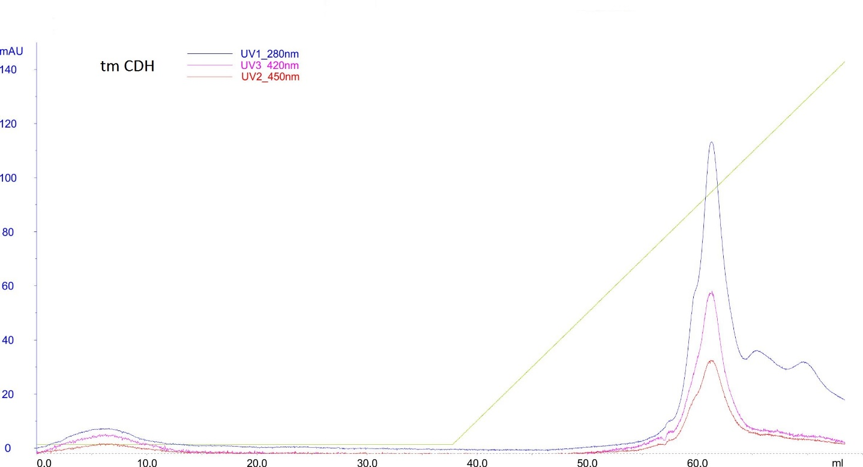
Fig. S1. Ion-exchange chromatography of tm CDH

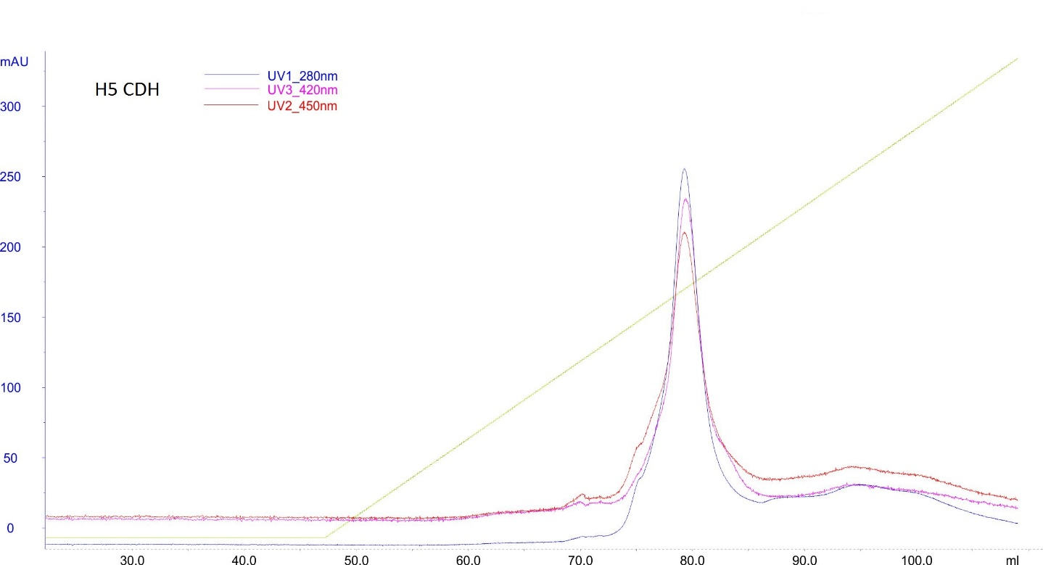
Fig. S2. Ion-exchange chromatography of H5 CDH

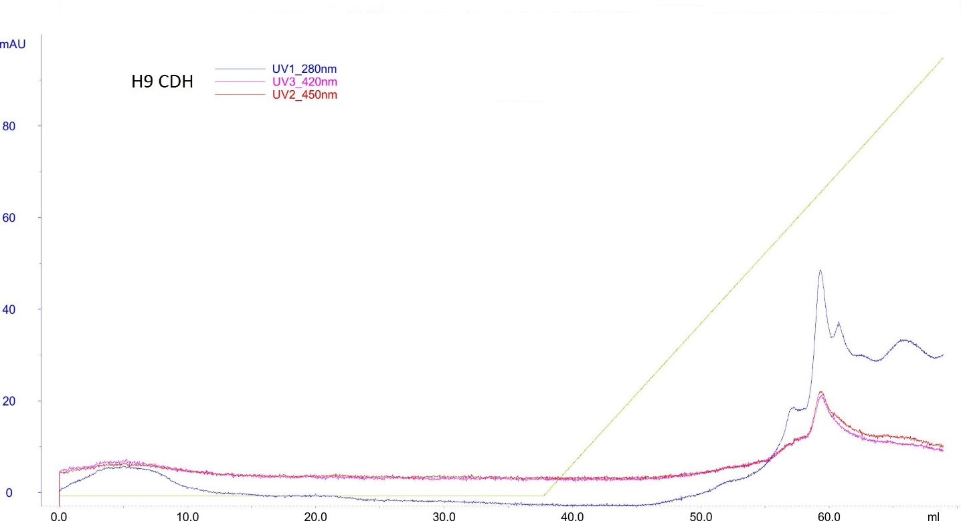
Fig. S3. Ion-exchange chromatography of H9 CDH

Fig. S4. Ion-exchange chromatography of wt CDH

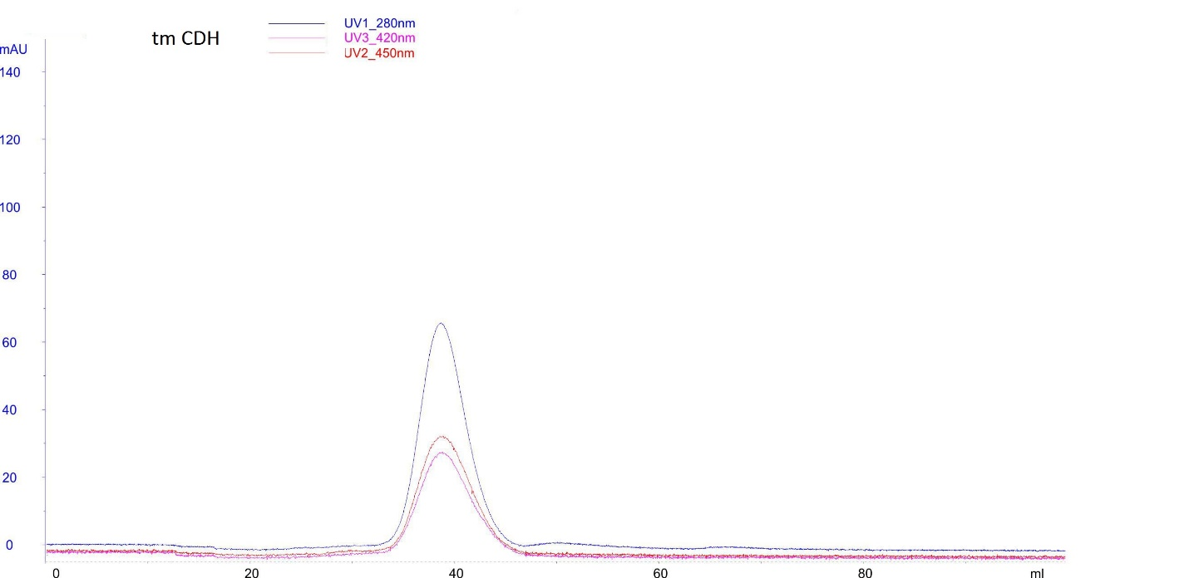
Fig. S5. Gel filtration of tm CDH

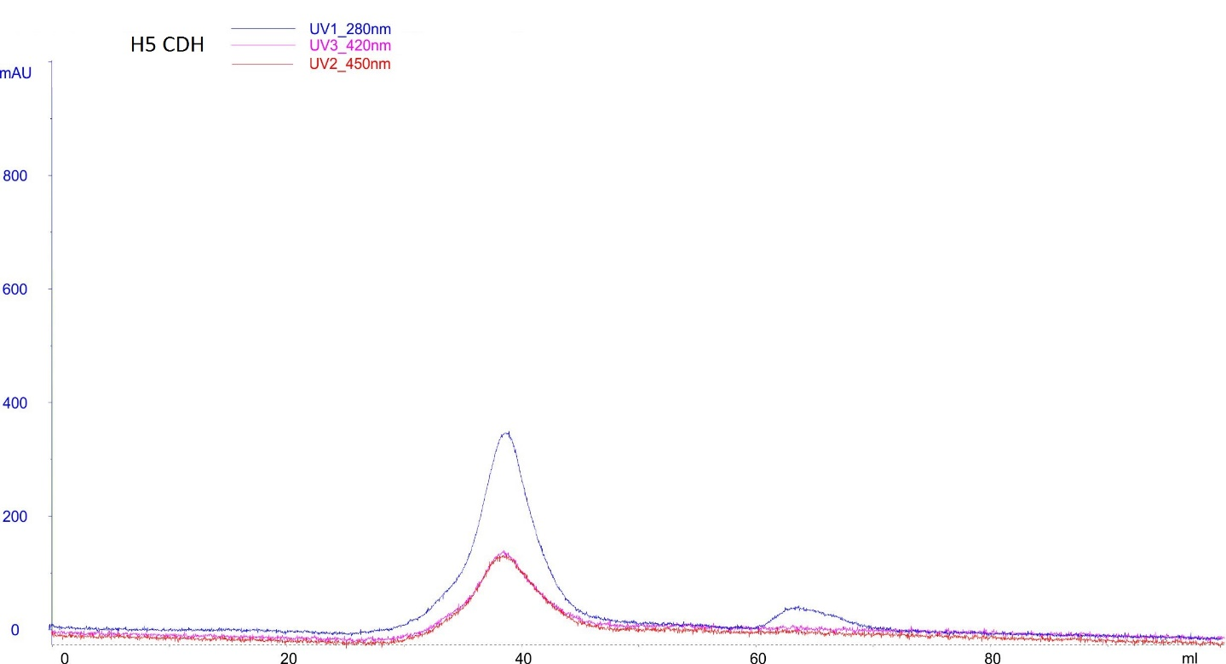
Fig. S6. Gel filtration of H5 CDH

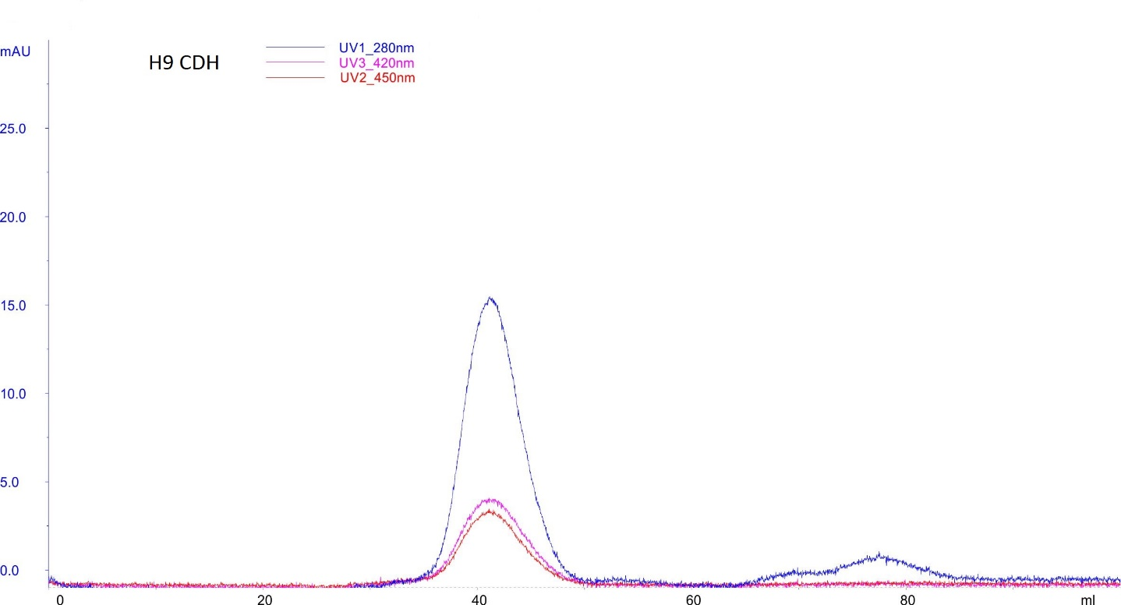
Fig. S7. Gel filtration of H9 CDH

Fig. S8. Gel filtration of wt CDH

TABLE S2 Purification table for CDH. FM-fermentation media, UF-ultrafiltrate, DEAE-sample after ion-exchange chromatography, GF-sample after gel filtration. Cp-protein concentration, Ac-enzyme activity, V-volume, Y-yield of purification, Pf-purification factor, Sp-specific enzyme activity.
 | tm CDH |  |  |  | H5 CDH |  |  |  | H9 CDH |  |  |  | wt CDH
 | FM | UF | DEAE | GF | FM | UF | DEAE | GF | FM | UF | DEAE | GF | FM | UF | DEAE | GF
Cp / mg mL⁻¹ | 0.59 | 0.42 | 0.48 | 0.08 | 0.52 | 0.45 | 0.74 | 0.17 | 0.46 | 0.20 | 0.15 | 0.024 | 0.57 | 0.72 | 0.59 | 0.22
Ac / IU mL⁻¹ | 0.91 | 2.34 | 5.41 | 1.17 | 1.99 | 7.30 | 16.5 | 4.89 | 0.42 | 1.10 | 1.87 | 0.34 | 4.04 | 8.86 | 8.1 | 4.49
V / mL | 50 | 12 | 3 | 7 | 50 | 12 | 3 | 6 | 50 | 12 | 3 | 5 | 50 | 12 | 5 | 6
Y / % | 100 | 62 | 36 | 18 | 100 | 88 | 50 | 29 | 100 | 63 | 27 | 8.2 | 100 | 53 | 20 | 14
Pf | 1 | 3.6 | 7.2 | 9.1 | 1 | 4.2 | 5.8 | 7.3 | 1 | 5.9 | 13 | 16 | 1 | 1.7 | 1.3 | 2.88
Sp / IU mg⁻¹ | 1.55 | 5.55 | 11.2 | 14.1 | 3.83 | 16.2 | 22.4 | 28.1 | 0.92 | 5.44 | 12.2 | 14.5 | 7.1 | 12.3 | 13.7 | 20.4

*Corresponding author. E-mail: rprodano@chem.bg.ac.rs

