**Responses for Referee 1**

1. The approach applied in choosing the process parameters, polymer/drug  
ration, type of polymer matrix is not systematical and it is quite difficult  
to follow. The authors in the optimization conditions changed both  
polymer/drug ratio and organic/water phase ratio for the same Lot, thus  
results can not be properly analyzed (which parameter more affected particle  
size, EE%, etc.). Also, only for one microspheres preparation, CAB as  
polymer matrix was used with no explanation why the authors did not set up  
the condition with this polymer, too.

**Responses:**

**1.a**/The purpose of this study was to optimize and formulate encapsulating microspheres with high encapsulation efficiency and prolonged release using emulsion-solvent evaporation technique. To achieve the desired goal, different parameters were investigated such as; polymer/solvent ratio, matrix type, stirring speed and the number of blades.

* In the optimization of the encapsulation parameters, we have changed **polymer /solvent** **ratio** and not **polymer/drug ratio** as mentioned by the reviewer comment.

Indeed, microspheres loaded with 2-ABZT were formulated **under the same process conditions** **for the same Lot** by changing **only the polymer /solvent** **ratio** while the other parameters such as: **organic/water phase ratio**, stirring speed and surfactant concentration were **kept constant** (Table I in the results and discussion section). So, the obtained results can be properly analyzed : the effect of polymer /solvent ratio parameter on particle size, surface morphology of microspheres, EE% and release rate was studied.

Moreover, the obtained results proved the effect of polymer:solvent ratio on particle  
size, EE% and especially on the surface morphology and the mean diameter of the prepared microsphere. This is directly related to the organic phase viscosity caused by the higher ethylcellulose polymer concentration.

The effect of polymer:solvent ratio is better explained in the following paragraph selected from the Results and discussion section *(Scanning Electron Microscopy (SEM) and particle size results ,* pages 5 and 6 of the article) with mentioning some previous studies references.

**In addition, the approach applied in choosing the process parameters is explained in detail by the following method:**

* **Experimental process conditions of microencapsulation:**

1. **a/ polymer/solvent ratio parameter**

In order to optimize the microencapsulation parameters, three different formulations of microspheres were studied by using different polymer/solvent ratios (%EC/DCM) 3.12%, 4.68% and 6.25%).

The studied formulations :

• polymer/solvent ratio : 3.12% (**Lot1, MS1**)

• polymer/solvent ratio : 4.68% (**Lot 2, MS2**)

• polymer/solvent ratio : 6.25% (**Lot 3, MS3**)

For these experiments the organic and the water phases were prepared as following:

* **Recipe for the organic phase:**

Weighed amounts of ethylcellulose EC (different polymer/solvent ratios were 3.12%, 4.68% and 6.25%) were dissolved in 32 g of dichloromethane, then, the amount of 2-ABZT (0.5 g) was added in this solution.

* **Recipe for the continuous phase (water phase):**

• Emulsifier concentration: 1% Tween 80.

• Volume of the continuous phase: 100 mL.

* The water solution recipe was kept constant during these experiments.

• Organic/water phase ratio for all the prepared formulations: 50 mL / 100 mL = 0.5

This emulsion was regularly agitated using four-bladed turbine impellers with a constant stirring speed at 600 rpm for 3h to harden the oil droplets. The Table I in the results and discussion section lists the different process condition.

* **Example of preparation of microspheres MS1 (Lot1)**

**Preparation conditions:** **Lot 1**, **for the organic phase**: polymer/solvent ratio = 3.12%, (%Pol./DCM in Table 1), drug : polymer ratio of 1:2; **for the water phase:** V = 100 mL of Tween 80 solution (1%) and stirring speed of 600 rpm.

Under the same operative conditions, the parameter polymer:solvent ratio was studied by varying the amount of the polymer ethylcellulose in a fixed mass of dichloromethane 32g (which means the ethylcellulose concentration in the organic phase ).

This organic phase was dispersed into 100 mL of Tween 80 solution (concentrations of 1 % (Table I).

So, in this study, we have changed the parameter **polymer:solvent ratio** and there is no change about the organic/water phase ratio. Thereby, for the same lot of microspheres and under the same operative conditions, we have studied only one parameter **the polymer:solvent ratio**, which affect strongly the microspheres properties. This observation is in agreement with the literature.

TABLE I. Experimental process conditions and encapsulation results of the prepared

microspheres; DL–Drug Loading; EE –Encapsulation Efficiency.

|  |  |  |  |  |  |  |  |  |  |
| --- | --- | --- | --- | --- | --- | --- | --- | --- | --- |
| Lot | Matrix | Pol./DCM, | 2-ABZT:Pol. | Speed, | DL / % | | EE/ % | d32 /μm | *δa* |
|  |  | % | ratio | rpm | Theoretical | Actual |  |  |  |
| MS1 | EC | 3.12 | 1:2 | 600 | 33.33 | 24 | 73 | 166±1.54 | 1.22±0.19 |
| MS2 | EC | 4.68 | 1:3 | 600 | 25.00 | 20 | 79 | 189±1.81 | 1.30±0.32 |
| MS3 | EC | 6.25 | 1:4 | 600 | 20.00 | 18 | 89 | 278±2.77 | 1.26±0.28 |
| MS4 | CAB | 3.12 | 1:2 | 600 | 33.33 | 27 | 82 | 113±0.98 | 1.19±0.12 |
| MS5 | EC | 3.12 | 1:2 | 600 | 33.33 | 28 | 84 | 181±2.33 | 1.34±0.25 |
| MS6 | EC | 3.12 | 1:2 | 1200 | 33.33 | 18 | 53 | 61±0.48 | 1.10±0.08 |

*δa*: The size distribution; MS4 : Formulation prepared using CAB as polymer matrix

with the ratio 1:2 of 2-ABZT:Pol.**;** MS5: Formulation prepared with 4 blades, all the

other formulations were prepared with 6 blades.

**1.b/** Also, only for one microspheres preparation, CAB as  
polymer matrix was used with no explanation why the authors did not set up  
the condition with this polymer, too.

**Response:**

Conditions of CAB microspheres were given under the Table 1 (See the Table 1).

To study the effect of the nature of the polymer matrix on the microspheres characteristics, CAB microspheres MS4 were prepared under the same process conditions of the EC microspheres MS1, smaller than the EC microspheres. (polymer /solvent ratio (%Pol./DCM)*,* blade number and stirring speed)

**Preparation of CAB microspheres (Lot MS4) :**

**Operative conditions**

Matrix polymer: CAB

%Pol./DCM = 3.12% ; 2-ABZT:EC ratio = 1:2

Stirring speed : 600 rpm

Water phase: 100 mL of Tween 80 solution 1%

**2/ The Chemical structures of the drug and the polymer matrices:**

 

2-Aminobenzothiazole (2-ABZT). Ethylcellulose (EC).



Cellulose acetate butyrate (CAB).

**Scheme 1**: Chemical structures of 2-Aminobenzothiazole and cellulose derivatives.

-The chemical structure of the drug was added in the article (in the end of the introduction, page 3).

**3/ Reorganization applied in the text (see the text in red color in the part RESULTS AND DISCUSSION).**

**4/ The text of** *Infrared Spectroscopy* **was corrected:**

Therefore, the FT-IR analysis proved the presence of 2-ABZT in microspheres without any new bands appeared and thereby, any chemical interaction between the drug and polymers.

**5/ The test of the XRD was corrected:**

The XRD diffraction technique was utilized to analyze the crystal structure of the entrapped drug in the microspheres.

**6/ Recommendations and remarks applied for the Table 1 (See the Table 1 given above).**

**7/ Figure 4 and not Figure 7 : the trace of graph a and graph b is done in the research article. The graph b which has showed the drug release in the starting 150 min (short time) is also done:**

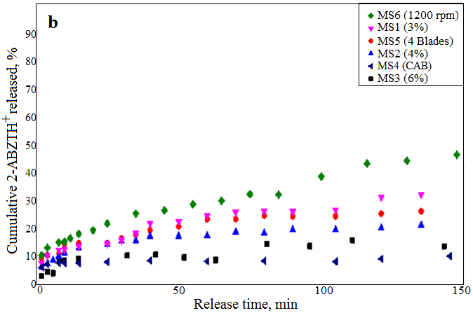

Fig. 4. Release profiles of 2-ABZTH+ from microspheres MS1-MS6 in pH 1.2 at 37°C (graph b).