DETAILED TABLES, SAMPLE TEACHING DESIGNS AND QUESTIONS

TABLE S-I. Students’ alternative conceptions of the “gases and gas laws” subject
 | Alternative Conceptions | Studies
 | - While gas molecules are combining, denser gas or gas with more molecules presses the other gas molecules and throws it out. | 9
 | - When some oxygen gas molecules are released from an oxygen gas container, the oxygen molecules in the container move top of the container.
 | - If oxygen and nitrogen gases fill in a container, oxygen gas descends, and nitrogen gas ascends. I do not think the gases will mix with each other.
 | - Gas molecules at the edges of a flask are more compressed. | 7, 10
 | - Gases cannot be compressed. They move the top of the container in the form of droplets.
 | - Heating rises gas molecules in a container up and shrinks them.
 | - A hot air balloon condenses and becomes heavier in hot environments. This is why it swells.
 | - Cold environment condenses air molecules and so, balloon swells more. Hot environment shrinks the balloon.
 | - Cold environment increases the volume of the balloon and decreases its pressure.
 | - Although students know ‘PV=nRT’ formula, they do not articulate its meaning. Also, they cannot often use it appropriately. | 2, 5, 7, 8, 10, 11, 12
 | - Students possess pitfalls at understanding relationships amongst pressure, temperature, volume, and mole.
 | - Gas molecules expand and flow upward when heated.
 | - If gas molecules end their energies up, they stop moving.
 | - Gas molecules in a container are scattered.
 | - An increase in the temperature does not change the volume of gas.
 | - Changes in the pressure and volume affect temperature of a compressed gas. | 2, 11

TABLE S-II. The criteria, scores and descriptions of the gas laws questionnaire
The First-Tier of the item |  |  | The Second-Tier of the item
Criteria | Score | Description | Criteria | Score | Description
Correct Option | 4 | Marks the correct response among options | Sound understanding | 8 | Includes all components of the validated response.
Incorrect Option | 1 | Marks a distracter among options | Partial understanding | 6 | Includes at least a component of the validated response, but not all components.
Blank | 0 | No option | Partial understanding with alternative conception | 2 | Includes a component of the validated response and specific alternative conception(s).
 |  |  | No understanding | 0 | Repeats question; irrelevant or unclear response; blank.

TABLE S-III. A sample rubric for analyzing the questions ‘identifying variables and formulating hypotheses’
Category | Description |  | Score
Identifying variables | Depicting at least five variables within the experiment. |  | 3
 | Depicting three or four variables within the experiment. |  | 2
 | Depicting only one or two variables within the experiment. |  | 1
 | Irrelevant variable(s) and/or leaving blank |  | 0
Formulating hypotheses | Writing a meaningful sentence for the effect of the independent variable on the dependent variable. |  | 2
 | Writing a purpose or question sentence for the effect of the independent variable on the dependent variable. |  | 1
 | Writing an irrelevant sentence and/or an overly general statement or leaving blank |  | 0
Dependent variable | Defining correctly a dependent variable. | If hypothesis is incorrectly formulated, these parameters are scored to zero point. | 1
 | Defining incorrectly a dependent variable or leaving blank. |  | 0
Independent variable | Defining correctly an independent variable. |  | 1
 | Defining incorrectly an independent variable or leaving blank. |  | 0
Controlled variable | Defining at least two controlled variables, except for dependent and independent variables. |  | 2
 | Defining only one controlled variable. |  | 1
 | Defining dependent and /or independent variable(s) instead of controlled one(s) or non-descriptive variables or leaving blank. |  | 0

TABLE S-IV. Percentages of the pre-service science teachers’ alternative conceptions of the “gases and gas laws” subject in the pre- and post- gas laws concept test.
Guide material(s) handling the alternative conceptions within the 5Es learning model | Targeted conceptions | Alternative Conceptions | Control Group (%) |  |  | Experimental Group (%)
 |  |  | PrT | PoT | CC | PrT | PoT | CC
The worksheets, analogy and experimental activities | The relationship between the temperature and pressure of a fixed quantity of gas (Gay-Lussac Gas Law) | - When a gas-filled piston injector is firstly submerged into ice water and then hot water respectively, its pressure firstly decreases and then increases.* | 48 | 32 | +8 | 40 | 13 | +27
The computer animations and experimental activities | The relationship between the temperature and pressure of a fixed quantity of gas (Gay-Lussac Gas Law) | 2. An increase in the pressure of gas into an injector decreases the pressure of the balloon, which is placed into the injector. | - | - | - | 17 | - | +17
The computer animations and experimental activities | The relationship between the temperature and pressure of a fixed quantity of gas (Gay-Lussac Gas Law) | 3. If the volume of the gas increases, its pressure increases as well. | - | - | - | 17 | - | +17
The computer animations | The relationship between the volume and pressure of a fixed quantity of gas (Boyle Gas Law) | 4. Filling a liquid to a closed container causes a decrease in a gas pressure.* | 4 | 4 | - | 4 | - | +4
The analogy and experimental activities | The relationship between the temperature and volume of a fixed quantity of gas (Charles Gas Law) | 5. An increase in the temperature boosts the volumes of gas molecules. | 8 | - | +8 | 4 | - | +4
The analogy and experimental activities | The relationship between the temperature and volume of a fixed quantity of gas (Charles Gas Law) | 6. Dipping an injector-filled gas into ice water will shrink gas molecules.* | 8 | - | +8 | - | - | -
The worksheets and computer animations | The relationship between the temperature and pressure of a fixed quantity of gas (Gay-Lussac Gas Law) | 7. Gas molecules in a closed container will crowd at its upper side when heated. | 32 | 28 | +4 | 17 | - | +17
The computer animations | Gas behavior (Kinetic Theory) | 8. As gas molecules are cooled, their energy decreases and stops moving. | 12 | 8 | +4 | - | - | -
The computer animations | Gas behavior (Kinetic Theory) | 9. Gas molecules in a container will crown at its upper side when heated; because its density decreases. | 4 | 8 | -4 | - | - | -
The computer animations and the experimental activities | Gas behavior (Kinetic Theory) | 10. An increase in temperature decreases kinetic energy of gas molecules.* | 4 | - | +4 | - | - | -
The analogy and experimental activities | The relationship between the temperature and volume of a fixed quantity of gas (Charles Gas Law) | 11. A decrease in air temperature will decrease size of gas molecules in a balloon, so the balloon shrinks. | 4 | - | +4 | - | - | -
CC: Conceptual Change; The (+) sign represents positive conceptual change in students while the (-) sign represents negative conceptual change. *These alternative conceptions, unlike related literature, have firstly been identified in pre-test.

Table S-V. The descriptive parameters for the
pre-service science teachers’ performances on the gas laws concept test
and science process skills test

Groups | Descriptive Parameters | Pre-test |  | Post-test
 |  | Gas Laws Test | Science Process Skills Test | Gas Laws Test | Science Process Skills Test
Experimental group | Mean | 27.54 | 68.84 | 59.54 | 130.84
 | Standard deviation | 11.34 | 11.66 | 7.37 | 12.75
 | Minimum score | 8.00 | 45.00 | 43.00 | 92.00
 | Maximum score | 47.00 | 91.00 | 70.00 | 145.00
Control group | Mean | 24.60 | 66.32 | 42.68 | 88.76
 | Standard deviation | 10.71 | 14.91 | 13.83 | 18.99
 | Minimum score | 5.00 | 44.00 | 9.00 | 51.00
 | Maximum score | 50.00 | 95.00 | 64.00 | 129.00

Appendix 1. A sample part of the worksheets
- Given the tools/materials, please design an experiment about how the volumes of the fixed quantity of the gases change in hot and cold environments.
Tools/Materials:
Thermometer. Tripod, Large size syringe, Packing tire, Beaker, Asbestos wire
..............................................................................................................................................................................................................................................................................................................................................................
- Please carefully follow the guidelines in designing the experiment.
Please write down your hypothesis/hypotheses of the experiment?
Hypothesis 1:
Hypothesis 2:
Hypothesis 3:
Please depict your variables of the experiment
All variables affecting your experiment:
Dependent variable:
Independent variable:
Controlled variable(s):
3. After measuring any change in the volume of a fixed quantity of the gas in the injector with a change in the temperature, please create your data chart.
Chart 1:.........................................................................................................

- Please draw your graph on the relationship between the temperature and volume of a fixed quantity of gas using your data chart.
Graph 1:.............................................................................................................

- What happened to the gas molecules in the injector with an increase in the temperature? How did the injector level change? Please defend your response
.......................................................................................................................................................

- If you were able to see the gas molecules in the injector, how could you imagine the gas molecules with increased and decreased temperatures?
.......................................................................................................................................................

- Please mathematically explain the relationship between the temperature and volume of a fixed quantity of gas at a constant pressure.
.......................................................................................................................................................

Appendix 2. A sample teaching design for the experimental group
Phase | Pre-Service Teacher’s role | Lecturer’s role | The sample images
Engage | Asked them to carefully watch the computer animations and respond provocative questions. Thus, this phase purposed to enhance their awareness of “Gas Laws” concept throughout their pre-existing ideas. | Passed the worksheets over to the PSTs. Then, she requested them to follow guidelines in the worksheet (e.g., the computer animations and provocative questions). Sample provocative questions are as follows: if an inflated balloon places into a liquid nitrogen filled container, what happens to the balloon? How does the volume of the hot air balloon change with an increase in altitude? Hence, an interactive discussion environment was created. | 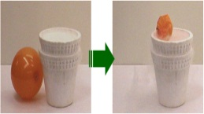
Explore | Called them for discovering the Charles law of gases in their small groups of 3-4. Thereby, they used such Science Process Skills (SPS) as: observing, measuring, identifying variables, formulating hypotheses, doing experiments, interpreting data and defining operationally. Also, they wrote their observations/measurements down on the worksheet. | Requested them to carry out relevant experiment concerning the Charles law of Gases. She called the PSTs to create and present their own data tables to the whole class. She asked such inquiry-based questions: What happens to the gas particles over an increase in the temperature? Please draw your own graph. How does an increase in the temperature influence the pressure and volume of a fixed quantity of gas? Is there any mathematical equation to address these relationships? Please defend your response given your data. | 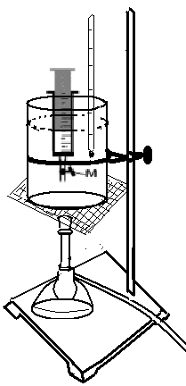
Explain | Required to present their arguments. Hence, they were able to decide whether their arguments were consistent with the scientific one. | Encouraged them to present their arguments. Then, she summarized and compared them with the scientific one. Also, she used the analogy to advocate their newly generated knowledge into long-term memory. | 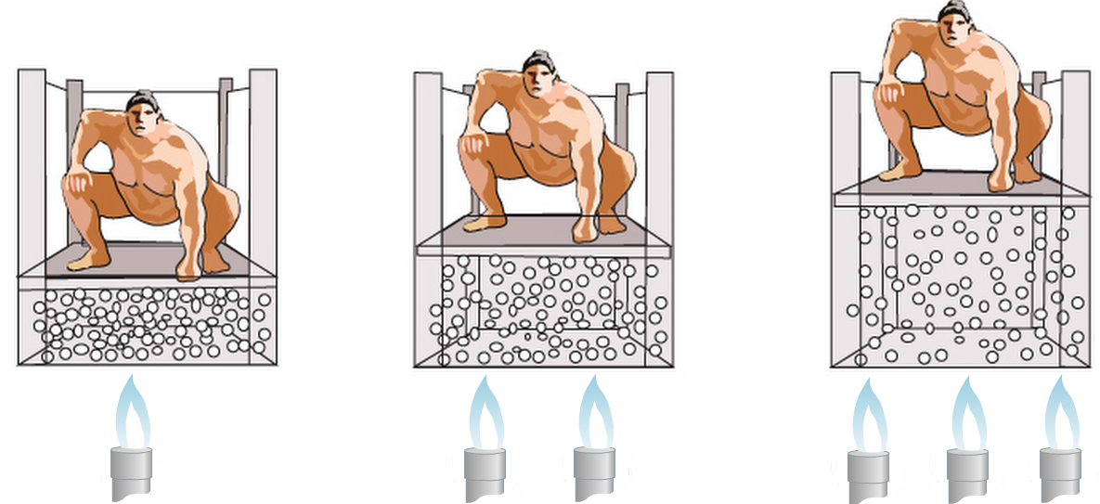
Elaborate | Asked them to examine the computer animations and discuss its daily life relationship(s) in their small groups. Hence, they were able to transfer their newly structured knowledge into daily life questions. | Called them for watching the computer animations. She aroused a group discussion to handle its daily life relationship(s). | 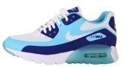  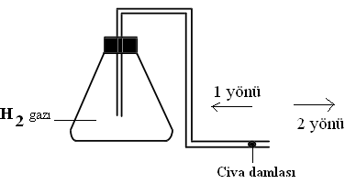
Evaluate | Applied their newly generated abilities and knowledge/ideas to novel cases. | Asked them to solve related problems via their newly generated knowledge.

Appendix 3. A sample teaching design for the control group
Phase | Pre-Service Teacher’s role | Lecturer’s role | The sample images
Theoretical knowledge | Asked them to carefully listen to the lecturer’s explanations and respond her questions. Thus, this phase purposed to provide fundamental knowledge of the subject and to attract their attention to the topic. | Probed some questions (i.e., How does an increase in the temperature influence the volume of a fixed quantity of gas?) and explained the effect of the temperature on the volume of a fixed quantity of gas (Charles law of gases).
Experiment | Called them for proving the effect of the temperature on the volume of a fixed quantity of gas in their small groups of 3-4. They confirmed the knowledge with experiments. | Requested them to prove the effect of the temperature on the volume of a fixed quantity of gas. She asked such inquiry-based questions: Is there any mathematical equation to address a temperature- volume relationship of a fixed quantity of gas?
Evaluate | Required them to answer the related questions using their knowledge. | Asked them to solve related problems (i.e., At the room temperature, there is 350 mL of gas in a free-piston injector. If the gas is heated to 600 Kelvin at a constant pressure, please calculate the volume of the gas).

Appendix 4. A sample question for the gas lawstest.

Question 6. | 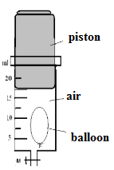 | In this figure, a moderately tumid kid’s balloon has been placed within a free-piston injector that contains a little air and a closed end. Accordingly, which of the following statements is true?
- If the injector is kept within a hot-water-filled-container, the volume of air will increase, and the volume of the balloon will remain the same.
- If the injector is placed within a liquid nitrogen-filled-container, the pressure of air within the balloon will increase.
- If the piston of the injector is hardly pushed, the temperature of the air within the balloon will increase.
- If the piston of the injector is pulled upward, the pressure of the air within the balloon will increase.
- If the injector is kept within a refrigerator for some time, the balloon will shrink.

Please write down your reason for selecting this option:
…………………………………………………………………………………………………………

Appendix 5. Sample questions for the science process skills test

Question 19. | A student blows some air to a kid’s balloon and then locates into water-filled beaker. Later, the experimental setup in figure is established. When the water temperature is at 10 ºC, the diameter of the balloon is measured to be 5 cm. When the water temperature is at 20 ºC, the diameter of the balloon is measured to be 7 cm. When the water temperature is at 30 ºC, the diameter of the balloon is measured to be 10 cm. When the water temperature is at 40 ºC, the diameter of the balloon is measured to be 12 cm. Given this experiment, please answer the following questions | 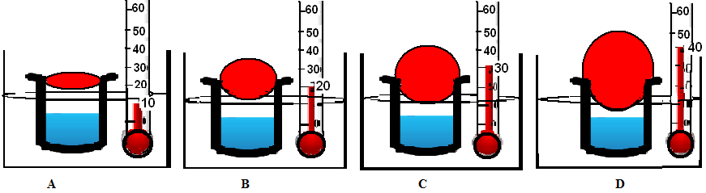
- What is the hypothesis of the experiment? Please write down.
.............................................................................................................
- Which variable(s) is the experiment involved? Please write down.
.............................................................................................................
- What is the dependent variable of the experiment? Please write down.
.............................................................................................................
- What is the independent variable of the experiment? Please write down.
.............................................................................................................
- What are the control variables of the experiment? Please write down.
.............................................................................................................

Question 28. Four identical beakers are half-filled with pure water, sea water, alcohol and milk respectively. TEach beakers was heated with identical heaters for some time. Afterwards, it is observed that all beakers are empty. How do you interpret this observation? Please select one of the following inferences.
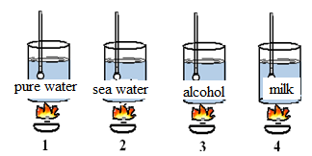
- Alcohol evaporates earlier than other liquids.
- Pure water's boiling point is lower than that of sea water.
- All liquids evaporate when they are placed in open beakers.
- Heater's intensity does not affect liquids' boiling points.
- Liquids need to be heated for evaporation at a certain time.

