Synthesis and efficacy of copper(II) complexes bearing N(4)-substituted thiosemicarbazide and diimine co-ligands on plasmid DNA and HeLa cell lines
NEELAVENI RAJENDRAN¹, ABIRAMI PERIYASAMY ², NITHYA KAMATCHI ³ and VASANTHA SOLOMON *
¹PG and Research Department of Chemistry, Lady Doak College, Madurai − 625002, Tamil Nadu, India ² Department of Biotechnology, Lady Doak College, Madurai − 625002, Tamil Nadu, India and ³PG and Research Department of Zoology, Lady Doak College, Madurai − 625002, Tamil Nadu, India
SUPPLEMENTARY DATA
Synthesis of thiosemicarbazone ligands
Preparation of 1-phenyl-2-((5-(pyridin-3-yl)-4H-1,2,4-triazol-3-yl)thio)ethanone HL
Color: Colorless; Yield: 68%; m.p 190 − 192°C ; Anal.Calcd for C₁₅H₁₂N₄OS: C, 60.79; H, 4.08; N, 18.19; S, 10.82%; Found: C, 60.68; H, 4.02; N, 18.25; S, 10.77%; Ʌ_{m} (Ω⁻¹cm² mol⁻¹): 5; ¹H NMR (300 MHz, DMSO): δ_{H} 9.15 (s, 1H), 8.59 (s, 1H), 8.26 (d, J = 6.0 Hz, 1H), 8.06 (d, J = 6.0 Hz, 2H), 7.66 − 7.61 (m, 1H), 7.54−7.49 (m, 2H), 7.39 (s, 2H), 4.87 (s, 2H).
General method of preparation of H(L1) − H(L3)
(E)-N-methyl-2-(1-phenyl-2-((5-(pyridin-3-yl)-4H-1,2,4-triazol-3-yl)thio)ethylidene) hydrazinecarbothioamide H(L1)
Color: Yellow; Yield: 74%; m.p 212 − 214°C; Anal.Calcd for C₁₇H₁₇N₇S₂: C, 53.24; H, 4.47; N, 25.57; S, 16.72 %. Found: C, 53.36; H, 4.44; N, 25.61; S, 16.80 %; Ʌ_{m} (Ω⁻¹cm² mol⁻¹): 4; ¹H NMR (300 MHz, DMSO): δ_{H} 10.88 (s, 1H), 9.32 (s, 1H), 9.23 (d, J = 15 Hz, 1H), 8.66 (s, 1H), 8.54 (d, J = 9.0 Hz, 1H), 8.25 (d, J = 3.0 Hz, 1H), 8.10 (s, 1H), 7.85 (t, J = 3.0 Hz, 1H), 7.56 (m, 1H), 7.43 (d, J = 3.0 Hz, 3H), 4.59 (s, 2H), 3.19 (d, J = 6.0 Hz, 3H); ¹³C NMR (75 MHz, DMSO): δ_{C} 179.5, 162.9, 151.0, 148.2, 147.8, 145.5, 136.4, 134.9, 133.8, 130.0, 129.3, 128.9, 127.3, 124.1, 36.8, 31.7, 26.8.FT−IR (KBr; cm⁻¹): 3340 (s, N(4)H), 3199, (s, N(2)H), 1554 (s, C=N), 813 (s, C=S), 987 (s, N−N); UV−Vis: λ_{max} (DMF) nm: 225, 295 and 355.
(E)-N-ethyl-2-(1-phenyl-2-((5-(pyridin-3-yl)-4H-1,2,4-triazol-3-yl)thio)ethylidene) hydrazinecarbothioamide H(L2)
Color: Yellow; Yield: 70%; m.p 222 − 224°C; Anal.Calcd for C₁₈H₁₉N₇S₂: C, 54.39; H, 4.82; N, 24.66; S, 16.13 %. Found: C, 54.42; H, 4.91; N, 24.79; S, 16.09 %; Ʌ_{m} (Ω⁻¹cm² mol⁻¹): 7; ¹H NMR (300 MHz, DMSO): δ_{H} 11.08 (s, 1H), 9.51 (s, 1H), 8.85 (d, J = 30.0 Hz, 2H), 8.53 (m, 1H), 8.14 (m, 1H), 7.96 (m, 2H), 7.86 (s, 1H), 7.62 (m, 3H), 4.75 (s, 2H), 3.95 (m, 2H), 1.46 (t, J = 6.0 Hz, 3H); ¹³C NMR (75 MHz, DMSO): δ_{C} 179.7, 160.1, 157.8, 157.4, 155.3, 154.9, 148.0, 136.9, 134.2, 131.8, 128.9, 128.8, 128.4, 128.1, 124.3, 38.1, 39.9, 15.8; FT−IR (KBr; cm⁻¹): 3240 (m, N(4)H), 2970 (s, N(2)H), 1518 (s, C=N), 808 (s, C=S), 977 (s, N−N); UV−Vis: λ_{max} (DMF) nm: 280 and 360.
(E)-N-phenyl-2-(1-phenyl-2-((5-(pyridin-3-yl)-4H-1,2,4-triazol-3-yl)thio)ethylidene) hydrazinecarbothioamide H(L3)
Color: Yellow; Yield: 61%; m.p 235 − 237°C; Anal.Calcd for C₂₂H₁₉N₇S₂: C, 59.30; H, 4.30; N, 22.01; S, 14.39%. Found: C, 59.26; H, 4.21; N, 22.11; S, 14.38 %; Ʌ_{m} (Ω⁻¹cm² mol⁻¹): 11;¹H NMR (300 MHz, DMSO): δ_{H} 11.60 (s, 1H), 10.02 (s, 1H), 9.74 (s, 1H), 9.61 (s, 2H), 8.99 – 8.96 (m, 1H), 8.90 – 8.88 (d, J = 6.0 Hz, 1H), 8.65 – 8.63 (d, J = 6.0 Hz, 1H), 8.43 – 8.40 (d, J = 9.0 Hz, 1H), 8.35 (s, 2H), 8.03 – 7.95 (m, 1H), 7.91 – 7.86 (m, 1H), 7.81 – 7.72 (m, 1H), 7.70 – 7.63 (m, 1H), 7.59 – 7.57 (m, 1H), 7.32 – 7.27 (m, 1H), 5.17 (s, 2H); ¹³C NMR (75 MHz, DMSO): δ_{C} 184.7, 155.1, 157.9, 157.5, 155.4, 148.1, 138.7, 135.8, 135.8, 132.7, 133.1, 131.2, 129.2, 129.0, 128.9, 128.8, 128.5, 128.4, 128.2, 126.9, 124.1, 38.4; FT−IR (KBr; cm⁻¹): 3290 (s, N(4)H), 3147 (s, N(2)H), 1534 (s, C=N), 826 (s, C=S), 973 (s, N−N); UV−Vis: λ_{max} (DMF) nm: 310 and 345.
Synthesis of copper(II) bis complexes (C1 − C3)
[Cu(L1)₂] (C1)
Color: Green; Yield: 69%; Anal.Calcd for: C₃₄H₃₂CuN₁₄S₄: C, 49.29; H, 3.89; N, 25.67; S, 15.48%; Found: C, 49.17; H, 3.81; N, 23.62; S, 15.39%; Ʌ_{m} (Ω⁻¹cm² mol⁻¹):16; FT−IR (KBr; cm⁻¹): 3059 (s, N(4)H), 1562 (s, C=N), 738 (s, C−S), 1047 (s, N−N), 425 (m, Cu−N) and 612 (m, Cu−S); UV−Vis: λ_{max} (DMF) nm: 295, 360 and 635 (d−d transition); EPR: A|| = 158 x 10⁻⁴ cm⁻¹; g|| = 2.252; g⊥ = 2.057; g _{ll} /A_{ll} = 140 cm; G = 4.38.The similar method was applied for the synthesis of complexes 2 and 3 using H(L2) and H(L3) instead of H(L1).
[Cu(L2)₂] (C2)
Color: Green; Yield: 62%; Anal.Calcd for: C₃₆H₃₆CuN₁₄S₄: C, 50.48; H, 4.24; N, 22.89; S, 14.97%; Found: C, 50.54; H, 4.29; N, 22.95; S, 14.89%; Ʌ_{m} (Ω⁻¹cm² mol⁻¹): 17; FT−IR (KBr; cm⁻¹): 3061 (s, NH), 1556 (s, C=N), 738 (s, C−S), 1012 (s, N−N), 430 (m, Cu−N) and 621 (s, Cu−S); UV−Vis: λ_{max} (DMF) nm: 290, 412 and 645 (d−d transition); EPR: A|| = 162 x 10⁻⁴ cm⁻¹; g|| = 2.249; g⊥ = 2.056; g _{ll} /A_{ll} = 138 cm; G = 4.59.
[Cu(L3)₂] (C3)
Color: Green; Yield: 58%; Anal.Calcd for: C₄₄H₃₆CuN₁₄S₄: C, 55.47; H, 3.81; N, 20.58; S, 13.46%; Found: C, 55.56; H, 3.75; N, 20.51; S, 13.49%; Ʌ_{m} (Ω⁻¹cm² mol⁻¹): 18; FT−IR (KBr; cm⁻¹): 3091(s, NH), 1572 (s, C=N), 745 (s, C−S), 1131 (s, N−N), 618 (s, Cu−N) and 428 (s, Cu−S); UV−Vis: λ_{max} (DMF) nm: 318, 380 and 715 (d−d transition); EPR: A|| = 160 x 10⁻⁴ cm⁻¹; g|| = 2.258; g⊥ = 2.062; g _{ll} /A_{ll} = 141 cm; G = 4.28.
Synthesis of mixed ligand copper(II) complexes (C4−C9)
[Cu(L1)(bpy)]Cl (C4)
To the 2 mmol ethanolic solution of ligand H(L1), solution of 2,2’-bipyridyl (1 mmol in ethanol) was added by constant stirring for 1 h. To this solution, copper(II) chloride dihydrate was added dropwise and again stirred for 30 min. Subsequently, the green precipitate obtained was washed several times with cold ethanol and dried. Color: Green; Yield: 61%; Anal.Calcd for: C₂₇H₂₄ClCuN₉S₂: C, 50.86; H, 3.79; N, 19.77; S, 10.06%; Found: C, 50.92; H, 3.71; N, 19.84; S, 50.88%; Ʌ_{m} (Ω⁻¹cm² mol⁻¹): 83; FT−IR (KBr; cm⁻¹): 3098 (s, NH), 1553 (s, C=N), 761 (s, C−S), 1115 (s, N−N), 461 (s, Cu−N) , 641 (s, Cu−S); UV−Vis: λ_{max} (DMF) nm: 310, 395 and 745 (d−d transition); EPR: A|| = 163 x 10⁻⁴ cm⁻¹; g|| = 2.257; g⊥ = 2.074; g _{ll} /A_{ll} = 139 cm; G = 4.55.
The similar method was applied for the synthesis of complexes 5 and 6 using H(L2) and H(L3) instead of H(L1).
[Cu(L2)(bpy)]Cl (C5)
Color: Green; Yield: 72%; Anal.Calcd for: C₂₈H₂₆ClCuN₉S₂: C, 51.60; H, 4.02; N, 19.34; S, 9.84%; Found: C, 51.70; H, 3.97; N, 19.34; S, 9.81%; Ʌ_{m} (Ω⁻¹cm² mol⁻¹): 89; FT−IR (KBr; cm⁻¹): 3074 (s, NH), 1559 (s, C=N), 758 (s, C−S), 1109 (s, N−N), 456 (s, Cu−N) and 643 (s, Cu−S); UV−Vis: λ_{max} (DMF) nm: 295, 415 and 725 (d−d transition); EPR: A|| = 160 x 10⁻⁴ cm⁻¹; g|| = 2.268; g⊥ = 2.063; g _{ll} /A_{ll} = 141 cm; G = 4.38.
[Cu(L3)(bpy)]Cl (C6)
Color: Green; Yield: 68%; Anal.Calcd for: C₃₂H₂₆ClCuN₉S₂: C, 54.93; H, 3.75; N, 18.02; S, 9.16%; Found: C, 54.89; H, 3.70; N, 18.07; S, 9.15%; Ʌ_{m} (Ω⁻¹cm² mol⁻¹): 96; FT−IR (KBr; cm⁻¹): 3088 (s, NH), 1549 (s, C=N), 752 (s, C−S), 1008 (s, N−N), 441 (s, Cu−N), 628 (s, Cu−S); UV−Vis: λ_{max} (DMF) nm: 335, 370 and 758 (d−d transition); EPR: A|| = 162 x 10⁻⁴ cm⁻¹; g|| = 2.254; g⊥ = 2.071; g _{ll} /A_{ll} = 139 cm; G = 3.66.
Complexes 7, 8 and 9 was prepared in a similar manner to complex 4, using 1,10-phenanthroline instead of 2,2’-bipyridyl.
[Cu(L1)(phen)]Cl (C7)
Color: Green; Yield: 75%; Anal.Calcd for: C₂₉H₂₄ClCuN₉S₂: C, 52.64; H, 3.66; N, 19.05; S, 9.69%; Found: C, 52.70; H, 3.61; N, 19.11; S, 9.74%; Ʌ_{m} (Ω⁻¹cm² mol⁻¹): 93; FT−IR (KBr; cm⁻¹): 3055 (s, NH), 1568 (s, C=N), 775 (s, C−S), 1045 (s, N−N), 424 (s, Cu−N), 642 (s, Cu−S); UV−Vis: λ_{max} (DMF) nm: 290, 335 and 685 (d−d transition); EPR: A|| = 163 x 10⁻⁴ cm⁻¹; g|| = 2.257; g⊥ = 2.059; g _{ll} /A_{ll} = 141 cm; G = 4.49.
[Cu(L2)(phen)]Cl (C8)
Color: Green; Yield: 68%; Anal.Calcd for: C₃₀H₂₆ClCuN₉S₂: C, 53.32; H, 3.88; N, 18.66; S, 9.49%; Found: C, 53.29; H, 3.81; N, 18.70; S, 9.43%; Ʌ_{m} (Ω⁻¹cm² mol⁻¹): 98; FT−IR (KBr; cm⁻¹): 3055 (s, NH), 1516 (s, C=N), 777 (s, C−S), 998 (s, N−N), 426 (s, Cu−N), 653 (s, Cu−S); UV−Vis: λ_{max} (DMF) nm: 295, 390 and 725 (d−d transition); EPR: A|| = 162 x 10⁻⁴ cm⁻¹; g|| = 2.258; g⊥ = 2.064; g _{ll} /A_{ll} = 140 cm; G = 4.14.
[Cu(L3)(phen)]Cl (C9)
Color: Green; Yield: 60%; Anal.Calcd for: C₃₄H₂₆ClCuN₁₄S₄: C, 56.42; H, 3.62; N, 17.42; S, 8.86%; Found: C, 56.46; H, 3.59; N, 17.49; S, 8.89%; Ʌ_{m} (Ω⁻¹cm² mol⁻¹): 103; FT−IR (KBr; cm⁻¹): 3059 (s, NH), 1543 (s, C=N), 771 (s, C−S), 1103 (s, N−N), 423 (s, Cu−N), 632 (s, Cu−S); UV−Vis: λ_{max} (DMF) nm: 335, 430 and 735 (d−d transition); EPR: A|| = 162 x 10⁻⁴ cm⁻¹; g|| = 2.260; g⊥ = 2.059; g _{ll} /A_{ll} = 139 cm; G = 4.54.
Fig. 1. ¹H NMR spectrum of H(L1) in DMSO-d₆
Fig. 2. ¹³C NMR spectrum of H(L1) in DMSO-d₆

Fig. 3. Electronic spectra of ligand H(L1) in DMF

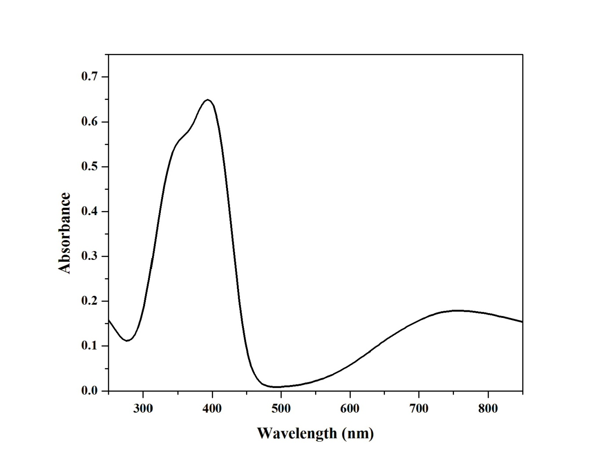
Fig. 4. Electronic spectra of complex C5 in DMF

Fig. 5. X-band EPR spectrum of complex C7 in frozen DMF solution
Fig. 6. Cyclic voltammogram of complex C2
Table I. Electrochemical data of thiosemicarbazone copper(II) complexes 1 − 9
Complexes | Cyclic voltammogram ª |  |  | Differential pulse voltammogram ª | Redox process
 | E_{pa}  (V) | E_{pc}  (V) | E_{1/2}  (V) | E_{1/2} (DPV)  (V)
[Cu(L1)₂] (C1) | 0.309 | 0.572 | 0.441 | 0.601 | Cu(II) → Cu(I)
[Cu(L2)₂] (C2) | 0.324 | 0.542 | 0.433 | 0.529 | Cu(II) → Cu(I)
[Cu(L3)₂] (C3) | 0.332 | 0.498 | 0.415 | 0.471 | Cu(II) → Cu(I)
[Cu(L1)(bpy)]Cl (C4) | 0.327 | 0.598 | 0.463 | 0.637 | Cu(II) → Cu(I)
[Cu(L2)(bpy)]Cl (C5) | 0.258 | 0.662 | 0.460 | 0.598 | Cu(II) → Cu(I)
[Cu(L3)(bpy)]Cl (C6) | 0.572 | 0.598 | 0.345 | 0.446 | Cu(II) → Cu(I)
[Cu(L1)(phen)]Cl (C7) | 0.327 | 0.559 | 0.659 | 0.643 | Cu(II) → Cu(I)
[Cu(L2)(phen)]Cl (C8) | 0.247 | 0.576 | 0.640 | 0.612 | Cu(II) → Cu(I)
[Cu(L3)(phen)]Cl (C9) | 0.022 | 0.551 | 0.638 | 0.587 | Cu(II) → Cu(I)
ª DMF (1 x 10⁻³ M), E_{1/2} = 0.5 (E_{pa} + E_{pc}), ∆E_{p} = E_{pa} − E_{pc}, where E_{pa} and E_{pc} were anodic and cathodic peak potentials respectively (Scan rate 50mVs⁻¹)
Table II. Diameter of zone of inhibition of thiosemicarbazone ligands and copper(II) complexes
Ligand  and  Complexes | Diameter of inhibition zone (mm)ª
 | E. coli |  | Bacillus sp.
 | 5 (μg / ml) | 50 (μg / ml) | 5 (μg / ml) | 50 (μg / ml)
H(L1) | 1 | 2 | 0 | 1
H(L2) | 1 | 4 | 0 | 1
H(L3) | 1 | 2 | 0 | 1
[Cu(L1)₂] (C1) | 3 | 5 | 4 | 5
[Cu(L2)₂] (C2) | 3 | 6 | 2 | 4
[Cu(L3)₂] (C3) | 2 | 5 | 1 | 3
[Cu(L1)(bpy)]Cl (C4) | 2 | 4 | 4 | 6
[Cu(L2)(bpy)]Cl (C5) | 2 | 5 | 5 | 7
[Cu(L3)(bpy)]Cl (C6) | 3 | 6 | 6 | 8
[Cu(L1)(phen)]Cl (C7) | 5 | 8 | 7 | 10
[Cu(L2)(phen)]Cl (C8) | 7 | 9 | 6 | 11
[Cu(L3)(phen)]Cl (C9) | 3 | 5 | 5 | 8
(positive control)^{b}  (Negative control)^{c} | 9  NA | 9  NA | 13  NA | 13  NA
ª Mean zone of inhibition in mm ^{b} standard antibacterial agent used was chloramphenicol (positive control) ^{c} Dimethyl formamide (negative control), NA = No activity
Table III. Percentage of cytotoxicity of the thiosemicarbazone ligands and its copper(II) complexes
Compounds | Cytotoxicity ª , %
 | HeLa ^{b}
H(L1) | 56.38 ± 0.31
H(L2) | 34.00 ± 0.10
H(L3) | 46.00 ± 0.01
[Cu(L1)₂] (C1) | 21.62 ± 0.10
[Cu(L2)₂] (C2) | 66.00 ± 0.21
[Cu(L3)₂] (C3) | 54.00 ± 0.09
[Cu(L1)(bpy)]Cl (C4) | 60.84 ± 0.36
[Cu(L2)(bpy)]Cl (C5) | 59.00 ± 0.05
[Cu(L3)(bpy)]Cl (C6) | 60.00 ± 0.12
[Cu(L1)(phen)]Cl (C7) | 81.79 ± 0.26
[Cu(L2)(phen)]Cl (C8) | 84.00 ± 0.04
[Cu(L3)(phen)]Cl (C9) | 73.00 ± 0.04
Cisplatin ^{c} | 96.00 ± 0.01
ª Percentage of cytotoxicity at 5 μM for 24 h with standard error values ^{b} Cervical cancer cell lines ^{c} Positive control

* Corresponding author E-mail: vasantha@ldc.edu.in (Tel:+919976366463)

