**Supplementary material to:**

**Maltose-mediated long-term stabilization of freeze- and spray- dried forms of bovine and porcine hemoglobin**

IVANA T. DRVENICA[1]*, ANA Z. STANČIĆ, ANA KALUŠEVIĆ1,2, SMILJA MARKOVIĆ3, JELENA DRAGIŠIĆ MAKSIMOVIĆ4, VIKTOR A. NEDOVIĆ1,

BRANKO M. BUGARSKI6, VESNA Lj. ILIĆ

*Institute for Medical Research, University of Belgrade, Belgrade, Serbia*

*1Faculty of Agriculture, University of Belgrade, Belgrade, Serbia*

*2Institute of Meat Hygiene and Technology, Belgrade, Serbia*

*3Institute of Technical Sciences of the Serbian Academy of Sciences and Arts, Belgrade, Serbia*

*4Institute for multidisciplinary research, University of Belgrade, Belgrade, Serbia*

*5Faculty of Technology and Metallurgy, University of Belgrade, Belgrade, Serbia*



Figure S1. DSC thermogram of un-aged amorphous maltose monohydrate showing the glass transition and enthalpy relaxation endotherm at the glass transition temperature.

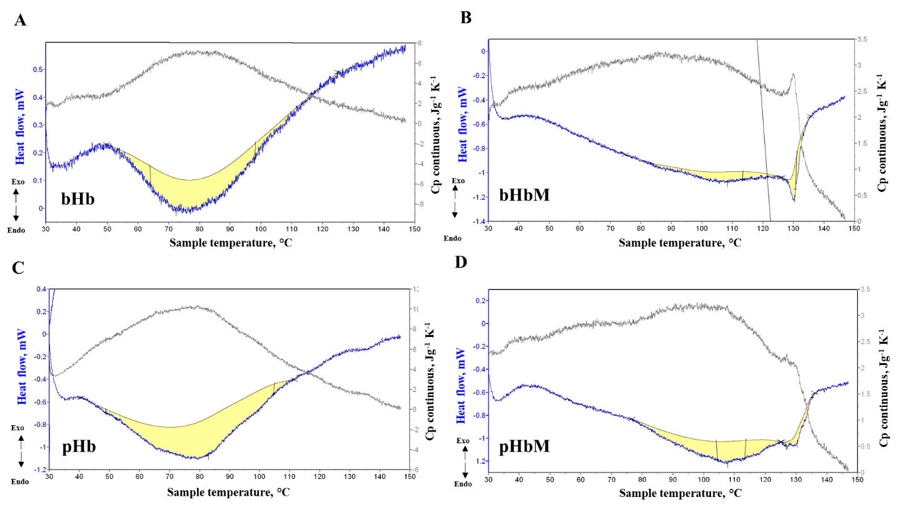

Fig S2. Thermal unfolding and denaturation profile of freeze-dried A) bovine hemoglobin without maltose (bHb) and B) with maltose (bHbM), C) porcine hemoglobin without maltose (pHb) and D) with maltose (pHbM)

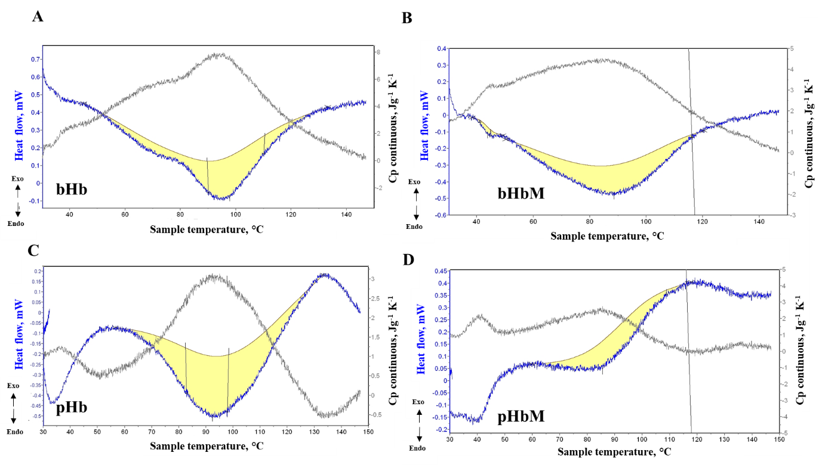

Fig S3. Thermal unfolding and denaturation profile of spray-dried A) bovine hemoglobin without maltose (bHb) and B) with maltose (bHbM), C) porcine hemoglobin without maltose (pHb) and D) with maltose (pHbM)

Table S1. Spectral characteristics of spray-dried and freeze dried pooled bovine and porcine hemoglobin without (Hb) and with maltose (HbM), rehydrated after 2 years storage at ambient temperature. Hemoglobin stored at -20°C represents a control of the measurement.

|  |  |  |  |  |  |
| --- | --- | --- | --- | --- | --- |
|  | Soret band (nm) | Δα/Δβ* | ΔAsoret/A275nm | ΔAsoret/A577nm | A630 |
|  | Bovine hemoglobin | | | | |
| Hb -20 ºC | 410.5 | 0.94 | 3.93 | 11.41 | 0.012 |
| Hb spray-dried | 406.5 | 0.04 | 4.27 | 28.78 | 0.029 |
| HbM spray-dried | 408.5 | 0.81 | 3.43 | 12.90 | 0.019 |
| Hb lyophilized | 405.0 | 0.05 | 4.47 | 30.38 | 0.027 |
| HbM lyophilized | 411.5 | 0.99 | 3.35 | 10.12 | 0.010 |
|  | Porcine Hb | | | | |
| Hb -20 ºC | 407.5 | 0.94 | 3.67 | 11.73 | 0.016 |
| Hb spray dried | 405.5 | 0.14 | 4.20 | 9.90 | 0.028 |
| HbM spray dried | 406.0 | 0.61 | 3.48 | 10.13 | 0.024 |
| Hb lyophilized | 406.0 | 0.14 | 4.09 | 20.17 | 0.029 |
| HbM lyophilized | 409.0 | 0.90 | 3.49 | 14.11 | 0.014 |
| * Δα/Δβ = (A577-A560) / (A541-A560) | | |  |  |  |

1. *Corresponding author. E-mail: ivana.drvenica@imi.bg.ac.rs