SUPPLEMENTARY MATERIAL
HPTLC Bioautography-Guided Isolation of Isogeranic Acid as the Main Antibacterial Constituent of Artemisia santonicum Essential Oil

JOVANA STANKOVIĆ¹, MIROSLAV NOVAKOVIĆ¹, VELE TEŠEVIĆ², ANA ĆIRIĆ³, MARINA SOKOVIĆ³, GORDANA ZDUNIĆ⁴, ZORA DAJIĆ-STEVANOVIĆ⁵ and DEJAN GOĐEVAC¹*

¹Institute of Chemistry, Technology and Metallurgy, National Institute, Njegoseva 12, 11000 Belgrade, Serbia, ²University of Belgrade -Faculty of Chemistry, Studentski trg 12-16, 11000 Belgrade, Serbia, ³Institute for Biological Research “Siniša Stanković”, University of Belgrade, Department of Plant Physiology, Bulevar Despota Stefana 142, 11000 Belgrade, Serbia, ⁴Institute for Medicinal Plant Research “Dr. Josif Pančić”, Tadeuša Košćuška 1, 11000 Belgrade, Serbia, ⁵Faculty of Agriculture, University of Belgrade, Nemanjina Street 6, 11080 Zemun,, Serbia
*Corresponding author, e-mail:dgodjev@chem.bg.ac.rs

Figure S1. GC/FID chromatogram of the essential oil (up) and pure isogeranic acid (down)

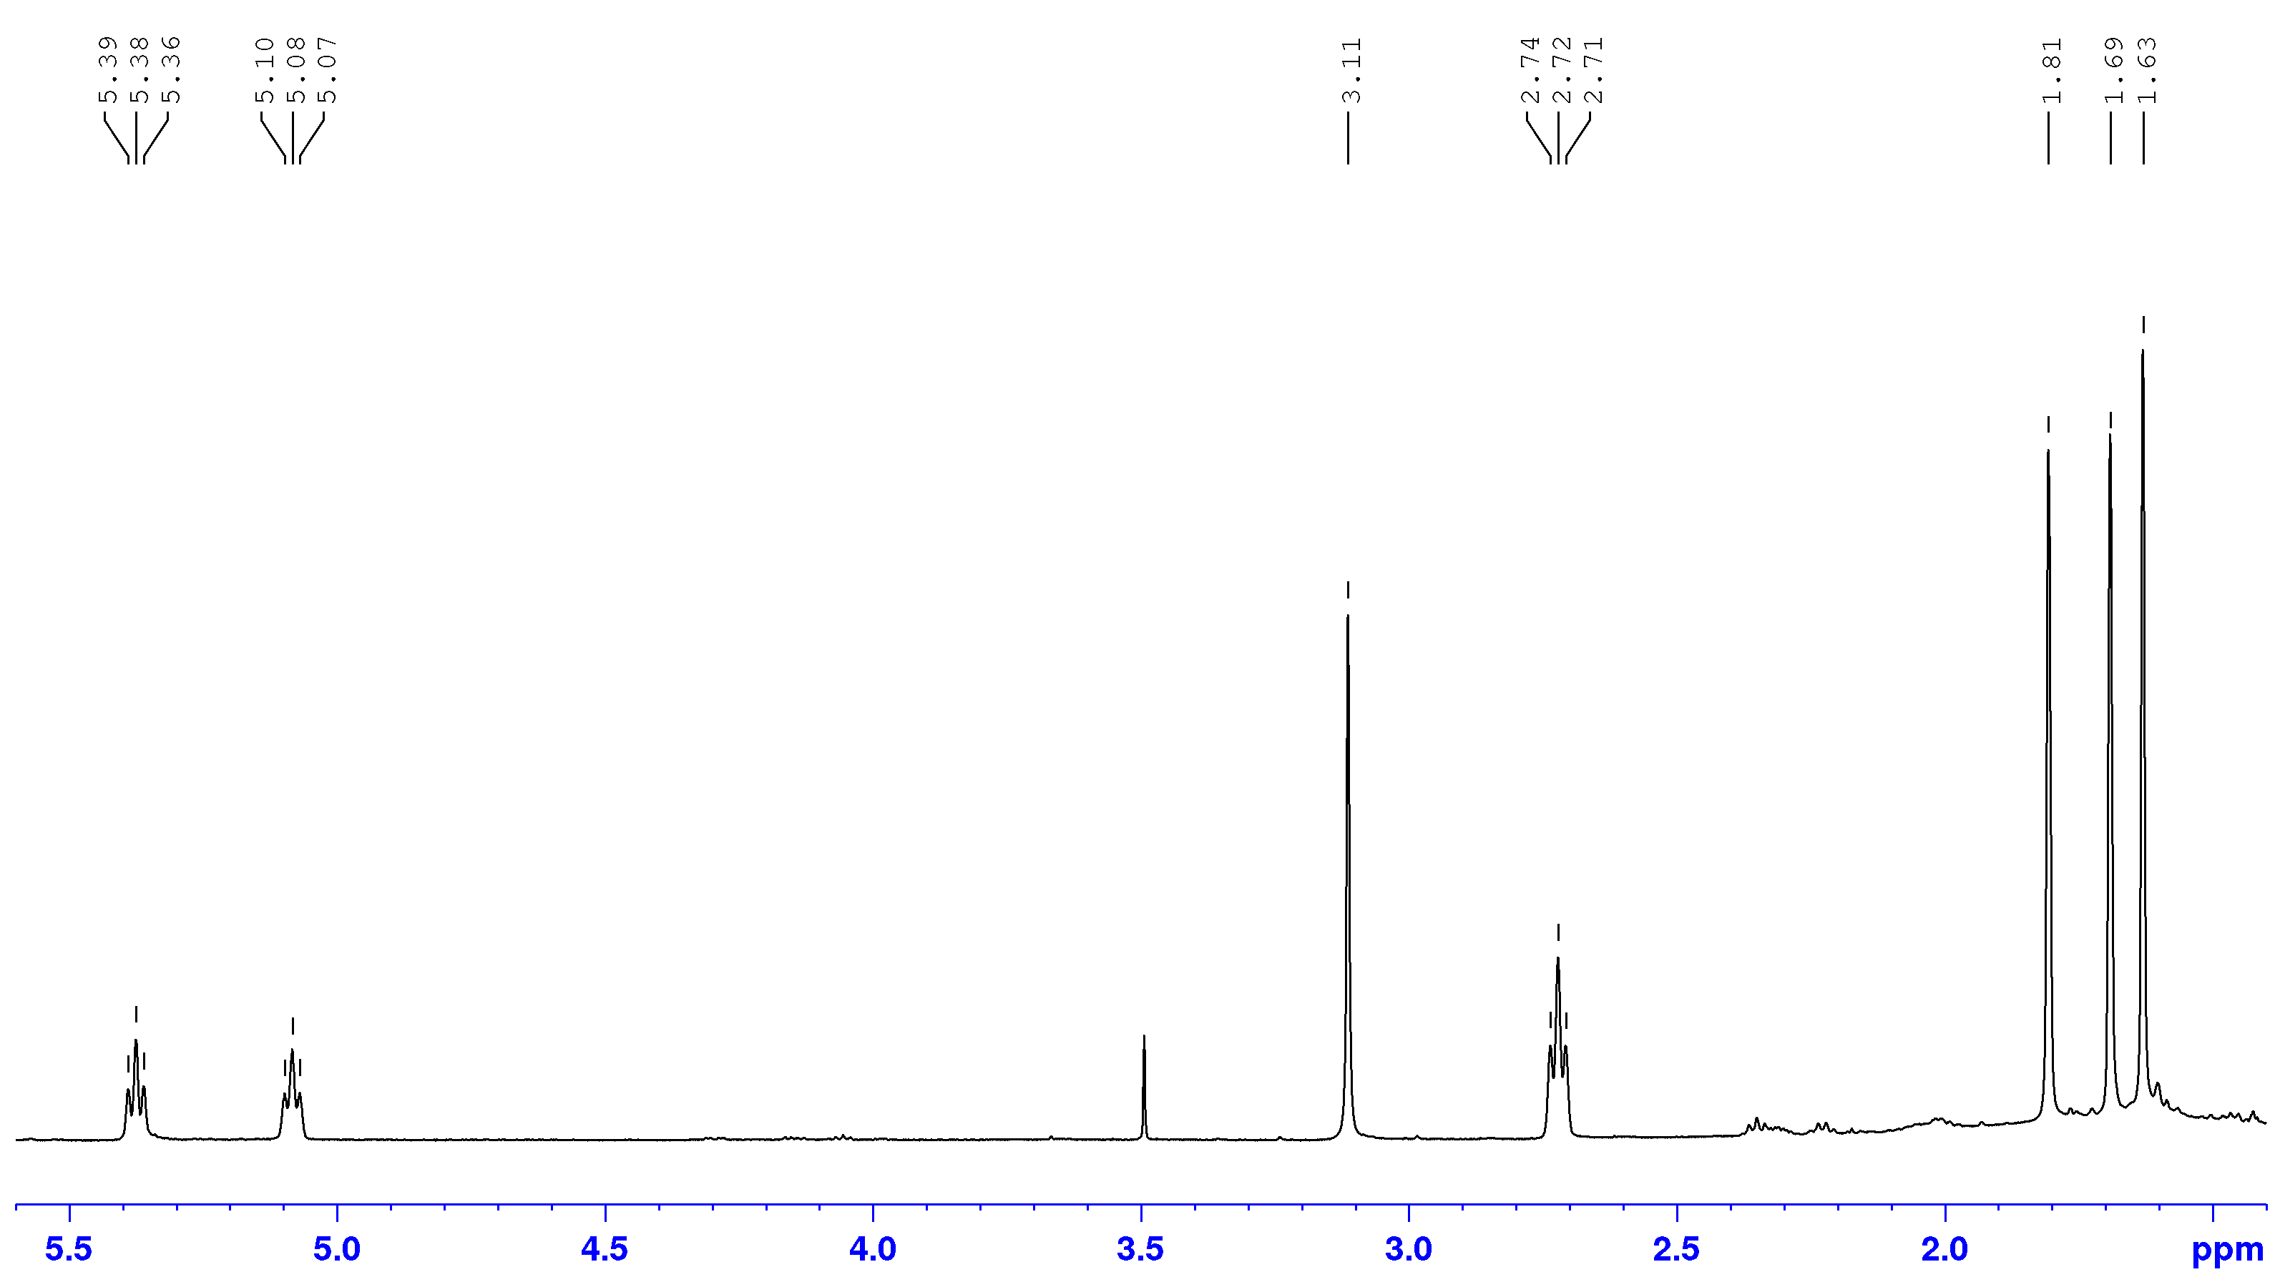
Figure S2. ¹H NMR spectrum of isogeranic acid
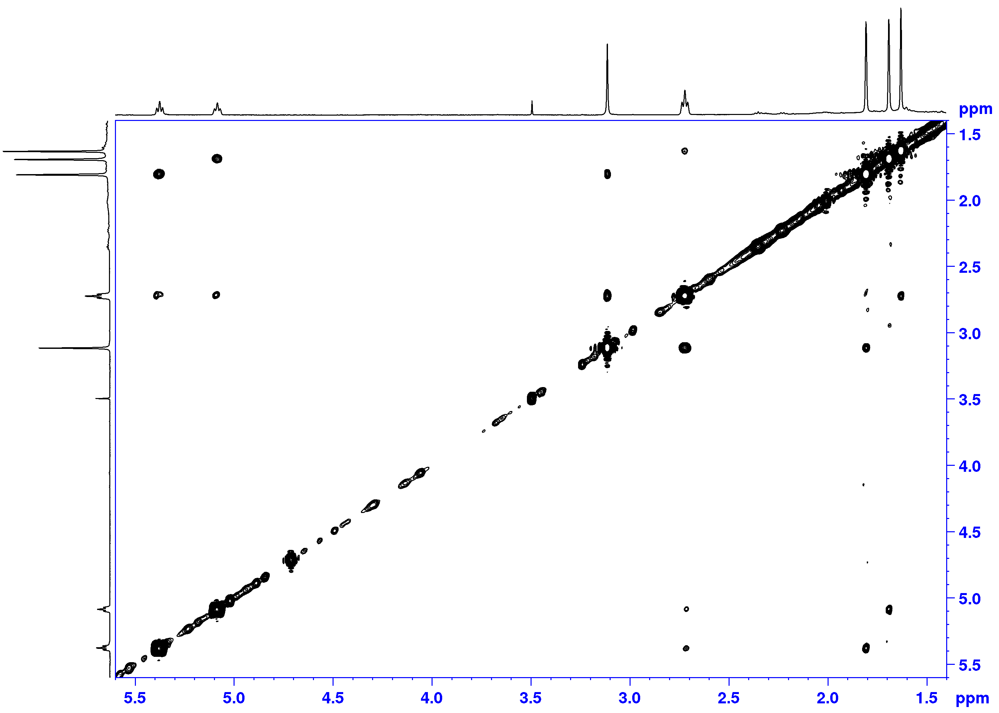
Figure S3. NOESY spectrum of isogeranic acid
Figure S4. DEPT spectrum of isogeranic acid

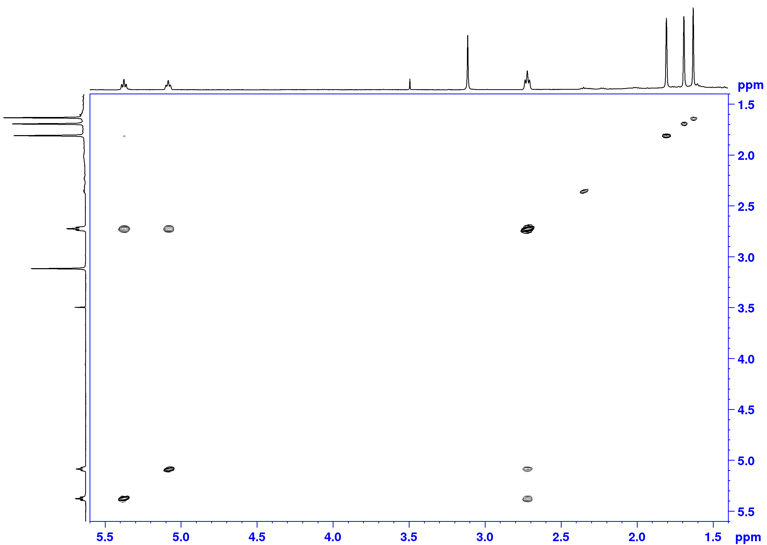
Figure S5. COSY spectrum of isogeranic acid

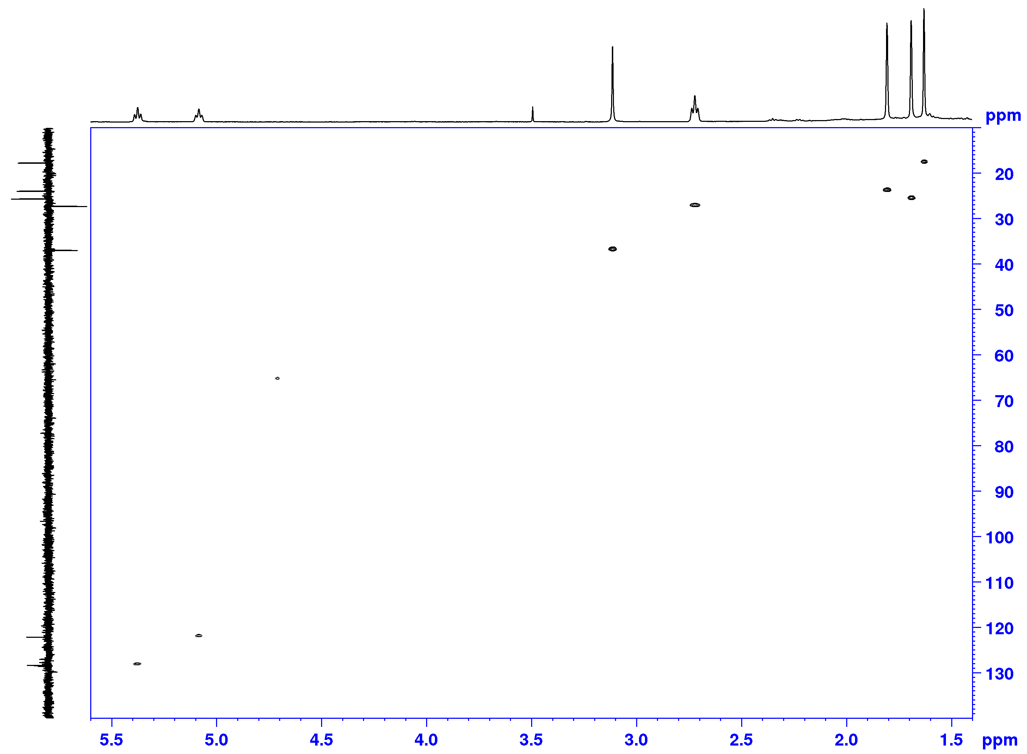
Figure S6. HSQC spectrum of isogeranic acid

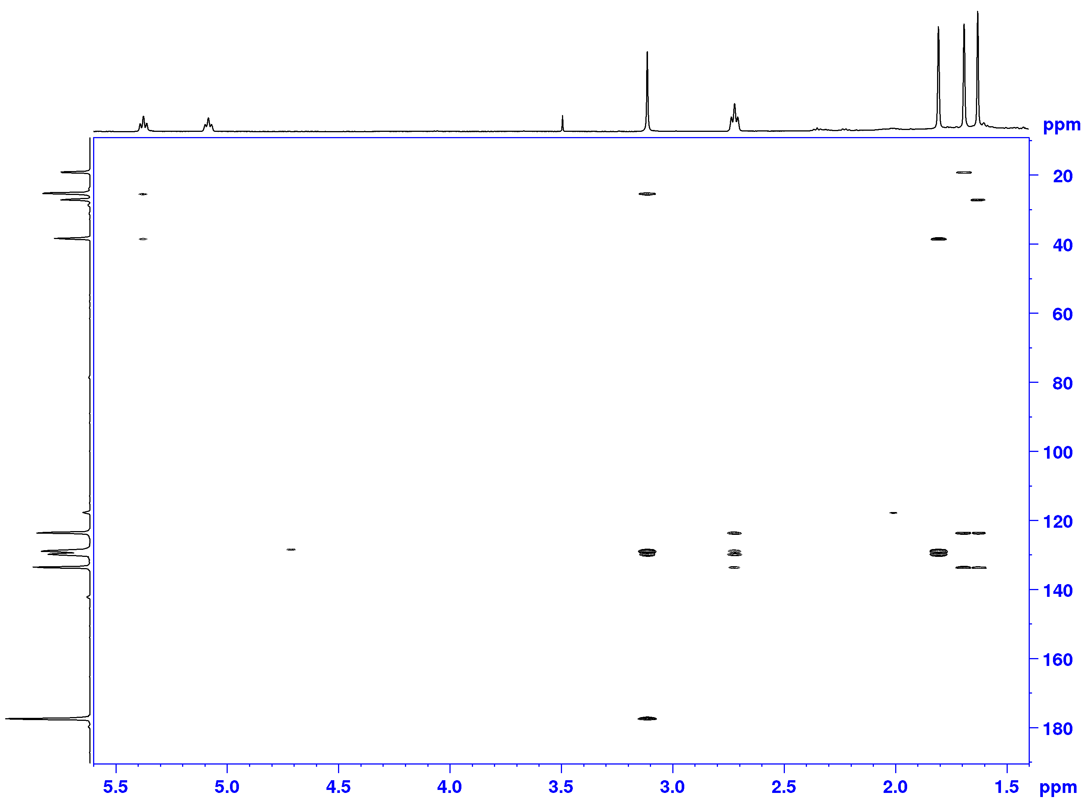
Figure S7. HMBC spectrum of isogeranic acid

Table S1. Compositionª of the Essential Oil from A. santonicum
No. | Compound | RI^{b} | Rt^{c}(min) | %ª
1 | 1,2,5,5-Tetramethyl-1,3-cyclopentadiene | 817 | 3.741 | 0.4
2 | NI | 868 | 4.599 | 0.1
3 | Tricyclene | 906 | 5.489 | 0.2
4 | α-Thujene | 914 | 5.579 | 0.2
5 | α-Pinene | 921 | 5.771 | 1.1
6 | Camphene | 936 | 6.171 | 0.8
7 | Thuja-2,4(10)-diene | 942 | 6.315 | 0.4
8 | Sabinene | 966 | 6.852 | 0.8
9 | β-Pinene | 971 | 6.972 | 0.3
10 | 1,8-Dehydro cineole | 985 | 7.379 | 0.3
11 | Mesitylene | 991 | 7.457 | 1.3
12 | Yomogi alcohol | 996 | 7.58 | 0.4
13 | α-Phellandrene | 999 | 7.808 | 0.2
14 | NI | 1006 | 8.081 | 0.1
15 | α-Terpinene | 1010 | 8.206 | 0.5
16 | 1,2,4-Trimethylbenzene | 1015 | 8.425 | 0.6
17 | p-Cymene | 1016 | 8.473 | 2.8
18 | 1,8-Cineole | 1022 | 8.739 | 18.8
19 | Santolina alcohol | 1026 | 8.848 | 0.3
21 | NI | 1036 | 9.300 | 0.1
22 | γ-Terpinene | 1046 | 9.698 | 0.9
23 | cis-Sabinene hydrate | 1056 | 10.006 | 0.3
24 | Artemisia alcohol | 1070 | 10.623 | 0.4
25 | NI | 1074 | 10.821 | 0.9
26 | NI | 1082 | 11.137 | 0.1
27 | Linalool | 1091 | 11.298 | 1.6
28 | Filifolone | 1094 | 11.455 | 2.6
29 | cis-Thujone | 1097 | 11.559 | 8.4
30 | trans-Thujone | 1110 | 11.969 | 1.6
31 | Isophorone | 1111 | 12.123 | 2.0
32 | Chrysanthenone | 1117 | 12.367 | 13.3
33 | trans-Sabinol | 1131 | 12.938 | 2.9
34 | Camphor | 1136 | 13.124 | 3.0
35 | p-Mentha-1,7-dien-8-ol | 1140 | 13.29 | 0.4
36 | NI | 1147 | 13.583 | 0.1
37 | Sabina ketone | 1150 | 13.669 | 0.2
38 | Pinocarvone | 1155 | 13.881 | 0.6
39 | Borneol | 1160 | 14.014 | 0.2
40 | p-Mentha-1,5-dien-8-ol | 1155 | 14.063 | 0.5
41 | Santolinyl acetate | 1159 | 14.253 | 0.2
42 | Terpinen-4-ol | 1171 | 14.522 | 1.5
43 | Thuj-3-en-10-al | 1178 | 14.848 | 0.4
44 | α-Terpineol | 1185 | 15.098 | 0.7
45 | Myrtenal | 1191 | 15.338 | 0.4
46 | Verbenone | 2004 | 15.898 | 0.8
47 | Cumin aldehyde | 1237 | 17.278 | 0.4
48 | Carvone | 1240 | 17.441 | 0.2
49 | Piperitone | 1250 | 17.891 | 0.3
50 | cis-Chrysanthenyl acetate | 1258 | 18.215 | 0.7
51 | p-Mentha-1,8-dien-3-one | 1268 | 18.673 | 0.5
52 | NI | 1276 | 19.013 | 0.1
53 | Bornyl acetate | 1277 | 19.303 | 0.3
54 | trans-Sabinyl acetate | 1285 | 19.636 | 3.3
55 | Terpinen-4-ol acetate | 1296 | 19.940 | 0.2
56 | Carvacrol | 1300 | 20.076 | 0.2
57 | NI | 1305 | 20.307 | 0.1
58 | NI | 1310 | 20.505 | 0.4
59 | Filifolide A | 1316 | 20.783 | 1.4
60 | NI | 1319 | 20.935 | 0.1
61 | NI | 1334 | 21.607 | 0.1
62 | Piperitenone | 1338 | 21.759 | 0.1
63 | Isogeranic acid | 1343 | 21.993 | 0.2
64 | α-Terpinyl acetate | 1345 | 22.127 | 0.1
65 | NI | 1348 | 22.205 | 0.1
66 | NI | 1352 | 22.371 | 0.2
67 | Eugenol | 1359 | 22.504 | Tr
68 | α-Copaene | 1368 | 23.296 | 0.3
69 | NI | 1373 | 23.51 | 0.1
70 | β-Bourbonene | 1381 | 23.689 | 0.1
71 | NI | 1391 | 24.172 | 3.3
72 | (Z)-Jasmone | 1394 | 24.293 | 1.0
73 | NI | 1401 | 24.587 | 0.1
74 | NI | 1411 | 25.028 | 0.2
75 | (E)-Caryophyllene | 1415 | 25.184 | 1.2
76 | α-Humulene | 1449 | 26.641 | 0.1
77 | (E)-β-Farnesene | 1453 | 26.803 | Tr
78 | Dehydro sesquicineole | 1464 | 27.303 | 0.3
79 | NI | 1471 | 27.586 | 0.6
80 | Germacrene D | 1479 | 27.837 | 1.8
81 | β-Selinene | 1482 | 28.033 | 1.6
82 | Chrysanthenyl pentanoate | 1486 | 28.174 | 0.8
83 | Bicyclogermacrene | 1494 | 28.48 | 0.4
84 | NI | 1501 | 28.742 | 0.3
85 | NI | 1512 | 29.247 | 0.3
86 | δ-Cadinene | 1516 | 29.597 | 0.1
87 | NI | 1534 | 30.304 | 0.1
88 | NI | 1550 | 30.818 | 0.1
90 | NI | 1562 | 31.359 | 0.1
91 | NI | 1571 | 31.691 | 0.2
92 | Spathulenol | 1574 | 31.81 | 1.1
93 | Caryophyllene oxide | 1580 | 32.023 | 0.5
94 | NI | 1587 | 32.382 | 0.6
95 | Ledol | 1599 | 32.842 | 0.1
96 | NI | 1604 | 33.073 | 0.1
97 | NI | 1607 | 33.172 | 0.1
98 | NI | 1609 | 33.282 | 0.1
99 | NI | 1619 | 33.636 | 0.1
100 | NI | 1624 | 33.855 | 0.2
101 | γ-Eudesmol | 1627 | 33.952 | 0.1
102 | NI | 1634 | 34.183 | 0.1
103 | epi-α-Murrolol | 1638 | 34.359 | 0.1
104 | α-Cadinol andNI | 1651 | 34.824 | 0.1
105 | NI | 1655 | 34.962 | 0.1
106 | NI | 1662 | 35.251 | 0.1
107 | 2,4-Dimethylether-phloroacetophenone | 1671 | 35.552 | 0.1
108 | NI | 1672 | 35.633 | 0.1
109 | Mustakone | 1675 | 35.748 | 0.1
110 | NI | 1677 | 35.883 | 0.1
111 | NI | 1764 | 39.008 | 0.1
112 | NI | 1782 | 39.684 | 0.1
113 | NI | 1798 | 40.263 | 0.1
Monoterpene hydrocarbons |  |  |  | 8.2
Oxygenated monoterpenes |  |  |  | 67.5
Sesquiterpene hydrocarbons |  |  |  | 5.6
Oxygenated sesquiterpenes |  |  |  | 3.3
Normonoterpenes |  |  |  | 2.6
Homomonoterpenes |  |  |  | 1.0
Aromatics |  |  |  | 1.9
Total |  |  |  | 90.1

ªRelative percentages obtained by FID peak area normalization;^{b}RI: Non-ishothermal Kovats retention indices on HP-5 MS (from temperature programming, using definition of Van den Dool and Kratz);^{c}Rt: Retention time; tr: Trace (compound present in an amount less than 0.1 %);NI: Not identified.

Table S2. NMR Spectroscopic Data of Isogeranic Acid in CDCl₃
Atom No | ¹H,δ (mult, Jin Hz), integral | ¹³C, δ | NOESY | HMBC
1 | 1.69 (s), 3H | 25.6 | H-3 | C-10
2 | / | 133.7 | / | H-10, H-1, H-4
3 | 5.08 (t, 7.1), 1H | 122.1 | H-1, H-4 | C-10, C-4, C-1
4 | 2.72 (t, 7.1), 2H | 27.2 | H-10,H-7, H-5,H-3 | C-3,C-5, C-6, C-2
5 | 5.37 (t, 7.2), 1H | 128.3 | H-9, H-4 | C-9, C-4, C-7
6 | / | 129.8 | / | H-9, H-4
7 | 3.11 (s), 2H | 36.9 | H-9, H-4 | C-5,C-6
8 | / | 177.6 | / | H-7
9 | 1.80 (s), 3H | 23.9 | H-7, H-5 | C-7
10 | 1.63 (s), 3H | 17.7 | H-4 | C-4

Table S3. Minimum Inhibitory (MIC) and Bactericidal Concentration (MBC) of A. santonicum Essential Oil and Isogeranic Acid
Bacteria | Essential oil MIC  MBC  mg/mL | Isogeranic acid MIC  MBC  mg/mL | Streptomycin  MIC  MBC  mg/mL | Ampicillin  MIC  MBC  mg/mL
Staphylococcus aureus | 15±2  50±3 | / | 0.04±0.003  0.10±0.006 | 0.25±0.008  0.40±0.009
Bacillus  cereus | 2±0.1  4±0.2 | / | 0.10±0.005  0.20±0.006 | 0.25±0.006  0.40±0.008
Micrococcus  flavus | 25±4  50±5 | 0.05  0.10 | 0.20±0.006  0.30±0.008 | 0.25±0.005  0.40±0.005
Listeria  monocytogenes | 15±6  50±3 | 0.05  0.10 | 0.20±0.006  0.30±0.005 | 0.40±0.005  0.50±0.006
Pseudomonas aeruginosa | 4±0.3  6±0.3 | 0.075  0.10 | 0.20±0.003  0.30±0.002 | 0.75±0.008  1.25±0.040
Salmonella typhimurium | 25±4  50±6 | / | 0.15±0.004  0.30±0.006 | 0.40±0.003  0.75±0.003
Escherichia  coli | 6±0.5  12±0.4 | 0.05  0.10 | 0.20±0.004  0.30±0.006 | 0.25±0.002  0.50±0.030
Enterobacter cloacae | 6±0.4  12±0.6 | / | 0.25±0.006  0.50±0.008 | 0.40±0.003  0.75±0.020
/ - not tested
Table S4. Effects of Essential Oil and Isogeranic Acid on Inhibition of Biofilm Formation of P.aeruginosa (PAO1)
Samples | Inhibition of biofilm formation*
 | 0.5MIC  (%±SE) | 0.25MIC  (%±SE) | 0.125MIC  (%±SE)
Essential oil | - | 1.52±0.62 | 42.54±2.77
Isogeranic acid | 46.77±0.82 | 34.82±0.32 | 18.41±0.19
Ampicillin | 65.28±0.65 | 58.94±0.46 | 85.24±0.37
Streptomyicin | 52.46±0.46 | 74.57±0.36 | 89.31±0.43
*Inhibition of biofilm formation values were calculated as: (mean A₆₂₀ control well -mean A₆₂₀ treated well)/(mean A₆₂₀ control well) ×100. Values are expressed as means ± SE.
- not activity

Table S5. Effects of Artemisia santonicumEssential Oil and Isogeranic Acid on Twitching and Protrusions Motility of Pseudomonas aeruginosa PAO1.
Agents | Colony diameter  (mm ± SD) | Protrusions diameter  (μm) | Colony  Colour | Colony edge on microscope
Essential oil | 11.00±2.65 | - | white | reduced protrusion
Ampicillin | 8.33±1.53 | - | white | reduced protrusion
Streptomycin | 6.00±1.73 | - | white | reduced protrusion
Control (PAO1) | 29.34±3.05 | 96-160 | green | regular protrusion
Isogeranic acid | 10.67±1.15 | - | white | reduced protrusion

Table S6. Reduction of the Pyocyanin Production
Isogeranic acid | 62.8 | 0.5
A. santonicum essential oil | 60.6 | 1.9
Streptomycin | 23.8 | 3.3
Ampicillin | 32.5 | 1.5
Control (PAO1) | 79.3 | 2.3

