Accepted Manuscript

This is an early electronic version of an as-received manuscript that has been accepted for publication in the Journal of the Serbian Chemical Society but has not yet been subjected to the editing process and publishing procedure applied by the JSCS Editorial Office.

Please cite this article as: M. Lashanizadegan, S. Shayegan, M. Sarkheil, J. Serb. Chem. Soc. (2015), doi:

This “raw” version of the manuscript is being provided to the authors and readers for their technical service. It must be stressed that the manuscript still has to be subjected to copyediting, typesetting, English grammar and syntax corrections, professional editing and authors’ review of the galley proof before it is published in its final form. Please note that during these publishing processes, many errors may emerge which could affect the final content of the manuscript and all legal disclaimers applied according to the policies of the Journal.

Copper(II) complex of (±)trans-1,2-cyclohexanediamine
azo-linked Schiff base ligand encapsulated in nanocavity of zeolite–Y for the catalytic oxidation of olefins
MARYAM LASHANIZADEGAN*, SAHAR SHAYEGAN and MARZIEH SARKHEIL
Department of Chemistry, Faculty of Physics and Chemistry, Al-zahra University,
P. O. Box 1993893973, Tehran, Iran
(Received 8 July, revised 2 October, accepted 7 October 2015)
Abstract: A Schiff base ligand derived from 4-(benzeneazo) salicylaldehyde and (±)trans-1,2-cyclohexanediamine (H₂L) and its corresponding Cu(II) complex (CuL) has been synthesized and characterized by FT-IR, UV-VIS and ¹H NMR. The copper Schiff base complex encapsulated in the nanopores of zeolite-Y (CuL-Y) by flexible ligand method and its encapsulation have been ensured by different studies. The homogeneous and its corresponding heterogeneous catalysts have been used for oxidation of different alkenes with tert-butyl hydroperoxide. Under the optimized reaction conditions, the oxidation of cyclooctene, cyclohexene, styrene and norbornene catalyzed by CuL gave 89, 63, 46 and 13% conversion, respectively. These olefins were oxidized efficiently with 50, 96, 96 and 92% conversion in the presence of CuL-Y, respectively. Comparison of the catalytic behavior of CuL and CuL-Y showed the higher catalytic activity and selectivity of the heterogeneous catalyst with respect to the homogenous one.
Keywords: catalyst; 4-(benzeneazo) salicylaldehyde; styrene; homogenous; heterogeneous.
INTRODUCTION
Various transition metal complexes have been used in the catalytic oxidation of organic substrates.¹ In particular, the catalysis of alkene oxidation by transition metal complexes is an area of current interest.^{2, 3} Schiff base ligands are easily synthesized by the condensation between amines and aldehydes.⁴ The development of the salen transition metal complexes has provided a useful catalyst for epoxidation reactions. In 1990 Jacobsen⁵ and Katsuki⁶ groups first reported that Mn(III) salen complexes were applied in epoxidation of unfunctionalized alkenes. They extensively studied the steric⁷ and electronic effects⁸ of substituent groups on the salen ligand that can affect the enantioselectivity and rate of this reaction.9 Schiff bases having both azo and azomethine groups are called azo Schiff bases. These compounds are used in the textile, leather and plastic industries¹⁰⁻¹² and have the potential for use in electronic and drug delivery applications.^{13, 14} Azo compounds are useful in analytical applications such as complexometric and pH indicators.¹⁵ Also, these derivatives show biological activities.^{16, 17} A few azo Schiff base complexes are reported to be catalytically active towards oxidation.¹⁸ Therefore, it is interesting to study azo linked compounds as catalysts.
Immobilization of homogeneous catalysts onto or into an insoluble solid, which can be either an inorganic solid or an organic polymer, provides higher activity, selectivity, and reusability of the catalysts.¹⁹⁻²² Several examples of heterogenization of homogeneous catalysts onto some inorganic supports, such as MCM-41,^{23, 24} SBA-15 ^{25, 26} and zeolites²⁷⁻²⁹ have been reported.
Among the different metal complexes, Cu(II) Schiff base complexes are known for oxygenation reactions. Various copper complexes catalyzed olefin oxidation reactions in homogeneous^{30, 31} and heterogeneous^{32, 33} media and the mechanisms of these reactions are well established.
In this study, we have encapsulated the copper(II) complex of an azo-linked Schiff base ligand in the nanocavity of zeolite-Y and the catalytic activity of the homogeneous and heterogeneous catalysts in the oxidation of various olefins with tert-butyl hydroperoxide has been investigated.
EXPERIMENTAL
Materials
All starting materials and solvents were purchased from Merck and were used without further purification.
Physical measurements
IR spectra (KBr discs, 500-4000 cm⁻¹) were recorded using a Bruker FTIR model Tensor 27 spectrometer. UV-VIS absorption spectra were recorded with a Perkin-Elmer Lambda 35 spectrophotometer. ¹H NMR spectra were collected on a Bruker FT-NMR 250 MHz spectrometer in CDCl₃ with TMS as the internal reference. X-ray diffractograms were recorded using XRD, Seifect, 3003 PTS diffractometer with a Cu-Kα target. The reaction products of oxidation were determined and analyzed by GC-MS Quadrupole Agilent 5973 MSD spectrometer.
Preparation of 4-(benzeneazo) salicylaldehyde
4-(benzeneazo) salicylaldehyde was prepared using standard procedure.³⁴
Preparation of Ligand (H₂L)
(±)trans-1,2-Cyclohexanediamine (0.5 mmol, 0.06 g) in 5 mL ethanol was added to a solution of 4-(benzeneazo) salicylaldehyde (1 mmol, 0.23 g) in 10 mL ethanol and chloroform with the ratio of 2 to 1. The resulting mixture was refluxed for 4 h. Finally, the precipitate of ligand (H₂L) was recovered by filtration and washed with ethanol and dried. The ligand was recrystallized from ethanol to give pure product (Fig. 1). Yield: 57% ; M.p. 156 ºC; ¹H NMR (250 MHz, CDCl₃, δ / ppm): 1.49–2.11 (8H, m, CH₂), 3.43–3.46 (2H, m, CH), 8.23-8.41 (2H, s, HC=N), 7.00-7.94 (m, 16H, Ar-H), 10.05-11.35 (s, 2H, OH); IR (KBr, cm⁻¹): 1281 (C-O), 1488 (C=C), 1630 (CH=N), 3449 (OH); UV-Vis (CH₃CN) (λ_{max} / nm): 242, 280 (sh), 377.
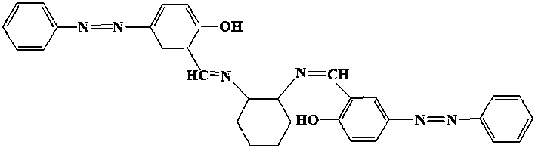
Fig. 1. Structure of ligand H₂L.
Preparation of CuL
The CuL complex was prepared by adding a chloroform solution of ligand (H₂L) (1.5 mmol, 0.29 g) to an ethanolic solution of Cu(CH₃COO)₂.H₂O (1.5 mmol, 0.79 g). The resulting mixture was refluxed around 2 h and a brown precipitate was obtained. Finally, the precipitate of complex was recovered by filtration, washed with ethanol and dried at room temperature. Yield: 85%; M.p. 291ºC, IR (KBr, cm⁻¹): 1110 (C-O), 1463 (C=C), 1608 (CH=N); UV-Vis (CH₃CN) (λ_{max} / nm): 243, 329, 524.
Incorporation of copper(II) in Na-Y (metal exchanged Y-zeolite)
The Cu-Y was prepared using the standard procedure.³⁵ 4 g Na-Y zeolite was suspended in 100 mL distilled water which contained copper(II) nitrate (4 mmol). The mixture was then stirred for 24 h. The solid was filtered and washed with deionized water and dried at room temperature to give a light blue powder of Cu-Y.
Immobilization of H₂L in Cu-Y
An amount of 0.6 g Cu-Y and 0.1 g of ligand H₂L were mixed in 50 mL of acetonitrile and the reaction mixture was refluxed for 7 h in an oil bath with constant stirring. The resulting material was taken out and extracted with acetonitrile using soxhlet extractor to remove unreacted ligand from the cavities of the zeolite as well as those located on the surface of the zeolite along with neat complexes, if any. The non-complexed metal ions present in the zeolite were removed by exchanging with aqueous 0.01 M NaCl solution. The resulting solid was finally washed with hot distilled water till no precipitation of AgCl was observed in reacting filtrate with AgNO₃ solution. This was then dried at 150 ºC for several hours till constant weight was achieved (Fig. 2).
Homogeneous oxidation
To a solution of cyclooctene (10 mmol) and CuL (10 mg, 0.02 mmol) in CH₃CN (5 mL), TBHP (25 mmol) was added. The resulting mixture was refluxed and the products were collected at different time intervals, identified and quantified by GC and verified by GC–MS.
Heterogeneous oxidation
Catalyst (20 mg), cyclooctene (10 mmol) and TBHP (25 mmol) were mixed in 5 mL of CH₃CN and the reaction mixture was refluxed with continuous stirring in an oil bath for 8 h. The products were collected at different time intervals and identified and quantified by GC and verified by GC–MS.
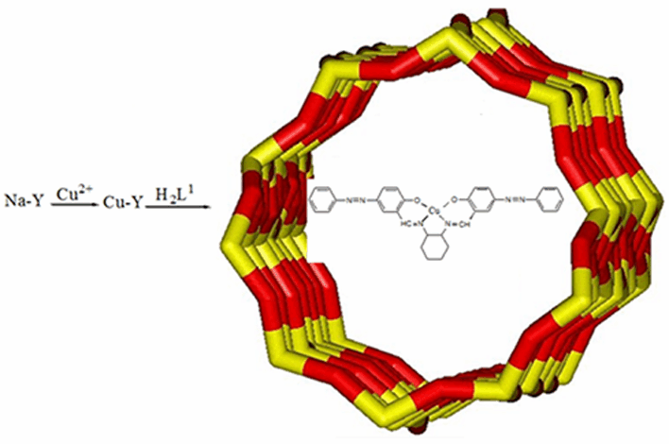 | Fig. 2. Preparation of encapsulated complex in the supercages of zeolite Y.
RESULTS AND DISCUSSION
Spectral studies
In the IR spectrum of the ligand (H₂L), a sharp band due to the azomethine ν(C=N) appears at 1630 cm^{–1}. The bands at 2853 and 2919 cm^{–1} are indicative of the presence of 1,2-cyclohexanediamine.^{36, 37} The band due to ν(C=N) in the H₂L shifts to lower wave numbers and appears at 1608 cm⁻¹ in the CuL. This indicates the involvement of azomethine nitrogen in coordination to the copper center. Also, ν(C=N) of CuL-Y appears at 1633 cm^{–1}. This observation suggest that the structure of CuL in zeolite is not identical to that of the neat complex due to some host-guest interactions. IR spectra of the hybrid material showed an intense band at 1022 cm⁻¹ attributable to the asymmetric stretching of Al–O–Si chain of zeolite. The symmetric stretching and bending frequency bands of Al–O–Si framework of zeolite appear at 789 and 458 cm⁻¹, respectively.³⁸
The X-ray powder diffraction patterns of CuL-Y and Na-Y are essentially similar except the intensities are weaker in the immobilized complex (Fig. 3). This observation indicates that the framework of the zeolite has not structurally changed during immobilization.
The ¹H NMR spectrum of the ligand (H₂L) was recorded using CDCl₃ solvent. Hydrogen atoms of the azomethine groups of H₂L appeared at δ 8.23-8.41 ppm. The hydrogen atoms of the CH2/CH groups in the cyclohexane ring are observed in the δ 1.49–3.46 ppm range. The phenolic OH protons are shown at 10.05 and 11.35 ppm. The aromatic protons are found in the range δ 7.00–7.94 ppm as a multiplet.^{36, 37, 39}
The electronic spectrum of CuL consists of one broad d–d transition band at 524 nm, as is usual for square planar geometry Cu(II). The higher energy bands are due to π–π* or n–π* transition.⁴⁰
The catalytic oxidation of alkenes
The catalytic performance of CuL in the oxidation of cyclooctene, as a model substrate, with H₂O₂ and TBHP as oxidizing agents was investigated. In Table I a series of blank experiments are shown which confirm the presence of catalyst is essential for oxidation of alkenes.
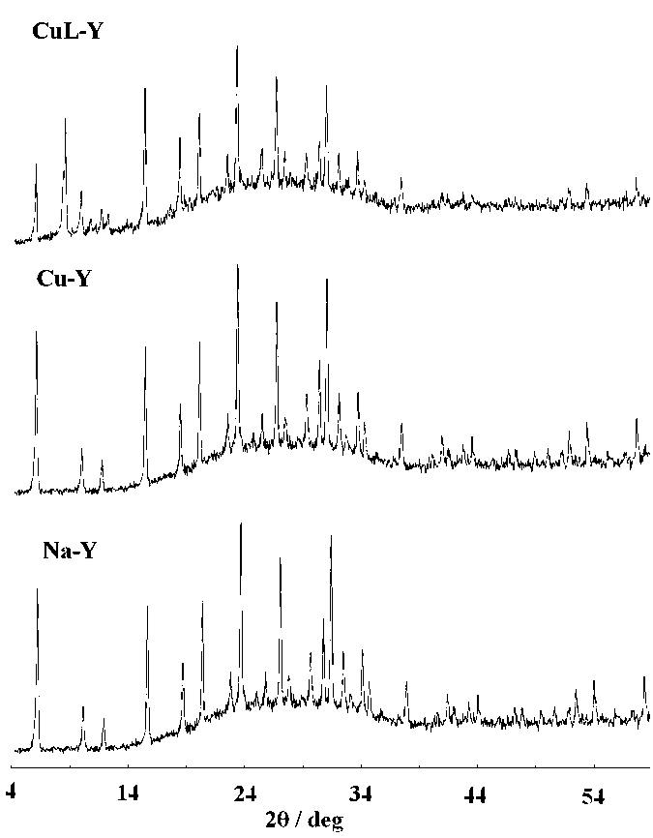 | Fig. 3. XRD patterns of Na-Y, Cu-Y and CuL-Y.
TABLE I. Blank experiments; reaction conditions: substrate, 10 mmol, TBHP, 25 mmol, acetonitrile, 5 ml; the reactions were run for 8 h under reflux
Entry | Alkene | Conversion, % | Selectivity, %
1 | Cycloctene | 5 | 50ª
2 | Cyclohexene | 7 | 64^{b}
3 | Styrene | 5 | 72^{c}
4 | Norbornene | 9 | 58^{d}
ªCyclooctene oxide; ^{b}2-cyclohexen-1-ol; ^{c}benzoic acid; ^{d}norbornene epoxide
Different reaction parameters such as reaction time, reaction solvent, catalyst concentration, the nature and the concentration of oxidant that may affect the conversion and selectivity of the reaction have been optimized.
Fig. 4 illustrates the influence of reaction time in the catalytic oxidation of cyclooctene by CuL. It was observed that oxidation of cyclooctene required 8 h for maximum conversion. The effect of the solvent nature in the catalytic activity of the CuL for oxidation of cyclooctene has been studied. Therefore, acetonitrile, ethanol, dichloromethane and chloroform were used and the highest conversion was obtained in acetonitrile (Table II). The higher conversions in acetonitrile (69 %) relative to the others possibly may be due to the polarity, hydrophilicity, size of the solvent molecule and higher boiling point of acetonitrile.41
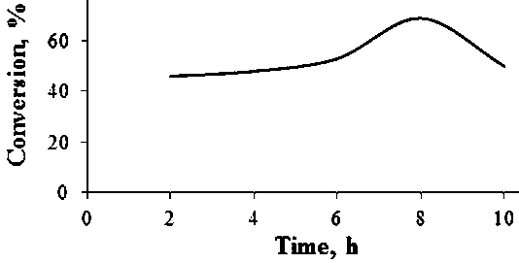 | Fig. 4. The effect of reaction time on the oxidation of cyclooctene. Reaction conditions: cyclooctene, 10 mmol, CuL, 0.02 mmol, TBHP, 25 mmol, solvent, CH₃CN, 5 mL, and reflux.
TABLE II. The influence of various solvents on the oxidation of cyclooctene in the presence of CuL; reaction conditions: cyclooctene, 10 mmol, CuL, 0.02 mmol, TBHP, 25 mmol and solvent, 5 mL; the reactions were run for 8 h under reflux
Entry | Solvent | Conversion  % | Selectivity, %
Entry | Solvent | Conversion  % | Cyclooctene oxide | Cyclooctenone | Other products
1 | Acetonitrile | 69 | 63 | 34 | 3
2 | Ethanol | 28 | 60 | 40 | 0
3 | Chloroform | 18 | 57 | 32 | 11
4 | Dichloromethane | 16 | 49 | 43 | 8
The effect of amount of catalyst has been investigated in the oxidation of cyclooctene. As seen in Table III, the highest conversion was obtained with 0.04 mmol (0.02 g) of catalyst. Different amounts of oxidant (TBHP) have been studied in the oxidation of cyclooctene (Table IV). The results indicate that the highest conversion (89%) was obtained at 1:2.5 molar ratio of cyclooctene to TBHP.
TABLE III. The effect of amount of CuL on the oxidation of cyclooctene; reaction conditions: cyclooctene (10 mmol), CH₃CN (5 mL) and TBHP (25 mmol); the reactions were run for 8 h under reflux
Entry | CuL  mmol | Conversion  % | Selectivity, %
Entry | CuL  mmol | Conversion  % | Cyclooctene oxide | Cyclooctenone | Other products
1 | 0.02 | 69 | 63 | 34 | 3
2 | 0.04 | 89 | 53 | 38 | 9
3 | 0.06 | 80 | 59 | 37 | 4
4 | 0.08 | 66 | 65 | 31 | 4
In order to investigate the effect of the oxidizing agent in the oxidation reaction, H₂O₂ and TBHP were used (Table V). In the presence of TBHP, higher conversion (89%) was obtained.
TABLE IV. The effect of amount of oxidant (TBHP) on the oxidation of cyclooctene in the presence of CuL; reaction conditions: cyclooctene (10 mmol), CuL (0.04 mmol) and CH₃CN (5 mL), the reactions were run for 8 h under reflux
Entry | TBHP  mmol | Conversion  % | Selectivity, %
Entry | TBHP  mmol | Conversion  % | Cyclooctene oxide | Cyclooctenone | Other products
1 | 20 | 59 | 63 | 35 | 9
2 | 25 | 89 | 53 | 38 | 9
3 | 30 | 81 | 59 | 37 | 5
TABLE V. The influence of kind of oxidant on the oxidation of cyclooctene in the presence of CuL; reaction conditions: cyclooctene (10 mmol), CuL (0.04mmol), CH₃CN (5 mL), oxidant (25 mmol); the reactions were run for 8 h under reflux
Entry | Oxidant | Conversion  % | Selectivity, %
Entry | Oxidant | Conversion  % | Cyclooctene oxide | Cyclooctenone | Other products
1 | TBHP | 89 | 53 | 38 | 9
2 | H2O2 | 23 | 100 | 0 | 0
To establish the general applicability of the method, under the optimized conditions, oxidation of different olefins was subjected in the presence of the catalytic amount of CuL and CuL-Y, the results are given in Tables VI and VII.
TABLE VI. Oxidation of olefins using TBHP catalyzed by CuL; reaction conditions: CuL(0.04 mmol), substrate (10 mmol), TBHP (25 mmol), acetonitrile (5 ml); the reactions were run for 8 h under reflux
Alkene | Conversion, % | Selectivity, %
Alkene | Conversion, % | Main product |  | Others
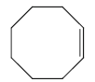 | 89 | a53ª | 38^{b} |  | 9
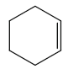 | 63 | 60^{c} | 40^{d} |  | 0
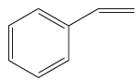 | 46 | 60e | 25^{f} |  | 9
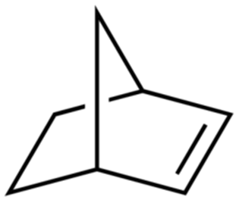 | 13 | 100^{g} | 0 |  | 0
ªCyclooctene oxide; ^{b}cyclooctenone; ^{c}cyclohexene oxide; ^{d}2-cyclohexen-1-ol; ^{e}benzaldehyde; ^{f}benzoic acid; ^{g}norbornene epoxide
Comparison of the catalytic behavior of the copper Schiff base complex encapsulated in the super cages of zeolite-Y and free CuL showed the higher catalytic activity and selectivity of the heterogeneous catalyst with respect to the homogenous one. When the reaction is occurred in the cavity of zeolite, the improvement of catalysis event is probably due to diffusional selectivity of the reaction and potentially increased stability via site isolation.
TABLE VII. Oxidation of olefins using TBHP catalyzed by CuL-Y; reaction conditions: CuL-Y (20 mg), substrate (10 mmol), TBHP (25 mmol), acetonitrile (5 ml); the reactions were run for 8 h under reflux
Alkene | Conversion, % | Selectivity, %
Alkene | Conversion, % | Main product | Others
 | 50 | 68ª | 32^{b}
 | 96 | 80^{c} | 20^{d}
 | 95 | 80e | 20^{f}
 | 92 | 100^{g} | 0
ªCyclooctene oxide; ^{b}cyclooctenone; ^{c}cyclohexene oxide; ^{d}2-cyclohexen-1-ol; ^{e}benzaldehyde; ^{f}benzoic acid; ^{g}norbornene epoxide
CONCLUSIONS
In summary, azo Schiff base ligand (H₂L) derivative of (±)trans-1,2-cyclohexanediamine and 4-(benzeneazo) salicylaldehyde was prepared. The copper Schiff base complex (CuL) encapsulated in the nanopores of zeolite-Y (CuL-Y). Also, these heterogeneous and homogeneous catalysts have been used for oxidation of different alkenes with tert-butyl hydroperoxide. Various reaction parameters were investigated and optimized in the oxidation reaction. The oxidation of cyclooctene, cyclohexene, styrene and norbornene catalyzed by CuL gave 89, 63, 46 and 13% conversion, respectively. Under the heterogeneous condition, the oxidation of these olefins with 50, 96, 96 and 92% conversion was obtained, respectively. It has been observed that CuL-Y has higher catalytic activity and selectivity than CuL. This change was specially seen for norbornene.
Acknowledgement. Financial assistance from Alzahra University is acknowledged.
ИЗВОД
Комплекси бакра(II) са (±)trans-1,2-циклохександиаминазо Шифовом базом као лигандом капсулирани у нанопорама зелита-Y као катализатори оксидације олефина
MARYAM LASHANIZADEGAN, SAHAR SHAYEGAN и MARZIEH SARKHEIL
Department of Chemistry, Faculty of Physics and Chemistry, Al-zahra University P. O. Box
1993893973, Tehran, Iran
Полазећи од 4-(бензеназо)салицилалдехида и (±)trans-1,2-циклохександиамина синтетисани су Шифова база као лиганд (H₂L) и одговарајући Cu(II) комплекс (CuL). За карактеризацију ових једињења употребљене су FT-IR, UV-Vis и ¹H-NMR спектроскопске методе. Бакар(II) комплекс је методом флексибилног лиганда капсулиран у нанопoре зеолита-Y (CuL-Y) и ово капсулирање је испитивано различитим методама. Хомогено и хетергено каталитичко својство овог капсулираног бакар(II) комплекса је употребљено за оксидацију различитих алкена у присуству tert-бутилхидропероксида. Под одговарајућим експерименталним условима, оксидација циклооктена, циклохексена, стирена и норборнена уз каталитичко дејство CuL комплекса се одиграва са 89, 63, 46, односно 13 % конверзијом. Ови олефини су у присуству CuL-Y комплекса веома ефикасно оксидовани са 50, 96, 96, односно 92% конверзијом. Поређена су каталитичка својства CuL и CuL-Y комплекса, при чему је нађено да хетерогена катализа показује веће каталитичко дејство и селективност у односу на хомогену катализу.
(Примљено 8. јула, ревидирано 2. октобра, прихваћено 7. октобра 2015)
REFRENCES
- R. G. Sheldon, B. J. Kochi, Metal-Catalyzed Oxidations of Organic Compounds, Academic Press, New York, 1981, p. 1
- X. Cai, H. Wang, Q. Zhang, J. Tong, Z. Lei, J. Mol. Catal. A: Chem. 383–384 (2014) 217
- M. Lashanizadegan, Z. Zareian, Catal. Lett. 141 (2011) 1698
- H. Schiff, Ann. Suppl. 3 (1864) 343
- W. Zhang, J.L. Loebach, S.R. Wilson, E.N. Jacobsen, J. Am. Chem. Soc. 112 (1990) 2801
- R. Irie, K. Noda, Y. Ito, N. Matsumoto, T. Katsuki, Tetrahedron Lett. 31 (1990) 7345
- E. N. Jacobsen, W. Zhang, M. L. Güler, J. Am. Chem. Soc. 113 (1991) 6703
- L. Cavallo, H. Jacobsen, J. Org. Chem. 68 (2003) 6202
- E. M. McGarrigle and D. G. Gilheany, Chem. Rev. 105 (2005) 1563
- S. C. Catino, E. Farris, Concise Encyclopedia of Chemical Technology, John Wiley, New York, 1985, p. 142
- K. Venkataraman, The Chemistry of Synthetic Dyes, Academic press, New York and London, 1974, p. 46
- K. Hunger, Industrial Dyes: Chemistry, Properties, Applications, Wiley–vch vertag, Germany, 2003, p. 375
- Y. S. Zhou, L. J. Zhung, X. R. Zeng, J. J. Vital, X. Z. You, J. Mol. Struct. 553 (2000) 25
- R. Walker, Food Cosmet. Toxicol. 8 (1970) 659
- S. Patai, The Chemistry of the Hydrazo, Azo and Azoxy Groups, John Wiley, London, 1997, p. 234
- P. Pathak, V. S. Jolly, K. P. Sharma, Orient. J. Chem. 15 (2000) 161
- H. Xu, X. Zeng, Bioorg. Med. Chem. Lett. 20 (2010) 4193
- E. Ispir, Dyes Pigments. 82 (2009) 13
- Y. Chang,Y. Lv, F. Lu, F. Zha, Z. Lei, J. Mol. Catal. A: 320 (2010) 56
- Y. Chang, X. L. Shi, D. M. Zhu, Y. Liu, Polym. Adv. Technol. 19 (2008) 877
- S. Sharma, S. Sinha, Chand, Ind. Eng. Chem. Res. 51 (2012) 8806
- Z. Li, R. Tang, G. Liu, Catal. Lett. 143 (2013) 592
- J. Adhikary, A. Guha, T. Chattopadhyay, D. Das, Inorg. Chim. Acta 406 (2013) 1
- S. Jana, B. Dutta, R. Bera, S. Koner, Langmuir 23 (2007) 2492
- X. Wang, G. Wu, W. Wei, Y. Sun, Catal. Lett. 136 (2010) 96
- Y. Yang, S. Hao, P. Qiu, F. Shang, W. Ding, Q. Kan, Reac. Kinet. Mech. Cat. 100 (2010) 363
- M. Ghorbanloo, S. Rahmani, H. Yahiro, Transition Met. Chem. 38 (2013) 725
- G. Willingh, H. S. Abbo, S. J. J. Titinchi, Catal. Today 227 (2014) 96
- H. S. Abbo, S. J. J. Titinchi, Appl. Catal. A: Gen. 356 (2009) 167
- S. M. Islam, A. S. Roy, P. Mondal, M. Mubarak, S. Mondal, D. Hossain, S. Banerjee, S. C. Santra, J. Mol. Catal. A: Chem. 336 (2011) 106
- F. Heshmatpour, S. Rayati, M. Afghan-Hajiabbas, P. Abdolalian, B. Neumüller, Polyhedron 31 (2012) 443
- H. Hosseini-Monfared, E. Pousaneh, S. Sadighian, S. W. Ng, E. R. T. Tiekink, Z. Anorg, Allg. Chem. 639 (2013) 435
- A. Bezaatpour, M. Behzad, V. Jahed, M. Amiri, Y. Mansoori, Z. Rajabalizadeh, S. Sarvi, Reac. Kinet. Mech. Cat. 107 (2012) 367
- A.Vogel, A Text-Book of Practical Organic Chemistry, Longman, New York, 1956, p. 620
- S. Koner, Chem. Commun. (1998) 593
- M. Aslantas, E. Kendi, N. Demir, A. E. S. Abik, M. Tumer, M. Kertmen, Spectrochim. Acta, Part A 74 (2009) 617
- M. Lashanizadegan, M. Sarkheil, Main Group Chem. 12 (2013) 15
- R. M. Barrer, Hydrothermal Chemistry of Zeolite, Academic Press, New York, 1982
- M. Lashanizadegan, M. Sarkheil, J. Serb. Chem. Soc. 77 (2012) 1589
- C. M. Liu, R. G. Xiong, X.Z. You, Polyhedron 16 (1997) 119
- R. Neumann, C. Abu-Gnim, J. Am. Chem. Soc. 112 (1990) 6025.

* Corresponding author. E-mail: m_lashani@alzahra.ac.ir doi:

