Dear Editor,
We have made corrections to our submission following reviewer’s comments. Three files of revised MS are attached, one file with track changes, other with accepted changes and PDF file. Changes are highlighted in yellow in the PDF file.
Below are the responses to reviewers’ comments:

RESPONSES TO REVIEWER COMMENTS

Title page (page 1, row 1)
Reviewer comment 1: In the title authors state that ‘chemical composition and distribution of the headspace volatiles in twenty-two commercial culinary herbs and spices’ will be showed by chemometric approach. Nevertheless, the samples from two species could not be analyzed by suggested method and of course there is no chemometric data for these samples.
Response 1: The title is changed: Chemical composition and distribution of the headspace volatiles in commercial culinary herbs and spices: chemometric approach. Additionally, number of studied spices was deleted from abstract and through text (pg. 1, row 12;)

Reviewer comment 2: Authors mention that in result (and discussion) section and hypothesize why these species could not give HSV GC profile. On the other hand, authors did not cite and discus other references about HSV of these plants (e.g. Ref. Volatiles from Chives (Allium schoenoprasum) from Acta Chemica Scandinavica 1965 (19) 1327-1332 could find under the link http://actachemscand.org/pdf/acta_vol_19_p1327-1332.pdf).
Response 2: Suggested reference could not be considered and cited in the discussion since very different principle of volatile isolation. Here is the Material and methods from Ref. Volatiles from Chives (Allium schoenoprasum) from Acta Chemica Scandinavica 1965 (19) 1327-1332
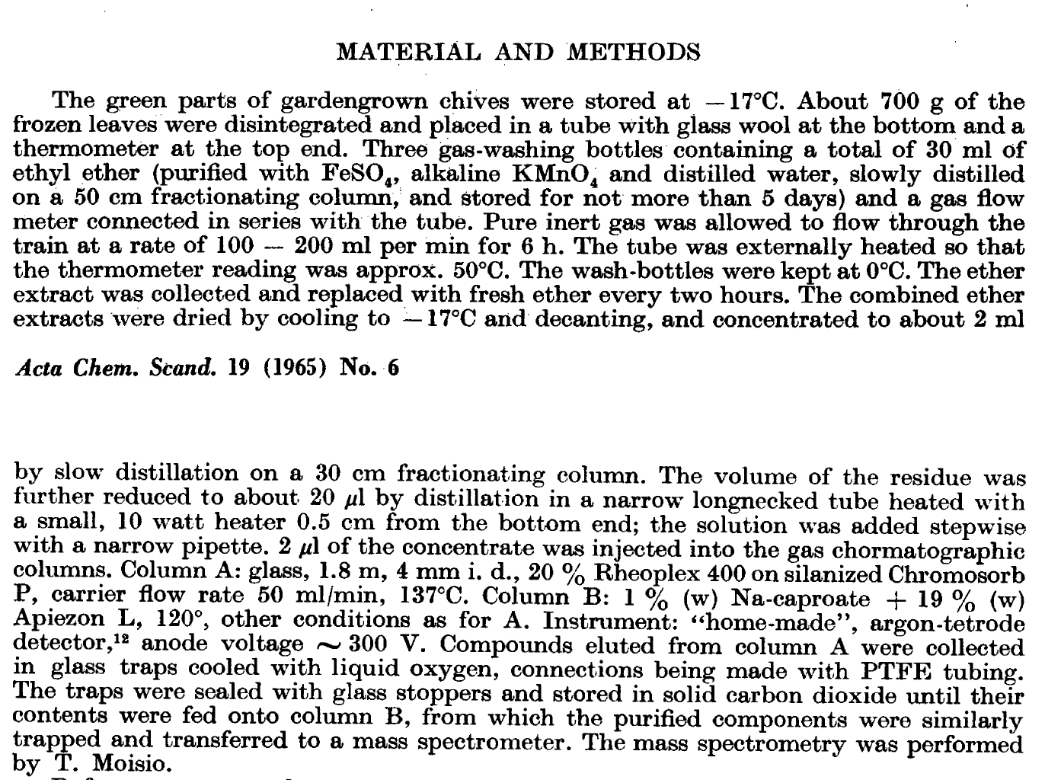

Since very diverse methodologies of volatiles isolation (Different conditions regarding temperature program, duration and possibly increasing the concentration of the sample before GC analysis. As evidenced by the attached Material and methods from suggested reference), authors decide to exclude samples of chives and white mustard from study. Deleted parts: pg. 3, rows 66, 74-75; pg. 4, rows 113-116.

Reviewer comment 3: Base on authors decision (it is recommended, but not mandatory) they could easily omit samples VIII and IX from the title number, and from other places (text, Figure and Tables). In order to make these changes it will be nice not just to omit numbers VIII and IX rather renumber all samples from X-XXII.
Response 3: Authors made changes regarding renumbering of spices and herbs as suggested from I to XX, since chive and white mustard were excluded. Changed parts: Figure 1: pg. 5, rows 137-143; Table SI in Supplementary data.

Reviewer comment 4: Nevertheless, as part of discussion section (in part of scope and limitation of used method not as part of results), authors should mention those limitation for chive and white mustard volatiles, because readers should be aware of it. The results of chemical analysis were clearly discus and in combination with supplementary data readers could have a lot of benefits from it.
Response 4: As already mentioned, the samples of chive and white mustard were excluded from the study, as well as discussion related to them. Deleted sentences from Results and Discussion: pg. 4, rows 113-118.

Reviewer comment 5: Authors state “The conducted PCA visualizes the variability and tendency between the 20 investigated species of spices and culinary herbs” and chemometric analysis was done in a proper way, but author should discus/hypothesize why are results of PCA (chemometric approach) important in this case, and how the results of PCA support at least some of the statements in Conclusion (e.g. In this sense, the results make a connection between the chemical composition/content of volatile compounds in the vapor (HSV) with the first sensation in the process of preparing and consuming food.).
Response 5: The several statements about conducted analysis are implemented in Conclusion implemented in paragraph pg. 9, rows 244-255:
PCA analysis enables visualization of the tendency of relationships, grouping and extraction in the mass of data. Thus, the analysis conducted visualizes the variability of a large number of spices tested with respect to the content of volatile compounds that define the aroma of a commercial product. From the raw data, the observer senses the range of variation in the quality of the spices, while looking at the resulting graphical representation of the PCA has a broader insight into variability.

Reviewer comment 6: In paragraph Plant material – purchased spices and herbs authors named the plan families but names of culinary herbs and spices move to the supplementary. It should be more informative that authors keep names of culinary herbs and spices as part of manuscript.
Response 6: This Table has been moved to the manuscript right below paragraph Plant material – purchased spices and herbs, assigned as Table I. Consequently, all Tables from Supplementary data were renumbered: from Table SI to Table SXXI. Changed parts: pg. 3, rows 78, 84; pg. 4, rows 121-124; pg.9, row 241.

Reviewer comment 7: In supplementary tables (SIII-SXXII) grouping of HSV could be confusing like in Table SVI:
Monoterpenoids 98.5
Hydrocarbons 97.2
Oxygenated 1.3
Sesquiterpenoids 0.4
Hydrocarbons 0.4
This correct naming was used in Table SII and it should be used in all other Tables.
Response 7: Naming in Tables SIII-SXXII (now SII-SXXI) was corrected as suggested.

