Design, synthesis and biological evaluation of new substituted benzofuran-based derivatives via C−H bond activation
BEHJAT POURAMIRI¹, MAHBOOBEH ZAHEDIFAR², ADILEH AYATI³, FARAH POURAMIRI⁴, and MAHDIYEH, AHMADI¹
¹Student Research Committee, Jiroft University of Medical Sciences, Jiroft, Iran;76179
²Department of Chemistry, Faculty of Science, University of Jiroft, Jiroft, 7867161167, Iran.

³Department of Medicinal Chemistry, Faculty of Pharmacy and Pharmaceutical Sciences Research Center, Tehran University of Medical Sciences, Tehran, Iran
⁴Department of Internal Medicine, Afzalipour Hospital, Kerman University of Medical Sciences, Kerman, Iran
Abstract: A series of biologically active disubstituted benzofuran derivatives (3a–d) have been designed and synthesized via C-H bond activation reaction. The chemical structures of all final compounds were confirmed by spectroscopic methods. In vitro anti acetylcholinesterase (AChE) activities of these novel compounds were evaluated and showed low to moderate results. Among them, compounds 3d moderately inhibited AChE activities with 68.12 % values.
Keywords: Carbon-carbon coupling, benzofuran, acetylcholinesterase, Alzheimer’s disease
RUNNING TITLE: SYNTHESIS OF BENZOFURAN DERIVATIVES VIA C-C COUPLING REACTION
INTRODUCTION
Alzheimer’s disease (AD) is a complex neurodegenerative disorder that influences the life quality of the elderly population of the world.¹ Although the patomechanism of AD has not been clearly recognized, the typical pathological marks are amyloid-β (Aβ) deposits, oxidative stress, and decreased levels of acetylcholine (ACh) in the brain.^{2,3} ACh is an important neurotransmitter responsible for memory. Acetylcholinesterase (AChE) and butyrylcholinesterase (BChE) are responsible enzymes for the metabolic hydrolysis of ACh at the cholinergic synapses.^{4,5} Acetylcholinesterase (AChE) inhibitor drugs involving donepezil, rivastigmine and galantamine have been widely used for the treatment of AD.⁶
Numerous investigations have been carried out with a hope to find more efficient anti- acetylcholinesterase compounds with new scaffold, mostly inspired by the dual-binding mode of action in donepezil. Among the large variety of anti-acetylcholinesterase compounds, benzofurans play an important role in the increasing the levels of acetylcholine.^{7,8} In addition, benzofuran derivatives are observed as essential building block in bioactive substances⁹ with broad range of biological and pharmaceutical activities such as anticancer,¹⁰ anti-bacteria (1),¹¹ antifungal (2), ¹² anti-inflammatory,¹³ and angiogenesis¹⁴ (Fig. 1).
Figure 1. Biologically active compounds containing benzofuran framework: 1 - anti-bacterial and 2 - antifungal compound.
On the other hand, the formation of C−C bonds is one of the most common transitions in all areas of organic and drug synthesis.^{15–16} Direct C–H bond activation reaction has become an efficient and clean strategy for C-C coupling because of its conciseness and atom economy according to the concepts of “green chemistry".^{17,18} Different transition-metals are widely used for this purpose.¹⁹ Among them, palladium or palladium complexes is commonly used in many coupling reactions such as Suzuki–Miyaura,²⁰ Sonogashira,²¹ Heck,²² Hiyama²³ and Negishi. ^{24,25}
The binding site on AChE is deep and narrow gorge and consists of several domains: catalytic, anioinic, acylic, oxyanionic, and peripheral anionic.²⁶ The most important of them are the catalytic active site (CAS) where ACh hydrolysis happens and the peripheral anionic site (PAS) placed near the entrance of the gorge and associated with the formation of amyloid plaques.²⁷ Thus, AChE is a target with dual functionality: ACh hydrolysis and amyloid beta (Aβ) peptide aggregation. Because of its importance, AChE is a focus of many intensive and extensive drug discovery studies during the last two decades.²⁸ These studies could be grouped into three directions: lead optimisation of known AChEIs, hybrids between them and search for new scaffolds. One of the most useful structure-based computational methods in the discovery of novel hits binding to a specific target is the molecular docking.²⁹⁻³¹
In the present study, we conducted a docking-based virtual screening Auto Dock database for the novel active inhibitors in order to identify novel hits binding to AChE.
Considering the importance of benzofuran derivatives in acetylcholinesterase inhibitor agents and following our research on the green synthesis of of biologically active heterocycles,³²⁻³⁵ herein, we decided to prepare novel disubstituted benzofurans via direct C−H activation reaction, with hopes to possess better anti acetylcholinesterase potencies (scheme 1).
Scheme 1. Synthesis of novel disubstitud benzofurans via direct C−H bond activation reaction
EXPERIMENTAL
Chemicals
All chemicals were purchased from Merck Company and were used without further puriﬁcation.
Apparatus
Melting points were measured on an Electro thermal 9100 apparatus and are uncorrected. Elemental analyses for C, H and N were performed using a Heraeus CHN-O-Rapid analyzer. IR spectra were recorded on a Shimadzu IR-460 spectrometer. ¹H and ¹³C NMR spectra were measured (DMSO-d₆) with Bruker DRX-500 AVANCE (at 500.1 and 125.8 MHz) with TMS as an internal standard. Benzofuran derivatives 1(a-d) were synthesized according to the reported procedure.²⁶
Biological activity assays
AChE (E.C.3.1.1.7, Type VeS, from Electric eel), Ellman's reagent (DTNB), butyrylthiocholine iodide (BTCh) and acetylthiocholine (ATC) were purchased from Sigma-Aldrich. 5,50-Dithiobis-(2-nitrobenzoic acid) (DTNB), potassium dihydrogen phosphate, dipotassium hydrogen phosphate potassium hydroxide and sodium hydrogen carbonate were purchased from Fluka.
Donepezil (Sigma) was used as reference drug for AChE inhibition. The AChE inhibitory activities of compounds 3(a-d) were determined by using previously reported method.³⁰
General procedure for the synthesis of disubstituted benzofuran 3(a-d):
A mixture of 1-(4-(benzofuran-2-yl)benzyl)derivatives 1(a-d) (1.0 equiv), NH₄OAc (3.0 equiv), aryl halide (1.5 equiv) and Pd(OAc)₂ (10 mol%) in DMF: H₂O (3:2, 5 mL) was refluxed for 8 h. The reaction progress was monitored by TLC using hexane/ ethyl acetate (4:2) as an eluent. After completion of the reaction, the mixture was cooled to room temperature and then H₂O (4 mL) was added. The solid product was filtered, washed with cold water (3 mL) to obtain essentially pure products. The crude product was purified by flash chromatography on silica gel.
The structure of all the products was characterized by IR, ¹H and ¹³C NMR spectra along with elemental analysis data and have been identified by comparison of the spectral data and melting point with those obtained in authentic samples. (see Supplementary Material).

RESULTS AND DISCUSSION
Initially, we have studies the coupling reaction of 1-(4-(benzofuran-2-yl)benzyl)piperidine (1 mmol), and bromobenzen (1.5 mmol) in the absence and presence of Pd(OAc)₂. The catalyzed-reaction was optimized by the various ligand, base and solvents, described in Table 1. In the absence of catalyst, the coupling reaction did not proceed and no product was observed, even after prolonged reaction time (Table 1, entry 1). Since, the synthesis of disubstituted benzofuran failed in the absence of Pd(OAc)₂ catalyst, the effect of Pd(OAc)₂ was also investigated in various conditions (Table 1, entries 2-12). With respect to the solvent system, the best result was obtained using DMF : H₂O (3:2) (Table 1, entry 10). Additionally, we have attempted different ratios of Pd(OAc)₂ (3, 5, 10, 12, and 15 mol%) and observed that 10 mol% of the catalyst was suitable for the optimum conversion (Table 1, entries 10, 11, 12). The increase in the molar ratio of Pd(OAc)₂ also did not improve the yield of reaction (Table 1, entry 12).
Screening the ratios of starting materials revealed that when 1.5 mmol of bromobenzen was used, the reaction proceeded successfully and gave the corresponding product in good yield.
A base screen revealed that NH₄OAc (3 mmol) gave best reactivity in this coupling reaction (Table 1, entries 9,10).
We were pleased to find that the use of the Pd(OAc)₂ in the presence of NH₄OAc and PPh₃ as base and ligand respectively in DMF: H₂O (3:2) provided the desired 1-(4-(3-phenylbenzofuran-2-yl)benzyl)piperidine 3a in 80 % isolated yield (Table 1, entry 10).
Table 1. Screening solvent, ligand and base conditions synthesis of the synthesis of 1-(4-(3-phenylbenzofuran-2-yl)benzyl)piperidine. Reaction condition: 1 mmol of 1-(4-(benzofuran-2-yl)benzyl)piperidine (1a) and 1.5 mmol of bromobenzen (2).
Entry | Content of Pd(OAc)₂, mol% | Ligand | Additive  (content, mol) | Solvent | Time (h) | Yieldª, %
1 | -------------- | ----------- | K₂CO₃ (2) | DMF | 24 | 0
2 | 10 | PPh₃ | K₂CO₃ (3) | Dioxane | 12 | 50
3 | 10 | PPh₃ | K₂CO₃ (3) | Dioxane | 14 | 55
4 | 5 | PPh₃ | Na₂CO₃ (3) | Dioxane : H₂O (2:1) | 12 | 50
5 | 5 | 1,10-Phenanthroline | K₂CO₃ (3) | DMF | 24 | 20
6 | 10 | 1,10-Phenanthroline | Na₂CO₃ (2) | DMF : H₂O (2:1) | 24 | 30
7 | 5 | PPh₃ | Cs₂CO₃ (3) | DMA | 24 | 40
8 | 10 | 10-Phenanthroline | Cs₂CO₃ (3) | DMF | 24 | 30
9 | 15 | PPh₃ | NH₄OAc (2) | Dioxane | 24 | 60
10 | 10 | PPh₃ | NH₄OAc (3) | DMF : H₂O (3:2) | 12 | 80
11 | 5 | PPh₃ | NH₄OAc (3) | DMF : H₂O (3:2) | 14 | 70
12 | 12 | PPh₃ | NH₄OAc (3) | DMF : H₂O (3:2) | 12 | 80
ªYields refer to pure isolated yields.
Furthermore, we have also examined the coupling reaction 1-(4-(benzofuran-2-yl)benzyl)piperidine, with iodobenzen in the same conditions. Interestingly, yield of the compound 3a increases to 88 % after 8 hours reflux (Table 2, entry 1).
Encouraged by this result, we synthesized several disubstituted benzofuran by the reaction of various substituted benzofurans with aryl halides via the coupling reaction. The results are presented in Table 2.

Table 2. Synthesis of 2,3-diarylbenzofurans.
Entry | Ar-X | Product | Time, h | Yieldª, %
1 |  |  | 8 | 88
2 |  |  | 12 | 80
3 |  |  | 11 | 67
4 |  |  | 12 | 65
5 |  |  | 10 | 78
6 |  |  | 12 | 72
7 |  |  | 8 | 70
8 |  |  | 10 | 75
9 |  |  | 8 | 70
10 |  |  | 16 | 68
11 |  |  | 24 | 65
ª Isolated yields.
In following, the newly synthesis compounds 3a-d were evaluated for their AChE inhibitory activities using modified colorimetric Ellman’s method ²⁹. The stock solutions of the target compounds were prepared in a mixture of DMSO (1 mL) and ethanol (9 mL) and diluted with 0.1 M MKH₂PO₄/K₂HPO₄ buffer (pH 8.0) to obtain final concentrations. 20 mL of substrate (acetylthiocholine iodide 0.075 M) was added to the test solution to obtain final concentration of 466 mM. Spectrophotometric measurements were performed on a UV Unico Double Beam Spectrophotometer.
The inhibitory potency of the synthesized compounds 3a-g toward AChE were determined, and compared with donepezil as the reference drug, reported in table 3.
These results show heterocycles containing nitrogen were more favorable than cycles with more than one heteroatom. In this regard, compounds 3d with piperazine substituent, exhibited better activities against the AChE with 68.12 % inhibition. No improvements were observed in thiomorpholine, morpholine and piperidine derivatives (table 3).
Table 3. In vitro inhibitory activity of compounds 3a-g against AChE.
Entry | Compounds | AChE IC50, μM ª
1 |  | 24.46±1.8
2 |  | 34.25±2.1
3 |  | 38.12±3.1
4 |  | 68.12±3.5
5 |  | 39.12±3.2
6 |  | 56.36±3.4
7 |  | 54.35±3.3
ª Data are expressed as Mean ± SD (three independent experiments).
Molecular docking analysis
The modeling study was performed in this paper showed great interactions between 3a, 3b, 3c, 3d and human acetylcholinesterase. The lowest-energy complexes were accepted as the calculated binding energy and its K_{i} (inhibition constant) value was used to define the binding affinity of the inhibitors and listed in Table1. The geometry of docking obtained with each of them with human acetylcholinesterase as shown in (Figure 1A, B, C and D), respectively. The four inhibitors were able to form hydrogen bonds (HBs) with the amino acid residues of the enzyme, hydrophobic and electrostatic interactions. In addition, the molecular docking results showed that other amino acids residues are involved in the interactions with the four inhibitors.
Table 4. AutoDock results (free binding energy, inhibition constant and intremolecular energy) of the novel inhibitors docked with acetylcholinesterase.
Intermolecular energy, Kcal/mol | K_{i} / nM | Free binding energy, Kcal/mol
-11.30 | 14.33 | -10.70 | 3a
-10.78 | 34.45 | -10.18 | 3b
-10.72 | 37.8 | -10.12 | 3c
-11.61 | 8.39 | -11.02 | 3d
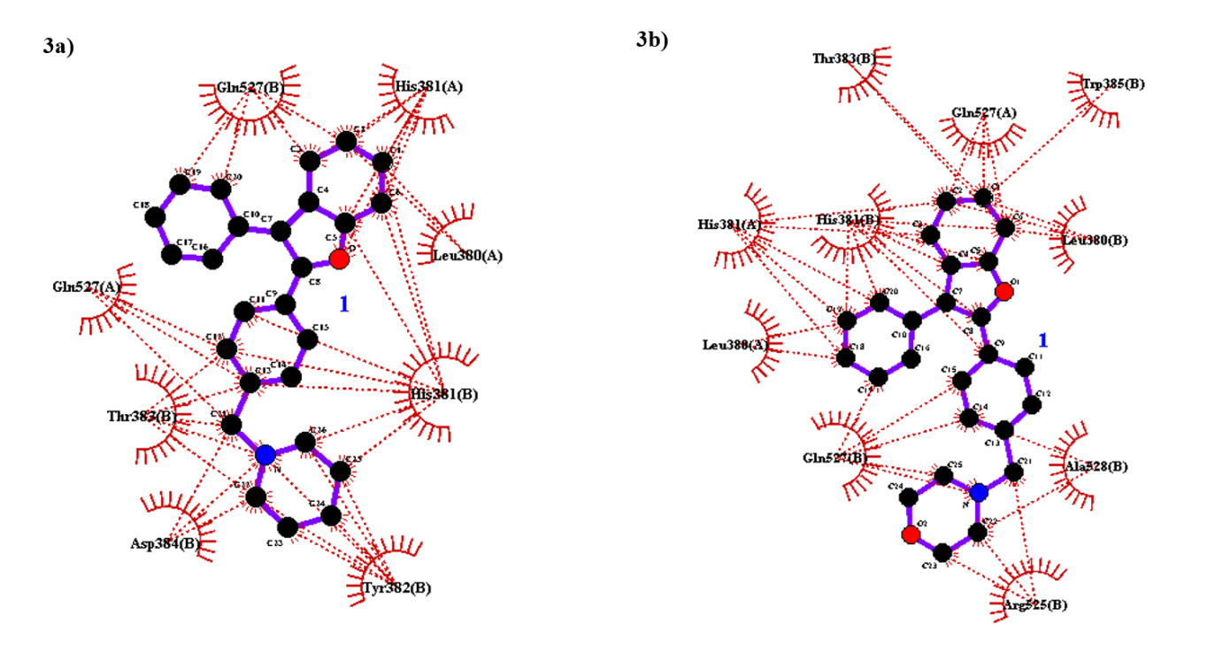
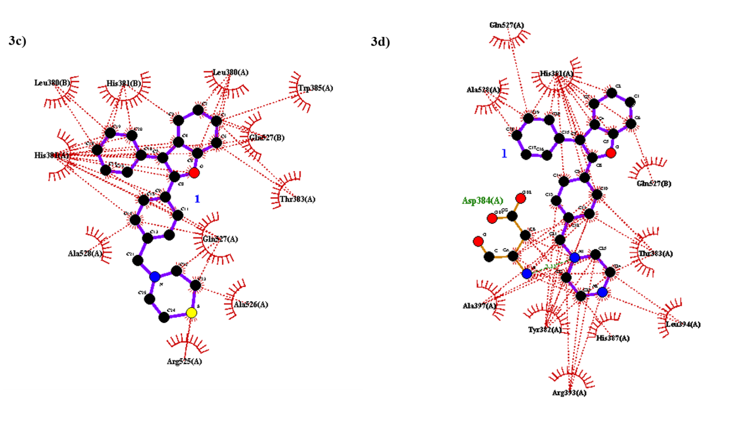
Fig 2. LIGPLOT of hydrophobic and polar contacts between 3a; 3b; 3c and 3d and amino acid residues in acetylcholinesterase.
During all these interactions, the hydrogen bond between ligand and enzyme is the most important, because in most cases it can decide the binding strength and the location of ligand, whereas the hydrophobic interaction of some certain groups can affect the inhibition specialty to a large extent. The calculated interaction energies of all complexes are in negative, which shows that 3a, 3b, 3c and 3d are potent inhibitor of acetylcholinesterase. In agreement with experimental results, the inhibitory potency of the synthesized compounds 3d toward AChE was higher than the other compounds.
CONCLUSIONS
In summary, we have designed and synthesized novel disubstituted benzofuran derivatives via carbon-carbon coupling reaction. The preliminary biological activities screening tests indicated that these synthesized derivatives 3(a-g) were identified as moderate anti-acethylcolinestrase active. These researches showed the key role of benzofuran scaffold in AChE inhibition.
ACKNOWLEDGMENT

We gratefully acknowledge the funding support received for this project from the Student Research Committee of Jiroft University of Medical Sciences.
REFERENCES

- N. C. Berchtold, C. W. Cotman, Neurobiol. Aging. 19 (1998) 173 (https://doi.org/10.1016/S0197-4580(98)00052-9)
- W. Thies, L. Bleiler, Alzheimer’s Dement. 9 (2012) 208 (https://doi.org/10.1016/j.jalz.2012.02.001)
- H. Feorstl, A. Kurz, Eur Arch Psychiatry Clin Neurosci. 249 (1999) 288 (https://doi.org/10.1007/s004060050101)
- C. G. Ballard, N. H. Greig, A. L. Guillozet-Bongaarts, A. Enz, S. Darvesh, Curr. Alz. Res. 2 (2005) 307 (https://doi.org/10.2174/1567205054367838)
- A. Mack, A. Robitzki, Prog. Neurobiol. 60 (2000) 607 (https://doi.org/10.1016/S0301-0082(99)00047-7)
- L. L. Shen, G. X. Liu, Y. Tang, Acta Pharmacol Sin. 28 (2007) 2053 (https://doi.org/10.1111/j.1745-7254.2007.00664.x)
- F. Baharloo, M. H. Moslemin, H. Nadri, A. Asadipour, M. Mahdavi, S. Emami, L. Firouzpour, R. Mohebat,A. Shafiee, A. Foroumadi, Eur. J. Med. Chem. 93 (2015) 196 (https://doi.org/10.1016/j.ejmech.2015.02.009)
- J. H. Byun, H. Y. Kim, Y. S. Kim, I. M. Jung, D. J. Kim, W. K. Lee, K. H. Yoo, Bioorg. Med. Chem. Lett. 18 (2008) 5591 (https://doi.org/10.1016/j.bmcl.2008.08.111)
- H. Khanam, Shamsuzzaman. Eur. J. Med. Chem. 97 (2015) 483 (https://doi.org/10.1016/j.ejmech.2014.11.039)
- W. C. Wan, W. Chen, L. X. Liu, Y. Li, L. J. Yang, X. Y. Deng, H. Bin Zhang, X. D. Yang, Med. Chem. Res. 23 (2014) 1599 (https://doi.org/10.1007/s00044-013-0760-8)
- B. F. Abdel-Wahab, H. A. Abdel-Aziz, E. M. Ahmed, Euro. J. Med. Chem. 44 (2009) 2632 (https://doi.org/10.1016/j.ejmech.2008.09.029)
- C. K. Ryu, A. L. Song, J. Y. Lee, J. A. Hong, J. H. Yoon, A. Kim, Bioorg. Med. Chem. Lett. 20 (2010) 6777 (https://doi.org/10.1016/j.bmcl.2010.08.129)
- P. Yadav, P. Singh, A. K. Tewari, Bioorg. Med. Chem. Lett. 24 (2014) 2251 (https://doi.org/10.1016/j.bmcl.2014.03.087)
- Y. Chen, S. Chen, X. Lu, H. Cheng, Y. Oua, H. Cheng, G. C. Zhou, Bioorg. Med. Chem. Lett. , 19 (2009) 1851 (https://doi.org/10.1016/j.bmcl.2009.02.082)
- J. P. Corbet, G. Mignani, Chem. Rev. 106 (2006) 2651 (https://doi.org/10.1021/cr0505268)
- C. C. C. Johansson Seechurn, M. O. Kitching, T. J. Colacot, V. Snieckus, Angew. Chem. , Int. Ed. 51 (2012) 5062 (https://doi.org/10.1002/anie.201107017)
- (a) C. Fischmeister, H. Doucet, Green. Chem. 13 (2011) 741 (https://doi.org/10.1039/C0GC00885K (b) T. W. Lyons, M. S. Sanford, Chem. Rev. 110 (2010) 1147 (https://doi.org/10.1021/cr900184e)
- S. L. Tang, R. L. Smith, M. Poliakoff, Green Chem. 7 (2005) 761 (https://doi.org/10.1039/B513020B)
- X. Chen, K. M. Engle, D. H. Wang, J. Q. Yu, Angew. Chem. , Int. Ed. 48 (2009) 5094 (b) M. Zhou, R. H. Crabtree, Chem. Soc. Rev. 40 (2011) 1875 (https://doi.org/10.1039/C0CS00099J)
- A. Suzuki, Pure. Appl. Chem. 57 (1985) 1749 (https://doi.org/10.1351/pac198557121749)
- K. Sonogashira, J. Organometal. Chem. 653 (2002) 46 (https://doi.org/10.1016/S0022-328X(02)01158-0)
- R. F. Heck, Org. React. 27 (1982) 345 (https://doi.org/10.1002/0471264180.or027.02)
- Y. Nakao, T. Hiyama, Chem. Soc. Rev. 40 (2011) 4893 (https://doi.org/10.1039/C1CS15122C)
- E. Negishi, Acc. Chem. Res. 15 (1982) 340 (https://doi.org/10.1021/ar00083a001)
- E. Erdik, Tetrahedron, 48 (1992) 9577 (https://doi.org/10.1016/S0040-4020(01)81181-9)
- A. Ordentlich, D. Barak, C. Kronman, N. Ariel, Y. Segall, B. Velan, A. Shafferman, J. Biol. Chem. , 273 (1998) 19509 (https://www.jbc.org/content/273/31/19509.long)
- F. J. Carvajal, N. C. Inestrosa, Front Mol. Neurosci. 4 (2011) 199 (https://doi.org/10.3389/fnmol.2011.00019)
- M. Rosini, E. Simoni, A. Minarini, C. Melchiorre, Neurochem. Res. 39 (2014) 1914 (https://doi.org/10.1007/s11064-014-1250-1)
- M. Yoosefian, N. Etminan, A. Juan, E. Mirhaji, RSC Advances 10 (2020) 2650 (https://doi.org/10.1039/C9RA09243A)
- G. M. Morris, R. Huey, W. Lindstrom, M. F. Sanner, R. K. Belew, D. S. Goodsell, A. J. Olson, J. Comput. Chem. 30 (2009) 2785 (https://doi.org/10.1002/jcc.21256)
- M. Yoosefian, N. Etminan, Amino Acids 50 (2018) 653-661 (https://doi.org/10.1007/s00726-018-2552-4)
- B. Pouramiri, M. Mahdavi, S. Moghimi, L. Firoozpour, H. Nadri, A. A. Moradi, E. Tavakolinejad-Kermani, A. Asadipour, A. Foroumadi, Lett. Drug. Des. Discov. 13 (2016) 897-902.
- B. Pouramiri, S. Moghimi, M. Mahdavi, H. Nadri, A. Moradi, E. Tavakolinejad‐Kermani, L. Firoozpour, A. Asadipour, A. Foroumadi, Chem. Biol. Drug. Des. 89 (2017) 783 (https://doi.org/10.1111/cbdd.12902)
- B. Pouramiri, E. T. Kermani, M. Khaleghi, J. Iran. Chem. Soc. 14 (2017) 2331 (https://doi.org/10.1007/s13738-017-1169-y)
- B. Pouramiri, M. Shirvani, E. T. Kermani, J. Serb. Chem. Soc. 82 (2017) 483 (https://doi.org/10.2298/JSC160803034P)
- H. Nadri, H. Pirali-Hamedani, M. Shekarchi, M. Abdollahi, V. Sheibani, M. Amanlou, A. Shafiee, A. Foroumadi, Bioorg. Med. Chem. 18 (2010) 6360 (https://doi.org/10.1016/j.bmc.2010.07.012).

Corresponding author. E-mail: etavakoly@yahoo.com

