DFT study and NBO analysis of solvation/substituent effects of 3-phenylbenzo[d]thiazole-2(3H)-imine derivatives

MARZIEH MIAR¹, ABOLFAZL SHIROUDI²∗, KHALIL POURSHAMSIAN^{1**},
AHMAD REZA OLIAEY¹ and FARHAD HATAMJAFARI¹

¹ Chemistry Department, Tonekabon Branch, Islamic Azad University, Tonekabon, Iran and
² Young Researchers and Elite Club, East Tehran Branch, Islamic Azad University, Tehran, Iran

SUPPLEMENTARY MATERIAL

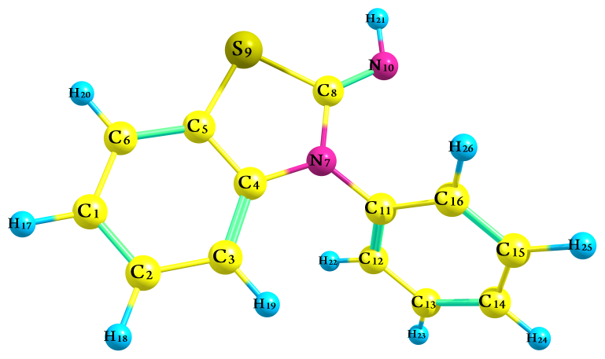

Fig. S-1a. 3-phenylbenzo[d]thiazol-2(3H)-imine [X=H]

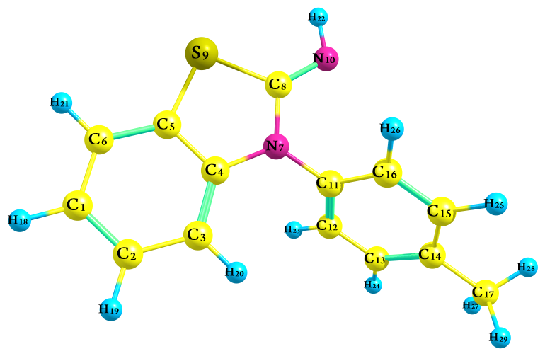

Fig. S-1b. 3-(p-tolyl)benzo[d]thiazol-2(3H)-imine [X=CH₃]

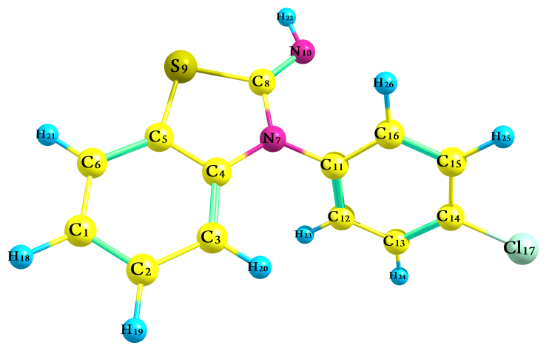

Fig. S-1c. 3-(4-chlorophenyl)benzo[d]thiazol-2(3H)-imine [X=Cl]

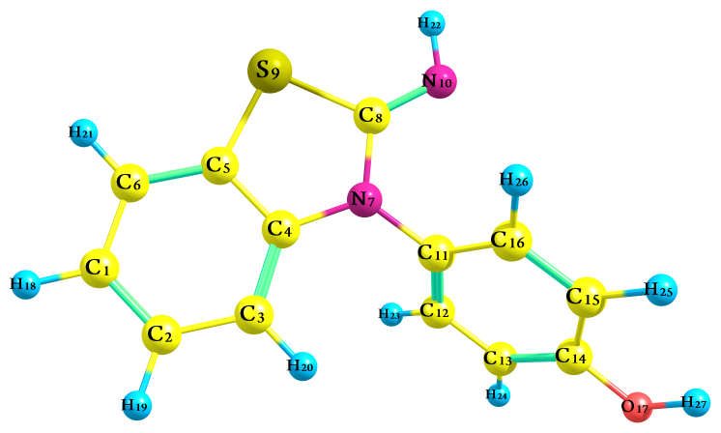

Fig. S-1d. 4-(2-iminobenzo[d]thiazol-3(2H)-yl)phenol [X=OH]

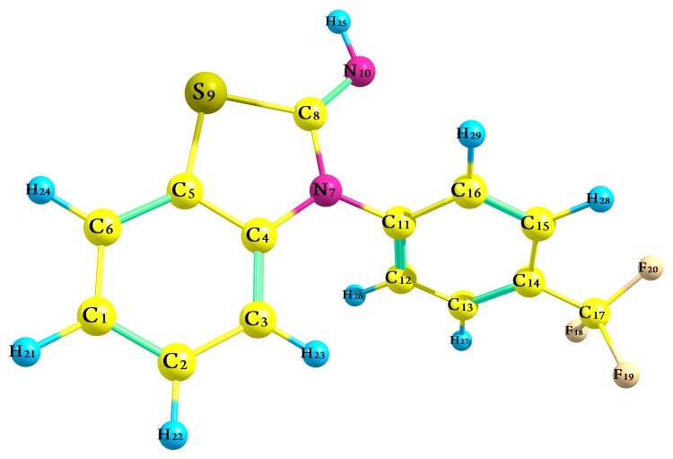

Fig. S-1e. 3-(4-(trifluoromethyl)phenyl)benzo[d]thiazol-2(3H)-imine [X=CF₃]

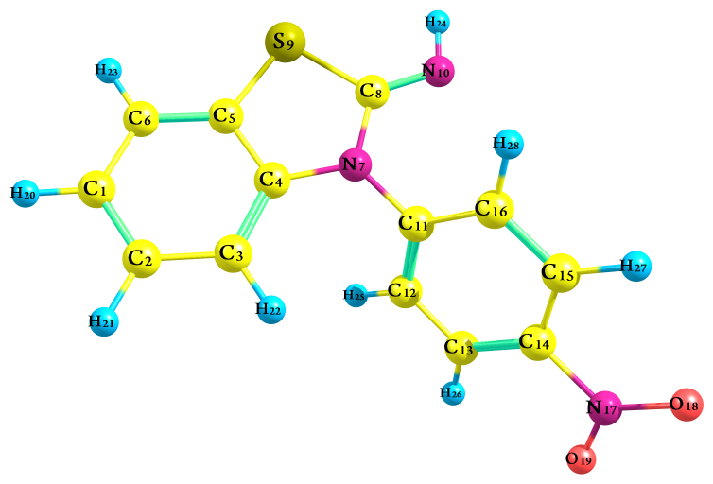

Fig. S-1f. 3-(4-nitrophenyl)benzo[d]thiazol-2(3H)-imine [X=NO₂]

Fig. S-1. The optimized molecular structure of the compounds 1−6.
HOMO (X=H): E = −7.0096 eV LUMO (X=H): E = −0.1510 eV
HOMO (X=CH₃): E = −6.9487 eV LUMO (X=CH₃): E = −0.1524 eV
HOMO (X=Cl); E = −7.1438 eV LUMO (X=Cl); E = −0.3023 eV
HOMO (X=OH); E = −6.9539 eV LUMO (X=OH); E = −0.2171 eV
HOMO (X=CF₃); E = −7.2788 eV LUMO (X=CF₃); E = −0.6332 eV
HOMO (X=NO₂); E = −7.4243 eV LUMO (X=NO₂); E = −1.7755 eV

Fig. S-2.The shapes of the HOMO and LUMO orbitals of compounds 1−6 at the M06-2x/6-311++G** level of theory.

Table S-I. Calculated NBO charges on ring atoms of the 3-substituted 3-phenylbenzo[d]thiazole-2(3H)-imine and its derivatives

Table S-Ia. Summary of natural population analysis [X=H]

Atom | No | Natural  charge | Natural population
 |  |  | Core | Valence | Rydberg | Total
C | 1 | -0.22296 | 1.99921 | 4.20621 | 0.01753 | 6.22296
C | 2 | -0.19443 | 1.99923 | 4.17818 | 0.01702 | 6.19443
C | 3 | -0.24133 | 1.99911 | 4.22807 | 0.01415 | 6.24133
C | 4 | 0.17376 | 1.99892 | 3.80749 | 0.01983 | 5.82624
C | 5 | -0.20438 | 1.99882 | 4.18611 | 0.01945 | 6.20438
C | 6 | -0.20846 | 1.99908 | 4.19084 | 0.01855 | 6.20846
N | 7 | -0.51340 | 1.99916 | 5.48747 | 0.02677 | 7.51340
C | 8 | 0.33961 | 1.99929 | 3.62186 | 0.03924 | 5.66039
S | 9 | 0.30698 | 9.99899 | 5.65736 | 0.03667 | 15.69302
N | 10 | -0.72158 | 1.99938 | 5.69661 | 0.02559 | 7.72158
C | 11 | 0.15776 | 1.99899 | 3.82156 | 0.02169 | 5.84224
C | 12 | -0.21253 | 1.99909 | 4.19824 | 0.0152 | 6.21253
C | 13 | -0.20290 | 1.99921 | 4.18661 | 0.01708 | 6.20290
C | 14 | -0.20373 | 1.99921 | 4.18763 | 0.01689 | 6.20373
C | 15 | -0.19844 | 1.99921 | 4.18239 | 0.01684 | 6.19844
C | 16 | -0.18327 | 1.99908 | 4.16832 | 0.01586 | 6.18327
H | 17 | 0.21462 | 0.00000 | 0.78399 | 0.00139 | 0.78538
H | 18 | 0.21366 | 0.00000 | 0.78492 | 0.00143 | 0.78634
H | 19 | 0.23215 | 0.00000 | 0.76618 | 0.00167 | 0.76785
H | 20 | 0.22069 | 0.00000 | 0.77779 | 0.00152 | 0.77931
H | 21 | 0.35294 | 0.00000 | 0.64442 | 0.00264 | 0.64706
H | 22 | 0.22445 | 0.00000 | 0.77402 | 0.00153 | 0.77555
H | 23 | 0.21352 | 0.00000 | 0.78497 | 0.0015 | 0.78648
H | 24 | 0.21247 | 0.00000 | 0.78613 | 0.0014 | 0.78753
H | 25 | 0.21386 | 0.00000 | 0.78463 | 0.00151 | 0.78614
H | 26 | 0.23094 | 0.00000 | 0.76748 | 0.00158 | 0.76906

Table S-Ib. Summary of natural population analysis [X=CH₃]

Atom | No | Natural  charge | Natural population
 |  |  | Core | Valence | Rydberg | Total
C | 1 | -0.22365 | 1.99921 | 4.20688 | 0.01756 | 6.22365
C | 2 | -0.19486 | 1.99923 | 4.17861 | 0.01703 | 6.19486
C | 3 | -0.24142 | 1.99911 | 4.22812 | 0.01419 | 6.24142
C | 4 | 0.17432 | 1.99892 | 3.80681 | 0.01995 | 5.82568
C | 5 | -0.20499 | 1.99883 | 4.18676 | 0.01940 | 6.20499
C | 6 | -0.20875 | 1.99908 | 4.19113 | 0.01855 | 6.20875
N | 7 | -0.51206 | 1.99916 | 5.48597 | 0.02694 | 7.51206
C | 8 | 0.34003 | 1.99929 | 3.62143 | 0.03925 | 5.65997
S | 9 | 0.3057 | 9.99899 | 5.65856 | 0.03676 | 15.69430
N | 10 | -0.722 | 1.99938 | 5.69699 | 0.02563 | 7.72200
C | 11 | 0.14786 | 1.99898 | 3.83152 | 0.02164 | 5.85214
C | 12 | -0.20329 | 1.99909 | 4.18875 | 0.01545 | 6.20329
C | 13 | -0.20406 | 1.99910 | 4.18889 | 0.01607 | 6.20406
C | 14 | -0.02914 | 1.99910 | 4.01533 | 0.01471 | 6.02914
C | 15 | -0.1987 | 1.99910 | 4.18375 | 0.01585 | 6.19870
C | 16 | -0.17451 | 1.99909 | 4.15929 | 0.01614 | 6.17451
C | 17 | -0.59855 | 1.99933 | 4.58982 | 0.00940 | 6.59855
H | 18 | 0.21433 | 0.00000 | 0.78428 | 0.00140 | 0.78567
H | 19 | 0.2133 | 0.00000 | 0.78527 | 0.00143 | 0.78670
H | 20 | 0.23211 | 0.00000 | 0.76621 | 0.00168 | 0.76789
H | 21 | 0.2204 | 0.00000 | 0.77807 | 0.00152 | 0.77960
H | 22 | 0.35237 | 0.00000 | 0.64498 | 0.00265 | 0.64763
H | 23 | 0.22345 | 0.00000 | 0.77504 | 0.00151 | 0.77655
H | 24 | 0.20964 | 0.00000 | 0.78875 | 0.00162 | 0.79036
H | 25 | 0.21002 | 0.00000 | 0.78838 | 0.00159 | 0.78998
H | 26 | 0.23004 | 0.00000 | 0.76839 | 0.00157 | 0.76996
H | 27 | 0.21035 | 0.00000 | 0.78821 | 0.00144 | 0.78965
H | 28 | 0.21452 | 0.00000 | 0.78403 | 0.00145 | 0.78548
H | 29 | 0.21756 | 0.00000 | 0.78095 | 0.00148 | 0.78244

Table S-Ic. Summary of natural population analysis [X=Cl]

Atom | No |  | Natural  charge | Natural population
 |  |  |  | Core | Valence | Rydberg | Total
C |  | 1 | -0.22109 | 1.99921 | 4.20440 | 0.01747 | 6.22109
C |  | 2 | -0.19340 | 1.99923 | 4.17716 | 0.01702 | 6.19340
C |  | 3 | -0.24186 | 1.99911 | 4.22859 | 0.01416 | 6.24186
C |  | 4 | 0.17195 | 1.99892 | 3.80921 | 0.01991 | 5.82805
C |  | 5 | -0.20450 | 1.99882 | 4.18622 | 0.01946 | 6.20450
C |  | 6 | -0.20733 | 1.99908 | 4.18973 | 0.01852 | 6.20733
N |  | 7 | -0.51398 | 1.99916 | 5.48806 | 0.02675 | 7.51398
C |  | 8 | 0.33817 | 1.99929 | 3.62324 | 0.03930 | 5.66183
S |  | 9 | 0.31156 | 9.99898 | 5.65272 | 0.03674 | 15.68844
N |  | 10 | -0.72168 | 1.99938 | 5.69671 | 0.02559 | 7.72168
C |  | 11 | 0.15530 | 1.99899 | 3.82434 | 0.02138 | 5.84470
C |  | 12 | -0.19563 | 1.99909 | 4.18159 | 0.01495 | 6.19563
C |  | 13 | -0.22392 | 1.99902 | 4.20656 | 0.01834 | 6.22392
C |  | 14 | -0.04327 | 1.99862 | 4.02155 | 0.02311 | 6.04327
C |  | 15 | -0.21928 | 1.99902 | 4.20215 | 0.01811 | 6.21928
C |  | 16 | -0.16629 | 1.99909 | 4.15137 | 0.01583 | 6.16629
Cl |  | 17 | 0.01100 | 9.99963 | 6.96890 | 0.02047 | 16.98900
H |  | 18 | 0.21554 | 0.00000 | 0.78307 | 0.00139 | 0.78446
H |  | 19 | 0.21468 | 0.00000 | 0.78390 | 0.00142 | 0.78532
H |  | 20 | 0.23127 | 0.00000 | 0.76703 | 0.00170 | 0.76873
H |  | 21 | 0.22148 | 0.00000 | 0.77700 | 0.00151 | 0.77852
H |  | 22 | 0.35456 | 0.00000 | 0.64283 | 0.00261 | 0.64544
H |  | 23 | 0.22930 | 0.00000 | 0.76922 | 0.00149 | 0.77070
H |  | 24 | 0.23032 | 0.00000 | 0.76788 | 0.00180 | 0.76968
H |  | 25 | 0.23065 | 0.00000 | 0.76756 | 0.00179 | 0.76935
H |  | 26 | 0.23645 | 0.00000 | 0.76200 | 0.00155 | 0.76355

Table S-Id. Summary of natural population analysis [X=OH]

Atom | No | Natural  charge | Natural population
 |  |  | Core | Valence | Rydberg | Total
C | 1 | -0.22360 | 1.99921 | 4.20685 | 0.01755 | 6.22360
C | 2 | -0.19449 | 1.99923 | 4.17824 | 0.01703 | 6.19449
C | 3 | -0.24189 | 1.99911 | 4.22854 | 0.01423 | 6.24189
C | 4 | 0.17411 | 1.99892 | 3.80697 | 0.01999 | 5.82589
C | 5 | -0.20493 | 1.99882 | 4.18669 | 0.01942 | 6.20493
C | 6 | -0.20861 | 1.99908 | 4.19098 | 0.01856 | 6.20861
N | 7 | -0.51070 | 1.99916 | 5.48458 | 0.02695 | 7.51070
C | 8 | 0.33997 | 1.99929 | 3.62146 | 0.03928 | 5.66003
S | 9 | 0.30587 | 9.99899 | 5.65844 | 0.03671 | 15.69413
N | 10 | -0.72398 | 1.99938 | 5.69893 | 0.02567 | 7.72398
C | 11 | 0.12327 | 1.99898 | 3.85598 | 0.02178 | 5.87673
C | 12 | -0.18724 | 1.99910 | 4.17325 | 0.01489 | 6.18724
C | 13 | -0.25242 | 1.99911 | 4.23610 | 0.01721 | 6.25242
C | 14 | 0.32693 | 1.99883 | 3.65071 | 0.02353 | 5.67307
C | 15 | -0.28023 | 1.99911 | 4.26460 | 0.01652 | 6.28023
C | 16 | -0.16015 | 1.99910 | 4.14484 | 0.01621 | 6.16015
O | 17 | -0.68134 | 1.99976 | 6.66855 | 0.01302 | 8.68134
H | 18 | 0.21448 | 0.00000 | 0.78412 | 0.00140 | 0.78552
H | 19 | 0.21358 | 0.00000 | 0.78499 | 0.00143 | 0.78642
H | 20 | 0.23186 | 0.00000 | 0.76646 | 0.00168 | 0.76814
H | 21 | 0.22049 | 0.00000 | 0.77798 | 0.00152 | 0.77951
H | 22 | 0.35246 | 0.00000 | 0.64489 | 0.00265 | 0.64754
H | 23 | 0.22536 | 0.00000 | 0.77316 | 0.00148 | 0.77464
H | 24 | 0.22770 | 0.00000 | 0.77064 | 0.00165 | 0.77230
H | 25 | 0.21035 | 0.00000 | 0.78779 | 0.00186 | 0.78965
H | 26 | 0.23175 | 0.00000 | 0.76669 | 0.00156 | 0.76825
H | 27 | 0.47143 | 0.00000 | 0.52407 | 0.00450 | 0.52857

Table S-Ie. Summary of natural population analysis [X=CF₃]

Atom | No | Natural  charge | Natural population
 |  |  | Core | Valence | Rydberg | Total
C | 1 | -0.21891 | 1.99921 | 4.20229 | 0.01742 | 6.21891
C | 2 | -0.19265 | 1.99922 | 4.17641 | 0.01701 | 6.19265
C | 3 | -0.24128 | 1.99911 | 4.22802 | 0.01414 | 6.24128
C | 4 | 0.16989 | 1.99892 | 3.81136 | 0.01983 | 5.83011
C | 5 | -0.20340 | 1.99882 | 4.18507 | 0.01951 | 6.20340
C | 6 | -0.20667 | 1.99908 | 4.18910 | 0.01849 | 6.20667
N | 7 | -0.51524 | 1.99916 | 5.48973 | 0.02635 | 7.51524
C | 8 | 0.33725 | 1.99929 | 3.62415 | 0.03930 | 5.66275
S | 9 | 0.31535 | 9.99898 | 5.64897 | 0.03670 | 15.68465
N | 10 | -0.72088 | 1.99937 | 5.69594 | 0.02557 | 7.72088
C | 11 | 0.17962 | 1.99899 | 3.80001 | 0.02137 | 5.82038
C | 12 | -0.20752 | 1.99910 | 4.19328 | 0.01514 | 6.20752
C | 13 | -0.17722 | 1.99913 | 4.16173 | 0.01636 | 6.17722
C | 14 | -0.14892 | 1.99895 | 4.13266 | 0.01731 | 6.14892
C | 15 | -0.17262 | 1.99913 | 4.15737 | 0.01612 | 6.17262
C | 16 | -0.17642 | 1.99909 | 4.16127 | 0.01605 | 6.17642
C | 17 | 1.08796 | 1.99913 | 2.85246 | 0.06045 | 4.91204
F | 18 | -0.36172 | 1.99992 | 7.35506 | 0.00674 | 9.36172
F | 19 | -0.36189 | 1.99992 | 7.35526 | 0.00672 | 9.36189
F | 20 | -0.36055 | 1.99992 | 7.35384 | 0.00679 | 9.36055
H | 21 | 0.21632 | 0.00000 | 0.78230 | 0.00138 | 0.78368
H | 22 | 0.21558 | 0.00000 | 0.78300 | 0.00142 | 0.78442
H | 23 | 0.23122 | 0.00000 | 0.76711 | 0.00168 | 0.76878
H | 24 | 0.22221 | 0.00000 | 0.77628 | 0.00151 | 0.77779
H | 25 | 0.35600 | 0.00000 | 0.64140 | 0.00260 | 0.64400
H | 26 | 0.23042 | 0.00000 | 0.76807 | 0.00151 | 0.76958
H | 27 | 0.23248 | 0.00000 | 0.76581 | 0.00171 | 0.76752
H | 28 | 0.23267 | 0.00000 | 0.76564 | 0.00170 | 0.76733
H | 29 | 0.23892 | 0.00000 | 0.75948 | 0.00160 | 0.76108

Table S-If. Summary of natural population analysis [X=NO₂]

Atom | No | Natural  charge | Natural population
 |  |  | Core | Valence | Rydberg | Total
C | 1 | -0.21652 | 1.99921 | 4.19995 | 0.01736 | 6.21652
C | 2 | -0.19189 | 1.99922 | 4.17566 | 0.01701 | 6.19189
C | 3 | -0.24080 | 1.99911 | 4.22754 | 0.01414 | 6.24080
C | 4 | 0.16800 | 1.99892 | 3.81328 | 0.01980 | 5.83200
C | 5 | -0.20311 | 1.99882 | 4.18474 | 0.01955 | 6.20311
C | 6 | -0.20578 | 1.99908 | 4.18823 | 0.01847 | 6.20578
N | 7 | -0.51537 | 1.99917 | 5.49011 | 0.02609 | 7.51537
C | 8 | 0.33565 | 1.99929 | 3.62569 | 0.03937 | 5.66435
S | 9 | 0.32064 | 9.99898 | 5.64360 | 0.03678 | 15.67936
N | 10 | -0.71983 | 1.99937 | 5.69488 | 0.02558 | 7.71983
C | 11 | 0.19328 | 1.99900 | 3.78675 | 0.02096 | 5.80672
C | 12 | -0.20947 | 1.99910 | 4.19549 | 0.01488 | 6.20947
C | 13 | -0.18653 | 1.99911 | 4.16929 | 0.01814 | 6.18653
C | 14 | 0.06419 | 1.99880 | 3.91641 | 0.02060 | 5.93581
C | 15 | -0.18178 | 1.99911 | 4.16482 | 0.01785 | 6.18178
C | 16 | -0.17749 | 1.99910 | 4.16247 | 0.01592 | 6.17749
N | 17 | 0.52074 | 1.99949 | 4.42127 | 0.05850 | 6.47926
O | 18 | -0.38935 | 1.99980 | 6.37322 | 0.01633 | 8.38935
O | 19 | -0.39247 | 1.99980 | 6.37635 | 0.01633 | 8.39247
H | 20 | 0.21728 | 0.00000 | 0.78135 | 0.00137 | 0.78272
H | 21 | 0.21654 | 0.00000 | 0.78205 | 0.00141 | 0.78346
H | 22 | 0.23052 | 0.00000 | 0.76779 | 0.00168 | 0.76948
H | 23 | 0.22303 | 0.00000 | 0.77547 | 0.00150 | 0.77697
H | 24 | 0.35771 | 0.00000 | 0.63971 | 0.00257 | 0.64229
H | 25 | 0.23340 | 0.00000 | 0.76508 | 0.00151 | 0.76660
H | 26 | 0.25303 | 0.00000 | 0.74498 | 0.00198 | 0.74697
H | 27 | 0.25314 | 0.00000 | 0.74489 | 0.00197 | 0.74686
H | 28 | 0.24322 | 0.00000 | 0.75516 | 0.00162 | 0.75678

Table S-II. NICS values (in ppm) as a function of distance (in Å) for the 3-phenylbenzo[d]thiazole-2(3H)-imine and its derivatives at the M06-2x/6-311++G** level of theory: isotropic chemical shift.
NICS, ppm | Phase | Compound 1 (X= H) |  |  |  |  | Compound 2 (X= CH₃)
 |  | Ring (6)  benzo | Ring (5)  thiazole | Ring (6)  phenyl | Rings  (6+5+6) |  | Ring (6)  benzo | Ring (5)  thiazole | Ring (6)  phenyl | Rings  (6+5+6)
2.0 | Gas | −4.6217 | −1.5146 | −4.4537 | −10.5900 |  | −4.6796 | −1.5846 | −4.2576 | −10.5218
 | Toluene | −4.2950 | −1.4442 | −4.5894 | −10.3286 |  | −4.5955 | −1.5935 | −4.1854 | −10.3744
 | Acetone | −4.5285 | −1.3832 | −4.5325 | −10.4442 |  | −4.5771 | −1.4834 | −4.1710 | −10.2315
 | Ethanol | −4.5081 | −1.4660 | −4.5328 | −10.5069 |  | −4.5562 | −1.4956 | −4.2113 | −10.2631
1.5 | Gas | −7.1722 | −2.0861 | −7.1897 | −16.448 |  | −7.2803 | −2.0840 | −6.8582 | −16.2225
 | Toluene | −6.8198 | −2.0056 | −7.2300 | −16.0554 |  | −7.1986 | −2.0498 | −6.8136 | −16.0620
 | Acetone | −7.1552 | −1.8674 | −7.2066 | −16.2292 |  | −7.1825 | −1.9111 | −6.8651 | −15.9587
 | Ethanol | −7.1078 | −1.9474 | −7.2317 | −16.2869 |  | −7.1425 | −1.9225 | −6.8546 | −15.9196
1.0 | Gas | −9.7105 | −3.1773 | −9.7558 | −22.6436 |  | −9.7869 | −3.1028 | −9.3313 | −22.2210
 | Toluene | −9.3577 | −3.0824 | −9.7729 | −22.2130 |  | −9.7275 | −2.9356 | −9.3519 | −22.0150
 | Acetone | −9.7522 | −2.7948 | −9.7675 | −22.3145 |  | −9.7202 | −2.7381 | −9.4464 | −21.9047
 | Ethanol | −9.7070 | −2.8572 | −9.8098 | −22.3740 |  | −9.6871 | −2.7460 | −9.4012 | −21.8343
0.5 | Gas | −9.6251 | −4.6895 | −9.3219 | −23.6365 |  | −9.5189 | −4.7553 | −8.9765 | −23.2507
 | Toluene | −9.3672 | −4.5635 | −9.3601 | −23.2908 |  | −9.5405 | −4.5131 | −9.0021 | −23.0557
 | Acetone | −9.6511 | −4.2552 | −9.3122 | −23.2185 |  | −9.5449 | −4.2524 | −9.0118 | −22.8091
 | Ethanol | −9.6485 | −4.3077 | −9.3255 | −23.2817 |  | −9.5463 | −4.2510 | −8.9992 | −22.7965
0.0 | Gas | −8.0102 | −5.4891 | −7.5476 | −21.0469 |  | −7.8825 | −5.6676 | −7.3470 | −20.8971
 | Toluene | −8.0260 | −5.4198 | −7.5399 | −20.9857 |  | −7.9679 | −5.3677 | −7.2553 | −20.5909
 | Acetone | −8.1074 | −5.1744 | −7.4336 | −20.7154 |  | −7.9860 | −5.2698 | −7.1951 | −20.4509
 | Ethanol | −8.1045 | −5.1636 | −7.4340 | −20.7021 |  | −7.9891 | −5.2555 | −7.2011 | −20.4457
−0.5 | Gas | −9.3195 | −4.7736 | −9.3764 | −23.4695 |  | −9.3556 | −4.8678 | −9.1387 | −23.3621
 | Toluene | −9.6110 | −4.8469 | −9.3544 | −23.8123 |  | −9.5149 | −4.4802 | −8.9907 | −22.9858
 | Acetone | −9.5762 | −4.5207 | −9.3241 | −23.4210 |  | −9.5540 | −4.5705 | −8.9850 | −23.1095
 | Ethanol | −9.5470 | −4.4643 | −9.3432 | −23.3545 |  | −9.5292 | −4.5575 | −8.9555 | −23.0422
−1.0 | Gas | −9.3223 | −3.0900 | −9.7775 | −22.1898 |  | −9.4463 | −3.1218 | −9.4708 | −22.0389
 | Toluene | −9.6890 | −3.1799 | −9.8100 | −22.6789 |  | −9.5736 | −2.8404 | −9.2951 | −21.7091
 | Acetone | −9.5506 | −2.9145 | −9.7841 | −22.2492 |  | −9.6188 | −2.9230 | −9.3682 | −21.9100
 | Ethanol | −9.5307 | −2.8811 | −9.8313 | −22.2431 |  | −9.5934 | −2.9155 | −9.2714 | −21.7803
−1.5 | Gas | −6.8060 | −1.7926 | −7.2211 | −15.8197 |  | −6.8632 | −1.8705 | −6.9403 | −15.6740
 | Toluene | −7.1479 | −1.8402 | −7.2340 | −16.2221 |  | −6.9291 | −1.7278 | −6.8916 | −15.5485
 | Acetone | −6.8996 | −1.7148 | −7.1579 | −15.7723 |  | −6.9726 | −1.8112 | −6.8048 | −15.5886
 | Ethanol | −6.9128 | −1.6737 | −7.1805 | −15.7670 |  | −6.9857 | −1.8015 | −6.7372 | −15.5244
−2.0 | Gas | −4.2921 | −1.1560 | −4.5723 | −10.0204 |  | −4.2886 | −1.2338 | −4.3525 | −9.8749
 | Toluene | −4.5971 | −1.1743 | −4.4791 | −10.2505 |  | −4.3248 | −1.1589 | −4.0689 | −9.5526
 | Acetone | −4.3068 | −1.1244 | −4.3748 | −9.80600 |  | −4.3612 | −1.2565 | −4.1913 | −9.8090
 | Ethanol | −4.3291 | −1.0720 | −4.3661 | −9.7672 |  | −4.3886 | −1.2448 | −4.1742 | −9.8076

Continued Table S-II.
NICS, ppm | Phase | Compound 3 (X= Cl) |  |  |  |  | Compound 4 (X= OH)
 |  | Ring (6)  benzo | Ring (5)  thiazole | Ring (6)  phenyl | Rings  (6+5+6) |  | Ring (6)  benzo | Ring (5)  thiazole | Ring (6)  phenyl | Rings  (6+5+6)
2.0 | Gas | −4.6681 | −1.5628 | −4.0381 | −10.2690 |  | −4.7094 | −1.7457 | −4.0738 | −10.5289
 | Toluene | −4.6665 | −1.6598 | −4.0823 | −10.4086 |  | −4.6473 | −1.5785 | −4.0031 | −10.2289
 | Acetone | −4.6309 | −1.5836 | −4.0536 | −10.2681 |  | −4.5602 | −1.4586 | −4.0422 | −10.0610
 | Ethanol | −4.5402 | −1.4353 | −4.2966 | −10.2721 |  | −4.5821 | −1.4760 | −4.0298 | −10.0879
1.5 | Gas | −7.2014 | −2.0954 | −6.6640 | −15.9608 |  | −7.3057 | −2.4003 | −6.6736 | −16.3796
 | Toluene | −7.2568 | −2.1913 | −6.6854 | −16.1335 |  | −7.2678 | −2.1900 | −6.6514 | −16.1092
 | Acetone | −7.2512 | −2.0519 | −6.7064 | −16.0095 |  | −7.2415 | −2.0276 | −6.7314 | −16.0005
 | Ethanol | −7.1267 | −2.0341 | −7.2034 | −16.3642 |  | −7.2516 | −2.0512 | −6.7240 | −16.0268
1.0 | Gas | −9.6856 | −3.2194 | −9.3089 | −22.2139 |  | −9.8479 | −3.6477 | −9.0224 | −22.5180
 | Toluene | −9.7555 | −3.2687 | −9.3198 | −22.3440 |  | −9.8214 | −3.3207 | −9.3572 | −22.4993
 | Acetone | −9.7947 | −2.9820 | −9.4063 | −22.1830 |  | −9.8998 | −3.1455 | −9.5258 | −22.5711
 | Ethanol | −9.7166 | −3.1670 | −9.9286 | −22.8122 |  | −9.8857 | −3.1751 | −9.5096 | −22.5704
0.5 | Gas | −9.5120 | −4.9156 | −9.3773 | −23.8049 |  | −9.6588 | −5.3680 | −9.6266 | −24.6534
 | Toluene | −9.5310 | −4.9931 | −9.3822 | −23.9063 |  | −9.6653 | −4.9427 | −9.5989 | −24.2069
 | Acetone | −9.5995 | −4.6078 | −9.4719 | −23.6792 |  | −9.7694 | −4.7929 | −9.7998 | −24.3621
 | Ethanol | −9.6751 | −4.8435 | −9.2333 | −23.7519 |  | −9.7504 | −4.8212 | −9.7707 | −24.3423
0.0 | Gas | −7.8765 | −5.8902 | −8.0624 | −21.8291 |  | −8.0422 | −6.2165 | −8.6032 | −22.8619
 | Toluene | −7.9215 | −5.7879 | −8.0107 | −21.7201 |  | −8.0993 | −5.9672 | −8.4406 | −22.5071
 | Acetone | −8.0107 | −5.5190 | −7.9977 | −21.5274 |  | −8.1710 | −5.7060 | −8.5125 | −22.3895
 | Ethanol | −8.1428 | −5.8223 | −7.1347 | −21.0998 |  | −8.1589 | −5.7133 | −8.4852 | −22.3574
−0.5 | Gas | −9.2556 | −5.2727 | −9.5289 | −24.0572 |  | −9.4764 | −5.4703 | −9.7847 | −24.7314
 | Toluene | −9.3926 | −4.8301 | −9.4502 | −23.6729 |  | −9.6168 | −5.3942 | −9.6601 | −24.6711
 | Acetone | −9.5688 | −4.6444 | −9.4202 | −23.6334 |  | −9.7630 | −4.8805 | −9.6745 | −24.3180
 | Ethanol | −9.5993 | −4.9761 | −8.3892 | −22.9646 |  | −9.7343 | −4.8686 | −9.7068 | −24.3097
−1.0 | Gas | −9.3146 | −3.4136 | −9.4464 | −22.1746 |  | −9.5338 | −3.6143 | −9.4197 | −22.5678
 | Toluene | −9.4574 | −3.0583 | −9.3680 | −21.8837 |  | −9.6447 | −3.5581 | −9.3829 | −22.5857
 | Acetone | −9.6439 | −2.9303 | −9.3398 | −21.9140 |  | −9.8477 | −3.1890 | −9.3784 | −22.4151
 | Ethanol | −9.6235 | −3.1776 | −8.3825 | −21.1836 |  | −9.8098 | −3.1729 | −9.4646 | −22.4473
−1.5 | Gas | −6.8322 | −1.9890 | −6.7578 | −15.579 |  | −6.9197 | −2.0288 | −6.7293 | −15.6778
 | Toluene | −6.8752 | −1.8077 | −6.7204 | −15.4033 |  | −6.9733 | −2.0325 | −6.6954 | −15.7012
 | Acetone | −6.9926 | −1.7763 | −6.6763 | −15.4452 |  | −7.1597 | −2.0090 | −6.6727 | −15.8414
 | Ethanol | −7.0321 | −1.9018 | −5.9164 | −14.8503 |  | −7.1302 | −1.9928 | −6.7297 | −15.8527
−2.0 | Gas | −4.3250 | −1.2899 | −4.1572 | −9.7721 |  | −4.3209 | −1.2282 | −4.1826 | −9.7317
 | Toluene | −4.3113 | −1.1861 | −4.1578 | −9.6552 |  | −4.3546 | −1.2863 | −4.1219 | −9.7628
 | Acetone | −4.3740 | −1.2191 | −4.1041 | −9.6972 |  | −4.4935 | −1.4191 | −4.0970 | −10.0096
 | Ethanol | −4.4458 | −1.2972 | −3.5713 | −9.3143 |  | −4.4758 | −1.4024 | −4.1087 | −9.9869

Continued Table S-II.
NICS, ppm | Phase | Compound 5 (X= CF₃) |  |  |  |  | Compound 6 (X= NO₂)
 |  | Ring (6)  benzo | Ring (5)  thiazole | Ring (6)  phenyl | Rings  (6+5+6) |  | Ring (6)  benzo | Ring (5)  thiazole | Ring (6)  phenyl | Rings  (6+5+6)
2.0 | Gas | −4.7764 | −1.6698 | −4.3416 | −10.7878 |  | −4.7860 | −1.6952 | −4.4284 | −10.9096
 | Toluene | −4.6909 | −1.5222 | −4.3154 | −10.5285 |  | −4.7806 | −1.6872 | −4.3765 | −10.8443
 | Acetone | −4.6578 | −1.5445 | −4.2791 | −10.4814 |  | −4.7183 | −1.4753 | −4.3726 | −10.5662
 | Ethanol | −4.7110 | −1.6052 | −4.2784 | −10.5946 |  | −4.7614 | −1.6647 | −4.3651 | −10.7912
1.5 | Gas | −7.3988 | −2.2247 | −7.0312 | −16.6547 |  | −7.4891 | −2.2215 | −7.0933 | −16.8039
 | Toluene | −7.2081 | −2.0835 | −6.9915 | −16.2831 |  | −7.4679 | −2.2036 | −7.1223 | −16.7938
 | Acetone | −7.2033 | −2.0777 | −6.9553 | −16.2363 |  | −7.2514 | −1.9962 | −7.0993 | −16.3469
 | Ethanol | −7.3038 | −2.1106 | −6.9598 | −16.3742 |  | −7.4179 | −2.1566 | −7.0828 | −16.6573
1.0 | Gas | −9.8903 | −3.3930 | −9.6912 | −22.9745 |  | −10.0383 | −3.3860 | −9.8248 | −23.2491
 | Toluene | −9.6709 | −3.2519 | −9.6516 | −22.5744 |  | −10.0074 | −3.3465 | −9.9034 | −23.2573
 | Acetone | −9.6767 | −3.1077 | −9.6472 | −22.4316 |  | −9.7023 | −3.1225 | −9.8662 | −22.6910
 | Ethanol | −9.7838 | −3.0890 | −9.6559 | −22.5287 |  | −9.9365 | −3.2173 | −9.8379 | −22.9917
0.5 | Gas | −9.5401 | −5.1370 | −9.5681 | −24.2452 |  | −9.5849 | −5.1226 | −10.0049 | −24.7124
 | Toluene | −9.5060 | −4.9890 | −9.5554 | −24.0504 |  | −9.5880 | −5.0746 | −10.0145 | −24.6771
 | Acetone | −9.5103 | −4.8049 | −9.5971 | −23.9123 |  | −9.5044 | −4.9364 | −9.9870 | −24.4278
 | Ethanol | −9.5310 | −4.7102 | −9.6019 | −23.8431 |  | −9.5788 | −4.8934 | −9.9441 | −24.4163
0.0 | Gas | −7.8398 | −6.0651 | −8.1246 | −22.0295 |  | −7.8252 | −6.0740 | −8.6750 | −22.5742
 | Toluene | −7.8940 | −5.9687 | −8.0934 | −21.9561 |  | −7.8684 | −6.0226 | −8.6578 | −22.5488
 | Acetone | −7.9521 | −5.7006 | −8.1007 | −21.7534 |  | −7.9199 | −5.8775 | −8.5944 | −22.3918
 | Ethanol | −7.9482 | −5.7010 | −8.0942 | −21.7434 |  | −7.9225 | −5.8506 | −8.5410 | −22.3141
−0.5 | Gas | −9.2892 | −5.4553 | −9.9172 | −24.6617 |  | −9.3353 | −5.6113 | −10.0874 | −25.0340
 | Toluene | −9.2785 | −5.3408 | −9.8329 | −24.4522 |  | −9.3847 | −5.5449 | −10.1003 | −25.0299
 | Acetone | −9.4378 | −4.7759 | −9.7833 | −23.9970 |  | −9.3375 | −4.9497 | −9.9816 | −24.2688
 | Ethanol | −9.4756 | −5.0680 | −9.7700 | −24.3136 |  | −9.4461 | −5.3594 | −9.9403 | −24.7458
−1.0 | Gas | −9.4275 | −3.5519 | −10.0560 | −23.0354 |  | −9.5453 | −3.7051 | −9.9428 | −23.1932
 | Toluene | −9.3261 | −3.4451 | −9.9313 | −22.7025 |  | −9.5602 | −3.6541 | −9.9960 | −23.2103
 | Acetone | −9.4878 | −3.0016 | −9.8462 | −22.3356 |  | −9.3709 | −3.1000 | −9.8634 | −22.3343
 | Ethanol | −9.5420 | −3.2870 | −9.8434 | −22.6724 |  | −9.5639 | −3.5248 | −9.8354 | −22.9241
−1.5 | Gas | −6.8642 | −1.9845 | −7.3348 | −16.1835 |  | −6.9204 | −2.0799 | −7.1695 | −16.1698
 | Toluene | −6.8310 | −1.9733 | −7.1842 | −15.9885 |  | −6.9216 | −2.0511 | −7.2112 | −16.1839
 | Acetone | −6.9114 | −1.8002 | −7.0990 | −15.8106 |  | −6.8397 | −1.8647 | −7.1235 | −15.8279
 | Ethanol | −6.9098 | −1.8985 | −7.1011 | −15.9094 |  | −6.9152 | −1.9909 | −7.1072 | −16.0133
−2.0 | Gas | −4.2885 | −1.2014 | −4.6150 | −10.1049 |  | −4.2845 | −1.2753 | −4.5061 | −10.0659
 | Toluene | −4.3180 | −1.2372 | −4.4740 | −10.0292 |  | −4.2878 | −1.2548 | −4.5134 | −10.056
 | Acetone | −4.3423 | −1.1925 | −4.4077 | −9.9425 |  | −4.3149 | −1.2554 | −4.4633 | −10.0336
 | Ethanol | −4.3089 | −1.1919 | −4.4078 | −9.9086 |  | −4.2946 | −1.2264 | −4.4560 | −9.9770

*,** Corresponding authors. E-mails: (*) abolfazl.shiroudi@iauet.ac.ir (A. Shiroudi); (**) kshams49@gmail.com (Kh. Pourshamsian)

