**Zinc oxide nanoparticles prepared by thermal decomposition of zinc benzenepolycarboxylato precursors: photoluminescent, photocatalytic and antimicrobial properties**

LIDIJA RADOVANOVIĆ1[1]*, JELENA D. ZDRAVKOVIĆ1, BOJANA SIMOVIĆ2, ŽELJKO RADOVANOVIĆ1, KATARINA MIHAJLOVSKI3, MIROSLAV D. DRAMIĆANIN4 and JELENA ROGAN3

*1Innovation Centre of Faculty of Technology and Metallurgy, University of Belgrade, Karnegijeva 4, Belgrade, Serbia*

*2Institute for Multidisciplinary Research, University of Belgrade, Kneza Višeslava 1, Belgrade, Serbia*

*3Faculty of Technology and Metallurgy, University of Belgrade, Karnegijeva 4, Belgrade, Serbia*

*4Vinča Institute of Nuclear Sciences, University of Belgrade, P.O. Box 522, Belgrade, Serbia*

EXPERIMENTAL

*Solid-state kinetics under non-isothermal conditions*

The general equation (Eq. (1)) is used to describe the kinetics of thermally induced reactions in the solid state1:

|  |  |
| --- | --- |
|  | (1) |

where *Ea* is the apparent activation energy, *A* is the pre-exponential factor, and *f*(*α*) is an algebraic expression of the kinetic model in the function of conversion degree, *α*. The value of *α*, at any temperature and for all heating rates was determined as

|  |  |
| --- | --- |
| *α* = $\frac{m_{i} – m}{m_{i} – m_{f}}$ | (2) |

where *m* is the mass of a sample at a certain temperature, while m*i* and *mf* are the initial and final masses, respectively. In DTG data, *α* represents the ratio of the partial peak surface area for a given temperature in relation to the total peak surface area.

Under non-isothermal conditions, for measurements at constant heating rates, the Eq. (1) is usually converted to:

|  |  |
| --- | --- |
|  | (3) |

where *β* is the heating rate, *β* = d*T*/d*τ*. The integral form (Eq. (4)) of the reaction can be obtained by integrating Eq. (3) as:

|  |  |
| --- | --- |
|  | (4) |

where *p*(*x*) is the temperature integral for *x* = *Ea*/*RT*, which does not have an analytical solution.2

The non-isothermal kinetic analysis of the complexes **1**–**4** was performed under four heating rates (15, 20, 25 and 30 ºC min−1) using Kissinger method3:

|  |  |
| --- | --- |
|  | (5) |

where *T* is the temperature corresponding to the maximum of the DTG peak.

The thermodynamic activation parameters, change of activation entropy (Δ*S*#), activation enthalpy (Δ*H*#) and Gibbs free energy of activation (Δ*G*#) were calculated for all degradation steps,4,5 using the following Eqs (6)–(8):

|  |  |
| --- | --- |
|  | (6) |
|  | (7) |
|  | (8) |

where *h* and *k*B are the Planck’s and the Boltzmann’s constants, respectively.

RESULTS AND DISCUSSION

**Table S-I.** Thermogravimetric results for precursors **1**–**4**.

|  |  |  |  |  |  |  |
| --- | --- | --- | --- | --- | --- | --- |
| **Precursor** | **Stage** | **TG range, °C** | **DTG peak temperature, °C** | **Mass loss, %**  **(calc., %)** | **Fragment loss** | **Residue** |
| **1** | 1 | 30–386 | 365 | 36.9 (34.2) | –C5H5N2 + CO2 |  |
| 2 | 386–465 | 432 | 26.7 (26.5) | –C5H4N + CO |  |
| 3 | 465–548 | 511 | 19.0 (17.4) | –C6H4 | ZnO |
| **2** | 1 | 30–411 | 402 | 30.5 (30.5) | –C5H4N + CO2 |  |
| 2 | 411–486 | 441 | 30.1 (30.2) | –C5H4N2+ CO |  |
| 3 | 486–560 | 510 | 18.7 (18.9) | –C6H4 | ZnO |
| **3** | 1 | 30–175 | 159 | 4.33 (4.30) | H2O |  |
| 2 | 175–348 | 310 | 17.0 (17.2) | CO2 +CO |  |
| 3 | 348–440 | 391 | 36.8 (36.8) | –C5H4N + –C6H4 |  |
| 4 | 440–504 | 491  502 | 24.7 (22.0) | –C5H4N2 | ZnO |
| **4** | 1 | 30–461 | 420 | 53.5 (53.4) | 2C10H9N3 + CO2 |  |
| 2 | 461–540 | 509 | 21.0 (20.1) | –C6H2+ CO + CO2 | 2ZnO |

**Table S-II.** Thermodynamic and kinetic parameters of the thermal degradation of **1**–**4**.

|  |  |  |  |  |  |  |
| --- | --- | --- | --- | --- | --- | --- |
| **Precursor** | **Stage** | ***Ea* / kJ mol–1** | **ln(*A* / min–1)** | **∆*H*# / kJ mol–1** | **∆*S*# / J mol–1 K–1** | **∆*G*# / kJ mol–1** |
| **1** | 1 | 235.7 ± 1.9 | 44.7 ± 10.6 | 230.4 | 86.2 | 175.4 |
| 2 | 163.9 ± 2.4 | 27.8 ± 10.3 | 158.0 | –54.6 | 196.5 |
| 3 | 75.8 ± 2.9 | 10.4± 9.6 | 69.3 | –200.3 | 226.4 |
| **26** | 1 | 284.1 ± 9.0 | 51.0 ± 12.0 | 278.5 | 138.6 | 191.1 |
| 2 | 254.9 ± 10.6 | 43.1 ± 12.8 | 248.9 | 72.2 | 203.3 |
| 3 | 105.6 ± 6.5 | 15.4 ± 10.5 | 99.1 | –160.2 | 231.1 |
| **3** | 1 | 100.6 ± 1.3 | 28.3 ± 9.8 | 97.0 | –46.5 | 117.1 |
| 2 | 136.6 ± 2.2 | 28.1 ± 10.2 | 131.8 | –50.8 | 161.4 |
| 3 | 294.2 ± 13.4 | 52.7 ± 12.9 | 288.7 | 152.9 | 187.1 |
| 4 | 196.5 ± 6.7 | 29.9 ± 11.1 | 190.1 | –37.8 | 219.4 |
| **4** | 1 | 296.5 ± 11.4 | 51.8 ± 14.2 | 290.7 | 145.0 | 190.2 |
| 2 | 68.1 ± 0.6 | 9.1 ± 8.1 | 61.5 | –211.1 | 226.7 |



Fig. S-1. XRPD patterns of **ZnO_1**–**ZnO_4**. Diffraction peaks are indexed according to PDF 80-0074.

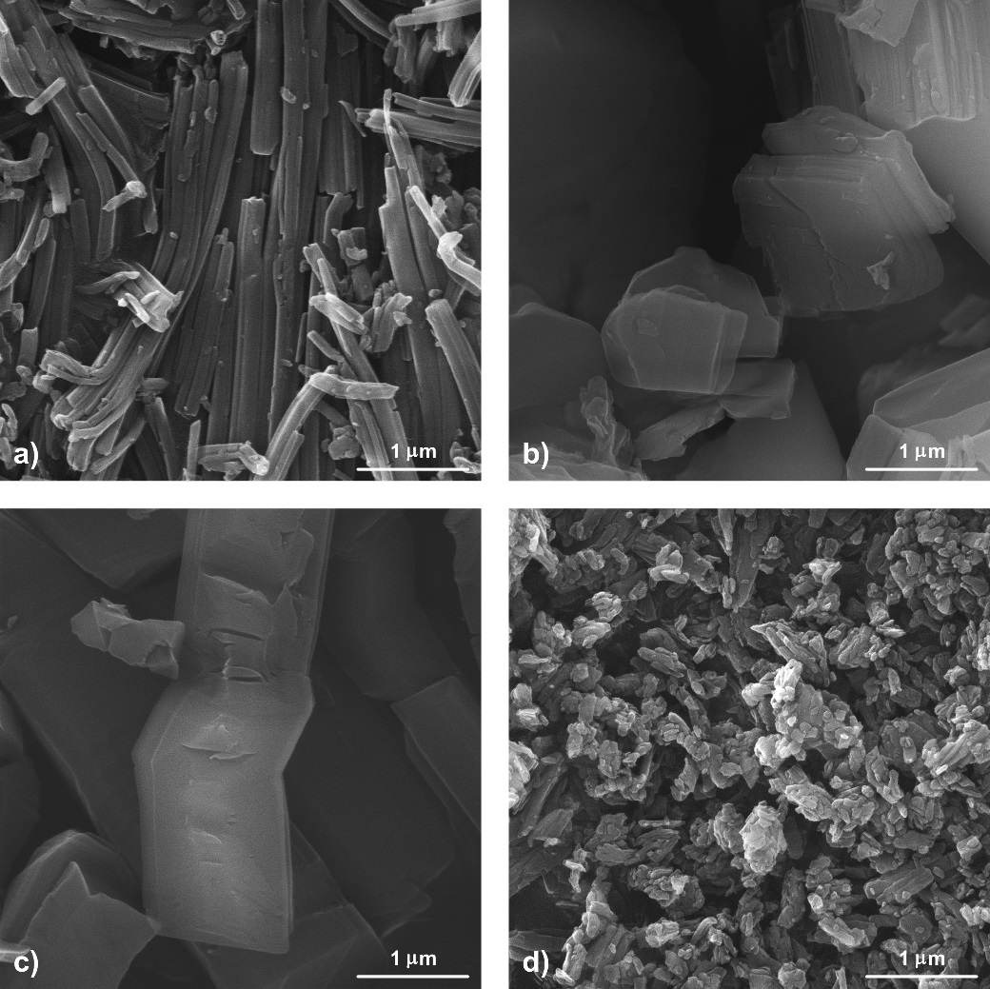

Fig. S-2. FESEM images of precursors **1** (a), **2** (b), **3** (c) and **4** (d).

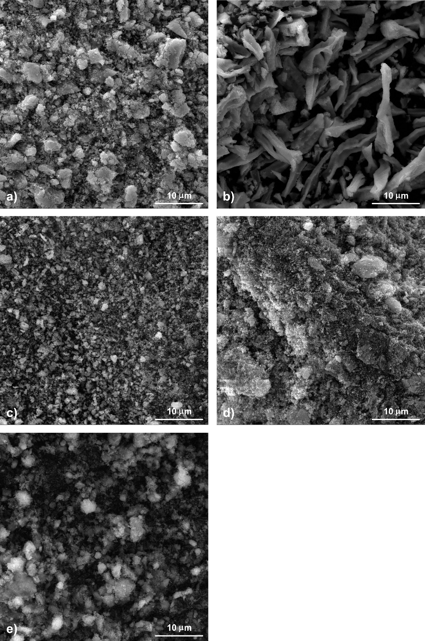

Fig. S-3. FESEM images of aglomerated **ZnO_1** (a), **ZnO_2** (b), **ZnO_3** (c), **ZnO_4** (d) and **ZnO_com** (e) at magnification of 5kx.



Fig. S-4. Plot of (F(*R*)*hν*)2 as a function of photon energy for **ZnO_1**–**ZnO_4** and **ZnO_com**.



Fig. S-5. Linear plots of pseudo-first order kinetic model of RO16 degradation on investigated ZnO powders.

REFERENCES

1. S. Vyazovkin, *Thermochim. Acta* **355** (2000) 155 (<https://doi.org/10.1016/S0040-6031(00)00445-7>)

2. S. Vyazovkin, K. Chrissafis, M. L. Di Lorenzo, N. Koga, M. Pijolat, B. Roduit, N. Sbirrazzuoli, J. J. Suñol, *Thermochim. Acta* **590** (2014) 1 (<https://doi.org/10.1016/j.tca.2014.05.036>)

3. H. E. Kissinger, *Anal. Chem.* **29** (1957) 1702 (<https://doi.org/10.1021/ac60131a045>)

4. H. J. Eyring, *J. Chem. Phys.* **3** (1935) 107 (<https://doi.org/10.1021/cr60056a006>)

5. M. G. Evans, M. Polanyi, *T. Faraday Soc.* **31** (1935) 875 (<https://doi.org/10.1039/TF9353100875>)

6. J. D. Zdravković, L. Radovanović, D. Poleti, J. Rogan, P. Vulić, Ž. Radovanović, D. M. Minić, *Solid State Sci.* **80** (2018) 123 (<https://doi.org/10.1016/j.solidstatesciences.2018.04.013>)

1. *Corresponding author. E-mail: lradovanovic@tmf.bg.ac.rs