Novel negatively-charged membrane adsorbers made using combination of photopolymerization and immersion precipitation

TANJA TOMKOVIĆ¹, FILIP RADOVANOVIĆ^{1*}, BRANIMIR GRGUR², ALEKSANDRA NASTASOVIĆ¹, DANA VASILJEVIĆ-RADOVIĆ¹ and ANTONIJE ONJIA³

¹Institute of Chemistry, Technology and Metallurgy, University of Belgrade, Njegoševa 12, Belgrade 11000, Serbia, ²Faculty of Technology and Metallurgy, University of Belgrade, Karnegijeva 4, Belgrade 11000, Serbia, ³Vinca Institute of Nuclear Sciences, University of Belgrade, P.O. Box 522, Serbia

Abstract: A novel method combining a traditional immersion precipitation process for making membranes with photopolymerization and crosslinking of functional monomers included in the casting solution was used to prepare asymmetric polyethersulfone membranes with submicron particles incorporating glycidyl methacrylate copolymer. In order to introduce sulfonic groups epoxide rings of glycidyl methacrylate were opened using two methods. The first method was functionalization with sodium sulfite, and the second method was functionalization with sulfuric acid and then grafting with 2-acrylamido-2-methylpropane sulfonic acid. Obtained membranes were characterized using infrared spectroscopy, conductometric titration and water permeability measurements. Scanning electron microscopy and atomic force microscopy were used to investigate the surface morphology and topology of membrane. Dynamic adsorption of Rhodamine B as a model dye was used to demonstrate suitability of these novel membranes for membrane adsorption since the adsorption capacity for dye cations was much better for both functionalized membrane with sodium sulfite and grafted membrane with 2-acrylamido-2-methylpropane sulfonic acid compared to the nonfunctionalized membrane.

Keywords: membrane formation; grafting; sulfonic acid; epoxide opening; polyethersulfone; glycidyl methacrylate

INTRODUCTION
Phase inversion techniques are the most important and commonly used processes for preparing membranes from a large number of polymers¹. Among these techniques, immersion precipitation is the preferred membrane formation method because it allows preparation of a wide range of membranes by varying the composition and properties of the initial polymer solution. In order to obtain flat membrane sheet a thin film of solution comprising at least one polymer, one good solvent, and additives is cast on a suitable support and immersed into a nonsolvent coagulation bath where it undergoes phase separation into a polymer-rich and a polymer-lean phase^{2,3}.
Polyethersulfone (PES) and PES-based membranes show outstanding chemical, thermal, and mechanical stability as indicated by its high glass transition temperature (Tg = 230 °C), which leads to its frequent use for preparation of asymmetric membranes by immersion precipitation¹. The main disadvantage of PES membranes is related to its relatively hydrophobic character and these membranes are prone to easy fouling by adsorption of nonpolar solutes, hydrophobic particles or bacteria⁴. In order to improve membrane wettability and performance in filtration of aqueous solutions used for bioseparations, or for more efficient ultrafiltration, various methods have been used for modification of PES membranes^{5,6}. These methods are: bulk material modification prior to preparing membranes, surface modification of prepared membranes, and blending of PES membranes with another material to introduce desired functionalities^{4,7}. Surface modification of polymeric membranes can be performed by surface coating and grafting induced by electron beam or gamma ray irradiation, plasma induced-grafting, ozone-induced grafting, thermal-induced grafting, redox-grafting techniques, surface-initiated atom transfer radical polymerization, etc. Membranes can be also prepared and modified using photoirradiation method⁸. Combination of immersion precipitation process and photopolymerization has been used to make asymmetric PES membranes with adsorbent particles incorporating crosslinked glycidyl methacrylate (GMA) copolymer^{9,10}. This method was also used for preparation of asymmetric membranes with interpenetrating proton-conducting morphology¹¹.
The strong interest in polymers based on GMA is mainly due to the ability of epoxide groups to enter into a large number of chemical reactions leading to numerous possible chemical modifications which enables a broad range of applications for these polymers¹². GMA represents a very attractive platform for the introduction of complex functional groups¹³, due to an easy transformation of epoxy group under mild reaction conditions into various functionalities¹⁴. There are a numerous publications on ring-opening of the epoxy groups with various reagents, such as amines and hydroxylamine, sulfuric acid, phosphoric acid, iminodiacetic acid, sodium sulfite, and others¹⁵. The high reactivity of the epoxy group is due to the considerable strain in the three-membered ring, which is also affected by its position, the presence of other polar groups, the type of solvent, and temperature¹². Macroporous copolymers based on GMA are very attractive as adsorbents in biochemical and chemical separations.
The sulfonic acid (SO₃H) is a strongly acidic ion-exchange group which can be introduced into polymeric materials in several ways: sulfonation with concentrated sulfuric acid, copolymerization with monomers containing SO₃H group, ring opening of the epoxides with sodium sulfite, or using different grafting procedures¹⁶. A grafting method catalyzed with cerium (IV) has often been used for surface modification providing that the substrate onto which the grafting occurs contains hydroxyl groups that are transformed into free radicals¹⁷. A single radical is formed on the oxygen atom of the hydroxyl group leading to surface-initiated polymerization while the undesirable competing reactions in the bulk solution are largely suppressed.
Ce(IV) + RCH₂OH → Ce(III) + H⁺ + RCH₂O•
In this study, combination of photopolymerization and liquid phase inversion was used to prepare negatively-charged membrane adsorbers. Polymerized methacrylate network in a PES solution was created using photoirradiation, and then it was converted into a porous asymmetric membrane with embedded particles by immersion in a water bath. In our previous work, the epoxide groups were transformed into amine groups by functionalization with diethylene triamine and the dynamic adsorption of Orange G⁹ or copper¹⁰ from dilute aqueous solutions was used to show efficient capturing of these species by amine groups. In this work, the epoxide groups were transformed into sulfonic groups by functionalization with sodium sulfite (SS) or by grafting with 2-acrylamido-2-methylpropane sulfonic acid (AMPS). Dynamic adsorption of Rhodamine B from a dilute aqueous solution was used to demonstrate efficient capturing of basic species by negatively-charged sulfonic groups.

EXPERIMENTAL
Chemicals and reagents
PES (Ultrason E 7020P, M_{w} 92,000, polydispersity index 3) was kindly provided by BASF. GMA (reagent grade), trimethylolpropane trimethacrylate (TMPTMA), N-methyl-2-pyrrolidone (NMP, 99 % purity), polyvinyl pyrrolidone (PVP, Mw 25,000), SS (reagent grade), isopropyl alcohol (IPA), sulfuric acid (H₂SO₄), nitric acid (HNO₃), ammonium cerium (IV) nitrate (ACN), AMPS (99 %), Rhodamine B, sodium hydroxide (NaOH), hydrochloric acid (HCl), sodium chloride (NaCl), and phenolphtalein were received from Sigma-Aldrich. The photoinitiator (PI), bis(2,4,6-trimethylbenzoyl)-phenylphosphineoxide (Irgacure 819), was kindly obtained by Ciba SC. All chemicals were used without previous purification. Tap water was used in the coagulation bath for precipitation of membranes. Milli-Q deionized water was used for pure water permeability tests.

Membrane preparation
Membranes were prepared using the following procedure. A 25 % by weight solution of PES in NMP was made by mixing at 80 °C overnight. A 25 % by weight solution of PVP was prepared by dissolving PVP in NMP at 80 °C. A solution of 1.27 g GMA and 0.45 g TMPTMA in 8.39 g NMP was made by mixing components in an amber vial cooled with ice and protected from ambient light. The solution for making membranes was prepared by mixing 1.25 g PES and 0.23 g PVP solutions with the freshly prepared solution of monomers. Before the casting, 1 % of PI based on the total weight of monomers was added to the solution. The initial concentration of PES in all solutions was 11 % by weight excluding the PVP additive. The concentration of GMA was calculated to be 3 mmol g⁻¹ of final dry membrane at a theoretical 100 % reactant conversion. The concentration of crosslinker (TMPTMA) in the solution was 15 mole percent based on the GMA concentration. In our previous work⁹, we found that this composition provided optimal balance of membrane strength and pure water permeability. The prepared solution was transparent confirming complete miscibility of the components.
Prepared solution was cast on a glass plate using a 7.62 cm-wide film applicator with a 200 µm gap (BYK-Gardner), then put in an experimental enclosure blanketed with nitrogen gas and exposed to UV irradiation through a glass window on top of the enclosure for 10 minutes. The exposure doze, mainly in the UVA region, was 4.5 J cm⁻², as measured by YK-35UV light meter. UV exposure initiated photopolymerization and crosslinking of GMA to create a gel in the cast film. Finally, after UV curing, cast film was immersed in water bath and phase separation occurred by instantaneous liquid-liquid demixing mechanism. After allowing at least 10 min to complete phase separation and solidification, obtained membrane was further extracted in distilled water overnight.

Opening of epoxide rings
We used two methods to open epoxide rings. In the first method, functionalization of membranes with SS was performed by immersing membranes in a solution containing SS, IPA, and distilled water under reflux conditions. In the second method, the epoxide groups of membranes comprising crosslinked polyGMA particles were hydrolyzed using sulfuric acid to produce diol groups before grafting the membranes with AMPS. Reaction conditions are given in Table I. Chemical reactions of functionalizations of given membranes using SS and H₂SO₄ are presented on Figures 1 and 2.

Grafting of AMPS
In order to graft the membranes with AMPS, we dissolved 0.137 g of ACN in 25 mL of water. Then, we added 0.116 g of 25 mmol L⁻¹ nitric acid followed immediately by the addition of 5,175 g of AMPS dissolved in 25 mL of water. The membranes previously converted into diol form were immersed in the freshly prepared solution of ACN and AMPS. This mixture was purged with nitrogen and the polymerization was allowed to proceed for 5 h at 60 °C under reflux conditions. Shematic overview of AMPS-grafting is presented on Fig. 3.

Membrane characterization
Pure water permeability of membrane samples was measured with a Millipore stirred cell, Model 8050 (13.4 cm² effective membrane area) using deionized water at 1 bar pressure difference.
Fourier transform infrared spectroscopy-attenuated total reflectance (FTIR-ATR) analysis was conducted with Thermo Scientific Nicolet 6700 instrument equipped with Smart ATR Diamond accessory.
Scanning electron microscopy (SEM) analysis was performed with JEOL JSM-6610 L instrument using W filament as an electron source. Air-dried membrane samples were fractured after cooling in liquid nitrogen and sputtered with gold.
Atomic force microscopy (AFM) analysis was conducted with AFM instrument (AutoProbe CP Research, TM microscopes) in noncontact mode. Root mean squared (R_{a}) roughness values were calculated by applying the software package Veeco SPMLab NT Ver.6.0.2 on 2d pictures (0.8 x 0.8 μm).
Conductometric titration was used to determine concentration of sulfonic groups. A membrane sample weighing around 0.1 g was cut into small pieces, than immersed in 10 mL of 0.1 M HCl and mixed for 30 min. After thorough rinsing with deionized water until the conductivity reduced to 1-2 µS cm⁻¹, 50 ml of 0.001 M NaCl was added and the solution was stirred for 10 min before measuring the initial pH value. 0.01 M NaOH was added slowly from the burette while stirring and the conductivity was measured 15-30 sec after each addition. Sulfonic groups in the membrane sample gradually changed from acidic to the sodium form reducing the solution conductivity until the minimum was reached at neutral pH. Then, the concentration of sulfonic groups was calculated from the volume of NaOH solution used for titration and the weight of dried membrane sample.
Separation performance for membranes functionalized with SS and grafted with AMPS was determined by filtration of a 50 mg L⁻¹ aqueous solution of Rhodamine B using a Millipore stirred cell, Model 8050. For nonfunctionalized membrane and membrane functionalized with SS, transmembrane pressure was 0.5 bar, and for membrane grafted with AMPS this pressure was 1 bar. Membrane samples were placed in the cell with bottom side facing the feed solution. The concentration of dye in the filtrate was determined by UV-Vis spectroscopy using Thermo Scientific Evolution 60 instrument at 550 nm where a maximum in light absorption was observed.

RESULTS AND DISCUSSION
SEM analysis
SEM image of the cross-section of the PES membrane made with initial concentration of 3 mmol g⁻¹ GMA and 15 mol % TMPTMA in Fig. 4 (left) shows a typical asymmetric structure with a thin selective skin layer on top over much thicker porous support. Based on the results of elemental analysis reported earlier⁹, degree of conversion (polymerization yield) for the reaction between GMA and TMPTMA for this membrane was 80 %. Fig. 4 (right) reveal clusters of submicron particles incorporated within the PES membrane structure in the middle section. Structures seen in this figure result from complex interplay of phenomena occurring during membrane formation, which was discussed in our previous work^{9,10}. Photoirradiation leads to GMA polymerization and crosslinking with TMPTMA, and as a result, an organogel is formed. During this step, phase separation between polymer-rich (PES) and methacrylate-rich phases is likely to occur. As a result, irradiated films were hazy indicating some degree of localized phase separation between macromolecular species. All irradiated films turned immediately white upon immersion into a water bath indicating that the membranes were formed by an instantaneous liquid-liquid demixing mechanism.
Submicron particles shown in SEM image are actually agglomerates of nodules, which were formed by coalescence prior to solidification¹⁸. Formation of nodular structures can be explained as follows. As discussed in literature¹⁹, diffusional exchange between solvent and nonsolvent driven by large chemical potential gradients leads to formation of macrovoids when polymer concentration is low and the composition in front of formed nuclei remains stable for a relatively long period. When the composition of the casting solution is located in the metastable region or close to the bimodal curve, macrovoids will not be formed, so the composition in front of formed nuclei enters the metastable region immediately^{20,21}.
Another phenomenon that affects creation of nodules is caused by the presence of an additional polymeric component (PVP) in the casting solution. The presence of PVP slows down the relaxation of polymer chains and leads to the phase separation of polymeric species by a spinodal decomposition mechanism forming a submicron nodular structure in the top surface layer²⁰. In the case of membranes described in this work, UV curing creates a network of crosslinked polyGMA mixed with PES molecules, and after immersion in the water bath, which creates thermodynamically unstable conditions, these polymeric species also separate by spinodal decomposition. As Radovanovic et al. explained⁹, formed nodules are probably mixtures of polymeric species with compositions dependent on the extent of phase separation during the UV curing step, because the spinodal decomposition process is faster than diffusion of polymer molecules. In the middle section of membrane molecules had more time to diffuse prior to solidification and nodules coalesce to form agglomerates. These nodules are connected to the pore walls by polymer chains, which are formed during an incomplete demixing of polymers throughout phase separation.

Water permeability measurements
Pure water permeability of the nonfunctionalized membrane, composed of 11 % by weight of PES, 3 mmol g⁻¹ GMA, 15 mol % TMPTMA, and 2 % by weight of PVP, was 988 L h⁻¹ m⁻² bar⁻¹. After functionalization with SS pure water permeability was 462 L h⁻¹ m⁻² bar⁻¹ and 403 L h⁻¹ m⁻² bar⁻¹ for membranes grafted with AMPS. These values are typical for ultrafiltration membranes. Our previous experiments with filtration of bovine serum albumin using the nonfunctionalized membrane have shown that the selective skin layer of this membrane has the effective pore radius of 4.85 nm⁹. As one can see, water permeability significantly reduced after SS functionalization and grafting with AMPS. This might be related to the swelling of nodules containing relatively high concentrations of negatively-charged sulfonic groups which could cut down the flow to a certain extent due to a reduction in the effective pore size.

FTIR-ATR analysis
Fig. 5 presents the FTIR-ATR spectra of the nonfunctionalized membrane and the membrane functionalized with SS. Strong carbonyl peaks at 1724 cm⁻¹ originate from both GMA and TMPTMA, while epoxide peaks at 907 cm⁻¹ come from GMA. Both spectra exhibit the following peaks characteristic for PES: 1147 cm⁻¹ for symmetric SO₂ stretching, as well as the aromatic bands at 1238, 1485, and 1577 cm⁻¹. After functionalization with SS, sulfonic group was introduced and as shown by the corresponding peak at 1043 cm⁻¹.
FTIR-ATR spectra of PES membranes before and after treatment with H₂SO₄ and after grafting with AMPS are shown in Fig. 6. Characteristic carbonyl peaks at 1723 cm⁻¹ originating from both GMA and TMPTMA and epoxide peaks at 907 cm⁻¹ coming only from GMA are present. In addition, broad peaks at 3400 cm⁻¹ characteristic for hydroxyl groups can be seen for both treated membranes in a small window included in Fig. 6. All spectra also contain peaks characteristic for PES: 1149 cm⁻¹ for symmetric SO₂ stretching, and 1238, 1485, and 1577 cm⁻¹ for aromatic bands. In addition, there is peak at 1043 cm⁻¹ resulting from the sulfonic group introduced by grafting with AMPS.

AFM analysis
AFM images of the top membrane surfaces were used to investigate membrane surface topology. AFM images obtained for nonfunctionalized PES membrane and membrane functionalized with SS showed that surface topographies were quite similar. Fig. 7 presents a membrane before and after grafting with AMPS. The surface topographies of these membranes are also very similar with nodules ranging from 20 to 50 nm with a slight increase in surface roughness from 5.36 to 8.23 nm after grafting. This increase in surface roughness might be a result of additional sulfonic groups grafted on the surface of the membrane.

Conductometric titration
Conductometric titration was used to determine the concentration of sulfonic groups in PES membranes functionalized with SS and grafted with AMPS. The results are listed in Table II and compared to the theoretical value of 2.4 mmol g⁻¹ (80 % polymerization yield starting from the initial GMA concentration of 3.0 mmol g⁻¹). Both concentrations are significantly lower than the theoretical value, which indicates that epoxide groups buried inside the nodules are not easily accessible for reaction. Relatively low value for membrane grafted with AMPS compared to the membrane functionalized with SS may have been a result of differences in molecular sizes of reactants. Lower conversions due to steric effects are often observed in polymer functionalization with larger molecules²².

Dynamic adsorption of cationic dye
In order to investigate the separation performances of nonfunctionalized PES membranes, functionalized membranes with SS, and membranes grafted with AMPS, a series of screening experiments using Rhodamine B as a model adsorbate was conducted and the results are shown in Fig 8. Rhodamine B is cationic dye, which has been used in pharmaceutics, cosmetics fields, and textile industry. The molecular weight of its chloride form is 479 g mol⁻¹ and it has one ammonium group per molecule which can bind electrostatically with sulfonic groups. The longest dimension of the Rhodamine B molecule has been reported as 1.77 nm²³. Due to its smaller molecular size than the pores present in the selective top surface of the membrane, dye adsorption occurs primarily by electrostatic binding between the dye ammonium groups and sulfonic groups in the functionalized membrane and not by a sieving mechanism. Dynamic adsorption experiments were conducted using transmembrane pressure ranging from 0.5 to 1 bar. As one can see in Fig. 8, instantaneous dye breakthrough occured with the nonfunctionalized membrane. This membrane captured only a minor fraction of the dye by nonspecific adsorption on the membrane material itself. PES membranes exhibit slightly negative charges in dilute aqueous solutions²⁴, which might explain adsorption of Rhodamine B by the nonfunctionalized membrane. The lowest concentrations of Rhodamine B in the permeate were observed for a membrane grafted with AMPS. Both the membrane functionalized with SS and the membrane grafted with AMPS had much greater adsorption capacity for dye cations compared to the nonfunctionalized membrane.

CONCLUSIONS
Combination of traditional liquid phase inversion process for making asymmetric membranes and photopolymerization was used for preparation of asymmetric PES membranes with submicron particles comprising GMA. Casting solution was exposed to a source of UV irradiation to polymerize the monomers and after immersion of the irradiated film into the water bath, phase separation between polymer-rich and polymer-lean phases was induced. This novel process led to the creation of asymmetric PES membranes with adsorbent particles comprising crosslinked GMA copolymer. Two methods were used in order to open epoxide rings and introduce sulfonic groups. In the first method obtained membranes were functionalized with SS, and in the second membranes were hydrolyzed using sulfuric acid to produce diol groups and then grafted with AMPS.
SEM images of the membrane cross-section revealed clusters of submicron particles embedded within the PES support matrix. Functionalization with SS and grafting with AMPS converted these submicron particles into microadsorbers by introducing sulfonic groups through the epoxide ring opening. FTIR-ATR spectra demonstrates presence of characteristic peaks originating from GMA, AMPS, SS and PES in final membranes. AFM images showed that the surface topographies of initial and grafted membranes are quite similar. In order to determine the concentration of sulfonic groups in PES membranes functionalized with SS and grafted with AMPS, conductometric titration was used. Separation performance of obtained membranes was examined by a series of experiments using Rhodamine B as a model dye. The dye retention in these dynamic adsorption experiments was highest for PES membranes grafted with AMPS.

Acknowledgements. This work has been funded by Serbian Ministry of Education, Science and Technological Development through the projects TR32008 and III 43009. The authors would like to thank Ciba SC for providing the photoinitiator.

REFERENCES

1. G.R. Guillen, Y. Pan, M. Li, E.M.V. Hoek, Ind. Eng. Chem. Res. 50 (2011) 3798
2. D.M. Koenhen, M.H.V. Mulder, C.A. Smolders, J. Appl. Polym. Sci. 21 (1977) 199
3. P. van de Witte, P.J. Dijkstra, J.W.A. van der Berg, J. Feijen, J. Membrane Sci. 117 (1996) 1
4. C. Zhao, J. Xue, F. Ran, S. Sun, Prog. Matter Sci. 58 (2013) 76
5. S. Belfer, R. Fainchtain, Y. Purinson, O. Kedem, J. Membr. Sci. 172 (2000) 113
6. K. C. Khulbe, C. Feng, T. Matsuura, J. Appl. Polym. Sci. 115 (2010) 855
7. C. Zhao, S. Nie, M. Tang, S. Sun, Prog. Polym. Sci. 36 (2011) 1499
8. D. He, H. Susanto, M. Ulbricht, Prog. Polym. Sci. 34 (2009) 62
9. F. Radovanović, A. Nastasović, T. Tomković, D. Vasiljević-Radović, A. Nešić, S. Veličković, A. Onjia, React. Funct. Polym. 77 (2014) 1
10. T. Tomković, F. Radovanović, A. Nastasović, D. Vasiljević-Radović, J. Marković, B. Grgur, A. Onjia, Eur. Polym. J. 63 (2015) 90
11. P. Radovanovic, M. Kellner, J. Matovic, R. Liska, T. Koch, J. Membr. Sci. 401-402 (2012) 254
12. K. D. Safa, M. H. Nasirtabrizi, Polym. Bull. 57 (2006) 293
13. R. Barbey, H. A. Klok, Langmuir 26 (2010) 18219
14. J. Kalal, F. Svec, V. Marousek, J. Polym. Sci. Polym. Symp. 47 (1974) 155
15. Y. Bondar, H. J. Kim, S. H. Yoon, Y. J. Lim, React. Funct. Polym. 58 (2004) 43
16. S. Tsuneda, H. Shinano, K. Saito, S. Furusaki, Biotechnol. Prog. 10 (1994) 76
17. C. Viklund, F. Svec, J. M. J. Fréchet, Biotechnol. Prog. 13 (1997) 597
18. I. Strużyńska-Piron, J. Loccufier, L. Vanmaele, I.F.J. Vankelecom, Chem. Commun. 49 (2013) 11494
19. C.A. Smolders, A J. Reuvers, R.M. Boom, I.M. Wienk, J. Membrane Sci. 73 (1992) 259
20. R.M. Boom, I.M. Wlenk, Th. van den Boomgaard, C A. Smolders, J. Membrane Sci. 73 (1992) 277
21. H-G. Hicke, I. Lehmann, G. Malsch, M. Ulbricht, M. Becker, J. Membrane Sci. 198 (2002) 187
22. Z. P. Sandić, A. B. Nastasović, N. P. Jović-Jovičić, A. D. Milutinović-Nikolić, D. M. Jovanović, J. Appl. Polymer Sci. 121 (2011) 234
23. J. Canning, G. Huyang, M. Ma, A. Beavis, D. Bishop, K. Cook, A. McDonagh, D. Shi, G. D. Peng, M. J. Crossley, Nanomaterials 4 (2014) 157
24. H. Susanto, M. Ulbricht, J. Membr. Sci. 327 (2009) 125.
Table captions
TABLE I. Reaction conditions of ring opening reaction.
TABLE II. Concentration of sulfonic acid groups from conductometric titration.

TABLE I. Reaction conditions of ring opening reaction.
Reactant | Medium | Temperature, °C | Reaction time, h
SS | SS/IPA/water = 10/15/75 (w/w/w) | 80 | 6
H₂SO₄ | 0.5 M solution | 60 | 4

TABLE II. Concentration of sulfonic acid groups from conductometric titration.
Membrane | Sulfonic group concentration, mmol g⁻¹
Nonfunctionalized PES membrane | 0.00
Membrane functionalized with SS | 0.79
Membrane grafted with AMPS | 0.29
Theoretical concentration of sulfonic groups | 2.40

Figure captions
Fig. 1. Ring opening using SS.
Fig. 2. Ring opening using sulfuric acid.
Fig. 3. Shematic overview of AMPS-grafting.
Fig. 4. SEM images of the cross-section of an asymmetric PES membranes with initial concentrations of 3 mmol g⁻¹ GMA and 15 mol % TMPTMA: full view (left) and middle section (right), from ref. ⁹
Fig. 5. The effects of functionalization with SS on FTIR-ATR spectra of PES membrane with embedded GMA particles: nonfunctionalized membrane (bottom), functionalized with SS (top).
Fig. 6. FTIR-ATR spectra for nonfunctionalized membrane (bottom), membrane after functionalization with H₂SO₄ (middle) and after grafting with AMPS (top).
Fig. 7. AFM images of the top surface of PES membrane with initial concentrations of 3 mmol g⁻¹ GMA and 15 mol % TMPTMA: nonfunctionalized (left) from ref. ¹⁰ and membrane after grafting with AMPS (right).
Fig 8. Filtration of Rhodamine B solution (feed concentration 50 mg L⁻¹, transmembrane pressure 0.5-1 bar) through: □ nonfunctionalized PES membrane; ○ PES membrane functionalized with SS; ∆ PES membrane grafted with AMPS.

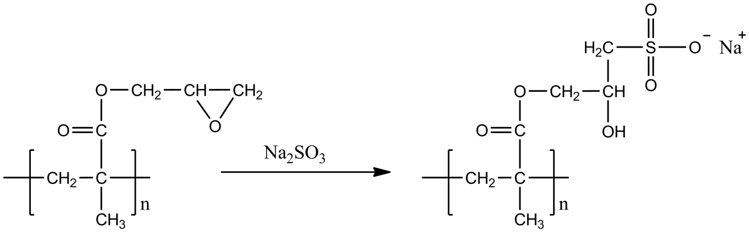
Fig. 1

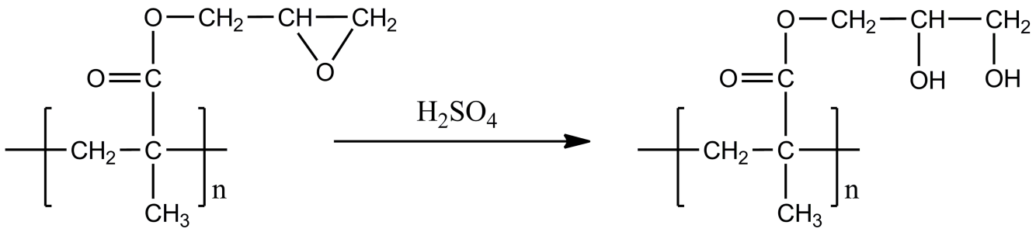
Fig. 2

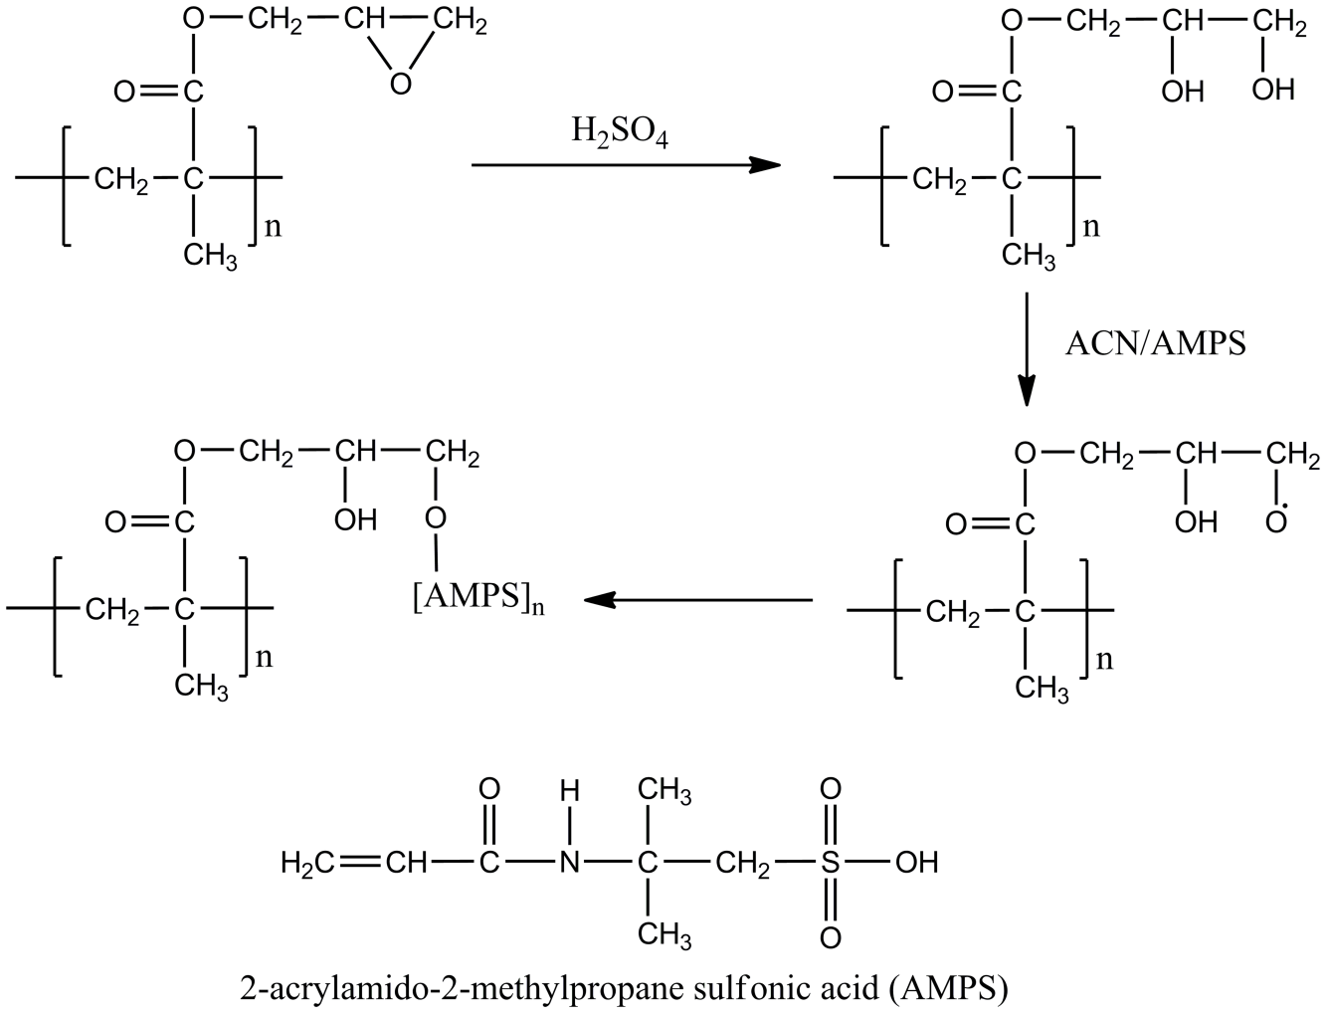
Fig. 3

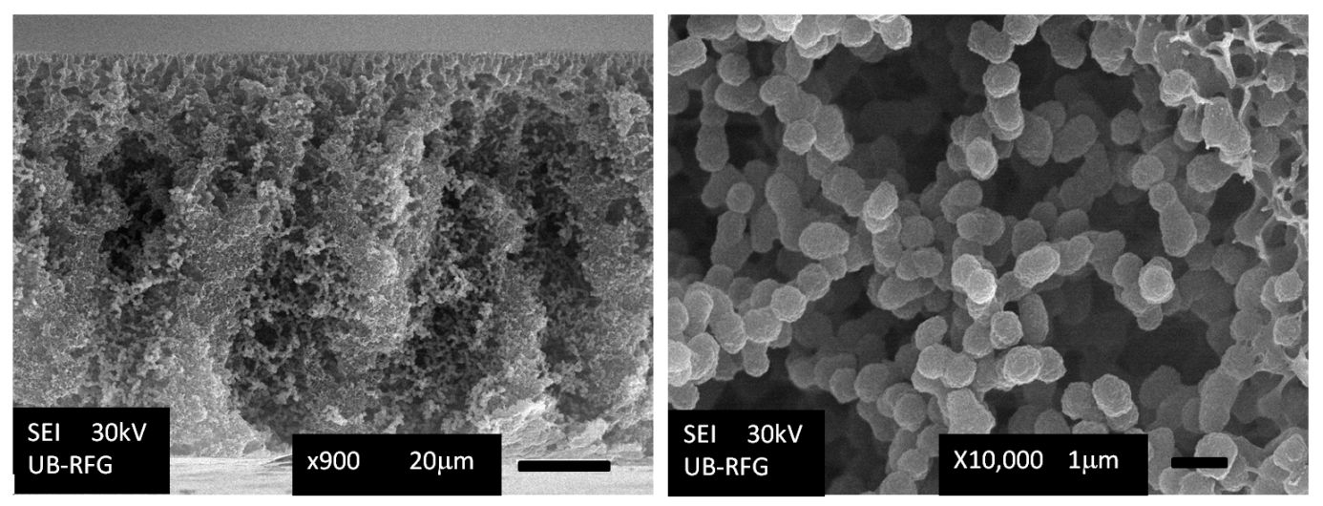
Fig. 4

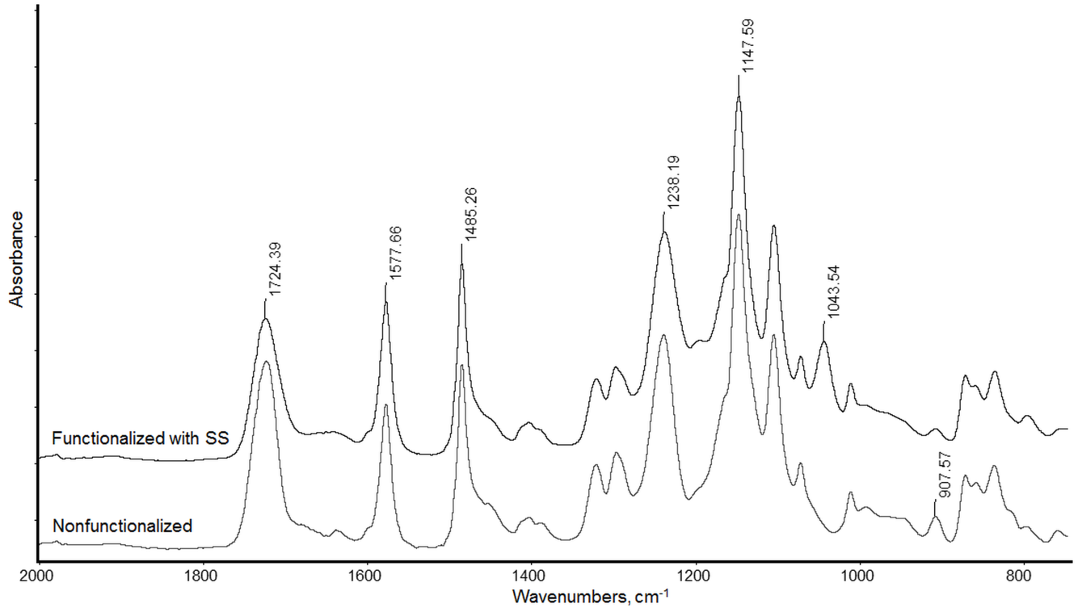
Fig. 5

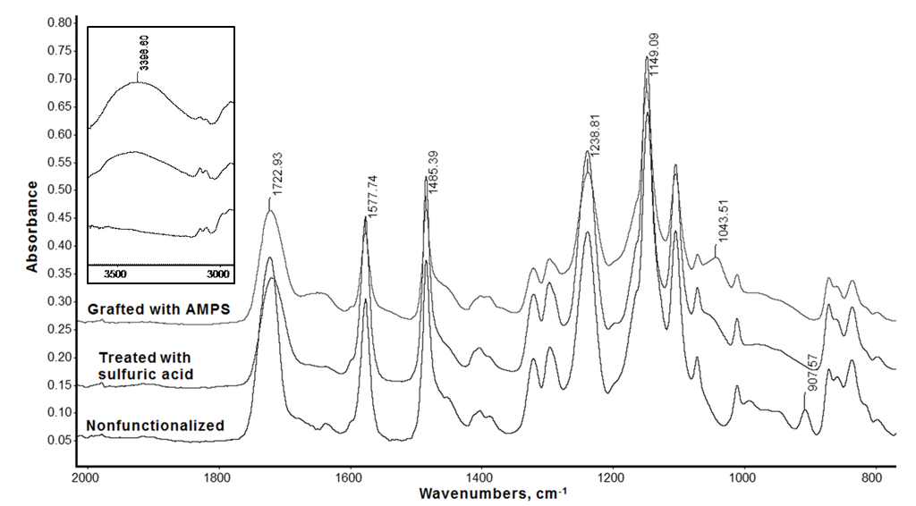
Fig. 6

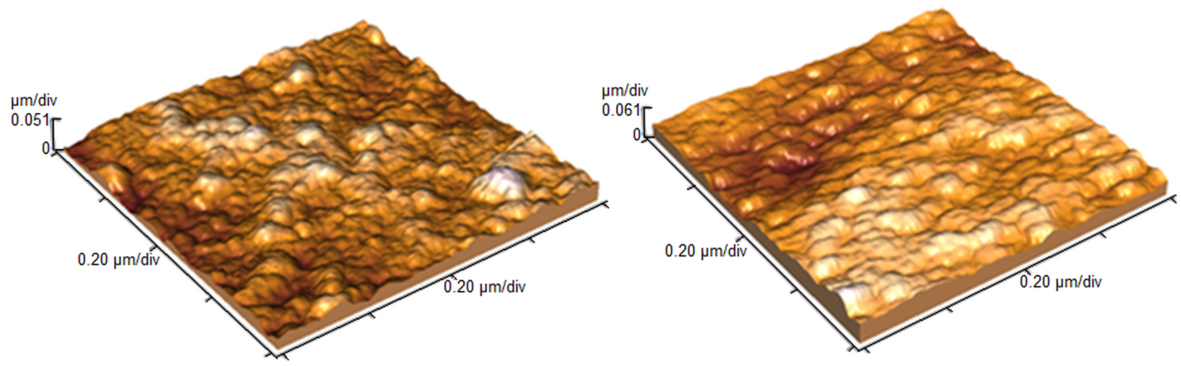
Fig. 7

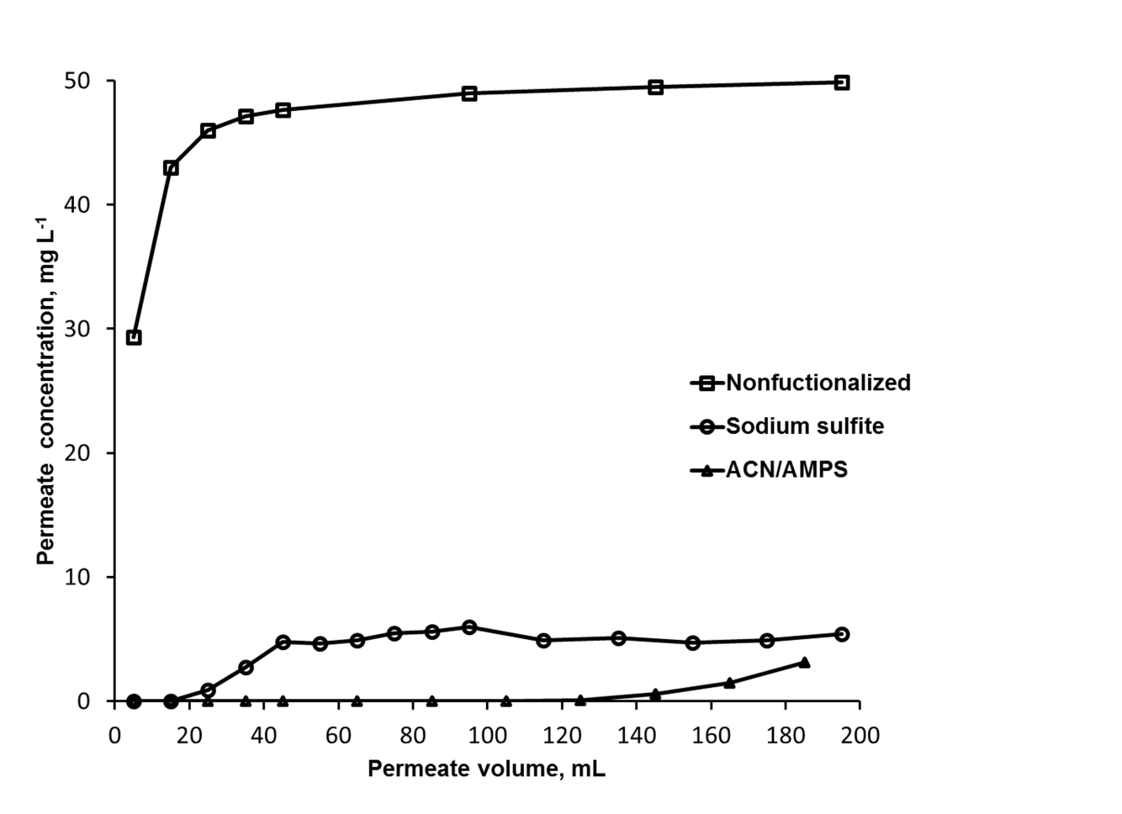
Fig. 8

ИЗВОД
НОВИ НЕГАТИВНО НАЕЛЕКТРИСАНИ МЕМБРАНСКИ АДСОРБЕРИ НАПРАВЉЕНИ КОМБИНАЦИЈОМ ФОТОПОЛИМЕРИЗАЦИЈЕ И ПОТАПАЊА У ВОДЕНО КУПАТИЛО

ТАЊА ТОМКОВИЋ¹, ФИЛИП РАДОВАНОВИЋ¹, БРАНИМИР ГРГУР², АЛЕКСАНДРА НАСТАСОВИЋ¹, ДАНА ВАСИЉЕВИЋ-РАДОВИЋ¹, АНТОНИЈЕ ОЊИА³

¹Институт за хемију, технологију и металургију, Универзитет у Београду, Његошева 12, 11000 Београд, Србија
²Технолошко-металуршки факултет, Универзитет у Београду, Карнегијева 4, 11000 Београд, Србија
³Институт за нуклеарне науке „Винча“, Универзитет у Београду, п. фах 522, Србија

Нови поступак прављења мембрана заснован на комбинацији традиционалног поступка потапања у водено купатило и фотополимеризације и умрежавања функционалних мономера у почетном раствору примењен је за прављење асиметричних мембрана од полиетарсулфона са уграђеним субмикронским честицама које садрже кополимер глицидил метакрилата. У циљу уградње сулфонских група примењене су две методе отварања епоксидних прстенова: функционализација натријум сулфитом и функционализација сумпорном киселином праћена калемљењем 2-акриламидо-2-метилпропан сулфонском киселином. Добијене мембране су карактерисане помоћу инфрацрвене спектроскопије, кондуктометријске титрације и мерењем пропустљивости воде. Површинска морфологија и топологија мембрана је испитана скенирајућом електронском микроскопијом и микроскопијом атомских сила. Динамичка адсорпција боје Родамин Б показала је да се овај нови тип мембрана може користити за мембранску адсорпцију пошто је капацитет адсорпције за катјоне боје био знатно већи за мембрану функционаклизовану натријум сулфитом и за мембрану калемљену 2-акриламидо-2-метилпропан сулфонском киселином него за нефункционализовану мембрану.

